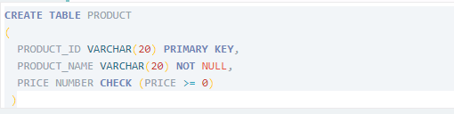

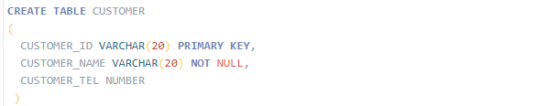

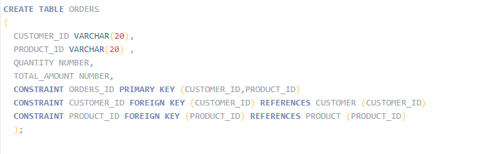





CREATE TABLE PRODUCT

(

PRODUCT_ID VARCHAR(20) PRIMARY KEY,

PRODUCT_NAME VARCHAR(20) NOT NULL,

PRICE NUMBER CHECK (PRICE >= 0)

)

CREATE TABLE CUSTOMER

(

CUSTOMER_ID VARCHAR(20) PRIMARY KEY,

CUSTOMER_NAME VARCHAR(20) NOT NULL,

CUSTOMER_TEL NUMBER

)

CREATE TABLE ORDERS

(

CUSTOMER_ID VARCHAR(20),

PRODUCT_ID VARCHAR(20) ,

QUANTITY NUMBER,

TOTAL_AMOUNT NUMBER,

CONSTRAINT ORDERS_ID PRIMARY KEY (CUSTOMER_ID,PRODUCT_ID)

CONSTRAINT CUSTOMER_ID FOREIGN KEY (CUSTOMER_ID) REFERENCES CUSTOMER (CUSTOMER_ID)

CONSTRAINT PRODUCT_ID FOREIGN KEY (PRODUCT_ID) REFERENCES PRODUCT (PRODUCT_ID)

);

ALTER TABLE PRODUCT ADD Category VARCHAR2(20);

ALTER TABLE ORDERS ADD OrderDate DATE default sysdate;