Task 1: Map Coloring in ASP
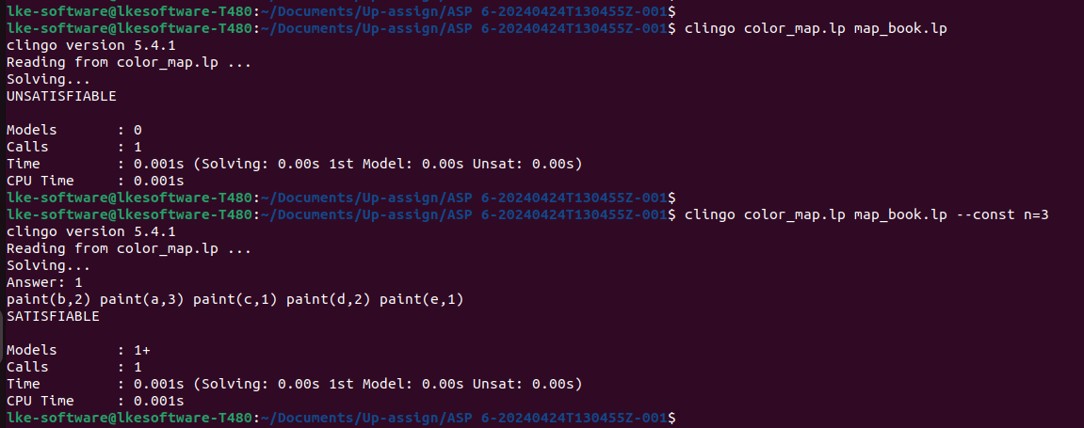
Task 2: Painting the Australian map

Use the encoding from color_map.lp on the Australian map (map_aus.lp), figuring out the minimum number of colors required:
$ clingo color_map.lp map_aus.lp --const n=3
Increment n until a solution is found that satisfies all constraints.
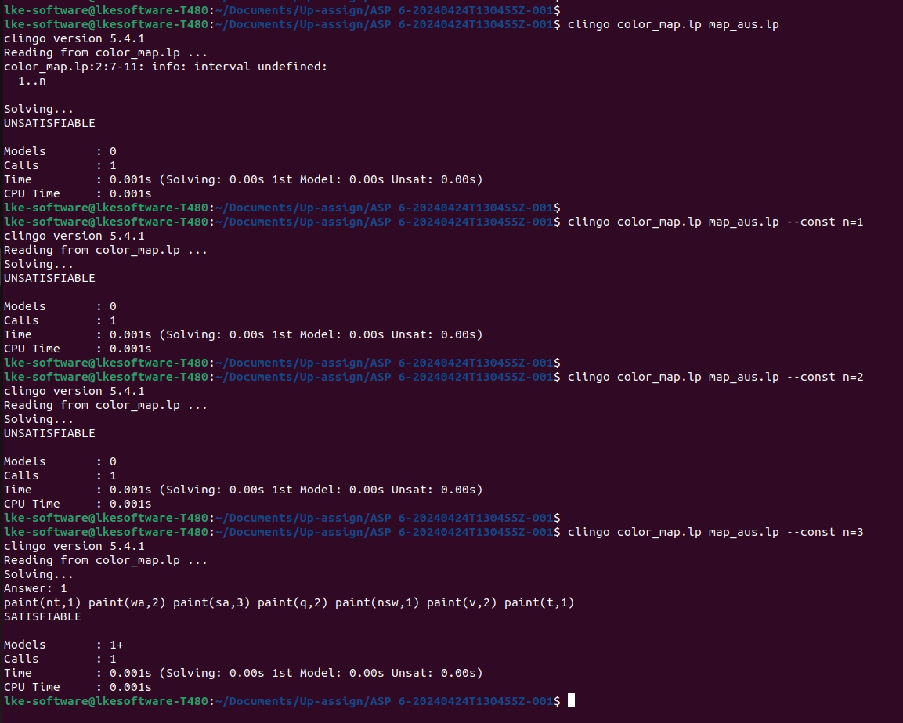
Task 3: Analyse your solution
$ python3 test.py --encoding color_map.lp --instances tests/1/instances --solutions tests/1/solutions --nosol 0 --timeout 10

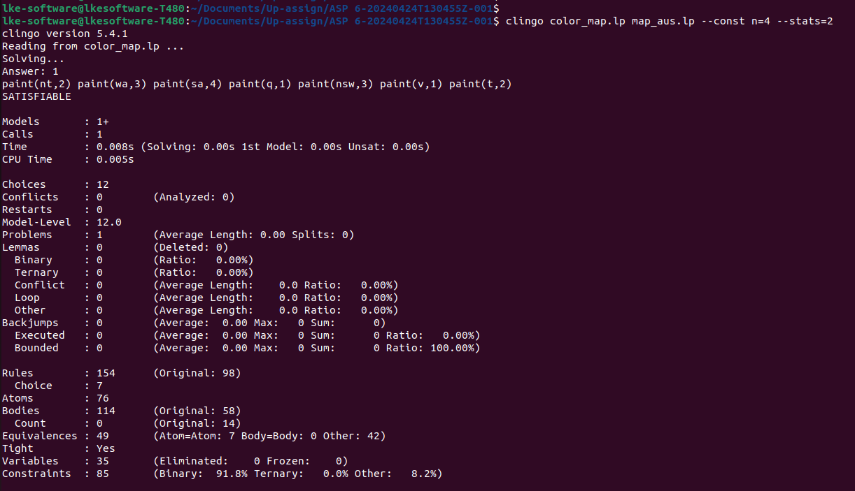
The number of original atoms, rules and bodies, and the number of equivalences found.
Rules : 154 (Original: 98)
Atoms : 76
Bodies : 114 (Original: 58)
Equivalences : 49 (Atom=Atom: 7 Body=Body: 0 Other: 42)

The number of variables and constraints induced in the final grounded encoding.
Variables : 35 (Eliminated: 0 Frozen: 0)
Constraints : 85 (Binary: 91.8% Ternary: 0.0% Other: 8.2%)

Check the difference between number of constraints and the number of original bodies.
The number of choices that Clingo found when solving the problem.
Choices : 12

