As threshold decreases the number mismatches between pair words decreases. We choose the threshold to be an average related to the distance between pairs of words

Female confusion matrix: 47 females

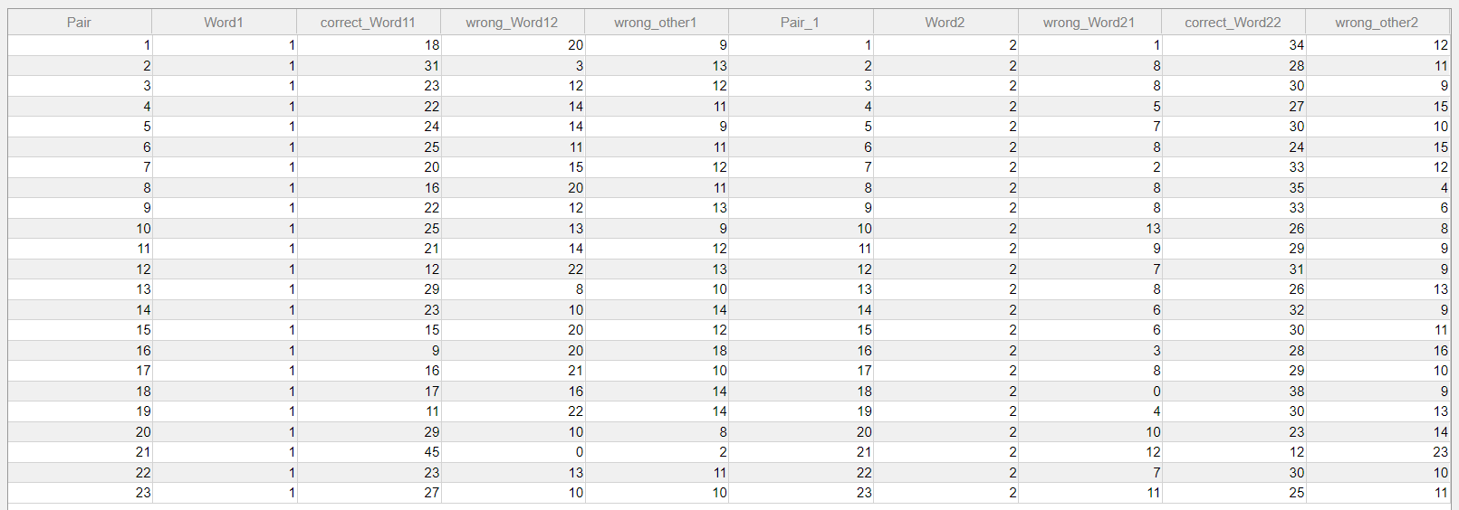

3 examples of mismatched words for female

In pair مسح/مسخ

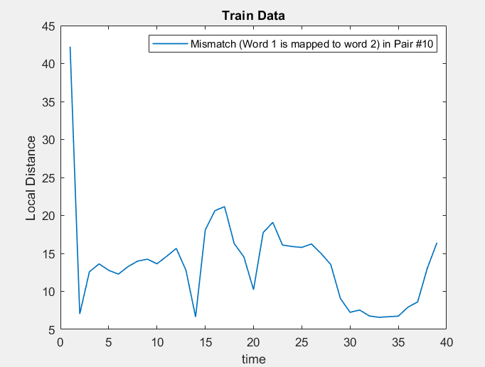

In pair عد/عض

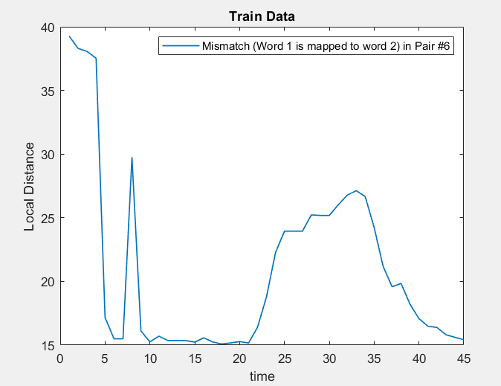

In pair نذير/نظير

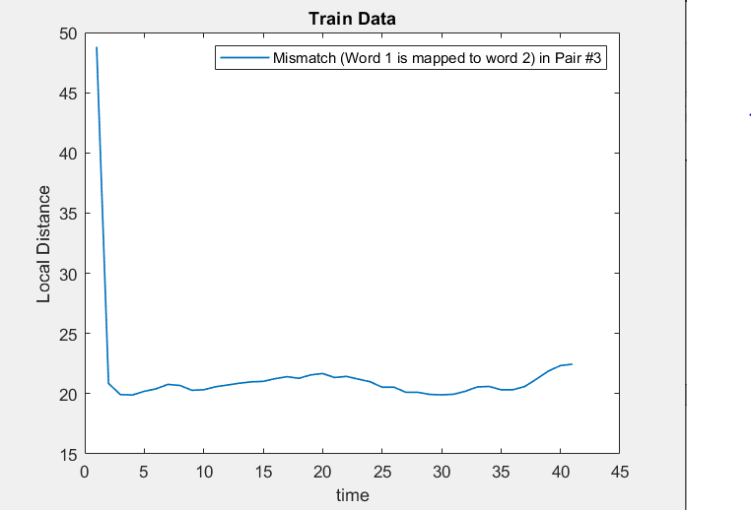

Male confusion matrix: 36 males

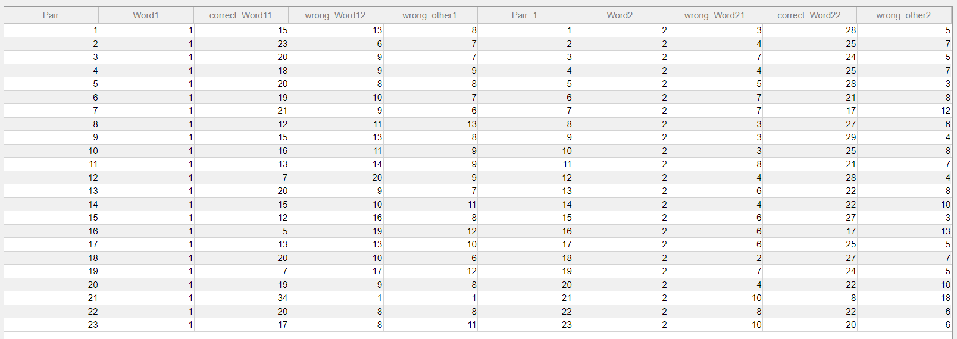

In pair صامد/صامت

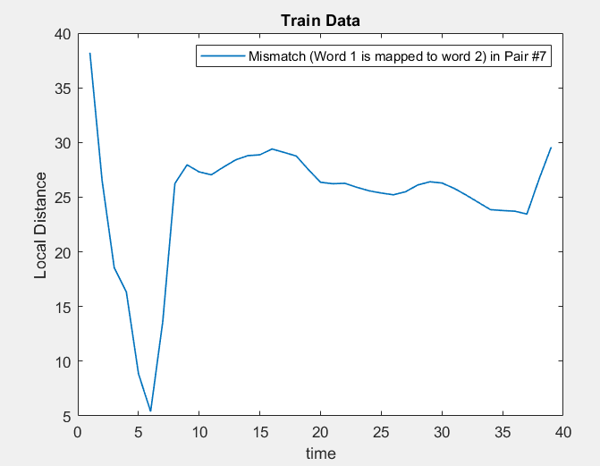

In pair تين/طين

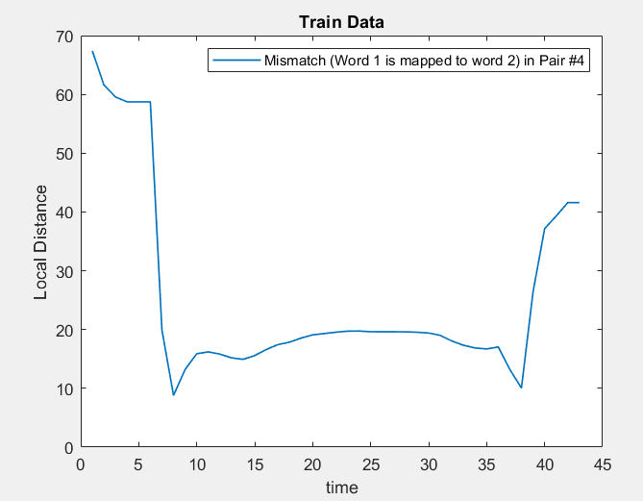

In pair ذل/زل

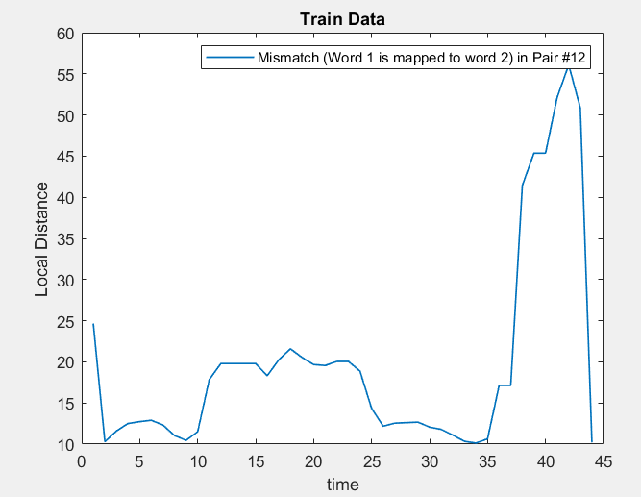

Child confusion matrix: 50 children

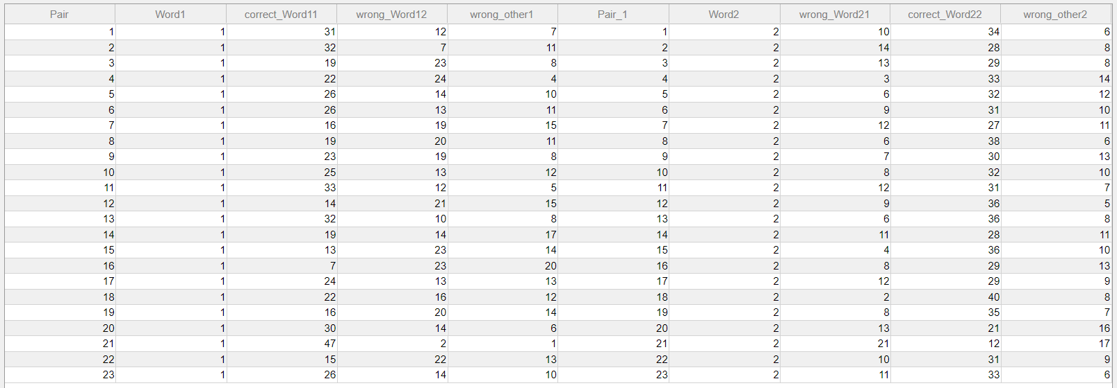

In pair ضن/ظن

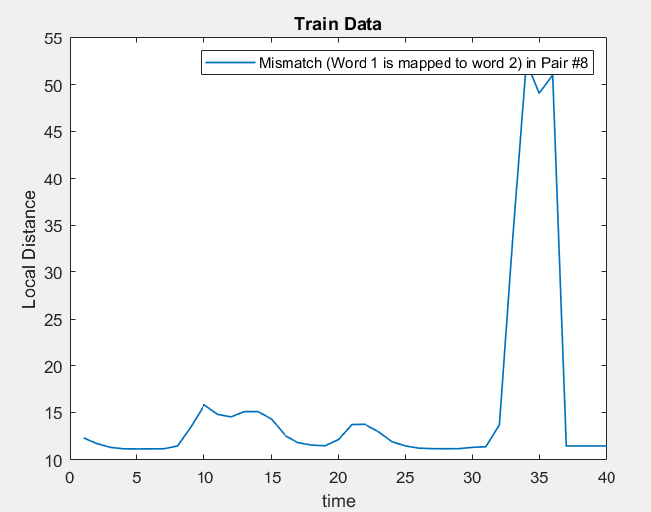

In pair نذير/نظير

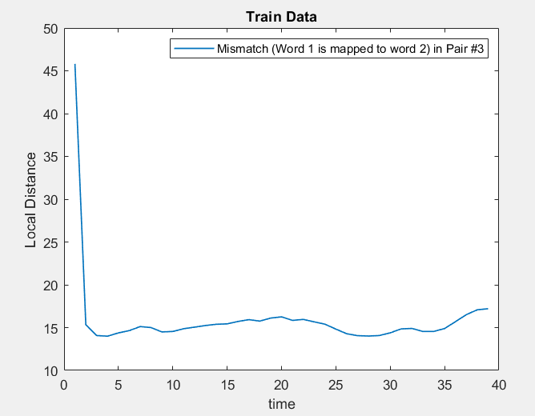

In pair تين/ طين

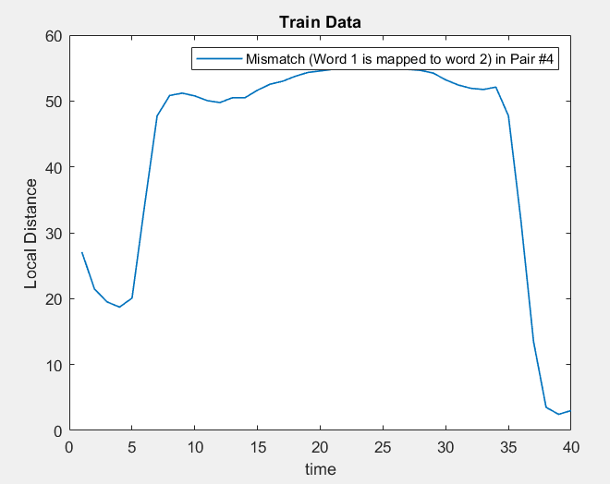

Accuracy of word mapping:

|  |  |
| --- | --- |
| Female | 46.5310% |
| Male | 46.0145% |
| Child | 46.6957% |

Accuracy of Reference mapping:

|  |  |
| --- | --- |
| Female | 0% |
| Male | 100% |
| Child (Male) | 100% |

Application: Input Female user 47 record

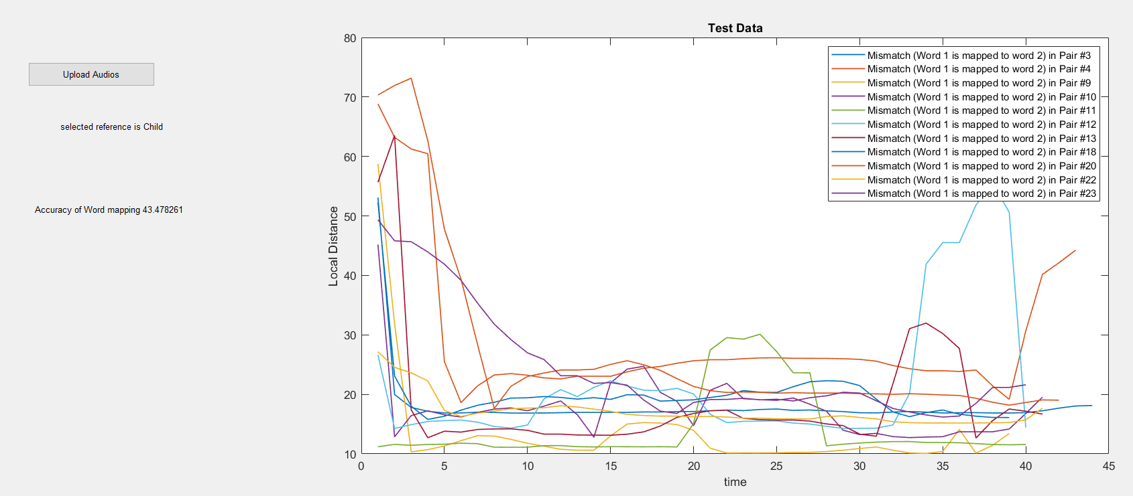

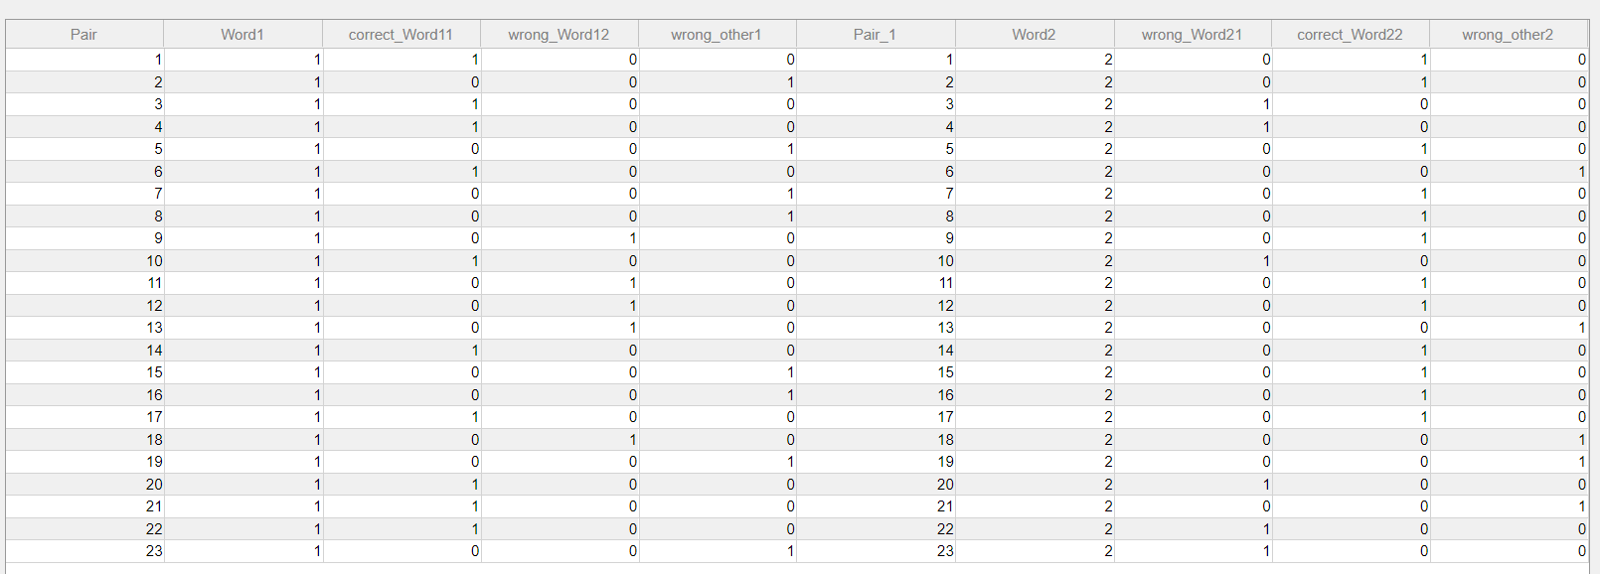

Application: Input child user 47 record

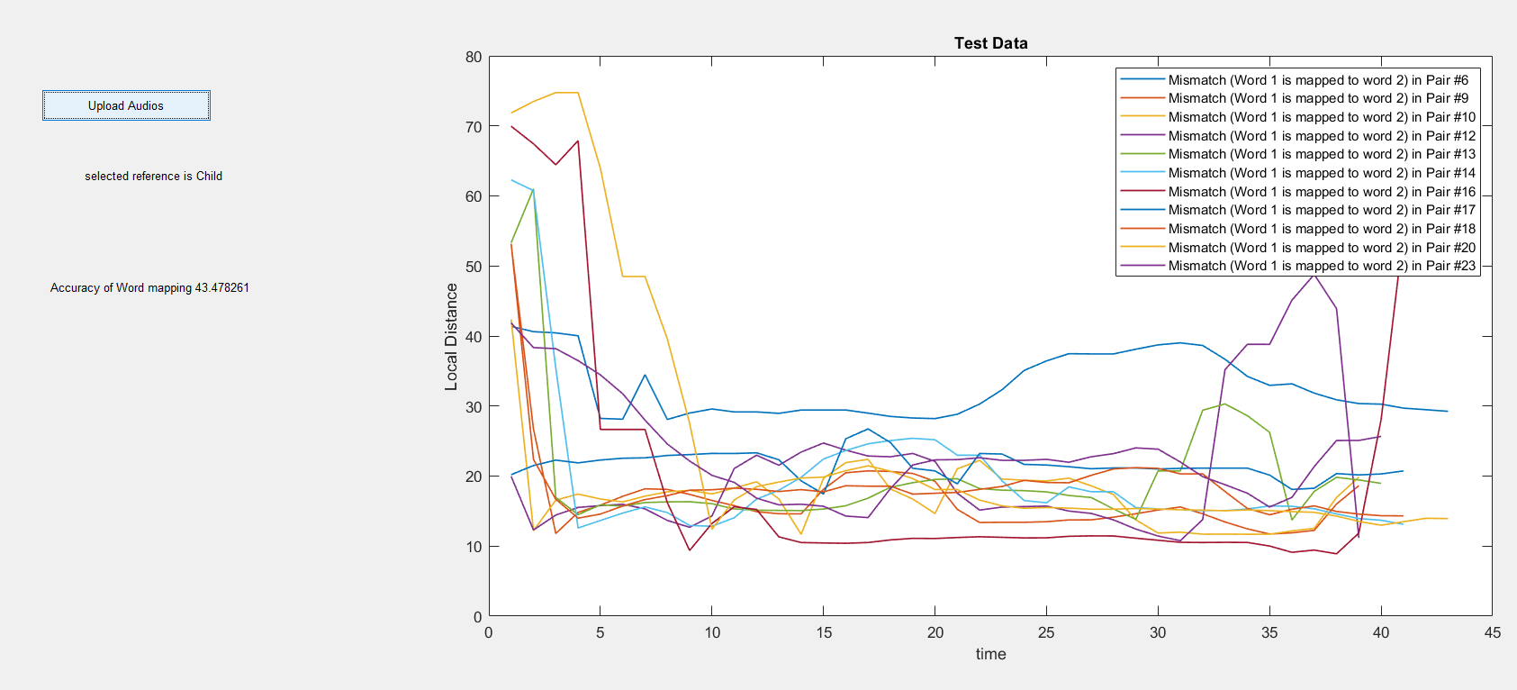

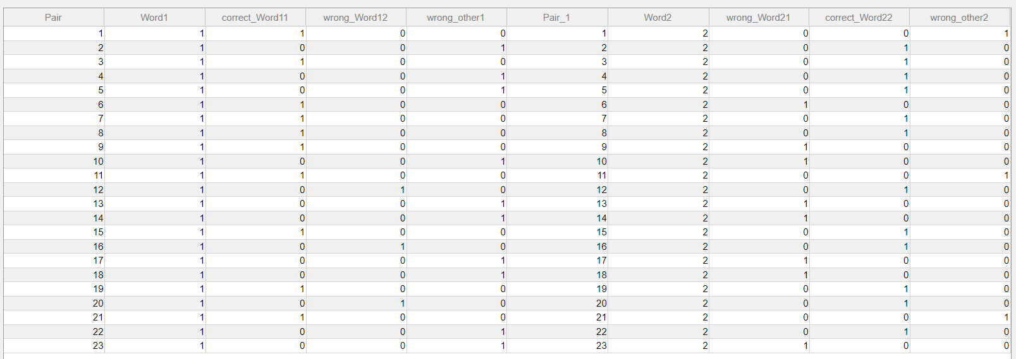

Application: Input male user 47 record

