Obrázok, na ktorom je text

Automaticky generovaný popis

**Projekt 2**

**BPC-BDS**

**Meno a priezvisko:** Vanesa Kociská

**Odbor:** Informačná bezpečnosť

**Skupina:** pondelok 15:00-17:00

**Rok:** 2021

Obsah

Dotazy 3

Create a query that will retrieve only selected columns from the selected table 3

Create a query that will select user/person or similar table based on the email. 3

Create at least one UPDATE, INSERT, DELETE, and ALTER TABLE 4

Create a series of queries that will separately use the following: 4

Where 4

LIKE; NOT LIKE 5

SUBSTRING; TRIM 5

COUNT; SUM; MIN; MAX; AVG; 6

GROUP BY; GROUP BY and HAVING; GROUP BY, HAVING, and WHERE 7

UNION ALL / UNION 8

DISTINCT 8

LEFT JOIN; RIGHT JOIN; FULL OUTER JOIN 9

Use in one query: LEFT JOIN, GROUP BY, HAVING, ORDER BY, AVG and DISTINCT 10

Create a query that will return the data from an arbitrary table for the last one and half days (1day + 12 hours, i.e., 36 hours). Do not hard code the query (e.g., created at >7-11-2021)! 10

Write a select that will remove accents on a selected string (e.g., ́a will be converted to a) 11

Create a query for pagination in an application (use LIMIT and OFFSET) 11

Create a query that will use subquery in FROM 12

Create a query that will use subquery in WHERE condition 12

Create a query that will use any aggregate function and GROUP BY with HAVING 13

Create a query that will join at least five tables 13

Create a query that will join at least three tables and will use GROUP BY, HAVING, and WHERE 13

Set cascading, explain places where you used cascading and why? 13

Create database indexes (create it only on columns where it can make a sense – explain in the provided document why it make sense on a certain column(s) 14

Create arbitrary database procedure (consider some complex case) 15

Create arbitrary database trigger 16

Create arbitrary database view (consider some complex case) 16

Create database materialized view 17

Create two roles teacher and student in your database. Assign for teacher privileges to SELECT, INSERT, UPDATE, and DELETE everything in arbitrary table. Furthermore, set for teacher the possibility to view only certain fields (e.g., without salary from ”person“ or your ”user“ object). For student assign a possibility to select only certain tables. 17

# Dotazy

## Create a query that will retrieve only selected columns from the selected table

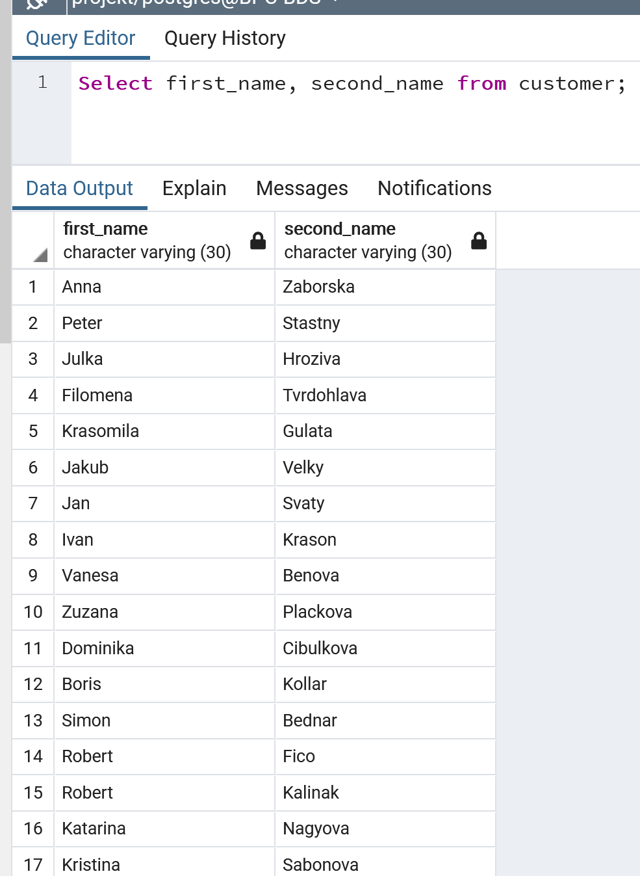

## Create a query that will select user/person or similar table based on the email.

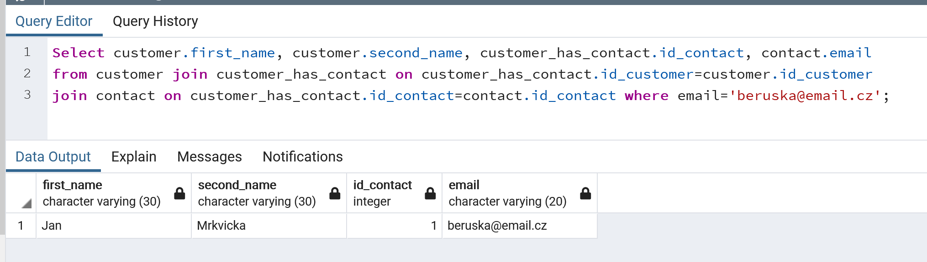

## Create at least one UPDATE, INSERT, DELETE, and ALTER TABLE

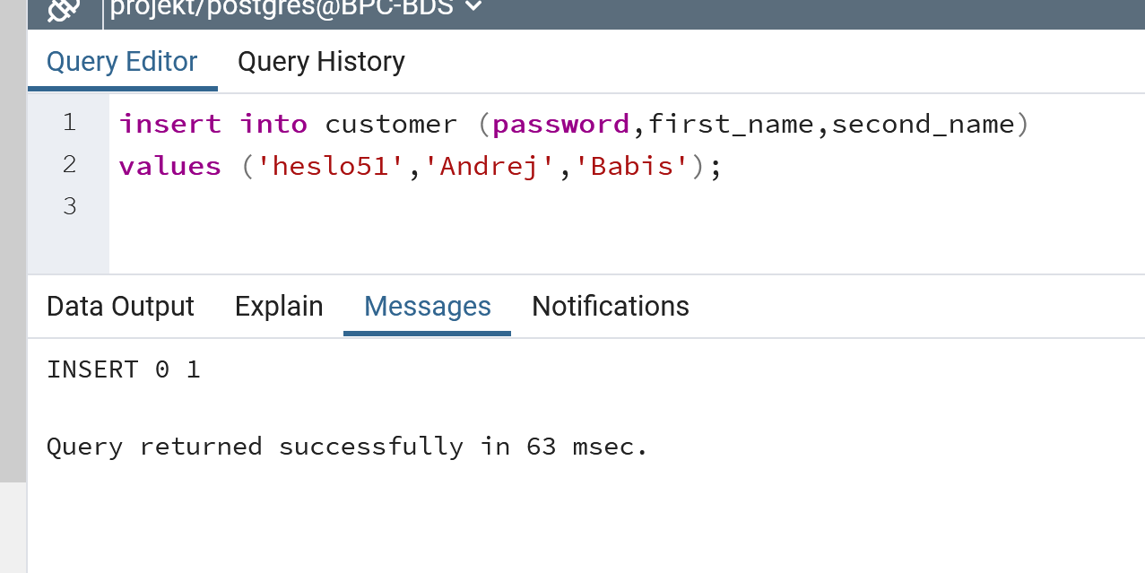

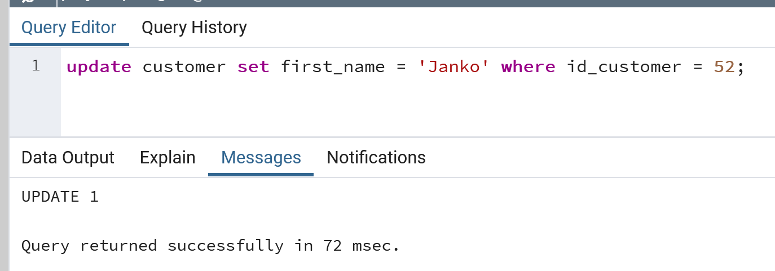

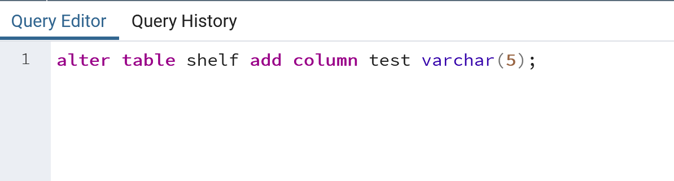

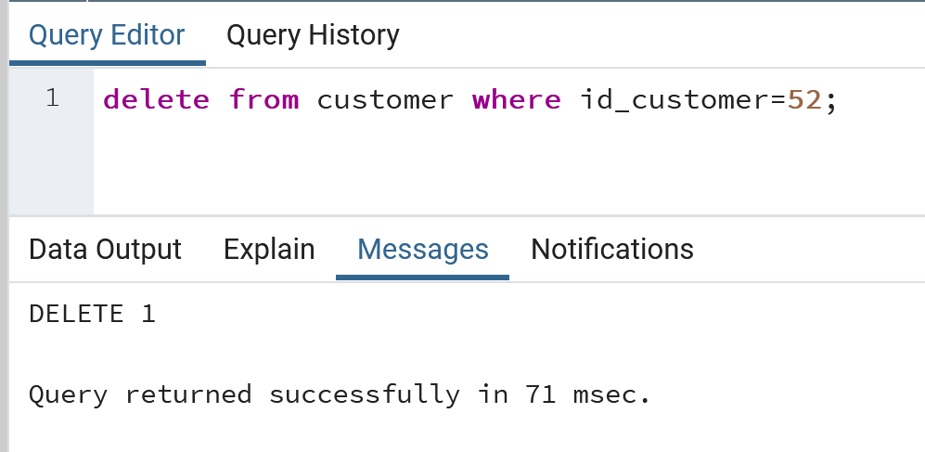

## Create a series of queries that will separately use the following:

## Where

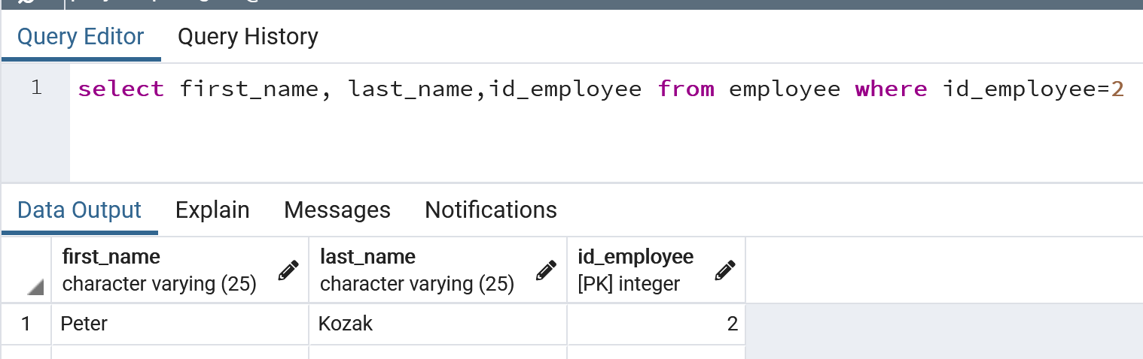

## LIKE; NOT LIKE

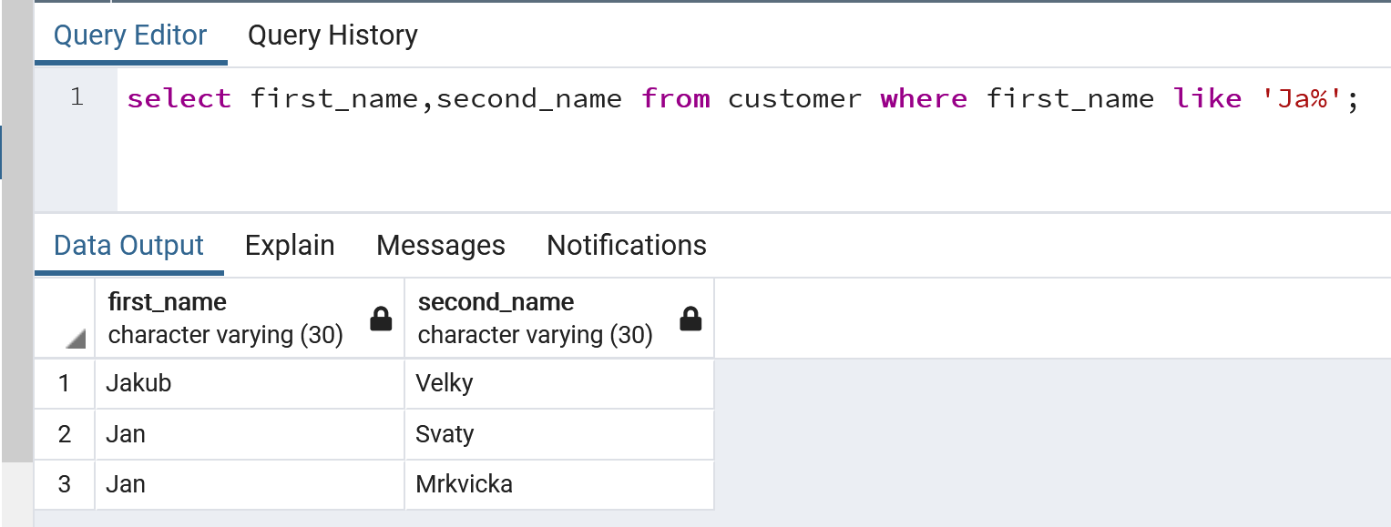

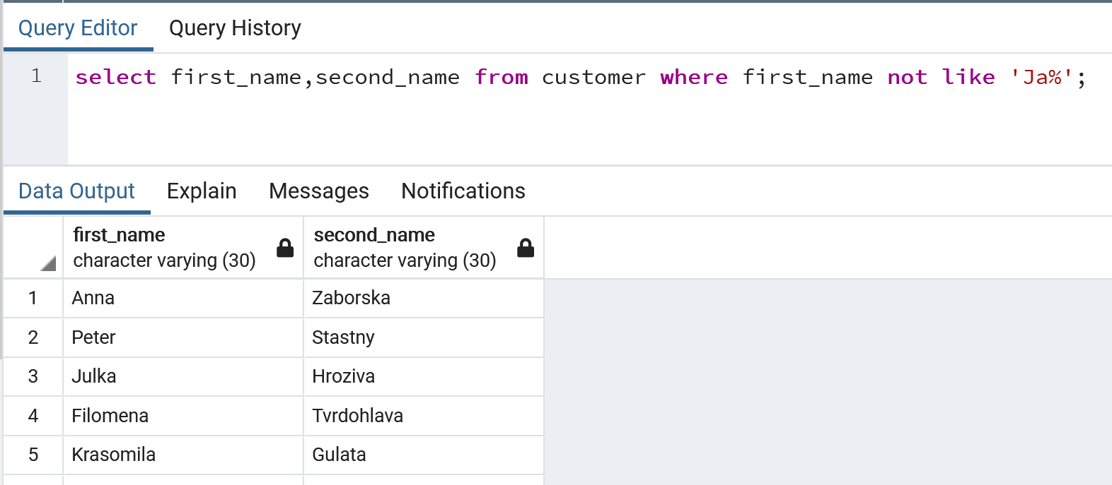

## SUBSTRING; TRIM

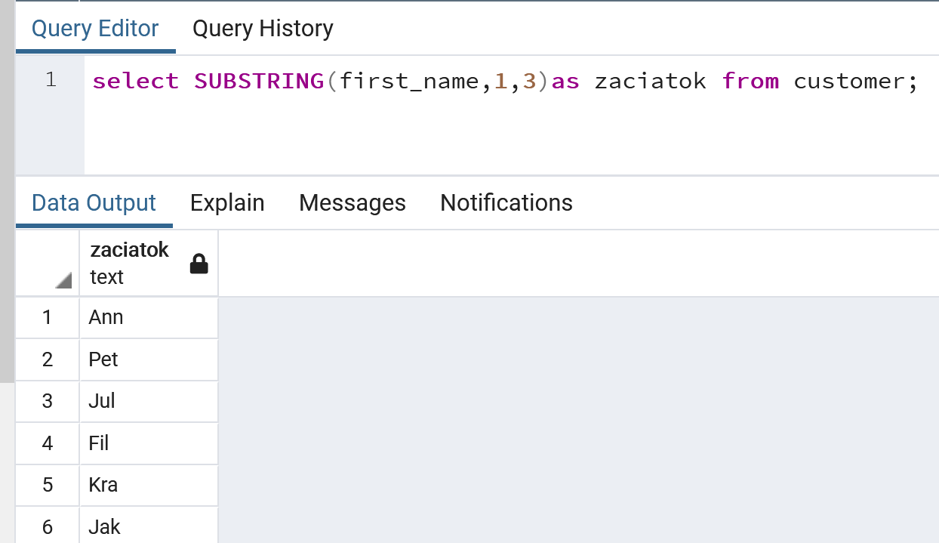

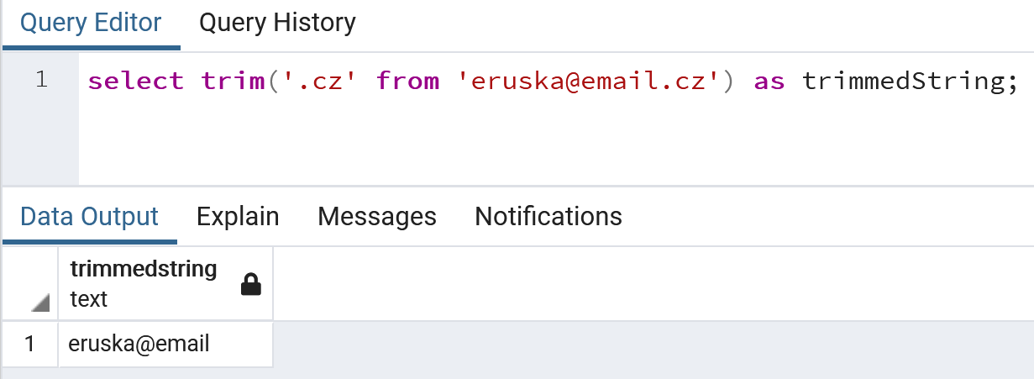

## COUNT; SUM; MIN; MAX; AVG;

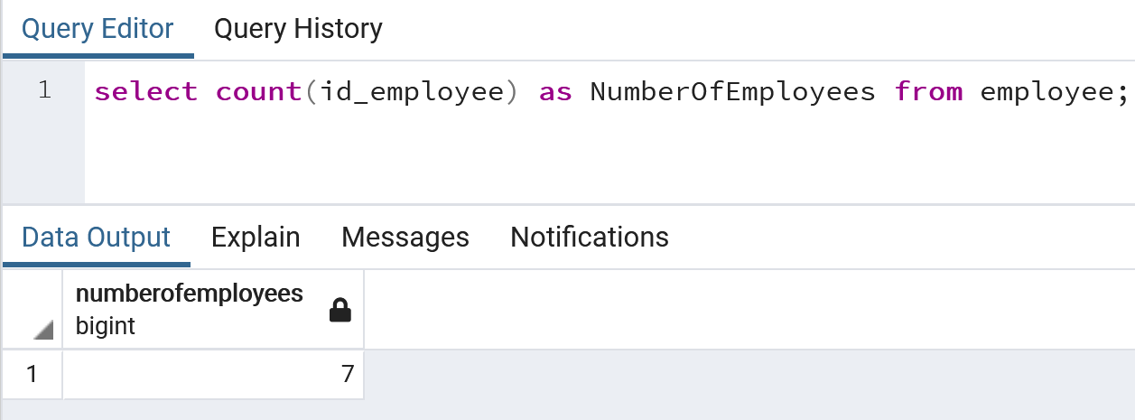

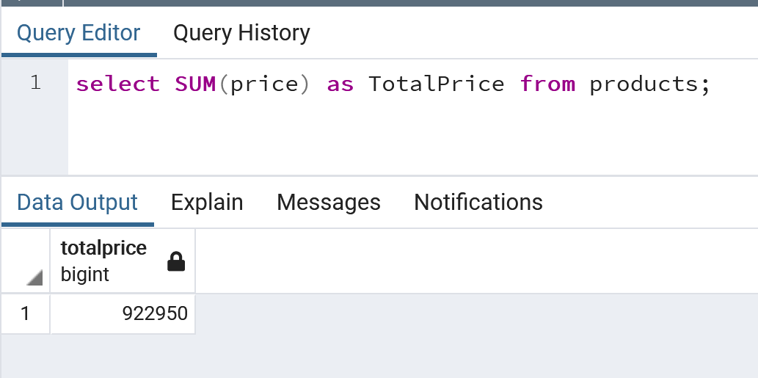

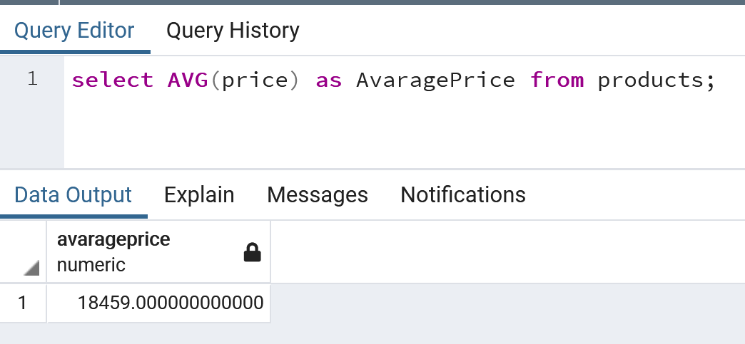

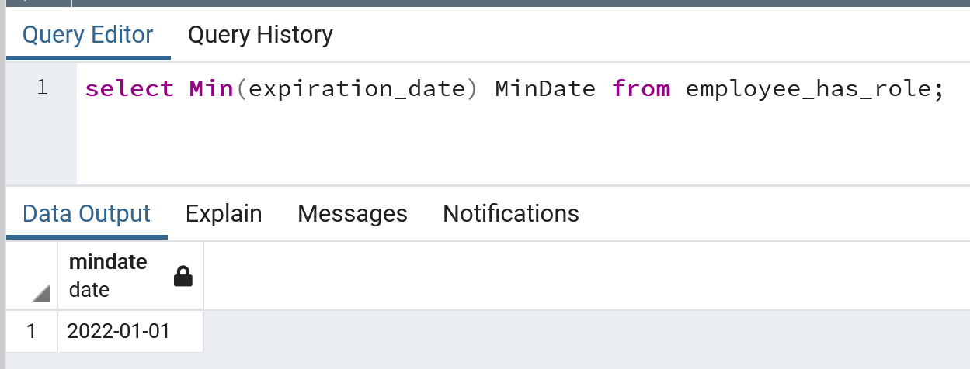

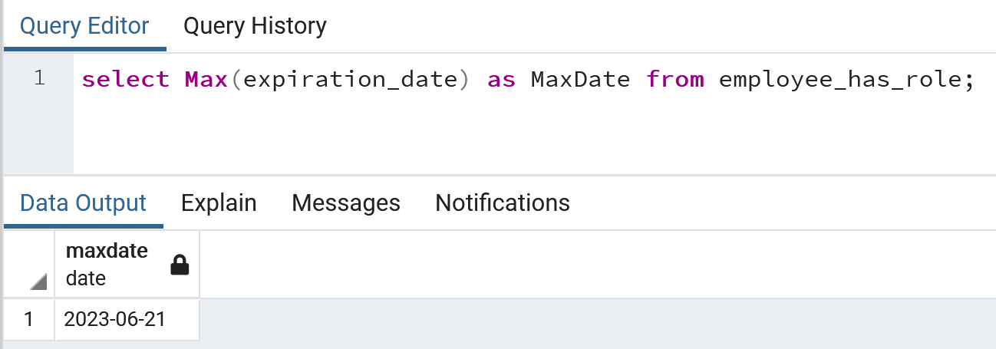

## GROUP BY; GROUP BY and HAVING; GROUP BY, HAVING, and WHERE

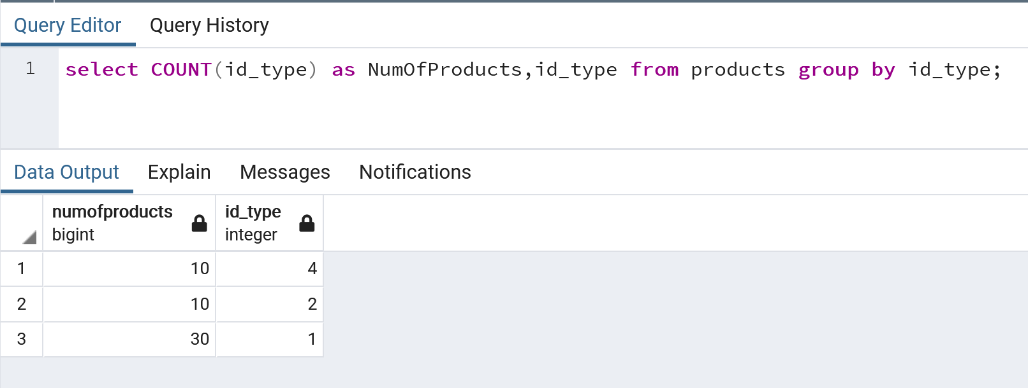

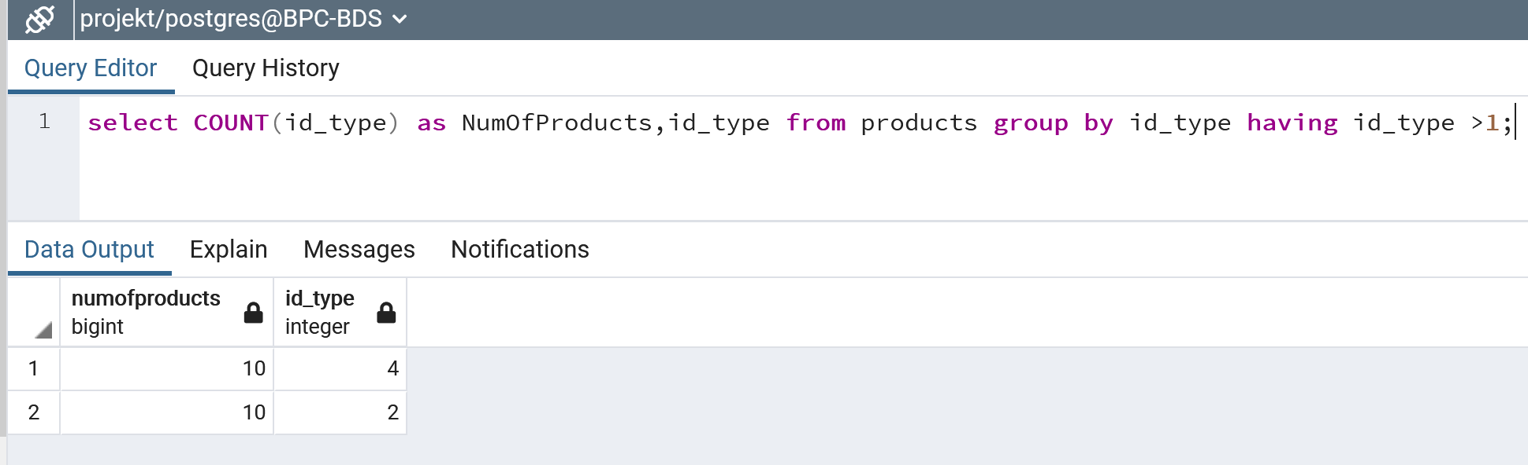

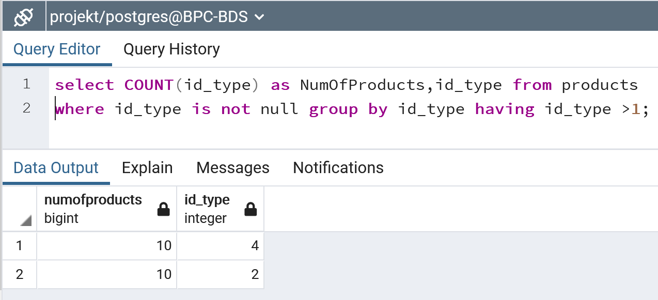

## UNION ALL / UNION

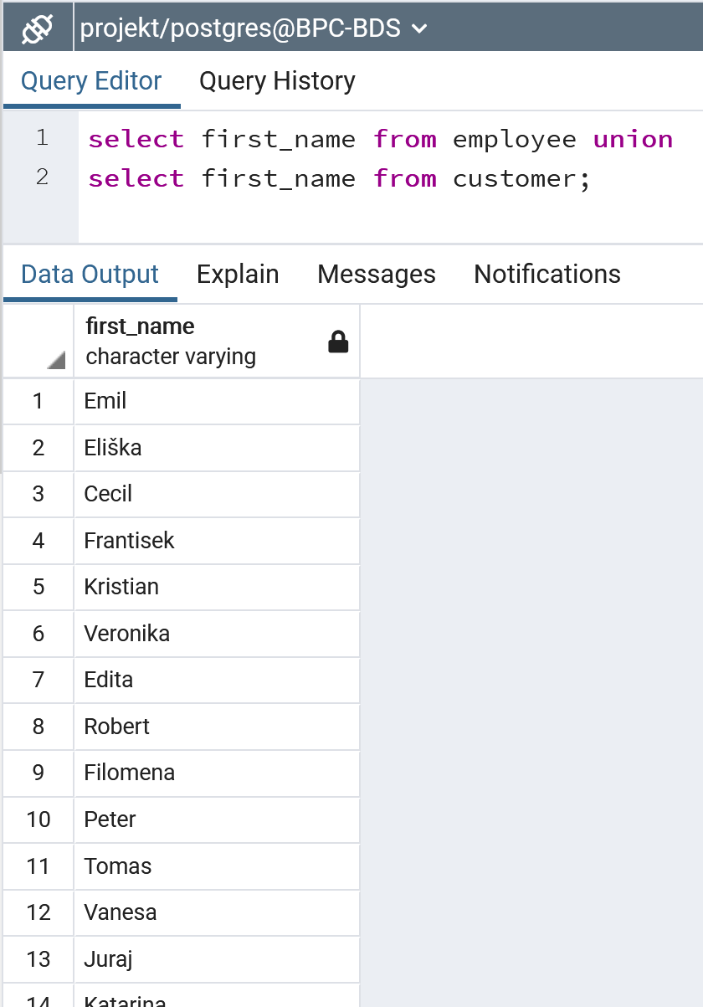

## DISTINCT

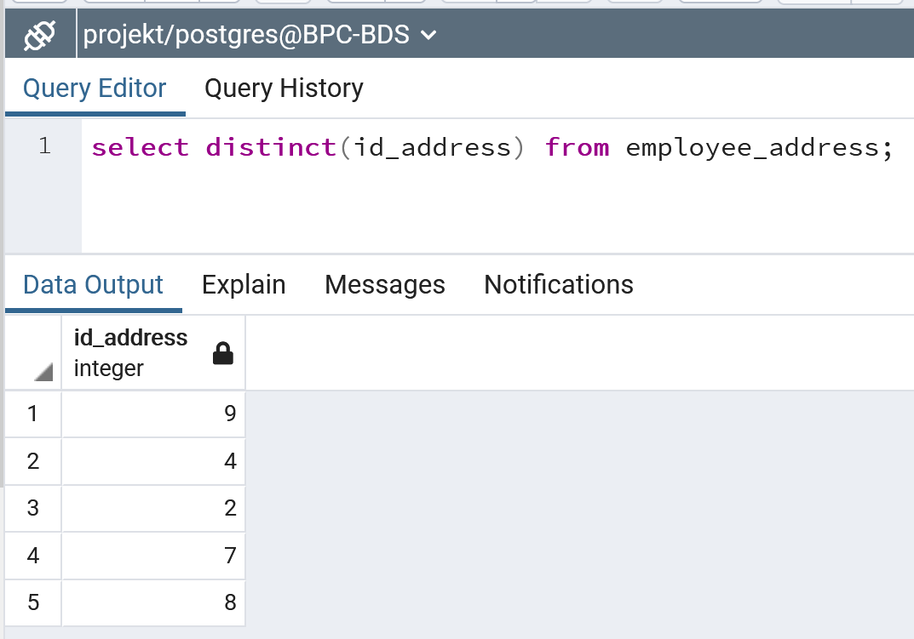

## LEFT JOIN; RIGHT JOIN; FULL OUTER JOIN

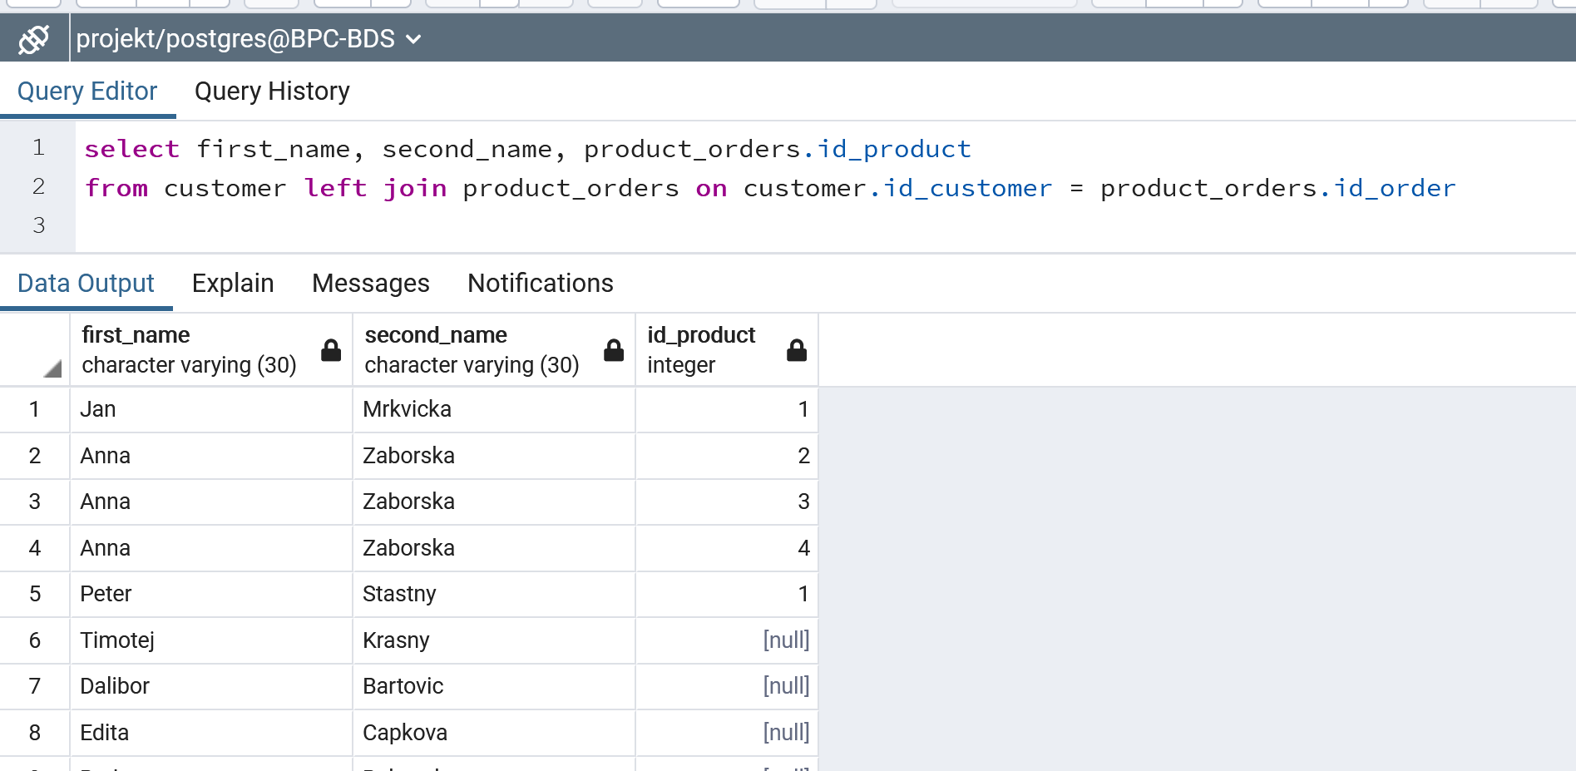

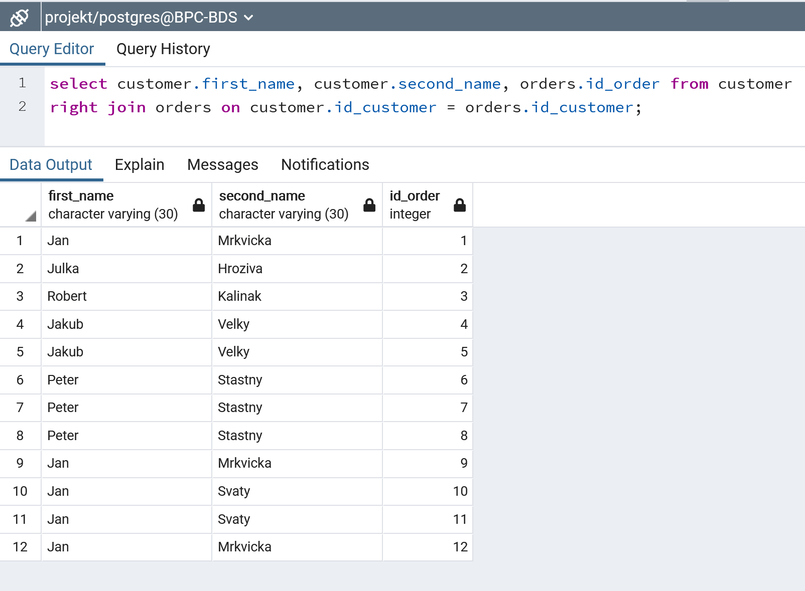

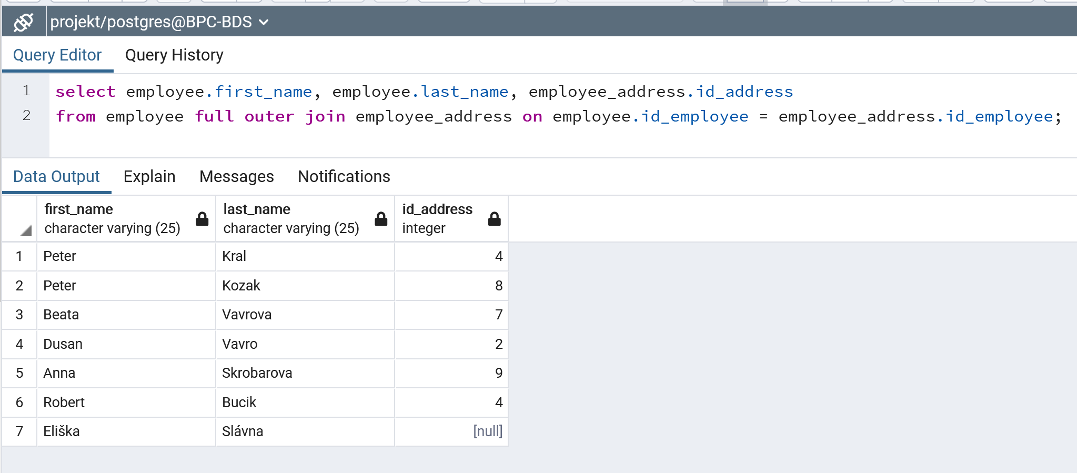

## Use in one query: LEFT JOIN, GROUP BY, HAVING, ORDER BY, AVG and DISTINCT

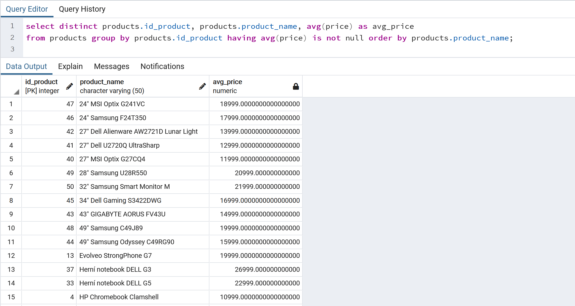

## Create a query that will return the data from an arbitrary table for the last one and half days (1day + 12 hours, i.e., 36 hours). Do not hard code the query (e.g., created at >7-11-2021)!

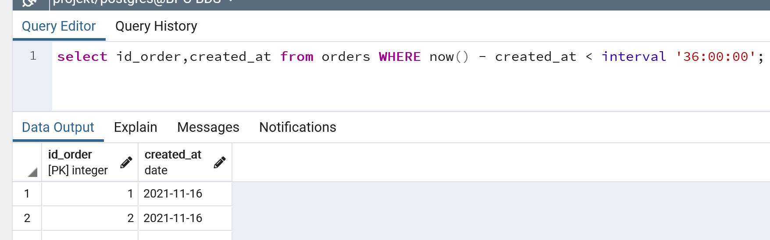

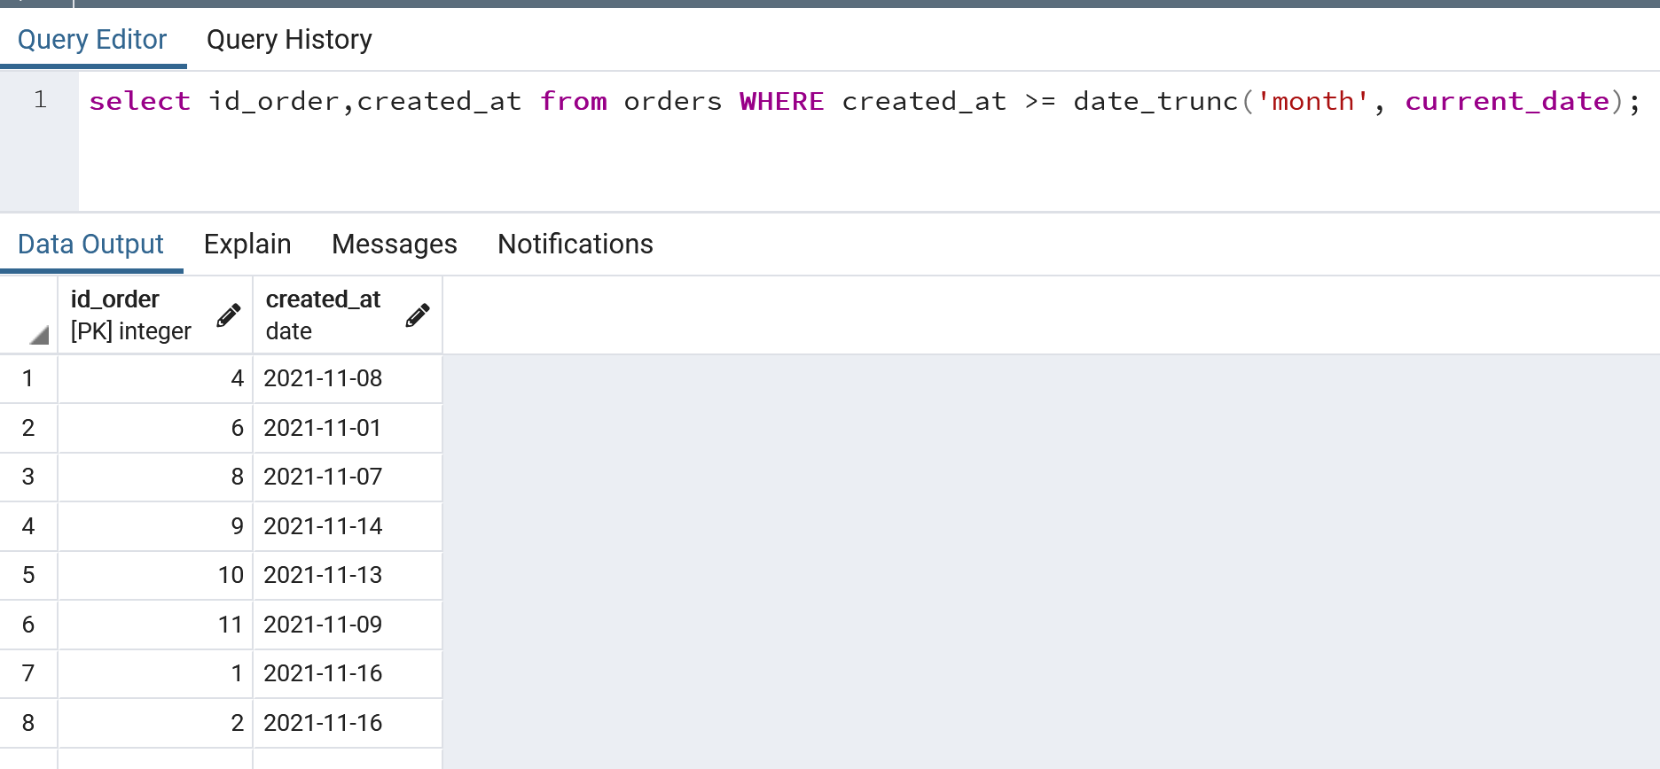

## Write a select that will remove accents on a selected string (e.g., ́a will be converted to a)

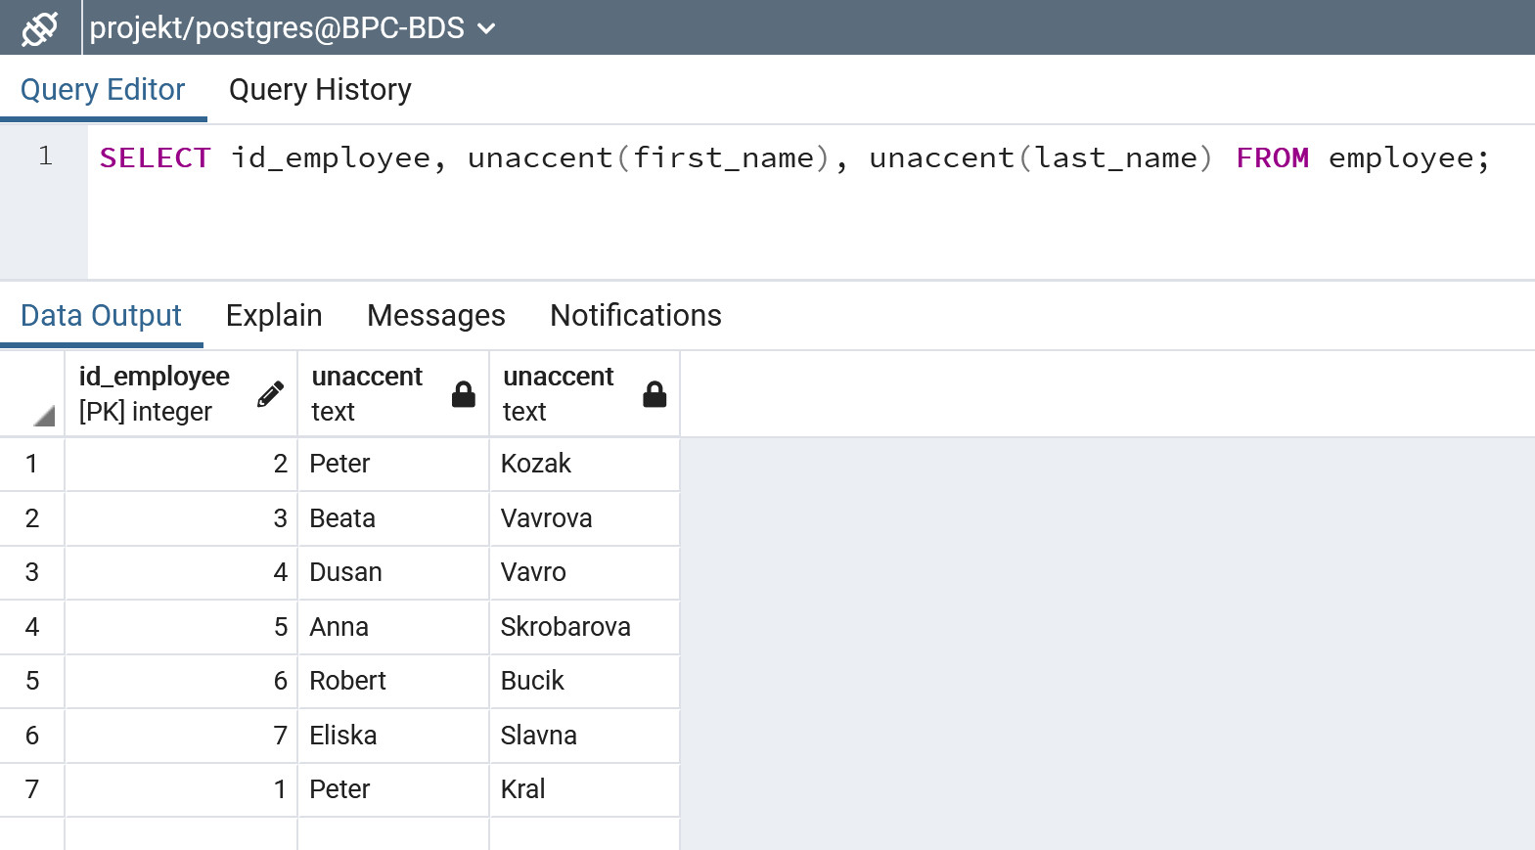

## Create a query for pagination in an application (use LIMIT and OFFSET)

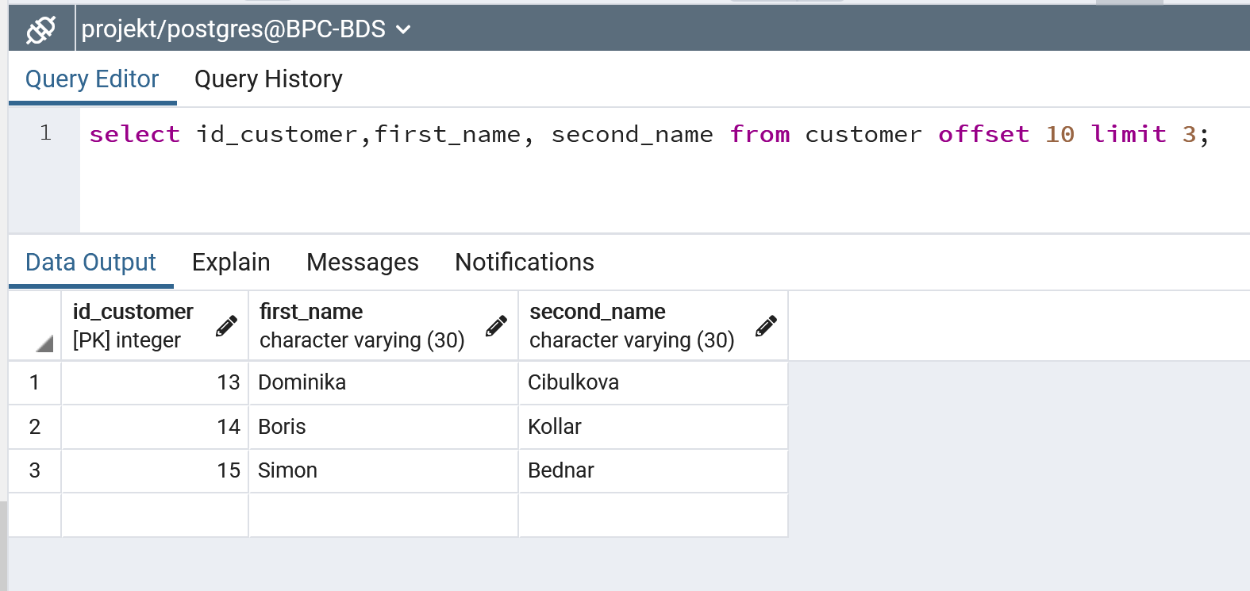

## Create a query that will use subquery in FROM

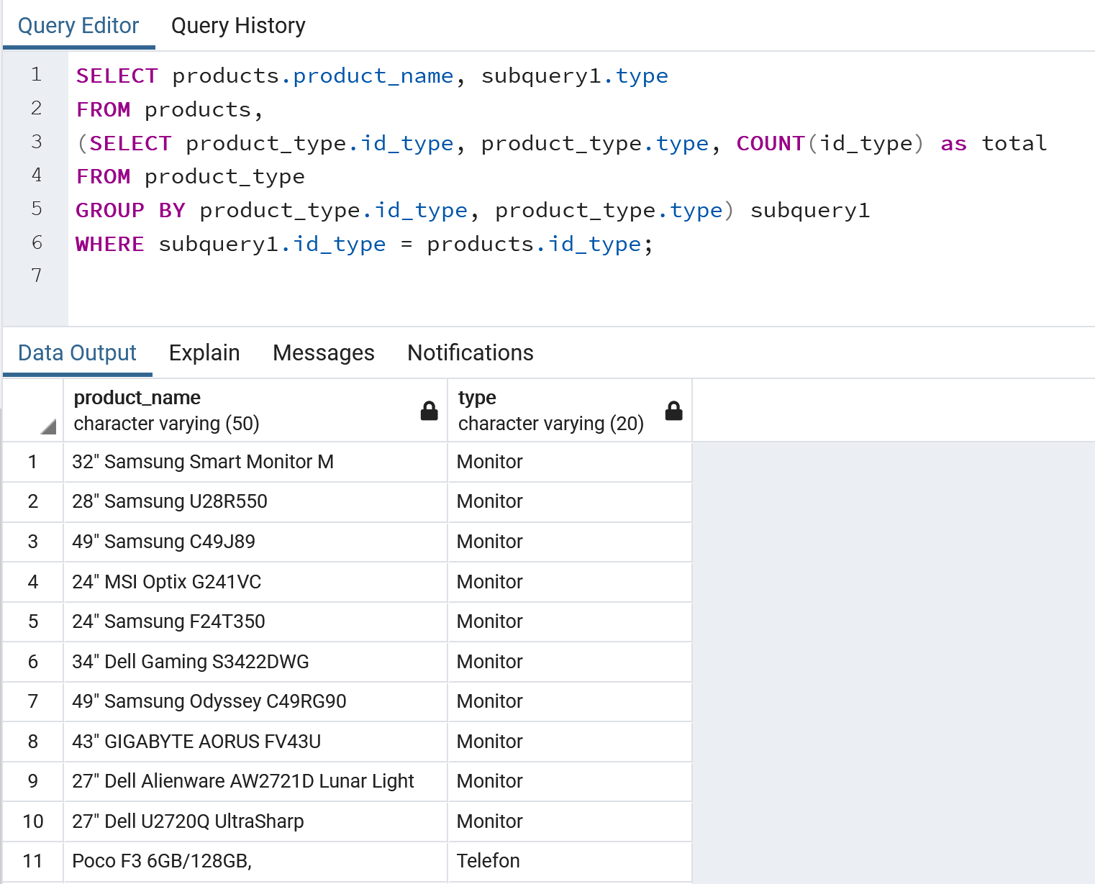

## Create a query that will use subquery in WHERE condition

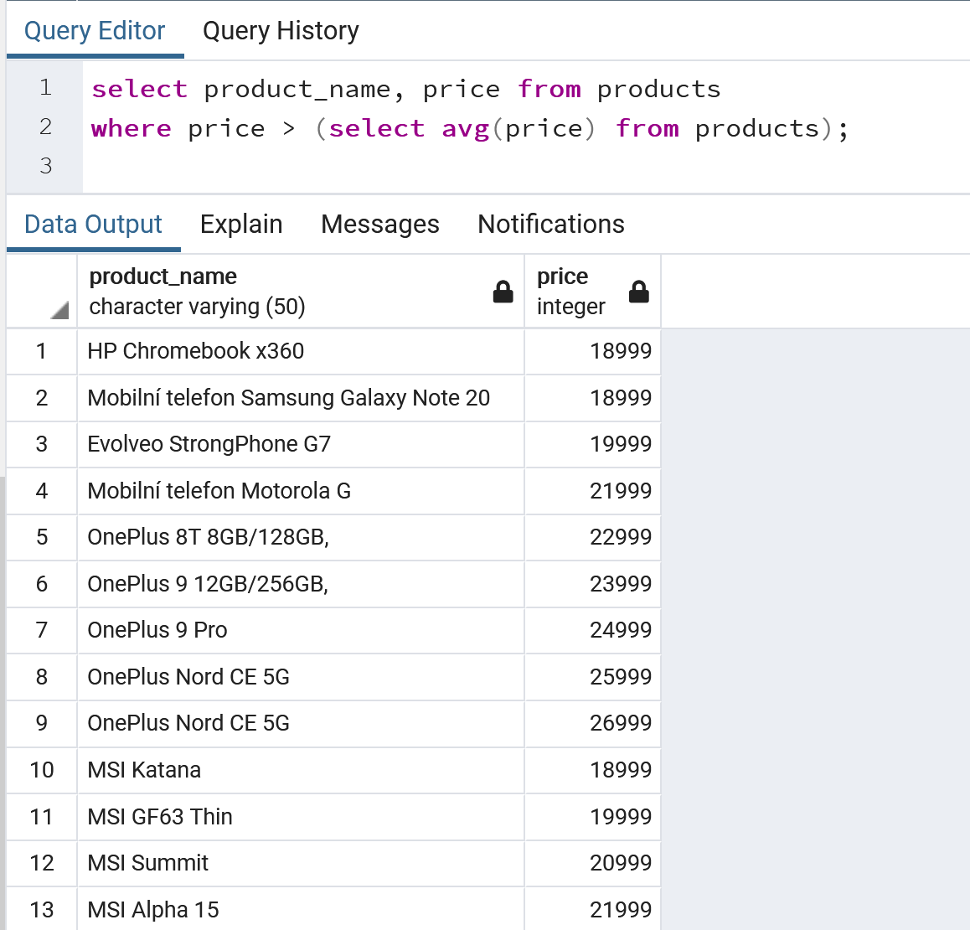

## Create a query that will use any aggregate function and GROUP BY with HAVING

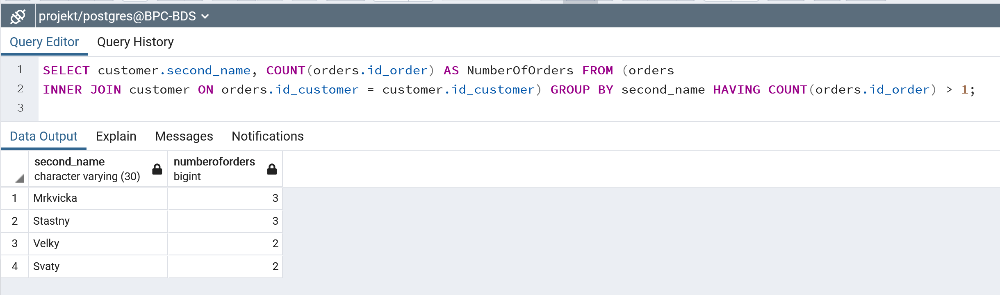

## Create a query that will join at least five tables

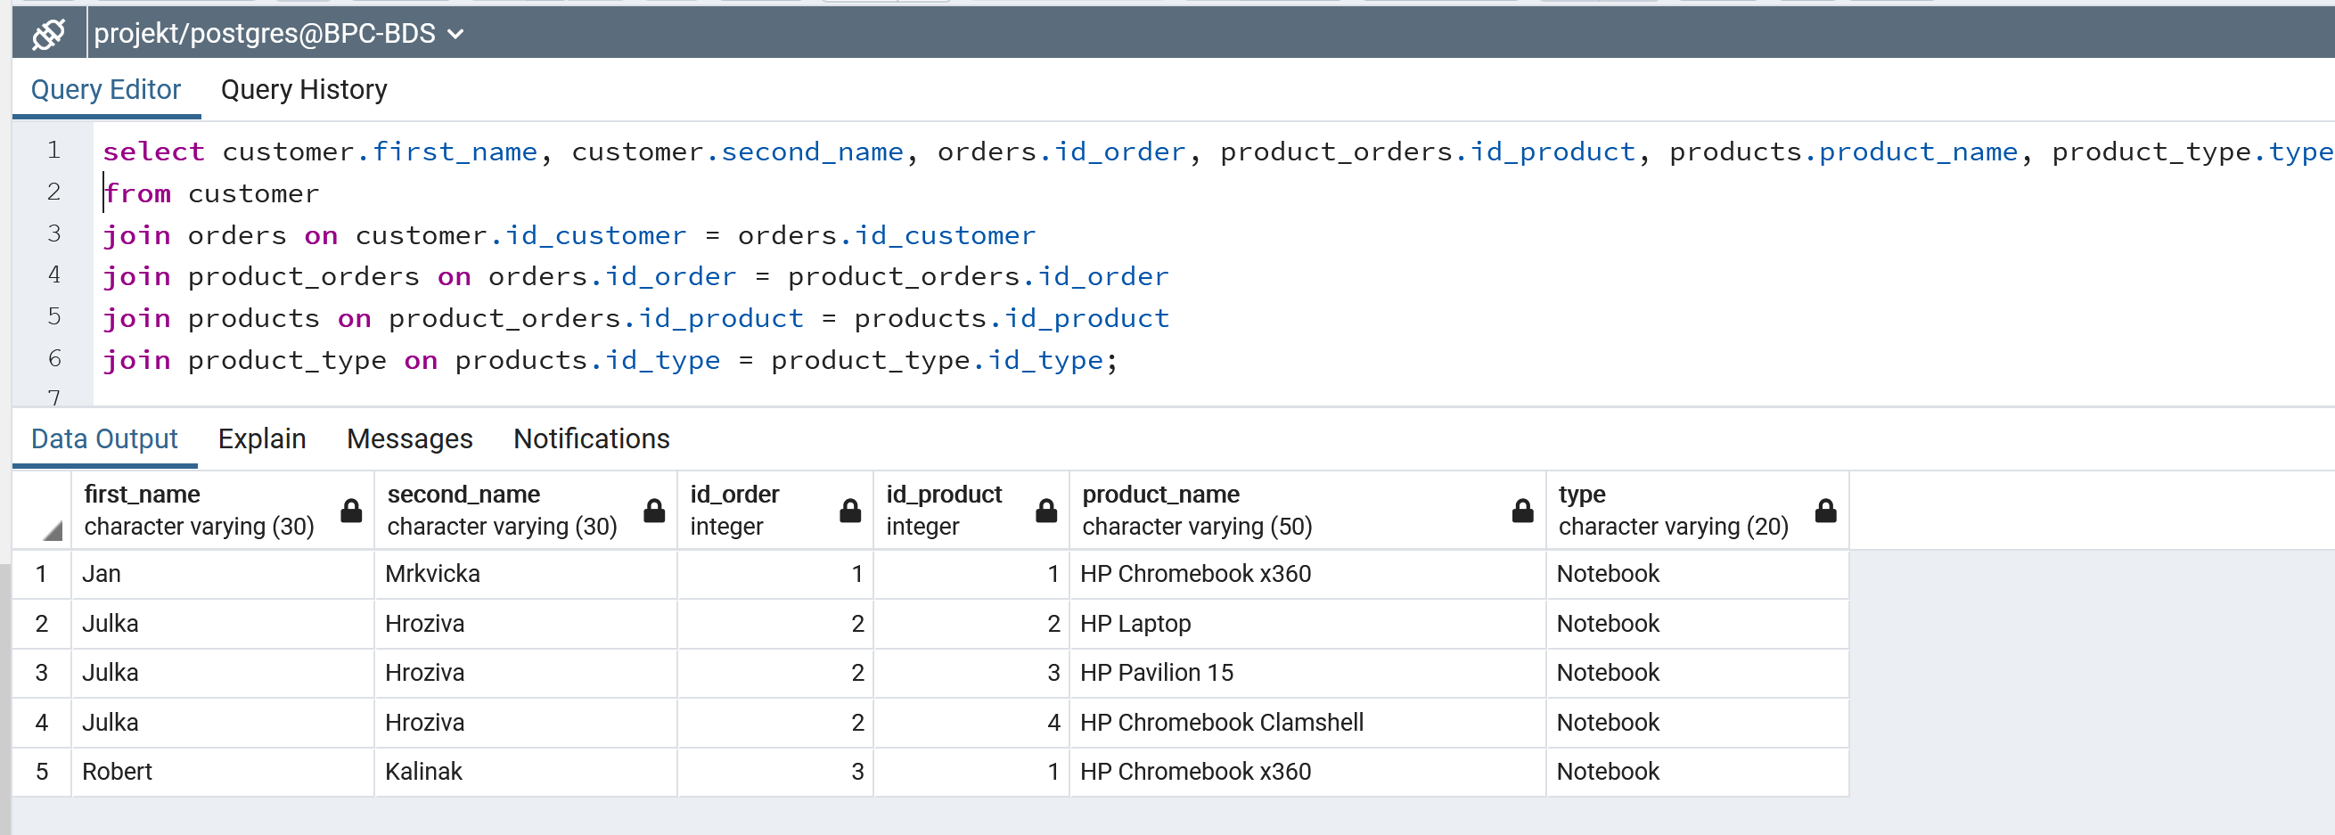

## Create a query that will join at least three tables and will use GROUP BY, HAVING, and WHERE

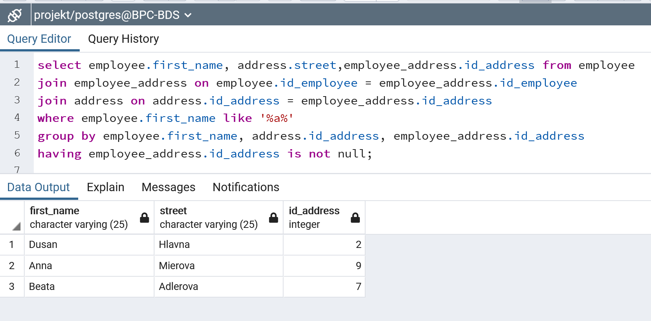

## Set cascading, explain places where you used cascading and why?

Kaskadovanie sa pouziva aby sa dali vymazat nejake záznamy, ktoré majú odkazy aj v inych tabulkach .. tym padom ked sa nastavi kaskadovanie a vymazeme takyto zaznam tak sa tento zaznam vymaze aj z ostatnych tabuliek ... ku FK treba pridat este ON DELETE CASCADE ,ON UPDATE CASCADE napr.

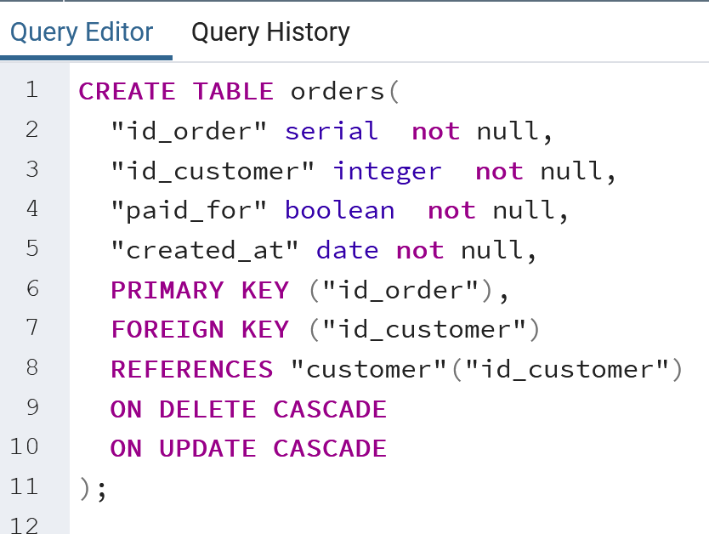

## Create database indexes (create it only on columns where it can make a sense – explain in the provided document why it make sense on a certain column(s)

Indexy pomahajú v rychlejsom vyhladavani tam, kde sa záznamy často nemenia. V adresach sa zaznamy tak casto nemenia, a casto sa vyhladava podla mesta, preto som si vybrala index prave na stĺpec mesto.

Pred indexom

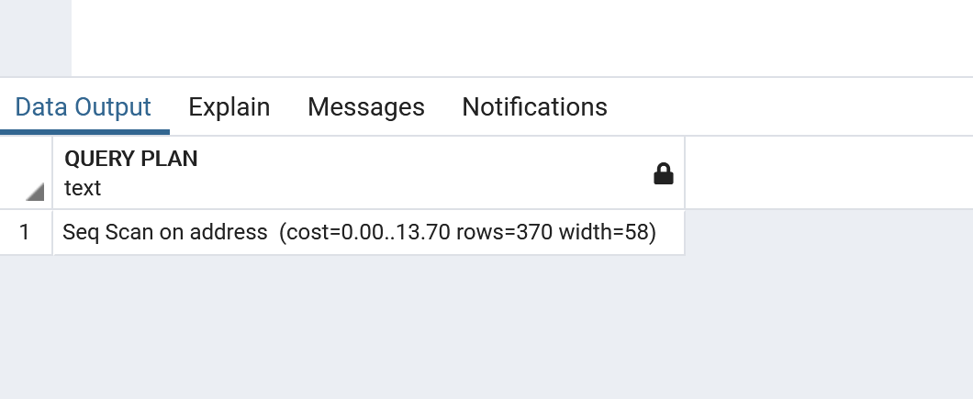

Po indexe

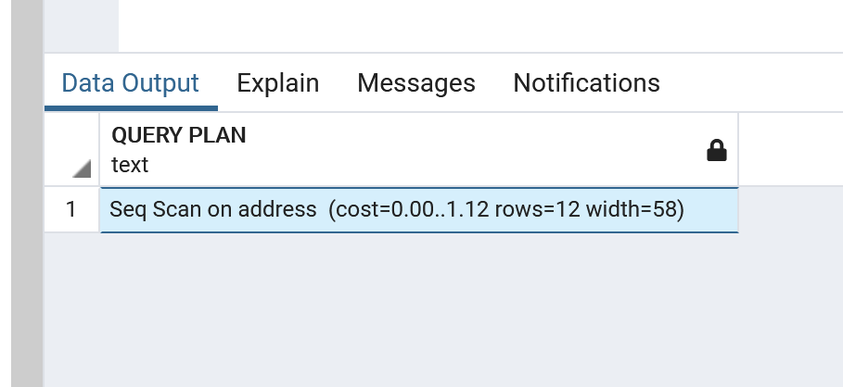

## Create arbitrary database procedure (consider some complex case)

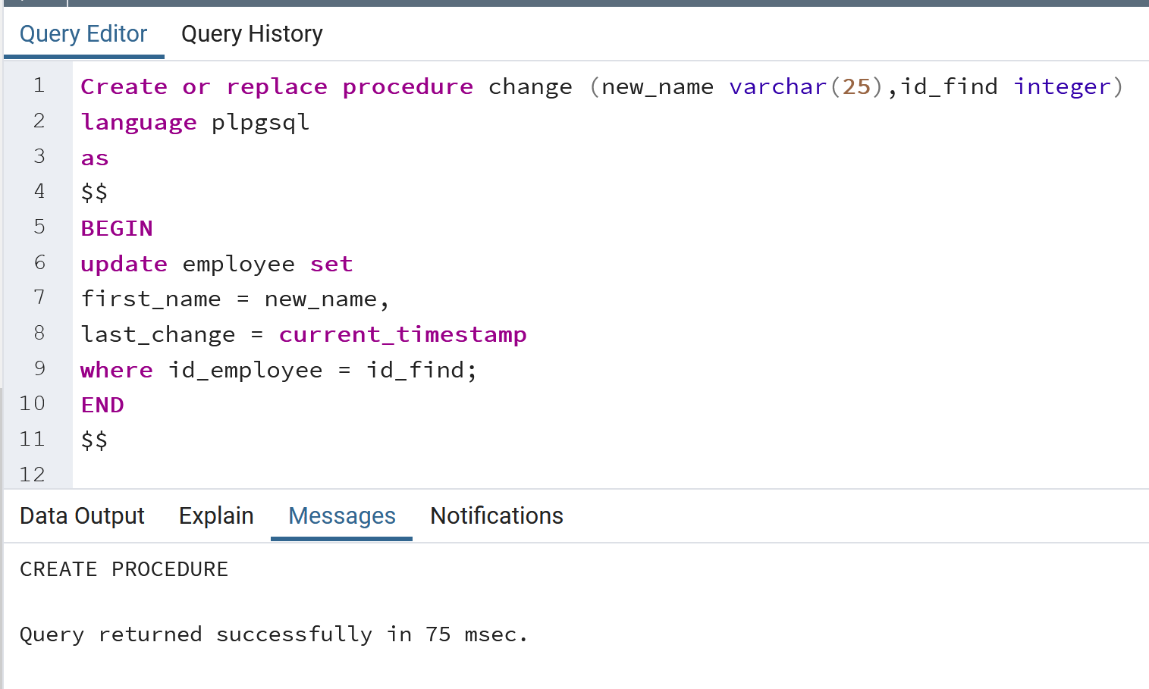  
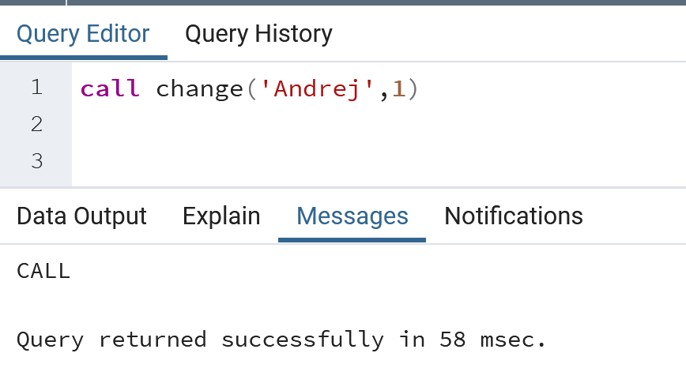

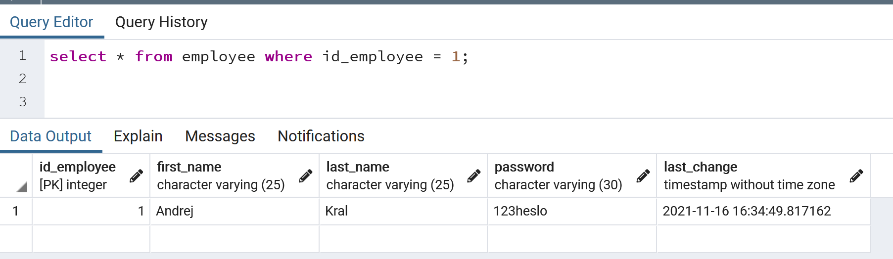

## Create arbitrary database trigger

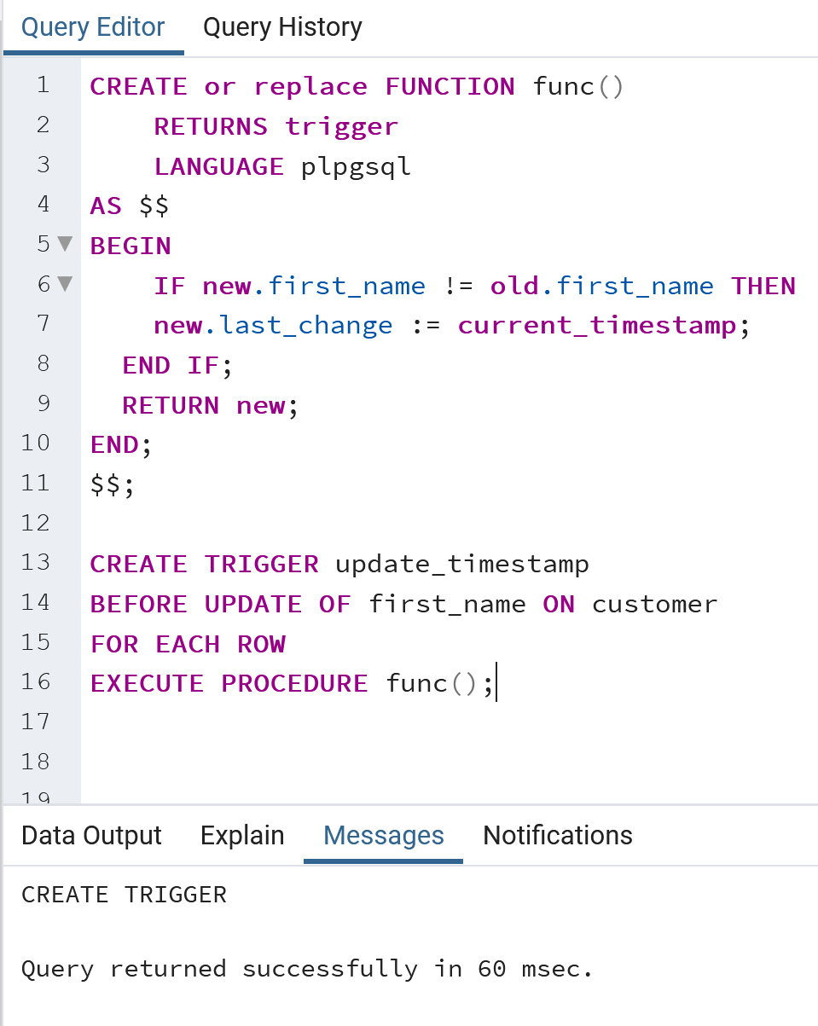

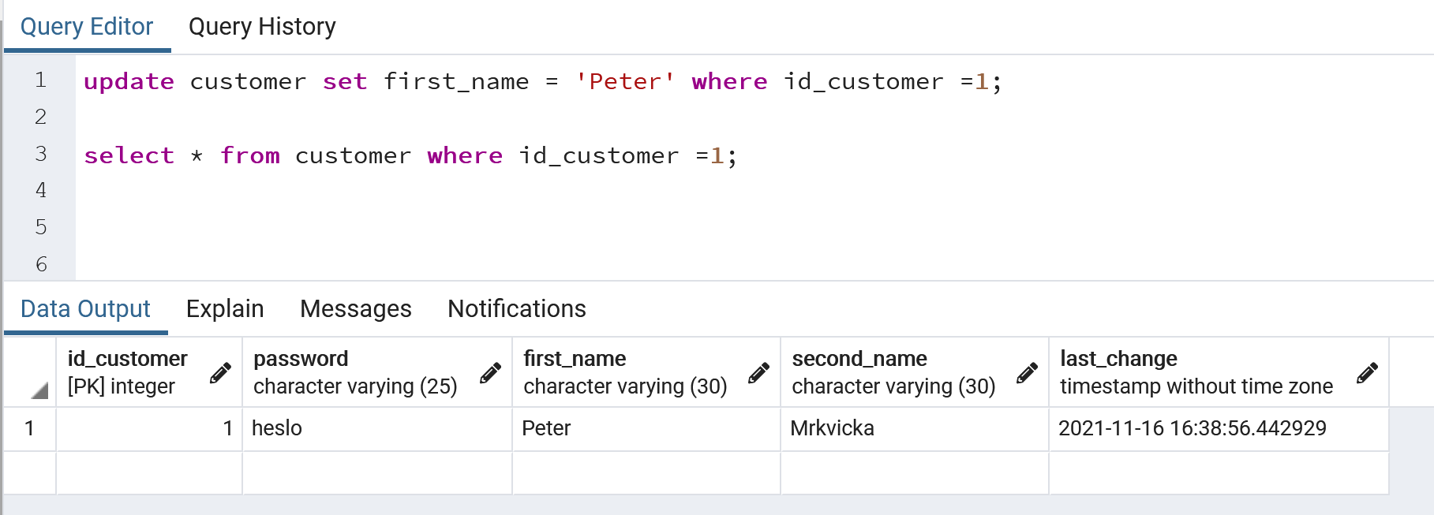

## Create arbitrary database view (consider some complex case)

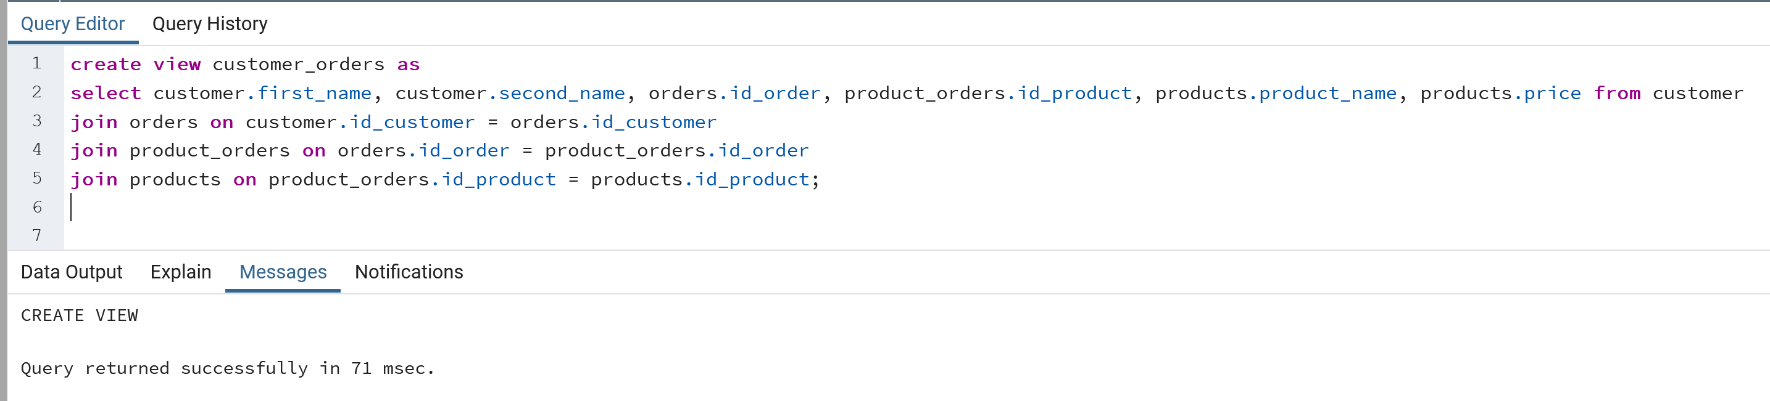

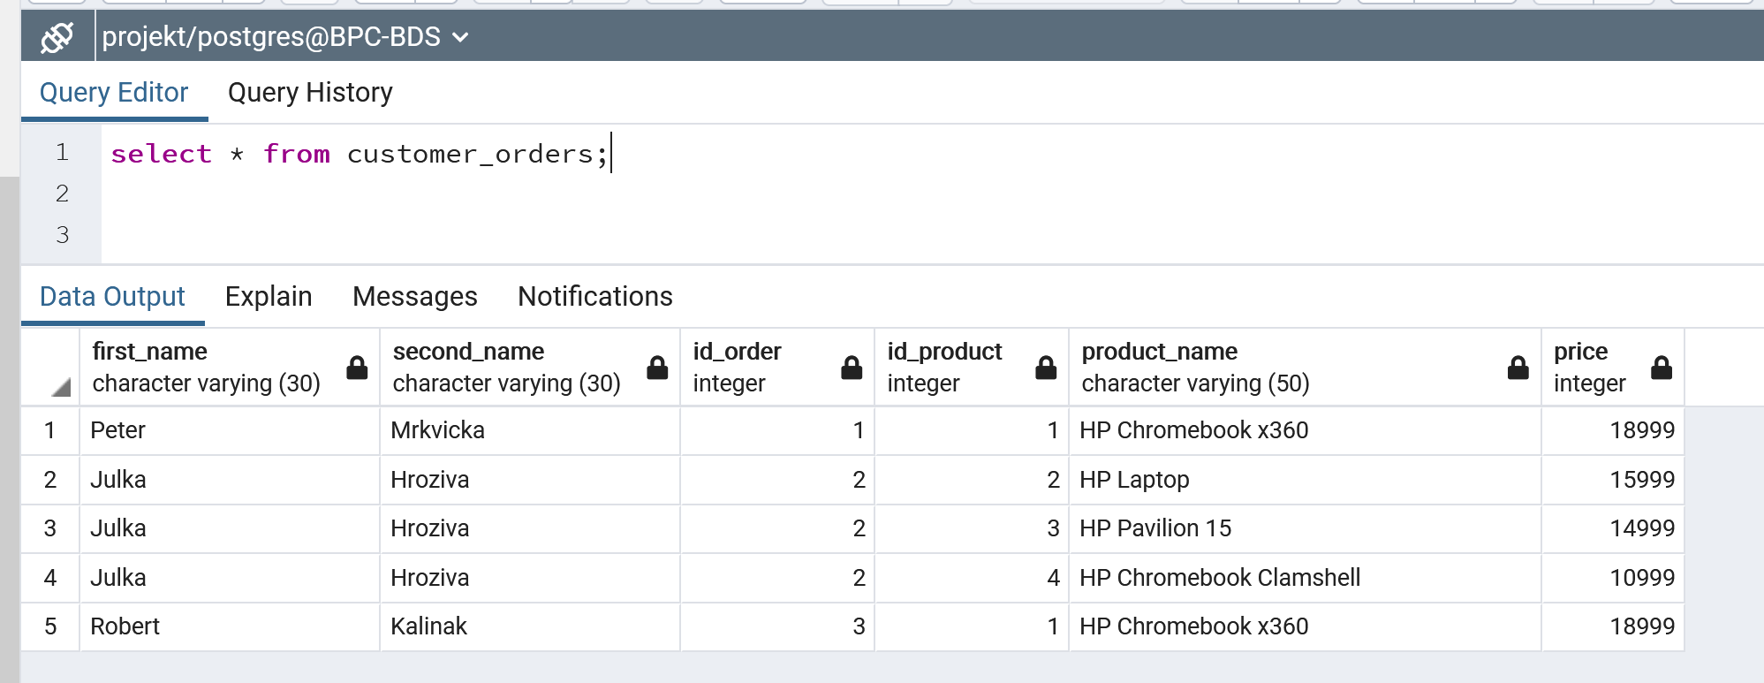

## Create database materialized view

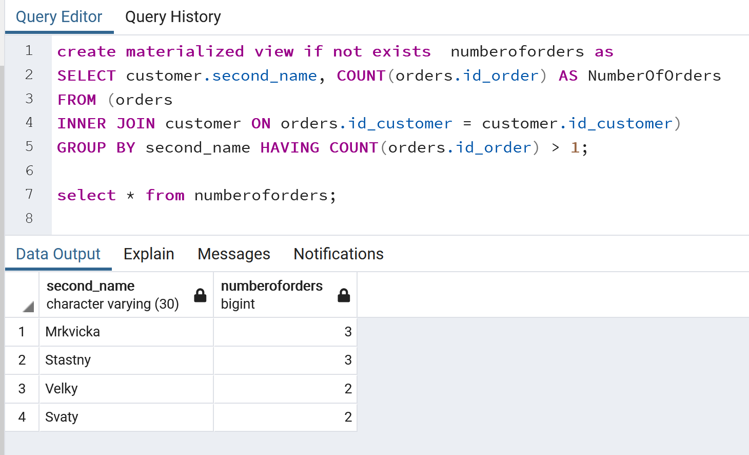

## Create two roles teacher and student in your database. Assign for teacher privileges to SELECT, INSERT, UPDATE, and DELETE everything in arbitrary table. Furthermore, set for teacher the possibility to view only certain fields (e.g., without salary from ”person“ or your ”user“ object). For student assign a possibility to select only certain tables.

