VFC - VOID FRACTION CALCULATOR is an open source program in C for extraction of void fraction as a function of vapor quality from various correlations.

**How to cite:** Oliveira, J.D., Cardoso, M.E., Copetti, J.M.,2020. VFC - VOID FRACTION CALCULATOR [Computer Software]. Retrieved from https://github.com/

**alpha_Armand** - A.A. Armand, The resistance during the movement of a two-phase system in horizontal pipes, Izv. Vses. Tepl. Inst. 1 (1946) 16e23.

**alpha_Bankoff** - S.G., Bankoff, 1960. A variable density single fluid model for two phase flow with particular reference to steam water flow. Trans. ASME, J. Heat Transfer 82, 265–272.

**alpha_Baroczy** - C.J. Baroczy, Correlation of liquid fraction in two-phase flow with applications to liquid metals, Chem. Eng. Prog. Symp. Ser. 61 (1965) 179e191.

**alpha_Chen** - J.J.J. Chen, P.L. Spedding, An extension of the LockharteMartinelli theory of two-phase pressure drop and holdup, Int. J. Multiphase Flow 7 (1981) 659e675.

**alpha_Chen86** - J.J.J., Chen, 1986. A further examination of void-fraction in annular two-phase flow. Int. J. Heat Mass Transfer 29, 1760–1763.

**alpha_Chisholm** - D. Chisholm, Pressure gradients due to friction during the flow of evaporating two-phase mixtures in smooth tubes and channels, Int. J. Heat Mass Transfer 16 (1973) 347e358.

**alpha_Chisholm_II** - D. Chisholm, Two Phase Flow in Pipelines and Heat Exchangers, Longman, New York, 1983.

**alpha_Czop** - V. Czop, D. Barbier, S. Dong, 1994. Pressure drop, void fraction and shear stress measurements in adiabatic two-phase flow in coiled tube. Nucl. Eng. Design 149, 323–333.

**alpha_Domanski** - P. Domanski, D. Didion, Computer Modeling of the Vapor Compression Cycle with Constant Flow Area Expansion Device, NBS Building Science Series 155, U.S. Department of Commerce & National Bureau of Standards, USA, 1983.

**alpha_Fauske** - H. Fauske, Critical two-phase, steamewater flows, in: Proceedings of 1961 Heat Transfer Fluid Mechanical Institute, Stanford University Press, California, 1961, pp. 79e89.

**alpha_Graham** - D.M. Graham, T.A. Newell, J.C. Chato, Experimental Investigation of Void Fraction during Refrigerant Condensation, ACRC TR-135, University of Illinois at Urbana-Champaign, USA, 1997.

**alpha_Guzhov** - A.L. Guzhov, V.A. Mamayev, G.E. Odishariya, A study of transportation in gas liquid systems, in: 10th International Gas Union Conference, 1967. Hamburg, Germany.

**alpha_Hamersma** - P.J., Hamersma, J., Hart, 1987. A pressure drop correlation for gas/liquid pipe flow with a small liquid holdup. Chem. Eng. Sci. 42, 1187–1196.

**alpha_Harms** - T.M. Harms, D. Li, E.A. Groll, J.E. Braun, A void fraction model for annular flow in horizontal tubes, Int. J. Heat Mass Transfer 46 (2003) 4051e4057.

**alpha_Homo** - Homogeneous model

**alpha_Huq** - R.H. Huq, J.L. Loth, Analytical two-phase flow void fraction prediction method, J. Thermophys 6 (1992) 139e144.

**alpha_Kawahara** - A. Kawahara, M. Sadatomi, K. Okayama, M. Kawaji, P.M.-Y. Chung, Effects of channel diameter and liquid properties on void fraction in adiabatic twophase flow through microchannels, Heat Transfer Eng. 26 (2005) 13e19.

**alpha_Kopke** - H.R. Kopke, T.A. Newell, J.C. Chato, Experimental Investigation of Void Fraction during Refrigerant Condensation in Horizontal Tubes, ACRC TR-142, University of Illinois at Urbana-Champaign, USA, 1998.

**alpha_Laird** - D., Chisholm, A.D.K., Laird, 1958. Two phase flow in rough tubes. Trans. ASME 80, 276–286.

**alpha_Lockhart** - R.W. Lockhart, R.C. Martinelli, Proposed correlation of data for isothermal two-phase, two-component flow in pipes, Chem. Eng. Prog. 45 (1949) 39e48.

**alpha_Madsen** - N. Madsen, 1975. A void fraction correlation for vertical and horizontal bulk-boiling of water. AIChE J. 21, 607–608.

**alpha_Massena** - W.A. Massena, Steam Water Pressure Drop and Critical Discharge Flow e a Digital Computer Program, 1960. HW-65706.

**alpha_Nishino** - H. Nishino, Y. Yamazaki, A new method of evaluating steam volume fractions in boiling systems, J. Soc. Atom. Energy Japan 5 (1963) 39e59.

**alpha_Premoli** - A. Premoli, D. Francesco, A. Prina, A dimensionless correlation for determining the density of two-phase mixtures, La Termotecnica 25 (1971) 17e26.

**alpha_Rouhani** - S.Z., Rouhani, E., Axelsson, 1970. Calculation of void volume fraction in the sub cooled and quality boiling regions. Int. J. Heat Mass Transfer 13, 383–393.

**alpha_Smith** - S.L. Smith, Void fractions in two phase flow: a correlation based upon an equal velocity head model, Proc. Inst. Mech. Eng. 36 (1969) 647e664.

**alpha_Spedding** - P.L., Spedding, J.J.J., Chen, 1984. Holdup in two phase flow. Int. J. Multiphase Flow 10, 307–339.

**alpha_Tandon** - T.N., Tandon, H.K., Varma, C.P., Gupta, 1985. A void fraction model for annular two-phase flow. Int. J. Heat Mass Transfer 28, 191–198.

**alpha_Thom** - J.R.S. Thom, Prediction of pressure drop during forced circulation boiling of water, Int. J. Heat Mass Transfer 7 (1964) 709e724.

**alpha_Turner** - J.M. Turner, G.B. Wallis, The Separate-cylinders Model of Two-phase Flow, NYO-3114-6, Thayer’s School Eng., Dartmouth College, Hanover, New Hampshire, USA, 1965.

**alpha_Wallis** - G.B. Wallis, One Dimensional Two-phase Flow, McGraw-Hill Inc., New York, 1969.

**alpha_Xu** - Y. Xu, X. Fang, Correlations of void fraction for two-phase refrigerant flow in pipes, Applied Thermal Eng. 64 (2014) 242e251.

**alpha_Yashar** - D.A. Yashar, D.M. Graham, M.J. Wilson, J.C. Chato, H.R. Kopke, T.A. Newell, Investigation of refrigerant void fraction in horizontal, microfin tubes, HVAC&R Res. 7 (2001) 67e82.

**alpha_Zivi** - S.M. Zivi, Estimation of steady state steam void fraction by means of the principle of minimum entropy production, J. Heat Transfer 86 (1964) 247e252.

Open the file results.csv and:

* Select the first cell.

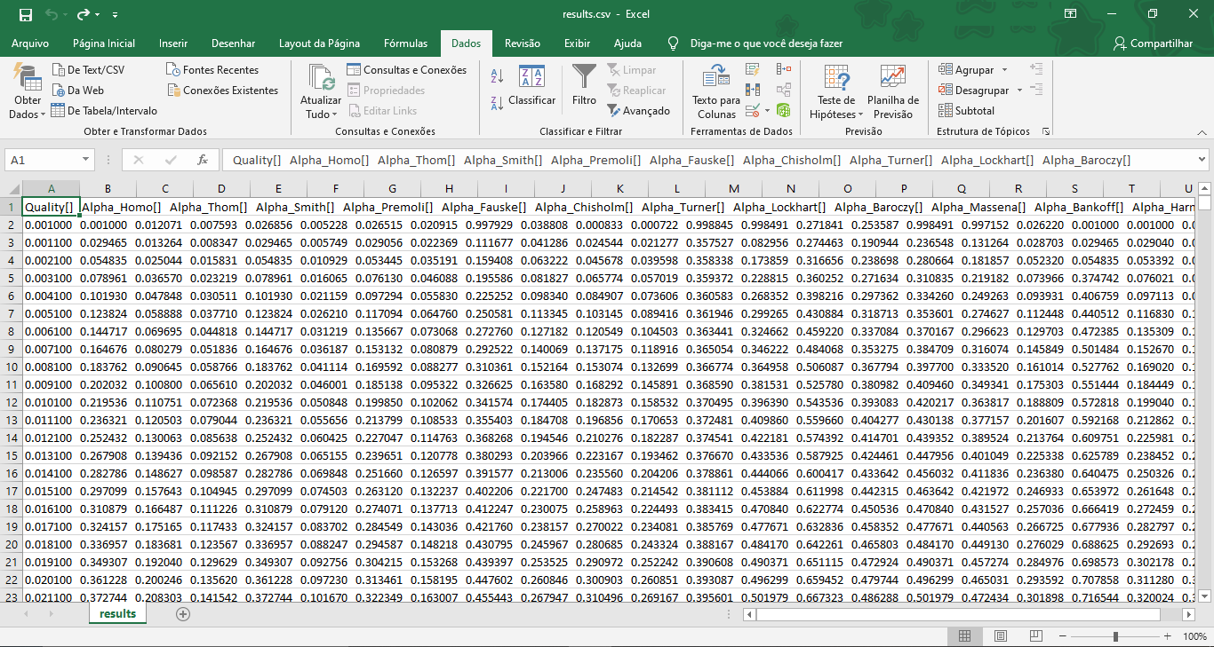

To access Text to Columns, select the dataset and go to Data → Data Tools → Text to Columns.

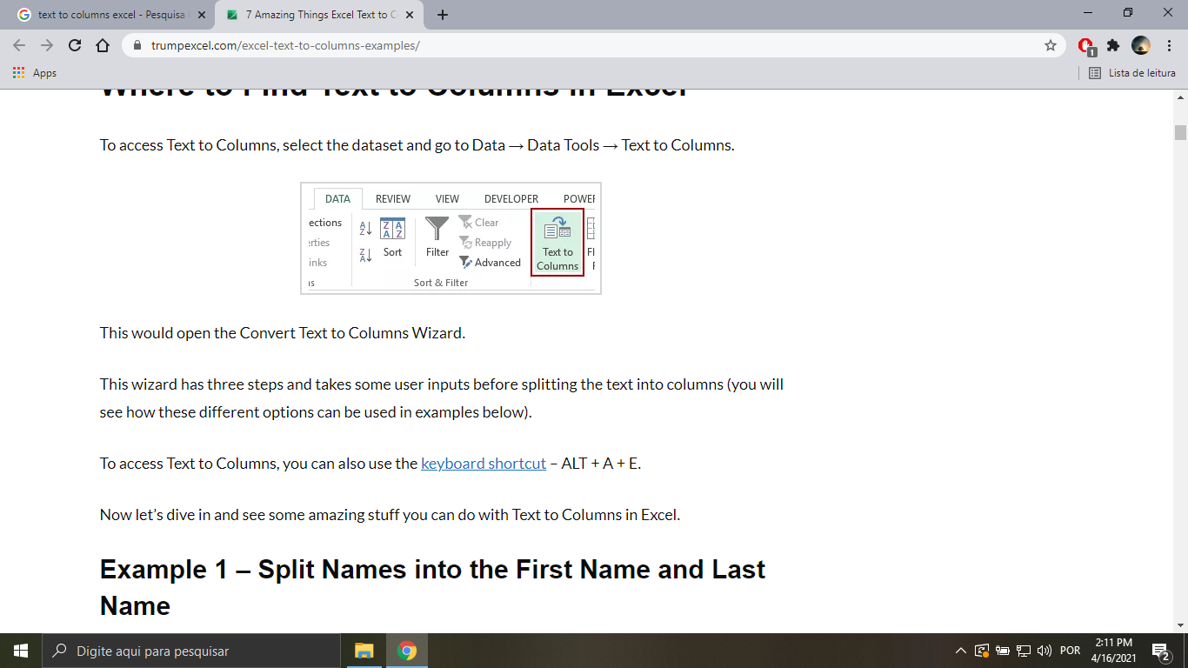

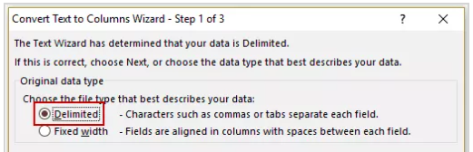

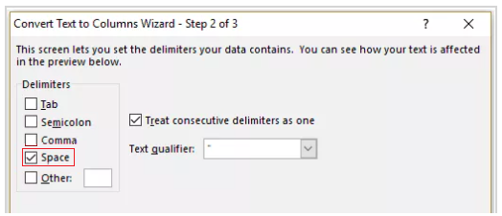

* Select the first column from line 2 to 1001.

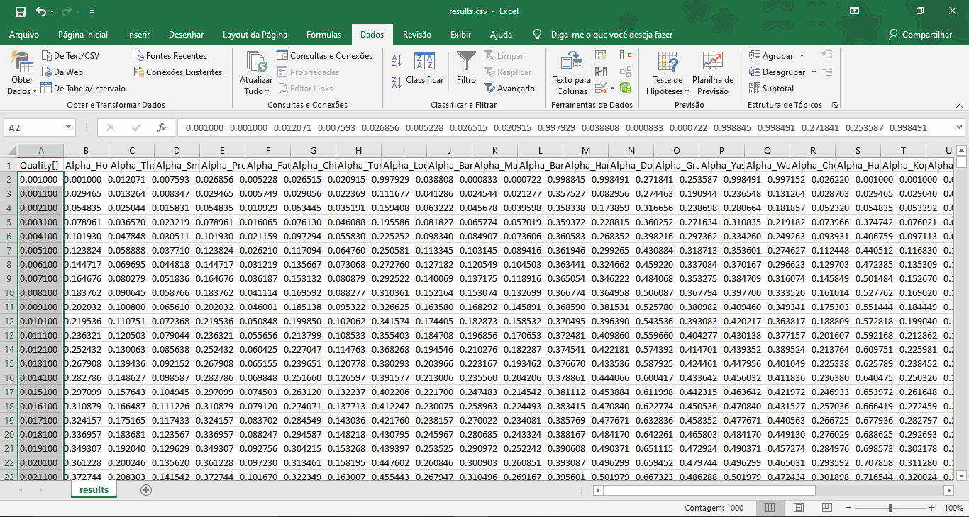

To access Text to Columns, select the dataset and go to Data → Data Tools → Text to Columns.





