// wallet link with wallet amount added DONE

// portfolio page has separate view now (menu created under social) DONE

// budget title Price range on favorite job DONE

// My removed from social profile DONE

// DOB calendar DONE

//https:// added by default in social urls DONE

//apply online popup changes done DONE

SEO - Page Title, description should be done dynamically as per page content - Like job, influencers and other dynamic public pages only ——————

Job Posting - Start date - calendar or show the job format -dd/mm/yy

————— DONE

In city Add - Any Location
Number of influencer Required –label DONE

New view for influencers integrated DONE

New view for influencers profile integrated DONE

————

Influencer:
Add/Edit profile :

Add – Textfield in top first place above bio : “Professional Headline” DONE
Allow to Select up-to 3 category

Youtube Embeded code is not working after adding and save text field get blank - also for embedded please increase the text filed height. ———— DONE

After the login or registration - send user to my account page

Influencer public profile page shud be with username (this we ask inside account setting page in dashboard ) https://selfieym.com/influencer-profile/19 = like this https://selfieym.com/influencer-profile/anands9 —— DONE

Price packaging Page - Make it as default design given inbuilt

Package detail need to show as well ribbon of colour is not showing in current design ( ur current design is all fine but need some

improvements) http://jobclass.bedigit.com/pricing ———

Influencer Packages - bids number will be debited from plan as per usage as per Packages there will be featured Job and featured Profile (label) its inbuilt for jobs check for influencer
Profile will be featured in his selected category.

——

Remove - per word from add job section - per hours DONE

——

Job Detail Page - Add one more box in right panel for “Employer verification” just above the tips for candidate

- Email Verified, Phone Verified, Payment method verified, profile completed DONE

Add one more box in right panel for “Your Package” Show package Name, Wallet Balance - Amount, Bids Quantity - 3/5 DONE

1 week ago - Security & Safety - Kolkata - 26 views - add here - “Bidding End in

6 Days, 06 Hours”. Add “Total Bids - 20”

Display Social media only that’s is filled by employer - now all are showing Change Button Name - Apply Online to - Place Bid
DONE

———————

Both user Dashboard: Separate Transaction and Wallet
------- DONE

Message box when sending check the title To and From - its coming same in - Coming sender name in To this sub be Receiver name

In Message box – add features of uploading image/file/doc/pdf (so project file
can be shared with clients) DONE

——

Add One link in left nav under for Influencer Profile – “My Rate” This will appear in influencer Profile page (design is done)

Basic

Price: ____500__(Enter Amount)

Service Offer: ___________________

Standard:
Price: ____500__(Enter Amount)
Service Offer: ___________________

Premium
Price: ____500__(Enter Amount)

Service Offer: ___________________

________(What service you will provide Max 100 word Limit)

________(What service you will provide Max 100 word Limit)

________(What service you will provide Max 100 word Limiand

also daynamic it at front end

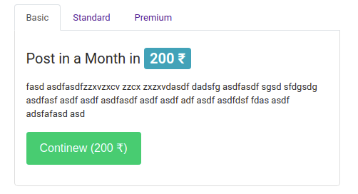

* also shows verification details at influncer page

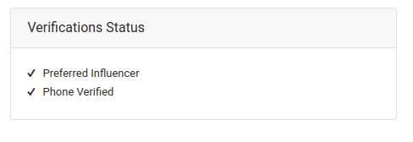

* also change the design of featured profile

