Ever felt like your data science project is a ship lost at sea? You have a destination in mind — valuable insights — but no map to get there. You’re not alone. Many projects, brimming with potential, get bogged down in messy data, shifting goals, and a lack of clear direction. They end up delivering little to no real business value. What if there was a proven roadmap? A framework that could guide you from a vague business question to a deployed, value-generating model?

Enter CRISP-DM.
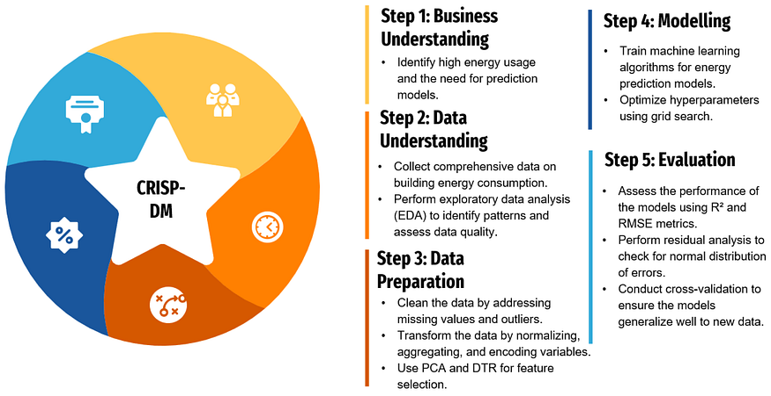

- CRISP-DM is a structured approach to data mining that breaks down a project’s lifecycle into six distinct, iterative phases.
- Its focus is on one critical thing: solving the business problem.
- The process is cyclical, meaning you can and often should revisit earlier steps as you learn more. It’s not a one-way street. This iterative nature is what makes it so robust and practical in the real world.

CRISP-DM Framework – House Construction Analogy
Phase 1: Business Understanding
This is the most crucial phase—and ironically, the one most often rushed.
A house is never built without a blueprint; similarly, a data project cannot succeed without clearly understanding the business problem, goals, and success criteria.
Before writing a single line of code, you must answer what problem you are trying to solve.

Phase 2: Data Understanding (EDA)
Once the blueprint is ready, the next step is understanding what materials are available.
EDA Type | Focus | What It Covers
Profile Data Analysis | Data structure & quality | Shape, data types, missing values, duplicates, unique values
Statistical Data Analysis | Numerical behavior | Mean, median, variance, distribution, skewness, correlation, outliers
Graphical Data Analysis | Visual patterns & trends | Histograms, boxplots, bar charts, line plots, scatter plots, heatmaps

Phase 3: Data Preparation
Now the real work starts. Raw materials are cleaned, shaped, and prepared.
Unnecessary or problematic elements—like excess cement or broken bricks—are removed so the structure remains strong. This phase ensures data is clean, structured, and ready for modeling.
Data cleaning addresses the missing values and outliers you found earlier, which could mean imputing, removing, or flagging them.
This is also where feature engineering happens, a creative process of creating new, more informative variables from existing ones.

Phase 4: Modeling
With clean materials in hand, we start building the house.
Different models are tried and trained, much like constructing sample structures to see which design stands best on the foundation.
This is where algorithms come into play.
The primary goal is to select and apply various modeling techniques (decision tree, neural network, or simple linear regression) to find the one that best addresses the business problem.

Phase 5: Evaluation
A house may look perfect, but the key question is: is it safe and functional?
Similarly, even if a model shows high accuracy, we must evaluate whether it truly solves the original business problem defined in Phase 1.

Phase 6: Deployment
Finally, the house is ready for people to live in.
The validated model is deployed into production, integrated with business systems, and monitored to ensure it continues to deliver value over time.

