The Five Senses
A Hands-On Activity Guide

Sight • Hearing • Smell • Taste • Touch

Sense of Smell
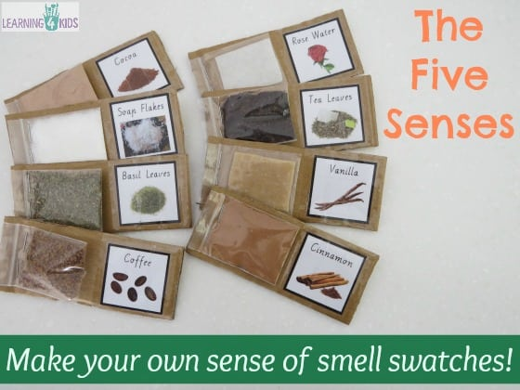

Materials Needed
- Cardboard or thick chart paper (cereal box cardboard works well)
- Transparent plastic sheets / ziplock bags / laminating pouches / clear tape
- Glue or hot glue gun
- Scissors
- Marker or printed labels
- Small amounts of scented items:
  - Coffee beans / powder
  - Tea leaves
  - Cinnamon
  - Vanilla essence (use cotton soaked with a drop)
  - Rose petals or rose water (cotton pad)
  - Soap flakes
  - Basil leaves
  - Cocoa powder
  - Any safe local spices or herbs

How to Make It
- Cut two equal square pieces of cardboard for each scent (approx. 3×3 inches).
- Cut small transparent plastic pieces slightly smaller than the cardboard.
- Stick three sides of the plastic to the cardboard to form a pocket; leave one side open.
- Put a small amount of each scented material inside the pocket.
- Seal the open side with tape or glue.
- Make matching cards with the name and a picture of each scent item.
- Decorate with coloured paper borders and label it Five Senses - Smell Activity.

This Feels Like…
Each swatch lets children explore familiar scents and describe them — sweet, spicy, fresh, earthy. Ask: What does this smell remind you of?

Sense of Taste
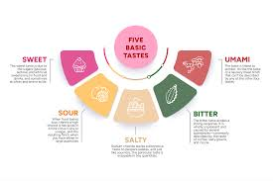
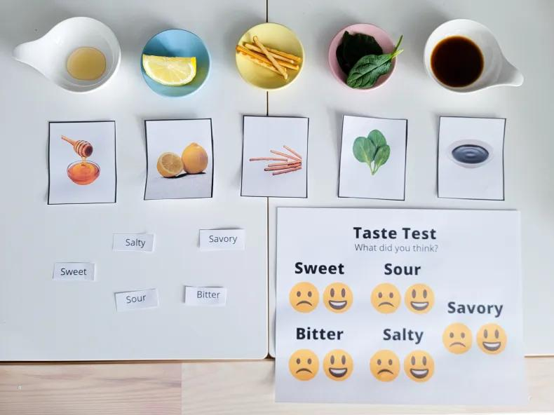

Materials Needed
- 5 small bowls or plates
- Tasting items for each basic taste:
  - Sweet — honey or sugar water
  - Sour — lemon juice or vinegar
  - Salty — pretzel sticks or salty crackers
  - Bitter — dark leafy greens (spinach) or unsweetened cocoa
  - Umami / Savory — soy sauce or a small piece of mushroom
- Printed taste labels (Sweet, Sour, Salty, Bitter, Savory)
- Picture cards of each food item
- Taste Test recording sheet with smiley/sad faces

How to Make It
- Prepare a small amount of each tasting item in separate bowls.
- Print or write labels for each taste and lay them on the table.
- Print picture cards of each food and mix them up for children to sort.
- Create a Taste Test sheet with columns for each taste and happy/sad face options.
- Let children taste each item and circle how they feel about it on the sheet.
- Discuss: Can you taste more than one flavour at once? Which did you like best?

This Tastes Like…
Tasting activities help children identify the five basic tastes and understand that our tongue and nose work together to give us the full flavour experience.

✋ Sense of Touch
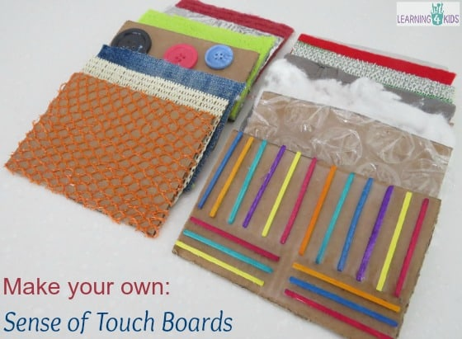

Materials Needed
- Pieces of cardboard (as bases)
- A variety of textured materials:
  - Fabric scraps — velvet, denim, lace, wool
  - Bubble wrap
  - Sandpaper
  - Cotton balls or cotton wool
  - Buttons
  - String or yarn
  - Foam sheets or sponges
  - Netting or mesh
  - Craft sticks or straws
- Glue (PVA, hot glue, or glue stick)
- Scissors

How to Make It
- Cut cardboard into equal-sized squares or rectangles (approx. 15×15 cm).
- Cut each textured material to fit one cardboard square.
- Glue each material firmly onto its cardboard base and allow to dry completely.
- Label each board with a descriptive word — rough, smooth, bumpy, soft, scratchy.
- Make two sets of boards for a matching game, or keep one set for free exploration.
- Optional: Blindfold children and have them match boards by touch alone.

This Feels Like…
Touch boards help children build vocabulary for textures and develop fine motor awareness. Ask: Is it rough or smooth? Hard or soft? What does it remind you of?

👁️ Sense of Sight
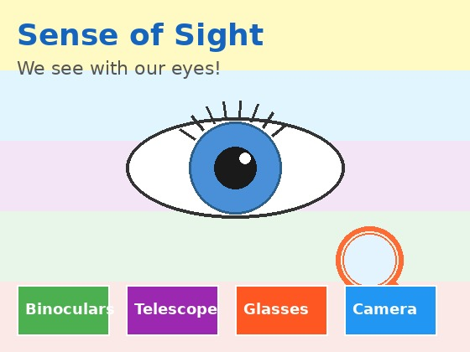

Materials Needed
- Magnifying glasses
- Binoculars or a DIY toilet-roll binoculars
- A tray with 5–7 small household objects
- A small towel or cloth to cover the tray
- Colourful paint swatch strips (from a hardware store)
- Blindfold (optional)
- Printed 'I Spy' cards or pictures

How to Make It
- Collect 5–7 small, safe household objects and place them on a tray.
- Let children look at and name each object, then cover the tray with a cloth.
- Remove one object secretly; uncover the tray and ask: What is missing?
- For a magnifying glass activity, place small natural items (leaf, feather, coin) on a table.
- Give children magnifying glasses to observe fine details and describe what they see.
- Make DIY binoculars from two toilet rolls taped together and decorated.
- Play 'I Spy' using colours, shapes, and sizes to practise descriptive sight vocabulary.

What We See…
Sight activities help children understand how their eyes interpret colour, shape, distance, and detail. Ask: What looks different under the magnifying glass?

Sense of Hearing
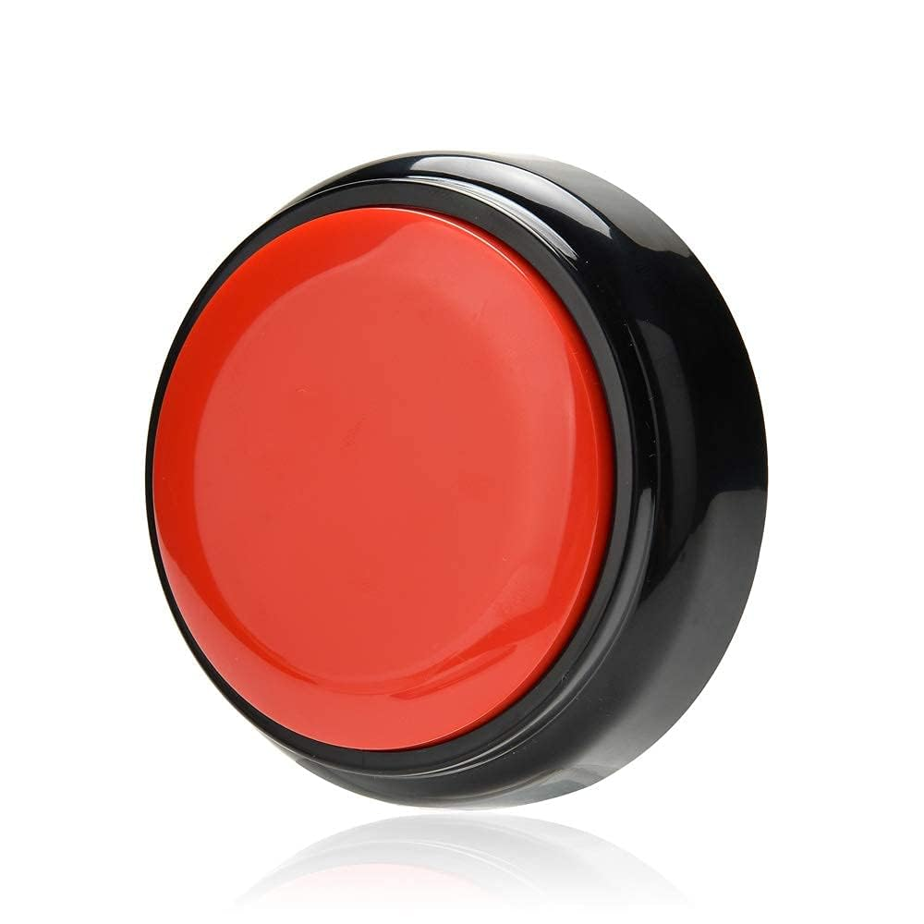

Materials Needed
- Recordable sound button (like the one shown above)
- Small opaque containers with lids (film canisters, plastic eggs, or small jars)
- Pairs of sound-making fillings:
  - Rice
  - Dried beans
  - Sand or salt
  - Small pebbles
  - Paper clips
- Stickers or coloured dots for matching
- Optional: recordings of animal sounds, nature sounds, or everyday sounds

How to Make It
- Fill pairs of containers with matching materials (two with rice, two with beans, etc.).
- Seal the lids securely with tape or glue so children cannot open them.
- Mark matching pairs on the bottom with the same coloured dot (for self-checking).
- Mix all the containers and ask children to shake and match by sound.
- For the sound button: record a short animal sound, song, or instruction on it.
- Place the button in a learning corner and let children press to hear and identify the sound.
- Extend the activity: play animal sounds and ask children to imitate or identify them.

What We Hear…
Hearing activities sharpen listening skills and sound discrimination. Ask: Is it loud or quiet? High or low? Encourage children to be still and listen to background sounds around them too.

