SCI-TEC Instruments Inc

Brewer CMD utility

design description document

Document #: 12340073
Revision: 01

REVISION HISTORY
REV | DESCRIPTION | DCN # | DATE | APPD
1 | See DCN |  | 11/8/2026
2 | Maintenance Update |  | 08/29/96

1 INTRODUCTION
This is a design description document. A design description document records a design and describes the reasons for that design.

2 Purpose
This document comprises a guide to the design of the Brewer CMD utility. It is intended for use by personnel of the SCI-TEC Engineering group as a guide in understanding the structure of the Brewer CMD utility in order to make any corrections, modifications or enhancements.
To achieve this end the document describes the design of the program both in terms of logical software structure and in terms of software source organization. The document explains how the design meets the specification when it is not obvious why the design should achieve the desired end.

3 Scope
The Brewer is an instrument used to measure light intensities in the UV, usually using the sun as the light source. It operates under the control of a personal computer via an RS232C communication link. The Brewer CMD utility is a low-level utility designed to simplify testing of the instrument.
This document applies to version 1 release 1 (V1R1) of this utility.
This document does not apply to any high-level Brewer functions, such as lamp scans, data collection or other such functions. Refer to the Brewer software documentation on these high-level functions.

4 Conventions
The Brewer CMD utility is designed run with any Brewer. Some features of the utility do not work on all Brewers: this will be noted in this document. This utility is written in C++, and compiled under Borland C++ 4.5. The reader is assumed to have adequate familiarity with each of these.
The term package is used to mean a block of software defining a single (data) abstraction. It is roughly equivalent to the ADA package or the C++ class except that there is normally a one-to-one correspondence between a package and a set of files with the same name and a variety of extensions.

5 Documents
The following documents provide reference material to this document.

12340002 Brewer Spectrophotometer controller/instrument ICD

6 Operational Overview

7 Program Concept
The Brewer CMD utility is designed to communicate with a Brewer instrument attached to a PC through the serial port. The user has complete control over the Brewer, and can send any information to it. However, because this is a low-level utility, no configuration information external to the Brewer can be used here.

8 Data Flow
The following diagram shows how the Brewer CMD utility interrelates with other sources of data:
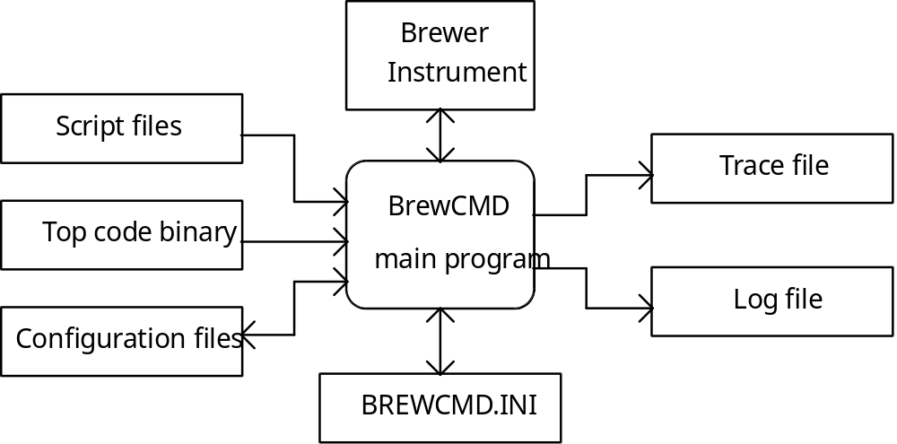
The main program is the box in the middle. It is initialized upon startup by the file BREWCMD.INI, which it creates if one is not present. The utility communicates with the Brewer instrument, and receives responses from it. This information is logged to a Log file, and may also be recorded as debug information in an optional Trace file.
To make work easier, the user can create Script files with a text editor. These files are simply a list of commands that the user wishes to send to the Brewer, which is run from within the program. (Refer to the user's manual for details.)
Two other files, specifically for use with Brewers with new electronics boards, can also be used. A Top code binary file, which will replace the Cosmac and Operating mode code, can be uploaded to the Brewer with this utility. Also, a Configuration file, which contains a list of configuration parameters, can be written to the Brewer or read from the Brewer. This is the ideal way of working with the Brewer's configuration.

9 Program Flow
The utility begins by initializing all information needed by the program. The first part of this is to read the INI file, creating one if none is present, and using the information within. This is handled by the BrewCMD INI support class.
The screen and device interfaces are initialized next. They use the INI information to establish communications with the Brewer, and initialize the output files. If communication with the Brewer cannot be established, the program will throw an exception. Once everything is set up, the utility will inform the user of the current status.
Next, the program enters a main loop. Here, the user is given control. The loop collects input from the user, takes action on the command typed, and repeats until the user decides to quit. The sequence is as follows:
• Get command from user
• If command is a built-in command, handle it appropriately
• If command is not built-in, send command to Brewer and wait for a response
• Log all information from entered command, as appropriate
• Repeat loop until user quits
When the program ends, the support classes simply clean up (files are closed, and so on).

10 File structure
The following is a list of all classes and packages that are part of this utility but are not in the library of reusable designs:

cmdini Brewer CMD utility INI support class
llcomm Brewer CMD utility low-level communications support class
cmdcomm Brewer CMD utility high-level communications support class
cmddisp Brewer CMD utility display and logging class
brewcmd Main program package

11 Source Code Structure
This section describes the hierarchy of classes and packages used to implement the software. The following sections each describe the function of a single class or package. Each class and package can be found in one or more source files with a single header file. Refer to this header file for a detailed description of the class design or package design.

12 INI Support Class (CMDINI.HPP)
This class provides a method for looking up strings from a string table, which has been read from the file BREWCMD.INI. The file is created if it is not provided. An exception will be thrown if the INI file cannot be created.

13 Display and Logging Class (CMDDISP.HPP)
This class is responsible for writing all information to the screen and output files. It handles all screen formatting internally, requiring no such information through the interface. The output files are determined by the BREWCMD.INI file, which is used via the INI Support class.

14 Low-Level Communications Support Class (LLCOMM.HPP)
This class contains methods and data needed to communicate with the Brewer instrument. They relate to checking instrument status, sending and receiving commands, and changing the instrument mode on Brewers with new electronics boards. Communications are initialized via information obtained through the INI Support class, and all output is printed via the Display and Logging class.

15 High-Level Communications Support Class (CMDCOMM.HPP)
This class contains exception handling and status display for the low-level communications commands, as outlined in Section 4.3. This is done to simplify the error handling in the main program and to simplify its structure. All output is again handled by the Display and Logging class.

16 Draft User's Manual
This section provides an overview of how to use the Brewer CMD utility. Knowledge of how the Brewer works is not necessary, but a general operational overview of the Brewer is extremely useful.

17 Introduction
The Brewer CMD utility is designed to provide a simple way to work with your Brewer, in a low-level way, without requiring the Brewer software to be present. This allows you to perform many simple tests (similar to the teletype [TT] routine), and even write simple test procedures in a text file for later use.

18 Getting Started
To use the Brewer CMD utility, you will first need to edit the BREWCMD.INI file. This file looks like this:

; BrewCMD Initialization File
;
; Copyright(C) 1995, SCI-TEC Instruments Inc.
; All rights reserved

COM Port=1
Baud Rate=1200
Tracing=off
Log File=brewcmd.log
The only line that must be edited is the COM Port=1 line. You must change the 1 to the COM port that your Brewer is attached to.
The Baud Rate entry is the default baud rate that you use to communicate with your Brewer. This baud rate will be used when the utility is first run. If communication cannot be established at this baud rate, an autobaud routine will try all baud rates to establish communication. If this also fails, the program will terminate.
The Brewer CMD utility logs all information typed by the user, and all Brewer responses, to a log file. The name of this file can be set by changing the Log File entry to a new filename.
If you are doing debug work, you may wish to trace all data sent and received by the computer. To do this, set the Tracing to text or full. Text tracing will display all information on a per-message basis. Full tracing will display all information one character at a time. Note that tracing generates a lot of information, and will result in large trace files.
When you have set all your options, save this file. To run the Brewer CMD utility, simply type BREWCMD at a DOS prompt.

19 The Main Screen
The following sample shows what the main screen looks like:

BrewCMD Communication Utility (V1R1)
Copyright(C) August 1996, SCI-TEC Instruments Inc. All rights reserved.
Type HELP at any time for help Type QUIT to quit

BOSS> Attempting to communicate at default baud rate
BOSS> Using cosmac mode at 1200 baud on port 1; tracing is off
USER> R,0,4,4;O
BWR > 120, 1, 208, 64, 20
USER> _

Status: Ready Wed Sep 03 (247) 01:11:00 1996
Messages with BOSS> at the beginning are written by the system itself. Messages with BWR > at the beginning are messages transmitted by the Brewer. Messages with USER> at the beginning are commands typed by the user.

20 Command Summary
By default, all commands are sent to the Brewer as they are typed. This allows the user to perform all actions using the normal Brewer commands. In addition, the Brewer CMD utility supports a number of special commands to perform other actions not directly supported by the Brewer firmware:

Command | LM | CM | OM | Description
COSMACMODE | yes | no | no | Switch to Cosmac mode at 1200 baud
GETCFG <file> | no | yes* | yes | Get the configuration from the Brewer and put into <file>
HELP | yes | yes | yes | Quick summary of commands
LOAD <file> | yes | no | no | Load new top-level code from <file> (recommend 4800 or 9600 baud for this task)
LOADMODE (<baud>) | no | yes* | yes | Switch to Load mode (at the specified baud rate, if desired)
OPMODE (<baud>) | yes | no | no | Switch to Operating mode (at the specified baud rate, if desired)
PUTCFG <file> | no | yes* | yes | Write the configuration in <file> to put into the Brewer
QUIT | yes | yes | yes | Exit program
READLOG | no | yes* | yes | Read all log entries from the Brewer
REPEAT <cmd> | no | yes | yes | Repeat <cmd> until stopped by user
RESET | yes | no | yes | Forces a warm reset by the Brewer
RUN <file> | no | yes | yes | Execute command script stored in <file>
SEND <cmd> | yes | yes | yes | Send a low-level command to the Brewer
STATUS | yes | yes | yes | Request system status
SYN | yes | no | yes | Request Brewer board status
ZERO | yes | no | yes | Sets the number of warm resets to zero
 |  |  |  | *Not allowed on Brewers with old electronics boards

