Republic of Malta, Reimbursable Advisory Services

Contribution Density and the Segmentation of Malta's Pension Contributory Base for PROST

1. Introduction and purpose
This note prepares and documents the Maltese pension contributory base for the projection work underpinning the next EU Aging Report. It has been prepared by the World Bank together with the Ministry for Finance (MFIN) Economic Policy Department. Its motivation is a practical modeling problem that has become unavoidable as Malta's labor market has changed: the population of people who contribute to the pension system in any given year is more heterogeneous than the model historically assumed. Fifteen years ago the contributory base could reasonably be represented as a stable body of roughly 165,000 essentially full-time workers, each expected to accumulate a long career and retire on the full two-thirds pension. Today the base is over seventy percent larger, and much of that growth consists of recent migrants, part-time and reduced-hours workers, and contingent or platform workers, many of whom will never accumulate the continuous career that the two-thirds pension presupposes. Treating this enlarged and diverse base as if it were the old homogeneous full-time workforce risks systematically over-stating future pension entitlements and obscuring the true financial position of the scheme.
Against that backdrop, this note has three objectives. First, it brings together the two data sources now available (the 2024 administrative update supplied by the Ministry for Finance and the longitudinal panel assembled for the earlier contribution-density work) and explains how they are constructed, cleaned, and linked at the level of the individual. Second, it provides a detailed empirical description of the contributory base: its size and composition, its distribution across employment types, its contribution density measured on three distinct horizons, and the distribution of wages within it. Third, it sets out a segmentation strategy that separates the base into four groups by the pension each is projected to draw, a full-career group that reaches the cohort requirement and earns the maximum two-thirds pension (Group 1), modeled in a dedicated PROST input file; a pro-rata group that vests but on a shorter career and draws a partial pension (Group 2); and a non-vested group that does not reach the ten-year minimum and earns no contributory pension (Group 3), and explains concretely which PROST inputs change as a result.
Throughout, the note is careful about one distinction that recurs at every stage: contribution density can be measured within a single year or across a career, and the two answer different questions. A great deal of the analysis below is devoted to showing, with the data, why this distinction matters and how it should shape both the description of the base and the modeling choices that follow.

2. Data sources and individual-level linkage
Two complementary datasets underpin the analysis, and a central methodological strength of this work is that they can be joined at the individual level through a common personal identifier.
The 2024 administrative update. The Ministry for Finance supplied two files for 2024, both keyed on the same personal identifier. The first is a contributions update covering roughly 297,650 individuals with a 2024 contribution record; for each person it reports the number of weeks contributed during the year by contribution class, the average weekly wage, the contribution and credit history, and indicators such as pensioner status, date of birth, gender and nationality code. The second is an employment-history update that records, for each person, citizenship and nationality and the employment status (full-time, part-time, reduced hours, or not working) observed at four points during the year, namely the end of January, April, August and December. Because both files share the personal identifier, employment type and nationality can be attached to each contributor's annual contribution and wage record.
It is worth being explicit about what these four employment snapshots can and cannot reveal. They establish whether a person was working, and in what capacity, at four moments in the year, but they do not record hours worked. A person recorded as part-time may be working twenty hours every week of the year or forty hours in some weeks and none in others; the snapshots cannot distinguish these. Equally, a person who contributed during the year but happened not to be employed at any of the four snapshot dates appears with no employment type at all. As shown later, this group is sizeable among non-Maltese contributors and is itself informative, since absence from every snapshot is the signature of short, intermittent spells.
The 2014-2023 longitudinal panel. The second source is the individual panel constructed for the contribution-density report, assembled in Stata from successive annual administrative files and cleaned through a documented pipeline. Unlike the single-year administrative update, the panel follows each person across ten years and therefore supports measures of career-length contribution density. It records, among other variables, the months contributed in each year, cumulative lifetime contributions, the first observed year of contribution, gender, birthdate and a harmonized nationality. From these the panel derives two career-density measures, defined in Section 5.
The two sources are joined on the personal identifier. Of the 2024 contributors, about 252,950 are found in the panel and therefore carry both a current within-year density and the career-density measures; the rest, with no prior history in the panel window, have a within-year measure only. This individual-level linkage is what makes it possible, later in the note, to compare the two horizons at the level of the individual.

3. How contributions are recorded and what “density” means
Interpreting the data correctly requires understanding how the Maltese system credits contributions, because the institutional rules determine what a measure of density actually captures. The contributory pension is financed by mandatory weekly contributions, and entitlement is built up in units of weeks. A central feature, clarified in detail during the technical discussions with the Ministry, is that a week counts as a contributory week whenever a contribution is paid in respect of that week, irrespective of the number of hours worked. Working one hour or forty hours in a week, provided a contribution is paid, yields the same single week of credited service; what differs is the amount of the contribution and hence the recorded weekly wage.
This rule has a direct and important consequence for the analysis. Reduced hours of work do not reduce the number of contributory weeks; they reduce the weekly wage. A person who works twenty hours a week throughout the year accumulates a full year of contributory weeks but at a lower weekly wage than a full-time colleague. Conversely, gaps in the year (weeks in which no contribution is paid, whether because of unemployment, emigration, or intermittent engagement) reduce the number of contributory weeks directly. The practical implication is that the intensity of part-time work shows up in the wage, while the discontinuity of a career shows up in the count of weeks. The two phenomena are distinct and, as the analysis will show, they map onto different parts of the contributory base and call for different modeling treatments.
A second institutional feature concerns credits. Periods such as unemployment, maternity and approved education can give rise to credited weeks that count toward length of service. These credits, however, are allocated only at the moment a person claims a pension, when the record is examined and missing weeks are filled where eligibility rules allow. They are therefore not visible in the contribution history while a person is still working, which means that observed histories tend to understate the length of service that individuals will eventually be credited with. This is a material caveat for any career-density measure built from contribution records, and it is one reason the note treats such measures as lower bounds for some groups, notably women with caregiving interruptions. Finally, eligibility for the full contributory (two-thirds) pension reflects a long career, and a minimum of ten years of contributions is required to qualify for a pension at all; partial pensions are paid pro-rata of the two-thirds amount according to the length of service achieved.

4. The 2024 contributory base: size and composition
The 2024 contributory base aged eighteen to sixty-five and excluding active pensioners comprises about 285,100 individuals, each counted once, the people-counting basis used throughout, consistent with the segmentation in Section 8. Of these, roughly 171,000 are Maltese and 114,000 non-Maltese, and the non-Maltese have a higher share of men, as Table 1 shows.
Table 1. The 2024 contributory base, by nationality and gender.
2024 contributory base | Men | Women | Total
Maltese | 91,467 | 79,500 | 170,967
Non-Maltese | 72,306 | 41,865 | 114,171
Total | 163,773 | 121,365 | 285,138
The composition by employment type, drawn from the four 2024 snapshots, differs between the two groups and previews much of the analysis that follows. Among Maltese contributors the great majority are recorded as full-time, with a meaningful minority (about one in nine) working part-time and a small reduced-hours group. Among non-Maltese the full-time share is lower, part-time work is rare, and thirty percent are not observed in any of the four snapshots at all. As argued above, this last group is not a data deficiency so much as a behavioral signature: these are predominantly workers whose engagement with the Maltese labor market in 2024 was short or intermittent, falling between the snapshot dates.
Figure 1. Employment-type composition of the contributory base, by nationality.
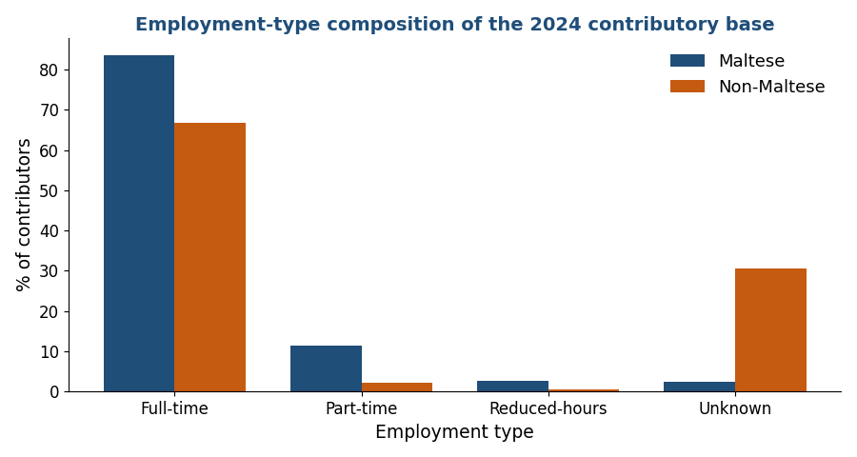
Table 2. Employment type as a share of contributors, by nationality.
Employment type (%) | Full-time | Reduced-hrs | Part-time | Unknown
Maltese | 83.7 | 2.6 | 11.3 | 2.3
Non-Maltese | 66.7 | 0.5 | 2.2 | 30.5
These compositional facts already suggest that a single, undifferentiated representation of the contributory base will misrepresent important sub-populations. The Maltese base looks broadly like the traditional full-time workforce, with part-time work expressed mainly through lower wages. The non-Maltese base looks different: full-time when present, but with a large share present only intermittently. Whether that intermittence reflects genuinely short Maltese careers or simply recent arrival is the question that the density analysis in the next section is designed to answer.

5. Contribution density under three definitions
Contribution density is the most important concept for what follows, and also the one most easily misused, because the same word denotes different quantities depending on the time horizon over which it is measured. This note uses three definitions throughout (one measured within a single year and two measured across a career) and treats them not as alternatives to be chosen between but as complementary lenses, each of which answers a distinct question about a contributor.
Within-year density (henceforth D1) is the number of weeks contributed during the year divided by fifty-two. It measures the share of a single year that a person spent contributing, and it is the density axis of the wage-density matrix introduced in Section 8. Its strength is that it is observable for everyone in the current data and reflects current engagement; its limitation is that it is silent about the rest of a career. A graduate who began contributing in October, or a migrant who arrived mid-year, will show a low D1 in that year not because their attachment is weak but simply because the year was incomplete for them.
The fixed-window career density (henceforth D2) is the number of months contributed over the fixed ten-year window 2014-2023 divided by 120. Because the denominator is always the full ten years regardless of when the person entered, any months before a person first appeared in Malta count as zero. This makes D2 a demanding measure of long-run attachment to the Maltese system: a recent migrant who has contributed fully since arriving two years ago still records a low D2, because eight of the ten years count against them. D2 is therefore informative about accumulated rights within a fixed reference period, but it conflates “low propensity to contribute” with “not yet present.”
The since-entry career density (henceforth D3) is the number of months contributed since the person's first observed contribution divided by the number of months available since that date. By starting the clock at entry, D3 removes the penalty for pre-arrival absence and measures the intensity of participation while the person has actually been in the system. For long-established Maltese workers D3 and D2 nearly coincide; for recent migrants D3 is higher than D2, because it no longer counts the pre-arrival years. D3 still cannot see the future, and it cannot net out people who will leave, so it should be read as the intensity of participation to date rather than as a forecast of a completed career.
The consequence of using three definitions, rather than one, becomes clear as soon as they are applied to the same people. For Maltese contributors, whose careers are long and continuous, the three measures broadly agree: most Maltese contribute most of the time on any of the three definitions. For non-Maltese the three diverge. On D1 they look reasonably engaged, because they tend to work most of the year while they are present. On D2 they look extremely sparse, because the fixed ten-year window is dominated, for most of them, by years before they arrived. On D3 they sit in between, more engaged than D2 suggests once pre-arrival absence is excluded, but still below Maltese levels. Reporting density without specifying which definition is in use would therefore give a fundamentally different impression of the non-Maltese base depending on the unstated choice, and would drive a correspondingly different segmentation. The figure and tables that follow report all three.
Figure 2. Contributors under the three density definitions, by nationality (share in each band).
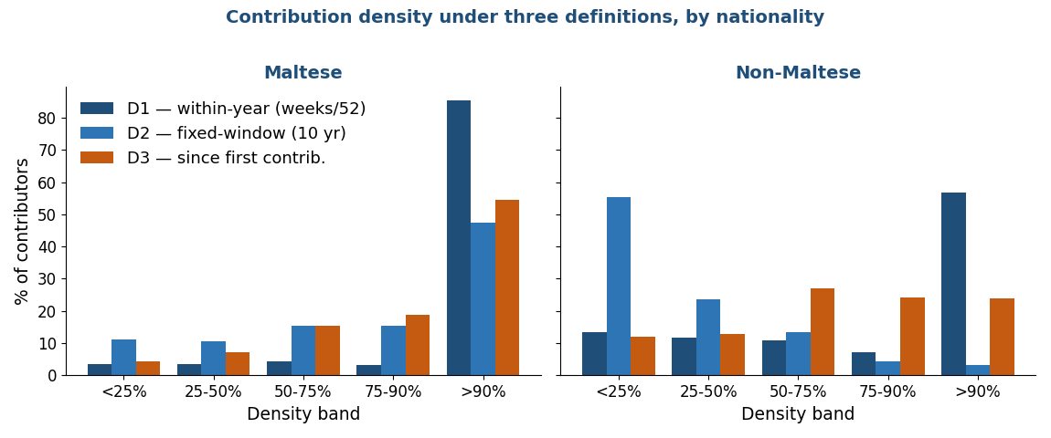
Figure 3. Number of contributors in each density band under the three definitions, by nationality.
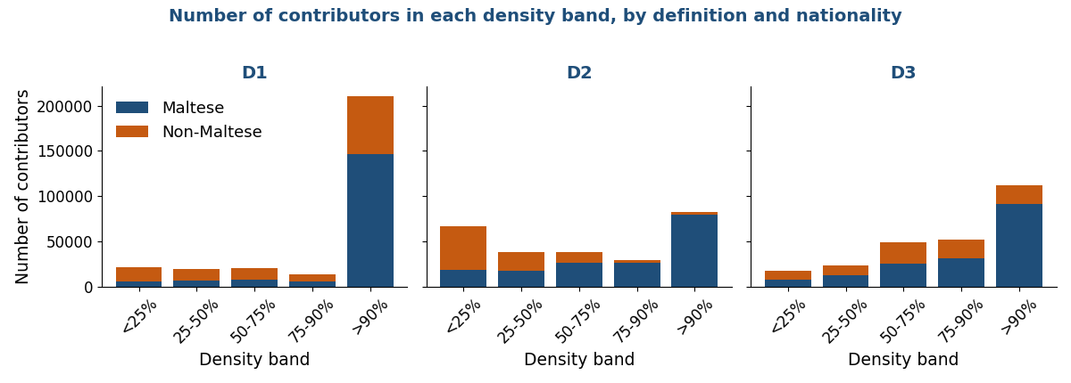
Because the policy question (who will accumulate enough to draw a meaningful contributory pension) is ultimately about whole people rather than shares, it is useful to look at the absolute number of contributors in each density band, not only the percentages. Figure 3 does this for all three definitions, and Figure 4 focuses on the within-year measure with the two nationalities stacked. The concentration of contributors in the highest within-year band is evident: more than 210,000 of the roughly 285,100 contributors contribute upward of ninety percent of the current year. The low-density tail, while a minority, is not negligible and is disproportionately non-Maltese.
Figure 4. Number of contributors by within-year density band, by nationality.
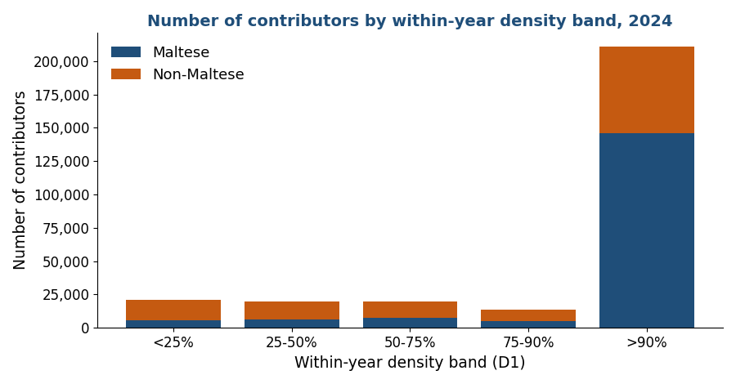
Tables 3a to 3c report the full breakdown by density band, employment type and nationality, one table per definition, expressed as the share of each nationality-and-employment-type group falling in each band. They are the quantitative core of this section. Under the within-year measure (Table 3a), Maltese full-timers are almost entirely in the top band, while part-timers are more dispersed, consistent with part-time work being concentrated in particular sectors with seasonal or variable engagement. Under D2 (Table 3b), the non-Maltese rows collapse toward the lowest band: about fifty-five percent of non-Maltese contributors fall below twenty-five percent career density on the fixed-window measure, an artefact of counting pre-arrival months as zero. Under D3 (Table 3c), the non-Maltese distribution shifts rightward once pre-arrival absence is removed from the denominator, though it still trails the Maltese distribution.
D1: within-year density (weeks contributed in 2024 ÷ 52):
Table 3a. Within-year density (D1): share in each band, by employment type and nationality.
Nationality | Job | n | <25% | 25-50% | 50-75% | 75-90% | >90%
Maltese | Full-time | 143,047 | 1.4 | 2.2 | 3.0 | 1.9 | 91.5
Maltese | Part-time | 19,399 | 14.4 | 13.2 | 14.8 | 11.0 | 46.6
Maltese | Reduced-hrs | 4,522 | 3.0 | 3.7 | 5.1 | 5.2 | 83.0
Maltese | Unknown | 3,999 | 23.6 | 6.3 | 5.6 | 2.9 | 61.7
Maltese | ALL | 170,967 | 3.4 | 3.6 | 4.5 | 3.1 | 85.5
Non-Maltese | Full-time | 76,207 | 7.9 | 9.2 | 9.7 | 7.8 | 65.4
Non-Maltese | Part-time | 2,524 | 18.0 | 18.5 | 18.0 | 11.5 | 34.0
Non-Maltese | Reduced-hrs | 570 | 5.8 | 9.6 | 10.5 | 11.1 | 63.0
Non-Maltese | Unknown | 34,870 | 25.4 | 16.9 | 12.7 | 5.5 | 39.5
Non-Maltese | ALL | 114,171 | 13.5 | 11.7 | 10.8 | 7.2 | 56.8
D2: career density over the fixed 2014-2023 window (months ÷ 120):
Table 3b. Fixed-window density (D2): share in each band, by employment type and nationality.
Nationality | Job | n | <25% | 25-50% | 50-75% | 75-90% | >90%
Maltese | Full-time | 141,663 | 7.0 | 9.5 | 15.4 | 16.0 | 52.0
Maltese | Part-time | 17,355 | 42.1 | 17.4 | 14.7 | 10.2 | 15.5
Maltese | Reduced-hrs | 4,463 | 11.3 | 10.1 | 16.2 | 16.7 | 45.6
Maltese | Unknown | 3,601 | 25.3 | 15.9 | 20.9 | 14.7 | 23.3
Maltese | ALL | 167,082 | 11.2 | 10.5 | 15.5 | 15.4 | 47.4
Non-Maltese | Full-time | 60,041 | 53.8 | 24.2 | 13.8 | 4.7 | 3.5
Non-Maltese | Part-time | 1,822 | 46.4 | 26.8 | 17.5 | 5.7 | 3.7
Non-Maltese | Reduced-hrs | 518 | 33.2 | 27.2 | 20.7 | 9.1 | 9.8
Non-Maltese | Unknown | 23,494 | 60.6 | 21.5 | 12.4 | 3.4 | 2.1
Non-Maltese | ALL | 85,875 | 55.4 | 23.5 | 13.5 | 4.4 | 3.2
D3: career density since first observed contribution:
Table 3c. Since-entry density (D3): share in each band, by employment type and nationality.
Nationality | Job | n | <25% | 25-50% | 50-75% | 75-90% | >90%
Maltese | Full-time | 141,663 | 2.3 | 5.5 | 14.1 | 18.9 | 59.2
Maltese | Part-time | 17,355 | 19.2 | 19.9 | 23.5 | 16.9 | 20.4
Maltese | Reduced-hrs | 4,463 | 4.2 | 6.8 | 14.6 | 21.0 | 53.3
Maltese | Unknown | 3,601 | 15.4 | 13.2 | 24.3 | 17.9 | 29.2
Maltese | ALL | 167,082 | 4.4 | 7.2 | 15.3 | 18.7 | 54.4
Non-Maltese | Full-time | 60,041 | 10.1 | 11.3 | 28.0 | 25.2 | 25.3
Non-Maltese | Part-time | 1,822 | 14.8 | 19.9 | 31.0 | 19.4 | 14.8
Non-Maltese | Reduced-hrs | 518 | 7.5 | 10.6 | 25.1 | 29.5 | 27.2
Non-Maltese | Unknown | 23,494 | 16.3 | 16.6 | 24.4 | 21.5 | 21.2
Non-Maltese | ALL | 85,875 | 11.9 | 13.0 | 27.1 | 24.1 | 24.0

5.1 Within-year and career density are only weakly related at the individual level
The aggregate divergence between the definitions could, in principle, mask a tighter relationship at the level of individuals, perhaps the people with high within-year density are largely the same people with high career density, and the aggregates differ only because of composition. Linking the two sources by personal identifier allows this to be tested directly, and it is not the case. Across the roughly 253,000 individuals who appear in both the 2024 update and the panel, the correlation between D1 and D2 is only 0.32 for Maltese and a mere 0.18 for non-Maltese. The relationship is barely closer on the operational since-entry measure, with the correlation between D1 and D3 reaching only 0.39 for Maltese and 0.30 for non-Maltese (Table 4). Knowing how much of the current year a person contributed tells one little about whether they have accumulated, or are on track to accumulate, a substantial career.
Table 4. Within-year versus career density at the individual level, by nationality.
Density (individual-level) | D1 (2024) | D2 | D3 | corr(D1,D2) | corr(D1,D3)
Maltese | 0.94 | 0.77 | 0.85 | 0.32 | 0.39
Non-Maltese | 0.87 | 0.32 | 0.71 | 0.18 | 0.30
The key pattern emerges when one isolates those who contributed almost the entire current year (a within-year density above ninety-five percent) and asks what their career density looks like, and the answer depends on which career measure is used. On the fixed-window measure D2, about seventy-three percent of non-Maltese in this group have a career density below one half, against only fifteen percent of Maltese. But D2 charges recent migrants for the years before they arrived, and on the since-entry measure D3 (the measure the projection actually uses) the non-Maltese share below one half falls to about fifteen percent. Figure 5 displays both cross-classifications side by side. Against D2 the upper-left cell, those with high within-year but low career density, comprises about a quarter of all linked individuals; against D3 it shrinks to about seven percent, as the pre-arrival absence that D2 counts against migrants is removed from the denominator. It is this residual group (high current engagement yet genuinely low career density even on D3, about half of them migrant) that the segmentation must still treat with care, and using D3 rather than D2 prevents the over-statement of the problem that the fixed window would produce.
Figure 5. Within-year density (D1) against career density, on D2 and D3, share of linked individuals.
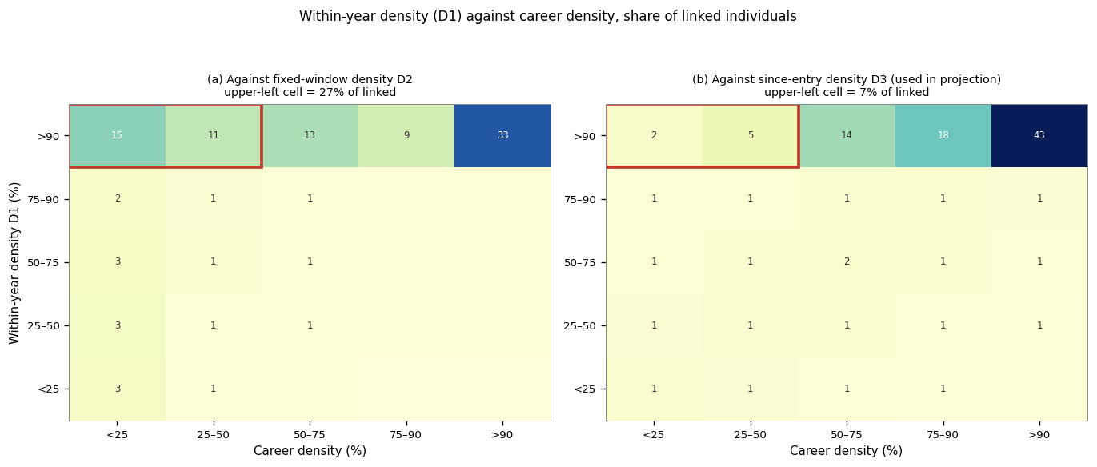
This finding is central to the exercise. It establishes that a segmentation based on the current year alone would misclassify a substantial, mostly migrant group as stable long-career contributors, and would thereby reproduce the over-statement of entitlements that the segmentation is meant to avoid. Any credible separation of a full-career population to be modeled conventionally from the groups handled separately must therefore use information about the career, not only the current year. The panel’s career-density measures, linked to the current base by personal identifier, are what make that possible.

6. The distribution of wages
Wages enter the projection in two ways: they determine contribution revenue, and, through the benefit formula, they shape the pensions that accrue. A faithful representation of the wage distribution is therefore as important as the count of contributors, and the heterogeneity documented above carries over directly into wages. This section describes the wage distribution comprehensively (by nationality and gender, across the density bands, and by employment type) before Section 8 sets out how it would be used in the model. Throughout, the wage is the average weekly wage annualized (multiplied by 52) and expressed in thousands of euro; this states each person's wage at a common annual rate while preserving the fact, established in Section 3, that reduced hours are already reflected in a lower weekly wage. For employees the weekly wage is the recorded average weekly wage; for the self-employed, who have no recorded weekly wage, it is derived from their class-2 contributions on the same convention used in the contribution-density panel, so that self-employed contributors also carry a wage rather than being dropped.
A point worth making here, now that the self-employed carry a derived wage, is that they are not a low-density fringe, if anything the opposite. About three-quarters of self-employed contributors sit at near-full within-year density (the band above ninety percent), only around six percent fall below half a year, and almost all of them (close to ninety-nine percent) have an established Maltese contribution history against which their career density can be measured, compared with about eighty-eight percent of employees; their median career density is close to seven-tenths. They are therefore densely engaged contributors, not a peripheral tail: their derived wages enter the contributor counts, revenue and accrual directly, which is why the class-2 derivation matters. Table 5 sets out the comparison.
Table 5. Within-year density: self-employed versus employees, and the share with an observed career.
Group | <25% | 25-50% | 50-75% | 75-90% | >90% | Career hist. avail.
Self-employed | 1.0 | 5.5 | 14.2 | 3.6 | 75.8 | 99%
Employees | 7.7 | 6.9 | 6.7 | 4.8 | 73.9 | 88%
Two features dominate the wage distribution. The first is a clear difference in level between Maltese and non-Maltese contributors. The second, and more important for modeling, is a difference in shape: the non-Maltese distribution is more skewed. Median non-Maltese earnings sit below the Maltese median, yet mean non-Maltese earnings are close to the Maltese mean, because a thin but high-earning tail (concentrated in finance, gaming and specialized professional services) pulls the average up while the bulk of non-Maltese earners are clustered at low wages. A single pooled wage distribution, or even a single distribution per gender, would misrepresent both groups: it would overstate the typical non-Maltese wage and understate the dispersion. Table 6 reports the full set of percentiles.
Figure 6. Distribution of annual wages, by nationality.
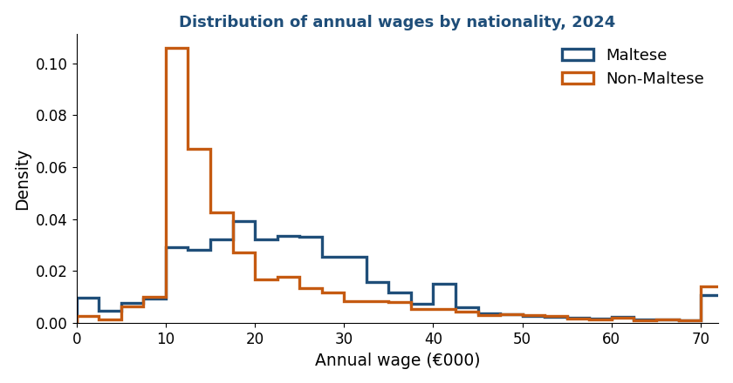
Table 6. Annual wage (€000) by nationality and gender: percentiles and mean.
Group | p10 | p25 | median | p75 | p90 | mean
Maltese Men | 11.4 | 17.2 | 23.8 | 33.6 | 47.1 | 28.3
Maltese Women | 10 | 14.6 | 22.2 | 30.1 | 38.7 | 23.8
Non-Maltese Men | 11.1 | 11.5 | 15.4 | 25.4 | 46.2 | 24.2
Non-Maltese Women | 11 | 11.7 | 15 | 25 | 37.9 | 21
Bringing wages together with density reveals the structure that the proposed matrix is built to exploit. Figure 7 plots median earnings against the within-year density band for each nationality, and the pattern is instructive. Earnings rise only modestly across the lower density bands and then jump in the highest band: the people who contribute almost the whole year are also, on the whole, the better-paid. For Maltese this gradient is steep, with full-year contributors earning roughly double the low-density groups; for non-Maltese the gradient is flatter, because even their full-year contributors are concentrated at modest wages. The low-density groups of both nationalities cluster at low annual earnings, unsurprisingly, since a partial year of contribution at a given weekly wage produces a low annualized figure, and many of these workers are in lower-paid sectors to begin with.
Figure 7. Median annual wage by within-year density band, by nationality.
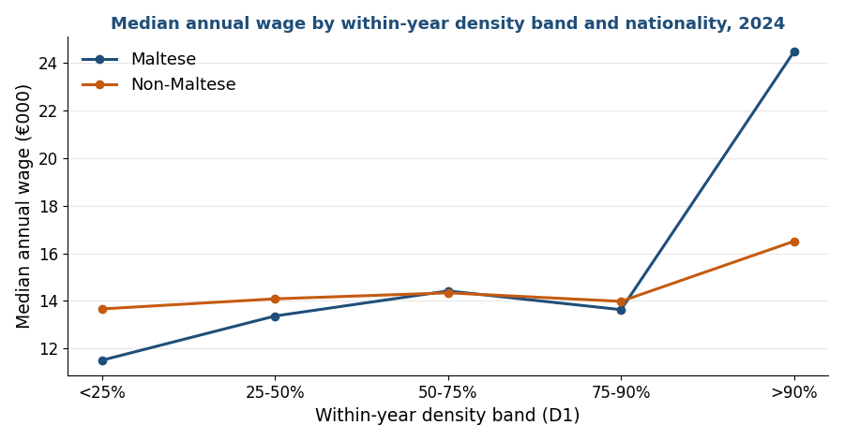
Table 7. Annual wage (€000) and number of contributors, by density band and nationality.
Density band | Nat. | median €000 | mean €000 | contributors
<25% | MT | 11.5 | 14.9 | 5,849
25-50% | MT | 13.4 | 17.1 | 6,091
50-75% | MT | 14.4 | 17.2 | 7,593
75-90% | MT | 13.6 | 17.2 | 5,269
>90% | MT | 24.5 | 27.8 | 146,080
<25% | non-MT | 13.7 | 21.6 | 15,390
25-50% | non-MT | 14.1 | 21.3 | 13,397
50-75% | non-MT | 14.3 | 21.2 | 12,367
75-90% | non-MT | 14 | 19.7 | 8,221
>90% | non-MT | 16.5 | 24.5 | 64,795
The dispersion of wages within each density band, shown in Figure 8, adds a further layer. The highest-density band is not only higher on average but also wider, spanning everything from minimum-wage full-year workers to high earners; the lower-density bands are both lower and more compressed. This matters for the benefit formula, which is progressive in the sense that the contributory pension is bounded below by a minimum and above by a maximum: the wide top band contains both workers whose pensions will be shaped by the maximum and workers whose pensions will be lifted by the minimum, while the compressed low-density bands contain workers who, if they vest at all, will mostly draw pensions close to the minimum.
Figure 8. Distribution of annual wages within each within-year density band.
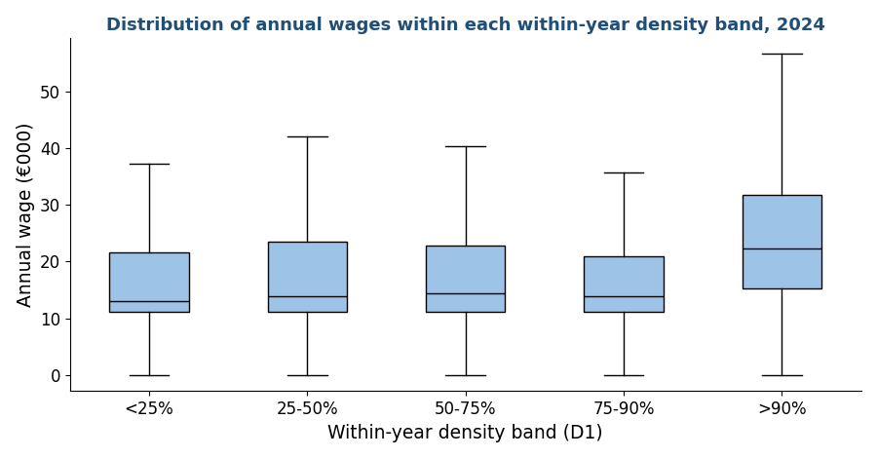
Finally, viewing wages by employment type confirms the institutional logic set out in Section 3. Part-time and reduced-hours contributors earn less per week, and hence per annualized year, than full-time contributors of the same nationality, direct evidence that the recorded wage already embodies the reduction in hours. This is the empirical basis for the treatment recommended in the modeling section: part-time status does not need to be modeled through a separate adjustment to length of service, because it is already present in the wage. The diagnostic cross-tabulation of wages by gender, nationality, employment type and density band, summarized in Figure 9, is provided in full in the accompanying file.
Figure 9. Median annual wage by employment type and nationality.
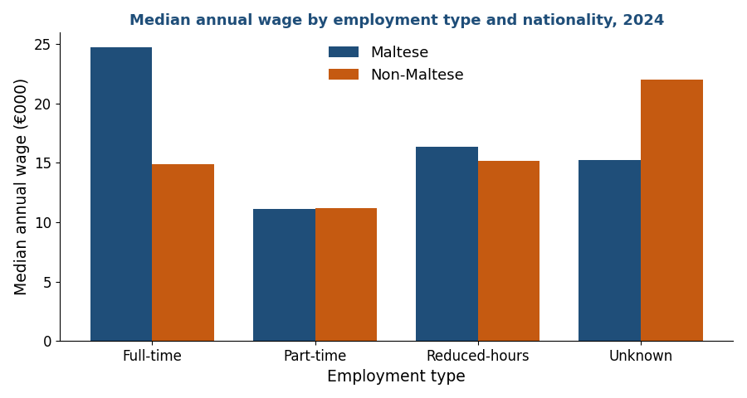
Two cautions attach to this wage analysis. The exact statutory weekly minimum wage for 2024 has not yet been incorporated; once confirmed, the wage bands can be expressed relative to the minimum, which is the natural reference for identifying below-minimum part-time earnings and for the wage brackets that PROST requires. And the wage measure reflects only contributions actually paid; imputed wages associated with credited periods (maternity, unemployment, education) are not present in the data, consistent with the institutional rule that credits are resolved only at claim.
The wage distributions that feed PROST are built separately for each entitlement group: the frequency distributions by income bracket and gender appear for Group 1 in Section 9.2 and for Group 2 in Section 10.3. This section gives the base-wide picture against which those group inputs are read.

7. The OAP beneficiary population
The six preceding sections describe the active contributory base: the people paying into the system in 2024 and the intensity with which they do so. What none of those measures can establish is how the careers now in progress will end, because the contribution histories of working-age people are by definition incomplete. The within-year and career densities of Section 5 record participation to date; they cannot record participation that has not yet happened. This section introduces the population that removes the need to infer it. The stock of people already drawing an old-age pension in 2024 consists of individuals whose contribution careers are finished, so that their length of service and their contribution density are observed in full rather than projected forward. These completed careers are the benchmark against which the projections of the active base are tested in Sections 9 to 11, and the source of the single adjustment the analysis ultimately makes; this section establishes the population and the way its careers are measured, in parallel to the treatment of the active base in Sections 2 to 6.
Not every old-age pensioner is comparable to the active base, and the first task is to isolate those who are. The 72,142 old-age pensioners in the file fall into two institutionally distinct systems, distinguished by the benefit-type code. The large majority (58,116, or about four in five) draw the Two-Thirds Pension (benefit type TTP), the earnings-related contributory pension introduced in 1979 under which a worker accrues up to two-thirds of pensionable income, and the scheme under which the entire active base is today accumulating rights. The remaining 14,026 receive one of the pre-1979 legacy benefits, the National Minimum Pension (NMP, 11,137 recipients) and its increased and decreased variants (INMP, 2,804; DNMP, 85), a flat-rate minimum system that predates the earnings-related rules and is gradually disappearing as its recipients age. Since the active base contributes wholly under the post-1979 earnings-related rules, only the Two-Thirds pensioners form a like-for-like benchmark, and the analysis is confined to them; Table 8 sets out the universe and the realized careers of each category.
Table 8. The old-age pensioner universe by benefit type and gender.
Benefit type | Gender | Recipients | Career (yrs) | Density | Pension (€/wk)
Two-Thirds (TTP) | Women | 15,825 | 26 | 0.66 | 184
 | Men | 42,291 | 40 | 0.92 | 235
National Minimum (NMP) | Women | 6,784 | 14 | 0.30 | 148
 | Men | 4,353 | 12 | 0.28 | 148
Increased Minimum (INMP) | Women | 548 | 24 | 0.58 | 177
 | Men | 2,256 | 41 | 0.92 | 223
Decreased Minimum (DNMP) | Women | 27 | 6 | 0.13 | 48
 | Men | 58 | 18 | 0.43 | 152

The realized careers explain the legacy categories. National Minimum recipients reach the minimum on short careers (a median of twelve to fourteen years at low density) and are mostly women. Increased Minimum recipients are mostly men with long, dense careers, about forty years at near-full density, whose pensionable income was too low to lift the earnings-related pension above the minimum. The Decreased Minimum is a small residual. None is earnings-related, which is why the benchmark is confined to the Two-Thirds pensioners.
Within the 58,116 Two-Thirds records a sequence of cleaning steps removes those whose careers cannot be measured reliably: records with an invalid or missing entry, birth or last-contribution date (leaving 57,900); records reporting no paid contributions at all (leaving 55,697); the handful with a non-positive span between entry and last contribution (leaving 55,692); and the 2,024 recipients born before 1940, whose Two-Thirds record captures only the later part of a career that began before the 1979 scheme and reports an artefactually low density (a median of about 0.22). The benchmark is 53,668 completed Two-Thirds careers. For each, the realized length of service is paid contributions divided by fifty-two and the realized density is that length divided by the working-life span (entry to last contribution); credited weeks, resolved at claim, are reported separately. Figures are stated on paid service for strict comparability with the active base; the realized retirement age, observed directly, has a median of sixty-one for men and sixty-two for women, below the statutory sixty-five to which the active base is projected.
Measured on this benchmark, completed careers differ systematically by gender, in a pattern that frames the central finding of the note.
Table 9. Realized careers of the Two-Thirds benchmark, by gender.
 | Men | Women
Completed careers (n) | 38,818 | 14,850
Share of benchmark | 72% | 28%
Median age at entry | 17 | 18
Median age at retirement | 61 | 62
Median working-life span (years) | 44 | 44
Median length of service, paid (years) | 39.8 | 26.0
Credited periods added (years, mean) | 1.5 | 0.6
Aggregate contribution density (paid) | 0.85 | 0.60
Median contribution density (paid) | 0.92 | 0.66
Share retiring below 0.5 density | 7% | 35%

The table isolates where the gender gap does and does not come from. It does not come from when careers begin or how long they run: men and women alike enter the system young, at a median of seventeen and eighteen, and both accumulate over a working-life span of about forty-four years. It comes entirely from how much of that span is actually contributed, the median man pays in 0.92 of his working life and retires with close to forty years of service, the median woman pays in 0.66 of hers and retires with twenty-six. Barely seven percent of men reach retirement below half density, against thirty-five percent of women. Credited periods, resolved at claim, add about a year and a half to the average man's service and only half a year to the average woman's, so they widen rather than narrow the gap.
The same divergence is visible in the full distribution and across the age of retirement. Figure 10 shows the density of completed careers by gender, separately for the stock of all Two-Thirds pensioners and the flow of new pensioners of 2023 and 2024: men concentrate against full density while women span the whole range, a pattern that holds in both stock and flow. Figure 11 traces how the median falls as the age at retirement rises, with the gender gap widest at the 2024 State Pension Age of sixty-four, where the bulk of new pensioners enter.
Figure 10. Contribution density at retirement, by gender: stock and flow (Two-Thirds).
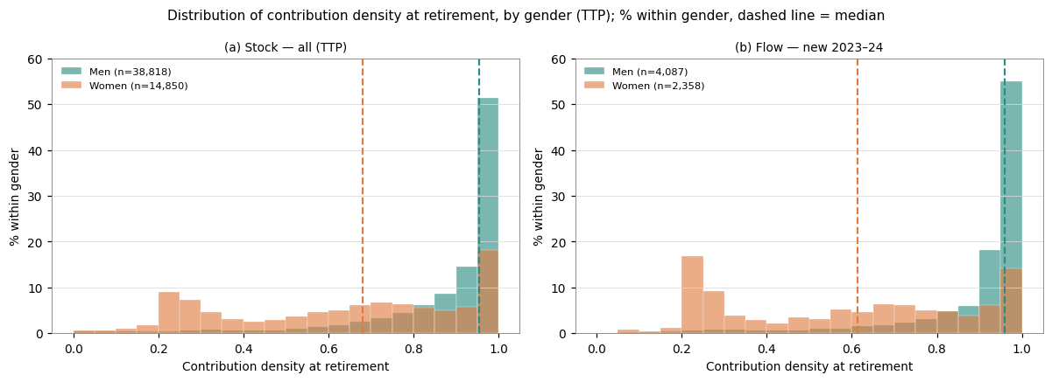
Figure 11. Median density at retirement by age at retirement, by gender (Two-Thirds).
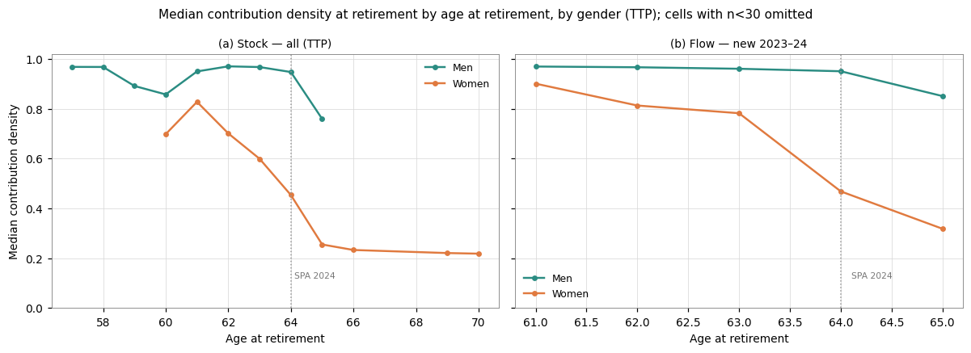

8. The segmentation strategy
The analysis above motivates a segmentation of the contributory base by the pension each contributor is projected to draw. Two statutory thresholds divide the base into a full-career population, a pro-rata population and a non-vested population; the pro-rata population is then split into a higher and a lower band, giving four groups in all. Group 1, the full-career population, accumulates enough to reach the cohort requirement and earn the maximum two-thirds pension, and can be projected with conventional length-of-service assumptions. Groups 2 and 3, the pro-rata population, vest for a partial pension on a shorter career and are treated separately, the higher band (Group 2) and the lower band (Group 3) reported apart because they differ in length of career and composition. Group 4, the non-vested population, does not reach the ten-year minimum and earns no contributory pension. How the lines between the groups are drawn was the central methodological choice of the exercise, and the criterion was refined over the course of the analysis from a fixed density cut to a forward-looking projection assessed against the statutory thresholds. This section sets out that criterion; Sections 9 to 12 characterize the four groups.
The natural first step is descriptive. Before any cut is taken, contributors are cross-classified on a grid of wage against within-year density so that the joint distribution can be seen directly. The same device underlies the modeling approach discussed with the World Bank pension team: all contributors are first placed on this wage-by-density grid, and only then is a decision taken on which cells enter the projection model as full contributors and which are handled by separate calculations.
Figure 12. The wage × density matrix (share of the contributory base in each cell).
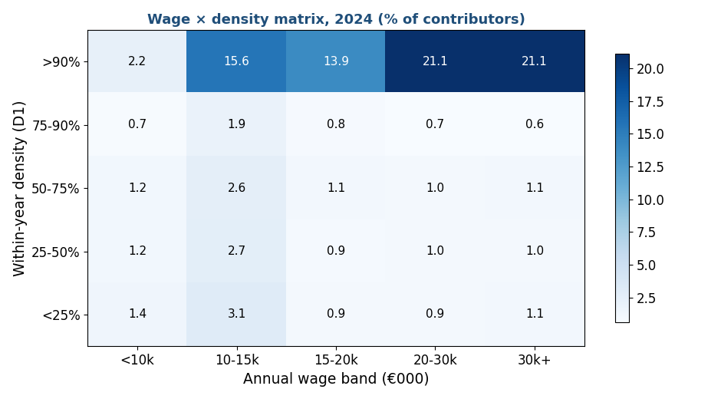
A first, descriptive cut of this grid at fixed thresholds (within-year density at least 0.90 together with a career density of at least 0.50) identifies a group of about 138,800 contributors. As a picture of who is densely engaged today this is informative; but as the operational test of who will actually draw the two-thirds it is insufficient, for two reasons. The thresholds are arbitrary: there is no particular reason a sustained density of 0.90 rather than 0.85 or 0.95 should mark eligibility. And, more fundamentally, a within-year density cut is a snapshot that ignores both how many weeks a contributor has already accumulated and how many years of contribution remain before retirement, which are what determine whether the two-thirds requirement will be met.
The requirement itself supplies a principled threshold. The full two-thirds pension is paid only to contributors who reach a minimum number of paid or credited contribution weeks, and that minimum is fixed by statute and was raised progressively by birth cohort under Malta's pension reform: 1,820 weeks (35 years) for those born up to 1961, 2,080 (40 years) for 1962 to 1968, 2,132 (41 years) for 1969 to 1975, and 2,184 (42 years) for 1976 and later. The label two-thirds is the benefit rate (two-thirds of pensionable income, which the accrual formula pays at its maximum) while the cohort figures are the contribution requirement, in weeks, that must be met to draw that maximum. To accumulate the requirement over a working life a contributor must sustain a density equal to the required years divided by the years available between entry and retirement, so the minimum sustained density is not a single number but rises with the age of entry and with the cohort requirement, as Table 10 shows.
Table 10. Minimum sustained density to reach the full two-thirds pension, by entry age and cohort.
Age of entry | Born ≤1961 (35y) | 1962-68 (40y) | 1969-75 (41y) | 1976+ (42y)
16 years | 0.71 | 0.82 | 0.84 | 0.86
18 years | 0.74 | 0.85 | 0.87 | 0.89
20 years | 0.78 | 0.89 | 0.91 | 0.93
22 years | 0.81 | 0.93 | 0.95 | 0.98
25 years | 0.88 | 1.00 | impossible | impossible
28 years | 0.95 | impossible | impossible | impossible
30 years | 1.00 | impossible | impossible | impossible
Two implications follow, and both bear directly on the Maltese base. First, because the threshold depends on entry age and cohort, no flat density cut is correct: an early entrant reaches the requirement at a sustained density of roughly 0.71 to 0.89, whereas a contributor entering in their late twenties needs close to full density, and one entering at thirty or beyond cannot reach the full pension at all. Second, late entry is itself disqualifying regardless of effort, a contributor who joins the system in mid-career has too few remaining years to accumulate the requirement even at perfect density, which is the situation of most non-Maltese contributors, who typically enter the Maltese system well after the start of their careers.
These considerations point to a forward-looking criterion applied at the level of the individual record. For each contributor the weeks already accumulated are added to the weeks expected from the contribution density applied over the years remaining to retirement; the projected total is then compared against the statutory thresholds defined in the Social Security Act:
projected weeks = accumulated paid weeks + density × 52 × (retirement age − current age) ≥ cohort requirement.
This criterion embeds both dimensions a flat cut omits. The cohort enters through the requirement; the age of entry enters through the accumulated weeks, since a late entrant has banked few weeks and cannot reach the requirement even with high forward density. It needs no separate record of the entry date (populated for only about two-fifths of the file) because the accumulated stock already encodes it.
Two statutory thresholds, both set by the Social Security Act, divide the base. The cohort requirement, 1,820 weeks (35 years) for those born in 1952-61, rising to 2,080, 2,132 and 2,184 weeks (40, 41, 42 years) for successively younger cohorts, is the paid-or-credited service needed for the maximum, full two-thirds pension. The ten-year minimum (520 weeks) is the service needed to qualify for any contributory pension at all, paid pro-rata between the two thresholds. A contributor whose projected weeks reach the cohort requirement belongs to Group 1, the full-career population; one who reaches the ten-year minimum but not the cohort requirement belongs to the pro-rata population, split at twenty years of projected service into a higher band (Group 2) and a lower band (Group 3); one who does not reach the ten-year minimum belongs to Group 4, the non-vested population, which earns no contributory pension. Neither line is a judgment, both are in the Act. The density used as the forward rate is itself a modeling choice and is carried as a scenario, because it is the most consequential assumption for migrants. Under the since-entry density (D3, the base case) the groups split the active base of 285,138 contributors as in Table 11a.
Table 11a. The entitlement groups under D3 (base case), by nationality.
 | Maltese | Non-Maltese | Total
Full-career | 79,445 | 1,443 | 80,888
Pro-rata (all bands) | 85,548 | 90,423 | 175,971
Non-vested (<10 years) | 5,974 | 22,305 | 28,279
Total | 170,967 | 114,171 | 285,138
Table 11b. The full-career group (Group 1) under the three density scenarios, by nationality.
Density (forward rate) | Maltese | Non-Maltese | Total
D1 within-year | 110,685 | 5,731 | 116,416
D2 fixed-window | 74,274 | 533 | 74,807
D3 since-entry (base case) | 79,445 | 1,443 | 80,888
Table 11c. The pro-rata group (Groups 2 and 3 combined) under the three density scenarios, by nationality.
Density (forward rate) | Maltese | Non-Maltese | Total
D1 within-year | 56,700 | 90,187 | 146,887
D2 fixed-window | 83,283 | 56,271 | 139,554
D3 since-entry (base case) | 85,548 | 90,423 | 175,971
The full-career group ranges from about 74,800 under the fixed-window measure to about 116,400 under the within-year measure, with the since-entry measure (the most defensible as a forward rate, because it captures intensity once a contributor is present without carrying the pre-arrival zeros) giving about 80,900 (Table 11b). The pro-rata group moves in the opposite direction (Table 11c), reaching its largest size of about 176,000 under that same since-entry measure, since it is the horizon on which the most contributors clear the ten-year minimum without yet reaching the full requirement. For Maltese contributors the three measures agree closely; for non-Maltese the full-career group is small under every measure, which is the structural-horizon effect rather than a question of density. The since-entry measure is taken as the base case.
One qualification carries across all four groups. The projection counts only paid weeks, whereas the Act counts paid or credited contributions; credited periods (for child-rearing, unemployment, education and the like) are added only when a pension is claimed, so the file understates final entitlement and, with it, the size of Group 1, most of all for women. The new-pensioner records, where credits are observed on completed careers, would quantify the shift but are not used here.
A second consideration concerns what can be assumed rather than who qualifies. The pro-rata population contains a large migrant component whose future presence in Malta is uncertain: a recent arrival projected to vest may instead leave, or may stay and accumulate more than the current record implies. The pro-rata population is therefore the part whose forward assumptions are least settled, and the one for which a separate treatment (rather than PROST’s full-career logic) is intended; the non-vested group generates contribution revenue but, by definition, no contributory pension.
For the current round the working preference is to retain PROST as the projection tool and to apply the segmentation on top of it, given the reporting deadline, while examining in more detail the population below the minimum wage. The wage-by-density matrix and the separate model for the groups outside the full-career core are the agreed direction for the next stage of work, to be built jointly on the latest administrative data. Two recording conventions confirmed with the counterpart bound the analysis throughout: one week of credit corresponds to one paid contribution in that week regardless of hours worked, so part-time status lowers the recorded wage and never the length of service; and credited periods are added only when a pension is claimed.
Two refinements complete the segmentation before the groups are examined in turn. The first concerns the pro-rata group, which is internally heterogeneous in a way that matters for the pension drawn. A contributor projected to accumulate, say, thirty years of service vests for a substantial fraction of the two-thirds pension, whereas one projected to reach only twelve years vests for little more than the floor; treating them as a single group would average over outcomes that differ by a factor of two or more. The pro-rata group is therefore split at twenty years of projected service into a higher band (twenty years up to the cohort requirement) and a lower band (the ten-year minimum up to twenty years) reported as separate sections from this point onward (higher band in Section 10, lower band in Section 11).
The second refinement is to apply the same segmentation to both populations at once. The criterion above classifies the active base by projected service; applied to the completed careers of the Two-Thirds pensioners introduced in Section 7, the identical thresholds classify realized service. Placing the two side by side gives a single panorama of where the projection and the realized record agree and where they diverge, and it is the map for the four group sections that follow.
Group 1 (Section 9) takes the agreement at the top; the two pro-rata bands (Sections 10 and 11) take the female divergence, which is where the projection is adjusted; the non-vested group (Section 12) takes the floor.
Table 12. Projected against realized, by group and gender.
Gender | Group | Share proj. | Share real. | LOS proj. | LOS real. | CD proj. | CD real.
Women | full | 25% | 23% | 45.4 | 39.8 | 0.99 | 0.93
 | pro-rata high | 52% | 37% | 32.0 | 29.0 | 0.82 | 0.68
 | pro-rata low | 14% | 31% | 15.6 | 12.6 | 0.49 | 0.32
 | non-vested | 9% | 9% | 6.0 | 6.3 | 0.20 | 0.19
Men | full | 31% | 67% | 46.2 | 41.9 | 0.98 | 0.94
 | pro-rata high | 45% | 21% | 31.7 | 30.8 | 0.84 | 0.71
 | pro-rata low | 14% | 6% | 15.3 | 14.1 | 0.58 | 0.39
 | non-vested | 11% | 6% | 5.4 | 4.3 | 0.26 | 0.14

Figure 13. Projected against realized, by group and gender: share, length of service, and density.
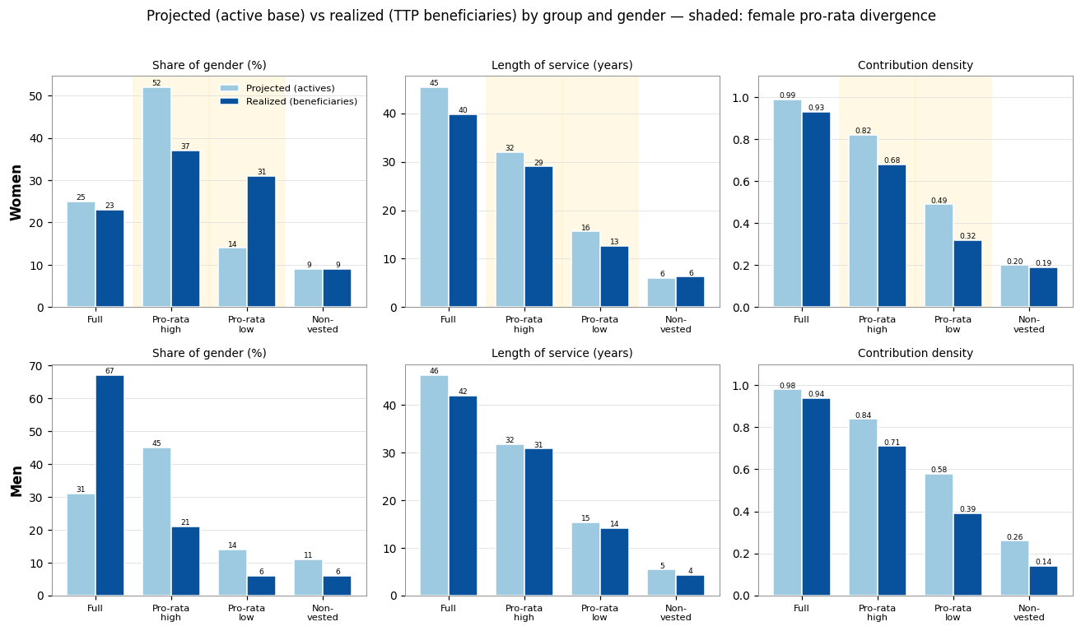

9. Group 1: the full-career (two-thirds) population modeled in PROST
This section characterizes Group 1, the contributors projected to reach the full cohort requirement under the criterion of Section 8, taking the since-entry density (D3) as the forward rate, which is the base case. On that basis Group 1 comprises about 80,900 contributors, who are projected to earn the maximum two-thirds pension. The section sets out the group's size, composition, density and wages, and the PROST inputs it determines; the pro-rata population is characterized in its higher band in Section 10 and its lower band in Section 11, and the non-vested population in Section 12. Under the two alternative density scenarios Group 1 would range from about 74,800 on the fixed-window measure to about 116,400 on the within-year measure (Table 11b).
A contributor enters Group 1 when the weeks already accumulated, plus the weeks expected from their contribution density over the years remaining to retirement, reach the cohort requirement. Because that test rewards both a long record to date and continued dense contribution, Group 1 is older and more settled than the base as a whole, and almost entirely Maltese: recent migrants, who enter the Maltese system late in their careers, almost all fall short of the full requirement on horizon grounds and are placed in a pro-rata band or, on the shortest careers, the non-vested group. Each person enters as a single contributor carrying their actual wage, not as a fraction of a full-time equivalent.

9.1 Size and composition
Counting each person once, Group 1 comprises about 80,900 contributors, roughly 50,600 men and 30,300 women. Table 13 sets it against the other two groups, and Table 14a breaks it down by nationality and gender. Group 1 is almost entirely Maltese: about 79,400 of its members, some 98 percent, are Maltese, against only about 1,400 non-Maltese, a direct consequence of the horizon effect, since recent migrants enter the system too late to accumulate the full requirement.
Table 13. Number of contributors by group and gender.
Group | Men | Women | Total
Full-career (two-thirds) | 50,627 | 30,261 | 80,888
Pro-rata (all bands) | 95,647 | 80,324 | 175,971
Non-vested (<10 yrs) | 17,499 | 10,780 | 28,279
Total | 163,773 | 121,365 | 285,138
Table 14a. Group 1 by nationality and gender.
Nationality | Men | Women | Total
Maltese | 49,761 | 29,684 | 79,445
Non-Maltese | 866 | 577 | 1,443
Total | 50,627 | 30,261 | 80,888
By employment type Group 1 is, as expected, predominantly full-time (about ninety-two percent) with small part-time and reduced-hours shares and a small group present in the contributions data but absent from all four employment snapshots (Table 14b). It remains a densely-contributing group, though now as a consequence of the criterion rather than mechanically: about ninety-six percent contribute upward of ninety percent of the current year, and the median since-entry career density is close to one, confirming that these are long-career contributors rather than people who merely worked one full year.
Table 14b. Group 1 by employment type.
Employment type | Number | Share
Full-time | 74,686 | 92.3%
Part-time | 3,107 | 3.8%
Reduced-hours (FT) | 1,777 | 2.2%
Unknown (no snapshot) | 1,318 | 1.6%
The age structure is that of a settled full-career workforce, concentrated in the prime and older working ages and peaking in the late forties. Table 15 gives the age-by-gender breakdown with the pro-rata group alongside, and Figure 14 shows the entitlement groups together as a population pyramid; the contrast with the younger pro-rata and non-vested groups is the clearest picture of why they call for different treatments.
Table 15. Contributors by age band and gender: Group 1 and the pro-rata population.
Age band | Group 1 M | Group 1 F | Pro-rata M | Pro-rata F | Group 1 total
18-24 | 1,956 | 1,464 | 11,582 | 10,673 | 3,420
25-29 | 2,953 | 2,158 | 19,257 | 14,516 | 5,111
30-34 | 5,774 | 4,700 | 19,470 | 13,966 | 10,474
35-39 | 7,246 | 5,423 | 15,804 | 11,975 | 12,669
40-44 | 7,489 | 5,022 | 11,764 | 9,588 | 12,511
45-49 | 7,978 | 4,834 | 8,125 | 7,445 | 12,812
50-54 | 7,514 | 3,722 | 5,093 | 5,694 | 11,236
55-59 | 6,901 | 2,324 | 3,139 | 4,389 | 9,225
60-65 | 2,816 | 614 | 1,413 | 2,078 | 3,430
Total | 50,627 | 30,261 | 95,647 | 80,324 | 80,888
Figure 14. Contributors by age, gender and entitlement group.
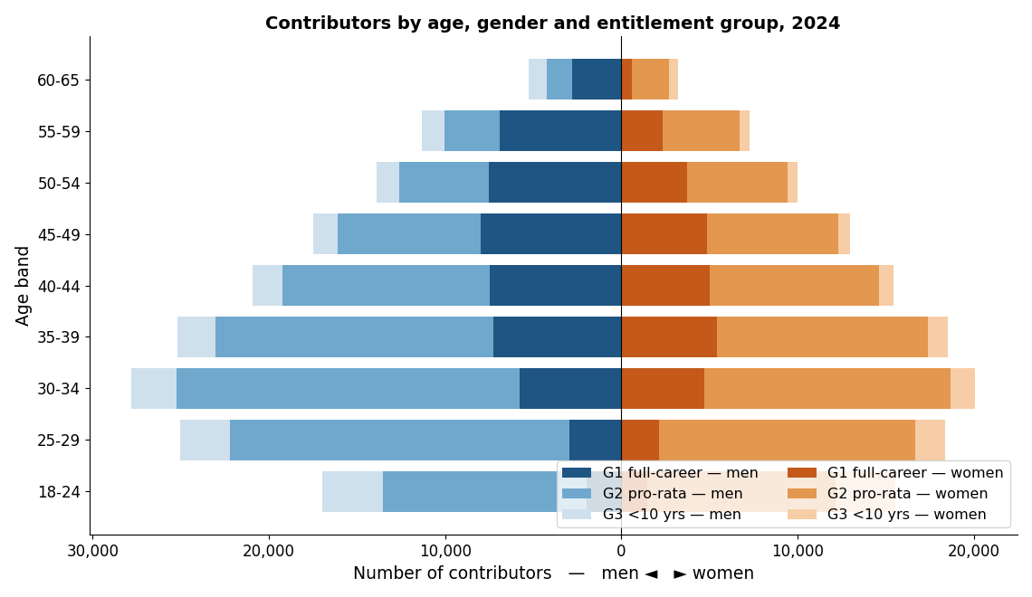

9.2 Wages
Table 16 and Figure 15 give the mean annual wage by age and gender for Group 1, the form in which it enters PROST's General tab: the profile rises through the early career, peaks in the late thirties to early forties, and eases gently thereafter, with a persistent male-female gap. Table 17a summarizes the distribution by gender, median earnings of about twenty-five to twenty-six thousand euro for both men and women, with a gap that widens in the upper tail.
Table 16. Mean annual wage (€000) by age band and gender, Group 1.
Age band | Group 1 men, €000 | Group 1 women, €000
18-24 | 17.2 | 15.9
25-29 | 24.3 | 24.4
30-34 | 31.1 | 28.4
35-39 | 34.3 | 30.1
40-44 | 33.8 | 29.5
45-49 | 33.6 | 30.2
50-54 | 32.1 | 31.1
55-59 | 30.2 | 29.2
60-65 | 30.6 | 30.5
Figure 15. Mean annual wage by age and gender, Group 1.
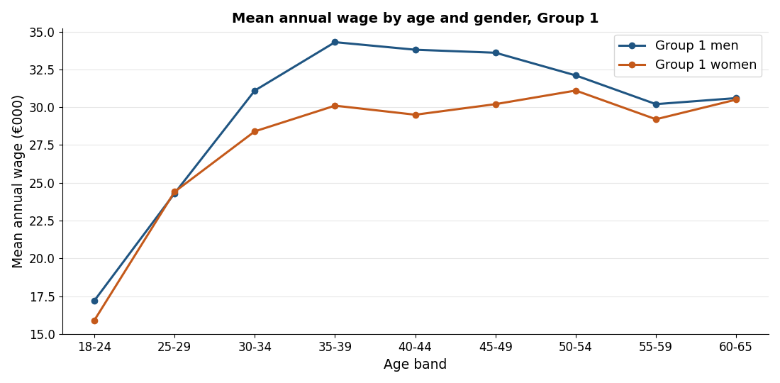
Table 17a. Annual wage (€000) of Group 1 by gender: percentiles and mean.
Gender | n | p10 | p25 | Median | p75 | p90 | Mean
Men | 48,178 | 15.4 | 19.8 | 25.4 | 35.1 | 53.8 | 31.4
Women | 29,906 | 14.5 | 19.5 | 26.5 | 33.2 | 43.2 | 28.7
PROST also requires the wage distribution as a set of brackets with the share of male and female contributors in each. Following the treatment recommended in this note, that distribution is built on the group's full-time members only: because a contributory week is credited regardless of hours, part-time status shows up as a lower weekly wage, and since hours are not recorded a part-timer's wage cannot be scaled to a full-time figure; building the distribution on full-time members avoids contaminating it with part-time wages that cannot be read as full-time earnings, while the group's part-timers still enter the contributor counts and revenue at their actual wage. The brackets follow the PROST convention: the bottom bracket is set from the natural distribution so that it holds about five percent of each gender (here about 5.0 percent of men and 4.6 percent of women), and the upper brackets follow the male wage ventiles in roughly five-per-cent steps, with an open top bracket; the statutory minimum wage is not required. Table 18 gives the twenty brackets with absolute and within-gender relative frequencies, and Figure 16 shows them as back-to-back bars.
Table 18. Wage distribution by bracket and gender, Group 1 (full-time members).
Annual wage bracket (€) | Men: n | Men: cum. % | Women: n | Women: cum. %
≤ 13,044 | 2,305 | 5.0 | 1,201 | 4.6
13,044-15,726 | 2,302 | 10.0 | 1,332 | 9.6
15,726-17,501 | 2,303 | 15.0 | 1,338 | 14.7
17,501-18,704 | 2,303 | 20.0 | 1,097 | 18.9
18,704-19,999 | 2,303 | 25.0 | 978 | 22.6
19,999-21,120 | 2,304 | 30.0 | 927 | 26.2
21,120-22,202 | 2,302 | 35.0 | 946 | 29.8
22,202-23,358 | 2,489 | 40.4 | 1,227 | 34.4
23,358-24,629 | 2,117 | 45.0 | 1,169 | 38.9
24,629-26,838 | 4,606 | 55.0 | 2,749 | 49.4
26,838-28,325 | 2,303 | 60.0 | 1,561 | 55.3
28,325-30,577 | 2,320 | 65.0 | 1,831 | 62.3
30,577-32,415 | 2,297 | 70.0 | 2,517 | 71.8
32,415-35,417 | 2,311 | 75.0 | 1,975 | 79.4
35,417-39,580 | 2,284 | 80.0 | 1,571 | 85.3
39,580-44,548 | 2,306 | 85.0 | 1,378 | 90.6
44,548-54,117 | 2,300 | 90.0 | 1,030 | 94.5
54,117-71,362 | 2,303 | 95.0 | 852 | 97.8
> 71,362 | 2,304 | 100.0 | 590 | 100.0
Total | 46,062 | 100.0 | 26,269 | 100.0
Figure 16. Group 1’s wage distribution, by gender.
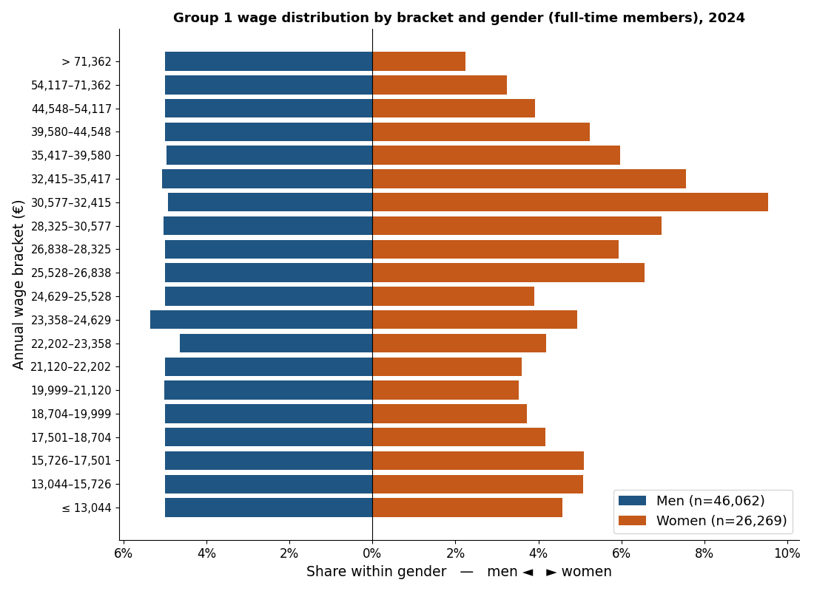

9.3 PROST inputs that change
Five PROST inputs change for this group relative to a whole-base parameterization. The two demographic inputs, the number of contributors and the average wage, each by age and gender (Tables 14 and 15), are re-derived from Group 1. The wage-distribution brackets are those of Table 18. The length of service at retirement is set to the long career the group achieves. And the share of length of service not claimed is set to zero, because here everyone is, by the criterion, projected to vest in full. Table 19 summarizes these and the tab affected in each case.
Table 19. PROST inputs that change for Group 1, and the tab affected.
PROST input | Tab | What changes
Contributors by age & gender | General | Replaced with the Group 1 counts (headcount, each person one record). See Table 15 / Figure 14.
Average wage by age & gender | General | Replaced with the Group 1 average wage by age and gender. See Table 16 / Figure 15.
Wage distribution (brackets) | General | The Group 1 full-time members (Table 18); full-timers used to avoid the unobserved-hours problem for part-timers.
Length of service at retirement | Pension | Set to the long career the group reaches, about forty years, and close for both genders, since Group 1 is selected on reaching the cohort requirement.
Share of LOS not claimed | General | Set to zero in the Group 1 input file (everyone vests); used only in the separate model for Group 2.
The share of length of service not claimed deserves a word, because its correct use depends on the segmentation. Within PROST this parameter reduces accrued service to reconcile the number of contributors, the assumed number of future pensioners and the length of service at retirement; it is meaningful only for a population containing people who will not ultimately vest. It is therefore set to zero for Group 1 and used only for the pro-rata and non-vested groups. Applying it to a single combined file would reduce accrued service indiscriminately across all cohorts, including genuine full-career workers, the distortion the segmentation removes.

9.4 Realized careers: the OAP benchmark
The completed careers of the Two-Thirds pensioners confirm this group with little qualification. Among pensioners who reached the cohort requirement, realized density is about 0.93 for women and 0.94 for men, against the 0.98 to 0.99 the projection assigns. The small shortfall is not a density error but a horizon effect: the projection accumulates service to the statutory age of sixty-five, whereas these careers were completed at a median of about sixty-one to sixty-two, so a few years of near-full density are added by the projection that the realized record, ending earlier, does not contain. The projected and realized shares of the full-career group also agree closely for women, at about 25 against 23 percent. For men the realized share is higher than the projected, the requirement effect working in the opposite direction, taken up in Section 12. No adjustment to this group is required.
Figure 17 places the beneficiaries in a matrix of awarded pension against realized density, for the stock and the flow. The mass concentrates in a high-density corner, at a density of about 0.95 or above, which holds roughly forty percent of new pensioners and is close to nine in ten male, at a median pension of about 288 euro per week. This corner is the observed full-career, two-thirds population, the empirical counterpart of the group modeled here as full-time, in place of a full-time-equivalent construction.
Figure 17. Awarded pension against density at retirement: stock and flow (Two-Thirds).
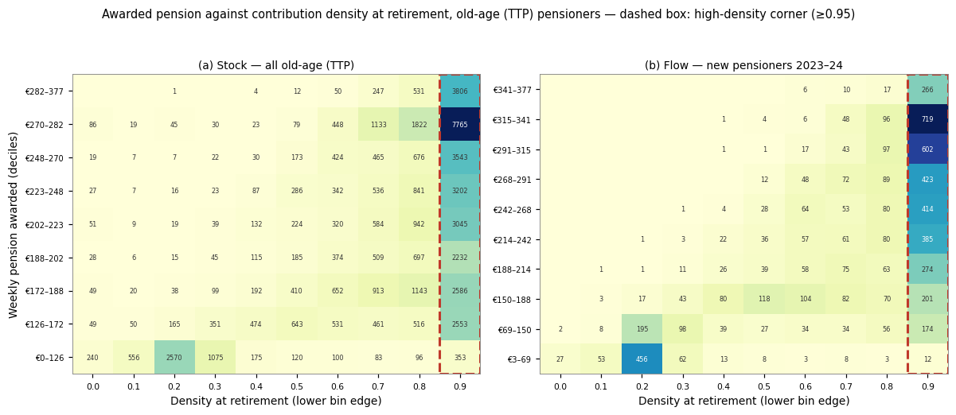

10. Group 2: the pro-rata population, higher band
Group 2 comprises the contributors projected to vest in a partial, pro-rata pension: they reach the ten-year minimum but fall short of the full cohort requirement, so their pension is paid pro-rata of the two-thirds amount according to the length of service achieved. Because the pro-rata population is internally heterogeneous in a way that matters for the pension drawn, it is reported in two bands split at twenty years of projected service, as set out in Section 8: this section covers the higher band (twenty years up to the cohort requirement), and Section 11 covers the lower band (the ten-year minimum up to twenty years). The higher band is the larger of the two, about 136,200 contributors, close to evenly split between Maltese and non-Maltese and predominantly full-time; its members retire on long but incomplete careers, just short of the full requirement. This section characterizes the higher band in the same terms as Section 9.

10.1 Size and composition
The higher pro-rata band comprises about 136,200 contributors, roughly 72,900 men and 63,300 women. Its nationality composition is close to balanced: about 46 percent are non-Maltese, against a heavier migrant presence in the lower band (Table 20). Its members are predominantly full-time, about 79 percent, with a median projected service of about thirty-two years, consistent with long-attached careers that nonetheless fall just short of the cohort requirement. The age profile (Table 21) is older than the lower band, concentrated in the thirties and forties; the pyramid in Figure 14 shows the groups together.
Table 20. Group 2 (pro-rata, higher band) by nationality and gender.
Nationality | Men | Women | Total
Maltese | 34,190 | 39,540 | 73,730
Non-Maltese | 38,700 | 23,709 | 62,409
Total | 72,890 | 63,249 | 136,139
Table 21. Group 2 (pro-rata, higher band) by age band and gender.
Age band | Men | Women | Total
18-24 | 7,821 | 6,848 | 14,669
25-29 | 15,345 | 11,912 | 27,257
30-34 | 16,153 | 12,205 | 28,358
35-39 | 12,735 | 10,162 | 22,897
40-44 | 9,167 | 7,985 | 17,152
45-49 | 5,707 | 5,812 | 11,519
50-54 | 3,050 | 4,082 | 7,132
55-59 | 1,919 | 2,957 | 4,876
60-65 | 993 | 1,286 | 2,279
Total | 72,890 | 63,249 | 136,139
By employment type the higher band is close to the full-career group: about seventy-nine percent full-time, with a modest part-time share and a small group present in the contributions data but absent from all four employment snapshots (Table 22).
Table 22. Group 2 (pro-rata, higher band) by employment type.
Employment type | Number | Share
Full-time | 105,927 | 77.8%
Part-time | 10,514 | 7.7%
Reduced-hours (FT) | 2,630 | 1.9%
Unknown (no snapshot) | 15,743 | 11.6%

10.2 Contribution density profile
What places the higher band short of the full pension is its career length, not its current-year engagement. On the within-year measure (D1) most members contribute upward of ninety percent of the current year, and on the operational since-entry measure (D3) the band is dense, with a projected density of about 0.82 and a median projected service of about thirty-two years, long but short of the full requirement. These are densely-contributing careers that, projected forward, clear the ten-year minimum and accumulate well beyond it without reaching the full cohort requirement; what holds them below the full pension is the years of service they fall short of, not a low contribution intensity.

10.3 Wages
The wages of the higher band sit between the full-career group and the lower band. Table 23 gives the distribution by gender (median annual earnings of about 359 euro per week for men and 369 for women) and Table 24 with Figure 18 give the full bracket distribution. The distribution is built on all members with positive earnings, on the same bracket convention.
Table 23. Annual wage (€000) of Group 2 (pro-rata, higher band) by gender: percentiles and mean.
Gender | n | p10 | p25 | Median | p75 | p90 | Mean
Men | 67,839 | 11.1 | 13.2 | 18.7 | 29.8 | 45.7 | 25.6
Women | 60,970 | 11.1 | 13.7 | 19.2 | 28.3 | 37.3 | 22.9
Table 24. Wage distribution by bracket and gender, Group 2 (pro-rata, higher band).
Annual wage bracket (€) | Men: n | Men: cum. % | Women: n | Women: cum. %
≤ 8,850 | 1,685 | 2.5 | 3,049 | 5.0
8,850-11,081 | 1,707 | 5.0 | 2,230 | 8.7
11,081-12,301 | 10,176 | 20.0 | 6,499 | 19.3
12,301-14,250 | 6,784 | 30.0 | 5,278 | 28.0
14,250-16,213 | 6,784 | 40.0 | 7,103 | 39.6
16,213-17,386 | 3,393 | 45.0 | 2,619 | 43.9
17,386-18,665 | 3,391 | 50.0 | 2,626 | 48.2
18,665-20,114 | 3,413 | 55.0 | 2,445 | 52.2
20,114-22,018 | 3,370 | 60.0 | 2,851 | 56.9
22,018-24,313 | 3,392 | 65.0 | 3,893 | 63.3
24,313-26,908 | 3,392 | 70.0 | 4,561 | 70.8
26,908-29,769 | 3,395 | 75.0 | 4,660 | 78.4
29,769-33,202 | 3,400 | 80.0 | 4,232 | 85.4
33,202-37,923 | 3,381 | 85.0 | 3,088 | 90.4
37,923-45,666 | 3,403 | 90.0 | 2,644 | 94.8
45,666-61,485 | 3,381 | 95.0 | 1,900 | 97.9
> 61,485 | 3,392 | 100.0 | 1,292 | 100.0
Total | 67,839 | 100.0 | 60,970 | 100.0
Figure 18. Group 2’s (pro-rata, higher band) wage distribution, by gender.
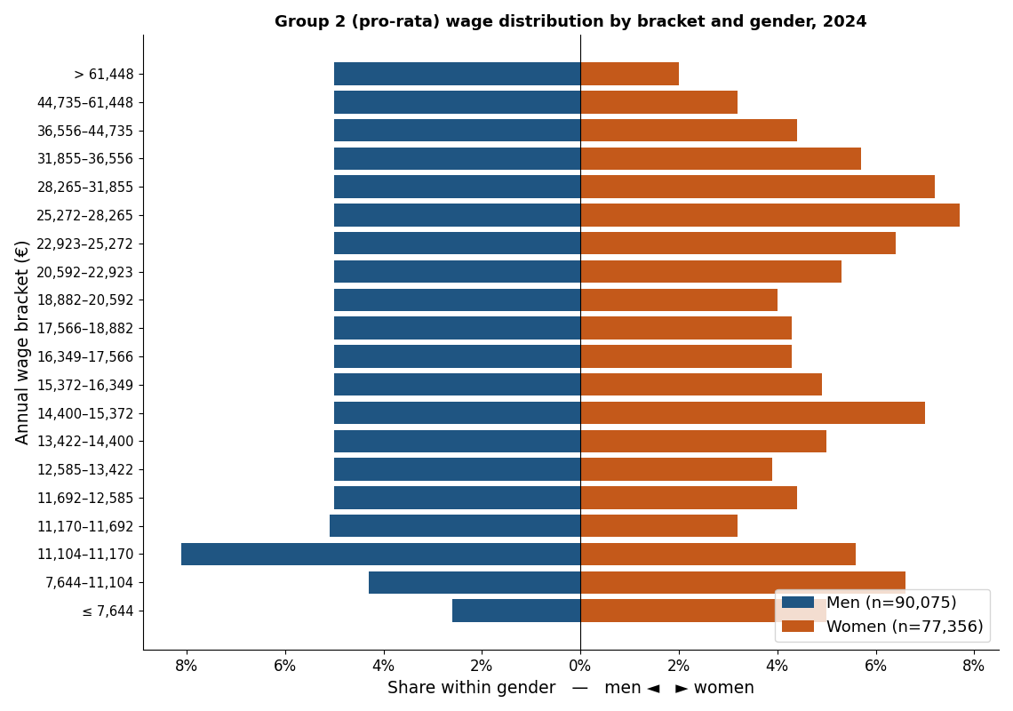
In the separate model the assumptions appropriate to the higher band are made explicitly: a length of service at retirement set to the long partial career the band actually achieves (about twenty-nine to thirty-two years) rather than the full career PROST’s full-time logic would impose; and, for the migrant component, an explicit assumption about how long they remain in Malta. Because these contributors vest and draw a pro-rata pension, their accrued service is claimed; the share of service never claimed belongs to the non-vested group. Confining these higher-uncertainty assumptions to a clearly labeled layer keeps the Group 1 projection transparent and lets the band be refined without disturbing the central estimate of two-thirds expenditure.

10.4 Realized careers: the OAP benchmark, and the adjustment
This is where the projection and the realized record part company, and for women only. For men the band is broadly reproduced: the realized share is lower than projected (the requirement effect, which reclassifies long male careers from full to pro-rata) but the realized length of service tracks the projection closely (about 30.8 against 31.7 years) and the realized density, about 0.71, sits close to the projected 0.84. For women the discrepancy is structural. The projection places about 52 percent of women in this higher band; the completed careers place only about 37 percent here, the remainder falling into the lower band. And within the band the projection attributes a density of about 0.82, where the completed careers reach only about 0.68. The projection expects women’s interrupted careers to be longer and denser than the completed record shows them to be.
The cause is selection in the active cross-section. The since-entry density is measured on women contributing now, and a woman whose career was interrupted in her thirties or forties has, by that fact, often already left the active base, while the women who remain attached into their fifties are those who did not interrupt. Measured on the survivors the cross-sectional density is high and rises with age; measured over completed careers it is lower. An independent source confirms this. The longitudinal panel measures the contribution intensity of women as a flow, the share of each year actually contributed, separately from the cumulative stock the projection relies on; estimated within individuals so that age is separated from cohort, the flow density of women is close to flat at about 0.67 across the working ages, with no pronounced dip at the childbearing ages, while the stock density of active women climbs toward 1.0 by the fifties, the signature of a survivor pool. The flow level, near 0.67, sits close to the realized density of female pensioners and below the active stock; it is the flow, not the survivor-inflated stock, that describes what an average active woman will accumulate going forward.
The adjustment follows from taking the completed careers as the benchmark they are. For women in the higher band the projected density of about 0.82 is replaced by the realized value of about 0.68, and the realized allocation (about 37 percent of women in this band, against the 52 percent the projection assigns) is adopted, the displaced share moving to the lower band in Section 11. The men’s parameters are left as the projection delivers them, and the female full-career and non-vested groups, the entire male base, the wage distribution and the headcounts are all unchanged. A uniform scaling of the whole female density was tested and rejected: it repairs the aggregate but at the cost of the full-career group, displacing women who genuinely reach the requirement, whereas correcting only the two pro-rata bands leaves the rest of the segmentation intact. One caveat qualifies the direction without reversing it: because credited periods are resolved only at claim, the realized lengths used as the benchmark omit the credits these women will ultimately receive, but the beneficiary record shows credited periods add only about half a year on average, so the omission is small and does not offset the survivorship correction.

11. Group 3: the pro-rata population, lower band
Group 3 is the lower band of the pro-rata population: contributors projected to clear the ten-year minimum but to accumulate fewer than twenty years of service, so they vest for a pro-rata pension close to the floor. It is the smaller of the two pro-rata bands, about 39,800 contributors, and differs from the higher band in composition as much as in length of career: it is much more heavily migrant (about seventy percent non-Maltese, against forty-six percent in the higher band), less full-time (about sixty-five percent), and lower-paid. These differences are why the two bands are reported separately. This section characterizes the lower band and sets out the adjustment that applies to its women.

11.1 Size and composition
The lower pro-rata band comprises about 39,800 contributors, roughly 22,700 men and 17,100 women. It is the most migrant of the vested groups: about seventy percent are non-Maltese, recent arrivals whose Maltese histories are short by construction. Its members have a median realized-to-date service near fifteen years and a median wage below the higher band (about 285 euro per week for men and 269 for women), and about sixty-five percent appear as full-time in a 2024 snapshot. The age profile is younger than the higher band, consistent with workers early in a Maltese career rather than at its end.
Table 25. Group 3 (pro-rata, lower band) by nationality and gender.
Nationality | Men | Women | Total
Maltese | 4,839 | 6,945 | 11,784
Non-Maltese | 17,884 | 10,108 | 27,992
Total | 22,723 | 17,053 | 39,776
Table 26. Group 3 (pro-rata, lower band) by age band and gender.
Age band | Men | Women | Total
18-24 | 3,751 | 3,815 | 7,566
25-29 | 3,905 | 2,603 | 6,508
30-34 | 3,311 | 1,759 | 5,070
35-39 | 3,064 | 1,809 | 4,873
40-44 | 2,594 | 1,601 | 4,195
45-49 | 2,416 | 1,632 | 4,048
50-54 | 2,042 | 1,612 | 3,654
55-59 | 1,220 | 1,430 | 2,650
60-65 | 420 | 792 | 1,212
Total | 22,723 | 17,053 | 39,776
By employment type the lower band is the least attached of the vested groups: about sixty-three percent full-time, with a larger part-time and unknown share than the higher band, consistent with its shorter and more interrupted careers. Table 27 sets out the composition.
Table 27. Group 3 (pro-rata, lower band) by employment type.
Employment type | Number | Share
Full-time | 25,151 | 63.2%
Part-time | 4,888 | 12.3%
Reduced-hours (FT) | 490 | 1.2%
Unknown (no snapshot) | 8,845 | 22.2%

11.2 Contribution density and the OAP benchmark
On the operational since-entry measure (D3) the lower band carries a projected density of about 0.49 and a median projected service of about sixteen years, enough to vest but well short of the higher band. As with the higher band the projection and the completed careers agree for men and part company for women. For men the realized length of service tracks the projection (about 14.1 against 15.3 years), with realized density about 0.39 against the projected 0.58. For women the projection again over-states both how many fall here and how dense their careers are: it places only about 14 percent of women in the lower band, where the completed careers place about 31 percent, and it attributes a density of about 0.49 where the realized careers reach only about 0.32.
The adjustment is the counterpart of the one applied to the higher band, and it absorbs the women the higher-band correction displaces. For women in the lower band the projected density of about 0.49 is replaced by the realized value of about 0.32, and the realized allocation (about 31 percent of women, against the 14 percent the projection assigns) is adopted. Taken together with the higher-band correction, the two adjustments move the female pro-rata population from the projection’s concentration in the higher band to the roughly even split across the two bands that the completed careers show, each band at its realized density. The men’s parameters and every other group are left unchanged. In PROST terms the lower band is modeled with the short partial career it achieves and an explicit assumption, for its large migrant component, about how long its members remain in Malta.

11.3 Wages
The wages of the lower band are the lowest among the vested groups, reflecting its short and interrupted careers and its large recent-migrant component. Table 28 gives the distribution by gender (median annual earnings of about 14,800 euro for men and 14,000 for women) and Table 29 with Figure 19 give the full bracket distribution. The distribution is built on all members with positive earnings, on the same bracket convention as the other groups.
Table 28. Annual wage (€000) of Group 3 (pro-rata, lower band) by gender: percentiles and mean.
Gender | n | p10 | p25 | Median | p75 | p90 | Mean
Men | 22,235 | 11.0 | 11.3 | 14.8 | 23.2 | 40.3 | 22.5
Women | 16,384 | 7.5 | 11.1 | 14.0 | 20.0 | 29.3 | 17.5
Table 29. Wage distribution by bracket and gender, Group 3 (pro-rata, lower band).
Annual wage bracket (€) | Men: n | Men: cum. % | Women: n | Women: cum. %
≤ 5,820 | 518 | 2.3 | 820 | 5.0
5,820-8,221 | 594 | 5.0 | 1,104 | 11.7
8,221-11,016 | 1,117 | 10.0 | 1,481 | 20.8
11,016-12,405 | 5,553 | 35.0 | 3,149 | 40.0
12,405-13,869 | 2,224 | 45.0 | 1,547 | 49.4
13,869-15,666 | 2,231 | 55.0 | 2,122 | 62.4
15,666-16,800 | 1,110 | 60.0 | 790 | 67.2
16,800-18,231 | 1,106 | 65.0 | 692 | 71.4
18,231-20,000 | 1,125 | 70.1 | 588 | 75.0
20,000-23,157 | 1,098 | 75.0 | 771 | 79.7
23,157-26,000 | 1,131 | 80.1 | 977 | 85.7
26,000-30,666 | 1,092 | 85.0 | 888 | 91.1
30,666-40,269 | 1,112 | 90.0 | 710 | 95.5
40,269-61,312 | 1,112 | 95.0 | 509 | 98.6
> 61,312 | 1,112 | 100.0 | 236 | 100.0
Figure 19. Group 3’s (pro-rata, lower band) wage distribution, by gender.

12. Group 4: the non-vested population
Group 4 comprises the contributors not projected to reach even the ten-year minimum: on the criterion of Section 8 their accumulated and expected weeks fall short of 520, so they do not qualify for any contributory pension. About 28,300 contributors fall here. They enter the projection only as contribution revenue, not as future pensioners, and in PROST terms their accrued service is the share that is “not claimed”. The group is predominantly migrant and short-tenured; it is characterized below for completeness, since its members nonetheless contribute in the base year, and any who remain in Malta and keep contributing would, in a later vintage, move into Group 2.

12.1 Size and composition
Group 4 comprises about 28,279 contributors, roughly 17,500 men and 10,800 women. It is predominantly non-Maltese: about 22,300, some 79 percent, are migrants, against about 6,000 Maltese (Table 30), the reverse of Group 1. Its age profile is the youngest of the groups (Table 31), concentrated below thirty-five, consistent with recent arrivals and young workers at the start of a career.
Table 30. Group 4 (non-vested) by nationality and gender.
Nationality | Men | Women | Total
Maltese | 2,656 | 3,318 | 5,974
Non-Maltese | 14,843 | 7,462 | 22,305
Total | 17,499 | 10,780 | 28,279
Table 31. Group 4 (non-vested) by age band and gender.
Age band | Men | Women | Total
18-24 | 3,418 | 3,397 | 6,815
25-29 | 2,801 | 1,704 | 4,505
30-34 | 2,536 | 1,388 | 3,924
35-39 | 2,113 | 1,123 | 3,236
40-44 | 1,677 | 834 | 2,511
45-49 | 1,384 | 675 | 2,059
50-54 | 1,288 | 589 | 1,877
55-59 | 1,276 | 570 | 1,846
60-65 | 1,006 | 500 | 1,506
Total | 17,499 | 10,780 | 28,279
By employment type Group 4 is the most loosely attached of the four groups: under half (about forty-eight percent) appear as full-time in a 2024 snapshot, and about forty percent are present in the contributions data but in none of the four employment snapshots, the signature of short, intermittent spells (Table 32).
Table 32. Group 4 (non-vested) by employment type.
Employment type | Number | Share
Full-time | 13,458 | 47.6%
Part-time | 3,400 | 12.0%
Reduced-hours (FT) | 195 | 0.7%
Unknown (no snapshot) | 11,226 | 39.7%

The completed careers add little here because there is little to add: a pensioner who never reached the ten-year minimum draws no Two-Thirds pension and barely appears in the beneficiary file, and the few very short careers that do appear sit at a realized density of about 0.19 to 0.20, essentially the value the projection assigns. The projected and realized non-vested shares agree for women at about 9 percent; for men the projected share modestly exceeds the realized, reflecting recent male migrants whose short current histories the projection does not extrapolate into vesting. The group remains a source of contribution revenue that generates no contributory pension, and no adjustment is required.

Annex A. OAP pensioners and their pensions, by group
This annex documents the completed-career side of the three contributory groups: the Two-Thirds pensioners whose realized records were used as the benchmark in Sections 9 to 11. For each group it reports the pensioner headcount by age at retirement and gender, and the distribution of awarded annual pensions by bracket and gender, on the same conventions used for the contributory wage distributions. The pensioners are mapped to the same four groups by their realized length of service: full-career (Group 1), higher pro-rata band (Group 2), and lower pro-rata band (Group 3).

A.1 Full-career (Group 1)
The full-career (Group 1) comprises 30,631 Two-Thirds pensioners, with a median awarded pension of about 13,375 euro a year drawn at a median retirement age of about 61. Table A1 gives the headcount by age at retirement and gender, and Table A2 the distribution of awarded annual pensions by bracket.
Table A1. Group 1 OAP pensioners by age at retirement and gender.
Age at retirement | Men | Women | Total
55 | 11 | 0 | 11
56 | 19 | 2 | 21
57 | 22 | 3 | 25
58 | 25 | 2 | 27
59 | 24 | 2 | 26
60 | 68 | 1,099 | 1,167
61 | 18,157 | 1,124 | 19,281
62 | 4,260 | 575 | 4,835
63 | 2,831 | 422 | 3,253
64 | 1,508 | 247 | 1,755
65 | 191 | 20 | 211
66 | 2 | 1 | 3
67 | 1 | 0 | 1
68 | 0 | 0 | 0
69 | 0 | 0 | 0
70 | 0 | 0 | 0
71 | 0 | 0 | 0
72 | 0 | 0 | 0
73 | 0 | 0 | 0
74 | 0 | 0 | 0
75 | 0 | 0 | 0
Total | 27,133 | 3,498 | 30,631
Table A2. Awarded annual pension distribution by bracket and gender, Group 1.
Annual pension bracket (€) | Men: n | Men: cum. % | Women: n | Women: cum. %
≤ 7,904 | 587 | 2.2 | 138 | 3.9
7,904-8,957 | 770 | 5.0 | 134 | 7.8
8,957-10,456 | 4,070 | 20.0 | 673 | 27.0
10,456-11,753 | 4,070 | 35.0 | 301 | 35.6
11,753-12,838 | 2,714 | 45.0 | 214 | 41.7
12,838-14,131 | 4,069 | 60.0 | 307 | 50.5
14,131-15,267 | 8,156 | 90.1 | 1,188 | 84.5
> 15,267 | 2,697 | 100.0 | 543 | 100.0

A.2 Higher pro-rata band (Group 2)
The higher pro-rata band (Group 2) comprises 14,106 Two-Thirds pensioners, with a median awarded pension of about 10,974 euro a year drawn at a median retirement age of about 61. Table A3 gives the headcount by age at retirement and gender, and Table A4 the distribution of awarded annual pensions by bracket.
Table A3. Group 2 OAP pensioners by age at retirement and gender.
Age at retirement | Men | Women | Total
55 | 11 | 2 | 13
56 | 4 | 2 | 6
57 | 10 | 3 | 13
58 | 11 | 1 | 12
59 | 8 | 7 | 15
60 | 37 | 1,707 | 1,744
61 | 5,952 | 1,206 | 7,158
62 | 1,138 | 1,179 | 2,317
63 | 695 | 960 | 1,655
64 | 396 | 569 | 965
65 | 67 | 43 | 110
66 | 3 | 1 | 4
67 | 1 | 0 | 1
68 | 1 | 0 | 1
69 | 1 | 0 | 1
70 | 2 | 0 | 2
71 | 0 | 1 | 1
72 | 0 | 1 | 1
73 | 1 | 0 | 1
74 | 0 | 0 | 0
75 | 0 | 0 | 0
Total | 8,415 | 5,691 | 14,106
Table A4. Awarded annual pension distribution by bracket and gender, Group 2.
Annual pension bracket (€) | Men: n | Men: cum. % | Women: n | Women: cum. %
≤ 7,247 | 94 | 1.1 | 22 | 0.4
7,247-8,465 | 327 | 5.0 | 317 | 6.0
8,465-9,480 | 1,262 | 20.0 | 1,133 | 25.9
9,480-10,723 | 2,525 | 50.0 | 953 | 42.6
10,723-11,982 | 1,262 | 65.0 | 649 | 54.0
11,982-13,044 | 841 | 75.0 | 531 | 63.3
13,044-14,172 | 841 | 85.0 | 649 | 74.7
> 14,172 | 1,263 | 100.0 | 1,437 | 100.0

A.3 Lower pro-rata band (Group 3)
The lower pro-rata band (Group 3) comprises 6,712 Two-Thirds pensioners, with a median awarded pension of about 5,890 euro a year drawn at a median retirement age of about 62. Table A5 gives the headcount by age at retirement and gender, and Table A6 the distribution of awarded annual pensions by bracket.
Table A5. Group 3 OAP pensioners by age at retirement and gender.
Age at retirement | Men | Women | Total
55 | 1 | 3 | 4
56 | 0 | 0 | 0
57 | 1 | 4 | 5
58 | 1 | 2 | 3
59 | 7 | 2 | 9
60 | 16 | 1,424 | 1,440
61 | 989 | 234 | 1,223
62 | 361 | 669 | 1,030
63 | 282 | 865 | 1,147
64 | 246 | 937 | 1,183
65 | 132 | 171 | 303
66 | 7 | 49 | 56
67 | 7 | 11 | 18
68 | 10 | 18 | 28
69 | 8 | 44 | 52
70 | 3 | 44 | 47
71 | 1 | 26 | 27
72 | 3 | 28 | 31
73 | 2 | 17 | 19
74 | 0 | 15 | 15
75 | 2 | 12 | 14
Total | 2,094 | 4,618 | 6,712
Table A6. Awarded annual pension distribution by bracket and gender, Group 3.
Annual pension bracket (€) | Men: n | Men: cum. % | Women: n | Women: cum. %
≤ 2,444 | 24 | 1.1 | 16 | 0.3
2,444-3,523 | 81 | 5.0 | 500 | 11.2
3,523-4,738 | 209 | 15.0 | 1,721 | 48.4
4,738-6,007 | 210 | 25.0 | 664 | 62.8
6,007-7,090 | 209 | 35.0 | 406 | 71.6
7,090-8,374 | 314 | 50.0 | 431 | 80.9
8,374-9,430 | 419 | 70.0 | 427 | 90.2
9,430-10,964 | 418 | 90.0 | 257 | 95.8
10,964-12,766 | 105 | 95.0 | 125 | 98.5
> 12,766 | 105 | 100.0 | 71 | 100.0

