METHODOLOGICAL NOTE
Distance to Eligibility and the Pension Pull
Transition rates for reform-consistent pension projections
Abstract
Reform simulation requires contribution behaviour to be modelled as a function of distance to pension eligibility rather than of age, because a matrix indexed to age is fixed to the rules in force when it is estimated and cannot represent how it shifts when the retirement age or contribution requirement changes. This note documents the empirical pattern that makes the distinction necessary. Using the Mexican IMSS administrative panel and a within-person fixed-effects design that removes the selection contaminating any cross-sectional comparison, it shows that the exit rate does not decline monotonically as workers approach eligibility. Among workers constrained by contribution weeks, it traces a U: exit is high when eligibility is far and unreachable (a repel), falls as the threshold becomes reachable (the pull), and jumps at eligibility itself (retirement). Among workers constrained only by age the repel is weak, and exit rises into eligibility largely tracking age itself — so the high exit far from eligibility that marks the response to the contribution requirement is pronounced among workers for whom contribution weeks bind, and the pattern is identified most cleanly there.
The implication for projection is direct. Because the response is anchored to eligibility, a transition matrix indexed to distance adjusts to reform automatically: when the rules change, each worker’s distance is recomputed and the applicable transition rates move with it, without re-estimation. The reachability of eligibility — the point past which the pull no longer operates — enters as an explicit, reform-responsive flag.

1 Modelling reform requires behaviour indexed to eligibility, not to age
Pension reforms work by changing the conditions under which a worker becomes entitled to a benefit — most often the retirement age, the number of contribution weeks required, or both. A projection model is only useful for evaluating such reforms if it captures how workers respond to those conditions. If contribution behaviour is modelled as a fixed function of age, the model implicitly assumes that a 59-year-old behaves the same way regardless of whether the retirement age is 60 or 65. That assumption is false in a way that matters: a worker one year from qualifying behaves very differently from a worker six years from qualifying, even at the same age. The behaviour tracks the eligibility finish line, not the calendar.
Indexing it to age also rests on a shaky base when the rules change. Suppose the retirement age rises from 60 to 65. To say how a 61-year-old will now behave, an age-based model has to lean on the workers who currently keep contributing past 60 — but those are an unusual group, precisely because they chose not to retire when they could, and their behaviour is a poor guide to how an ordinary worker would act if eligibility moved. Distance to eligibility sidesteps this. Today a 59-year-old behaves like the whole cohort approaching retirement; under a higher retirement age, that same near-eligibility pattern is what a worker would carry to 61 or 62. The reform changes how far each worker is from qualifying, and the response is read off that distance — estimated from the broad population approaching eligibility, not from the small and atypical group still working past today’s retirement age.
Two monthly transition rates summarise contribution behaviour. T1 is the probability that an active contributor stops contributing; T2 is the probability that an inactive worker resumes. Eligibility in the Mexican system requires meeting two conditions at once: reaching the statutory minimum eligibility age — 60, known in the Mexican system as cesantía en edad avanzada (old-age unemployment), the earliest age at which a retirement pension can be claimed — and accumulating the required contribution weeks. A worker’s distance to eligibility is how far they are from satisfying whichever of these two conditions is still binding; its construction and the underlying data are set out in Box 1. This note asks how T1 and T2 respond to that distance, and shows that the answer is what makes a distance-based projection necessary.
This object — how transition rates move with distance to eligibility — is what a projection model must reproduce under alternative rules. The pattern documented here is established empirically; the production model estimates the transition rates that embed it. The two are complementary, and together they make the case that distance, rather than age, is the right axis for the transition matrix. The point can be sharpened by anticipating an objection. An earlier formulation of this work proposed that the pull would weaken, and might reverse, once eligibility becomes unreachable: when length-of-service eligibility falls at a much older age than age eligibility, a worker loses the realistic prospect of a pension and the incentive to keep contributing collapses. The evidence below bears this out. Both the pull and the predicted reversal appear; they are concentrated, as anticipated, among workers constrained by contribution weeks rather than by age; and the limit beyond which the pull no longer operates enters the model as an explicit, reform-responsive condition (Section 4). The reversal is not a complication to be explained away — it is the central finding.

2 Comparing workers across distances confounds behaviour with worker type
Any comparison between workers close to eligibility and workers far from it confounds two distinct things: the effect of proximity on behaviour, and the type of worker who reaches proximity in the first place. Workers close to eligibility at age 50 are close precisely because they contributed consistently — they are high-density contributors as a type, and their low exit rate reflects that selection, not the threshold’s effect. Because distance is itself built from accumulated contributions, it partly encodes the worker’s type: a low-density worker accumulates weeks slowly, so their length-of-service gap, and therefore their distance, is mechanically large. Sorting workers by distance sorts them by type. Any between-worker comparison inherits this contamination, however the groups are formed.
The only way to separate the effect of proximity from the type of worker is to compare each worker to themselves at different points in their own career. Distance is not a fixed attribute: the same person moves through many distance values over time, far from eligibility early and progressively closer as age advances and contributions accumulate. The estimation assigns each worker their own baseline level — an individual fixed effect that absorbs every time-invariant characteristic, from contribution-density type to age at entry to employment history — and uses only the within-person variation that remains. Estimated by the within transformation, this removes the between-worker gradient that the cross-section would show, and leaves the pattern the next section describes.
Box 1. Data and construction
Source. Mexican Social Security Institute (IMSS) administrative records, 1997–2021, observed at monthly frequency. The analysis uses a systematic 5 percent sample of affiliated workers (approximately 3.25 million individuals), selected on the terminal digits of the administrative identifier.
Transition rates. Each worker-month records whether the worker contributed (active) or not (inactive). T1 is defined on workers active in the previous month as the probability of becoming inactive; T2 is defined on workers inactive in the previous month as the probability of becoming active. Both are rare monthly events (sample means 0.023 and 0.015).
Distance to eligibility. For each worker-month, the age gap is (RA − age) × 12 months and the length-of-service gap is (threshold − accumulated months), each floored at zero. Distance is the larger of the two — the longer of the two waits the worker still faces. In the figures and regressions this raw distance is grouped into five bands oriented toward eligibility, so that a higher band means closer to qualifying. The eligibility threshold is 231 months (1,000 contribution weeks); the reference retirement age is 60, with 65 used for the reform scenario.
Length of service. Because the panel begins in 1997, contributions accrued before then are not directly observed. Pre-1997 service is recovered from each worker’s reported total contribution weeks (semanas cotizadas) and added to the months observed in the panel, anchoring length of service to the worker’s full career rather than to the panel window alone.
Analysis window. Transition regressions are estimated on workers aged 40 to 65, the range over which proximity to eligibility matters.

3 Within a worker’s career, the pull near eligibility reverses to a repel when eligibility is out of reach
The effect of distance on the exit rate is not a single slope. It reverses sign with distance, and it does so almost entirely among workers for whom contribution weeks, rather than age, are the binding constraint. Figure 1 plots the exit rate T1 by distance to eligibility, separately for workers constrained by length of service and by age.
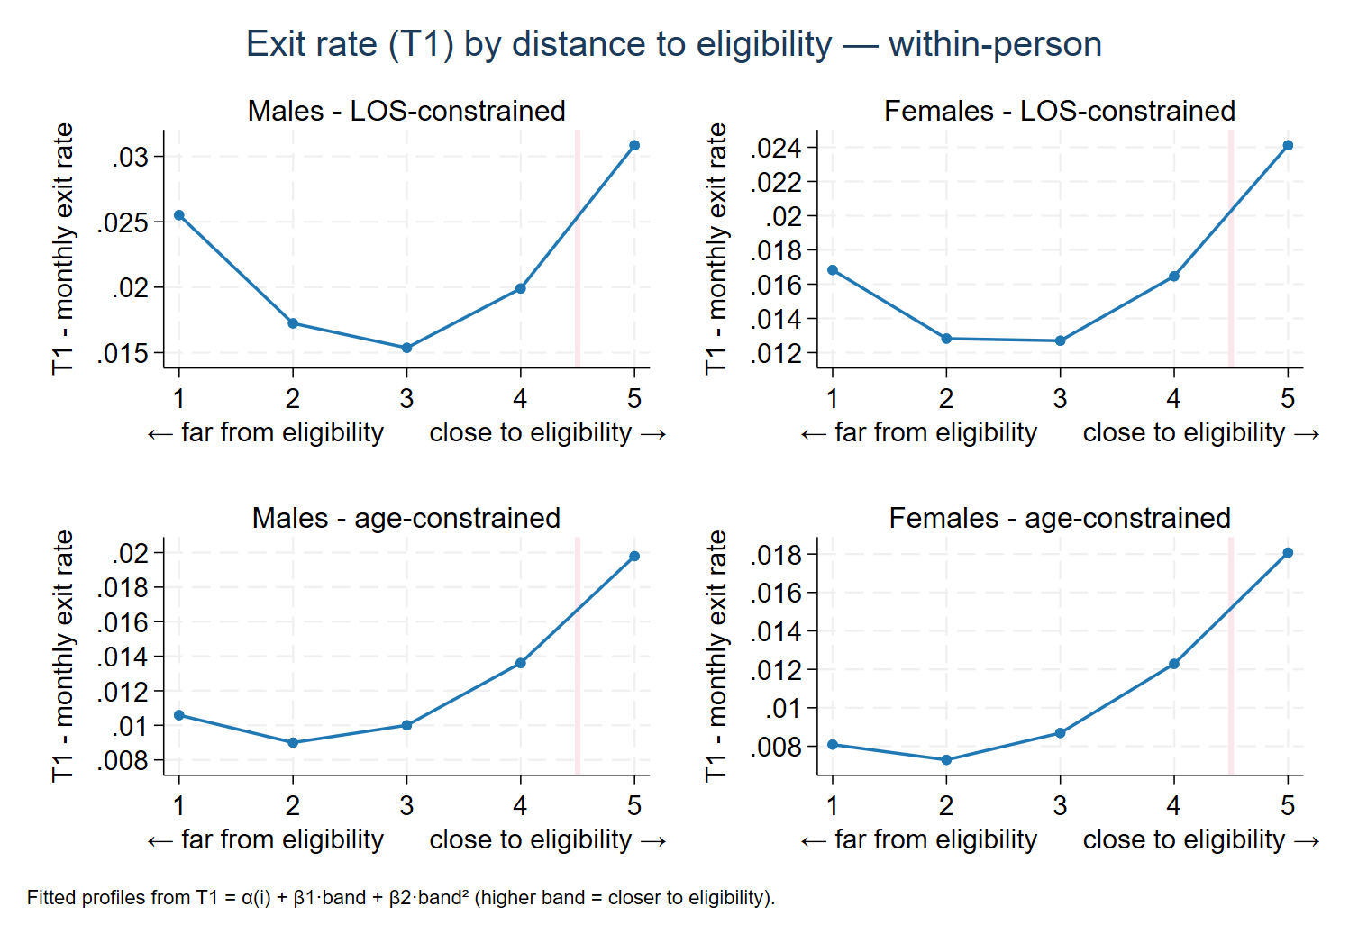
Figure 1. Monthly exit rate (T1) by distance to eligibility, length-of-service–constrained (top row) and age-constrained (bottom row) workers, men and women. Each curve is a fitted within-person profile, quadratic in distance band, with higher bands closer to eligibility. T1 traces a U in every panel — high far from eligibility, falling as the threshold becomes reachable, and rising into eligibility. The U is deep among length-of-service–constrained workers, where the far-side repel is pronounced, and much shallower among age-constrained workers, where the far arm is weak. Distance = max(age gap, LOS gap).
Far from eligibility, exit among length-of-service–constrained workers is high: a worker short of weeks, with little prospect of making them up, detaches from the system — the repel. As distance shrinks and the threshold becomes reachable, exit falls to a minimum — the pull. Closer still, exit rises as workers who have qualified retire. These are three distinct regimes: the repel is the behavioural response to the eligibility incentive, the final rise is the mechanical retirement transition, and the intermediate dip — the pull — is real in the profile but, within a career, not separable from age (Section 5). Age-constrained workers, who already hold the required weeks, trace a much shallower U: their far-side repel is weak, and the profile is dominated by the rise into eligibility. Within their careers distance and age move together, so that rise cannot be separated from the ordinary tendency of older workers to retire (Section 5). The repel — high exit when eligibility is distant — is pronounced among workers for whom contribution weeks bind, and it is the part of the pattern that identifies a response to the eligibility rule rather than to age.
The exit results have a counterpart in the return rate. Figure 2 plots T2, the monthly probability that an inactive worker resumes contributing, as the same fitted within-person profiles. Return is highest in the reachable middle range, where the prospect of qualifying draws workers back, and falls steeply into eligibility, where those who have qualified retire rather than re-enter. The shape holds for both length-of-service– and age-constrained workers, reinforcing from the entry side what the exit rate shows from the exit side: behaviour bends around eligibility, not around age as such.
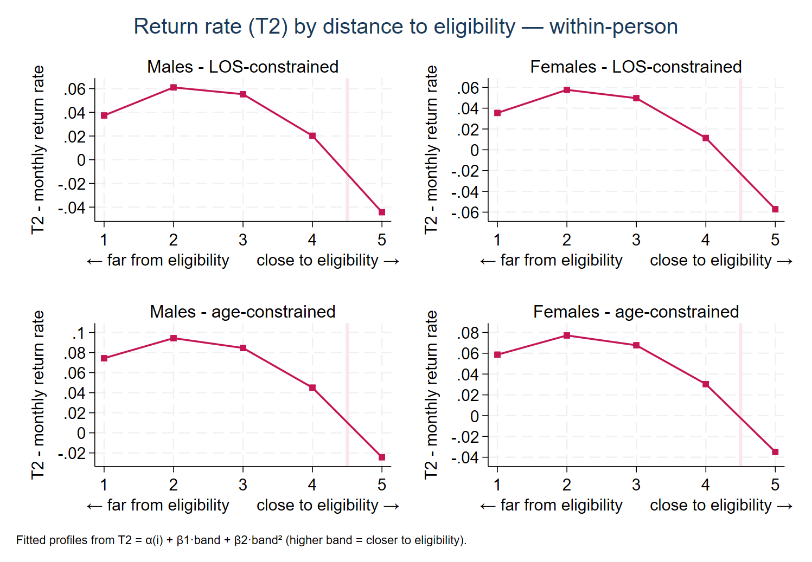
Figure 2. Monthly return rate (T2) by distance to eligibility, length-of-service–constrained (top row) and age-constrained (bottom row) workers, men and women. Each curve is a fitted within-person profile, quadratic in distance band. Return peaks in the reachable middle range and falls steeply into eligibility, where qualified workers retire rather than re-enter. The fitted profile turns negative at the threshold; this is an artefact of the quadratic fit, not a negative probability. Distance = max(age gap, LOS gap).
This pattern is confirmed in estimation. Within-person fixed-effects equations for the exit rate (T1) and the return rate (T2), with proximity to eligibility entered in five-year bands and a quadratic term, trace two mirror-image curves. Proximity is oriented so that a higher value means the worker is closer to the threshold; both coefficients are estimated with high precision.
T1ᵢₜ = αᵢ + β₁·distᵢₜ + β₂·dist²ᵢₜ + εᵢₜ
where αᵢ is a worker fixed effect, distᵢₜ is proximity to eligibility in five-year bands (higher = closer), and standard errors are clustered by worker i. The same specification is estimated for the return rate T2.
Table 1. Distance effect on the exit (T1) and return (T2) rates, per five-year band
Transition rate | β₁ (per band) | t | β₂ (per band²) | t
Exit rate (T1) | −0.0151 | −28.6 | +0.0035 | +27.0
Return rate (T2) | +0.0863 | +22.6 | −0.0205 | −21.9
Within-person fixed-effects estimates for the exit rate (T1) and the return rate (T2). Distance is entered in five-year bands oriented toward eligibility (higher = closer), with a quadratic term. Standard errors clustered by worker; t-statistics shown. Both rates highly significant; the exit curve is U-shaped and the return curve its mirror image.
A single linear coefficient would misrepresent the exit curve. Because it is U-shaped — high far from eligibility, falling to a minimum in the middle range, and rising at the threshold — a straight line returns a slope dominated by the far region. The quadratic term is highly significant for both rates; the return curve (T2) is the mirror image of the exit curve, peaking in the reachable middle range where the exit rate troughs and falling into eligibility. The fitted profiles in Figures 1 and 2 show the shape the coefficients imply.
3.1 The pull weakens where eligibility is out of reach: a pension repel
The pull does not operate uniformly across the distance range. A worker who is so far from the contribution requirement that qualifying is no longer realistic — one who would only reach length-of-service eligibility at an age well beyond the retirement age — has little incentive to hold on, and the pull should weaken and may reverse. This is the pension repel.
To test it, the exit equation lets the effect of proximity differ by whether eligibility is still reachable. A worker is flagged as having no realistic prospect of qualifying when the remaining contribution requirement exceeds the time left until the retirement age, so that length-of-service eligibility would fall beyond it (no_hope = 1). The estimated exit equation is:
T1ᵢₜ = αᵢ + β₁·distᵢₜ + β₂·no_hopeᵢₜ + β₃·(distᵢₜ × no_hopeᵢₜ) + εᵢₜ
where a higher dist means the worker is closer to eligibility. Among workers who can still realistically qualify, proximity lowers exit (β₁ = −0.0004, t = −3.4) — the pull. The interaction is positive and highly significant (β₃ = +0.0042, t = +8.6): among workers who can no longer reach the threshold, the combined effect (β₁ + β₃ = +0.0038) is positive. The pull disappears and reverses. Proximity retains workers only while qualifying remains within reach; once length-of-service eligibility lies beyond the retirement age, approaching that unreachable threshold no longer holds workers in contribution. This is the pension repel, operating exactly where contribution weeks, rather than age, place eligibility out of reach.

4 A distance-based transition matrix tracks reform where an age-based matrix cannot
The pattern is tied to eligibility, not to turning 60, and this is what makes it consequential for reform. A transition matrix indexed to age is fixed to the rules in force when it was estimated: it records how a 59-year-old behaves today, when the retirement age (RA) is 60, and has no way to represent how that same 59-year-old would behave if the retirement age were 65. Yet that is precisely what changes under reform — the response between 60 and 65 shifts substantially, and a raised contribution requirement shifts it further. The behaviour that responds to reform is the pension-system component, distinct from the labour-market forces that age captures; separating the two requires a parameter that moves with the eligibility rules. Distance to eligibility is that parameter.
Which of the two conditions binds determines whether a worker is subject to the response. Figure 3 classifies workers at each age by their binding constraint under two retirement ages. The age-binding zone (blue) is workers who will reach the contribution threshold before the retirement age; the length-of-service–binding zone (orange) is workers who will reach the retirement age first.
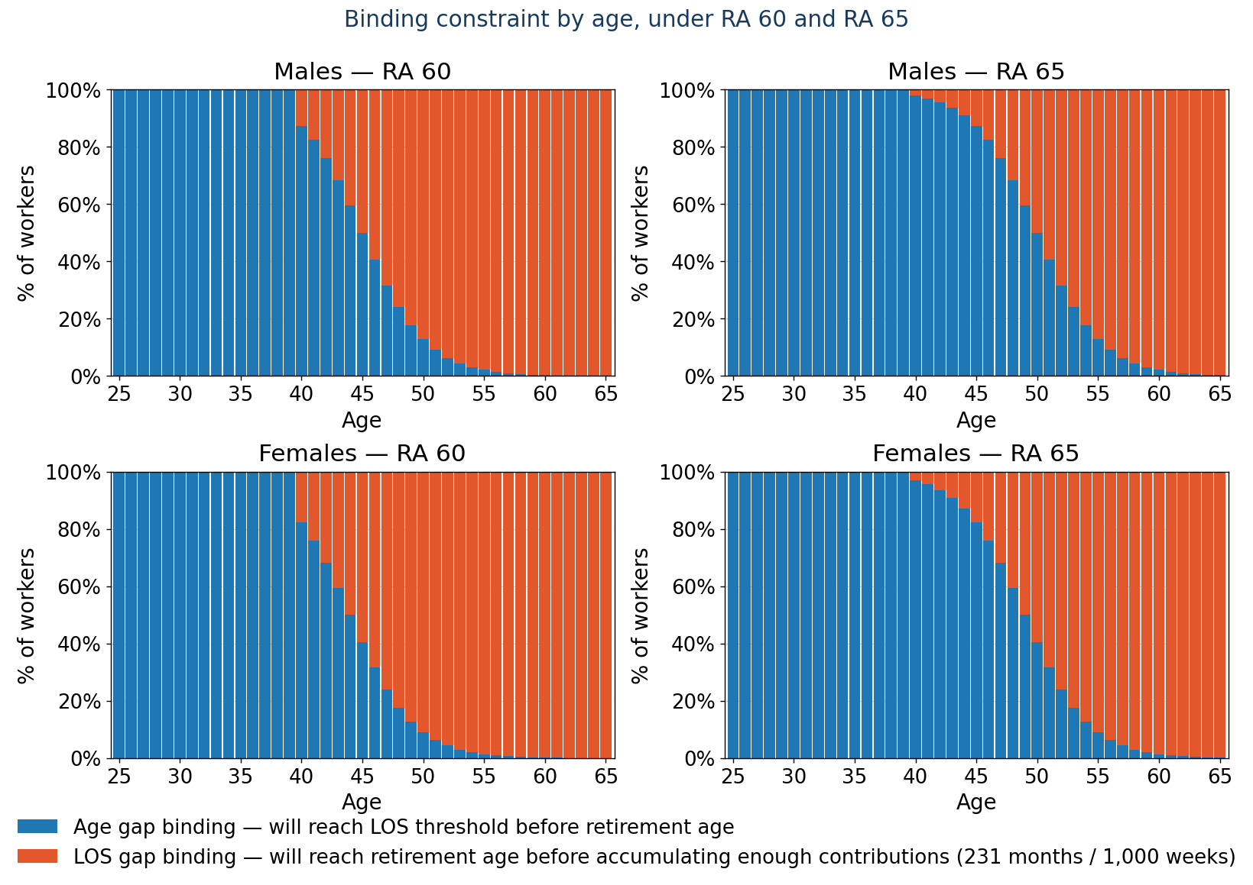
Figure 3. Share of workers age-constrained (blue) versus length-of-service–constrained (orange) at each age, under RA 60 and RA 65. Raising the retirement age shifts the boundary about five years to the right.
Raising the retirement age from 60 to 65 shifts the boundary roughly five years to the right: a worker length-of-service–constrained at 55 under RA 60 is age-constrained at 55 under RA 65. The mechanism is concrete at the level of a single worker. A 59-year-old sits about twelve months from eligibility under RA 60; under RA 65 the same worker sits about seventy-two months away, and their transition rates are read from the cell of the matrix that corresponds to the new distance — automatically, with no re-estimation. Because the pull–repel response lives in the length-of-service–constrained group, moving the boundary moves who is subject to the response. An age-based matrix cannot represent this: it fixes the retirement spike at 60 by construction and would keep projecting exits at 60–64 under a reform that makes retirement there impossible. A distance-based matrix relocates the spike because each worker’s distance is recomputed against the new rules.
Working along the distance dimension also keeps a reform consistent. A change in the retirement age or the required weeks changes one thing — every worker’s distance — and the transition rates follow from that single recomputation. The response is built into the distance axis once, so a reform scenario does not require the same change to be entered by hand in several places, and the projection stays internally coherent.
This works best for moderate reforms. Moving the eligibility age by a few years shifts the response across a range where the workers approaching eligibility today are a good guide; a very large shift would move it well beyond that range, where other factors — health, and how older workers fare in the labour market — would need to be considered separately.

4.1 The limit of the effect: reachable eligibility
The repel has a structural interpretation the model can use directly. A worker is subject to the pull only while eligibility remains reachable — while continued contribution can still close the length-of-service gap within a reasonable horizon. The principled criterion is a cost–benefit one: a worker stops having reason to contribute when the cost of the remaining required contributions exceeds the expected value of the pension — that is, when the contribution rate applied over the years still needed to qualify exceeds the replacement rate applied over remaining life expectancy beyond the eligibility age. The data needed to apply this criterion directly — individual replacement rates and life expectancy — are not in the present sample, so Figure 4 implements a simpler, transparent proxy: within the length-of-service–constrained zone, it separates workers who can still reach the threshold by contributing continuously up to five years past the retirement age from those who cannot. The unreachable zone grows with age and marks where the pull no longer operates.
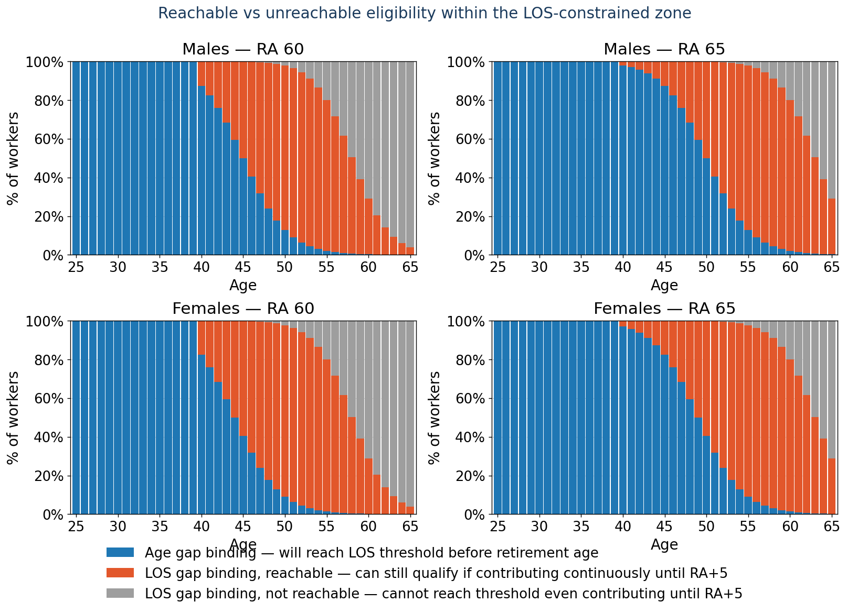
Figure 4. Within the length-of-service–constrained zone, workers who can still reach the threshold by contributing continuously (orange) versus those who cannot, even by contributing to five years past the retirement age (grey). The grey zone identifies where eligibility is no longer reachable and the pull no longer applies.
In the projection this enters as an indicator of reachable eligibility, recomputed for each worker under whatever rules a scenario imposes. When a reform changes the retirement age or the required weeks, the indicator is re-evaluated and workers are redistributed between the reachable and unreachable groups; the response — pull where eligibility is reachable, repel where it is not — then follows the reform with no new assumption. This is the core of the proposal: separating what is labour-market determined from what is pension-system determined, so that when the rules change, only the pension-system component moves.

5 The repel is identified most cleanly where contribution weeks bind
Within a worker’s career, distance to eligibility and age are nearly collinear — for age-constrained workers, distance is an exact linear function of age, and the two effects cannot be separated. The apparent pull is therefore not separately identified from age in these data: it is real in the profile and consistent with retention near eligibility, but isolating it from the age gradient would need exogenous variation, such as a reform, that these data do not provide. The pattern is identified most cleanly among length-of-service–constrained workers, where distance is driven by the contribution gap and varies independently of age; the repel — high exit when eligibility is out of reach — is the better-identified part of the pattern.
The descriptive estimates do not control for the duration of the current contribution spell. Because spell length is correlated with the contribution gap, part of the within-person pattern may reflect duration dependence rather than the eligibility incentive. The production model controls for spell length directly; the figures here do not, and the curves should be read as evidence of the regime structure — repel, pull, retirement — rather than as fully duration-adjusted hazards.

