Ansible

Roles:

Roles are ways of automatically loading certain vars_files, tasks, and handlers based on a known file structure. Grouping content by roles also allows easy sharing of roles with other users

e.g.

site.yml
webservers.yml
fooservers.yml
roles/
common/
tasks/
handlers/
files/
templates/
vars/
defaults/
meta/
webservers/
tasks/
defaults/
meta/

- Roles expect files to be in certain directory names. When in use, each directory must contain a 'main.yml' file which contains the relevant content
- Roles must include one of the following directories however you can exclude any which are unused:
- tasks – contains main list of tasks to be executed by the role
- defaults – default variables for the role
- vars – other variables for the role
- templates – contains templates (Jinja2/.j2) which can be deployed via the role

Other YAML files can be included in certain directories also

Using Roles:

The classic (original) way to use roles is via the “roles:” option for a given play e.g.

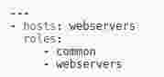

This designates the following behaviours, for each role 'x':
- If roles/x/tasks.main.yml exists, tasks listed therein will be added to the play
- ...
- If roles/x/vars/main.yml exists, variables listed therein will be added to the play.
- Any copy, script, template or include tasks (in the role) can reference files in roles/x/{files,templates,tasks}/ (dir depends on task) without having to path them relatively or absolutely.

Role Search Path:

Ansible will search for roles in the following way:
- A 'roles/' directory, relative to the playbook file
- By default, in /etc/ansible/roles
- via an additional roles_path vairable within the ansible.cfg file (in Ansible 1.4). This is used to share roles easily between multiple playbook projects

Configuring Ansible:

Certain settings in Ansible are adjustable via a configuration file (ansible.cfg).
Default location is /etc/ansible/ansible.cfg
The file is searched for in the following order:
- ANSIBLE_CONFIG (environment variable if set)
- ansible.cfg (in current directory)
- ~/.ansible.cfg (in home directory)
- /etc/ansible/ansible.cfg

Inventory:

Hosts & Groups

- Ansible works against multiple systems in your infrastructure at the same time. It does this by selecting portions of systems listed in Ansible's inventory (default location = /etc/ansible/hosts)
- You can specify a different inventory file using the '-i <path>' option on the command line
- You can also specify a different default path in the ansible.cfg file
- Hosts inventory file can be in different formats: ini & YAML

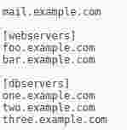
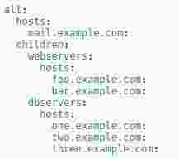

- Headings in the brackets are group names, which are used to classify systems and decide what systems you are controlling at what times and for what purposes
- Above mail.example.com is an example of an host entry. Foo.example.com is an example of a host entry within the webservers group
- You can add systems into multiple groups
- You can give systems specific settings or 'host variables' e.g. ports, aliases, IPs etc

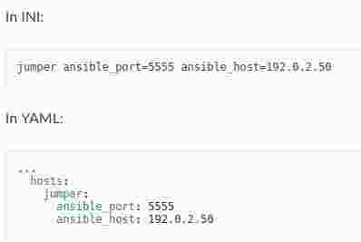

You can add lots of hosts following similar patterns too



Group Variables

Group variables can also be applied to an entire group at once

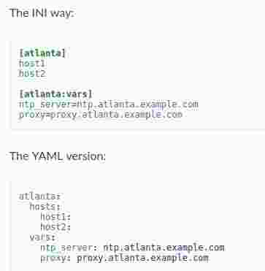

You can also make groups of groups using the :children suffix (ini) or children: entry (YAML) & apply variables using the :vars or vars:
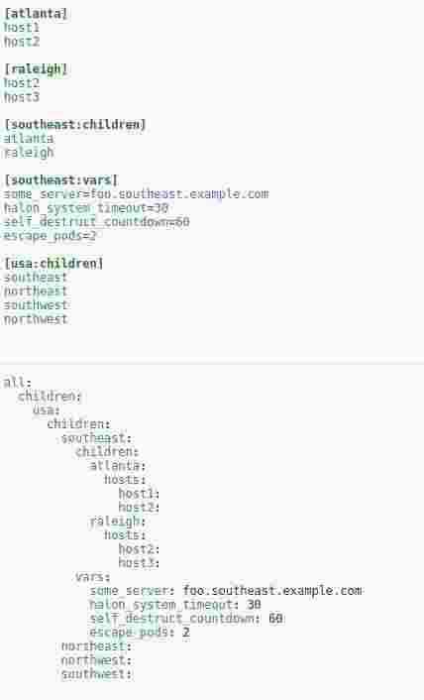

There are two default groups:
- all – contains every host
- ungrouped – contains all hosts that don't have another group aside from 'all'

Splitting out host and group specific data

- The preferred practice in Ansible is to not store variables in the main inventory file.
- In addition to storing variables directly in the inventory file, host and group variables can be stored in individual files relative to the inventory file (not directory, it is always the file)
- Variables stored in YAML format (.yml, .yaml, or .json)
- It is OK for the files to not exist, as this is an optional feature
- You can also create directories named after the groups or hosts (extension of example below) in order to keep variables organised
- TIP: The group_vars/ and host_vars/ directories can exist in the playbook directory OR the inventory directory. If both paths exist variables in the playbook directory override

e.g.
Assuming an inventory path of /etc/ansible/hosts

If a host is named 'ROUTER1' and is in groups 'WKG' & 'PROD', variables in YAML files at the following locations will be made available to the host...

/etc/ansible/group_vars/WKG
/etc/ansible/group_vars/PROD
/etc/ansible/host_vars/ROUTER1

WKG file may look like...

---
ntp_server: acme.example.org
database_server: storage.example.org

Brief list of behavioral inventory parameters...
ansible_connection {smart|ssh|paramiko}
ansible_host
ansible_port
ansible_user

Built-in variables:

- hostvars (e.g. hostvars[other.example.com][...])
- group_names (groups containing current host)
- groups (all groups and hosts in the inventory)
- inventory_hostname (current host as in inventory)
- inventory_hostname_short (first component of inventory_hostname)
- play_hosts (hostnames in scope for current play)
- inventory_dir (location of the inventory)
- inventoty_file (name of the inventory)

Usefull links

Ansible Cheat Sheet - https://gist.github.com/andreicristianpetcu/b892338de279af9dac067891579cad7d
https://ansible-tips-and-tricks.readthedocs.io/en/latest/ansible/inventory/

