A

Techniques

Standard and Private Techniques
For some XIE operations, there are several recognized algorithms or techniques which offer varying tradeoffs between quality of results and performance. Also, in some cases, different techniques are required due to an image's class or content. In general, techniques that are specified for import and export elements identify image compression schemes, whereas techniques that are specified for process elements identify various image processing or enhancement algorithms.
Several standard techniques are defined in this appendix. Standard techniques are those which are well known to the image processing community. They are further categorized in this document as required, optional, or excluded (see Table B-2). While required techniques must be implemented in all servers, it is expected that most optional techniques will also be widely available. Some techniques are excluded from certain subsets.
Vendors may choose to extend XIE with their own private techniques to provide for their particular needs. Therefore, private techniques are likely to be available only on a particular vendor's platforms.

Technique numbers
Standard and private techniques can be differentiated by their technique numbers. The most significant bit of the technique number is zero for standard techniques and one for private techniques. Standard technique numbers are defined in this document (see Appendix C). Private technique numbers are assigned dynamically (the method for generating private technique numbers is chosen by the server implementor). Since private technique numbers are not statically defined, the number to name-string mapping must be obtained on a per-server basis via the QueryTechniques protocol request.

Technique names
The name string for standard techniques contains only the name of the algorithm or compression scheme (e.g. “ERROR-DIFFUSION” or “CCITT-G32D”). Private technique name strings also include the name of the vendor that owns the rights to the technique (e.g. “_PHOTOCO_SQUASH-BITS”). Since the organization name is encompassed by “_” (underscore) characters, the leading underscore provides another means by which standard techniques can be can differentiated from private techniques.

Default Techniques
In some cases it is appropriate to assign a default technique. A default technique is a synonym that must be bound to a standard or private technique. Where there is no required standard technique, a default technique must be defined which is bound to an optional or a private technique. No default is defined in cases where it would be inappropriate (e.g. decode techniques describing client data).

Technique parameters
For each occurrence of a technique within an element definition, allowance is made to pass parameters that are specific to the technique. Some techniques have defined parameters and others have none. For techniques that do have defined parameters, the QueryTechniques request can be invoked to determine if the parameters must be supplied. If the parameters are optional and they are omitted by the client, the server will supply implementation specific default values in their place.
If the default technique is requested, no additional parameters are accepted (implementation specific default values will be provided for parameters defined for the technique to which Default is bound).

Technique information
The QueryTechniques request returns information about: All techniques, all Default techniques, or a group of techniques which are functionally similar (e.g. Dither, Encode, Geometry, etc.). The following information is returned about the selected techniques:
needs-parameters indicates that the technique requires additional parameters; if false, the technique takes no parameters, or its parameters are optional. If the parameters are optional, they can be totally omitted, otherwise they must all be supplied.
group identifies which group the technique belongs to.
number the numeric identifier assigned to the technique (MS bit is zero for standard techniques, or one for private techniques).
speed the server's assessment of the speed of this technique relative to other techniques in the same group (where 0 is the slowest, and 255 is the fastest).
name the technique name string of the form:
<STANDARD-TECHNIQUE-NAME> or
_<ORGANIZATION-NAME>_<PRIVATE-TECHNIQUE-NAME>
The remainder of this appendix provides a complete description of each technique and its parameters.

Color Allocation Techniques
Color allocation techniques allocate or match colors or gray shades from a COLORMAP. Cells allocated from a dynamic COLORMAP are recorded in a ColorList. If the COLORMAP is static, image pixels can only be matched to existing COLORMAP entries; no allocations are made and no ColorList needs to be specified.

AllocAll
Parameters
fill CARD32
AllocAll allocates a read-only COLORMAP cell for each new pixel found. If the COLORMAP runs out of cells, the remaining new pixels are mapped to fill. A ColorAlloc event can be sent if it is necessary to use fill. AllocAll is only appropriate for dynamic COLORMAPs and requires that the number of discrete image pixels fit within the size of the COLORMAP to avoid running out of cells.

Match
Parameters
match-limit XieTypFloat
gray-limit XieTypFloat
Match allows a trade-off between image fidelity and COLORMAP usage via a pair of granularity parameters []. The highest priority is given to allocating read-only cells in a sequence that provides an even distribution of pixels throughout the colorspace. Secondary priority is given to the frequency of usage of image pixels. Any image pixel which is a close enough match to an existing read-only cell will share that cell (where “close” is determined by the granularity controls). For other image pixels, new read-only allocations are made. When no more cells are available, each remaining image pixel is matched to the closest read-only cell. Match is appropriate for both static and dynamic COLORMAPs. For the sake of computational efficiency the number of discrete image pixels should not exceed the size of the COLORMAP.
Match-limit and gray-match control the allocation of colors and gray shades respectively. The minimum value (0.0) specifies exact matches (within the limits of the COLORMAP). The maximum value (1.0) encompasses the entire colorspace within which no new cells are allocated. A ColorAlloc event can be sent if the COLORMAP runs out of cells.

Requantize
Parameters
max-cells CARD32
Requantize first reduces the total number of discrete pixels values in the image to be no more than a specified number, and then allocates the resulting pixels values as read-only cells from the COLORMAP. One method of accomplishing this reduction process can be found in [].
Max-cells specifies the maximum number of COLORMAP allocations to allow. If max-cells is zero or greater than the number of unallocated COLORMAP cells, the reduction algorithm will restrict its output to the number of free cells. A ColorAlloc event can be sent if the number of pixels had to be restricted to a lesser number than max-cells due to a lack of free COLORMAP cells. Requantize is only appropriate for dynamic COLORMAPs.

Constrain Techniques

ClipScale
Parameters
input-low XieTypConstant
input-high XieTypConstant
output-low XieTypLevels
output-high XieTypLevels
For each band, output pixels will be clipped to the range [output-low, output-high].
If input-low is less than input-high, then all pixels less than or equal to input-low will map to output-low, and all pixels that are greater than or equal to input-high will map to output-high. All intermediate pixel values are scaled proportionately to the output range. Non-integral output values are rounded to the nearest integer.
If input-low is greater than input-high then all pixels that are greater than or equal to input-low will map to output-low, and all pixels that are less than or equal to input-high will map to output-high. All intermediate pixel values will be linearly mapped to the output range, such that input-low maps to output-low, and input-high maps to output-high. Non-integral output values are rounded to the nearest integer.
If input-low equals input-high, or if output-low is not less than output-high, or if output-high exceeds levels-1, a FloTechnique error is generated.

HardClip
Parameters
< none >
HardClip constrains the data such that all negative pixels are set to zero, and all pixels greater than levels-1 are set to levels-1. All other pixels are rounded to the nearest integer value.

Convert From RGB
CIELab
Parameters
matrix XieTypMatrix
white-adjust XieTypWhiteAdjustTechnique
white-params <technique-dependent>
Matrix is a 3x3 RGB to CIEXYZ conversion matrix (the source white point is also encoded in matrix). White-adjust is the WhiteAdjustTechnique that can be used to shift the white point of the output data. White-params is the list of parameters required by white-adjust.
The input DataType can be Constrained or Unconstrained; the output DataType is always Unconstrained. When the input is Constrained, the data are normalized to the range [0, 1] (i.e. scaled by 1/(levels - 1) prior to the conversion.

CIEXYZ
Parameters
matrix XieTypMatrix
white-adjust XieTypWhiteAdjustTechnique
white-params <technique-dependent>
Matrix is a 3x3 RGB to CIEXYZ conversion matrix (the source white point is also encoded in matrix). White-adjust is the WhiteAdjustTechnique that can be used to shift the white point of the output data. White-params is the list of parameters required by white-adjust.
The input DataType can be Constrained or Unconstrained; the output DataType is always Unconstrained. When the input is Constrained, the data are normalized to the range [0, 1] (i.e. scaled by 1/(levels - 1) prior to the conversion.

YCbCr
Parameters
luma XieTypConstant
levels XieTypLevels
bias XieTypConstant
Luma represents the proportions of red, green, and blue in the luminance band, Y. Levels determines the output levels, if src is Constrained (otherwise levels is ignored). Bias is used to add an offset to the output pixels values.
Source data may be Constrained or Unconstrained; the output type will match.

YCC
Parameters
luma XieTypConstant
levels XieTypLevels
scale XieTypFloat
Luma represents the proportions of red, green, and blue in the luminance band, Y. Levels determines the output levels, if src is Constrained (otherwise levels is ignored). Scale is used to compress the output pixels (a typical value is about 1.35 to 1.4 in the literature).

Convert To RGB

CIELab
Parameters
matrix XieTypMatrix
white-adjust XieTypWhiteAdjustTechnique
white-params <technique-dependent>
gamut-compress XieTypGamutTechnique
gamut-params <technique-dependent>
Matrix is a 3x3 CIEXYZ to RGB conversion matrix (the target white point is also encoded in matrix). White-adjust is the WhiteAdjustTechnique that can be used to shift the white point of the source data prior to conversion. White-params is the list of parameters required by white-adjust. Gamut-compress is the GamutTechnique that can be used to keep the output pixels within the bounds of the RGB colorspace. Gamut-params is the list of parameters required by gamut-compress.
The input DataType must be Unconstrained; the output DataType is also Unconstrained.

CIEXYZ
Parameters
matrix XieTypMatrix
white-adjust XieTypWhiteAdjustTechnique
white-params <technique-dependent>
gamut-compress XieTypGamutTechnique
gamut-params <technique-dependent>
Matrix is a 3x3 CIEXYZ to RGB conversion matrix (the target white point is also encoded in matrix). White-adjust is the WhiteAdjustTechnique that can be used to shift the white point of the source data prior to conversion. White-params is the list of parameters required by white-adjust. Gamut-compress is the GamutTechnique that can be used to keep the output pixels within the bounds of the RGB colorspace. Gamut-params is the list of parameters required by gamut-compress.
The input DataType must be Unconstrained; the output DataType is also Unconstrained.

YCbCr
Parameters
luma XieTypConstant
levels XieTypLevels
bias XieTypConstant
gamut-compress XieTypGamutTechnique
gamut-params <technique-dependent>
Luma represents the proportions of red, green, and blue in the luminance band, Y. Levels determines the output levels, if src is Constrained (otherwise levels is ignored). Bias is used to remove any offset from the source pixels values. Gamut-compress is the GamutTechnique that can be used to keep the output pixels within the bounds of the RGB colorspace. Gamut-params is the list of parameters required by gamut-compress.
Source data may be Constrained or Unconstrained; the output type will match.

YCC
Parameters
luma XieTypConstant
levels XieTypLevels
scale XieTypFloat
gamut-compress XieTypGamutTechnique
gamut-params <technique-dependent>
Luma represents the proportions of red, green, and blue in luminance Y. Levels determines the output levels, if src is Constrained (otherwise levels is ignored). Scale is used to expand the source pixels (a typical value is about 1.35 to 1.4 in the literature). Gamut-compress is the GamutTechnique that can be used to keep the output pixels within the bounds of the RGB colorspace. Gamut-params is the list of parameters required by gamut-compress.
Source data may be Constrained or Unconstrained; the output type will match.

Convolution Edge Techniques
Various methods of handling edge conditions are provided for Convolve. These techniques determine what pixel values are used when Convolve requires data beyond the image bounds. ConvolveTechniques only come into play when the kernel is positioned partially off the edge of the image. Data around the edges of a ProcessDomain are convolved with adjacent image pixels wherever possible.

Constant
Parameters
constant XieTypConstant
Constant uses the value specified by constant if pixels are required from beyond the edge of the image.

Replicate
Parameters
< none >
Replicate uses the nearest edge pixel value if pixels are required from beyond the edge of the image.

Decode Techniques

UncompressedSingle
Parameters
fill-order XieTypOrientation
pixel-order XieTypOrientation
pixel-stride CARD8
left-pad CARD8
scanline-pad CARD8

UncompressedTriple
Parameters
fill-order XieTypOrientation
pixel-order XieTypOrientation
band-order XieTypOrientation
interleave XieTypInterleave
pixel-stride XieTypTripletofCARD8
left-pad XieTypTripletofCARD8
scanline-pad XieTypTripletofCARD8
These techniques are used when no compression scheme has been applied to the image data. They are used for SingleBand and TripleBand data, respectively. Their parameters define the format of the DataStream of uncompressed data (the server may re-format the data as it chooses prior to processing or storage).
The following parameters are common to both techniques:
• When multiple pixels are put in the same byte, or a pixel spans multiple bytes, fill-order specifies whether the pixels (or parts of pixels) are packed into the most or least significant bits of a byte first.
• For pixels that span a byte boundary, pixel-order defines whether the most or least significant bits of the pixel are transported first within the DataStream.
• Pixel-stride is the number of bits between the start of consecutive pixels within a scanline. It must be at least enough bits to contain the number of input levels.
• Left-pad is the number of pad bits preceding the first image pixel in each scanline. If the server's Alignment attribute is Alignable, or pixel-stride fits the definition of Alignable, the value of left-pad must be a multiple of pixel-stride or a multiple of 8; otherwise, left-pad may be any arbitrary value.
• Scanline-pad defines a multiple of bytes to which each scanline is padded; valid values are: 0 (not aligned), 1, 2, 4, 8, and 16. The total number of bits-per-scanline in the DataStream includes: left-pad, the image data (width x pixel-stride), and sufficient additional bits to satisfy scanline-pad.
The following parameters are only used by UncompressedTriple:
• Band-order is the order of the image bands or image planes as they are transmitted through the protocol stream.
• Interleave describes how the image bands are interleaved (per pixel within a single plane, or sent as three separate planes). If interleave is BandByPixel, inter-band dimensions must match (i.e. the widths and the heights of all bands must match).

CCITT-G31D
Parameters
encoded-order XieTypOrientation
radiometric BOOL
normal BOOL
CCITT-G31D is the CCITT group 3 one dimensional encoding technique as defined by [].
Encoded-order specifies the bit-order of the encoded data. Radiometric specifies that “white runs” in the encoded data should be represented as image ones upon decode (maximum intensity), or conversely, they will be decoded as image zeros if radiometric is false. Normal specifies that the data was processed according to its normal fill-order when it was originally encoded .

CCITT-G32D
Parameters
encoded-order XieTypOrientation
radiometric BOOL
normal BOOL
CCITT-G32D is the CCITT group 3 two dimensional encoding technique as defined by [¹].
Encoded-order specifies the bit-order of the encoded data. Radiometric specifies that “white runs” in the encoded data should be represented as image ones upon decode (maximum intensity), or conversely, they will be decoded as image zeros if radiometric is false. Normal specifies that the data was processed according to its normal fill-order when it was originally encoded ².

CCITT-G42D
Parameters
encoded-order XieTypOrientation
radiometric BOOL
normal BOOL
CCITT-G42D is the CCITT group 4 two dimensional encoding technique as defined by [].
Encoded-order specifies the bit-order of the encoded data. Radiometric specifies that “white runs” in the encoded data should be represented as image ones upon decode (maximum intensity), or conversely, they will be decoded as image zeros if radiometric is false. Normal specifies that the data was processed according to its normal fill-order when it was originally encoded ².

JPEG-Baseline
Parameters
interleave XieTypInterleave
band-order XieTypOrientation
up-sample BOOL
JPEG-Baseline is the baseline Huffman DCT encoding technique that is defined in []. Only JPEG Interchange Format (JIF) is supported (i.e. all tables, compressed data, etc. are embedded in the data stream, all delineated by markers).
Interleave determines if all bands of a TripleBand image will be interleaved within a single encoded stream, or if three separate encoded streams are expected. Band-order specifies the order in which the image bands were originally encoded. Up-sample specifies that if any bands in an interleaved encoded data stream are down-sampled, they should be up-sampled by the JPEG decoder.
Interleave, band-order, and up-sample are ignored for SingleBand images, and up-sample is always ignored if interleave is BandByPlane. If up-sample is false and some of the encoded bands of an interleaved image were down-sampled, an alternative method for up-sampling the image would be to use a Geometry element with appropriate band-mask and sample technique parameters.

JPEG-Lossless
Parameters
interleave XieTypInterleave
band-order XieTypOrientation
JPEG-Lossless is the Huffman predictive sequential lossless encoding technique that is defined in [¹].
Interleave describes how the bands of TripleBand data are interleaved; either all bands are interleaved within a single encoded stream, or three separate encoded streams are expected. Band-order specifies the order in which the image bands were originally encoded.
Interleave and band-order are ignored for SingleBand images.

TIFF-2
Parameters
encoded-order XieTypOrientation
radiometric BOOL
normal BOOL
TIFF-2 is modified Huffman encoding as described in []. (TIFF compression scheme 2).
Encoded-order specifies the bit-order of the encoded data. Radiometric specifies that “white runs” in the encoded data should be represented as image ones upon decode (maximum intensity), or conversely, they will be decoded as image zeros if radiometric is false. Normal specifies that the data was processed according to its normal fill-order when it was originally encoded .

TIFF-PackBits
Parameters
encoded-order XieTypOrientation
normal BOOL
TIFF-PackBits is byte-oriented run-length encoding as described in [¹] (TIFF compression scheme 32773).
Encoded-order specifies the bit-order of the encoded data. Normal specifies that the data was processed according to its normal fill-order when it was originally encoded ².

Dithering Techniques
Dithering reduces the z-resolution, or number of quantization levels, in a continuous tone image. It simulates the visual appearance of the original image by substituting the original continuous tone data with patterns of lower z-resolution data. In ordered dither, fixed patterns are used. In error-diffusion dither, the patterns are somewhat random and generally less distracting to the eye. A thorough treatment of dithering techniques can be found in [].

ErrorDiffusion
Parameters
< none >
ErrorDiffusion dither is an image level reduction process where the difference (error) between output pixel values and input pixel values is fed back through a filter to be applied to future input pixels. Thus past quantization errors are negatively distributed or diffused into the yet to be requantized image.
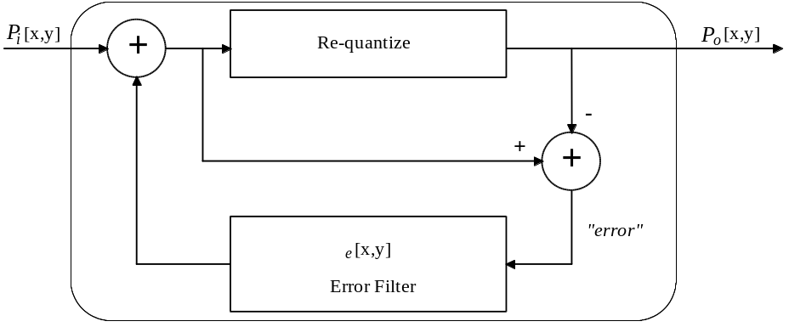
Figure A-1 Diagram of the ErrorDiffusion algorithm
An analysis of various error filters is presented in chapter 8 of [¹]. One popular error filter is described in [].

Ordered
Parameters
threshold-order CARD8
Dispersed-dot Ordered dither replaces a matrix, or block, of pixels with a patterned matrix of pixels. This patterned matrix of pixels is applied across the entire image. Since these patterns may introduce artifacts that are distracting to the eye, the threshold-order parameter is available to determine the size of the dither matrix, and therefore, the number of levels that can be simulated. If the value of threshold-order is M, the threshold matrix can simulate 2^{M}+1 levels.
For more information refer to [], and chapter 6 of [].

Encode Techniques

ServerChoice (only valid for ExportPhotomap)
Parameters
preference CARD8 { PreferDefault, PreferSpace, PreferTime }
ServerChoice allows the server to choose an encode technique. An optional “hint” can be provided to help the server make its choice, but the server is not obligated to obey the hint. PreferTime hints that retrieval performance is the desired metric, whereas PreferSpace indicates that frugal use of storage space is more important. Normally ServerChoice must choose a lossless encode technique, but when data is received from an adjacent upstream import element it may choose to pass the import element’s input data directly to the Photomap.

UncompressedSingle
Parameters
fill-order XieTypOrientation
pixel-order XieTypOrientation
pixel-stride CARD8
scanline-pad CARD8

UncompressedTriple
Parameters
fill-order XieTypOrientation
pixel-order XieTypOrientation
band-order XieTypOrientation
interleave XieTypInterleave
pixel-stride XieTypTripletofCARD8
scanline-pad XieTypTripletofCARD8
UncompressedSingle and UncompressedTriple specify that no compression scheme is to be applied to the image data. They are used for SingleBand and TripleBand data, respectively. Their parameters define the format of the DataStream of uncompressed data that is made available for client retrieval via GetClientData.
The following parameters are common to both techniques:
• When multiple pixels are put in the same byte or a pixel spans multiple bytes, fill-order specifies whether the pixels (or parts of pixels) are packed into the most or least significant bits of a byte first.
• For pixels that span a byte boundary, pixel-order defines whether the most or least significant bits of the pixel are put first within the DataStream.
• Pixel-stride is the number of bits between the start of consecutive pixels within a scanline. It must be at least enough bits to contain the number of src levels.
• Scanline-pad defines a multiple of bytes to which each scanline is padded; valid values are: 0 (not aligned), 1, 2, 4, 8, and 16.
The following parameters are only used by UncompressedTriple:
• Band-order is the order of the image bands or image planes as they are transmitted through the protocol stream.
• Interleave describes how the bands are interleaved (per pixel within a single plane, or sent as three separate planes). Export of down-sampled BandByPixel data is not supported (i.e. all bands must have equal widths and equal heights).

CCITT-G31D
Parameters
align-eol BOOL
radiometric BOOL
encoded-order XieTypOrientation
CCITT-G31D is the CCITT group 3 one dimensional encoding technique as defined by [].
Align-eol, if true, specifies that sufficient fill bits must precede EOL codes to guarantee that each EOL will end on a byte boundary (thus EOL will be a nibble of 0 followed by a byte of 1: xxxx,00002 0000,00012). Radiometric specifies that image ones will be encoded as “white runs”, or conversely, image zeros will be encoded as “white runs”, if radiometric is false. Encoded-order specifies the bit-order for the encoded data.

CCITT-G32D
Parameters
uncompressed BOOL
align-eol BOOL
radiometric BOOL
encoded-order XieTypOrientation
k-factor CARD32
CCITT-G32D is the CCITT group 3 two dimensional encoding technique as defined by [¹].
Uncompressed, if true, will enable the use of the uncompressed-mode CCITT extension. Align-eol, if true, specifies that sufficient fill bits must precede EOL codes to guarantee that each EOL will end on a byte boundary (thus EOL will be a nibble of 0 followed by a byte of 1: xxxx,00002 0000,00012). Radiometric specifies that image ones will be encoded as “white runs”, or conversely, image zeros will be encoded as “white runs”, if radiometric is false. Encoded-order specifies the bit-order for the encoded data. K-factor specifies the number of 2D scanlines to produce for each 1D scanline.

CCITT-G42D
Parameters
uncompressed BOOL
radiometric BOOL
encoded-order XieTypOrientation
CCITT-G42D is the CCITT group 4 two dimensional encoding technique as defined by [].
Uncompressed, if true, will enable the use of the uncompressed-mode CCITT extension. Radiometric specifies that image ones will be encoded as “white runs”, or conversely, image zeros will be encoded as “white runs”, if radiometric is false. Encoded-order specifies the bit-order for the encoded data.

JPEG-Baseline
Parameters
interleave XieTypInterleave
band-order XieTypOrientation
horizontal-samples XieTypTripletofCARD8
vertical-samples XieTypTripletofCARD8
q-table LISTofCARD8
ac-table LISTofCARD8
dc-table LISTofCARD8
JPEG-Baseline is baseline Huffman DCT encoding as defined by []. A stream of JPEG Interchange Format (JIF) data is produced (i.e. all tables, compressed data, etc., delineated by markers).
Interleave determines if all bands of a TripleBand image will be interleaved within a single encoded stream, or if three separate encoded streams will be produced. Band-order specifies the order in which the bands are encoded. Horizontal-samples and vertical-samples are the horizontal and vertical sampling factors. Q-table is the quantization table. Ac-table specifies the AC Huffman table and dc-table specifies the DC Huffman table.
There may be one q-table per band or a single q-table shared between all bands. Generally there is a single AC/DC pair of Huffman tables, but for TripleBand BandByPixel data there may be two pairs of tables (one for the luminance band and the other for the chromanance bands). If any table is specified with zero length, it indicates that the server implementor is to supply that table (e.g. the example tables defined in [¹]).
Interleave, band-order, horizontal-samples, and vertical-samples are ignored for SingleBand images, and horizontal-samples and vertical-samples are always ignored if interleave is BandByPlane. Horizontal-samples and vertical-samples share the definitions and restrictions stipulated for parameters H_{i} and V_{i}, respectively, that are specified in annexes A and B of [¹].

JPEG-Lossless
Parameters
interleave XieTypInterleave
band-order XieTypOrientation
predictor { PredictorNone None
PredictorA A
PredictorB B
PredictorC C
PredictorABC A+B-C
PredictorABC2 A+((B-C)/2)
PredictorBAC2 B+((A-C)/2)
PredictorAB2 } (A+B)/2
table LISTofCARD8
JPEG-Lossless, corresponds to frames encoded using Huffman, predictive sequential lossless encoding as defined by [¹]. A DataStream of JPEG Interchange Format (JIF) data is returned (i.e. all tables, compressed data, etc., delineated by markers).
Interleave determines if all bands of a TripleBand image will be interleaved within a single encoded stream, or if three separate encoded streams will be produced. Band-order specifies the order in which the bands are encoded. Interleave and band-order are ignored for SingleBand images.
Predictor is the predictor selection value (one per band). Table is the lossless entropy encoding table (up to one per band). Specifying a table of length zero indicates that the server implementor should supply a table (e.g. the example tables defined in [¹]).

TIFF-2
Parameters
radiometric BOOL
encoded-order XieTypOrientation
TIFF-2 is modified Huffman compression as described in [] (TIFF compression scheme 2).
Radiometric specifies that image ones will be encoded as “white runs”, or conversely, image zeros will be encoded as “white runs”, if radiometric is false. Encoded-order specifies the bit-order for the encoded data.

TIFF-PackBits
Parameters
encoded-order XieTypOrientation
TIFF-PackBits is byte-oriented run-length encoding as described in [¹] (TIFF compression scheme 32773).
Encoded-order specifies the bit-order of the encoded data.

Gamut Compression Techniques
GamutTechnique defines the gamut compression techniques used by the ConvertToRGB element. It deals with converted colors that fall outside the gamut of the RGB colorspace.

None
Parameters
< none >
None specifies that no gamut compression is required.

ClipRGB
Parameters
< none >
ClipRGB ensures that Unconstrained output pixel values remain within the implicit range [0.0, 1.0].
Note that Constrained data are clipped to the range [0, levels-1] by definition.

Geometry Techniques

Antialias
Parameters
< none >
Some Geometry techniques produce artifacts when replicating pixels or sampling the input image at distinct intervals. One example are the “jaggies” that one often sees along diagonal lines and curved objects in an image. Another indication is that some techniques, such as nearest neighbor, seem to drop image detail. For example, one could scale down an image by four simply by selecting every fourth row and column in the input image. Given an image with a set of randomly placed vertical lines, each line will have a 75% chance of being dropped in the output image. As a result, the output image in the worst case may have little resemblance to the input image.
Antialiasing techniques incorporate information from an area of pixels in the input image in order to produce each output pixel. This implies that line dropouts and other artifacts will occur less often, and the output image may have markedly better resemblance to the input image.
The techniques AntialiasByArea and AntialiasByLowpass are two examples of specific antialiasing algorithms. Antialias may be mapped to either of them, or to a vendor-private algorithm. All parameters for the specific algorithm employed are defaulted by the server.

AntialiasByArea
Parameters
simple INT16
Geometry may be used to scale an image down from a larger size to a smaller size. This will decrease the density of pixels per unit area in the image. In Figure A-2(a), an input image at the original resolution is displayed. It is to be reduced to the grid shown in Figure A-2(b), where the original image is super-imposed on the new, lower density grid. Figure A-2(c) shows a possible result of using nearest-neighbor sampling to fill the output grid. Specifically, the output pixel's upper-left corner is matched against the nearest upper-left corner of pixels in the input image. If the nearest input pixel is black, the output pixel is filled with black. Otherwise it is filled with white. While the pixel intensities (in this case, pure black and pure white) are preserved by this operation, the overall image shape is changed.

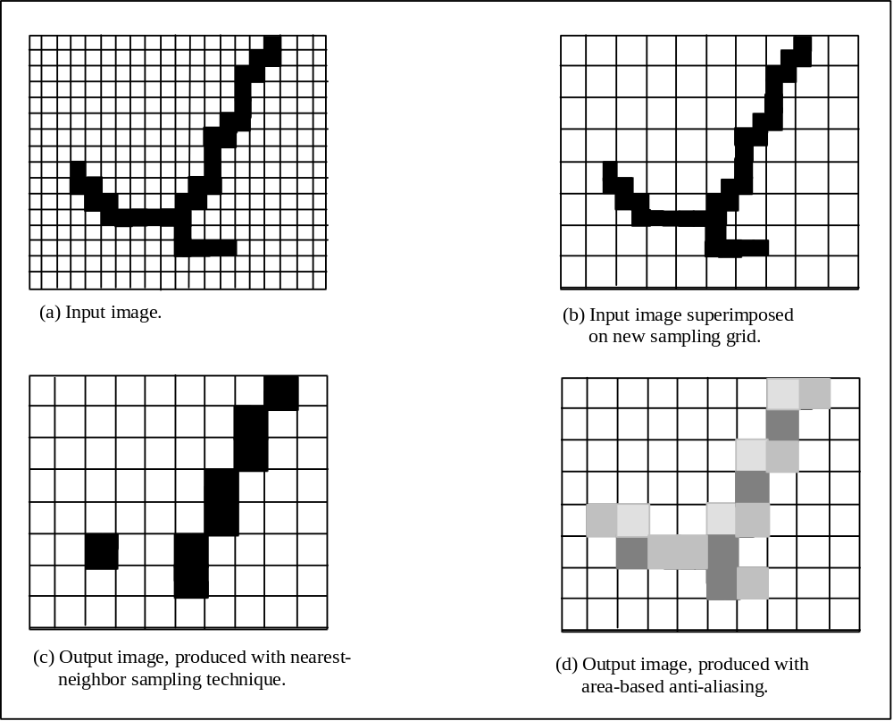
Figure A-2 Effect of sampling technique when scaling to a lower pixel density
In Figure A-2(d), the output image is computed by assigning to each output pixel the weighted average of the intensity values of input pixels which fall within its “area”. That is, the four corners of the output pixel are projected back onto the input image. The input pixels which lie within this area contribute according to:
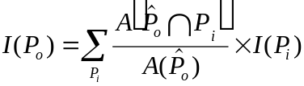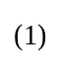
Here 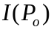 is the intensity of output pixel , stands for the projection of into the input image space, 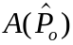 is the area of in the input image space, 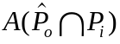 is the area of the intersection of with the rectangular locus of , and the sum progresses over all pixels in the input image (note that for most such pixels, the area of intersection will be zero).

Figure A-3 illustrates the calculation for a single output pixel, P, whose projection intersects nine input pixels to various degrees. Note that the number of pixels intersected depends on the degree of scaling involved. A greater reduction in producing the output image will cause more input pixels to be intersected per output pixel. Also, in case of non-orthogonal rotation of the image, the areas of intersection will not be rectangular in general.

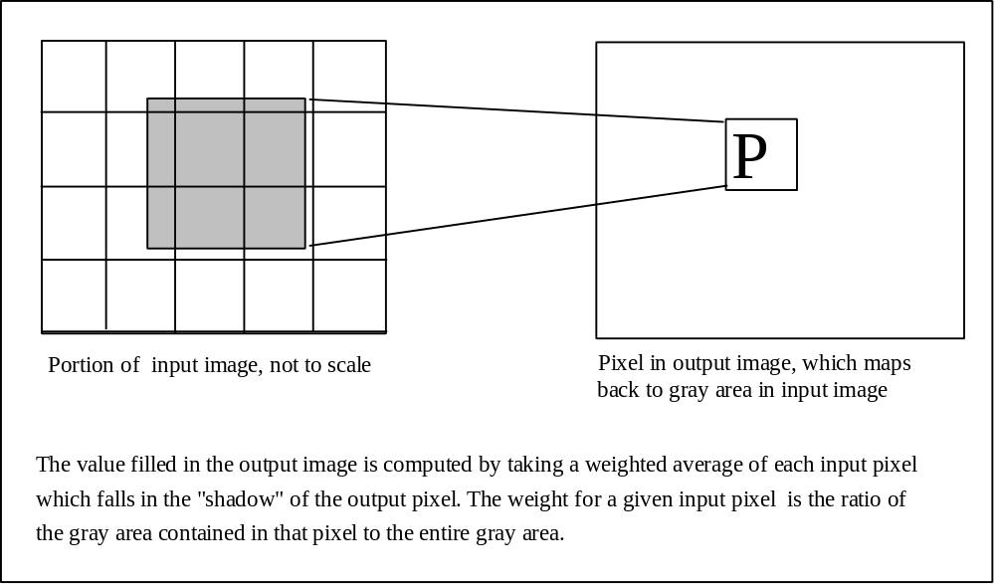
Figure A-3 Illustration of an output pixel mapping back to the input image
Because of the computational complexity of this method, two approximations are supported. If simple is non-zero, the pixels covered by the projected area will be averaged without regard to the relative amount of gray area which they contain: if they are touched by the area, they are included in a simple average. If simple is set to N, with N odd and greater than one (3,5,7, ...), then only the center point of the output pixel is projected, and a simple average is taken of an N by N window centered on the projection. For best results, N should correspond roughly to the amount of scaling which will be done.

AntialiasByLowpass
Parameters
kernel-size INT16
Geometry may be used to scale an image down from a larger size to a smaller size. This will decrease the density of pixels per unit area in the image. Figure A-2 demonstrates the difference between scaling an image down using nearest-neighbor vs. antialias techniques. AntialiasByArea preserves shape, as in Figure A-2 (d) but can be very slow computationally. The method presented here represents an approximation to AntialiasByArea which can be faster, yet provides similar results.
Figure A-4 demonstrates how antialiasing can be produced using a low-pass filter. A 3x3 boxcar kernel is passed over the original input image, in Figure A-4 (b). This image is shown superimposed on the lower density grid in Figure A-4 (c). Nearest neighbor sampling by selecting the value of the input pixel in the upper left hand corner of the output pixel area results in the image in Figure
A-4(d). As was the case with AntialiasByArea, the overall structure of the input image is maintained.
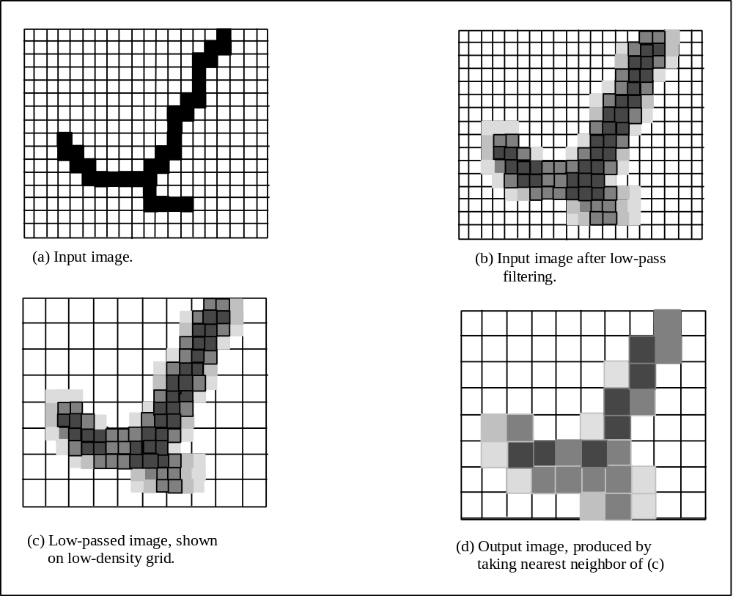
Figure A-4 Sequence producing an antialiased image using a low-pass filter
The user is allowed to select the size of the image kernel via the kernel-size parameter. For best results, kernel-size should be chosen to correspond roughly to the amount of scaling which will be done. Note that the server chooses the best kernel for the appropriate size; the values used in the kernel are not alterable by the client application. Clients wishing to specify the kernel in more detail should use Convolve directly.

BilinearInterpolation
Parameters
< none >
Geometry maps each pixel (x',y') in the output image to the coordinate location (x,y) in the input image by:
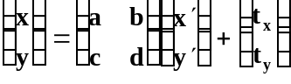 (1)

It is not unusual that the input location (x,y) so derived will be non-integral, and will not correspond exactly to a single pixel in the input image. In this case, we can obtain an interpolated value by first interpolating its neighbors in the X direction, followed by an interpolation in the Y direction, as depicted below.
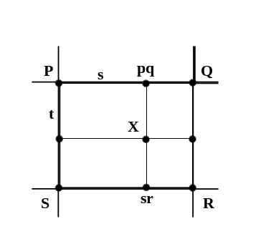
Pixel grid locations P, Q, R, and S are integral. Pixel location X = (x,y)T, obtained from the mapping equation above, differs from P by fractional amounts s in the x direction and t in the y direction. Point pq is the projection of X on line PQ, and point sr is the projection of X on line SR.
Let I(P) be the value of the input image at coordinate P, if P is within the image extent. Otherwise, let I(P) be constant, where constant is the pixel value passed to the Geometry element. A value of I(X)must be estimated from I(P), I(Q), I(R), and I(S). We may obtain estimates of I(pq) and I(sr) by:
I(pq) = (1 - s) * I(P) + s * I(Q)
I(sr) = (1 - s) * I(S) + s * I(R)
Given values for I(pq) and I(sr), I(X) is obtained by interpolating in the y direction:
I(X) = (1 - t) * I(pq) + t * I(sr)
Thus
I(X) = (1 - s) * (1 - t) * I(P) + (1 - s) * t * I(S) + s * (1 - t) * I(Q) + s * t * I(R)
Note that I(X) provides sensible values for the extreme values of s and t (0 and 1), and for
s = t = ¹/₂.

Gaussian
Parameters
sigma XieTypFloat
normalize XieTypFloat
radius CARD8
simple BOOL
Sigma is the drop-off rate, normalize is a normalization constant, radius defines the extent of computation, and simple allows the use of an approximate form.
Geometry maps each pixel (x',y') in the output image to the coordinate location (x,y) in the input image by:
(1)

It is not unusual that the input location (x,y) so derived will be non-integral, and will not correspond exactly to a single pixel in the input image. The situation is depicted below:
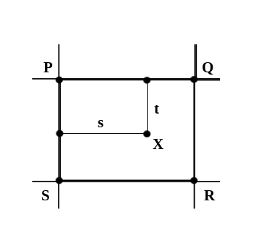
Pixel grid locations P, Q, R, and S are integral. Pixel location X = (x,y)T, obtained from the mapping equation above, differs from P by fractional amounts s (horizontally) and t (vertically).
Let I(P) be the value of the input image at coordinate P, if P is within the image extent. Otherwise, let I(P) be constant, where constant is the pixel value passed to the Geometry element. A value of I(X) must be estimated from I(P), I(Q), I(R), and I(S). From sampling theory, a band width limited continuous input image can be recovered perfectly (under certain conditions) from its sampled output by computing the convolution:
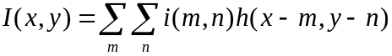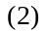
Here I(x,y) is the continuous image, i(m,n) the discrete sampled image, and h(u,v) is the impulse response function for an appropriate low pass filter. Note that both nearest-neighbor and bilinear interpolation resampling techniques may be cast in this form [].
A Gaussian impulse response function has the quality that its Fourier transform has the same “bell curve” shape. For certain kinds of images, this provides a better approximation to an ideal low-pass filter than is represented by either bilinear or nearest-neighbor interpolation. The specific form of h(u,v) is given by:
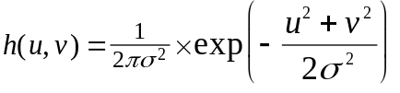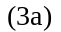
The 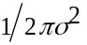 term is called the normalization constant and may be altered using the normalize parameter. The suggested value for σ is 1. Note that all technique parameters must be chosen in concert.
As an example of Gaussian interpolation, assume σ = 1 and that point P in the above figure has coordinates (m',n'). Then x = m'+ s and y = n'+ t, and the basic interpolation equation at (x,y) becomes:
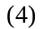
The contribution from point P in this equation is represented by the summation value for m = m', n = n'. Identifying this term in Eq (4), the contribution is:
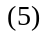
Or
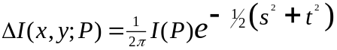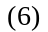
Similar calculations reveal
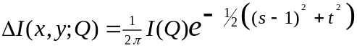 (7)
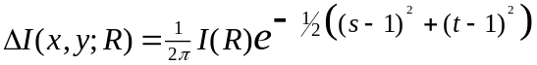 (8)
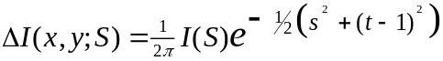 (9)
A suggested value for radius is one, that is, only pixels within a distance of one in either the x or y direction are involved in the calculation. Thus I(x,y) is given by the sum of Eqs. 6-9. Choosing a larger radius would bring in more terms.
For computational convenience, a simplified form of Gaussian interpolation is provided. If simple is true, the impulse-response function of Equation 3a is replaced by:
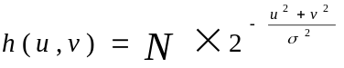 (3b)
The normalization factor N is defined by normalize. As with true Gaussian interpolation, the radius parameter is used to determine the number of pixels involved in the computation.

NearestNeighbor
Parameters
modify CARD8 { FavorDown, FavorUp,
RoundNW, RoundNE,
RoundSW, RoundSE }
Geometry maps each pixel (x',y') in the output image to the coordinate location (x,y) in the input image by:
(1)

It is not unusual that the input location (x,y) so derived will be non-integral, and will not correspond exactly to a single pixel in the input image. The situation is depicted below:
Pixel grid locations P, Q, R, and S are integral. Pixel location X = (x,y)T, obtained from the mapping equation above, differs from P by fractional amounts s in the x direction and t in the y direction.
Let I(P) be the value of the input image at coordinate P, if P is within the image extent. Otherwise, let I(P) be constant, where constant is the pixel value passed to the Geometry element. A value of I(X) must be estimated from I(P), I(Q), I(R), and I(S). In nearest-neighbor sampling, we simply choose the image value from the discrete location closest to X. Thus,
if s < 1/2, t < 1/2, set I(X) = I(P),
if s > 1/2, t < 1/2, set I(X) = I(Q),
if s > 1/2, t > 1/2, set I(X) = I(R),
if s < 1/2, t > 1/2, set I(X) = I(S).
The behavior on even boundaries (s = 1/2 or t = 1/2) is determined by the modify parameter. If modify is FavorDown, all less than signs in the above are replaced with less than or equal signs. Thus, P would win all ties, S and Q would lose to P but win over R, and R would lose all ties. If modify is FavorUp , then all greater than signs would be replaced with greater than or equals, and the opposite behavior would occur.
Four additional options are provided. The RoundNW option will always choose P, RoundNE will always choose Q, RoundSE will always choose R, and RoundSW will always choose S. These are not strictly nearest neighbor algorithms but are available for computational/filtering convenience.

Histogram Shapes
MatchHistogram matches the histogram of a source image to a specific shape represented by a probability density function. HistogramShape defines various shapes that can be requested.

Flat
Parameters
< none >
Flat specifies that the output image is to have a histogram that approximates a uniform density (histogram equalization). No additional parameters are required.

Gaussian
Parameters
mean XieTypFloat
sigma XieTypFloat
Gaussian specifies that the output image is to have histogram that approximates a Gaussian probability density. The supplied parameters are used to generate a Gaussian probability density function centered around the mean level with a “spread” specified by sigma:
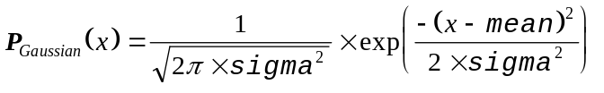

Hyperbolic
Parameters
constant XieTypFloat
shape-factor BOOL
Hyperbolic specifies that the output image is to have histogram that approximates a hyperbolic probability density.
Constant is used to generate a hyperbolic probability density function:
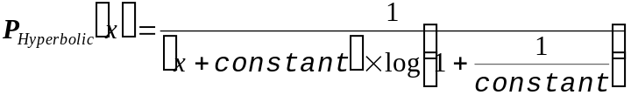
Shape-factor should be specified as false if the histogram shape represents decreasing values for higher levels, or true if the shape represents increasing values for higher levels.

White Point Adjustment Techniques
WhiteAdjustTechnique defines the white point adjustment techniques which can be used when converting to or from the RGB colorspace. White point correction can be used to ensure that white looks white, or it can be used to change the overall tint of an image.

None
Parameters
< none >
None specifies that no white point correction is desired.

CIELabShift
Parameters
white-point XieTypConstant
CIELabShift specifies that white point correction is to be accomplished by adding the white point displacement to the a*b* plane in the CIELab colorspace. The white-point is specified using CIEXYZ encodings.
If WhiteAdjustTechnique is used with ConvertFromRGB, white-point specifies the desired white point of the output data.
If WhiteAdjustTechnique is used with ConvertToRGB, white-point specifies the white point of the source data.

A full description of the color matching algorithm is available upon request from author Shelley.
"Color image quantization for frame buffer display", by P. S. Heckbert, Computer Graphics (ACM SIGGRAPH '82 Conf. Proc.), vol. 16, no. 3, page 297.
CCITT T.4, "Standardization of Group 3 Facsimile Apparatus for Document Transmission"
Image compression generally starts with the least significant pixel in the image (at coordinate 0,0) and proceeds in raster order to the end of the image. This would be the normal order. Some encoders read pixels in reversed order within each byte (i.e. start reading at bit 7 and proceed down through 0, then 15 through 8, etc.). Specifying normal as false can correct for this situation upon decode (i.e. the bit order within each byte of decoded data is reversed before the data are forwarded to downstream elements).
CCITT T.6, "Facsimile Coding Schemes and Coding Control Functions for Group 4 Facsimile Apparatus"
ISO DIS 10918-1 "Digital Compression and Coding of Continuous-tone Still Images"
"TIFF Tag Image File Format", revision 6.0, draft 2, by Aldus Corporation
Image compression generally starts with the least significant pixel in the image (at coordinate 0,0) and proceeds in raster order to the end of the image. This would be the normal order. Some encoders read pixels in reversed order within each byte (i.e. start reading at bit 7 and proceed down through 0, then 15 through 8, etc.). Specifying normal as false can correct for this situation upon decode (i.e. the bit order within each byte of decoded data is reversed before the data are forwarded to downstream elements).
"Digital Halftoning", by R. A. Ulichney, Cambridge, MA: The MIT Press
"Adaptive algorithm for spatial grey scale", by R. W. Floyd and L. Steinberg, SID Int. Sym. Digest of Tech. Papers, page 36
"An optimum method for two level rendition of continuous-tone pictures", by B. E. Bayer, Proc. IEEE Int. Conf. Commun., Conference Record, page 26-11
"Digital Halftoning", by R. A. Ulichney, Cambridge, MA: The MIT Press
CCITT T.4, "Standardization of Group 3 Facsimile Apparatus for Document Transmission"
CCITT T.6 "Facsimile Coding Schemes and Coding Control Functions for Group 4 Facsimile Apparatus"
ISO DIS 10918-1 "Digital Compression and Coding of Continuous-tone Still Images"
"TIFF Tag Image File Format", revision 6.0, draft 2, by Aldus Corporation
A. Jain. Fundamentals of Digital Image Processing. Englewood Cliffs, J.J.: Prentice-Hall, 1989

