WPF demo application
© Jurijs Juhno 2019
All rights reserved

Table of Contents

1. Purpose 3
2. functional requirements 3
3. the solution overview 3
3.1. Core 3
3.2. UI 3
3.3. Helpers 4
3.4. Test application tests 4
3.5. Test project 4
3.6. User interface 4
3.6.1. MainWindow.xaml 4
3.6.2. Calculator.xaml 4
3.6.3. CurrencyConverter.xaml 5

Purpose
This software application is the WPF .NET solution. Program purpose is to demonstarte WPF possibilities and MVVM pattern. The solution consists of different .NET projects to apply styles, to create MVVM models and view models, the project to use unit tests and the project with WPF demonstrations.
Some functionalities are based on the project https://github.com/angelsix/fasetto-word
In turn main project demonstrates calculator and currency converter funcionalities.

functional requirements
The .NET application has been created in the MS Viual Studio 2017 environment and uses .NET 4.6 Framework.
Some projects (the Core project) from the solution use the plugin Fody PropertyChanged, which raises the PropertyChanged event, into property setters of classes which implement INotifyPropertyChanged. The plugin can found here https://github.com/Fody/PropertyChanged.

the solution overview
The solution has the following .NET projects:

Core
This project contains all models and view models the presantion solution. Mainly all view models in te project derive from the BaseModel class. From it derives BaseViewModel class, which contains main methods to operate with windows (close, open, open dialog, activated). From this class derives WindowViewModel to manipulate with main window in the presentaion project.
To show windows with panel and title is used TitlePanelViewModel. From it derive CalculatorViewModel and CurrencyConverterViewModel.
Also this project contains different attached properties and the class to create relay commands.

UI
This project conatins different resource dictionaries with styles. Winndows.xaml conatains styles for windows’ styling, Buttons.xaml contains buttons’ styles for the main window and other windows. Colors.xaml contains common colors and brushes to use in the whole solution.

Helpers
This purpose of this project is to create additional methods, classes and functions to use in another projects in the solution. There can be found different animations for windows, extension methods and behaviours.

Test application tests
This project contains unit tests for the View Models from the Core project.

Test project
This is the main project to demonstrate WPF visual possibilities. It contains one main window MainWindow.xaml and window with calculator Calculator.xaml and currency converter CurrencyConverter.xaml

User interface

MainWindow.xaml
In this screen user can make a choice between calculator and currency converter.

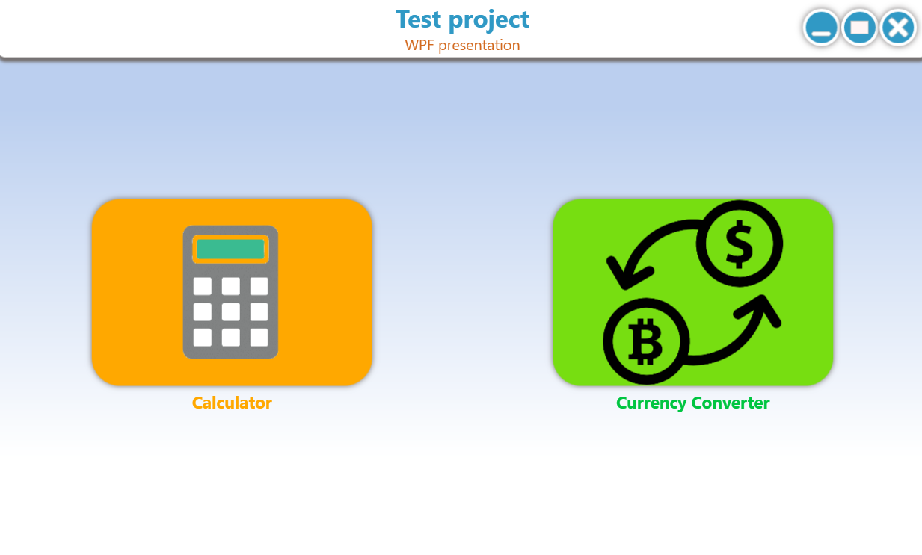

Calculator.xaml
In this screen is presented a calculator for simple mathematical computations.
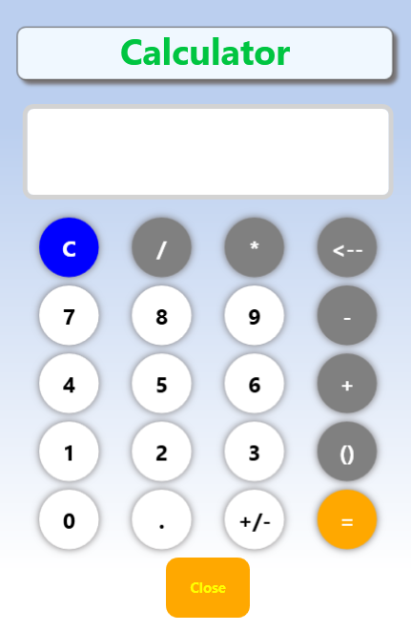

CurrencyConverter.xaml
In this screen user can calculate prices of the currenties based on the rates from the https://www.bank.lv/ web site.
