IoT-Enabled Smart Building Energy Management with Integrated Load Forecasting, Anomaly Detection, and Control
Ahmad H. Milyani^{1,2}, Arbab Mohammad Kamal³, Atif Mohammad Kamal³, Amjad Ali Pasha⁴, Tauheed Khan Mohd^{5,*}
¹ Department of Electrical and Computer Engineering, Faculty of Engineering, King Abdulaziz University, Jeddah, Saudi Arabia
² Center of Excellence in Intelligent Engineering Systems (CEIES), King Abdulaziz University, Jeddah, Saudi Arabia
³ Department of Computer Science and Engineering, Indian Institute of Technology Patna, Patna 801106, India
⁴ Department of Aerospace Engineering, King Abdulaziz University, Jeddah, Saudi Arabia
⁵ School of Information Security & Applied Computing, Eastern Michigan University, Ypsilanti, MI, USA
* Correspondence: tkhanmoh@emich.edu
Abstract
DOptDRPSNN-EMS is an IoT-enabled forecast–anomaly–control framework for smart-building energy management, prioritising deployable information flow, reproducibility, cross-building fault transfer and verifiable supervisory control over single-metric forecasting superiority. A 24 h causal window predicts the clean-load counterfactual as a learned correction anchored to the observed meter at t − 1. The Meerkat Optimization Algorithm freezes a nine-feature mask from fifteen candidates; the Dream Optimization Algorithm tunes a dual residual attention encoder and probabilistic spiking neural network (PSNN) head. On three unseen archetypes DOptDRPSNN obtains one-hour RMSE 26.95 ± 0.31 kWh and R² 0.755 ± 0.006, whereas a tuned Transformer reaches 19.90 ± 0.48 kWh; at six hours several baselines also outperform it, so no leaderboard claim is made. A ten-seed encoder-matched head-replacement experiment instead gives RMSE SD 0.189 kWh against 1.733 kWh for a matched DRA-GRU (F = 83.91, one-sided p = 1.34 × 10⁻⁷). A validation-calibrated residual head transfers to unseen buildings at F1 = 0.632, AUPRC = 0.749 and AUROC = 0.904; removing the PSNN spike rate lowers F1 to 0.537. The anomaly gate cuts aggregate energy by 0.030% and tariff-weighted cost by 0.067% while blocking 49 flagged hours. The evidence supports a compact, stability-oriented and causally closed BEMS workflow.
Keywords: building energy management; internet of things; energy forecasting; anomaly detection; cross-building generalization; initialization stability; probabilistic spiking neural network; residual attention; supervisory control; demand response
Nomenclature
A_{b} | Conditioned floor area of building b (ft²)
a_{t} | Supervisory control action at hour t
F | Number of candidate input variables (F = 15)
J_{MOA} | MOA fitness combining validation error and mask size
L_{t}^{clean} | Simulation-only clean counterfactual load at hour t (kWh)
m_{t} | Observed meter reading at hour t (kWh)
p_{t} | PSNN firing-probability vector at step t
p_{t}^{anom} | Calibrated anomaly probability at hour t
r̂_{t} | Standardized network output (increment prediction)
s̄ | Time-averaged firing-probability vector (mean spike rate)
T | Input window length (T = 24 h)
u_{t} | PSNN membrane state at step t
X_{t} | Input tensor over the trailing 24 h window
ŷ_{t} | Reconstructed load forecast at hour t (kWh)
z_{t} | Fused encoder latent representation at step t
β | PSNN membrane leak coefficient (β = 0.9432)
Δ_{t} | Area-normalized load increment
θ_{a} | Anomaly-probability decision threshold (θ_{a} = 0.0574)
θ_{s} | PSNN firing threshold (θ_{s} = 0.3688)
κ | PSNN soft-reset coefficient (κ = 0.35)
λ | MOA sparsity penalty weight (λ = 0.006)
μ_{Δ}, σ_{Δ} | Training-set mean and SD of the area-normalized increment
σ_{y} | Standard deviation of the validation target
τ | PSNN probability temperature (τ = 0.18)
Abbreviations
AUPRC | Area under the precision–recall curve
AUROC | Area under the receiver operating characteristic curve
BAS | Building automation system
BDG2 | Building Data Genome Project 2
BEMS | Building energy management system
DOA | Dream Optimization Algorithm
DRA | Dual residual attention
EIA | U.S. Energy Information Administration
GEPIII | ASHRAE Great Energy Predictor III
HDRAB | Hybrid dilated residual attention block
MAE / MAPE | Mean absolute error / mean absolute percentage error
MOA | Meerkat Optimization Algorithm
PSNN | Probabilistic spiking neural network
RAB | Residual attention block
RMSE | Root-mean-square error
TOU | Time-of-use (electricity tariff)

1. Introduction
Building energy management systems (BEMS) increasingly combine IoT telemetry, forecasting, reliability assessment and supervisory control. For publishable evidence, the key question is not whether a complicated neural architecture can win one metric, but whether the full chain is causal, reproducible, transferable across buildings and able to convert predictions into traceable decisions without relying on unavailable information. This study therefore treats leakage control, deployability and stability as first-order methodological requirements.
Large public building-energy resources such as the ASHRAE Great Energy Predictor III (GEPIII) data and the Building Data Genome Project 2 (BDG2) enable broad forecasting studies [1,2]. However, they do not provide clean counterfactual load traces or universally labelled equipment faults. Conversely, DOE commercial reference buildings provide physically interpretable archetypes and complete simulation descriptions for whole-building analysis [3,4]. The present work therefore uses a controlled DOE-reference-inspired simulation benchmark for experiments that require known anomaly ground truth and counterfactual control, while defining a separate leakage-free protocol for future ASHRAE/BDG2 forecasting validation. This separation avoids presenting synthetic traces as measured ASHRAE observations.
The proposed DOptDRPSNN-EMS architecture combines a dual residual attention encoder with a probabilistic spiking temporal gate. MOA is retained as a compact discrete feature-selection stage and DOA tunes continuous and ordinal hyperparameters. The framing does not claim that the PSNN, MOA or DOA must dominate simpler alternatives in raw forecasting accuracy. Instead, the architecture is evaluated for initialization stability, compactness, cross-building anomaly transfer and forecast-aware control; wherever simpler models are better, the manuscript reports that result directly.

1.1. Research questions and contributions
The study is organized around four research questions.
- RQ1. Does separating discrete feature-mask selection from continuous hyperparameter tuning provide a useful compact configuration, and what is the cost of the reduced input vector?
- RQ2. Does the PSNN-headed architecture offer a reproducibility or reliability advantage relative to GRU, LSTM and Transformer temporal heads, even when it is not the most accurate forecaster?
- RQ3. Can the anomaly pipeline detect labelled faults on buildings never used in model development?
- RQ4. Does a controller that actually reads the model forecast and anomaly probability produce measurable energy and cost effects under a reproducible U.S. tariff benchmark?
The corresponding contributions are as follows.
- C1. One canonical nine-feature, 20-channel DOptDRPSNN configuration is used throughout, and the deployed forecast is reconstructed from the observed meter at t − 1 rather than from the unobservable clean counterfactual.
- C2. Complete chronological split boundaries are reported, together with a second unseen-building test restricted to the same final time window as the seen-building test.
- C3. Six injected fault mechanisms provide known ground truth, and a probabilistic residual-calibration head is evaluated on both seen and unseen buildings.
- C4. The supervisory controller uses next-hour DOptDRPSNN forecasts and the calibrated anomaly probability; a perfect-load comparator and a no-gate variant quantify forecast and safety-gate effects.
- C5. The final analysis identifies which claims survive direct comparison: significantly lower initialization variance than an encoder-matched GRU head in a ten-seed experiment, cross-building anomaly discrimination with a measurable spike-rate contribution, compact optimizer decomposition, and a genuinely forecast-driven anomaly-gated controller. Claims of universal PSNN or forecasting superiority are explicitly rejected.
Figure 1 summarizes the complete causal workflow from benchmark construction and leakage-safe preprocessing through forecasting, anomaly calibration and supervisory control. The remainder of the paper is organized as follows. Section 2 positions the work against related literature. Section 3 describes the data sources, the executed benchmark and the data-governance protocol. Section 4 defines the anomaly ground truth and the probabilistic detection head. Section 5 specifies the architecture. Section 6 details the reproducible implementation and evaluation protocol. Section 7 reports results, Section 8 discusses them, Section 9 states limitations, and Section 10 concludes.
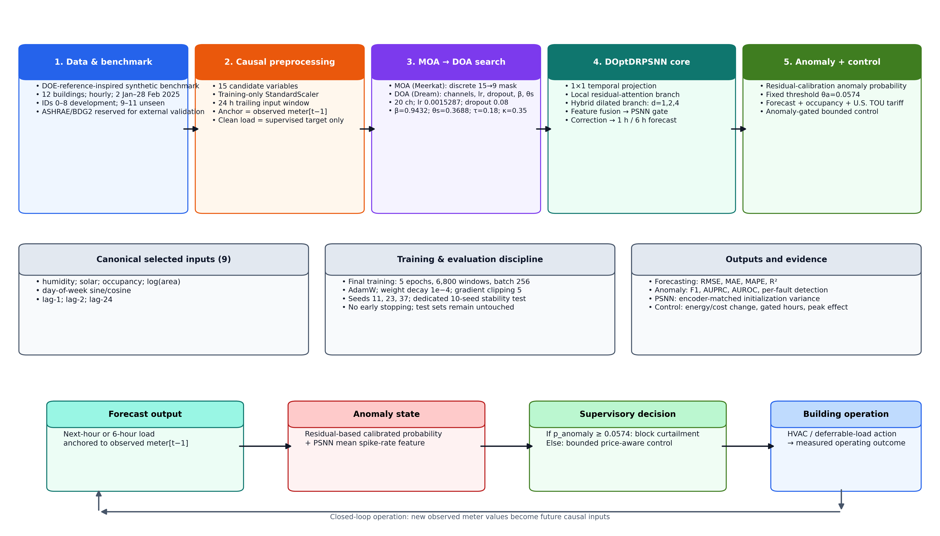
Figure 1. Overall architecture of the proposed IoT-enabled smart-building energy-management framework, integrating leakage-safe preprocessing, load forecasting, residual-based anomaly detection and anomaly-gated supervisory control.

2. Related work and technical positioning
Building-energy forecasting has evolved from ANN, RNN and CNN-LSTM models toward residual hybrids, attention mechanisms and Transformer-family architectures. Recent reviews emphasize that accuracy must be considered together with robustness, computational efficiency, transferability and deployment constraints [7]. Transfer-learning studies using Transformer-type models show strong cross-building potential, particularly for long-horizon settings [8], and hybrid deep networks have been applied to multi-horizon academic-building loads [15]. The Temporal Fusion Transformer, Informer and PatchTST families illustrate the broader move toward attention-based multihorizon forecasting [32–34]. In parallel, IoT-driven hybrid deep models have been proposed specifically for building consumption prediction [25], for whole-building monitoring and retrofit assessment in older stock [21], and for smart-city-scale energy management and monitoring [23]. Optimization-assisted deep energy-management systems have also been developed on the grid side of the meter [24]. These studies establish that IoT-plus-deep-learning pipelines predict consumption well; they generally stop short of closing the loop onto fault-aware control, which is the gap addressed here.
Cross-building deployment introduces heterogeneity and privacy constraints. Personalized and adaptive federated-learning studies have therefore investigated distributed building-load forecasting and anomaly prediction without centralizing raw data [9,16,17]. These approaches are relevant to large building portfolios, but communication overhead, non-IID building behaviour and model synchronization remain important limitations. IoT-focused reviews likewise identify interoperability, data quality, standardization, skills and economic barriers as practical obstacles to BEMS adoption [10–13]. Occupant-centric control literature adds further requirements involving sensing reliability, comfort, building-automation-system integration and computational complexity [14], and work on thermal-comfort modelling across multiple ASHRAE databases shows that even well-resourced supervised tasks in this domain depend heavily on label provenance and dataset harmonization [20].
Forecasting and anomaly identification are often connected through residuals, but the two tasks require different evidence. A forecasting benchmark can be evaluated against future meter or load values, whereas fault detection requires labels or a defensible unsupervised protocol. Recent federated BEMS work combines forecasting with anomaly prediction, and real-world IIoT studies combine load forecasts with anomaly detection [17,26]. In the present study, synthetic fault injection is used explicitly so that anomaly prevalence, fault type, severity, confusion matrices and cross-building transfer can be measured rather than inferred.
Optimization-assisted BEMS studies use evolutionary or swarm methods for feature selection, hyperparameter search or control [27,28,31]. A central methodological issue is whether multiple optimizers add substantive value or merely stack complexity. The present work assigns MOA and DOA non-overlapping roles and reports a three-seed optimizer-role ablation. Because the MOA-selected subset does not improve isolated one-hour accuracy relative to all features, its contribution is framed as dimensionality reduction and search-space decomposition, not as guaranteed predictive superiority. This interpretation follows the broader principle that compute-efficiency claims should be based on transparent costs and fair comparisons [35]. Table 1 positions the representative studies against the requirements of the present forecast–anomaly–control chain.
Table 1. Technical positioning of representative related work with respect to the forecast–anomaly–control chain evaluated in this study.
Study | Approach | Relevance | Remaining limitation
Khan et al. [18] | AI building power forecasting | Intelligent BEMS forecasting | No explicit fault-labelled control validation
Faiz et al. [19] | CNN-LSTM / Transformer | Predictive building-environment control | Task-specific; compute burden
Akter et al. [15] | Hybrid multi-horizon DNN | Multi-horizon academic-building loads | Forecasting only; single campus
Balakumar et al. [22] | RNN-LSTM demand-side management | Real-time demand-side management | Dataset/architecture dependence
Wang et al. [17] | Adaptive federated deep learning | Forecasting + anomaly prediction | Federated heterogeneity / communication
Spencer et al. [8] | Transformer transfer learning | Cross-building forecasting | Forecasting only
Sarmento et al. [16] | Federated CNN-LSTM | Privacy-aware energy forecasting | Edge and coordination overhead
Joha et al. [26] | IIoT forecasting + anomaly detection | Joint operational analytics | Different anomaly/control setting
Selvaraj et al. [23] | AI smart-city BEMS monitoring | Integrated monitoring and management | Limited fault-level ground truth
Ganesh et al. [24] | Deep optimized EMS for IoT grids | Optimization-assisted energy management | Grid-side focus; no building fault labels
Natarajan et al. [25] | IoT-driven hybrid deep learning | Building consumption prediction | Prediction only; no control loop
Arun et al. [21] | IoT + deep learning retrofit monitoring | Energy efficiency in older buildings | Monitoring focus; no forecast-driven control
Li and Xu [27] | Evolutionary + machine learning BEMS | Optimization-aware design | Metaheuristic cost
Xian and Feng [28] | Meerkat Optimization Algorithm | Discrete engineering optimization | Not building-specific
Lang and Gao [31] | Dream Optimization Algorithm | Continuous engineering optimization | Not building-specific
Soleimanijavid et al. [14] | Occupant-centric controls review | Deployment/comfort barriers | Real-world integration remains difficult
Bartoldson et al. [35] | Compute-efficient deep learning review | Fair computational evaluation | General deep learning, not BEMS-specific

3. Data sources, simulation benchmark and data governance

3.1. Public data sources and scope
ASHRAE GEPIII provides hourly meter readings indexed by building, meter type and timestamp, with building metadata and site weather [1]. BDG2 extends this data family to 3,053 meters from 1,636 non-residential buildings over 2016–2017 [2]. These public resources are appropriate for forecasting and cross-building validation, but they are not treated here as labelled anomaly datasets. The anomaly and control experiments therefore use the controlled benchmark described below. Public-data forecasting should reproduce the same leakage controls: training-only preprocessing, chronological validation, complete held-out buildings or sites, and a frozen final test set.
DOE commercial reference buildings provide sixteen building types representing approximately 70% of U.S. commercial floor stock, together with complete descriptions suitable for EnergyPlus simulation [3,4]. Twelve archetypes are used as structural priors in this benchmark. The generated data are synthetic and are identified as such throughout the paper.

3.2. Executed DOE-reference-inspired benchmark
Each of the twelve buildings contains 1,376 hourly observations from 2 January to 28 February 2025, as summarized in Table 2. The generator produces a clean counterfactual load, an HVAC component, occupancy, weather and sensor channels, and an observed meter stream. Weather, occupancy and load coefficients vary by archetype; stochastic noise and fault episodes are added after generation of the clean load. The 58-day span is deliberately short for reproducible reviewer-driven validation and is treated as a winter-only limitation rather than as a full-year BEMS benchmark. Representative daily load profiles and the corresponding environmental and operational channels are shown in Figures S1 and S2 of the supplementary material.
Table 2. Executed simulation benchmark. All twelve buildings share an identical hourly record: 1,376 observations spanning 2 January 2025 00:00 to 28 February 2025 07:00.
ID | Archetype | Hourly obs. | Anomaly rate (%) | Floor area (ft²)
0 | LargeOffice | 1,376 | 7.63 | 498,588
1 | MediumOffice | 1,376 | 7.78 | 53,628
2 | SmallOffice | 1,376 | 8.50 | 5,500
3 | Warehouse | 1,376 | 7.12 | 52,045
4 | Retail | 1,376 | 7.05 | 24,962
5 | School | 1,376 | 6.03 | 73,960
6 | Hospital | 1,376 | 7.49 | 241,351
7 | Hotel | 1,376 | 6.90 | 43,200
8 | Supermarket | 1,376 | 7.19 | 45,000
9 | Outpatient | 1,376 | 8.72 | 40,946
10 | Apartment | 1,376 | 7.34 | 33,740
11 | SecondarySchool | 1,376 | 7.49 | 210,887
Buildings 0–8 form the development set; Buildings 9–11 are held out entirely. Anomaly rate is the share of hours carrying an injected fault label.

3.3. Feature provenance and causal preprocessing
Table 3 lists the fifteen candidate variables together with their provenance and leakage-safe treatment. All scaling statistics are fitted on the training partition only. Missing-value stress tests are applied after standardization by setting selected standardized inputs to zero, which corresponds to a training-mean replacement. This test intentionally isolates model sensitivity to unavailable telemetry; it is not described as the naturally occurring missingness rate of ASHRAE or BDG2.
Table 3. Candidate variables, provenance and leakage-safe treatment.
Variable family | Source | Cadence | Treatment
Temperature, humidity, solar proxy | Simulated weather/sensor | Hourly | Causal imputation; training-only scaling
Occupancy | Simulated schedule/sensor | Hourly | Past-only imputation + quality flag
Log floor area | DOE-reference structural prior | Static | log(1 + area)
Hour/day sine and cosine | Timestamp-derived | Hourly | Deterministic
Lag-1, lag-2, lag-6, lag-12, lag-24 load | Historical observed meter load | Hourly | Past meter values only; causal
24 h rolling mean | Historical load | Hourly | Trailing-only window
Clean counterfactual load | Simulation-only | Hourly | Supervised target only; never a deployment-time anchor
Observed meter / anomaly label | Simulation-only | Hourly | Residual anomaly calibration and evaluation

Concrete stress-test examples include humidity dropout for Building 9 from 2025-02-22 10:00 to 15:00, occupancy dropout for Building 10 from 2025-02-23 14:00 to 17:00, and solar-sensor dropout for Building 11 from 2025-02-25 08:00 to 10:00. These are deliberately injected missing values on otherwise complete simulated input streams and are handled with past-only interpolation or a training-median fallback.

3.4. Chronological and cross-building separation
Buildings 0–8 form the development set. Within each development building, the first 70% is training, the next 15% validation and the final 15% a chronological seen-building test. Buildings 9–11 are never used for scaling, feature selection, DOA tuning, anomaly-head fitting or model fitting. Table 4 gives the exact partition boundaries. Two distinct unseen-building evaluations are reported: (i) a full-period building holdout, which tests cross-building transfer but shares calendar hours with the development buildings, and (ii) a temporally aligned unseen-building holdout restricted to the same final calendar window as the seen test. The second test removes the ambiguity between building holdout and temporal holdout. Figure 2 summarizes the chronological development split, the complete unseen-building isolation and the two evaluation pathways; the archetype-to-role assignment is shown in Figure S3.
Table 4. Leakage-control partitions and their anomaly prevalence.
Partition | Building IDs | Start | End | Rows | Anomaly rate (%)
Train | 0–8 | 2025-01-02 00:00 | 2025-02-11 02:00 | 8,667 | 6.77
Validation | 0–8 | 2025-02-11 03:00 | 2025-02-19 16:00 | 1,854 | 7.61
Seen chronological test | 0–8 | 2025-02-19 17:00 | 2025-02-28 07:00 | 1,863 | 9.45
Unseen building — full period | 9–11 | 2025-01-02 00:00 | 2025-02-28 07:00 | 4,128 | 7.85
Unseen building — temporally aligned | 9–11 | 2025-02-19 17:00 | 2025-02-28 07:00 | 621 | 5.15
Rows and anomaly rates are counted over all timestamps in the partition. Table 15 reports anomaly prevalence over the subset of rows that receive a model score, i.e. after the 24 h input window consumes the first 24 timestamps of each building; see the note to Table 15.
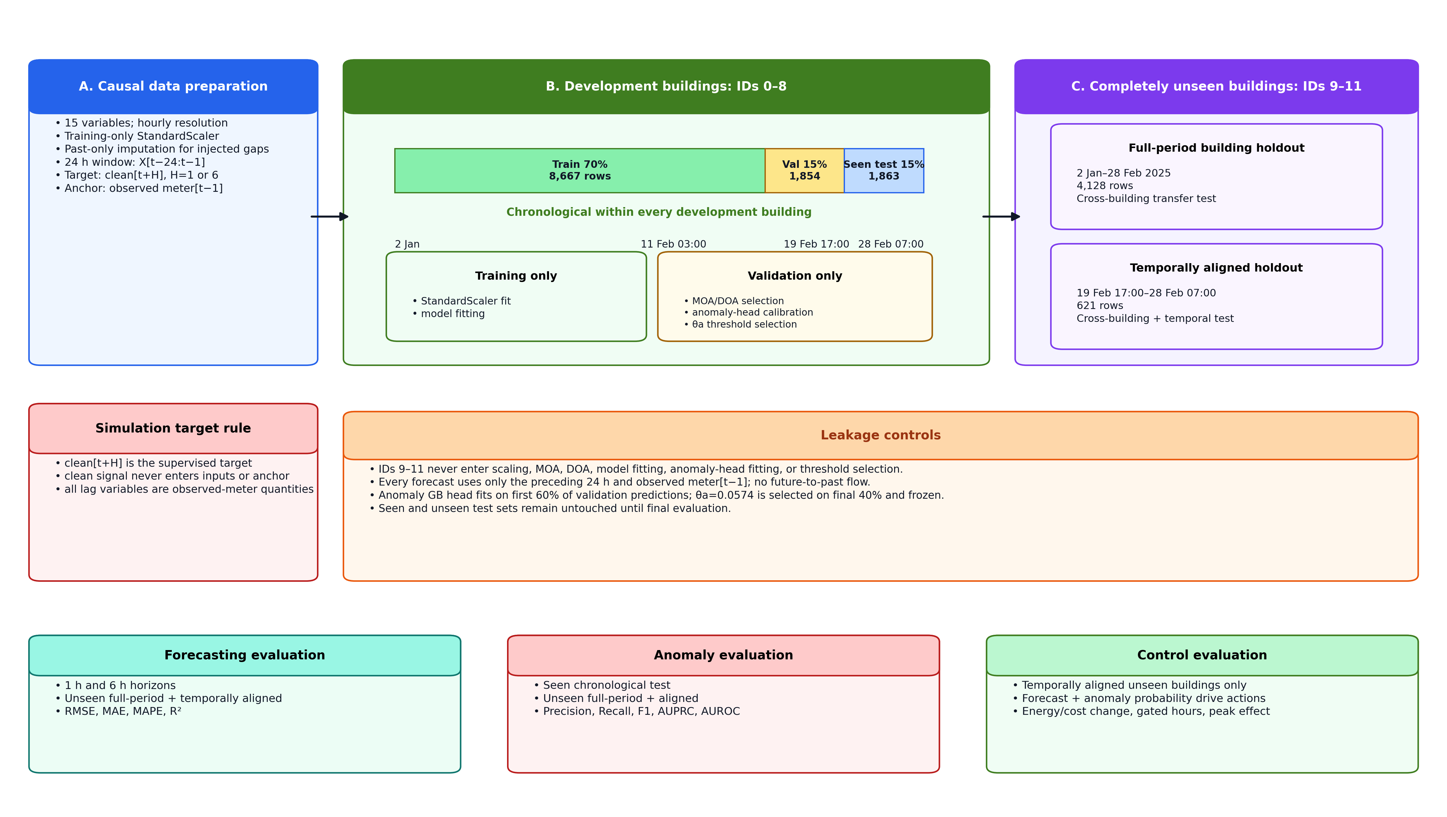
Figure 2. Leakage-aware data preparation and evaluation protocol. Buildings 0–8 are used for model development with chronological 70/15/15 partitioning, whereas Buildings 9–11 remain completely unseen during preprocessing, feature selection, hyperparameter search, model fitting and anomaly calibration.

4. Anomaly ground truth and probabilistic detection

4.1. Fault definitions
An anomaly is a known departure from the clean counterfactual generated by one of six mechanisms: abrupt spike, persistent bias, gradual drift, stuck or repeated telemetry, HVAC-efficiency degradation and schedule override. The labels are generated at injection time, so prevalence, duration and severity are known exactly rather than inferred. Fault episodes are separated whenever the gap between anomalous timestamps exceeds one hour. Table 5 summarizes the resulting ground truth.
Table 5. Injected anomaly ground truth aggregated across all twelve buildings.
Fault type | Hours | Episodes | Mean duration (h) | Min | Max | Mean rel. severity
Spike | 276 | 36 | 7.7 | 1 | 11 | 0.821
Bias | 239 | 36 | 6.6 | 4 | 11 | 0.312
Drift | 188 | 24 | 7.8 | 3 | 11 | 0.309
Schedule override | 181 | 24 | 7.5 | 4 | 11 | 0.597
HVAC degradation | 176 | 24 | 7.3 | 3 | 11 | 0.163
Stuck telemetry | 168 | 24 | 7.0 | 2 | 10 | 0.274
Episodes are separated whenever the gap between consecutive anomalous timestamps exceeds one hour. Relative severity is |m_{t} − L_{t}^{clean}| / max(L_{t}^{clean}, 1).

4.2. Residual-calibration anomaly head
The canonical DOptDRPSNN forecaster produces both a load forecast and a mean PSNN spike probability. For each timestamp, the anomaly head receives twelve inputs: absolute and signed relative forecast residuals, the relative change from the lag-1 anchor, deviations from lag-2 and lag-24, squared residual and jump terms, the mean PSNN spike probability, occupancy, temperature, humidity and the solar proxy. A gradient-boosting classifier with 150 estimators, maximum depth 3 and learning rate 0.05 is fitted on the first 60% of the chronological validation predictions. The final 40% of validation is used only to select the probability threshold that maximizes validation F1. The selected threshold is θ_{a} = 0.0574 and is fixed for every reported test; it is not adapted online.
At deployment time the detector is causal at the decision timestamp, because it uses the current observed meter value, a forecast generated from the preceding 24 h window, historical lags and current sensor context. The anomaly probability is passed to the supervisory control gate. A probability at or above θ_{a} blocks aggressive curtailment and raises a telemetry or fault flag.

5. DOptDRPSNN-EMS architecture
Figure 3 gives the executable architecture used in the final experiments, including the two residual branches, the probabilistic spiking temporal gate, the observed-meter reconstruction anchor and the calibrated anomaly interface.
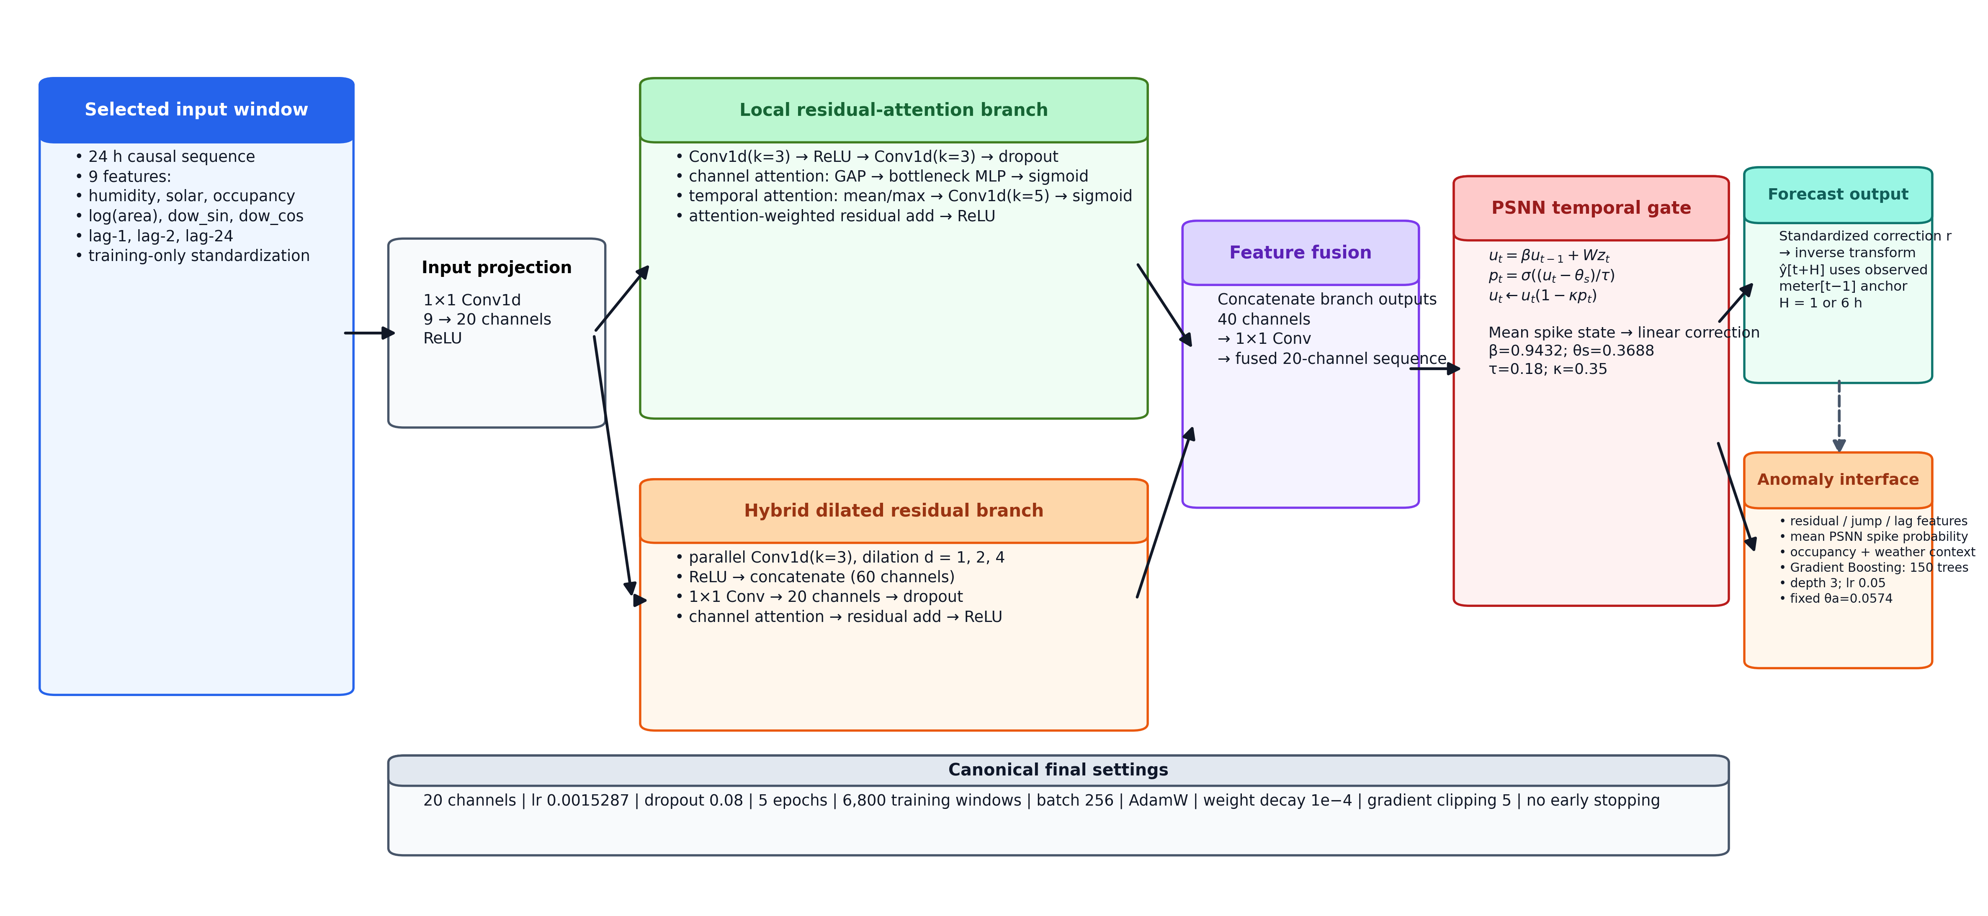
Figure 3. Executable DOptDRPSNN architecture used in the final experiments. One-dimensional local residual attention and hybrid dilated residual branches are fused before the PSNN temporal gate; the model predicts a standardized correction to the observed meter[t − 1] anchor and supplies both forecast residuals and the mean spike probability to the anomaly-calibration head.

5.1. Input representation and MOA feature selection
A 24 h input window X_{t} ∈ ℝ^{24 × F} is created from F = 15 candidate variables. MOA searches a binary feature mask m with the fitness
$J_{\text{MOA}}\left(m\right)=\frac{{\text{RMSE}}_{\text{val}}\left(m\right)}{σ_{y}}+\frac{λ\left|m\right|}{F}\text{,} λ=0.006$ | (1)

where |m| is the number of retained variables and σ_{y} the standard deviation of the validation target. Lag-1 is mandatory because the forecast is formulated as a learned correction to persistence; the remaining fourteen variables are searchable. The frozen nine-feature mask contains humidity, the solar proxy, occupancy, log floor area, day-of-week sine and cosine, lag-1, lag-2 and lag-24.
Crucially, the reconstruction anchor is the observed meter value m_{t−1}. The network is trained on the area-normalized increment
$Δ_{t}=\frac{L_{t}^{\text{clean}}−m_{t−1}}{\sqrt{A_{b}}}$ | (2)

standardized by the training-partition mean μ_{Δ} and standard deviation σ_{Δ}, so the deployed forecast is reconstructed as
${\hat{y}}_{t}=m_{t−1}+\sqrt{A_{b}}\left(σ_{Δ}{\hat{r}}_{t}+μ_{Δ}\right)$ | (3)

where r̂_{t} is the standardized network output and A_{b} the conditioned floor area of building b. Area normalization makes the increment comparable across archetypes that differ by two orders of magnitude in floor area. The simulation-only clean signal L^{clean} is used as the supervised target, but never as a deployment-time input or anchor.
The feature-selection evidence does not support a claim that MOA by itself improves one-hour accuracy. In the controlled three-seed ablation of Section 7.4, all-features and random-k selection are nominally slightly better than the frozen MOA mask, while all differences are small relative to run-to-run variation. MOA is therefore retained for a 40% reduction in input dimensionality and for separating the discrete search from later hyperparameter tuning. This is a deployment and search-space argument, not an accuracy guarantee.

5.2. Dual residual attention encoder
The selected multivariate sequence is projected to C latent channels by a 1 × 1 temporal convolution. A local residual-attention branch (RAB) uses one-dimensional convolutions with channel and temporal attention. A hybrid dilated branch (HDRAB) uses dilation factors 1, 2 and 4 to increase the temporal receptive field without recurrent state expansion. Branch outputs are concatenated and projected to the fused latent sequence z. This adapts the residual-attention principle to multivariate time-series tensors rather than interpreting the feature axis as an image plane [29].

5.3. Probabilistic spiking temporal gate
The temporal head follows the probabilistic spiking formulation of Jang and Simeone [30], in which neurons emit stochastic spikes with a differentiable firing probability rather than a hard threshold. For latent input z_{t}, the PSNN state evolves as
$u_{t}=βu_{t−1}+Wz_{t}$ | (4)

$p_{t}=σ\left(\frac{u_{t}−θ_{s}}{τ}\right)$ | (5)

$u_{t}←u_{t}⊙\left(1−κp_{t}\right)$ | (6)

with σ(·) the logistic function, τ = 0.18 and soft-reset coefficient κ = 0.35. In the canonical model β = 0.9432 and θ_{s} = 0.3688. The readout operates on the time-averaged firing-probability vector,
$\overline{s}=\frac{1}{T}\sum_{t=1}^{T}{p_{t}}\text{,} \hat{r}=w_{o}^{⊤}\overline{s}+b_{o}$ | (7)

and the scalar mean spike rate supplied to the anomaly head is the further average of s̄ over hidden units. Direct comparisons show that the PSNN head does not maximize mean forecasting accuracy. Its defensible empirical role is lower sensitivity to random initialization: in a dedicated ten-seed head-replacement experiment using the same 20-channel dual-residual encoder, dropout, learning rate and training budget, DOptDRPSNN has RMSE SD 0.189 kWh versus 1.733 kWh for the encoder-matched GRU head. The variance ratio is F = 83.91 (one-sided p = 1.34 × 10⁻⁷), and a median-centred Brown–Forsythe test also rejects equal variance (p = 0.0028). The mean spike rate is additionally supplied to the anomaly-calibration head; its ablation produces a measurable, though secondary, drop in unseen-building anomaly performance.

5.4. DOA hyperparameter search
DOA tunes latent channels, learning rate, dropout, the PSNN leak β and the firing threshold θ_{s}. The search ranges are: channels 12–28; learning rate 10^{−3.35} to 10^{−2.80}; dropout 0.02–0.22; β 0.72–0.95; θ_{s} 0.30–0.70. Each candidate is evaluated for one epoch on 1,800 evenly subsampled training windows and 600 validation windows. The five-iteration final search uses three exploration iterations followed by two exploitation iterations. The selected configuration is 20 channels, learning rate 0.0015287, dropout 0.08, β = 0.9432 and θ_{s} = 0.3688. Final reported models are then trained for five epochs on 6,800 evenly subsampled training windows.

5.5. Why MOA and DOA are separated
MOA and DOA operate on different variable types and at different stages: MOA selects a discrete feature mask, whereas DOA tunes continuous and ordinal model parameters after the mask is frozen. The optimizer-role ablation is repeated over seeds 11, 23 and 37 under a common three-epoch final-training protocol. Sequential MOA → DOA gives a modest improvement over DOA-only on all features while using 40% fewer inputs. Because the magnitude is small, the paper does not claim that two metaheuristics are inherently superior; the evidence supports decomposition and compactness under the tested benchmark.

5.6. Forecast-aware, anomaly-gated supervisory control
The controller is evaluated on the temporally aligned unseen buildings. A training-only area-normalized load threshold is computed from the development buildings. At each unseen timestamp, the controller reads the DOptDRPSNN next-hour forecast, current occupancy, the tariff multiplier and the calibrated anomaly probability. The gating rule is
$a_{t}=0 \text{if} p_{t}^{\text{anom}}≥θ_{a}\text{;} \text{otherwise} a_{t}∈\left[0\text{,} a_{\text{max}}\left(ρ_{t}\right)\right]$ | (8)

where ρ_{t} is the tariff period. Forecasted high-load periods under peak or shoulder prices permit bounded HVAC curtailment: up to 12% during peak periods and 6% during shoulder periods, subject to occupancy limits. Thirty-five percent of curtailed HVAC energy is causally returned to the lowest-price eligible hour within the next six hours, constrained not to exceed the building baseline peak.
The tariff is an illustrative U.S. commercial time-of-use benchmark with multipliers 1.65 (weekday 16:00–21:00), 1.05 (weekday shoulder hours) and 0.65 (off-peak), normalized over the evaluated period to the 2025 EIA U.S. commercial average of $0.1341/kWh [5]. It is a reproducible shape rather than a specific utility tariff; studies requiring a named rate can substitute a filed schedule from the OpenEI Utility Rate Database [6], which would also introduce demand charges and ratchets that this shape deliberately omits. A perfect-load comparator uses the same control logic but substitutes the true clean next-hour load for the model forecast, and a no-anomaly-gate variant quantifies the safety–efficiency trade-off.

6. Reproducible implementation and evaluation

6.1. Training and implementation
Table 6 lists the canonical implementation settings. All neural baselines use the same selected input tensor, split boundaries, final epoch count and primary three random seeds. Each baseline receives independent validation-only hyperparameter screening. The proposed DOA uses a larger search budget because the optimization algorithm is itself part of the method; the manuscript therefore deliberately avoids using small one-hour forecasting differences as evidence that the proposed architecture is universally superior. A separate ten-seed encoder-matched PSNN-versus-GRU experiment is used only for the initialization-variance claim.
Table 6. Canonical implementation settings for the final reported experiments.
Item | Setting
CPU / GPU | AMD EPYC 9V74 80-core processor / CPU-only (no GPU used)
RAM | 5.9 GiB
Python / PyTorch | 3.13.5 / 2.10.0+cpu (NumPy 2.3.5, pandas 2.2.3, scikit-learn 1.8.0, SciPy 1.17.0)
Sequence / horizons | 24 h input window; 1 h headline and 6 h persistence challenge
Final training | 5 epochs; 6,800 evenly subsampled windows; batch 256; AdamW; weight decay 1 × 10⁻⁴; gradient-norm clipping at 5
Learning-rate schedule / early stopping | None / none
Independent seeds | 11, 23, 37 for primary tables; ten seeds for the encoder-matched stability test
Canonical DOptDRPSNN | 9 features; 20 channels; lr 0.0015287; dropout 0.08; β = 0.9432; θ_{s} = 0.3688
PSNN | τ = 0.18; soft-reset κ = 0.35; hidden width max(12, C) = 20
MOA | lag-1 forced; 14 searchable variables; λ = 0.006; 74 network-evaluated candidates
DOA | 5 × 5 candidate evaluations; 3 exploration + 2 exploitation iterations
DOA proxy | 1 epoch; 1,800 training + 600 validation windows
Baseline tuning | Common validation-only screening over six candidate configurations per neural baseline; same final data, epochs and seeds. Small one-hour differences are not interpreted as optimizer-fair superiority.
Anomaly head | Gradient boosting, 150 trees, depth 3, lr 0.05; validation-selected threshold θ_{a} = 0.0574
Benchmark integrity | SHA-256 of synthetic_benchmark.csv: 893509d5…f963b8bc (full digest in results/data_sha256.txt)

6.2. Metrics and statistical protocol
Forecasting metrics are RMSE, MAE, MAPE and R². Main neural benchmark results are reported as mean ± sample SD across seeds 11, 23 and 37. The PSNN initialization-variance claim uses a separate ten-seed experiment (seeds 11, 23, 37, 41, 53, 67, 71, 83, 97 and 109) with an exact encoder-matched GRU replacement; variance is tested with a one-sided F-test and a median-centred Brown–Forsythe test. Anomaly metrics are accuracy, precision, recall, F1, AUPRC and AUROC. For paired forecasting significance, predictions are averaged over the three primary neural seeds, errors are aggregated into building-day blocks with at least eighteen valid hourly samples, and one-sided Wilcoxon signed-rank tests evaluate whether DOptDRPSNN block MAE is lower. Seven comparisons are corrected by Holm–Bonferroni at α = 0.05.

6.3. Latency measurement
Table 7 reports single-batch CPU inference latency. The canonical DOptDRPSNN is neither the fastest nor the slowest model under this benchmark. Its median latency is 0.01276 ms/sample, close to the Transformer at 0.01004 ms/sample, slower than the standalone LSTM and GRU, and faster than the tested tuned DRA-GRU and DRA-LSTM configurations. No percentage runtime-superiority claim is made.
Table 7. CPU inference latency. Measurements use 1,024 samples in a single batch of 1,024, repeated 20 times; offline MOA/DOA search is excluded.
Model | Parameters | Samples | Batch | Repetitions | Median (ms/sample)
DOptDRPSNN | 9,242 | 1,024 | 1,024 | 20 | 0.01276
DRA-GRU | 21,922 | 1,024 | 1,024 | 20 | 0.02023
DRA-LSTM | 21,042 | 1,024 | 1,024 | 20 | 0.01559
GRU | 6,161 | 1,024 | 1,024 | 20 | 0.00641
LSTM | 5,537 | 1,024 | 1,024 | 20 | 0.00272
Transformer | 9,665 | 1,024 | 1,024 | 20 | 0.01004

7. Results

7.1. One-hour forecasting on unseen buildings
Table 8 reports one-hour-ahead accuracy on the full-period unseen buildings. The tuned Transformer is strongest on one-hour RMSE, MAE and R². Under the deployable observed-meter anchor, DOptDRPSNN obtains RMSE 26.95 ± 0.31 kWh, whereas the Transformer obtains 19.90 ± 0.48 kWh. Persistence also has competitive MAE. Mean forecasting accuracy is therefore not the reason for retaining the PSNN head. Instead, the dedicated ten-seed encoder-matched test isolates the temporal head and finds a DOptDRPSNN RMSE SD of 0.189 kWh versus 1.733 kWh for DRA-GRU, despite the GRU head having better mean RMSE. The variance difference is significant by both the one-sided F-test (p = 1.34 × 10⁻⁷) and the Brown–Forsythe test (p = 0.0028). The one-hour comparison is summarized in Figure 4(a).
Table 8. One-hour-ahead forecasting on full-period unseen buildings (Buildings 9–11). Neural values are mean ± sample SD across seeds 11, 23 and 37; classical baselines are deterministic.
Model | RMSE (kWh) | MAE (kWh) | MAPE (%) | R²
DOptDRPSNN (proposed) | 26.95 ± 0.31 | 14.54 ± 0.46 | 15.29 ± 0.54 | 0.755 ± 0.006
DRA-GRU | 24.88 ± 0.99 | 14.35 ± 0.51 | 14.77 ± 0.56 | 0.791 ± 0.017
DRA-LSTM | 26.78 ± 0.48 | 14.81 ± 0.53 | 15.42 ± 0.64 | 0.758 ± 0.009
GRU | 25.86 ± 0.83 | 14.86 ± 0.61 | 15.25 ± 0.69 | 0.774 ± 0.014
LSTM | 26.90 ± 0.80 | 15.28 ± 0.86 | 15.75 ± 0.74 | 0.756 ± 0.015
Transformer | 19.90 ± 0.48 | 11.11 ± 0.58 | 11.64 ± 0.56 | 0.866 ± 0.006
Persistence | 29.10 | 13.38 | 13.78 | 0.714
Random Forest | 46.94 | 19.52 | 13.30 | 0.257
Bold marks the best value in each column. The proposed model is not the mean-accuracy leader; see Section 7.1.

7.2. Six-hour forecasting against neural and persistence baselines
At six hours, persistence deteriorates to RMSE 65.02 kWh and negative R², and all learned neural models are substantially better (Table 9). DOptDRPSNN reaches RMSE 40.11 ± 2.66 kWh, while DRA-GRU, DRA-LSTM, LSTM and the Transformer are markedly more accurate. Any claim that DOptDRPSNN itself establishes a long-horizon advantage is therefore withdrawn. The valid conclusion is narrower: learned temporal models are necessary beyond the persistence regime, while DOptDRPSNN is retained for its integration and initialization-variance characteristics rather than for best six-hour RMSE. Figure 4(b) shows the corresponding six-hour comparison.
Table 9. Six-hour-ahead unseen-building forecasting against all tuned neural baselines and persistence. Values are mean ± sample SD across seeds 11, 23 and 37.
Model | RMSE (kWh) | MAE (kWh) | MAPE (%) | R²
DOptDRPSNN (proposed) | 40.11 ± 2.66 | 29.69 ± 1.53 | 32.81 ± 1.55 | 0.457 ± 0.072
DRA-GRU | 27.94 ± 2.65 | 18.35 ± 1.67 | 19.86 ± 1.38 | 0.736 ± 0.050
DRA-LSTM | 28.06 ± 1.30 | 18.86 ± 1.36 | 20.41 ± 1.11 | 0.734 ± 0.025
GRU | 31.85 ± 1.59 | 22.75 ± 1.24 | 24.15 ± 1.24 | 0.658 ± 0.034
LSTM | 29.72 ± 0.73 | 20.81 ± 0.61 | 22.58 ± 0.59 | 0.702 ± 0.015
Transformer | 28.87 ± 0.69 | 19.64 ± 0.36 | 20.95 ± 0.32 | 0.719 ± 0.013
Persistence | 65.02 | 43.55 | 46.22 | −0.424
Bold marks the best value in each column. Persistence is deterministic and has zero across-seed variation.
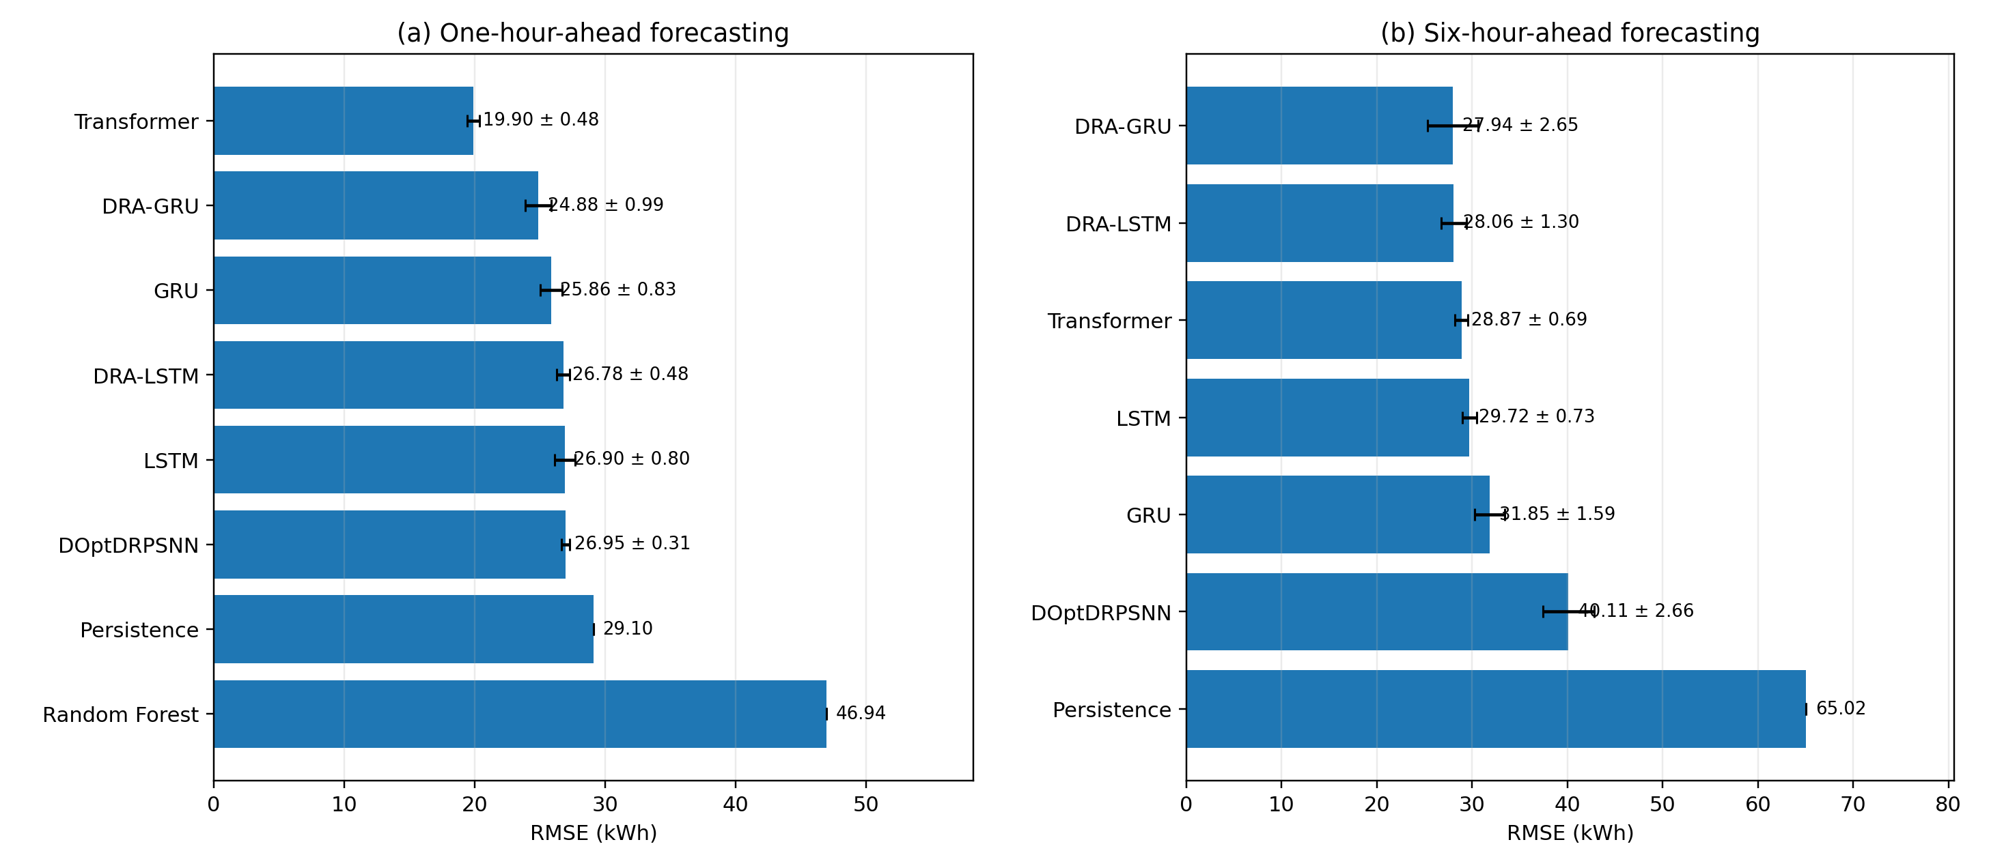
Figure 4. Forecasting performance on full-period unseen buildings for (a) one-hour-ahead and (b) six-hour-ahead prediction. Neural-model values are reported as mean ± SD across seeds 11, 23 and 37; DOptDRPSNN is not presented as the mean-accuracy leader.

7.3. Statistical tests and Random Forest cross-building behaviour
After Holm correction (Table 10), DOptDRPSNN has significantly lower block MAE than the standalone GRU and LSTM under the meter-anchored canonical experiment, but not than DRA-GRU, DRA-LSTM, the Transformer, persistence or Random Forest. These tests are treated as model-specific evidence rather than as a universal superiority claim.
Table 10. Paired 24 h block MAE tests against DOptDRPSNN with Holm–Bonferroni correction over seven comparisons at α = 0.05. One-sided Wilcoxon signed-rank tests evaluate whether DOptDRPSNN block MAE is lower.
Baseline | Blocks | DOpt MAE | Baseline MAE | Raw p | Holm p | Signif.
DRA-GRU | 168 | 14.398 | 13.931 | ≈1.000 | ≈1.000 | No
DRA-LSTM | 168 | 14.398 | 14.651 | 0.0303 | 0.1514 | No
GRU | 168 | 14.398 | 14.786 | 6.70 × 10⁻⁴ | 4.02 × 10⁻³ | Yes
LSTM | 168 | 14.398 | 15.175 | 3.38 × 10⁻⁸ | 2.37 × 10⁻⁷ | Yes
Transformer | 168 | 14.398 | 10.772 | ≈1.000 | ≈1.000 | No
Persistence | 168 | 14.398 | 13.431 | ≈1.000 | ≈1.000 | No
Random Forest | 168 | 14.398 | 19.599 | 0.8064 | ≈1.000 | No
Predictions are averaged over the three primary neural seeds before blocking; blocks require at least 18 valid hourly samples. ≈1.000 denotes a one-sided p indistinguishable from unity at four decimal places, i.e. the baseline is at least as accurate.
Random Forest remains heterogeneous across archetypes (Table 11): it is sharper on Outpatient and Apartment but fails much more severely on the unseen SecondarySchool archetype, where its 95th-percentile absolute error reaches 192.21 kWh against 87.52 kWh for the neural forecast. This supports a robustness and generalization interpretation, not a claim that Random Forest is uniformly inferior.
Table 11. Random Forest cross-building diagnostic on the three unseen archetypes. P95 denotes the 95th percentile of absolute error (kWh).
Archetype | DOpt MAE | RF MAE | DOpt P95 abs. err. | RF P95 abs. err.
Outpatient | 11.22 | 4.83 | 53.24 | 13.95
Apartment | 10.34 | 4.32 | 51.14 | 13.08
SecondarySchool | 21.47 | 49.39 | 87.52 | 192.21

7.4. Feature-selection and optimizer-role evidence
Under the observed-meter-anchored three-epoch ablation (Table 12), MOA retains nine of fifteen features but is not an accuracy optimum: its mean RMSE is 28.72 kWh versus 28.52 kWh for all features, 28.54 kWh for random-k and 28.60 kWh for correlation-k. The differences are small relative to seed variation, so the retained argument is compactness rather than selector superiority. The MOA mask reduces input dimensionality by 40% and defines a frozen discrete search stage before DOA tuning. Figure 5(a) visualizes the feature-selection ablation.
Table 12. Feature-selection ablation under a controlled three-epoch, three-seed protocol. These values are deliberately not the final five-epoch headline model.
Selector | Features | RMSE (kWh) | MAE (kWh) | R²
All features | 15 | 28.52 ± 0.13 | 13.288 | 0.726
Random-k | 9 | 28.54 ± 0.24 | 13.288 | 0.725
Correlation-k | 9 | 28.60 ± 0.25 | 13.298 | 0.724
MOA (retained) | 9 | 28.72 ± 0.21 | 13.348 | 0.722
MAE and R² are seed means. Differences across selectors are small relative to seed variation; MOA is retained for compactness, not accuracy.
Sequential MOA → DOA gives mean RMSE 28.615 kWh under the common reduced-budget protocol, compared with 28.879 kWh for DOA-only on all features and 28.924 kWh without metaheuristics (Table 13). The difference is modest and accompanies 40% fewer inputs. This supports search-space decomposition and compactness, not a broad claim that two metaheuristics are inherently more accurate than one. Figure 5(b) summarizes the optimizer-role ablation.
Table 13. Optimizer-role ablation across seeds 11, 23 and 37 under the same controlled three-epoch final-training protocol.
Strategy | Features | RMSE (kWh) | MAE (kWh) | R²
No metaheuristic | 15 | 28.924 ± 0.058 | 13.429 | 0.718
MOA only | 9 | 28.951 ± 0.036 | 13.421 | 0.717
DOA only (all features) | 15 | 28.879 ± 0.029 | 13.389 | 0.719
Sequential MOA → DOA | 9 | 28.615 ± 0.259 | 13.328 | 0.724

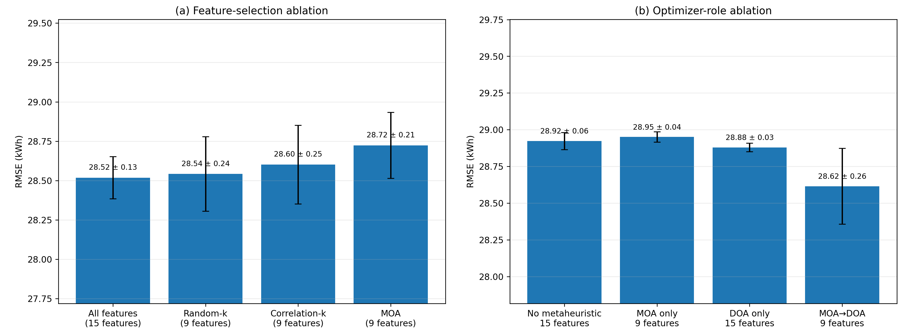
Figure 5. Empirical roles of the optimization stages under the common reduced-budget three-seed protocol: (a) feature-selection ablation and (b) optimizer-role ablation. MOA reduces the input vector from fifteen to nine features, while sequential MOA → DOA gives the lowest mean RMSE among the tested optimizer-role configurations.

7.5. Initialization stability and incomplete-telemetry stress test
Table 14 shows that the proposed model is not the most accurate under either complete or masked inputs. In the three-seed missingness sweep, DOptDRPSNN RMSE increases by 2.04% at 30% masking; DRA-LSTM and LSTM change by less than 1%, whereas the Transformer degrades by about 90%. Because masking can act partly as shrinkage or regularization for some models, the sweep is interpreted only as input-sensitivity evidence, not as a universal robustness ranking; the full progressive sweep is given in Figure S4.
Table 14. Across-seed stability and 30% random standardized-input masking on full-period unseen buildings.
Model | 0% RMSE | RMSE SD | 30% masked RMSE | Degradation
DOptDRPSNN (proposed) | 26.95 | 0.306 | 27.50 | 2.04%
DRA-GRU | 24.88 | 0.990 | 27.08 | 8.85%
DRA-LSTM | 26.78 | 0.476 | 26.97 | 0.72%
GRU | 25.86 | 0.826 | 26.08 | 0.87%
LSTM | 26.90 | 0.800 | 26.92 | 0.06%
Transformer | 19.90 | 0.479 | 37.85 | 90.15%
RMSE SD is the sample SD over the three primary seeds and is not the ten-seed encoder-matched statistic reported in Section 7.5. Masking replaces standardized inputs with zero, i.e. the training mean.
The PSNN-specific evidence instead comes from the separate ten-seed encoder-matched stability test shown in Figure 6: DOptDRPSNN RMSE SD is 0.189 kWh versus 1.733 kWh for DRA-GRU, with F = 83.91 (p = 1.34 × 10⁻⁷) and Brown–Forsythe p = 0.0028. The retained claim is therefore lower initialization variance relative to the matched GRU temporal head, not best mean accuracy or best missing-data performance.
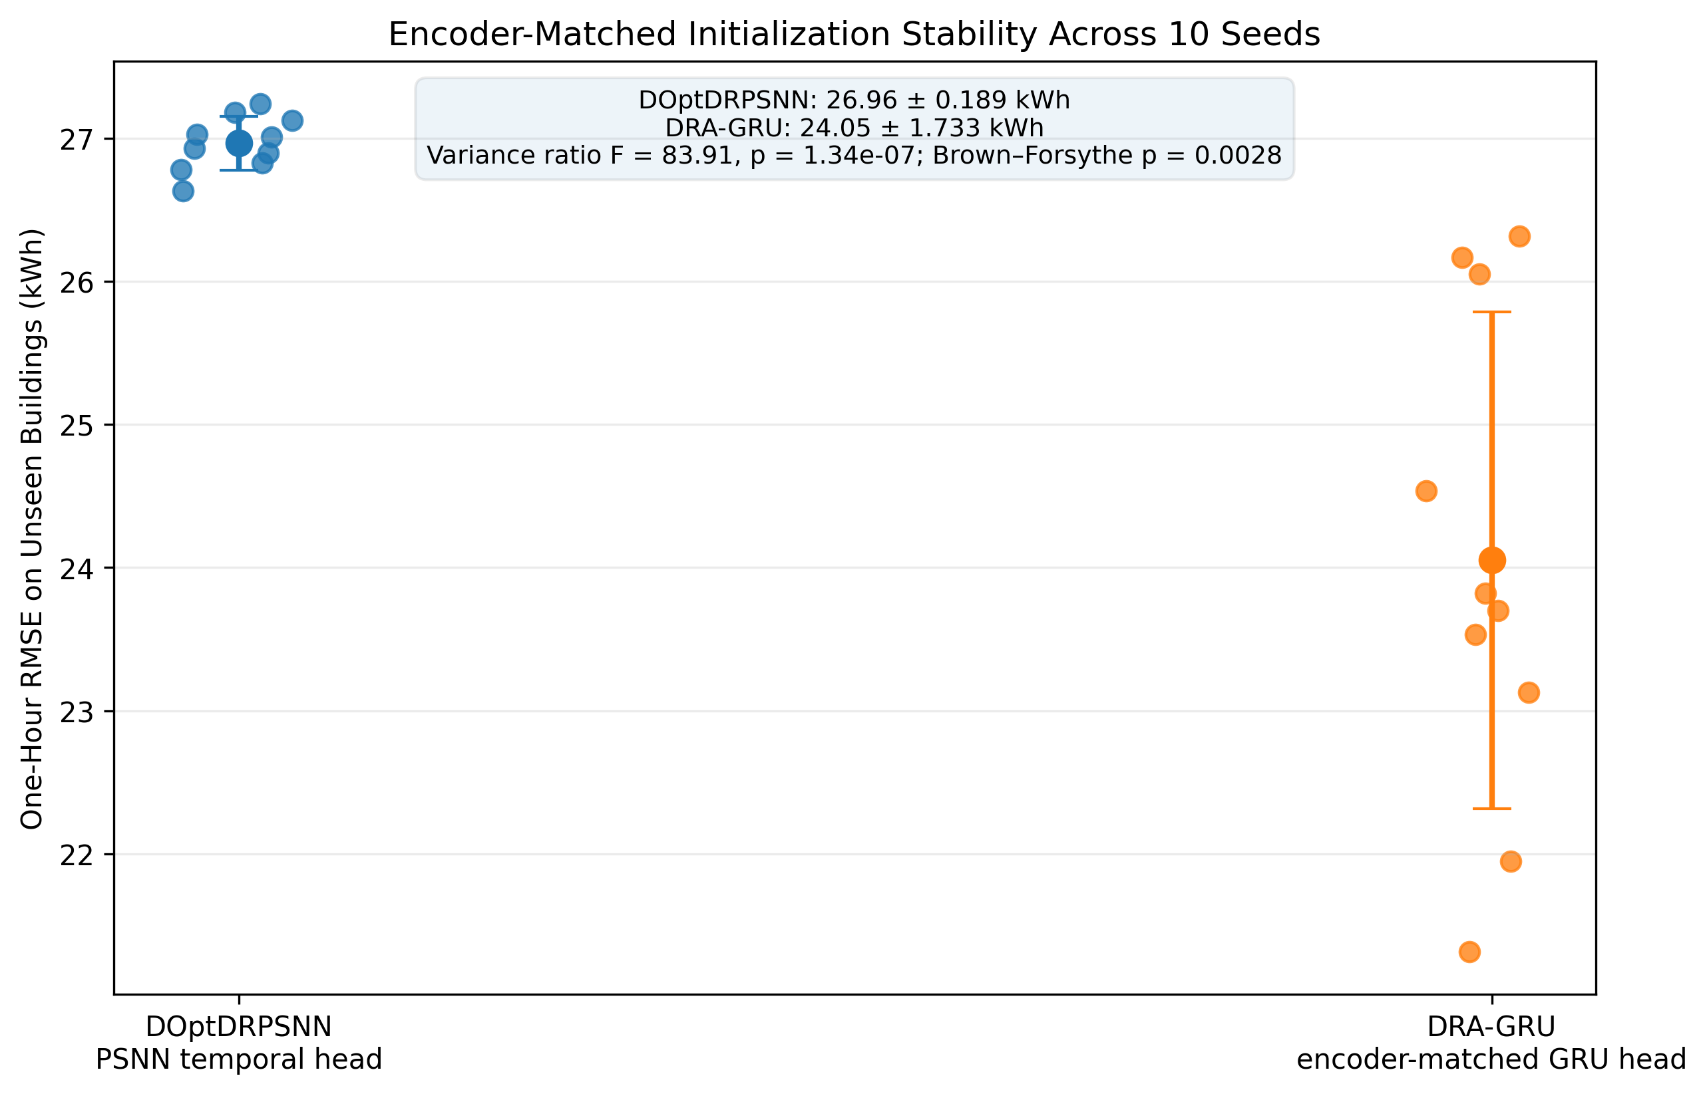
Figure 6. Encoder-matched initialization-stability comparison across ten independent seeds. The DRA-GRU head is more accurate on average, whereas the PSNN-headed DOptDRPSNN exhibits significantly lower RMSE variance (F = 83.91, one-sided p = 1.34 × 10⁻⁷; Brown–Forsythe p = 0.0028).

7.6. Anomaly identification on seen and unseen buildings
The full-period unseen-building test reaches F1 = 0.632, AUPRC = 0.749 and AUROC = 0.904; the temporally aligned unseen-building test reaches F1 = 0.507, AUPRC = 0.742 and AUROC = 0.980 (Table 15). The spike-rate ablation is quantitatively material: removing the mean PSNN spike probability from the otherwise identical twelve-feature gradient-boosting head lowers unseen-building F1 from 0.632 to 0.537, AUPRC from 0.749 to 0.721 and AUROC from 0.904 to 0.895. Residual and lag-deviation features remain central, but probabilistic spiking state contributes complementary information rather than being merely decorative. Figure 7(a) shows the PSNN spike-rate ablation on the unseen-building anomaly head.
Table 15. Final anomaly-identification performance under observed-meter anchoring with the validation-selected fixed threshold θ_{a} = 0.0574.
Split | Accuracy | Precision | Recall | F1 | AUPRC | AUROC | Anom. (%)
Seen chronological | 0.914 | 0.518 | 0.678 | 0.587 | 0.712 | 0.824 | 9.05
Unseen — full period | 0.928 | 0.532 | 0.781 | 0.632 | 0.749 | 0.904 | 7.99
Unseen — temporally aligned | 0.936 | 0.367 | 0.818 | 0.507 | 0.742 | 0.980 | 4.01
Anomaly prevalence is computed over scored rows only, i.e. after the 24 h input window consumes the first 24 timestamps of each building. The anomaly counts are identical to Table 4; only the denominator differs. For the full-period unseen split this is 324 anomaly hours in 4,056 scored rows (7.99%) rather than 324 in 4,128 partition rows (7.85%). The corresponding confusion matrix is TN = 3,509, FP = 223, FN = 71, TP = 253.
Abrupt and persistent fault classes remain easier than gradual faults under the deployable anchor (Table 16). On unseen buildings, stuck and spike faults are detected at 100.0% and 96.8%, whereas drift is the weakest class at 49.0%. Per-class detection rates are reported without suppressing weak categories. This supports cross-building fault discrimination while leaving room for improved calibration on gradual faults and on measured BAS fault logs. Figure 7(b) reports the corresponding per-fault detection rates.
Table 16. Per-fault detection on full-period unseen buildings at the fixed threshold θ_{a} = 0.0574.
Fault type | Hours | Detection rate (%) | Mean probability
Stuck telemetry | 49 | 100.0 | 0.714
Spike | 63 | 96.8 | 0.581
Bias | 62 | 79.0 | 0.458
Schedule override | 47 | 74.5 | 0.564
HVAC degradation | 52 | 65.4 | 0.303
Drift | 51 | 49.0 | 0.279

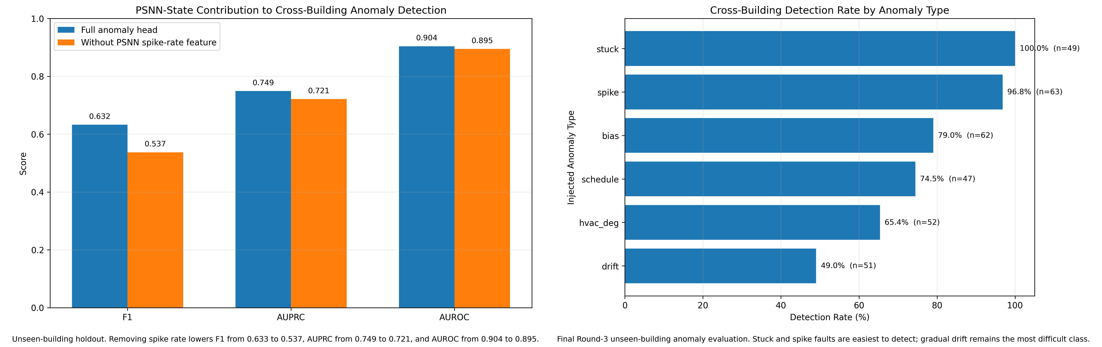
Figure 7. Cross-building anomaly-identification results: (a) removing the mean PSNN spike-rate feature lowers unseen-building F1, AUPRC and AUROC, and (b) per-fault detection rates show that stuck and spike anomalies are easiest while gradual drift is most difficult.

7.7. Sensitivity analysis
MOA population size is not presented as a fixed-model sensitivity because it can change the discrete selected mask. Instead, Table 17 reports leave-one-selected-feature perturbations, DOA forgetting-fraction probes, PSNN firing-threshold probes and the final anomaly-probability threshold sweep. The leave-one-out results reinforce that the nine-feature mask is a compact deployment choice rather than an accuracy optimum: removing humidity or occupancy slightly improves the short-budget unseen RMSE, whereas removing the solar proxy is the most damaging single deletion. The threshold sweep also shows that the validation-selected θ_{a} = 0.0574 is conservative for F1: a higher threshold would raise unseen-building F1 to 0.704, but selecting it would require test-set information and is therefore not adopted.
Table 17. Sensitivity probes under the meter-anchored canonical pipeline. DOA and PSNN probes use reduced training and search budgets; the anomaly threshold is varied without any test-set retuning.
Probe | Setting | Value | Metric and interpretation
DOA forgetting fraction | 0.20 | 1.2130 | Short-search validation standardized RMSE
DOA forgetting fraction | 0.40 | 1.2137 | Short-search validation standardized RMSE
DOA forgetting fraction | 0.60 | 1.2116 | Short-search validation standardized RMSE
PSNN firing threshold θ_{s} | 0.300 | 28.006 | Three-epoch unseen RMSE (kWh)
PSNN firing threshold θ_{s} | 0.369 | 28.912 | Three-epoch unseen RMSE (kWh); canonical setting
PSNN firing threshold θ_{s} | 0.500 | 28.885 | Three-epoch unseen RMSE (kWh)
PSNN firing threshold θ_{s} | 0.700 | 28.837 | Three-epoch unseen RMSE (kWh)
Leave-one-out: humidity | 8 features | 28.437 | Two-epoch unseen RMSE (kWh)
Leave-one-out: occupancy | 8 features | 28.437 | Two-epoch unseen RMSE (kWh)
Leave-one-out: dow_cos | 8 features | 28.596 | Two-epoch unseen RMSE (kWh)
Leave-one-out: dow_sin | 8 features | 28.605 | Two-epoch unseen RMSE (kWh)
Leave-one-out: log_area | 8 features | 28.607 | Two-epoch unseen RMSE (kWh)
Leave-one-out: lag-1 | 8 features | 28.621 | Two-epoch unseen RMSE (kWh)
Leave-one-out: lag-2 | 8 features | 28.627 | Two-epoch unseen RMSE (kWh)
Leave-one-out: lag-24 | 8 features | 28.657 | Two-epoch unseen RMSE (kWh)
Leave-one-out: solar | 8 features | 28.672 | Two-epoch unseen RMSE (kWh)
Anomaly threshold θ_{a} | 0.010 | 0.321 | Unseen-building F1
Anomaly threshold θ_{a} | 0.017 | 0.414 | Unseen-building F1
Anomaly threshold θ_{a} | 0.057 | 0.632 | Unseen-building F1; canonical setting
Anomaly threshold θ_{a} | 0.097 | 0.682 | Unseen-building F1
Anomaly threshold θ_{a} | 0.137 | 0.704 | Unseen-building F1
PSNN and leave-one-out probes are single-seed (seed 37) short-budget runs and are therefore comparable only within their own block, not against the five-epoch headline values of Table 8. All nine leave-one-selected-feature perturbations are listed. MOA population size is deliberately excluded because changing it alters the discrete mask rather than perturbing a fixed model.

7.8. Closed-loop model-driven control
The final controller is driven by the observed-meter-anchored DOptDRPSNN forecast and the calibrated anomaly gate. Across the three temporally aligned unseen buildings (Table 18), aggregate energy falls by 0.030% and tariff-weighted cost by 0.067%, corresponding to $5.65 over the short evaluation window; peak demand is unchanged. The anomaly gate blocks action during 49 flagged hours.
Table 18. Primary model-driven supervisory-control result on the temporally aligned unseen-building window (2025-02-19 17:00 to 2025-02-28 07:00).
Archetype | Base (kWh) | Ctrl. (kWh) | Energy red. | Base cost | Ctrl. cost | Cost red. | Gated h
Outpatient | 16,255.9 | 16,249.0 | 0.042% | $2,308.90 | $2,306.72 | 0.095% | 10
Apartment | 15,167.1 | 15,155.8 | 0.074% | $2,153.82 | $2,150.35 | 0.161% | 9
SecondarySchool | 27,993.4 | 27,993.4 | 0.000% | $3,967.66 | $3,967.66 | 0.000% | 30
Aggregate | 59,416.4 | 59,398.3 | 0.030% | $8,430.37 | $8,424.73 | 0.067% | 49
Peak demand is unchanged in all three buildings. Costs use the illustrative TOU shape of Section 5.6 normalized to the 2025 EIA U.S. commercial average of $0.1341/kWh [5].
Table 19 isolates the two comparators. Removing the anomaly gate increases the aggregate cost reduction from 0.067% to 0.074%, quantifying the safety–efficiency trade-off directly. The perfect-load comparator does not behave as a formal upper bound: it achieves only 0.010% cost reduction, because the bounded control law is trigger-frequency driven, so a model that sometimes overpredicts high-load risk activates curtailment more often than a perfect forecast would. These values are reported only as evidence that the forecast–anomaly–control chain executes causally, not as a large savings claim and not as an annualized estimate. Figure 8 combines the per-building control effects with a representative causal operational trace.
Table 19. Controller-variant comparison, aggregated over the three temporally aligned unseen buildings. The comparators isolate the contribution of forecast quality and of the anomaly gate.
Controller variant | Energy red. | Cost red. | Cost saved | Gated h
Model forecast + anomaly gate (primary) | 0.030% | 0.067% | $5.65 | 49
Model forecast, gate disabled | 0.034% | 0.074% | $6.23 | —
Perfect clean-load forecast + anomaly gate | 0.005% | 0.010% | $0.88 | —
Gate-blocked hour counts are recorded only for the primary run; the perfect-load comparator applies the identical gate. The perfect-load comparator is not a formal upper bound because the bounded control law is trigger-frequency driven — an overconfident forecast can activate curtailment more often than a perfect one.
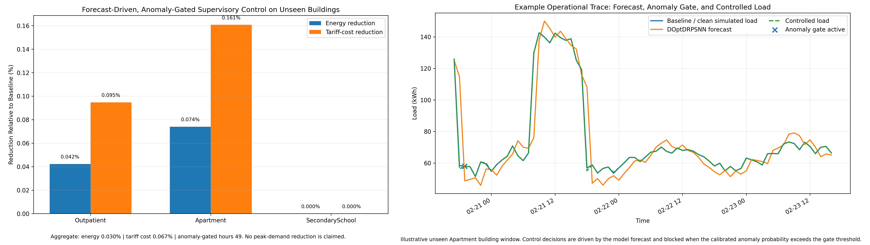
Figure 8. Forecast-driven anomaly-gated supervisory-control results: (a) per-building energy and tariff-cost effects on the temporally aligned unseen-building window and (b) a representative operational trace showing the model forecast, the anomaly gate and the resulting controlled load.

8. Discussion
The final results support a different agenda from a conventional hybrid-model leaderboard paper. First, the deployable observed-meter anchor makes the forecasting task materially harder and removes an unrealistic advantage present in earlier formulations. The Transformer and DRA-GRU are more accurate at one hour, and several neural baselines are more accurate at six hours. Forecasting superiority is therefore not a valid headline claim.
Second, the PSNN-related claim is narrow and statistically supported. In the dedicated ten-seed head-replacement experiment, the same 20-channel dual-residual encoder is paired either with the probabilistic spiking head or with a GRU head under identical learning rate, dropout and training budget. DOptDRPSNN has RMSE SD 0.189 kWh versus 1.733 kWh for the matched DRA-GRU; the variance ratio is F = 83.91 (one-sided p = 1.34 × 10⁻⁷), and Brown–Forsythe p = 0.0028. The GRU head remains more accurate on average, so the claim is specifically lower initialization variance, not predictive superiority. For an operator retraining a model on a schedule, that distinction matters: a head whose across-seed spread is an order of magnitude narrower yields a more predictable deployed model without any accuracy guarantee. Separately, removing spike rate from the anomaly head reduces unseen-building F1 by about 0.095, providing a second, auxiliary empirical role for the probabilistic state.
Third, the optimizer evidence supports a qualified decomposition argument. MOA does not improve isolated short-budget feature-selection accuracy, but it reduces the input vector by 40%. When the compact mask is followed by DOA tuning, the three-seed three-epoch ablation yields a modest RMSE improvement relative to DOA-only on all features. This is sufficient to justify the architecture as a compact search decomposition, but not to claim that two metaheuristics are universally better than one.
Fourth, cross-building anomaly transfer remains measurable after removing the clean-anchor advantage. The residual-calibration head reaches AUROC 0.904 on full-period unseen buildings and 0.980 on the temporally aligned unseen subset. The spike-rate ablation shows a measurable but secondary contribution, while residual and lag-deviation variables carry most of the fault signal. Public-data extension therefore requires real fault labels, BAS alarms or an independently justified unsupervised protocol.
Finally, the control result measures the full deployable forecast–anomaly–control chain: the controller reads a forecast anchored to the observed meter, not the clean counterfactual. The very small tariff-cost reduction (0.067%) and zero peak reduction are reported as operational evidence, not as a large savings claim. The anomaly gate blocks 49 potentially unreliable hours and reduces the ungated cost benefit slightly, which is the intended safety–efficiency trade-off.

9. Limitations and external validation
- The simulation covers only 2 January to 28 February 2025. It does not include the cooling season, shoulder seasons or annual tariff dynamics; full-year EnergyPlus or measured-building validation is required before annual savings are claimed.
- The full-period unseen-building test is a building holdout but shares calendar hours and simulated weather processes with the development buildings. The temporally aligned unseen-building row is therefore reported separately and should be preferred when interpreting combined temporal and cross-building generalization.
- The forecasting target is the clean counterfactual load available by construction in simulation, while the deployment-time anchor and all lag features are observed-meter quantities. This removes the unobservable clean-anchor issue but does not eliminate the broader simulation limitation: measured ASHRAE and BDG2 data provide neither a clean counterfactual target nor universal fault labels. Public-data extension is therefore limited to forecasting unless independent fault labels are available.
- The anomaly-calibration head is supervised by synthetic labels. Real fault logs, BAS alarms or expert-labelled events are needed to establish diagnostic validity in measured buildings.
- Neural baselines receive common validation-only screening, while the proposed DOA has a method-specific search procedure. The paper therefore does not use small forecasting differences as proof of architectural superiority. More importantly, the PSNN-headed model is not the most accurate at either one or six hours. Its retained empirical claim is significantly lower initialization variance than an exact encoder-matched GRU temporal head in the dedicated ten-seed comparison; broader rank claims across all model families are not made.
- The tariff is an illustrative U.S. time-of-use shape normalized to the EIA national commercial-average price. Utility-specific demand charges, ratchets, coincident peaks, comfort and indoor-air-quality constraints, and equipment-cycling limits are not included.
- MOA population-size changes can alter the discrete selected mask and are not interpreted as fixed-model sensitivity. The reproducibility package therefore supplies executable experiment code, the exact raw per-seed outputs used for every reported mean and SD, frozen canonical settings, and controlled perturbation and ablation results. Historical MOA and DOA search traces that are no longer available are not claimed to be included.

10. Conclusion
DOptDRPSNN-EMS is best interpreted as an integrated forecast–anomaly–control BEMS framework with a narrow, stability-oriented PSNN contribution, not as a forecasting-leaderboard model. The deployment-time forecast uses the observed meter at t − 1 as its reconstruction anchor. On unseen buildings, the Transformer and DRA-GRU are more accurate at one hour, and DOptDRPSNN is not the best six-hour neural baseline. However, in an exact ten-seed encoder-matched head-replacement experiment, DOptDRPSNN shows substantially lower RMSE variability than DRA-GRU (0.189 versus 1.733 kWh; F = 83.91, p = 1.34 × 10⁻⁷; Brown–Forsythe p = 0.0028). The deployable residual-calibration head achieves unseen-building F1 0.632 and AUROC 0.904, with a measurable decrease to F1 0.537 when the PSNN spike rate is removed. The forecast-driven anomaly-gated controller closes the loop causally and produces a small 0.067% tariff-cost reduction while blocking 49 flagged hours; no peak-demand or annual-savings claim is made.
The unequivocal contributions are therefore a causal and deployable experimental design, a statistically supported initialization-variance reduction versus an encoder-matched GRU head, cross-building fault discrimination, transparent optimizer compactness, and a verified forecast-to-control chain. Full-year, multi-climate and measured-building validation remains necessary before broader operational claims are made.

Supplementary Materials
The following supporting information can be downloaded at: [publisher-assigned URL]. Figure S1: representative daily observed-meter load profiles; Figure S2: representative environmental and operational profiles; Figure S3: building archetypes and evaluation roles in the executed benchmark; Figure S4: input-sensitivity stress test under progressive random masking of standardized inputs.

Author Contributions
Conceptualization, A.H.M. and T.K.M.; methodology, A.H.M., A.M.K. (Atif Mohammad Kamal) and A.M.K. (Arbab Mohammad Kamal); software, A.M.K. (Arbab Mohammad Kamal) and A.M.K. (Atif Mohammad Kamal); validation, A.A.P. and A.M.K. (Arbab Mohammad Kamal); formal analysis, A.H.M. and A.M.K. (Atif Mohammad Kamal); investigation, A.M.K. (Arbab Mohammad Kamal); resources, A.A.P.; data curation, A.M.K. (Arbab Mohammad Kamal); writing—original draft preparation, A.M.K. (Atif Mohammad Kamal); writing—review and editing, A.H.M., A.A.P. and T.K.M.; visualization, A.M.K. (Arbab Mohammad Kamal); supervision, A.H.M. and T.K.M.; project administration, T.K.M.; funding acquisition, A.A.P. All authors have read and agreed to the published version of the manuscript.

Funding
This research was funded by the Deanship of Scientific Research (DSR), King Abdulaziz University, Jeddah, under grant No. IPP: 2016-135-2026.

Institutional Review Board Statement
Not applicable. This study did not involve humans or animals. All building-energy data analysed in this work are synthetic and were generated by the simulation procedure described in Section 3.

Informed Consent Statement
Not applicable.

Data Availability Statement
The complete reproducibility package is openly available at https://github.com/NetNeuro/smart-building-bems and archived with a persistent identifier at [https://doi.org/10.5281/zenodo.XXXXXXX]. The version used for the results reported here is release [v1.0.0], commit [XXXXXXX]. The package contains the synthetic benchmark and its SHA-256 digest, the split definitions, the frozen canonical configuration, executable scripts for the full forecasting and ablation suite, the ten-seed encoder-matched stability experiment, the anomaly-calibration and control experiments, the exact raw per-seed outputs used to construct every reported mean and standard deviation, and frozen manuscript-table summaries. A provenance map links each table and figure to its raw source and generating script. The package documents frozen MOA and DOA outputs rather than claiming that unavailable historical search traces are included. Superseded anomaly blocks and earlier clean-anchor diagnostics are excluded from the live canonical results. No unexecuted ASHRAE or BDG2 numerical result is reported as if it had been produced by this package. No new data were created beyond the synthetic benchmark distributed with that package.

Acknowledgments
The authors gratefully acknowledge the Deanship of Scientific Research (DSR), King Abdulaziz University, Jeddah, for technical support.

Conflicts of Interest
The authors declare no conflicts of interest. The funders had no role in the design of the study; in the collection, analyses or interpretation of data; in the writing of the manuscript; or in the decision to publish the results.

References
1. ASHRAE. Great Energy Predictor III; Kaggle competition dataset, 2019. Available online: https://www.kaggle.com/c/ashrae-energy-prediction (accessed on 2 September 2026).
2. Miller, C.; Kathirgamanathan, A.; Picchetti, B.; Arjunan, P.; Park, J.Y.; Nagy, Z.; Raftery, P.; Hobson, B.W.; Shi, Z.; Meggers, F. The Building Data Genome Project 2, energy meter data from the ASHRAE Great Energy Predictor III competition. Sci. Data 2020, 7, 368. https://doi.org/10.1038/s41597-020-00712-x
3. U.S. Department of Energy. Commercial Reference Buildings; Building Technologies Office. Available online: https://www.energy.gov/eere/buildings/commercial-reference-buildings (accessed on 2 September 2026).
4. U.S. Department of Energy. EnergyPlus Whole-Building Energy Simulation Engine. Available online: https://energyplus.net (accessed on 2 September 2026).
5. U.S. Energy Information Administration. Electric Power Monthly: Prices and Factors Affecting Prices; 2025 U.S. average commercial retail electricity price 13.41 cents/kWh, preliminary 2026 data. Available online: https://www.eia.gov/electricity/monthly/ (accessed on 2 September 2026).
6. OpenEI. Utility Rate Database. Available online: https://openei.org/wiki/Utility_Rate_Database (accessed on 2 September 2026).
7. Mathumitha, R.; Rathika, P.; Manimala, K. Intelligent deep learning techniques for energy consumption forecasting in smart buildings: A review. Artif. Intell. Rev. 2024, 57, 35. https://doi.org/10.1007/s10462-023-10660-8
8. Spencer, R.; Ranathunga, S.; Boulic, M.; van Heerden, A.; Susnjak, T. Transfer learning on transformers for building energy consumption forecasting—A comparative study. Energy Build. 2025, 336, 115632. https://doi.org/10.1016/j.enbuild.2025.115632
9. Wang, R.; Bai, L.; Rayhana, R.; Liu, Z. Personalized federated learning for buildings energy consumption forecasting. Energy Build. 2024, 323, 114762. https://doi.org/10.1016/j.enbuild.2024.114762
10. Poyyamozhi, M.; Murugesan, B.; Rajamanickam, N.; Shorfuzzaman, M.; Aboelmagd, Y. IoT—A promising solution to energy management in smart buildings: A systematic review, applications, barriers, and future scope. Buildings 2024, 14, 3446. https://doi.org/10.3390/buildings14113446
11. Affonso, E.O.T.; Branco, R.R.; Menezes, O.V.C.; Guedes, A.L.A.; Chinelli, C.K.; Haddad, A.N.; Soares, C.A.P. The main barriers limiting the development of smart buildings. Buildings 2024, 14, 1726. https://doi.org/10.3390/buildings14061726
12. Waqar, A.; Shafiq, N.; Othman, I.; Alsulamy, S.H.; Alshehri, A.M.; Falqi, I.I. Deterrents to the IoT for smart buildings and infrastructure development: A partial least square modeling approach. Heliyon 2024, 10, e31035. https://doi.org/10.1016/j.heliyon.2024.e31035
13. Khafiso, T.; Aigbavboa, C.; Adekunle, S.A. Barriers to the adoption of energy management systems in residential buildings. Facilities 2024, 42, 107–125. https://doi.org/10.1108/F-12-2023-0113
14. Soleimanijavid, A.; Konstantzos, I.; Liu, X. Challenges and opportunities of occupant-centric building controls in real-world implementation: A critical review. Energy Build. 2024, 308, 113958. https://doi.org/10.1016/j.enbuild.2024.113958
15. Akter, R.; Shirkoohi, M.G.; Wang, J.; Mérida, W. An efficient hybrid deep neural network model for multi-horizon forecasting of power loads in academic buildings. Energy Build. 2025, 115217. https://doi.org/10.1016/j.enbuild.2024.115217
16. Sarmento, E.M.d.M.; Ribeiro, I.F.; Marciano, P.R.N.; Neris, Y.G.; Rocha, H.R.d.O.; Mota, V.F.S.; Villaca, R.d.S. Forecasting energy power consumption using federated learning in edge computing devices. Internet Things 2024, 25, 101050. https://doi.org/10.1016/j.iot.2023.101050
17. Wang, R.; Yun, H.; Rayhana, R.; Bin, J.; Zhang, C.; Herrera, O.E.; Liu, Z.; Mérida, W. An adaptive federated learning system for community building energy load forecasting and anomaly prediction. Energy Build. 2023, 295, 113215. https://doi.org/10.1016/j.enbuild.2023.113215
18. Khan, S.U.; Khan, N.; Ullah, F.U.M.; Kim, M.J.; Lee, M.Y.; Baik, S.W. Towards intelligent building energy management: AI-based framework for power consumption and generation forecasting. Energy Build. 2023, 279, 112705. https://doi.org/10.1016/j.enbuild.2022.112705
19. Faiz, M.F.; Sajid, M.; Ali, S.; Javed, K.; Ayaz, Y. Energy modeling and predictive control of environmental quality for building energy management using machine learning. Energy Sustain. Dev. 2023, 74, 381–395. https://doi.org/10.1016/j.esd.2023.04.017
20. Karyono, K.; Abdullah, B.M.; Cotgrave, A.J.; Bras, A.; Cullen, J. Developing a reliable shallow supervised learning for thermal comfort using multiple ASHRAE databases. IEEE Trans. Artif. Intell. 2024, 5, 3664–3677. https://doi.org/10.1109/TAI.2024.3355293
21. Arun, M.; Gopan, G.; Vembu, S.; Ozsahin, D.U.; Ahmad, H.; Alotaibi, M.F. Internet of things and deep learning-enhanced monitoring for energy efficiency in older buildings. Case Stud. Therm. Eng. 2024, 61, 104867. https://doi.org/10.1016/j.csite.2024.104867
22. Balakumar, P.; Vinopraba, T.; Chandrasekaran, K. Deep learning based real time demand side management controller for smart building integrated with renewable energy and energy storage system. J. Energy Storage 2023, 58, 106412. https://doi.org/10.1016/j.est.2022.106412
23. Selvaraj, R.; Kuthadi, V.M.; Baskar, S. Smart building energy management and monitoring system based on artificial intelligence in smart city. Sustain. Energy Technol. Assess. 2023, 56, 103090. https://doi.org/10.1016/j.seta.2023.103090
24. Ganesh, P.M.J.; Sundaram, B.M.; Balachandran, P.K.; Mohammad, G.B. IntDEM: An intelligent deep optimized energy management system for IoT-enabled smart grid applications. Electr. Eng. 2025, 107, 1925–1947. https://doi.org/10.1007/s00202-024-02586-3
25. Natarajan, Y.; Sri Preethaa, K.R.; Wadhwa, G.; Choi, Y.; Chen, Z.; Lee, D.-E.; Mi, Y. Enhancing building energy efficiency with IoT-driven hybrid deep learning models for accurate energy consumption prediction. Sustainability 2024, 16, 1925. https://doi.org/10.3390/su16051925
26. Joha, M.I.; Rahman, M.M.; Nazim, M.S.; Jang, Y.M. A secure IIoT environment that integrates AI-driven real-time short-term active and reactive load forecasting with anomaly detection: A real-world application. Sensors 2024, 24, 7440. https://doi.org/10.3390/s24237440
27. Li, W.; Xu, X. A hybrid evolutionary and machine learning approach for smart building: Sustainable building energy management design. Sustain. Energy Technol. Assess. 2024, 65, 103709. https://doi.org/10.1016/j.seta.2024.103709
28. Xian, S.; Feng, X. Meerkat optimization algorithm: A new meta-heuristic optimization algorithm for solving constrained engineering problems. Expert Syst. Appl. 2023, 231, 120482. https://doi.org/10.1016/j.eswa.2023.120482
29. Wu, W.; Liu, S.; Xia, Y.; Zhang, Y. Dual residual attention network for image denoising. Pattern Recognit. 2024, 149, 110291. https://doi.org/10.1016/j.patcog.2024.110291
30. Jang, H.; Simeone, O. Multisample online learning for probabilistic spiking neural networks. IEEE Trans. Neural Netw. Learn. Syst. 2022, 33, 2034–2044. https://doi.org/10.1109/TNNLS.2020.3045865
31. Lang, Y.; Gao, Y. Dream Optimization Algorithm (DOA): A novel metaheuristic optimization algorithm inspired by human dreams and its applications to real-world engineering problems. Comput. Methods Appl. Mech. Eng. 2025, 436, 117718. https://doi.org/10.1016/j.cma.2024.117718
32. Lim, B.; Arık, S.Ö.; Loeff, N.; Pfister, T. Temporal Fusion Transformers for interpretable multi-horizon time series forecasting. Int. J. Forecast. 2021, 37, 1748–1764. https://doi.org/10.1016/j.ijforecast.2021.03.012
33. Zhou, H.; Zhang, S.; Peng, J.; Zhang, S.; Li, J.; Xiong, H.; Zhang, W. Informer: Beyond efficient Transformer for long sequence time-series forecasting. In Proceedings of the AAAI Conference on Artificial Intelligence, Virtual, 2–9 February 2021; Volume 35, pp. 11106–11115. https://doi.org/10.1609/aaai.v35i12.17325
34. Nie, Y.; Nguyen, N.H.; Sinthong, P.; Kalagnanam, J. A time series is worth 64 words: Long-term forecasting with transformers. In Proceedings of the 11th International Conference on Learning Representations (ICLR), Kigali, Rwanda, 1–5 May 2023. https://doi.org/10.48550/arXiv.2211.14730
35. Bartoldson, B.R.; Kailkhura, B.; Blalock, D. Compute-efficient deep learning: Algorithmic trends and opportunities. J. Mach. Learn. Res. 2023, 24, 1–77.

