Supplementary Material
IoT-Enabled Smart Building Energy Management with Integrated Load Forecasting, Anomaly Detection, and Control
Ahmad H. Milyani, Arbab Mohammad Kamal, Atif Mohammad Kamal, Amjad Ali Pasha, Tauheed Khan Mohd
These supplementary figures provide descriptive benchmark context and an input-sensitivity stress test. They are not used to extend the main-paper claims beyond the executed synthetic benchmark. All panels are generated by scripts/make_figures.py in the reproducibility package from the sources listed in docs/FINAL_FIGURE_MAP.md.
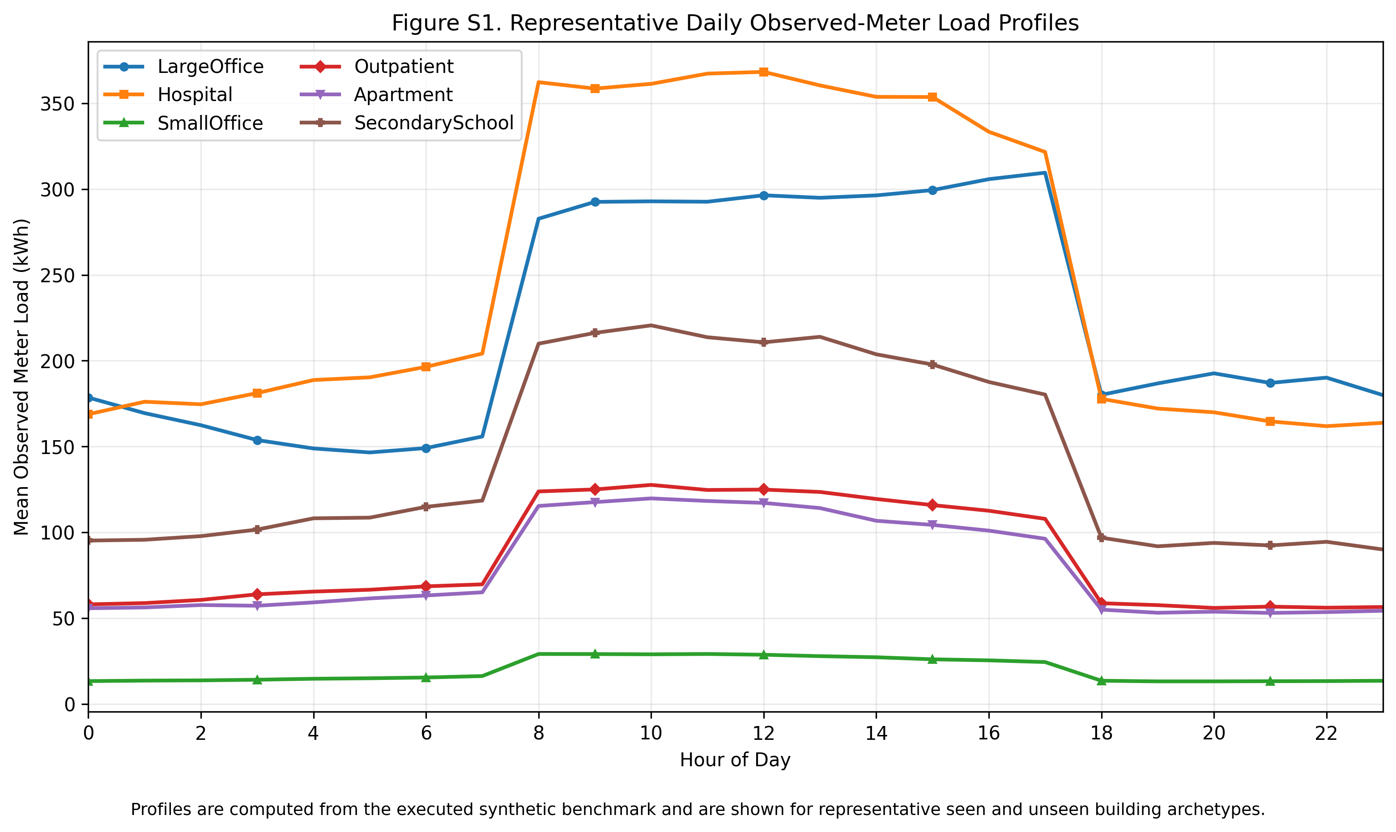
Figure S1. Representative daily observed-meter load profiles computed from the executed synthetic benchmark for representative seen and unseen building archetypes. Profiles are shown on the observed meter channel, i.e. including injected fault episodes, and therefore illustrate the signal the deployed model actually receives.
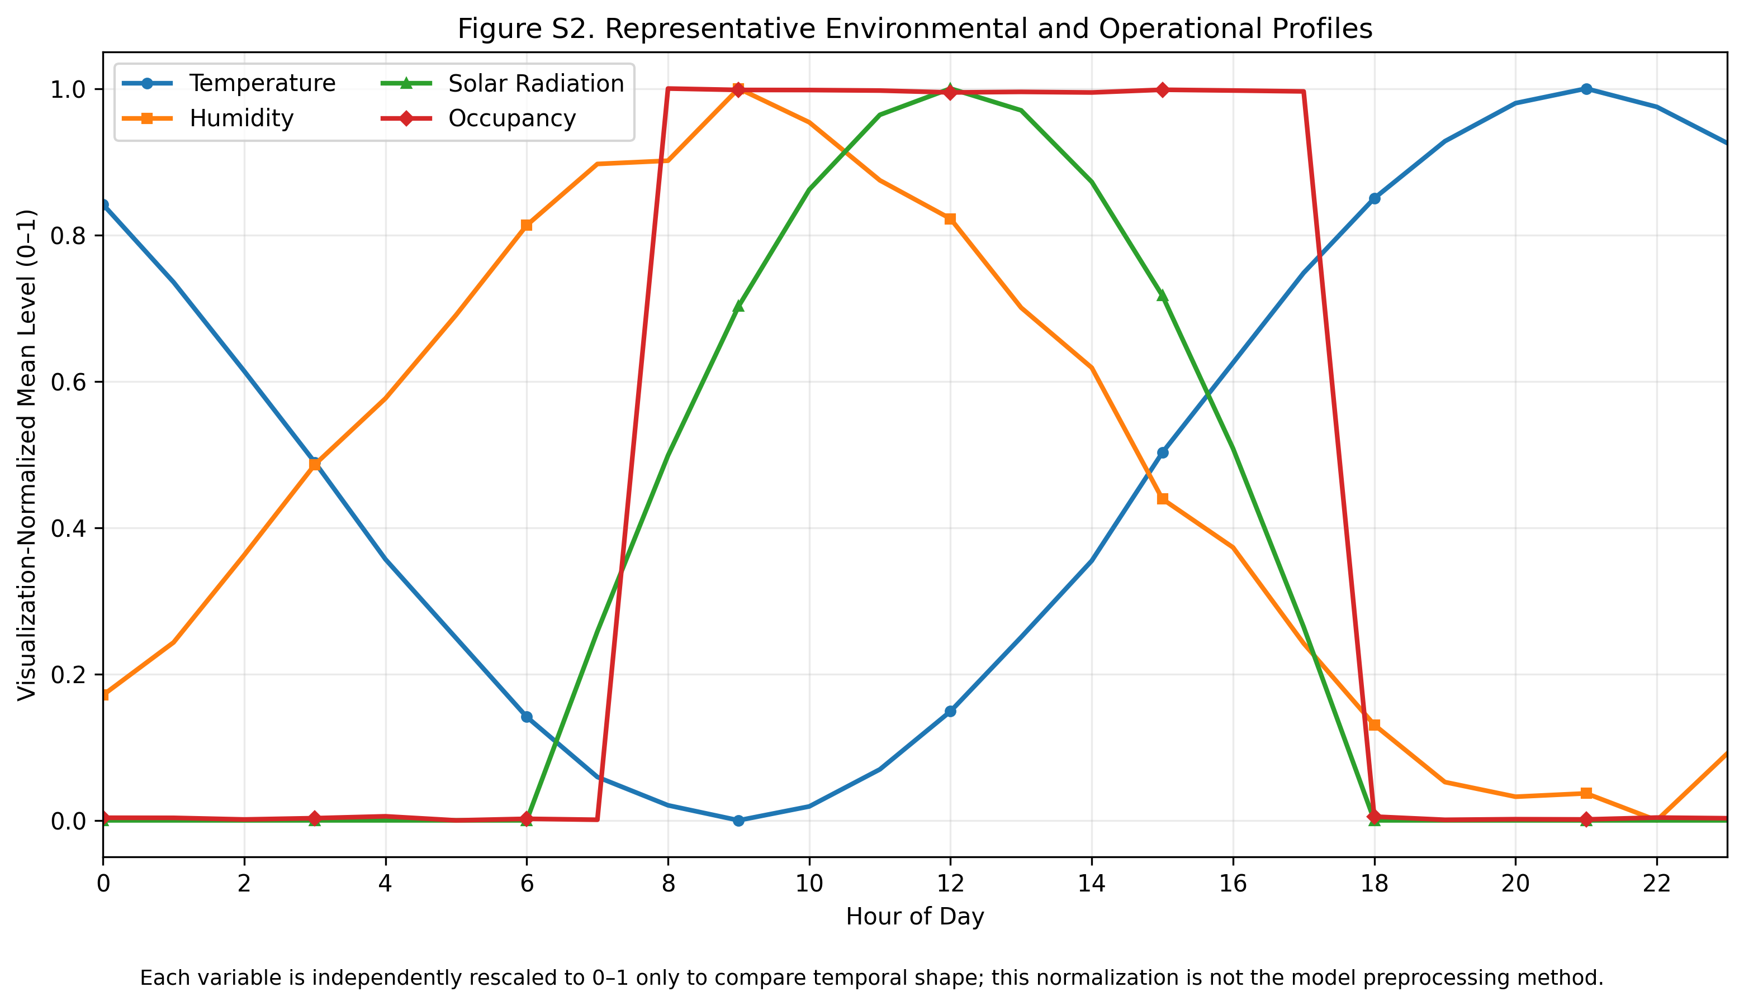
Figure S2. Representative environmental and operational profiles. Each variable is independently rescaled to 0–1 only for visualization of temporal shape; this is not the model preprocessing method, which fits all scaling statistics on the training partition alone (Section 3.3 of the main paper).
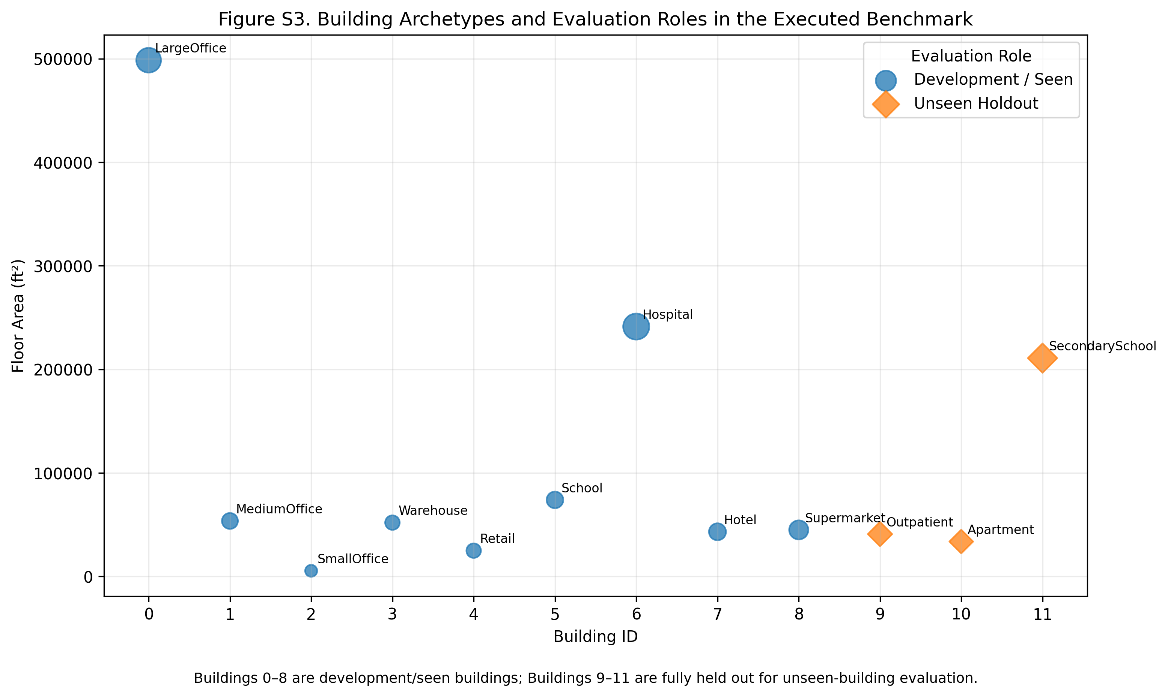
Figure S3. Building archetypes and evaluation roles in the executed benchmark. Buildings 0–8 form the development set used for preprocessing, feature selection, hyperparameter search, model fitting and anomaly calibration, whereas Buildings 9–11 remain fully held out for unseen-building evaluation.
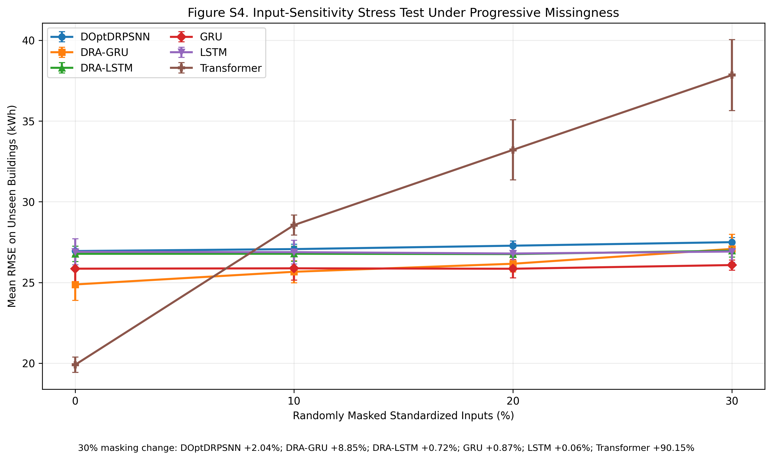
Figure S4. Input-sensitivity stress test under progressive random masking of standardized inputs (0%, 10%, 20% and 30%). Values are means over seeds 11, 23 and 37 on the full-period unseen buildings. The sweep is interpreted as sensitivity to unavailable telemetry rather than as a universal robustness ranking, because masking can act partly as shrinkage for some models; the 30% column corresponds to Table 14 of the main paper.

