Aadhaar Intel Engine
Research Outcomes Report
UIDAI operational aggregates · Patterns, anomalies, and predictive indicators
Code-aligned living document with figure and table provisions
Repository: github.com/NetRunnerXD/Aadhaar-Intel-Engine-UIDAI

Disclaimers: Isolation Forest scores are unsupervised outliers (“look here”), not fraud labels. Forecasts and decision bands guide planning envelopes and are not guarantees. Data are aggregate enrolment/update volumes only (no Aadhaar numbers or biometrics).

Project: Aadhaar Intel Engine (UIDAI operational aggregates)
Problem framing: Identify patterns, trends, anomalies, and predictive indicators from Aadhaar enrolment and update aggregates to support informed operations—not individual identity adjudication.
Repository: NetRunnerXD/Aadhaar-Intel-Engine-UIDAI
Document type: Research outcomes report (code-aligned)
Status: Living document — replace placeholders and fill measured tables after each capture run
**Important disclaimers (from implementation):** - Isolation Forest scores are unsupervised multi-feature outliers (“look here”), **not fraud labels**. - Forecasts and decision bands guide planning envelopes; they are **not guarantees**. - Data are **aggregate** enrolment/update volumes (no Aadhaar numbers or biometrics).

How to use this document
Action | Convention
Screenshots | Prefer `docs/live_captures/` from `python docs/capture_live_assets.py`
Static figures | Prefer `images/` or `figures/`
New assets | Drop files under `docs/figures/` (create if needed) and update paths below
Placeholders | Blocks marked **`[FIGURE — …]`** or **`[TABLE — fill]`** are intentional slots

Suggested capture pipeline
python -m src.etl.build_cache # optional: refresh marts
streamlit run app.py # or: python run_web.py
python docs/capture_live_assets.py # writes docs/live_captures/*

1. Executive summary of outcomes

1.1 What was built
An end-to-end research and operations analytics stack that:
- Ingests multi-shard UIDAI-style CSV aggregates (enrolment, biometric updates, demographic updates).
- Repairs geography via a versioned rule pack (aliases, district-as-state, AP→Telangana, PIN fallback) with optional gold evaluation.
- Materialises daily parquet marts (date × state × district) for fast reload.
- Applies durable human governance (merge/delete patches + audit).
- Detects multi-feature district outliers (Isolation Forest).
- Forecasts national or state daily enrolment via a multi-model bake-off with baseline gate and split-conformal intervals.
- Maps volume intensity (2D / heatmap / 3D) on a light basemap with district centroids.
- Surfaces hybrid AI briefs (engine-authored numbers + optional Ollama narrative).
- Exposes two UIs: Streamlit research app and React + FastAPI professional web UI sharing the same engine.

1.2 Primary research contributions
# | Outcome | Evidence in codebase
C1 | **Production-style geo repair pipeline** with measurable rule pack and gold eval harness | `src/geo/*`, `assets/reference/*`, `tests/test_geo_repair.py`
C2 | **Cache-first analytics marts** that separate pin-level natural keys from daily ops grain | `src/data_manager.py`, `src/etl/build_cache.py`, `CACHE_SCHEMA_VERSION`
C3 | **Multi-feature Isolation Forest** at state×district with reason codes and investigation notes | `src/ai_core.py`
C4 | **Research-grade forecast selection**: rolling CV, MASE primary, beat SN+MA gate, conformal bands | `src/forecasting.py`, `src/config.py`
C5 | **Human-in-the-loop governance** with durable patches and audit (not one-off spreadsheet fixes) | `src/services/governance_store.py`, governance UI
C6 | **Evidence-locked hybrid AI** so LLM prose cannot invent metrics | `src/ai/research_insights.py`
C7 | **Dual presentation layer** with Streamlit ↔ React feature parity | `app.py`, `web/`, `web/FEATURE_PARITY.md`

1.3 Headline visual
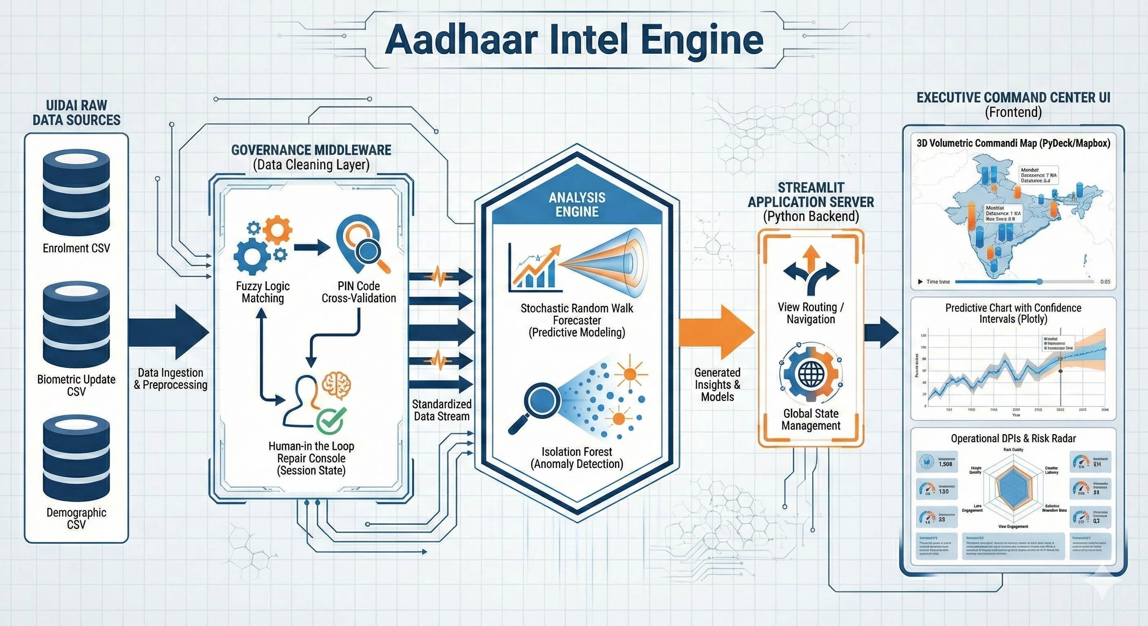
System architecture overview
Figure 1. Architecture overview (replace/update with latest diagram if needed).
`[FIGURE — optional architecture refresh]`
Path: docs/figures/architecture_latest.png
Caption: *Dual UI (Streamlit + React) over shared AnalyticsEngine, marts, and governance store.*

2. Problem, scope, and research questions

2.1 Operational problem
Public Aadhaar dashboards often stop at totals and maps. Operational teams need:
- Clean, comparable geography across noisy free-text place names
- Transparent outlier investigation at district grain
- Demand outlook with uncertainty, not a single curve
- Governance that survives reloads

2.2 Research questions (as implemented)
ID | Question | Approach in system
RQ1 | Can automated geo rules recover official states/districts at high accuracy on a gold set? | Rule pack + `evaluate_geo_cleaning`
RQ2 | Do multi-feature outliers surface actionable investigation cells beyond raw volume spikes? | Isolation Forest on volume, CV, bio/demo ratios, WoW growth, etc.
RQ3 | When should a complex forecast beat simple baselines on noisy daily enrolment series? | Bake-off + baseline gate
RQ4 | Can hybrid AI assist operators without fabricating numbers? | Evidence dict → deterministic draft → optional LLM
RQ5 | Can a professional web UI retain research fidelity of the Streamlit prototype? | Shared engine + FastAPI + React

2.3 Non-goals (explicit)
- Individual-level identity, biometric matching, or legal fraud determination
- Claiming causal migration or policy impact from aggregates alone
- Guaranteeing forecast accuracy under structural breaks without re-evaluation

3. Data and methods

3.1 Data contracts
Stream | Grain (raw) | Daily mart grain | Core metrics
Enrolment | date × state × district × pincode | date × state × district | age bands, adult/total enrolments
Biometric updates | same | date × state × district | bio age bands, bio stress
Demographic updates | same | date × state × district | demo age bands, update volume

Natural key for de-duplication: date, state, district, pincode (NATURAL_KEY).
Analytics grain: date, state, district (DAILY_KEY).
`[TABLE — fill after load]` Dataset inventory
Source files | Rows (enrol / bio / demo) | Date min | Date max | Notes
*fill* | *fill* | *fill* | *fill* | From sidebar / `/api/meta`

3.2 Ingest and mart construction
CSV shards
→ classify (enrol / bio / demo)
→ validate dates & pincode range
→ quarantine invalid rows
→ collapse NATURAL_KEY duplicates (sum)
→ canonicalize state
→ full_geo_repair
→ optional AUTO_BUILD_CACHE → parquet marts + manifest fingerprint
`[FIGURE — data pipeline diagram]`
Path: docs/figures/pipeline_etl.png
Caption: *Ingest → repair → marts → filters → engine.*
Related live diagram (if present):
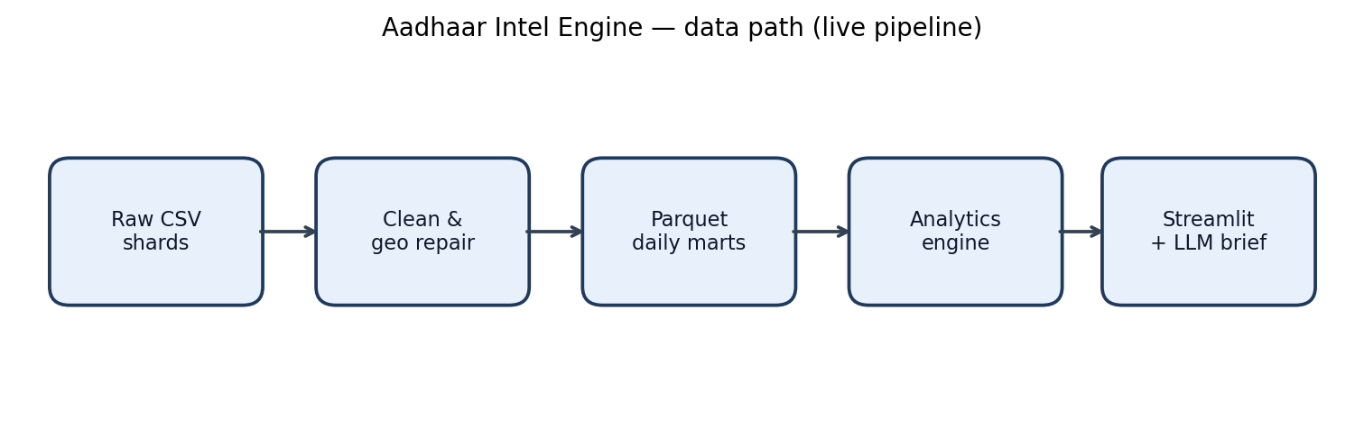
Architecture capture

3.3 Geography repair (RQ1)
Ordered stages in full_geo_repair():
- District typed as state (district_as_state.json + corpus majority map)
- District aliases (district_aliases.json)
- AP → Telangana boundary (allowlist of Telangana districts still tagged Andhra Pradesh)
- PIN prefix → state fallback when state remains non-official
Rule pack version: `GEO_RULE_PACK_VERSION = 1.1.0`.
Gold evaluation: assets/reference/eval_geo_gold.json via evaluate_geo_cleaning (tests require high state/both accuracy).
`[TABLE — fill from load_report / eval]` Geo repair outcomes
Metric | Value | Source
district_as_state repairs | *fill* | `load_report.geo_repair_stats`
district_aliases applied | *fill* | same
ap_to_telangana reassignments | *fill* | same
pin_prefix_fallback rows | *fill* | same
Gold state accuracy | *fill* | `geo_eval` / test harness
Gold both accuracy | *fill* | same
Rule pack version | 1.1.0 | config

`[FIGURE — geo repair before/after sample]`
Path: docs/figures/geo_repair_example.png
Caption: *Example rows: misfiled state → official state; AP+Nalgonda → Telangana.*

3.4 Governance (human overrides)
- Scans for residual state/district name issues (PIN overlap heuristics via dim_geo)
- Actions: Merge / Delete / Ignore with pagination, auto-fix high confidence, merge-all confirm
- Durable store: output/governance_patches.json + output/governance_audit.csv
- Import/export pack JSON
`[FIGURE — governance UI]`
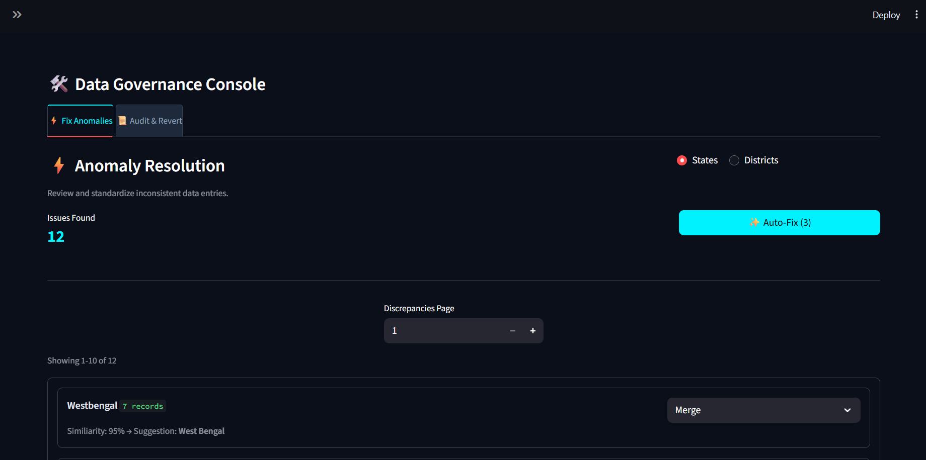
Governance console
*Also:* !Live governance

3.5 Anomaly detection (RQ2)
Unit of analysis: state × district (composite cell).
Features (per cell): volume, log volume, day-to-day CV, bio ratio, demo ratio, week-over-week growth, active days, volume vs state median.
Model: sklearn.ensemble.IsolationForest
- Default contamination 0.05 (UI: 0.01–0.15)
- Default min volume 50
- n_estimators=200, fixed random_state
Outputs: risk score (scaled for outliers), top feature → reason text, investigation notes.
`[FIGURE — anomaly scatter / bars]`
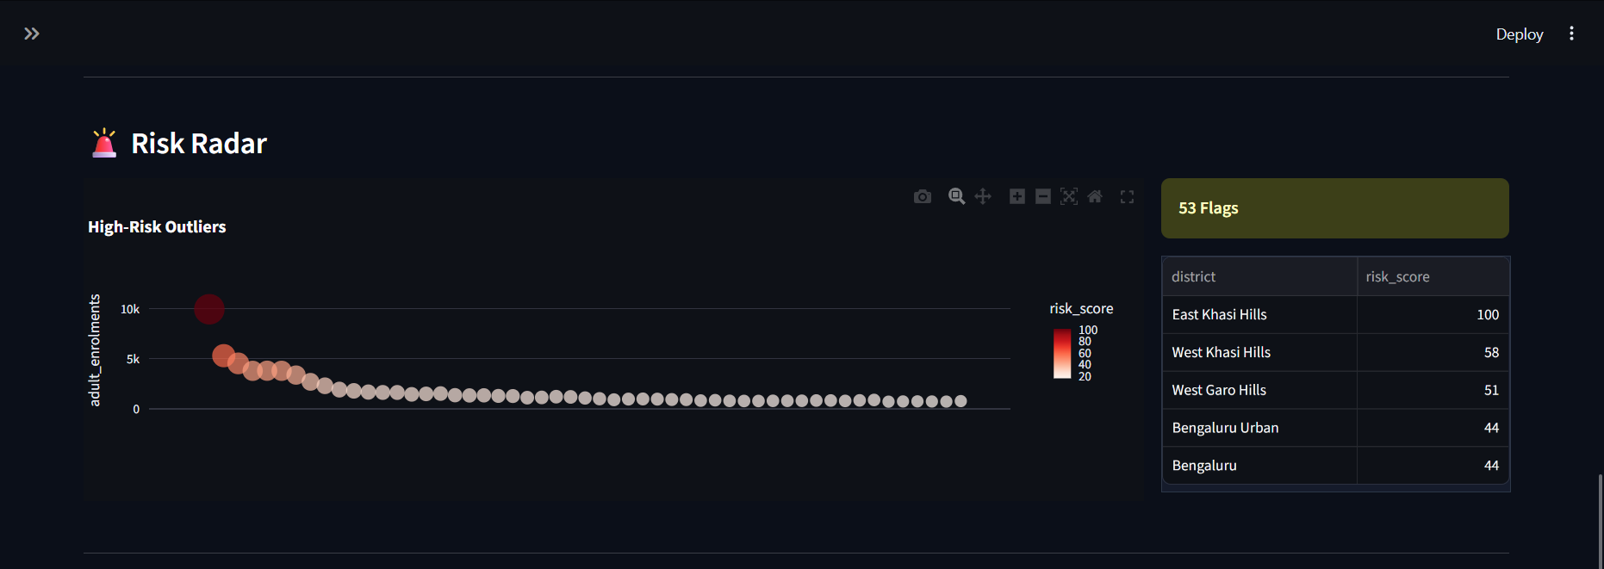
Anomaly scatter
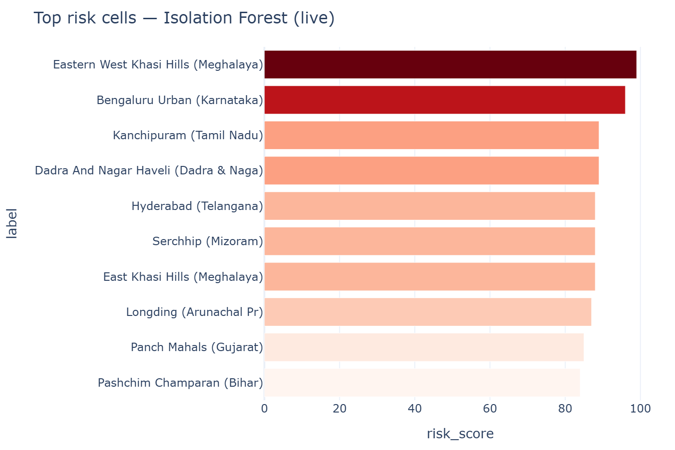
Anomaly chart
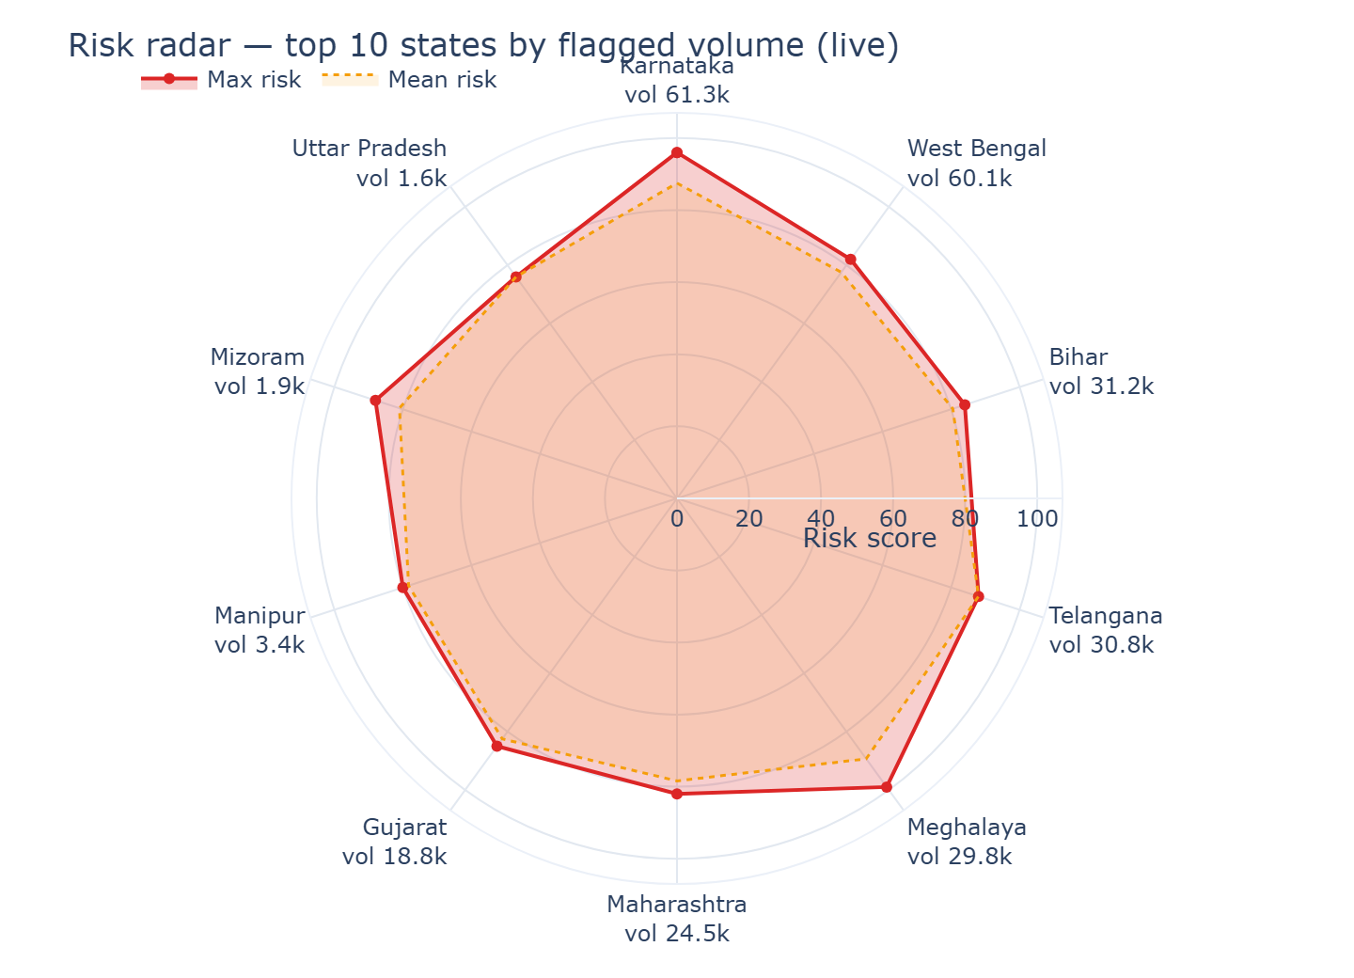
Risk radar
`[TABLE — fill from Analytics/Dashboard]` Top risk cells (example run)
State | District | Volume | Risk | Reason | bio | demo | cv
*fill* | *fill* | *fill* | *fill* | *fill* | *fill* | *fill* | *fill*

3.6 Forecasting (RQ3)
Series: national or single-state daily enrolment; missing calendar days filled with 0 (preserves DOW structure).
Candidates: MovingAverage, Drift, Ensemble, SeasonalNaive.
Evaluation: rolling-origin CV when history allows (else single holdout).
Auto selection:
- Rank by primary metric (MASE by default).
- Accept SeasonalNaive / MovingAverage / Drift if best.
- Accept other winners (e.g. Ensemble) only if they strictly beat both SeasonalNaive and MovingAverage on MASE (FORECAST_BEAT_BASELINE_EPS = 0).
- Else fall back to better of SN vs MA.
Intervals: split conformal absolute residual quantile (α = 0.1).
Decision bands
Band | MASE | sMAPE (fallback) | Ops meaning
tight | &lt; 0.85 | &lt; 20% | finer short-horizon planning
directional | &lt; 1.15 | &lt; 40% | direction / envelope
exploratory | ≥ 1.15 | ≥ 40% | monitor actuals closely

`[FIGURE — forecast path]`
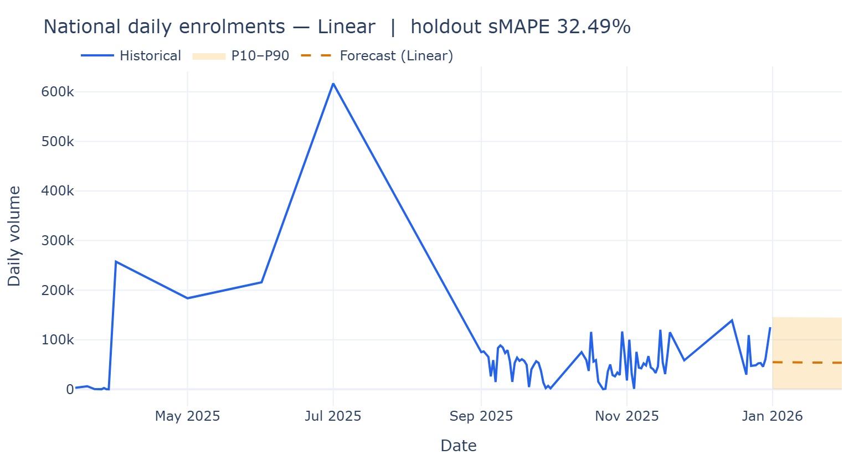
Forecast
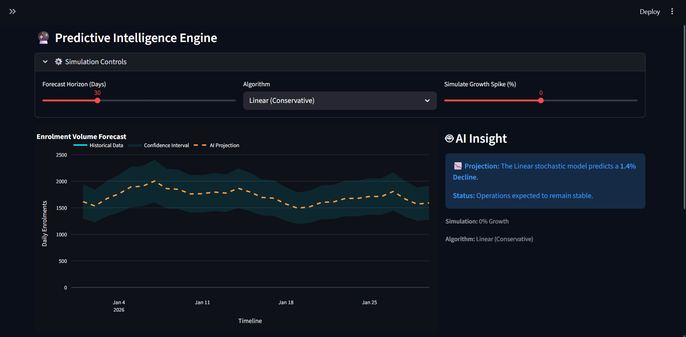
Stochastic forecast
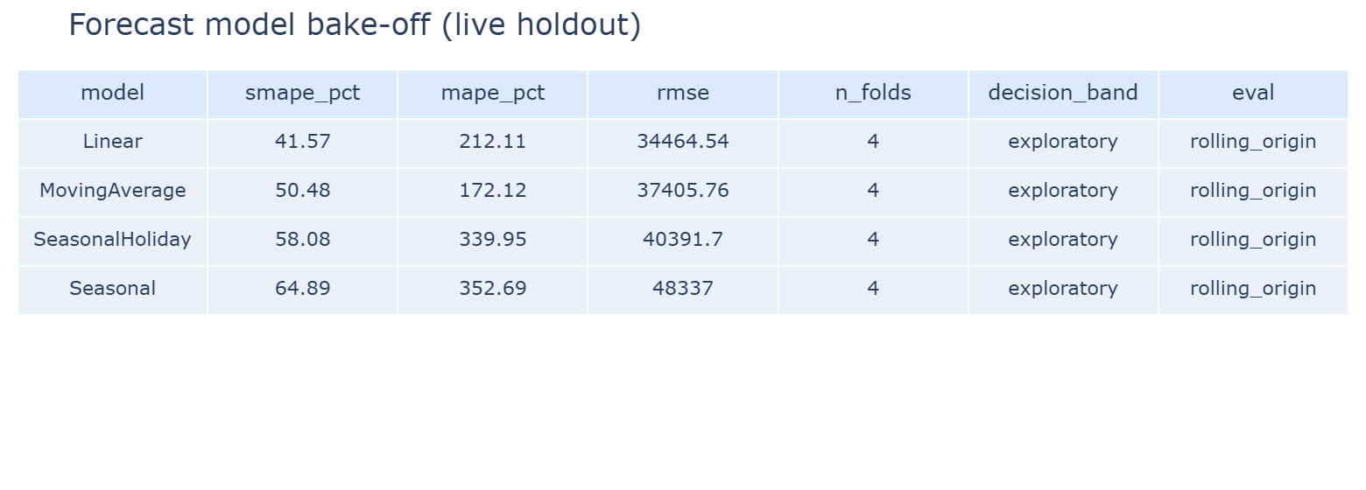
Bake-off
`[FIGURE — model selection views]`
Path: docs/figures/model_selection_mase_rank.png
Caption: *MASE rank with best-baseline reference (from Forecast → Model selection).*
Path: docs/figures/model_selection_baseline_gate.png
Caption: *Δ MASE vs best baseline (green = beats gate).*
[TABLE — fill from Forecast UI] Bake-off (example run, scope: National / *state*)**
Rank | Model | MASE | sMAPE % | RMSE | Band | Folds | Selected?
1 | *fill* | *fill* | *fill* | *fill* | *fill* | *fill*
2 | *fill* | *fill* | *fill* | *fill* | *fill* | *fill*
3 | *fill* | *fill* | *fill* | *fill* | *fill* | *fill*
4 | *fill* | *fill* | *fill* | *fill* | *fill* | *fill*

Selection reason (from meta): *beats_baselines / best_baseline_or_top / baseline_gate_blocked / …* → `[fill]`

3.7 Geospatial analytics
- Prefer district centroids; else state centroid + jitter (centroid_source exposed).
- Intensity bands: bottom 10% / 10–30% / top of volume range (same colour logic as Streamlit).
- Modes: intensity scatter, heatmap, 3D columns; log vs linear size/elevation.
- Web UI: fullscreen map, basemap switch, intensity chips, rankings, fly-to hotspot.
`[FIGURE — map]`
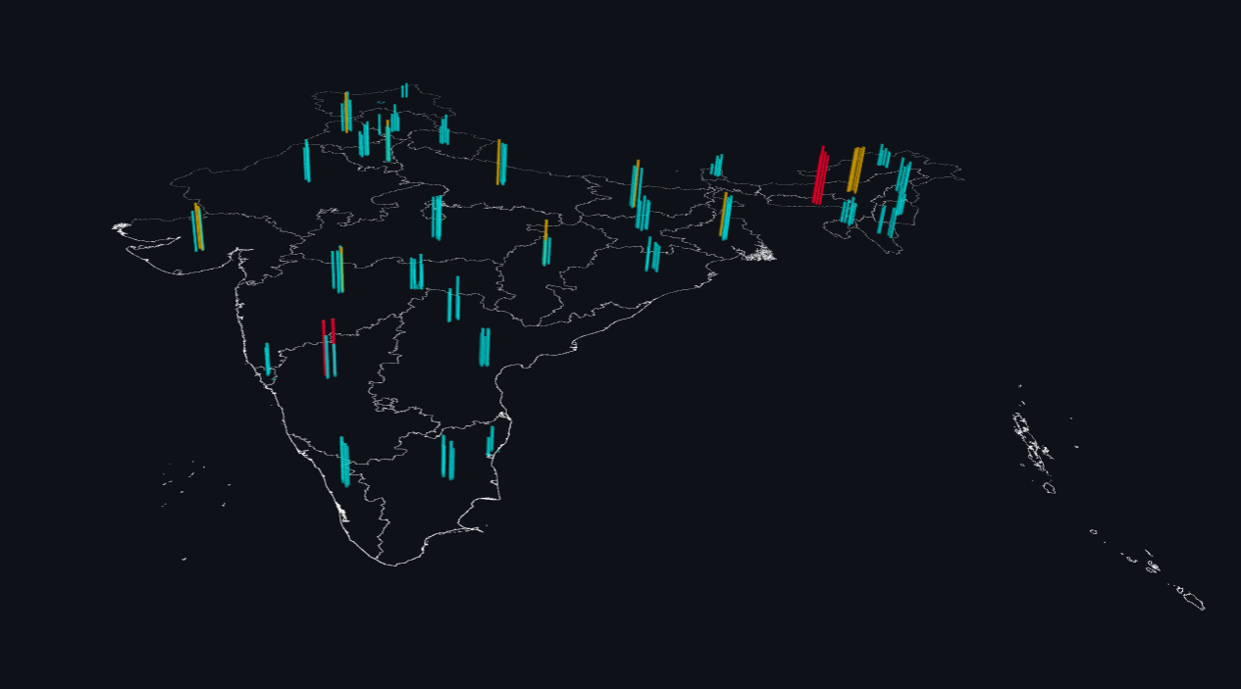
Geospatial map
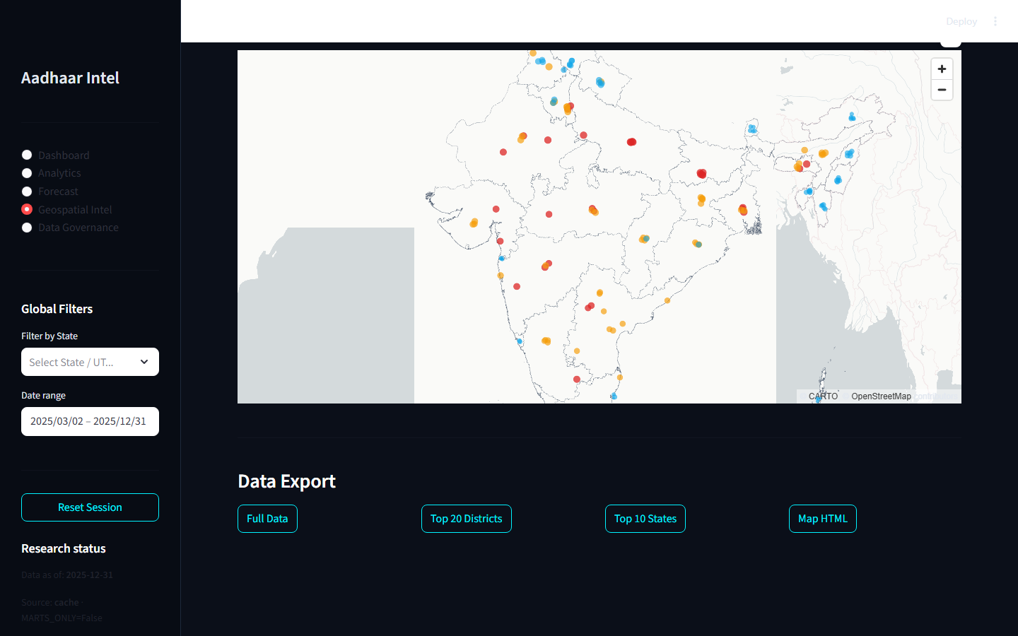
Live geospatial
`[FIGURE — map intensity legend / top districts]`
Path: docs/figures/map_top_districts.png

3.8 Hybrid AI briefs (RQ4)
Engine evidence (metrics, ranks, KPIs)
→ deterministic Insights + Actions
→ optional Ollama prose (must not invent numbers)
→ Key numbers always engine-authored
Default model env: OLLAMA_MODEL (e.g. qwen2.5:latest). Offline → engine-only analysis.
`[FIGURE — AI panel screenshot]`
Path: docs/figures/ai_brief_dashboard.png
Path: docs/figures/ai_brief_forecast.png

4. System architecture and delivery outcomes

4.1 Dual UI
Layer | Entry | Stack
Research UI | `python main.py` / `streamlit run app.py` | Streamlit, Plotly, pydeck
Professional web | `python run_web.py` | FastAPI + React (Vite), Recharts, deck.gl/MapLibre

Shared core: DataLoader, AnalyticsEngine, ForecastBackend, geo repair, governance store.
`[FIGURE — UI modules collage]`
Module | Live capture | Alternate
Dashboard | ![Dashboard](live_captures/01_dashboard.png) | ![alt](../images/dashboard_main.png)
Analytics | ![Analytics](live_captures/02_analytics.png)
Forecast | ![Forecast](live_captures/03_forecast.png)
Geospatial | ![Map](live_captures/04_geospatial.png)
Governance | ![Gov](live_captures/05_governance.png)

4.2 Product / engineering outcomes
- Feature parity between Streamlit modules and React pages (documented in web/FEATURE_PARITY.md).
- Single-command web launch with optional --skip-build.
- Export paths: analytics CSV pack, forecast CSV, map CSV (full / top districts / top states), governance pack + audit.
- Reproducibility knobs: seeds, contamination, holdout/rolling folds, conformal α.

5. Empirical outcomes (fill after a documented run)
Record date, UI (Streamlit/Web), filters (states, date range), and git commit SHA for every filled table.
Run metadata
Field | Value
Date | *YYYY-MM-DD*
Git commit | *sha*
UI | Streamlit / React `:port`
Filters | States: *All / …* · Range: *…*
Contamination / min volume | *0.05 / 50*
Forecast horizon / scope | *30 / National*

5.1 Operational KPIs
`[TABLE — fill]`
KPI | Value
Total enrolments
Adult (18+) enrolments
Biometric updates
Demographic updates
Active states / districts
Risk cells flagged
Forecast growth Δ (30d)
Selected model
MASE / sMAPE
Decision band

`[FIGURE — dashboard KPI strip]`
Path: docs/figures/kpi_strip.png
*Reference:* !Workload mix

5.2 Workload and age structure
`[FIGURE — age mix / workload mix]`
Path: docs/figures/age_workload_mix.png
*Reference:* !Efficiency donut

5.3 Anomaly investigation summary
`[TABLE — fill]` Counts by reason / top states by flagged volume
Reason code | # cells | Flagged volume
*fill*

`[FIGURE — risk gradient bars]`
Path: docs/figures/anomaly_risk_bars.png

5.4 Forecast quality and selection
`[TABLE — fill]` Auto selection audit
Item | Value
Best by MASE (raw #1)
Selected after gate
Selection reason
Best baseline MASE
Δ selected vs best baseline
Conformal q
Peak / floor (horizon)

5.5 Geospatial concentration
`[TABLE — fill]` Top 5 districts by mapped volume
Rank | State | District | Volume | Intensity | Share %
1
…

`[FIGURE — map fullscreen / intensity]`
Path: docs/figures/map_fullscreen.png

5.6 Geo evaluation (automated)
Run: pytest tests/test_geo_repair.py -q (or project test suite).
`[TABLE — fill]`
Check | Result
AP→Telangana unit test | pass / fail
Gold state accuracy ≥ 0.9
Gold both accuracy ≥ 0.9
Forecast unit tests

6. Interpretation and implications

6.1 For operations
- Geo repair + governance reduce silent geographic bias in state/district rollups before any ML.
- Risk cells prioritise investigation capacity; treat scores as triage, not guilt.
- Baseline-gated forecasts discourage overconfident complex models on noisy series; decision bands communicate use-case fit.
- Maps support regional staffing envelopes when combined with top-district rankings and intensity share.

6.2 For research / methods
- Demonstrates a full ops research pipeline: dirty public-sector aggregates → rule-based cleaning → unsupervised outlier detection → multi-model forecast with honest baselines → dual UI.
- Hybrid AI pattern separates measurement (engine) from narrative (LLM).
- Dual UI shows research prototypes can graduate to professional SPA without forking analytics logic.

6.3 Limitations
Limitation | Mitigation in system / practice
Unsupervised anomalies ≠ fraud | Explicit UI/API disclaimers; investigation notes
Forecast degradation under breaks | Rolling CV, decision bands, conformal intervals
Centroid approx. for some districts | `centroid_source` exposed; prefer district file when present
Rule pack coverage gaps | Gold eval + human governance for residuals
LLM may restate poorly if unconstrained | Locked metric evidence; hybrid assembly
Aggregate data only | No individual-level claims

7. Reproducibility and artefacts

7.1 Key configuration (as of codebase)
Parameter | Default
`CACHE_SCHEMA_VERSION` | 4
`GEO_RULE_PACK_VERSION` | 1.1.0
`ANOMALY_CONTAMINATION` | 0.05
`ANOMALY_MIN_VOLUME` | 50
`FORECAST_CANDIDATES` | MA, Drift, Ensemble, SeasonalNaive
`FORECAST_PRIMARY_METRIC` | mase
`FORECAST_BEAT_BASELINE_EPS` | 0.0
`FORECAST_CONFORMAL_ALPHA` | 0.1
`FORECAST_ROLLING_FOLDS` | 4
`FORECAST_RANDOM_SEED` | 42

7.2 Artefact checklist
Artefact | Location | Present?
Parquet marts | `data/processed/` | `[ ]`
Manifest | `data/processed/manifest.json` | `[ ]`
Governance patches | `output/governance_patches.json` | `[ ]`
Audit log | `output/governance_audit.csv` | `[ ]`
Live captures | `docs/live_captures/` | `[x]` (seed set)
Symposium paper | `docs/*_NSEFCCIC2026_Paper.pdf` | `[x]`
Flowchart | `flowchart.md` | `[x]`
This outcomes report | `docs/RESEARCH_OUTCOMES.md` | `[x]`

7.3 Recommended figure pack for publication
Create docs/figures/ and export:
- Architecture
- ETL + geo repair pipeline
- Dashboard overview
- Anomaly bars + radar
- Forecast path + model selection (rank + baseline gate)
- Geospatial map + top districts
- Governance scan example
- Hybrid AI brief (with Key numbers visible)

8. Conclusions
The Aadhaar Intel Engine demonstrates that noisy national-scale identity-system aggregates can support transparent operational intelligence when:
- Geography is repaired and governed as a first-class pipeline,
- Outlier detection is multi-feature and explicitly non-accusatory,
- Forecasting is baseline-honest and interval-aware,
- AI assists with evidence-locked narrative, and
- Research and professional UIs share one analytics core.
Measured outcomes (KPIs, bake-off metrics, geo gold accuracy, risk tables) should be filled from a dated, version-pinned run using the tables and figure slots above.

9. Appendix A — Figure index (paths)
Fig. | Description | Path
A1 | Architecture | `images/architecture_diagram.png`
A2 | Dashboard (static) | `images/dashboard_main.png`
A3 | Dashboard (live) | `docs/live_captures/01_dashboard.png`
A4 | Analytics (live) | `docs/live_captures/02_analytics.png`
A5 | Forecast (live) | `docs/live_captures/03_forecast.png`
A6 | Geospatial (live) | `docs/live_captures/04_geospatial.png`
A7 | Governance (live) | `docs/live_captures/05_governance.png`
A8 | Anomaly chart | `docs/live_captures/chart_anomalies.png`
A9 | Risk radar | `docs/live_captures/chart_risk_radar.png`
A10 | Forecast chart | `docs/live_captures/chart_forecast.png`
A11 | Bake-off chart | `docs/live_captures/chart_bakeoff.png`
A12 | Workload mix | `docs/live_captures/chart_workload_mix.png`
A13 | Map (static) | `images/geospatial_map.png`
A14 | Resource planning | `images/resource_planning.png`
A15+ | *Add new exports here* | `docs/figures/…`

10. Appendix B — Placeholder gallery
Copy this block for each new experiment run:
### Run: YYYY-MM-DD — short title
**Commit:** `sha` · **UI:** React/Streamlit · **Scope:** …
![Dashboard](figures/run_YYYYMMDD_dashboard.png)
![Forecast](figures/run_YYYYMMDD_forecast.png)
![Model selection](figures/run_YYYYMMDD_model_selection.png)
![Map](figures/run_YYYYMMDD_map.png)
![Anomalies](figures/run_YYYYMMDD_anomalies.png)
| KPI | Value |
|-----|-------|
| … | … |

11. References (in-repo)
- flowchart.md — system flowcharts
- web/FEATURE_PARITY.md — Streamlit ↔ React parity
- docs/build_symposium_paper.py — paper builder
- docs/capture_live_assets.py — UI/chart capture
- tests/test_geo_repair.py, tests/test_forecast.py — automated checks
- src/config.py — knobs cited above
Generated from the current repository design and implementation. Update tables and figure paths when re-running experiments.

