# Understanding the 5G NR PHY

## Objective

This experiment has four goals. First, to gain an appreciation for the 5G NR physical layer, i.e., the time-frequency resource grid in the OFDM access scheme. Second, to understand how a packet is transmitted over this OFDM PHY in NetSim, and the assumptions involved. Third, to analytically estimate (per 3GPP standards) the application throughput for a simple use case. And finally, to simulate and analyze throughput as different PHY parameters are varied.

## I**ntroduction**

**OFDM:** 5G uses Orthogonal Frequency Domain Multiplexing (OFDM) as the multiple access scheme for both downlink and uplink transmissions with the flexibility of multiple subcarriers spacing that supports diverse application scenarios. The smallest physical resource, known as the resource element (RE), comprises one subcarrier and one OFDM symbol.

The time-domain transmission structure comprises of frames 10 ms (to support backward compatibility with LTE). Each frame is composed of 10 subframes of 1 ms each. The 1 ms subframe is then divided into one or more slots in 5G, whereas LTE had exactly two slots in a subframe. The slot size depends on the numerology, $μ,$ and is equal to $\frac{1}{2^{μ}}$ ms. The number of OFDM symbols per slot is 14 for a configuration using a normal cyclic prefix. For extended cyclic prefixes, the number of OFDM symbols per slot is 12. Data is transmitted over these symbols.

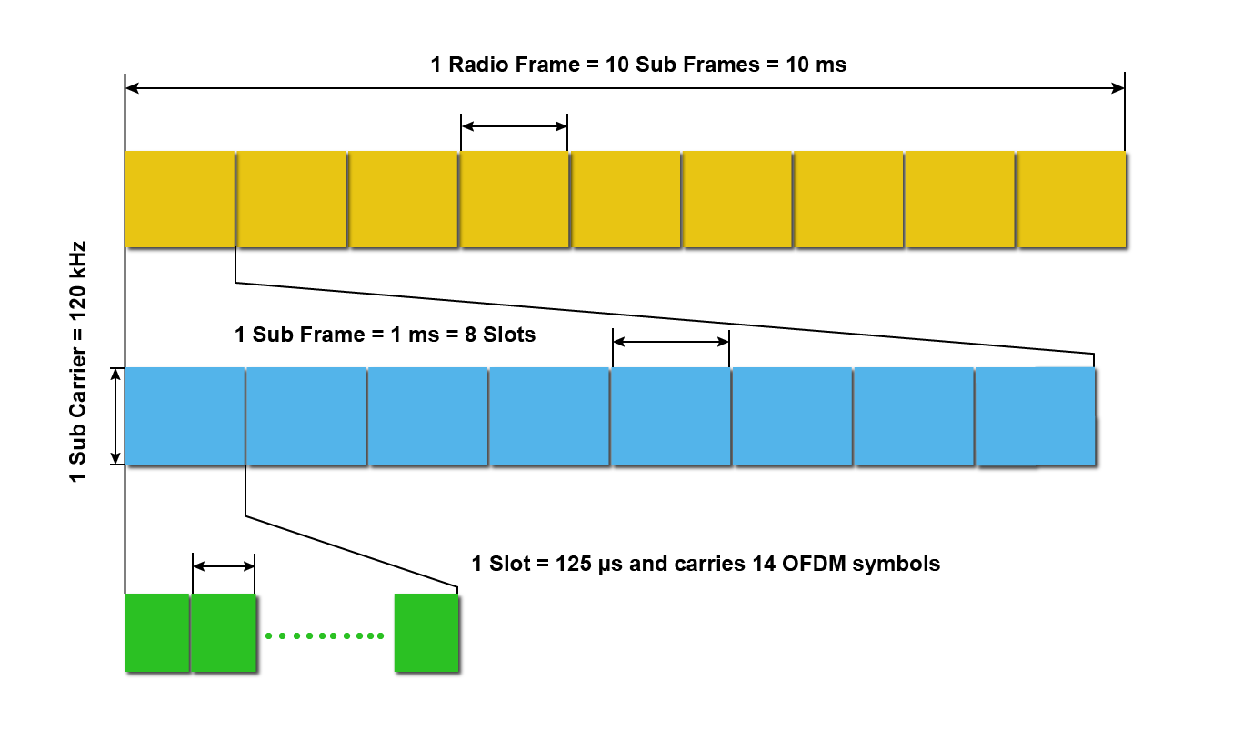

Fig 1: NR Frame Structure when numerology μ is set to 3.

In the time division duplex version, each frame is partitioned into downlink subframes and uplink subframes. The downlink part of each frame is used to send data from the gNB to the UEs. The uplink part of the frame is used to send data from the UEs to the destinations, via the gNB. The uplink-downlink ratio is a GUI parameter in NetSim. If Internet access is a major application in a system, then the downlink part of the frame would be substantially larger than the uplink part, due to the asymmetry of Internet access traffic.

In the frequency domain, the group of 12 consecutive sub-carriers forms a resource block (RB). The sub carrier spacing (SCS) is also dependent on numerology, $μ$ and is equal to $2^{μ}×15$ KHz. 5G supports total carrier bandwidth up to 400 MHz with a maximum of 275 RBs.

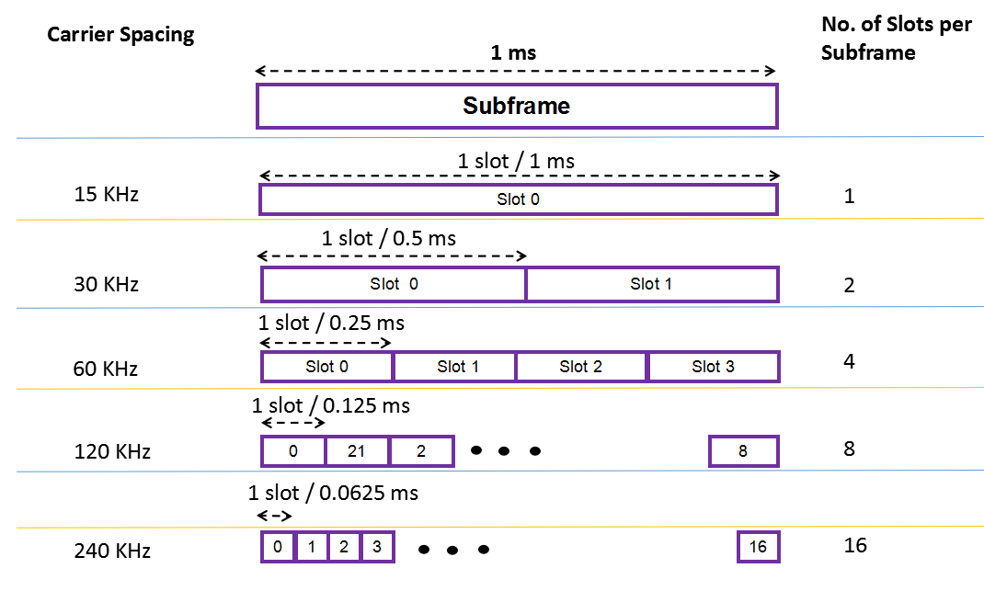

Fig 2: The OFDM frame structure. Slot times get shorter as the sub-carrier spacing gets larger.

**Data Transmission in NetSim**

* In TDD operation the UL and DL transmissions are separated in the time-domain over different frames/subframes/slots/symbols and use the same carrier frequency. In FDD operation UL and DL transmissions are separated in the frequency domain, with different frequencies used for UL and for DL transmissions. NetSim does slot-based scheduling. For example, if the DL:UL ratio is 4:1 then 4 slots are allotted to DL and 1 slot to UL.
* Higher layer packets arrive at the RLC buffer for each UE and each gNB.
* The MAC Scheduler determines the Transport block size (TBS) based on the channel quality index (CQI). The CQI is determined by the Adaptive Modulation and Coding (AMC) function based on the SNR.
* Now, the SNR is determined from a) large-scale path loss and shadowing calculated per the 3GPP’s stochastic propagation models, and b) the small-scale fading which leads to beamforming gains when using MIMO. These models provide signal attenuation as an output. Several parameters are used in the model, including the distance between the transmitter and the receiver. These computations are executed each associated UE-gNB pair, in DL and UL, at the start of simulation and again at every mobility event. In calculating SNR, the noise power is obtained from $N=k×T×B$.
* Note that the SNR/CQI is not computed/fed-back using reference signals but is computed on the data channel. Then it is assumed to be instantaneously known to the transmitter and receiver. This assumption is known as perfect CSIT and CSIR. With perfect CSIT the transmitter can adapt its transmission rate (MCS) relative to the instantaneous channel state (SNR).
* Based on this SNR the AMC determines a wideband CQI which indicates the highest rate Modulation and coding scheme (MCS), that it can reliably decode, if the entire system bandwidth were allocated to that user. The rate adaptation is discrete (not continuous), and the modulation and coding scheme (MCS) is selected from a standard specified table. The modulation scheme defines the number of bits, that can be carried by a single RE. Modulation schemes supported by 5G include QPSK (2 bits), 16 QAM (4 bits), 64 QAM (6 bits), and 256 QAM (8 bits). The code rate defines the proportion of bits transmitted that are useful. It is computed as the ratio of useful bits by total bits that are transmitted. The modulation order $Q_{m}$, which denotes the number of bits per RE, and the code rate denoted by $R$ are jointly encoded as modulation and coding scheme (MCS) index. These values of $Q_{m}$ and $R$ are then passed to the TBS determination function.
* At each gNB a frame of length 10ms is started. Each frame in turn starts 10 sub frames each of length 1ms. Each sub frame then starts a certain number of slots based on numerology.
* The PHY layer in NetSim then notifies the MAC about the slot start. The MAC sub layer in turn seeks a buffer status report from the RLC layer and invokes the MAC scheduler. It then notifies the RLC of the transmission. The RLC then transmits the transport block to the PHY layer. The downlink and uplink data channels (PDSCH, PUSCH) receive this transport block as its service data unit (SDU), which is then processed and transmitted over the radio interface.

## Procedure:

1. Use the following download Link to download a compressed zip folder which contains the workspace [GitHub link](https://github.com/NetSim-TETCOS/5G_Advanced_Experiments_v13.3/archive/refs/heads/main.zip)
2. Extract the zip folder.
3. The extracted project folder consists of a NetSim workspace file (5G_advanced_experiments_with_NetSim.netsimexp).
4. Go to NetSim Home window, go to Your Work and click on import.

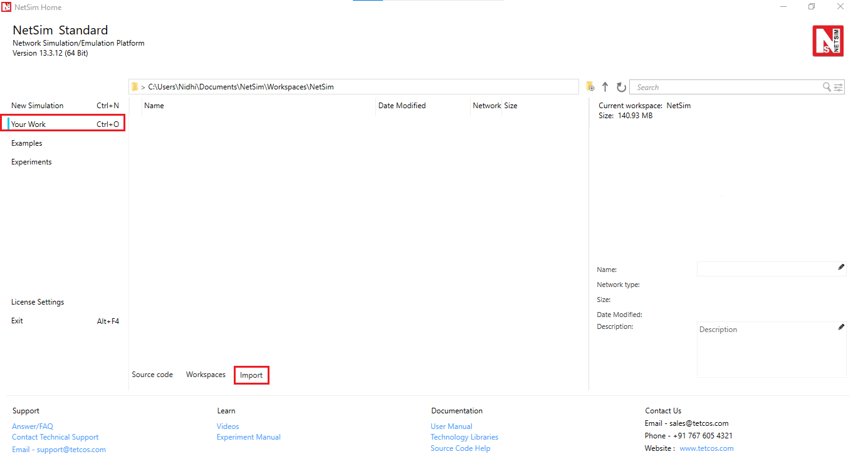

Fig 3: NetSim Home Window

1. In the Import Workspace Window, browse and select the 5G_advanced_experiments_with_NetSim.netsimexp file from the extracted directory. Click on create a new workspace option and browse to select a path in your system where you want to set up the workspace folder.
2. Choose a suitable name for the workspace of your choice. Click Import.

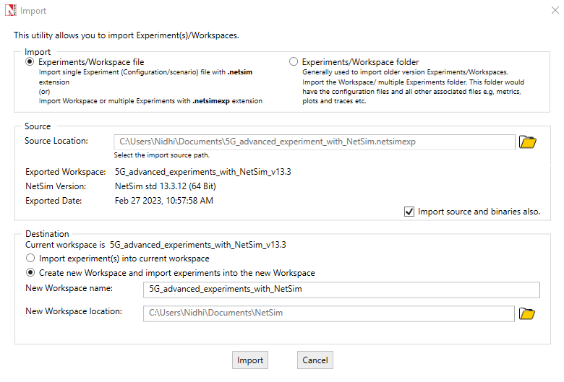

Fig 4: NetSim Your Work Window to import a workspace.

1. The Imported Project workspace will automatically be set as the current workspace.
2. The list of experiments is now loaded onto the selected workspace.

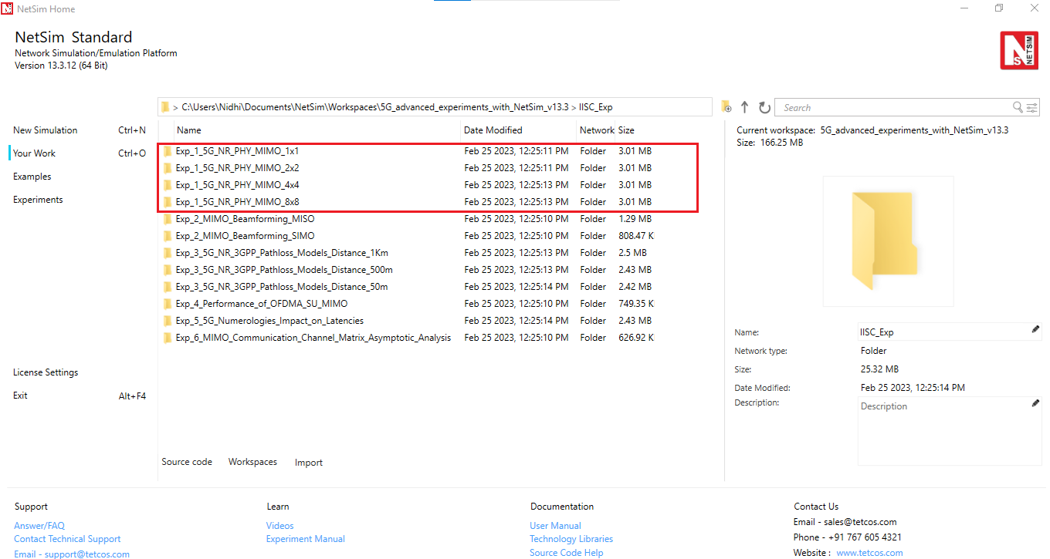

Fig 5: NetSim Your Work Window with the experiment folders inside the workspace.

## Network scenario:

NetSim UI would display the following network topology when you open the example configuration file as shown below screenshot.

Fig 6: Network topology in this experiment

### Settings:

The following settings were configured in the network setup.

1. The UE was placed 100m away from the gNB.
2. The following properties were set in Interface 5G RAN, Physical Layer of gNB.

|  |  |
| --- | --- |
| gNB Interface 5G RAN | |
| gNB Height (m) | 10 |
| Tx Power (dBm) | 31, 34, 37, 40, 43 (Varied) |
| Tx Antenna Count | 1* (varied from 1 to 8) |
| Rx Antenna Count | 4 |
| CA Type | Single Band |
| CA Configuration | n261 |
| DL: UL Ratio | 4:1 |
| Numerology | 3 |
| Channel Bandwidth (MHz) | 50, 100, 200, 400 (Varied) |
| MCS Table | QAM256 |
| CQI Table | TABLE2 |
| Outdoor Scenario | Rural Macro |
| Indoor Office Type | Mixed Office |
| Pathloss Model | 3GPPTR38.901-7.4.1 |
| LOS Mode | User Defined |
| LOS Probability | 0 |
| Shadow Fading Model | None |
| Fading and Beamforming | No Fading |

Table 1: gNB properties

1. Tx Antenna Count =4 and Rx Antenna Count is varied from 1 to 8 in UE > Interface 5G RAN > Physical Layer
2. A downlink CBR application was configured from Wired Node to UE with Packet Size 1460B and IAT (varied for each layer count) and the start time was set to 1s.
3. Run the simulation for 1.2s.
4. Run the simulation for different MIMO Layers and different Tx Powers in gNB and note down the throughput obtained.

### Analytical Estimation of Data Throughput

We derive the throughput for the setting involving $2×2$ MIMO (2-layers) with 100MHz Bandwidth and 31 dBm Transmit power. The procedure for TBS determination given in the steps below is per 3GPP TS 38.214 Section 5.1.3.2 (DL).

1. Initially, the Pathloss (dB) is calculated based on the Pathloss models specified in the 3GPP standards[1]. Pathloss in this example turns out to be $122.26 dB$
2. The Total Loss is then calculated using the following equation:

$$TotalLoss \left(dB\right)=Pathloss \left(dB\right)+ShadowFading Loss+O2I Loss+Additional Loss$$

In this example, $Shadow Fading Loss=0$, $O2I Loss=0$, $Additional Loss=0$

$$Total Loss=122.26+0+0+0=122.26 dB$$

1. The Received power (Per layer) is calculated, using the Tx Power (per layer), the Total Loss and the Beamforming Gain (per layer). Since fading is turned off the Beamforming (BF) gain per layer is 0 dB.
$$Rx Power_{Layer} \left(dBm\right)=Tx Power_{Layer} \left(dBm\right)-Total Loss \left(dB\right)+BFGain_{Layer}$$

$$Rx Power_{Layer 1}=27.98-122.26+0= -94.28 dBm$$

$$Rx Power_{Layer 2}=27.98-122.26+0= -94.28 dBm$$

2. Thermal Noise computation

$$Thermal Noise=k×T×B$$

$k (Boltzmann^{'}s constant)= 1.38*{10}^{-23}$, $T \left(Temperature\right)=300 K, B=100 MHz$

$Thermal Noise=$ $4.14×{10}^{-13}W$

$$=-93.829 dBm$$

1. From the Rx Power and Thermal Noise, SNR is calculated
$Rx Power in dBm is converted into mW$

$$Rx Power, P= -94.28 dBm=3.73×{10}^{-10}mW$$

$Thermal Noise in dBm is converted into mW$

$$Thermal Noise, N= -93.82 dBm=4.14*{10}^{-10} mW$$

2. $SNR\left(Linear\right)=\frac{E_{b}}{N_{0}}=\frac{Rx Power}{Thermal Noise}=\frac{P}{N}$ = $\frac{{3.73×10}^{-10}}{4.14×{10}^{-10}}=0.902$
3. From SNR, the Spectral Efficiency is calculated as follows:
$$Spectral Efficiency_{Layer}=\log_{2}\left(1+\left(\frac{E_{b}}{N_{0}}\right)\right)$$

$$=\log_{2}\left(1+\left(0.902\right)\right)= 0.927$$

4. The CQI Index is then looked up from the respective CQI Table using the spectral efficiency obtained. The table is given below:

{0, Modulation_Zero, 0, 0}, //out of range

{1, Modulation_QPSK, 78, 0.1523},

{2, Modulation_QPSK, 193, 0.3770},

{3, Modulation_QPSK, 449, 0.8770},

{4, Modulation_16_QAM, 378, 1.4766},

{5, Modulation_16_QAM, 490, 1.9141},

{6, Modulation_16_QAM, 616, 2.4063},

{7, Modulation_64_QAM, 466, 2.7305},

{8, Modulation_64_QAM, 567, 3.3223},

{9, Modulation_64_QAM, 666, 3.9023},

{10, Modulation_64_QAM, 772, 4.5234},

{11, Modulation_64_QAM, 873, 5.1152},

{12, Modulation_256_QAM, 711, 5.5547},

{13, Modulation_256_QAM, 797, 6.2266},

{14, Modulation_256_QAM, 885, 6.9141},

{15, Modulation_256_QAM, 948, 7.4063},

Since the Spectral Efficiency is 0.927, from the CQI Table, $CQI Index=3$ is chosen.

1. Similarly, the MCS Index is taken from the respective MCS Table with respect to the spectral efficiency from the CQI Table:

{0, 2, Modulation_QPSK, 120, 0.2344},

{1, 2, Modulation_QPSK, 193, 0.3770},

{2, 2, Modulation_QPSK, 308, 0.6016},

{3, 2, Modulation_QPSK, 449, 0.8770},

{4, 2, Modulation_QPSK, 602, 1.1758},

{5, 4, Modulation_16_QAM, 378, 1.4766},

{6, 4, Modulation_16_QAM, 434, 1.6953},

{7, 4, Modulation_16_QAM, 490, 1.9141},

{8, 4, Modulation_16_QAM, 553, 2.1602},

{9, 4, Modulation_16_QAM, 616, 2.4063},

{10, 4, Modulation_16_QAM, 658, 2.5703},

{11, 6, Modulation_64_QAM, 466, 2.7305},

{12, 6, Modulation_64_QAM, 517, 3.0293},

{13, 6, Modulation_64_QAM, 567, 3.3223},

{14, 6, Modulation_64_QAM, 616, 3.6094},

{15, 6, Modulation_64_QAM, 666, 3.9023},

{16, 6, Modulation_64_QAM, 719, 4.2129},

{17, 6, Modulation_64_QAM, 772, 4.5234},

{18, 6, Modulation_64_QAM, 822, 4.8164},

{19, 6, Modulation_64_QAM, 873, 5.1152},

{20, 8, Modulation_256_QAM, 682.5, 5.3320},

{21, 8, Modulation_256_QAM, 711, 5.5547},

{22, 8, Modulation_256_QAM, 754, 5.8906},

{23, 8, Modulation_256_QAM, 797, 6.2266},

{24, 8, Modulation_256_QAM, 841, 6.5703},

{25, 8, Modulation_256_QAM, 885, 6.9141},

{26, 8, Modulation_256_QAM, 916.5, 7.1602},

{27, 8, Modulation_256_QAM, 948, 7.4063},

Since the Spectral Efficiency is 0.927, MCS Index 3 which corresponds to this spectral efficiency is chosen and the $Modulation Order=2$

1. The TBS size is then determined using the Modulation Order and code rate.
2. Determination of number of Resource Elements within the slot.
$$N_{RE}^{'}=N_{SC}^{RB}×N_{Symb}^{Sh}-N_{DMRS}^{PRB}-N_{OH}^{PRB}$$

$$N_{SC}^{RB}=12. Number of subcarriers in Physical Resource Block$$

$$N_{Symb}^{Sh}= 14. Number of Symbols per Slot$$

$$N_{DMRS}^{PRB}= 0→Number of Resource Elements for DM-RS per PRB$$

$$N_{OH}^{PRB}= 0. PDSCH overhead$$

$$N_{RE}^{'}=12×14-0-0=168$$

3. Total number of Resource Elements allocated for PDSCH
$$N_{RE}=\min\left(156, N_{RE}^{'}\right)×n_{PRB}$$

$$n_{PRB}= 1. Number of allocated PRBs for the UE$$

$$N_{RE}=\min\left(156, 168\right)×1=156×1=156$$

4. Intermediate number of information bits is calculated.

$$N_{info}=N_{RE}×R×Q_{m}$$

$R=\frac{MCS_{CodeRate}}{1024}=\frac{449}{1024}=0.438$ and $Q_{m}=2$ (Modulation order)

$$N_{info}=156×0.438×2=136.65$$

1. Since $N_{info}≤3824$, the TBS Size is calculated

$$N_{info}^{'}=\max\left(24, 2^{n}×floor\left(\frac{N_{info}}{2^{n}}\right)\right)$$

Where $n=max⁡(3, floor(\log_{2}{(N_{info}))-6)}$

$$=max⁡(3, floor(\log_{2}{(136.65))-6)}=\max{ \left(3, 1\right)}=3$$

$$N_{info}^{'}=\max\left({24, 2}^{3}×floor\left(\frac{136.65}{2^{3}}\right)\right)=\max{ \left(24, 136\right)=136}$$

Hence, the TBS size will be 136, i.e., index 15.

1. The bits per PRB per layer is determined based on the TBS size.
2. For Layer 1,

$$bitsperPRB=bits per PRB (initial)+TBS Size$$

$$=0+136=136$$

For Layer 2,

$$bitsperPRB_{L2}=bitsperPRB_{L1}+TBS Size$$

$$=136+136=272$$

1. The Total PRB available is dependent on bandwidth and $μ$ and is shown in the GUI. In this example $PRB available=PRB Count=66$
2. The total PRB available is calculated.

$$Total PRB available=PRBCount-ceil(PRB count×OH_{Downlink})$$

$PRB Count=66$, $OH_{Downlink}=0.18$ (Per standard)

$$Total PRB available=66-ceil\left(66×0.18\right)$$

$$=66-11=54$$

1. Number of PRBs allocated is 54.
2. The slot allocation will then take place and the bits per slot is assigned.
$$bits per Slot=bits per PRB×allocated PRB$$

$$=272×54=14688 bits=1836 Bytes$$

$$i.e., a slot can transmit a maximum of 1836 Bytes$$

3. Throughput estimation. $DL UL Ratio=4:1,$ implies a DL fraction of $0.8$. Since $μ=3$, slot time $\frac{1}{2^{3}}$ ms.

$$DL MAC Throughput=\frac{1836×8×0.8}{{\left(\frac{1}{2^{3}}\right)×10}^{-3}}=94 Mbps$$

$$DL Application Throughput=DL MAC Throughput ×\left(\frac{ApplicationPacketSize}{MACPacketSize }\right)$$

$$=94×\left(\frac{1460}{1488}\right)=92.23 Mbps$$

(Matches with NetSim’s Result of 92.21 Mbps, which can be seen in Table 2 entry pertaining to MIMO 2*2, Bandwidth 100MHz and Tx Power 31 dBm. The entry is marked in green.)

### Results

The following throughputs were obtained after running simulations with different Antenna counts (MIMO layers), Bandwidths and Transmit Power values.

|  |  |  |  |  |  |
| --- | --- | --- | --- | --- | --- |
| **MIMO** | **Total Tx Power[2] (dBm)** | **Peak Application Throughput (Mbps)**  **for various** | | | |
| **Bandwidth (MHz)** | | | |
| **50** | **100** | **200** | **400** |
| 1*1 | 31 | 47.82 | 74.69 | 89.81 | 74.69 |
| 34 | 68.44 | 100.50 | 149.38 | 180.68 |
| 37 | 96.76 | 143.25 | 202.06 | 298.77 |
| 40 | 112.18 | 202.06 | 287.62 | 405.23 |
| 43 | 141.91 | 234.12 | 405.23 | 576.29 |
|  | | | | | |
| 2*2 | 31 | 71.01 | 89.81 | 74.69 | 84.50 |
| 34 | 96.76 | 149.38 | 180.68 | 149.38 |
| 37 | 137.94 | 202.06 | 298.77 | 362.43 |
| 40 | 194.58 | 287.62 | 405.23 | 597.66 |
| 43 | 225.42 | 405.23 | 576.29 | 811.52 |
|  | | | | | |
| 4*4 | 31 | 86.43 | 74.69 | 84.50 | 170.00 |
| 34 | 143.13 | 180.68 | 149.38 | 170.00 |
| 37 | 194.58 | 298.77 | 362.43 | 298.77 |
| 40 | 276.93 | 405.23 | 597.66 | 725.97 |
| 43 | 390.17 | 576.29 | 811.52 | 1196.44 |
|  | | | | | |
| 8*8 | 31 | 71.01 | 84.50 | 170.00 | 0 |
| 34 | 174.26 | 149.38 | 170.00 | 341.05 |
| 37 | 287.26 | 362.43 | 298.77 | 341.05 |
| 40 | 390.17 | 597.66 | 725.97 | 597.66 |
| 43 | 554.91 | 811.52 | 1196.44 | 1452.99 |

Table 2: Saturation throughput obtained for n261 band (gNB-UE distance of 100m, Rural macro pathloss) for various Bandwidth-MIMO-TxPower combinations. The blue entries show the doubling of throughput when power and BW is doubled. Red shows examples where throughput decreases with increase in bandwidth for fixed power and MIMO layers. Green entries are where throughput decreases with increase in MIMO layers, for fixed BW and power.

### Discussion:

In Table 2 we observe entries marked in:

* Blue: When both the bandwidth and the power are doubled, with MIMO count kept constant, the peak throughput doubles. This is along expected lines.
* Red: In the high bandwidth and low power regime, when the bandwidth is doubled with the transmit power and MIMO count held constant, the peak throughput does not increase but rather decreases.
* Green: At low power when the MIMO layers are increased with fixed transmit power and bandwidth, the peak throughput surprisingly decreases.

Let us understand the red entries, i.e., throughput of 1*1 MIMO, 31 dBm Tx power for bandwidths of 200 and 400 MHz. We can simplify the PHY rate as equal to $k×L×Q×B×R$ where $k$ is some constant, $L$ is the number of layers (set to 2 here), $Q$ is the modulation order (2 in this case), $R$ is the code rate and $B$ is the bandwidth. From **Error! Reference source not found.** we see that when the bandwidth increases the spectral efficiency decreases due to an increase in thermal noise at higher bandwidths. The received power is constant since the transmit power is fixed. Since the drop in the MCS[3] (due to the reduced spectral efficiency) is larger than the bandwidth increase - $0.438×200$ vs. $0.188×400$- the net effect is a decline in the throughput.

|  |  |  |  |  |  |  |  |  |  |
| --- | --- | --- | --- | --- | --- | --- | --- | --- | --- |
| BW (MHz) | Rx Power  (dB) | Noise  (KTB) | SNR | Spectral Efficiency | Spec Eff Table cut off | MCS Index | MCS Code Rate | R  (Code rate/1024) | Throughput  (Mbps) |
| 200 | -91.26 | -90.81 | -0.44 | 0.927 | 0.8770 | 3 | 449 | 0.438 | 92.21 |
| 400 | -91.26 | -87.80 | -3.45 | 0.537 | 0.3770 | 1 | 193 | 0.188 | 75.92 |

Table 3: Rx Power, Noise, SNR, Spectral Efficiency obtained for different bandwidths with Tx power at 31 dBm.

Next, we turn to the green entries. In Table 2 notice that when the MIMO layer count is increased from 4 to 8, the received power (per layer) decreases. This happens because the transmit power is equally divided among all the layers. As SNR reduces, the spectral efficiency per layer decreases. Since the MCS drop (due to lower spectral efficiency) is larger than the multiplexing gain got from multiple MIMO streams - $4×0.438$ vs $8×0.188$- the consequence is a decrease in throughput.

|  |  |  |  |  |  |  |  |  |  |  |
| --- | --- | --- | --- | --- | --- | --- | --- | --- | --- | --- |
| MIMO Layers | BW (MHz) | Rx Power  (dB) | Noise  (KTB) | SNR | Spec Efficiency | Spec Eff Table cut off | MCS Index | MCS Code Rate | R  (Code rate/ 1024) | Throughput (Mbps) |
| 4 | 50 | -97.28 | -96.83 | -0.44 | 0.927 | 0.8770 | 3 | 449 | 0.438 | 88.76 |
| 8 | 50 | -100.29 | -96.83 | -3.45 | 0.537 | 0.3770 | 1 | 193 | 0.188 | 73.11 |

Table 4: Rx Power, Noise, SNR, Spectral Efficiency obtained for each MIMO layer with Tx power set to 31 dBm.

### Exercises

1. Estimate the data throughput analytically for different values of Transmit power, Bandwidth and MIMO layer count (Each student can be given a personalized experiment)

1. We do not get into the details of the pathloss computations here. The specifics are explained in Experiment 4: Understand 3GPP 5GNR pathloss models.
2. This is the transmit power summed over entire BW and summed over all MIMO streams.
3. Refer Steps 5 through 8 in the section Analytical estimation of Data throughput, to understand how spectral efficiency is got from SNR, and then how MCS is set from spectral efficiency.