# 5G Numerologies and their impact on end-to-end latencies

## Objective:

5G NR supports a flexible numerology with a range of subcarrier spacings, based on scaling a baseline subcarrier spacing of 15 kHz to support diverse spectrum bands/types and deployment models. The numerology, $μ$, can take values from 0 to 4 and specifies the Sub-Carrier Spacing (SCS) as $15×2^{µ}$ kHz and a slot length of $\frac{1}{2^{µ}}$ ms. With $μ$ varying from 0 to 4, Sub- Carrier Spacing (SCS) varies from 15 to 240 kHz.

We investigate the impact of numerology on latency and throughput in two cases

* A simple case where one UE is transmitting and receiving UDP traffic from a server
* A complex 5G scenario with Sensors, Cameras and Smartphones having DL and UL, TCP and UDP flows[1].

## Theory:

In NetSim, for data channels FR1 supports $μ=0, 1, 2$ and FR2 supports $μ=2, 3$. The setting $μ=0$ corresponds to the LTE (4G) system configuration. In the time domain (to support backwards compatibility with LTE) the frame length in 5G NR is set to 10 ms, and each frame is composed of 10 subframes of 1 ms each. The 1 ms subframe is then divided into one or more slots in 5G, whereas LTE had exactly two slots in a subframe. The slot size is defined based on $μ$, and the number of slots is $2^{μ}$. The number of OFDM symbols per slot is 14 for a configuration using normal cyclic prefix. For extended cyclic prefix, the number of OFDM symbols per slot is 12.

Fig 1: Frame, subframe and slot structure for different numerologies

For $μ=0$ there are 1 slot per subframe, for $μ=1$ there are 2 slots per subframe, for $μ=2$ there are 4 slots per subframe and so on. Number of slots per frame is ten times of number of slots per sub frame. Hence for $μ=2$, there are 40 slots/frame.

|  |  |  |  |  |
| --- | --- | --- | --- | --- |
| Numerology | Sub-Carrier  Spacing  (KHz) | OFDM  Symbols  per Slot | Slots  per  Frame | Slots  per  Sub-frame |
| 0 | 15 | 14 | 10 | 1 |
| 1 | 30 | 14 | 20 | 2 |
| 2 | 60 | 14 | 40 | 4 |
| 3 | 120 | 14 | 80 | 8 |
| 4 | 240 | 14 | 160 | 16 |

Table 1: Sub-carrier spacing, number of OFDM symbols per slot, slots

per frame and sub-frame for different Numerologies.

## Procedure:

1. Use the following download Link to download a compressed zip folder which contains the workspace:  [GitHub link](https://github.com/NetSim-TETCOS/5G_Experiments_v13_2_20/archive/refs/heads/main.zip%20)
2. Extract the zip folder.
3. The extracted project folder consists of a NetSim workspace file 5G_advanced_experiments_with_NetSim.netsimexp.
4. Go to NetSim Home window, go to Your Work and click on Import.

Fig 2: NetSim Home Window

1. In the Import Workspace Window, browse and select the 5G_advanced_experiments_with_NetSim.netsimexp file from the extracted directory. Click on create a new workspace option and browse to select a path in your system where you want to set up the workspace folder.
2. Choose a suitable name for the workspace of your choice. Click Import.

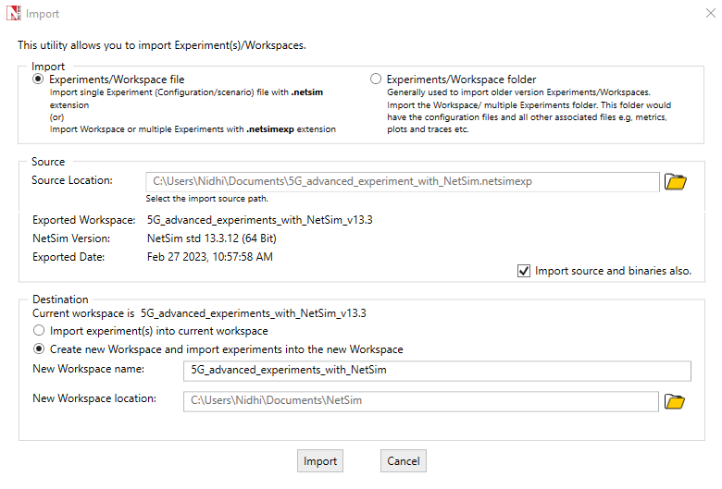

Fig 3: NetSim Import workspace window

1. The Imported Project workspace will automatically be set as the current workspace.
2. The list of experiments is now loaded onto the selected workspace.

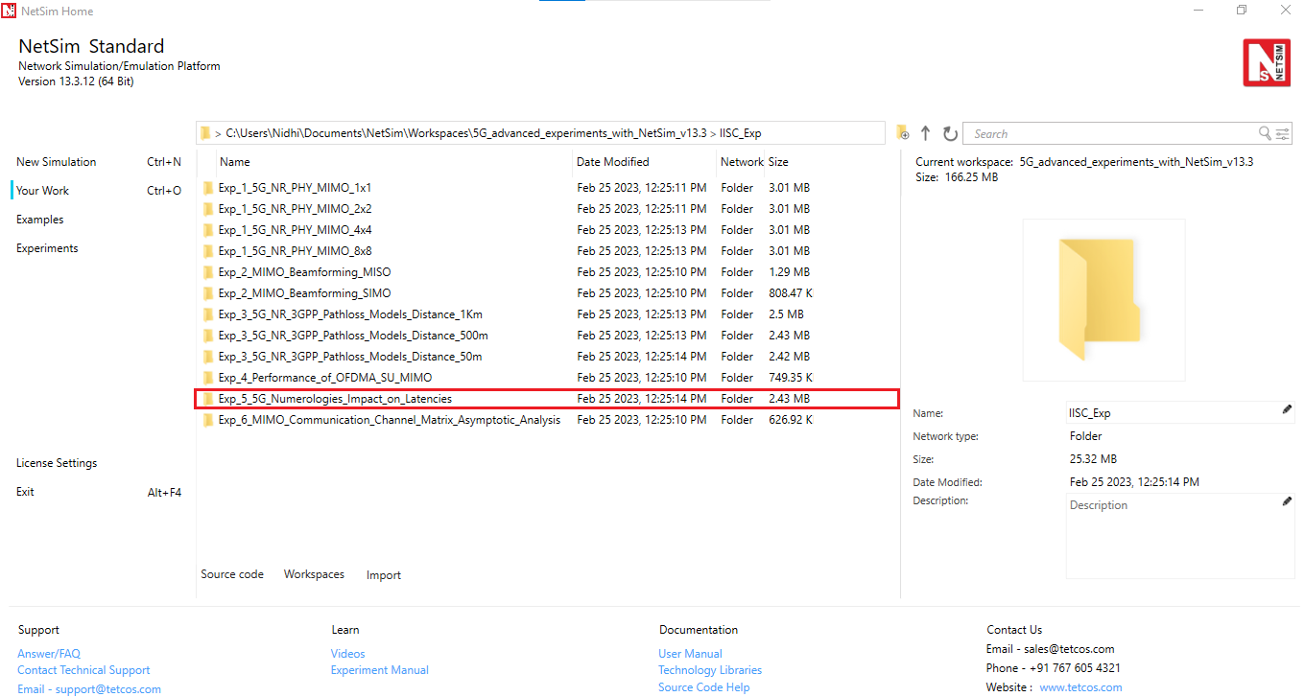

Fig 4: NetSim Your Work Window with the experiment folders inside the workspace

## Network Model

### Case 1: One UE is transmitting and receiving UDP traffic from a server

This is a simple scenario whereby the UE is transmitting and receiving UDP traffic from a server as shown in Fig 5.

Fig 5: Network scenario. a) The RAN with a User Equipment b) 5G Core and C) Cloud Server. The device in the RAN has both UL and DL communication with the cloud server.

The UE connects to the gNB which connects to the 5G core. The 5G core then connects to the remote server over the cloud (represented by the router and WAN links).

Keeping all other parameters fixed, we vary the numerology $μ$, as 0, 1, 2 and see its impact on end-to-end latency and application (user) throughput. In terms of application data traffic, the User Equipment (UE) has two UDP flows, one Uplink and one Downlink, that goes in the UL towards a remote node on the Internet. These flows are fixed-rate flows:

### Procedure:

1. For the above scenario set the following properties:

|  |  |
| --- | --- |
| gNB Properties -> Interface (5G_RAN) | |
| Pathloss Model | None |
| Frequency Range | FR1 |
| CA Type | Single Band CA |
| CA Configuration | n78 |
| Numerology | 0,1 and 2 |
| Channel Bandwidth | 10 MHz |
| DL: UL Ratio | 1:1 |
| MCS Table | QAM64 |
| CQI Table | Table 1 |

Table 2:The Physical Layer properties set in 5G RAN interface of gNB

|  |  |
| --- | --- |
| Link Properties (All wired links) | |
| Uplink/ Downlink Speed (Mbps) | 10000 |
| Uplink/ Downlink BER | 0 |
| Uplink/ Downlink  Propagation Delay (µs) | 0 |

Table 3:Wired Link properties set in this experiment

|  |  |  |
| --- | --- | --- |
| CUSTOM UL UDP | | |
| Generation Rate (Mbps) | 5.8 |
| Transport Protocol | UDP |
| Application Type | Custom |
| Packet Size (Bytes) | 1460 |
| IAT Distribution | Exponential |
| Inter Arrival Time (μs) | 2000 |

Table 4: Custom application properties for UL UDP

|  |  |  |
| --- | --- | --- |
| CUSTOM DL UDP | | |
| Generation Rate (Mbps) | 5.8 |
| Transport Protocol | UDP |
| Application Type | Custom |
| Packet Size (Bytes) | 1460 |
| IAT Distribution | Exponential |
| Inter Arrival Time (μs) | 2000 |

Table 5:Custom application properties for DL UDP

1. The Tx_Antenna_Count was set to 2 and Rx_Antenna_Count was set to 2 in gNB > Interface 5G_RAN >Physical Layer.
2. The Tx_Antenna_Count was set to 2 and Rx_Antenna_Count was set to 2 in UE > Interface 5G_RAN >Physical Layer.
3. Run simulation for 10 sec. After simulation completes go to metrics window and note down throughput and delay value from application metrics.

### Case 2: A complex 5G scenario with Sensors, Cameras and Smartphones having DL and UL, TCP and UDP flows

To model a real-world scenario, we base our simulation on the setup shown inFig 6**.** The link between the gNB and the L2_Switches that represents the Core Network (CN) is made with a point-to-point 10 Gb/s link, without propagation delay. The Radio Area Network (RAN) is served by 1 gNB, in which different UEs share the connectivity. We have 25 smartphones, 6 sensors, and 3 IP cameras. The bandwidth is 100MHz and Round Robin MAC Scheduler.

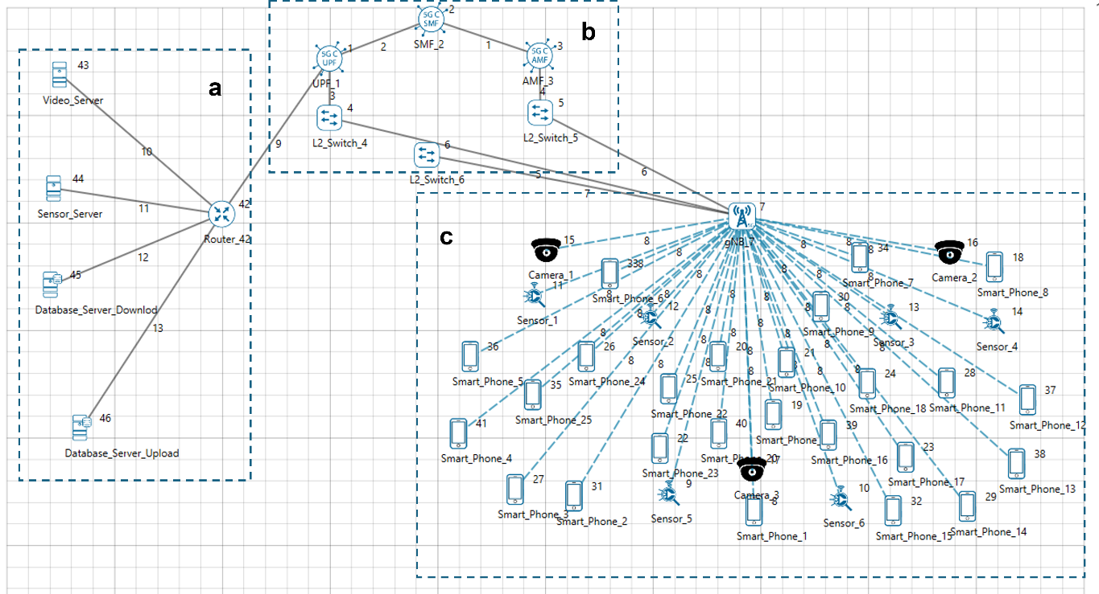

Fig 6: Network scenario. a) Cloud servers b) 5G Core and C) The RAN with 25 smartphones, 6 sensors and 3 cameras communicating. The devices in the RAN communicate with respective cloud servers for both Downloads and Uploads.

In terms of data traffic, the camera (video) and sensor nodes have one UDP flow each, that goes in the UL towards a remote node on the Internet. These flows are fixed-rate flows: we have a continuous transmission of 5 Mb/s for the video nodes, to simulate a 720p24 HD video, and the sensors transmit a payload of 500 bytes each 2.5 ms, that gives a rate of 1.6 Mb/s. For the smartphones, we use TCP as the transmission protocol. These connect to database servers. Each phone downloads a 25 MB file and uploads one file of 1.5 MB. These flows start at different times: the upload starts at a random time between the 4.5th and the 105th simulation seconds, while each download starts at a random time between the 1.5th and the 105th simulation seconds.

|  |  |  |  |  |  |
| --- | --- | --- | --- | --- | --- |
|  | Flows  (No of devices) | Traffic Rate (Mbps) | Segment / File Size (B) | Traffic Dir. | TCP ACK Dir. |
| Camera (UDP) | 3 | 5 | 500 | UL | - |
| Sensor (UDP) | 6 | 1.6 | 500 | UL | - |
| Smartphone Upload (TCP) | 25 | - | 1,500,000 | UL | DL |
| Smartphone Download (TCP) | 25 | - | 25,000,000 | DL | UL |

Table 6:Various parameters of the Traffic flow models for all the devices.

The numerology $μ$ can take values from 0 to 3 and specifies an SCS of $15×2^{μ}$ kHz and a slot length of $\frac{1}{2^{μ}}$ ms. FR1 support $μ=0, 1$ and $2$, while FR2 supports $μ=2, 3.$ We study the impact of different numerologies, and how they affect the end-to-end performance. The metrics measured and analyzed are a) Throughput of TCP uploads and b) Latency of the UDP uploads and downloads

### Procedure:

1. For the above scenario set the following properties:

|  |  |
| --- | --- |
| gNB Properties -> Interface (5G_RAN) | |
| Pathloss Model | None |
| Frequency Range | FR1 |
| CA Type | Inter Band CA |
| CA Configuration | CA_2DL_2UL_n40_n41 |
| CA1 | |
| Numerology | 0, 1 and 2 |
| Channel Bandwidth | 50 MHz |
| DL: UL Ratio | 1:4 |
| CA2 | |
| Numerology | 0, 1 and 2 |
| Channel Bandwidth | 50 MHz |
| DL: UL Ratio | 1:4 |
| MCS Table | QAM64 |
| CQI Table | Table 1 |

Table 7: The Physical Layer properties set in 5G Ran interface of gNB

|  |  |
| --- | --- |
| Phone UL TCP | |
| Application Type | FTP |
| Transport Protocol | TCP |
| Start Time (s) | $$4.5+4\left(i-1\right)where, i=1,2,….25$$ |
| Stop Time (s) | 105 |
| File Size (B) | 1,500,000 |
| Inter Arrival Time (μs) | 200 (simulation ends at 100s and hence only one file is sent) |

Table 8:Phone applications for UL TCP

|  |  |
| --- | --- |
| Link Properties (All wired links) | |
| Uplink/ Downlink Speed (Mbps) | 10000 |
| Uplink/ Downlink BER | 0 |
| Uplink/ Downlink Propagation Delay (μs) | 5 |

Table 9: Wired link properties set in this experiment

|  |  |
| --- | --- |
| Sensor UL UDP | |
| Generation Rate (Mbps) | 1.6 |
| Transport Protocol | UDP |
| Application Type | Custom |
| Packet Size (Bytes) | 500 |
| Inter Arrival Time (μs) | 2500 |

Table 10: Sensor application properties for UL UDP

|  |  |
| --- | --- |
| Camera UL UDP | |
| Generation Rate (Mbps) | 5 |
| Transport Protocol | UDP |
| Application Type | Custom |
| Packet Size (Bytes) | 500 |
| Inter Arrival Time (μs) | 800 |

Table 11:Camera application properties for UL UDP

|  |  |
| --- | --- |
| Phone DL TCP | |
| Application Type | FTP |
| Transport Protocol | TCP |
| Start Time (s) | $$1.5+4\left(i-1\right)where, i=1,2,….25$$ |
| Stop Time (s) | 105 |
| File Size (B) | 25,000,000 |
| Inter Arrival Time (μs) | 200 (simulation ends at 100s and hence only one file is sent) |

Table 12:Laptop application properties for DL UDP

1. The Tx_Antenna_Count was set to 2 and Rx_Antenna_Count was set to 2 in gNB > Interface 5G_RAN >Physical Layer.
2. The Tx_Antenna_Count was set to 2 and Rx_Antenna_Count was set to 2 in UE > Interface 5G_RAN >Physical Layer.
3. Run simulation for 110 sec. After simulation completes go to metrics window and note down throughput and delay value from application metrics.

### Results:

**Case 1:**

|  |  |  |  |  |
| --- | --- | --- | --- | --- |
| Application Type | Throughput (Mbps) | | | |
| Numerology, $μ=0$ | Numerology, $μ=1$ | Numerology, $μ=2$ |
| Custom DL (UDP) | 5.82 | 5.82 | 5.82 |
| Custom UL (UDP) | 5.77 | 5.77 | 5.77 |

Table 13: Throughputs obtained for UL and DL UDP flows when numerology is varied from 0 to 2.

|  |  |  |  |  |
| --- | --- | --- | --- | --- |
| Application Type | Delay (ms) | | | |
| Numerology, $μ=0$ | Numerology, $μ=1$ | Numerology, $μ=2$ |
| Custom DL (UDP) | 2.003 | 1.139 | 0.598 |
| Custom UL (UDP) | 2.013 | 1.126 | 0.598 |

Table 14: Delay obtained for UL and DL UDP applications when numerology is varied from 0 to 2.

Fig 7: Custom DL and UL throughput vs numerology. Numerology has no impact on throughput

Fig 8: Custom DL and UL delay vs numerology. The delay for both DL and UL decreases as numerology is increased.

**Case 2:**

|  |  |  |  |  |
| --- | --- | --- | --- | --- |
| Application Type | Average Throughput (Mbps) | | | |
| Numerology, $μ=0$ | Numerology, $μ=1$ | Numerology, $μ=2$ |
| Camera Video UL (UDP) | 4.99 | 4.99 | 5 |
| Sensor UL (UDP) | 1.6 | 1.6 | 1.6 |
| Smartphone UL (TCP) | 85.69 | 172.52 | 344.74 |
| Smartphone DL (TCP) | 89.80 | 154.02 | 149.33 |

Table 15: Average and aggregate throughputs obtained for Camera, Sensors and Smartphones, when numerology is varied from 0 to 2.

|  |  |  |  |  |
| --- | --- | --- | --- | --- |
| Application Type | Average Delay (ms) | | | |
| Numerology, $μ=0$ | Numerology, $μ=1$ | Numerology, $μ=2$ |
| Camera Video UL (UDP) | 1.84 | 1.15 | 0.86 |
| Sensor UL (UDP) | 2.27 | 1.52 | 0.77 |
| Smartphone UL (TCP) | 79.75 | 39.90 | 20.02 |
| Smartphone DL (TCP) | 1076.93 | 652.77 | 671.02 |

Table 16: Average delay obtained for Camera, Sensors and Smartphones, when numerology is varied from 0 to 2.

Fig 9: The average uplink throughputs for Cameras and Sensors remains the same as the numerology is increased. This is because the flow is UDP.

Fig 10: The average uplink delays for cameras and sensors decreases as the numerology is increases

Fig 11: The average throughput for smartphone downlink and uplink increases with numerology. This is because the flow is TCP.

Fig 12: The average delay for smartphone downlink and uplink decreases with numerology. This is because the flow is TCP.

### Discussion:

For UDP applications, the Numerology, $μ$ does not impact the throughput.

The TCP throughput is inversely proportional to round trip time. Therefore, for applications running over TCP the throughput increases with higher numerology since a higher Numerology leads to reduced round-trip times.

Therefore, the selection of the numerology in an NR system should be carefully made by considering the traffic patterns.

# References:

1. Patriciello, N., Lagen, S., Giupponi, L., & Bojovic, B. (2018). 5G New Radio Numerologies and their Impact on the End-To-End Latency. *IEEE 23rd International Workshop on Computer Aided Modeling and Design of Communication Links and Networks (CAMAD)*.

1. This is adapted from (Patriciello, Lagen, Giupponi, & Bojovic, 2018)