# Experiment – 07

# Impact of Interference in 5G Networks

# Objective

In this experiment, we will simulate and study the impact of downlink interference on the signal-to-interference ratio (SINR) in Netsim **v14.2**. We will study the following aspects.

1. We consider a handover procedure in a cellular system and analyse the following cases:
2. The handover of a UE without any interference, with pathloss exponent, ,
3. The handover of a UE without any interference, with pathloss exponent ,
4. The handover of a UE with interference, with pathloss exponent , and
5. The handover of a UE with interference, with pathloss exponent .
6. To understand the effect of path loss exponents with and without interferences on the point of handovers in cellular systems.

In this experiment, we consider the following handover scenario: A UE starts from and moves in a straight line to . While the UE is attached to it experiences interference from . Once it gets handed over to the UE experiences interference from . There is always thus only one interferer, and we analyse the SINR as the UE moves a straight line from to .

Fig 1: UE1 is initially attached to BS1. The signal from BS1 is the desired signal while the signal from BS2 is the interfering signal. Post-handover, the desired signal is transmitted from BS2 while signal from BS1 is the interfering signal. We assume omni-directional antennas at both BSs and consider cases with .

# Introduction[1]

Due to the scarcity of the wireless spectrum, it is not possible in 5G networks to separate concurrent transmissions completely in frequency. Some transmissions will necessarily occur at the same time in the same frequency band, separated only in space, and the signals operating on the same time-frequency resources from many undesired or interfering transmitters are added to the desired transmitter’s signal at a receiver. The main determinants of the interference are

* The network geometry, i.e., the location of the receivers and the transmitters
* Base stations’ (or gNBs’) transmit power, and
* The path loss model (signal attenuation with distance).

The performance and coverage of a 5G network critically depends on the signal-to-interference-and-noise ratios (SINRs) level at the receivers. This is defined as

Where is the received power of the desired signal, is the bandwidth, is the thermal noise and is the received power of interfering signals. In 5G, the modulation and coding scheme (MCS) is computed from the SINR. The higher the SINR, the higher the MCS, and hence the higher the date rate. Interference is therefore an important performance-limiting factor in wireless networks and hence it is crucial to characterize the effect of interference.

# A. Network setup: ISD = 500m, C Band, 100 MHz, Urban Macro.

In our network scenario, the inter-site distance (ISD) between and is 500m. Both base stations (gNB) operate in the 3.5 GHz band, called the C band, with a bandwidth of 100 MHz. The environment is assumed to be urban with signal attenuation as per the 3G PP Urban Macro pathloss model. Shadow-fading and fast fading are turned off to avoid sources of randomness.

# Case #1: No interference in both base stations with

## Procedure:

1. Use the following download Link to download a compressed zip folder which contains the workspace:  [GitHub link](https://github.com/NetSim-TETCOS/5G_Advanced_Experiments_v14.2/archive/refs/heads/main.zip)
2. Extract the zip folder.
3. The extracted project folder consists of a NetSim workspace file 5G_advanced_experiments_with_NetSim.netsimexp.
4. Go to NetSim Home window, go to Your Work and click on Import.

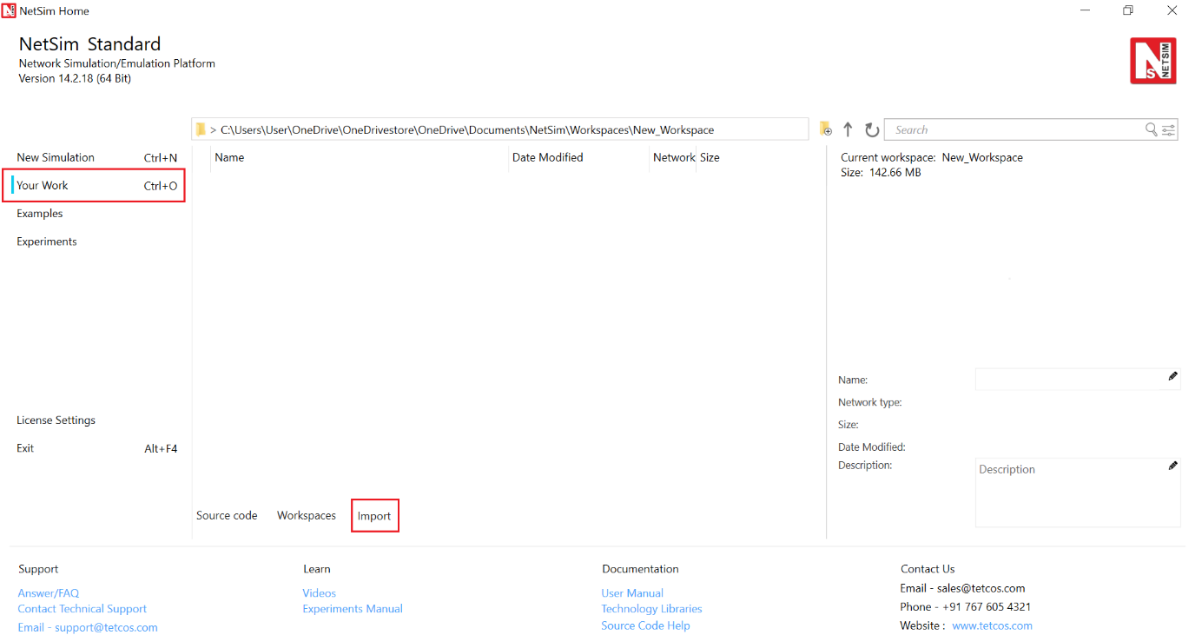Fig 2: NetSim Home Window

1. In the Import Workspace Window, browse and select the 5G_advanced_experiments_with_NetSim.netsimexp file from the extracted directory. Click on create a new workspace option and browse to select a path in your system where you want to set up the workspace folder.
2. Choose a suitable name for the workspace of your choice. Click Import.

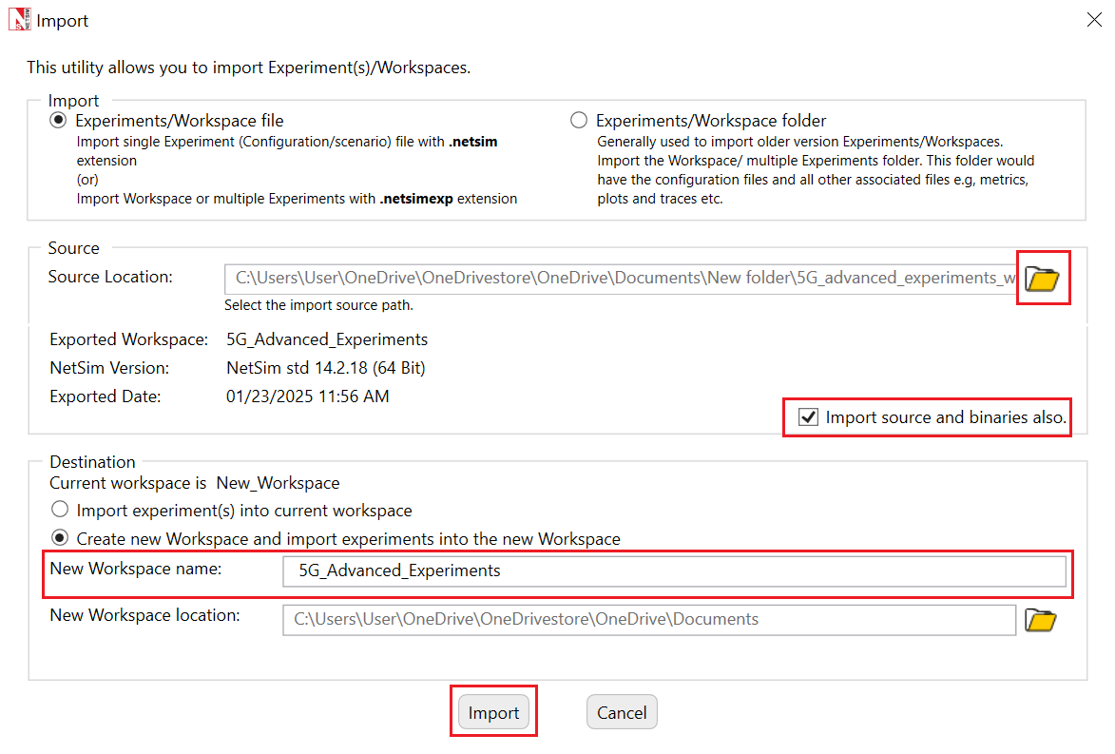

Fig 3: NetSim Import workspace window

1. The Imported Project workspace will automatically be set as the current workspace.
2. The list of experiments is now loaded onto the selected workspace.

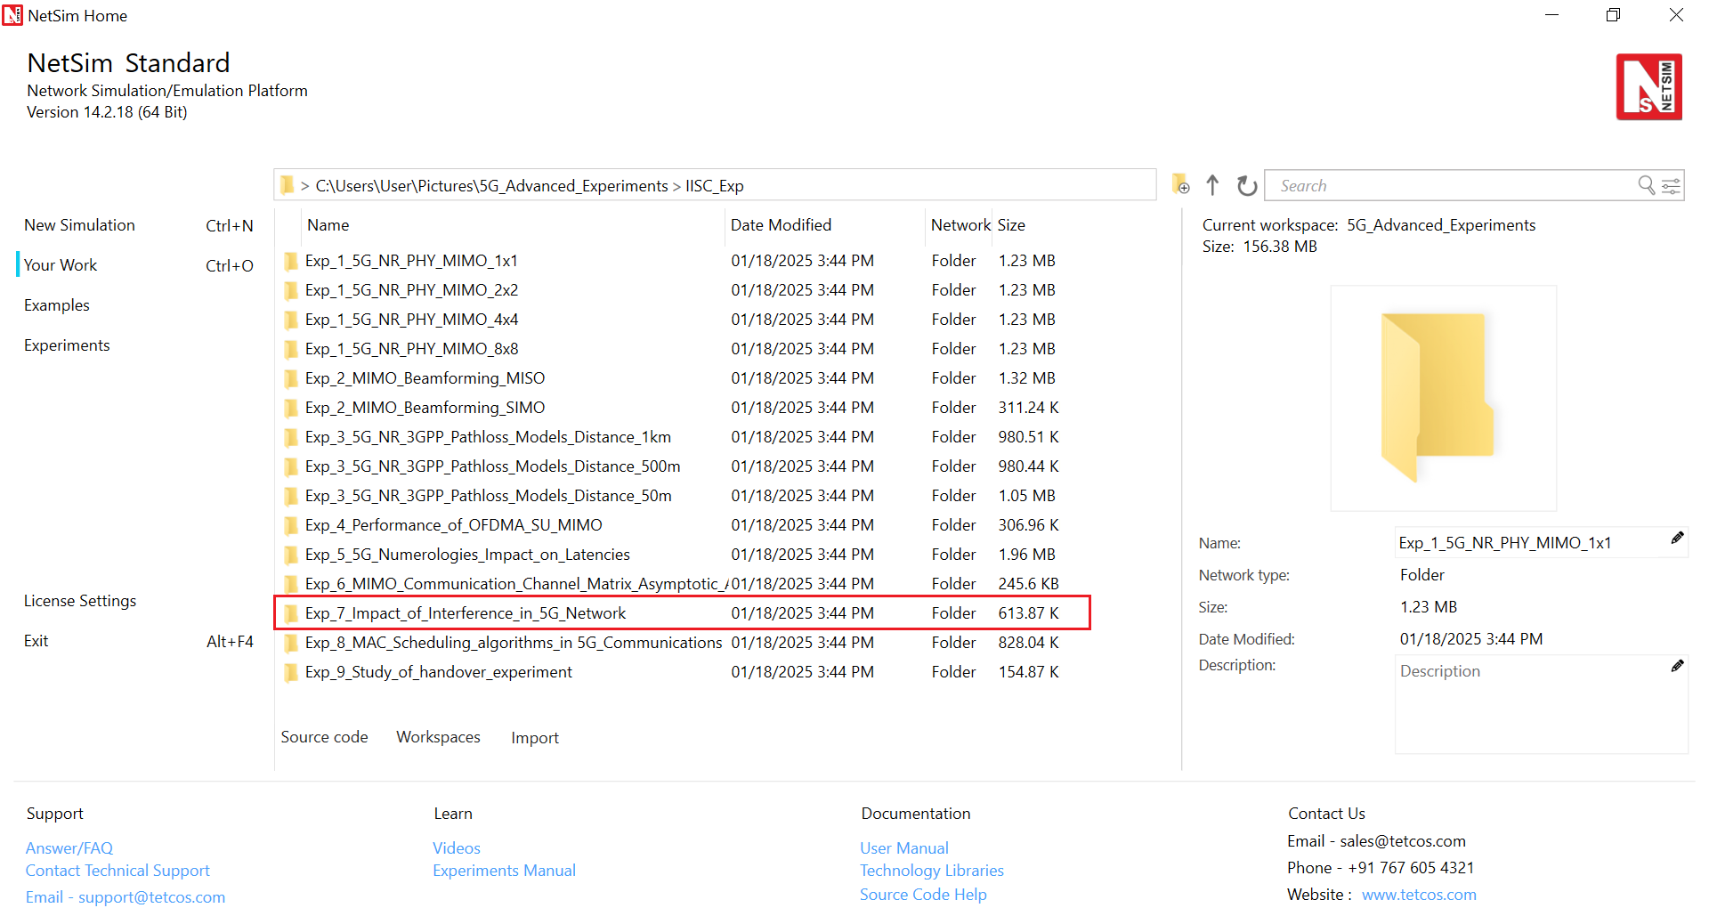

Fig 4: NetSim Your Work Window with the experiment folders inside the workspac

## Network Scenario

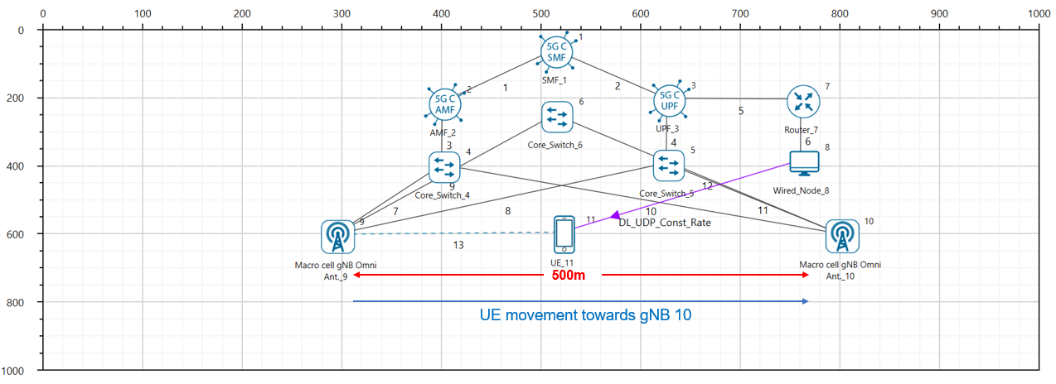Fig 5: NetSim Scenario during mobility.

## Simulation parameters:

Consider the grid environment as 1000 m. Place the two gNBs on the grid environment. Distance between two gNBs is 500m.

|  |  |  |
| --- | --- | --- |
| **Devices** | **X** | **Y** |
| gNB_9 | 300 | 600 |
| gNB_10 | 800 | 600 |
| UE_11 | 300 | 600 |

Table 1:Device Co-ordinates

1. Go to gNB properties. In the RAN interface set physical layer properties as shown in the below table. Similarly set the same properties in another gNB.

|  |  |
| --- | --- |
| gnb> Interface 5G RAN | |
| gNB Height (m) | 10 |
| Tx Power (dBm) | 40dBm |
| Tx Antenna Count | 1 |
| Rx Antenna Count | 1 |
| CA Type | Single Band |
| CA Configuration | n78 (C Band) |
| F_Low (MHz) | 3300 |
| F_High (MHz) | 3800 |
| DL: UL Ratio | 4:1 |
| Numerology | 2 |
| Channel Bandwidth (MHz) | 100MHZ |
| MCS Table | QAM64 |
| CQI Table | TABLE1 |
| Outdoor Scenario | Urban Macro |
| Indoor Office Type | Mixed Office |
| PathLoss Model | LOG_DISTANCE |
| PathLoss Exponent | 2.5 |
| Shadow Fading Model | None |
| Fading and Beamforming | NO FADING MIMO UNIT GAIN |
| Downlink interference model | No interference |

Table 2: Values set for different parameters in simulation

1. Go to UE properties. In the RAN Interface set physical layer properties in both UEs as shown below.

|  |  |
| --- | --- |
| UE > Interface 5G RAN | |
| UE Height | 1.50 |
| Tx Power | 23 dBm |
| Tx Antenna Count | 1 |
| Rx Antenna Count | 1 |

Table 3: Properties set for UE

1. In the position layer, set UE X and Y coordinates as the gNB1’s X and Y coordinates. That is, the initial position of UE must be the position of gNB1.
2. Set the mobility model as file-based mobility and configure the mobility that UE needs to be travel straight towards to the gNB2. So, configure the mobility file according to the distance that UE needs to travel. For example, in the above scenario, UE needs to travel 500m from gNB1 to gNB2 So, it is travelling straight towards to another gNB since it’s Y coordinate is fixed. Hence, give input in the excel sheet as in Fig. 5.

|  |  |
| --- | --- |
|  |  |

Fig 6: UE mobility file for 500m

1. Before clicking on Run, select the “plots/logs” tab in right panel, and check “LTENR Radio Measurements Log as shown below and simulate it for 12 seconds.

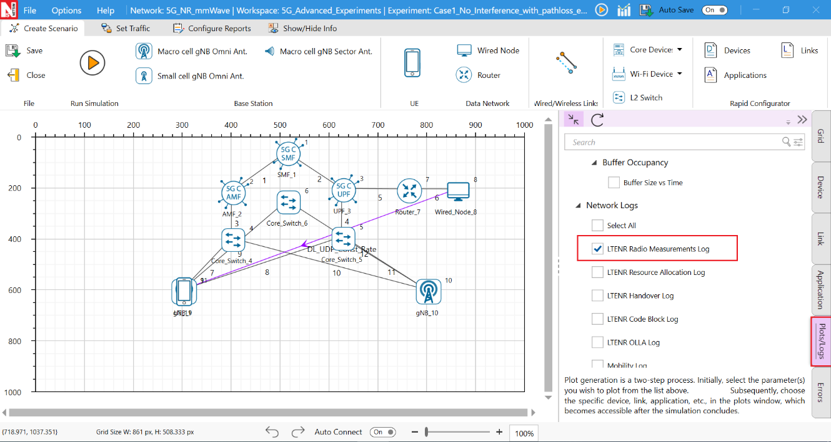

Fig 7: Enabling the LTENR Radio Measurement log

1. After simulation, open LTENR Radio measurement log present under the Log section in the Results Dashboard as shown below.

Fig 8:ISD 500m simulation result Dashboard.

Follow the below steps to obtain SINR values from the LTENR Radio measurement file.

|  |  |
| --- | --- |
| Fig 9: Inserting pivot table | Fig 10: Creating pivot table |

1. Create a pivot table for this log file by clicking the pivot option present at the top of the ribbon under insert section as shown below.
2. In the pivot table drop ‘gNB/eNB Name’, ‘UE Name’, ‘Channel’ fields under filters area, drop ‘Distance’ in Row area and drop ‘SINR’ in Value area. Set the SINR values to max by clicking on the arrow icon present at the end of the field ->value field setting->max as shown below as shown in Fig 10.
3. Now filter gNB as gNB9, UE name as UE_11, Channel as PDSCH as shown in Fig 11.
4. Copy the values from 0 to 290 along with Row Labels and Max_SINR_dB header and paste it into another sheet. Similarly filter gNB/eNB name to GNB_10 and copy the row

label value along with SINR and paste it into next to the previously created new sheet.

1. NetSim calculates the distance of a UE from its attached gNB. In the plot that we eventually wish to obtain the X axis has distance from the initial attached gNB which is gNB9. In our experiment, UE11 is initially attached to gNB9 and post-handover it gets attached to gNB10. Since gNB9 to gNB10 distance is 500m, post-handover the distance of UE11 from the initial gNB9 is i.e.,
   1. Copy the Row table and distance to the empty cells after filtering that gNB/eNB Name to gNB10 and UE Name to UE11 as shown in Fig 11
   2. In the adjacent cell calculate the UE_11 distance from gNB_9 as shown below as shown in Fig 12. Observe that it is initially and post-handover it is
   3. Distance between UE11 and gNB9, , along with the SINR value and copy them into new cells
   4. Filter it from the ascending order/ smallest to largest, copy these values to the paste it below the previously created new sheet as shown in Fig 13

|  |  |
| --- | --- |
| Fig 11: Copying the Distance and SINR values into new cells. | Fig 12: Inserting filter. |

Fig 13: Sorting from smallest to largest

## Results:

|  |  |  |  |  |  |  |  |  |  |  |  |  |  |  |  |  |  |  |  |  |  |  |  |  |  |  |  |  |  |  |  |  |  |  |  |  |  |  |  |  |  |  |  |  |  |  |  |  |  |  |  |  |  |  |  |  |  |  |  |  |  |  |  |  |  |  |  |  |  |  |  |  |  |  |  |  |  |  |  |  |  |  |  |  |  |  |  |  |  |  |  |  |  |  |  |  |  |  |  |  |  |  |  |  |  |  |  |  |  |
| --- | --- | --- | --- | --- | --- | --- | --- | --- | --- | --- | --- | --- | --- | --- | --- | --- | --- | --- | --- | --- | --- | --- | --- | --- | --- | --- | --- | --- | --- | --- | --- | --- | --- | --- | --- | --- | --- | --- | --- | --- | --- | --- | --- | --- | --- | --- | --- | --- | --- | --- | --- | --- | --- | --- | --- | --- | --- | --- | --- | --- | --- | --- | --- | --- | --- | --- | --- | --- | --- | --- | --- | --- | --- | --- | --- | --- | --- | --- | --- | --- | --- | --- | --- | --- | --- | --- | --- | --- | --- | --- | --- | --- | --- | --- | --- | --- | --- | --- | --- | --- | --- | --- | --- | --- | --- | --- | --- | --- | --- |
| |  |  | | --- | --- | | **Distance** | **Max of SNR(dB)** | | 0 | 62.43 | | 10 | 62.43 | | 20 | 56.95 | | 30 | 53.03 | | 40 | 50.09 | | 50 | 47.75 | | 60 | 45.82 | | 70 | 44.17 | | 80 | 42.74 | | 90 | 41.48 | | 100 | 40.34 | | 110 | 39.31 | | 120 | 38.37 | | 130 | 37.51 | | 140 | 36.71 | | 150 | 35.96 | | 160 | 35.26 | | 170 | 34.61 | | 180 | 33.99 | | 190 | 33.40 | | 200 | 32.85 | | 210 | 32.32 | | 220 | 31.81 | | 230 | 31.33 | | 240 | 30.87 | | 250 | 30.43 | | 260 | 30.00 | | 270 | 29.59 | | 280 | 29.20 | | 290 | 28.82 | | |  |  | | --- | --- | | **Distance** | **Max of SNR(dB)** | | 290 | 32.32 | | 300 | 32.85 | | 310 | 33.40 | | 320 | 33.99 | | 330 | 34.61 | | 340 | 35.26 | | 350 | 35.96 | | 360 | 36.71 | | 370 | 37.51 | | 380 | 38.37 | | 390 | 39.31 | | 400 | 40.34 | | 410 | 41.48 | | 420 | 42.74 | | 430 | 44.17 | | 440 | 45.82 | | 450 | 47.75 | | 460 | 50.09 | | 470 | 53.03 | | 480 | 56.95 | | 490 | 62.43 | | 500 | 62.43 |   Fig 14: Downlink SINR results GNB_10, with ISD = 500m |

Fig 15: Downlink SINR values for GNB_9, with ISD = 500m.

# Case #2: No interference in both base stations with

|  |  |
| --- | --- |
| gNB9 > Interface 5G RAN | |
| PathLoss Model | LOG_DISTANCE |
| PathLoss Exponent | 4 |
| Downlink Interference | No Interference |
| gNB 10 > Interface 5G RAN | |
| PathLoss Model | LOG_DISTANCE |
| PathLoss Exponent | 4 |
| Downlink interference | No Interference |

Table 4: Properties set for Case 02.

Set the above property values and simulate the scenario for 12 sec. Tabulate the results obtained from LTENR Radio measurement log in the simulation metrics window.

# Case #3: UE to Both Base stations is in .

|  |  |
| --- | --- |
| gNB 9 > Interface 5G RAN | |
| PathLoss Model | LOG_DISTANCE |
| PathLoss Exponent | 2.5 |
| Downlink Interference | Exact geometric model |
| gNB 10 > Interface 5G RAN | |
| PathLoss Model | LOG_DISTANCE |
| PathLoss Exponent | 2.5 |
| Downlink interference | Exact geometric model |

Table 5: Properties set for Case 03.

Set the above property values and simulate the scenario for 12 sec. Tabulate the results obtained from LTENR Radio measurement log in the simulation metrics window.

# Case #4: UE to Both Base stations with .

|  |  |
| --- | --- |
| gNB 9 > Interface 5G RAN | |
| PathLoss Model | LOG_DISTANCE |
| PathLoss Exponent | 4 |
| Downlink Interference | Exact geometric model |
| gNB 10 > Interface 5G RAN | |
| PathLoss Model | LOG_DISTANCE |
| PathLoss Exponent | 4 |
| Downlink interference | Exact geometric model |

Table 6: Properties set for Case 04.

Set the above property values and simulate the scenario for 12 sec. Tabulate the results obtained from LTENR Radio measurement log in simulation metrics window.

# Results. UE with

|  |  |  |  |
| --- | --- | --- | --- |
| Distance | Case #2 DL SINR (dB) | Case #3 DL SINR (dB) | Case #4  DL SINR (dB) |
| 0 | 45.66 | 39.50 | 45.58 |
| 10 | 45.66 | 39.28 | 45.58 |
| 20 | 36.90 | 33.59 | 36.81 |
| 30 | 30.63 | 29.44 | 30.53 |
| 40 | 25.92 | 26.26 | 25.81 |
| 50 | 22.18 | 23.69 | 22.06 |
| 60 | 19.08 | 21.51 | 18.96 |
| 70 | 16.45 | 19.62 | 16.31 |
| 80 | 14.16 | 17.93 | 14.01 |
| 90 | 12.13 | 16.40 | 11.97 |
| 100 | 10.32 | 15.00 | 10.14 |
| 110 | 8.67 | 13.70 | 8.47 |
| 120 | 7.17 | 12.48 | 6.95 |
| 130 | 5.79 | 11.33 | 5.54 |
| 140 | 4.50 | 10.23 | 4.23 |
| 150 | 3.31 | 9.18 | 3.01 |
| 160 | 2.19 | 8.16 | 1.85 |
| 170 | 1.14 | 7.18 | 0.76 |
| 180 | 0.15 | 6.23 | -0.28 |
| 190 | -0.79 | 5.30 | -1.27 |
| 200 | -1.68 | 4.39 | -2.22 |
| 210 | -2.52 | 3.49 | -3.14 |
| 220 | -3.33 | 2.61 | -4.04 |
| 230 | -4.10 | 1.73 | -4.91 |
| 240 | -4.84 | 0.86 | -5.77 |
| 250 | -5.55 | 0.00 | -6.61 |
| 260 | -6.23 | -0.87 | -7.46 |
| 270 | -6.88 | -1.74 | -8.31 |
| 280 | -7.51 | -2.62 | -9.17 |
| 280 | -3.33 | -2.62 | -4.04 |
| 290 | -2.52 | -3.50 | -3.14 |
| 290 | -2.52 | 3.49 | -3.14 |
| 300 | -1.68 | 4.39 | -2.22 |
| 310 | -0.79 | 5.30 | -1.27 |
| 320 | 0.15 | 6.23 | -0.28 |
| 330 | 1.14 | 7.18 | 0.76 |
| 340 | 2.19 | 8.16 | 1.85 |
| 350 | 3.31 | 9.18 | 3.01 |
| 360 | 4.50 | 10.23 | 4.23 |
| 370 | 5.79 | 11.33 | 5.54 |
| 380 | 7.17 | 12.48 | 6.95 |
| 390 | 8.67 | 13.70 | 8.47 |
| 400 | 10.32 | 15.00 | 10.14 |
| 410 | 12.13 | 16.40 | 11.97 |
| 420 | 14.16 | 17.93 | 14.01 |
| 430 | 16.45 | 19.62 | 16.31 |
| 440 | 19.08 | 21.51 | 18.96 |
| 450 | 22.18 | 23.69 | 22.06 |
| 460 | 25.92 | 26.26 | 25.81 |
| 470 | 30.63 | 29.44 | 30.53 |
| 480 | 36.90 | 33.59 | 36.81 |
| 490 | 45.66 | 39.28 | 45.58 |
| 500 | 45.66 | 39.50 | 45.58 |

Table 7: Results for SINR vs. distance for ISD-500m downlink.

The red marks indicate the points of handover.

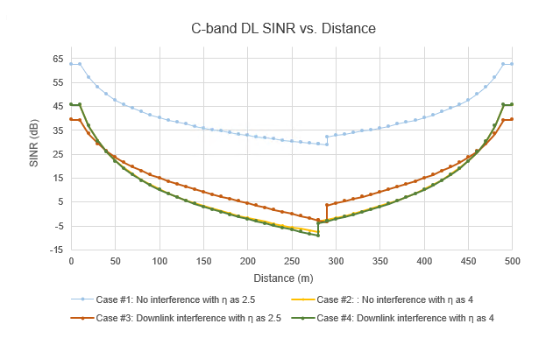

Fig 16: Downlink SINR vs. distance plot for C-band for different network configurations.

# Discussion

Initially (in case 1), the UE is attached to . In the scenario, the UE moves in a straight line towards and at 290 m it is handed over to Till 290 m the “desired” signal is from while the “interfering” signal is from . Post-handover there is a reversal; the desired signal is from while the interfering signal is from

Signals from and from to the UE undergo pathloss. If the transmit powers at both s are then the works out to be

Where is the pathloss loss (per the 3GPP pathloss models) at a distance of . Since the distance between the two s is equal to , the inter site distance, the UE is at a distance of ) from the interfering , and hence the term in the denominator. When there is a line-of-sight (LOS) condition with a gNB, the path loss is lower, modelled here by setting the path loss exponent as 2.5. When there is a non-line-of-sight (NLOS) condition with a gNB, the path loss is higher, modelled here by setting the path loss exponent as 4.

With this background, let us look Fig 16

* In all cases, we see a constant SINR till 10m because the pathloss equations defined in the standard take effect only from 10m.
* SINR. vs distance is plotted for four cases
  + Case #1: UE is in LOS with both BSs, interference is turned off
  + Case #2: UE is in NLOS with both BSs, interference is turned off
  + Case #3: UE is in LOS with both BSs, with interference turned on
  + Case #4: UE is in NLOS with both BSs, with interference turned on

**Note: Here, we use the terms LOS for , and NLOS for for simplicity.**

* In case 1 and case 2, the term in is set to zero. Practically, this means that the two BSs operate in non-overlapping frequency bands. Therefore, .We see the SNR dropping as the UE moves away from . At 280/290m, it gets handed over to , and we see the SNR increasing as the UE moves closer to . Why is there a “jump” at the handover point? This is because the standards specify that handover should occur only when target-gNB’s SINR is offset (3 dB) higher than serving-gNB’s SINR. This condition is satisfied at 280m. You are encouraged to think about the question: Why does the standard specify such an offset?
* Next, we observe that the NLOS curve (purple) is lower than the LOS curve (blue). This is because NLOS pathloss is higher than the LOS pathloss.
* In Cases 3, and 4, the observations are similar to above, but they are lower than their respective counterparts in cases 1 and 2, due to additional interferences which degrade the SINR further. Further, we notice that the two curves of cases 2 and 4 are very close to each other. Why?
  + Open the log files for these cases and observe the following: The pathloss is more pronounced in these cases, and the interference also decays faster than the case (3) case. Hence, the effect of interference is not very pronounced, leading to almost similar performance.
  + **Optional Exercise**: Check whether the gap between the two curves increases by increasing gNB transmit powers (i.e., increasing the interference power).

# Understanding the points of handoff

For the sake of exposition, we investigate the point of hand-off for case #1 and case #2 where the interferences are assumed to be absent from the base-stations. This therefore represents a noise limited regime, or a scenario where the two BSs use non-overlapping frequency bands. In such a scenario, as the UE moves from BS1 towards BS2, the SNR from BS1 decreases, while the SNR from BS2 increases. The point where the SNR from BS2 is 3 dB higher than that from BS1 determines the point of handoff. But we observe that between the cases with path loss exponents of 2.5 and 4, the points of handovers are different! Why? Read the discussion below.

**Further Discussion:**

For the sake of generality, we discuss the effect of path loss exponent on handover in a general setting independent of the values obtained in the experiment. Consider the scenario:

Received SNR



Base station B

Base station A

X

d0 (in NLOS)

d0 (in LOS)

Y

Distance (Km)

Fig 17: Illustration of different handover points in LOS/NLOS cases

**Case A: Noise limited scenario**

Let a UE move from base station A towards base station B with inter site distance = 1 km as shown in Fig 17. Consider for the moment that we are in a noise-limited regime, where the interferences are assumed to be absent from the base-stations. In such a scenario, as the UE moves from BS A towards BS B, the SNR seen by the UE from BS A decreases, while the SNR seen from BS B increases. For example, let the path loss exponent be set to 1 (ƞ=1), then solid blue curve represents the received SNR as a function of distance seen from BS A, while solid purple curve represents the received SNR as a function of distance seen from BS B. Further, assume that is the “handoff threshold” or “handover margin”, i.e., the required SNR difference between the base stations in order to perform a handoff from BS A to BS B. Let the distance at this point be d0. This point is indicated by the point Y in the above plot.

However, when the path loss exponent increases to 2, i.e., ƞ=2, the received SNR from both the BSs changes and the corresponding curves are shown in the above figure using dashed lines. Clearly, due to the differing slopes in the SNR curves at different values of ƞ, **the point at which the handoff occurs is different** (in fact it occurs earlier than the former case) and this point is indicated by X.

**Conclusion**: The point of handoff is different for environments with different pathloss exponents for a given handoff threshold.

**Remarks:** Observe from the figure that, as we increase the path loss from 1 to 2, the point of handoff occurs at d = 1.7 Km and d = 1.76 Km, respectively. This difference is more pronounced when the pathloss difference increases.

**Case B: Interference limited scenario.**

In this case, a similar plot (like above) can be used for handoff analysis, except that y-axis will now have the SINR instead of SNR. It is an exercise for the reader to understand and explain the impact of interference on the handover points in the LOS/NLOS cases.

# YOUR EXERCISES

**Let the last two digits of your trainee ID be xx. Then set the inter-gNB distance to (500 + ceil(xx/2)) meters in the GUI.**

1. **Replicate the above experiment (reproduce table 7, and figure 10,11 and 12, only) for all the four cases. Set the mobility profile accordingly.**
2. **Repeat question – 1 using a different band (for example n5 or low band, 850 MHz). Justify the changes in your results compared to Q1 (if any.)**
3. **In the above two exercises, no fluctuations in the channel were enabled. Now, repeat question (1) by adding shadowing in the simulations and observe possible ping-pong handovers. Interpret your observations with suitable justifications.**

# References

[1] M. Haenggi and R. K. Ganti, “Interference in Large Wireless Networks,” 2009.

**Note:**

**Go to the gNB properties. Then under 5G RAN settings: select following:**

1. **Duplex Mode: FDD**
2. **CA Type: SINGLE_BAND**
3. **CA Configuration: n5**

1. Some of the content in this section is from [1].