# Experiment 08

# On the Study of MAC Scheduling algorithms in 5G Communications

**Objective:** In this experiment, we understand how different scheduling algorithms affect the UDP download throughput of a multi-user (multi-UE) system. We will focus on three popular scheduler algorithms: Max-rate scheduler, Proportional fair (PF), and round-robin scheduler, and gain insights on the following aspects.

1. How does the throughput vary in networks with multiple UEs when channel is not time varying?
2. How does the throughput vary in networks with multiple UEs when channel is time varying?
3. Understanding the design of the proportional fair scheduler.

This experiment also introduces the notion of **multi-user diversity**.

## Introduction and Theory

One of the key requirements of 5G systems is the support of many users communicating through a wide range of devices and applications. These conditions give rise to heterogeneous traffic offered to the network. To carry such traffic in a wireless network, the design and development of schedulers capable of considering the conditions of each user is needed. Schedulers are usually the “secret sauce” to obtain superior performance of any network operator and hence is an important design element. Among the class of several schedulers, we will focus on three popular algorithms in this experiment: **Max-rate, proportional fair (PF) and round-robin (RR).**

## Max-rate scheduler:

In this type of scheduler, the gNB schedules the UE who observes the best instantaneous channel condition among all the UEs. Mathematically, in every time slot *t*, the user $k^{*}$ is selected as per the following criterion:

$k^{*}(t)=arg\max_{k∈\{1,2,…, K\}}{{|h_{k}(t)|}^{2}}$,

where $h_{k}$ is the channel seen by $k$ th user from the gNB in a *K* user system. This scheduler ensures that the total system throughput is the best possible among all other schedulers.

To understand the effect of max-rate scheduling on the impact of system throughput, we first understand the behavior of the metric $\max_{k∈\{1,2,…, K\}}{{|h_{k}(t)|}^{2}}$ as a function of *K*, the total number of UEs in the system. As an example, if we consider that every UE experiences a Rayleigh channel from the gNB and assuming that channels across UEs are independent, we can show that the probability distribution of the metric is shown in Fig. 1.



Fig 1: probability density function of $\max_{k∈\{1,2,…, K\}}{{|h_{k}(t)|}^{2}}.$

From Fig.1, as the total number of UEs increases, the best channel “hardens”, i.e., it concentrates around its mean value, and the support of the distribution keeps shifting towards the right, indicating that the average SNR seen by the system under max rate scheduling monotonically increases with the number of UEs in the system. The following theorem accurately quantifies this behavior.

**Theorem 1:** Assume that a system is equipped with a single antenna gNB and UE with independent Rayleigh channels across the UEs. Then, under max-rate scheduling, the system spectral efficiency $R^{(K)}$ asymptotically (i.e., as K gets large) scales as

$\lim_{K →∞}\left(R^{(K)}-\log_{2}\left(1+\frac{P}{σ^{2}}×\log_{e}{(K)}\right)\right)=0$,

where P and $σ^{2}$ denote the transmit power and receiver noise power, respectively. $∎$

Thus, we see that the average SNR of this system scales as $\log_{e}{(K)}$ with K, the number of UEs, when max-rate scheduling is employed. This effect of obtaining additional gain in the SNR by having multiple (or many) users in the system and **opportunistically** scheduling the UEs in every time-resource element is called as **multi-user diversity**.

A naïve way to implement this type of scheduling strategy is to first broadcast a common pilot symbol (possibly in a mini slot) by the gNB to all the UEs, and each UE computes the CQI using the above expression. Then, all UEs feedback only their CQI, and the gNB schedules that UE with the best UE. This process repeats in every time slot.

The max-rate scheduler achieves the highest possible system throughput and is therefore attractive to an operator that wants to maximize its revenue, when the revenue depends mainly on the amount of data consumed by the UEs. It’s drawback? A user who is far away from the gNB always sees a weak channel, and would therefore rarely be scheduled. Such a user may remain unhappy and switch away from the operator, resulting in a loss of revenue in the long term. The round-robin scheduler, discussed next, is at the opposite end of the spectrum: it is absolutely fair across the users, but loses out on the achievable network throughput.

## Round-robin (RR):

In this type of scheduling mechanism, the emphasis of the scheduler is to ensure fairness among UEs in scheduling. As discussed above, although the max-rate scheduler achieves the highest system throughput, it does not ensure fairness among users in terms of the relative number of times any UE is scheduled. For example, if a UE is located on the cell edge, then it is highly unlikely that the UE will get scheduled at any time slot due to high path loss which deteriorates the CQI of the UE. To tackle this problem, the RR scheduler completely disregards the instantaneous CQI and schedules the users one after the other, in a round-robin fashion. This ensures that every user gets equal resource allocation regardless of the instantaneous CQI. A toy illustration of the mechanism of RR scheduling is shown below, in a system with 4 users.

1 time slot

**Scheduling chart:**

|  |  |  |  |  |  |  |  |  |  |
| --- | --- | --- | --- | --- | --- | --- | --- | --- | --- |
| UE – 1 | UE – 2 | UE – 3 | UE – 4 | UE – 1 | UE – 2 | UE – 3 | UE – 4 | …… | ……. |

Round: n + 1

Round: n

Clearly, there is no feedback required from the UE to gNB, unlike the max – rate scheduler.

## Proportional fair (PF):

It is clear that while the max-rate scheduler achieves the highest sum rate, it does not ensure fairness among users. On the other hand, the RR scheduler ensures highest fairness among users, while the throughput of the system is compromised. This necessitates the need for a scheduler that strikes a good trade-off between achievable throughput and fairness in the system. This is accomplished by the proportional-fair scheduler. In PF scheduler, in any time slot *t*, user $k^{*}$ is selected as follows:

$k^{*}\left(t\right)= arg\max_{k∈\{1,2,…, K\}}{\frac{R_{k}(t)}{T_{k}(t)}}$,

where $R_{k}\left(t\right)=\log_{2}\left(1+\frac{{\left|h_{k}\left(t\right)\right|}^{2}P}{σ^{2}}\right)$ and $T_{k}\left(t\right)$ are the instantaneous rate and average rate of user *k* in the system, respectively. In particular, $T_{k}\left(t\right)$ can be updated recursively as follows:

$$T_{k}\left(t+1\right)= \left\{\begin{aligned}\left(1-\frac{1}{α}\right) T_{k}\left(t\right)+\frac{1}{α} R_{k}\left(t\right), k=k^{*}(t) \\ \left(1-\frac{1}{α}\right) T_{k}\left(t\right), k≠k^{*}(t)\end{aligned}\right.$$

In the above, the parameter $α$ dictates the trade-off between the throughput and fairness in the system and is a designer’s choice. It can be shown that,

* Higher values of $α$ makes the PF scheduler perform close to a max-rate scheduler,
* Lower values of $α (α≈1)$ makes the PF scheduler perform close to an RR scheduler.

## CASE I: UEs at different distances and the channel is constant over time.

## Procedure:

1. Use the following download Link to download a compressed zip folder which contains the workspace:  [GitHub link](https://github.com/NetSim-TETCOS/5G_Advanced_Experiments_v14.2/archive/refs/heads/main.zip)
2. Extract the zip folder.
3. The extracted project folder consists of a NetSim workspace file 5G_advanced_experiments_with_NetSim.netsimexp.
4. Go to NetSim Home window, go to Your Work and click on Import.

Fig 2: NetSim Home Window

1. In the Import Workspace Window, browse and select the 5G_advanced_experiments_with_NetSim.netsimexp file from the extracted directory. Click on create a new workspace option and browse to select a path in your system where you want to set up the workspace folder.
2. Choose a suitable name for the workspace of your choice. Click Import.

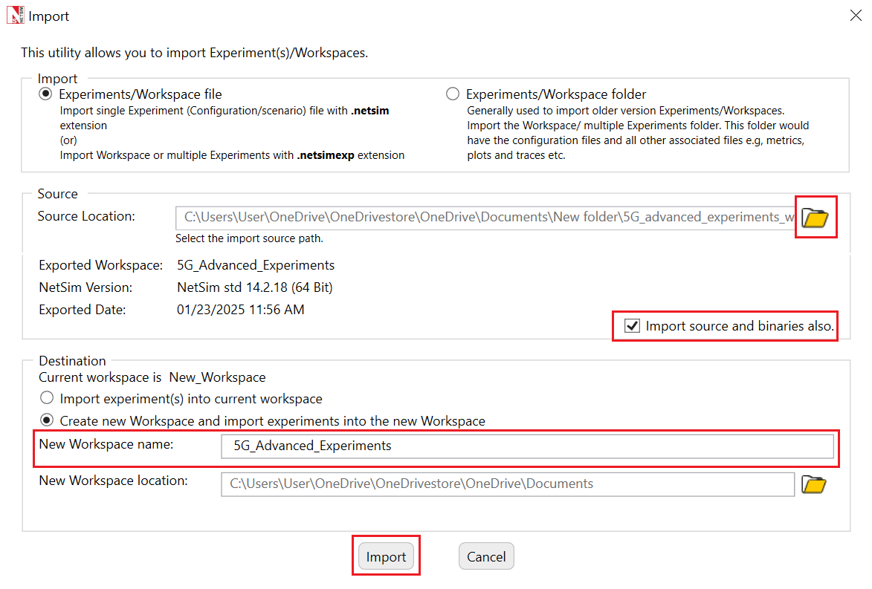

Fig 3: NetSim Import workspace window

1. The Imported Project workspace will automatically be set as the current workspace.
2. The list of experiments is now loaded onto the selected workspace.

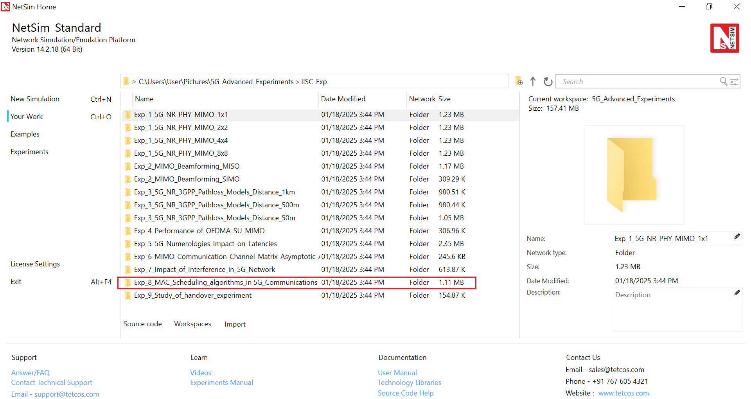

Fig 4: NetSim Your Work Window with the experiment folders inside the workspace

Fig 5: Network set up for studying the Scheduling example.

**Configuring the scheduling algorithm, and parameter settings in example config files**

1. Set grid length as 6000 m from Environment setting.
2. Set distance as follows.
3. gNB_8 to UE_10 = 1500 m
4. gNB_8 to UE_11 = 2000 m, and
5. gNB_8 to UE_12 = 2500 m
6. Go to Wired link properties and set the properties shown in Table 1.

|  |  |
| --- | --- |
| Wired Link Properties | |
| Uplink Speed | 10000 Mbps |
| Downlink Speed | 10000 Mbps |

Table 1: Wired Link Properties

1. Go to gNB properties à Interface (5G_RAN), and set the properties shown in Table 2**.** In the first sample the scheduling type is set to Round Robin, in the second to Proportional fair, and in the third to Max throughput.

|  |  |
| --- | --- |
| Properties | |
| Data Link Layer Properties | |
| Scheduling Type | Varies: Proportional Fair, Max throughput, Round Robin |
| Physical Layer Properties | |
| CA Type | SINGLE_BAND |
| CA Configuration | n78 |
| CA1 | |
| Numerology | 1 |
| Channel Bandwidth | 100 MHz |
| Outdoor_Scenario | URBAN_MACRO |
| LOS NLOS Selection | USER_DEFINED |
| LOS Probabillity | 1 |
| Pathloss Model | 3GPPTR38.901-7.4.1 |
| Shadow Fading Model | None |
| Fading and Beamforming | NO_FADING_MIMO_UNIT_GAIN |

Table 2: gNB >Interface (5G_RAN) >Data Link/Physical layer properties

1. Go to Application properties and set the properties shown in Table 3.

|  |  |  |  |
| --- | --- | --- | --- |
| Application Properties | | | |
|  | **Application 1** | **Application 2** | **Application 3** |
| Application Type | CBR | CBR | CBR |
| Source ID | 8 | 8 | 8 |
| Destination ID | 10 | 11 | 12 |
| QoS | UGS | UGS | UGS |
| Transport Protocol | UDP | UDP | UDP |
| Packet Size | 1460Bytes | 1460Bytes | 1460Bytes |
| Inter-arrival time | 10μs | 10μs | 10μs |
| Start Time | 1s | 1s | 1s |

Table 3: Application properties

1. Run the simulation for 1.5s and note down the throughput value from the results window in each sample. Recall that each sample has a different scheduling algorithm configured.

**Results and discussions**

The results with all the three UEs simultaneously downloading data is as given below.

|  |  |  |  |  |
| --- | --- | --- | --- | --- |
| Throughput (Mbps) | | | | |
| Scheduling | **Application 1** | **Application 2** | **Application 3** | **Aggregate** |
| Round Robin | 64.73 | 37.12 | 16.61 | 118.46 |
| Proportional Fair | 64.73 | 37.26 | 16.54 | 118.53 |
| Max Throughput | 193.70 | 0 | 0 | 193.70 |

Table 4: UDP download throughputs for different scheduling algorithms when all three 3 UEs are simultaneously downloading data.

Next, consider a scenario with only one of the UEs seeing DL traffic (we don’t provide an inbuilt configuration file for this, and since it is a simple exercise for a user) First, run for the UE at 1500m, and then for UE at 2000m, 2500m. This gives the maximum achievable throughput per node since the gNB resources (bandwidth) is not shared between 3 UEs and is fully dedicated to just one UE. The results are below.

|  |  |  |  |
| --- | --- | --- | --- |
| Distance from gNB (m) | Application ID | Throughput (Mbps) | Remarks |
| 1500 | 1 | 193.70 | UE 1 alone has full buffer DL traffic |
| 2000 | 2 | 111.52 | UE 2 alone has full buffer DL traffic |
| 2500 | 3 | 49.89 | UE 3 alone has full buffer DL traffic |

Table 5: UE throughputs if they were run standalone (without the other UEs downloading data)

The PHY rate is decided by the received SNR. Therefore, a UE closer to the gNB will get a higher date rate than a UE further away. In this example, the distances from the gNB are such that UE10_Distance > UE9_Distance > UE8_Distance.

In Round Robin scheduling, PRBs are allocated equally among the three UEs. However, throughputs are in the order UE8 > UE9 > UE10 because of their distances from the gNB. The individual throughputs seen by each of the UEs is exactly $\frac{1}{3}$ of the throughput shown in Table 5. The PF scheduler results will match that of the RR scheduler since the channel is not time varying (why?). In Max-throughput scheduling, the PRBs are allocated such that the system gets the maximum download throughput. The nearest UE will get all the resources and its throughput will be $3$ times the throughput of the UE which got the max throughout in RR.

## CASE II: UEs at different distances and the channel is time-varying.

## Procedure:

Fig 6: Network set up for studying the Scheduling example

The rest of the procedure and configuration remains the same as the first case except that now we will enable the fading in the settings to obtain temporal variations in the channel.

|  |  |
| --- | --- |
| Properties | |
| Data Link Layer Properties | |
| Scheduling Type | Varies: Proportional Fair, Max throughput, Round Robin |
| Physical Layer Properties | |
| Fading and Beamforming | Rayleigh with Eigen Beamforming |

Table 6: Data Link Layer Properties

1. Run the simulation for 1.5 s and note down the throughput value from the results window in each sample.

**Results and discussion**

|  |  |  |  |  |
| --- | --- | --- | --- | --- |
| Throughput (Mbps) | | | | |
| Scheduling | **Application 1** | **Application 2** | **Application 3** | **Aggregate** |
| Round Robin | 50.64 | 30.79 | 18.48 | 99.91 |
| Proportional Fair | 65.76 | 38.47 | 22.92 | 127.15 |
| Max Throughput | 138.92 | 23.97 | 5.16 | 168.05 |

Table 7: UDP download throughputs for different scheduling algorithms when all three 3 UEs simultaneously downloading data

* When the channel is time-varying, the RR scheduler yields lower throughput than the PF scheduler. This is because the RR scheduler is not “opportunistic,” i.e., it does not take advantage of the knowledge that a UE has a good channel in the next slot and continues to serve the UEs cyclically irrespective of the channel state.
* We see that the performance of PFS has improved over the case of when the channel is not time-varying. This is because, when the channel fluctuates, the multi-user diversity gain improves because of more variability in the channel coefficients while performing opportunistic selection of user.
* It may appear that the performance of Max_throughput has deteriorated compared to Case I, but this is not the correct interpretation. This result is an artifact of the fact that, the simulation time was not sufficiently long enough to capture all possible channel realizations, and hence the sum-rate appears to be lower than in Case 1.

## CASE III: A study of the performance of the PF scheduler.

## Procedure:

Open NetSim, Select **Examples ->5G NR ->Scheduling ->** **UEs at different distances with time varying channel**.Then click on “**Proportional Fair**” tile in the middle panel to load the example as shown in below screenshot.

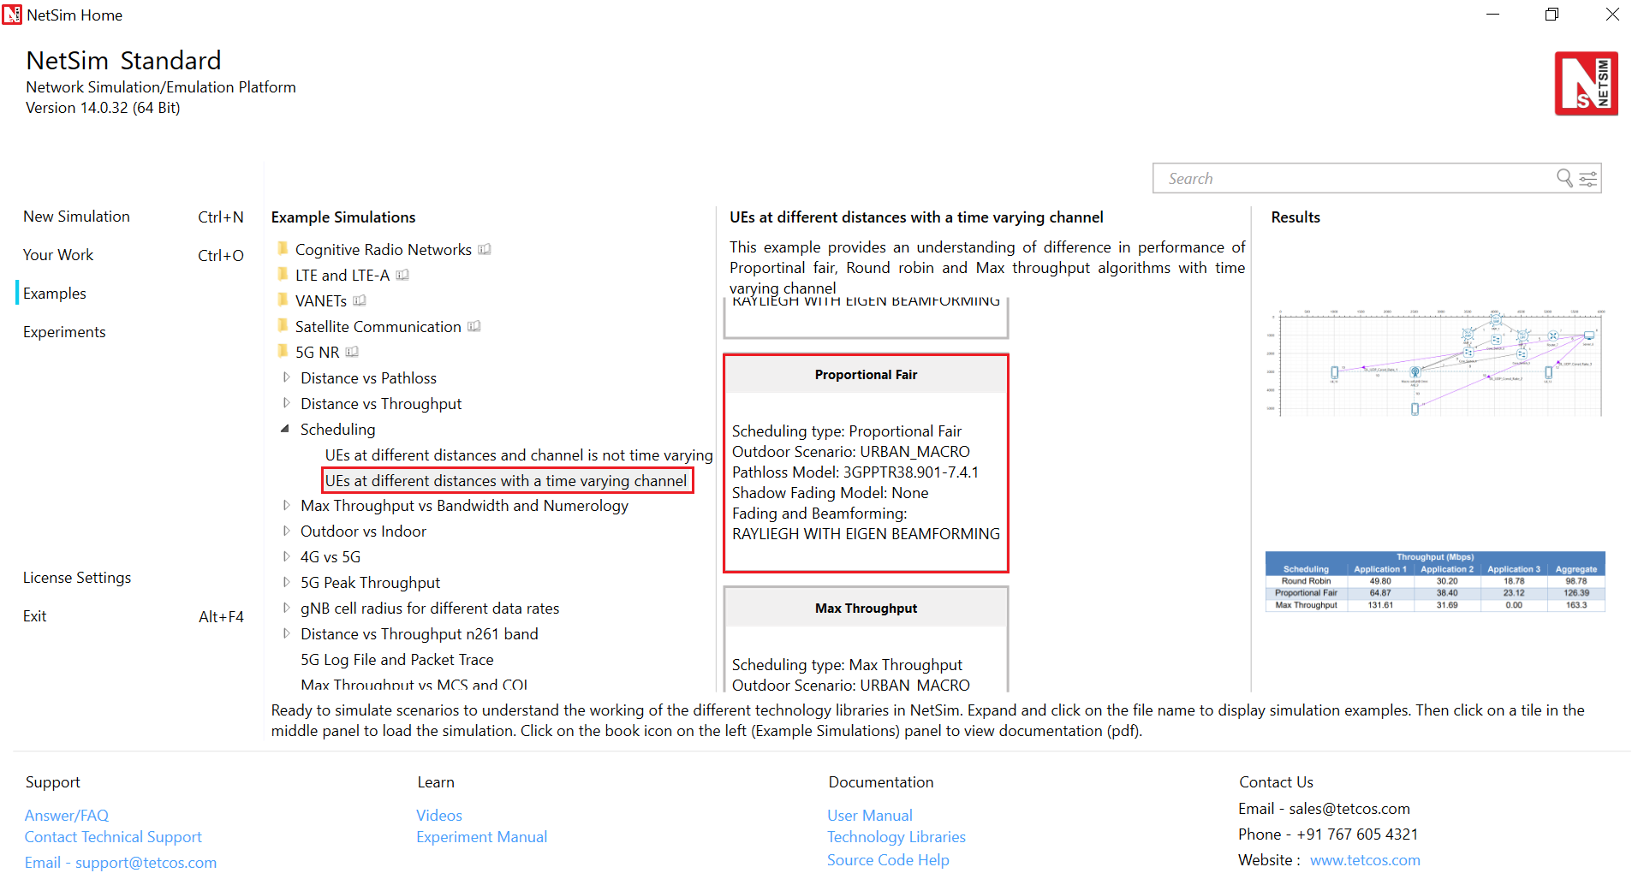Fig 7: List of scenarios for the example UEs equidistant and a time varying channel.

In this study, we will understand the design of Proportional fair scheduler in detail. Specifically, we will study the performance of PFS when the factor $α$ as it appears in the average throughput calculation for the PFS is varied. Note that, in cases 1 and 2, we had $α=50$ in all cases with PFS. To change this, change the settings as follows. Note: $α$ is called as the “EWMA Averaging rate” in Netsim (EWMA stands for “exponentially weighted moving average”.)

|  |  |
| --- | --- |
| Properties | |
| Data Link Layer Properties | |
| Scheduling Type | Proportional Fair |
| EWMA Averaging rate $(α)$ | Vary: 0.0001, 0.02 and 0.999 |
| Physical Layer Properties | |
| Fading and Beamforming | Rayleigh with Eigen Beamforming |

Table 8: gNB >Interface (5G_RAN) >Data Link/Physical layer properties

1. Now, set $α=0.0001, 0.02 and 0.999$ successively, and obtain the throughputs of the three UEs under PF scheduler.
2. The rest of the procedure and settings remain the same as in Case – II.
3. Run the simulation for 1.5 s and note down the throughput value from the results window.

**Results and discussion**

|  |  |  |  |  |
| --- | --- | --- | --- | --- |
| Throughput (Mbps) | | | | |
| Scheduling using PFS | **Application 1** | **Application 2** | **Application 3** | **Aggregate** |
| $$α=0.999$$ | 57.41 | 25.39 | 20.46 | 103.26 |
| $$α=0.02$$ | 65.96 | 38.77 | 22.40 | 127.13 |
| $$α=0.0001$$ | 74.54 | 37.46 | 25.13 | 137.13 |

Table 9: UDP download throughputs for PFS scheduling when all three 3 UEs are simultaneously downloading data.

We make the following observations:

* In all cases, the throughputs of UEs vary as UE_10 > UE_11 > UE_12. This is because of the increasing path loss of these UEs.
* At any given UE, as $α$ is varied, the throughput varies as: $α=0.0001$ > $α=0.02$ > $α= 0.999$. The reason for this observation is: as $α$ increases, the performance gets closer to that of a max-rate scheduler, and as $α$ decreases, it tends to a round robin scheduler. It must be noted that these are slightly hand-waving explanations; in fact, the PFS retains fairness over a sufficiently long-time window, whose duration depends on the value of $α$, so PFS does not quite “reduce” to the max rate scheduler for any value of $α$. These corroborate well with the theory.

**YOUR EXERCISES:**

**Let xx be last two digits of your trainee ID.**

1. **The first exercise is to understand the working of round-robin, max-rate and PF schedulers, as in Table 4. Take 3 UEs in an asymmetrical scenario, with the inter-gNB distances set as per the following:**

**gNB-UE_1 distance = 1400 + (2*xx);**

**gNB-UE_2 distance = 1900 + (2*xx);**

**gNB-UE_3 distance = 2400 + (2*xx);**

**Replicate table 4 for this case and make inferences. Compare your results with that in table 4.**

1. **In this exercise, we will study the effect of multi-user diversity by varying the number of transmit antennas at the gNB and observe the throughputs. For this experiment, consider only the performance of the max-rate and PF schedulers. Further, consider all UEs placed at the same distance from the gNB, with inter gNB- UE distance = 1400 + (2*xx);**

**Vary the transmit antenna count as 1, 4, and 128 at the gNB only and replicate table 7 (where fading is enabled) for each antenna count. Infer your results and justify.**

1. **In this exercise, we will demonstrate the utility of multi-user diversity as a function of the number of UEs in the system. Consider a symmetrical scenario such that inter gNB-UE distance = 1400 + (2*xx). Enable fading in the system (i.e., case – II of this experiment.)**

* **First place 2- UEs in the system, and obtain the throughputs of max-throughput scheduler, PFS with $α=1.1$, PFS with $α=100$, PFS with $α=9999$. Compute the aggregate throughputs in each of the cases.**
* **Now repeat the above exercise when there are 4, 5, 8, and 10 UEs in the system with four aggregate throughputs (for max-throughput scheduler, PFS with $α=0.909$, PFS with $α=0.01$, PFS with $α=0.0001$) for each of 4 –, 5 –, 8 –, and 10 – UE systems.**
* **Report all your values in the form of a tabular column as given below.**

|  |  |  |  |  |  |
| --- | --- | --- | --- | --- | --- |
| Aggregate Throughput (Mbps) in symmetrical scenario | | | | |  |
| Scheduler | **2 – UE system** | **4 – UE system** | **5 – UE system** | **8 – UE system** | **10 – UE system** |
| Max – rate | To be filled | To be filled | To be filled | To be filled | To be filled |
| PFS; $α=0.909$ | To be filled | To be filled | To be filled | To be filled | To be filled |
| PFS; $α=0.01$ | To be filled | To be filled | To be filled | To be filled | To be filled |
| PFS; $α=0.0001$ | To be filled | To be filled | To be filled | To be filled | To be filled |

* **Now plot a graph showing the aggregate throughput (y-axis) as a function of number of UEs (x-axis) for different scheduling schemes (different curves).**
* **Infer and justify all your results.**

**HINT:**

**Read Sec. II of the following paper, and you might want to produce plots like Fig. 1 of this paper.**

***[1] Yashvanth, L., & Chandra R. Murthy. (2022). “Performance Analysis of Intelligent Reflecting Surface Assisted Opportunistic Communications”. ArXiv. Link:*** [***https://arxiv.org/abs/2203.06313***](https://arxiv.org/abs/2203.06313)

**Note: In the above paper, $α$ denotes a channel fluctuation factor and $τ$ denotes the PF scheduler constant (which was denoted by $α$ in this experiment).**

**Note: To insert a new UE in the network, do the following:**

1. **Click on the UE icon on the top toolbar and click it again on the grid somewhere near the gNB. You can change the co-ordinate of the UE to achieve a inter-gNB UE distance as you want! This question has to have to a symmetrical network!**
2. **Establish a connection between the gNB and UE by clicking on option "Wired/wireless" on the top toolbar and connect both the gNB and new UE by placing mouse at the gNB, then click it, and click the mouse again after placing the mouse at the UE.**
3. **Then add a new application: Click on the "Application" option on the top toolbar, and create a new application - to do this, in the application box, on the left, there will be option to create a new application (look at "+" symbol). After creating one, change the source node to the device ID of the "Wired Node" icon in the GUI; may be this is device ID 10 - please recheck this. Then select the destination ID as the device ID of the newly inserted UE.**
4. **Please ensure that all the "Application properties" and "UE properties" of the newly inserted UE are identical to the existing UEs for fair comparisons.**
5. **Repeat this procedure for all the other UEs.**