# Experiment – 09

# Study of 5G Handover procedure (Level 2)

## Objective

In this experiment, we will study the procedure of handovers in 5G networks in more details. We will study the following aspects through Netsim **v14.2**:

1. The process of handover signaling via packet analysis through the RAN and core-network.
2. The impact of handover on the delay and throughput of the UE under handover.

## Introduction

The handover logic of NetSim 5G library is based on the Strongest Adjacent Cell Handover Algorithm (Ref: Handover within 3GPP LTE: Design Principles and Performance. Konstantinos Dimou. Ericsson Research). The algorithm enables each UE to connect to that gNB which provides the highest Reference Signal Received Power (RSRP). Therefore, a handover occurs the moment a better gNB (adjacent cell has offset stronger RSRP, measured as SNR in NetSim) is detected.

This algorithm is similar to 38.331, 5.5.4.4 Event A3 wherein Neighbor cell’s RSRP becomes Offset better than serving cell’s RSRP. Note that in NetSim report-type is periodical and not event Trigerred since NetSim is a discrete event simulator and not a continuous time simulator.

This algorithm is susceptible to ping-pong handovers; continuous handovers between the serving and adjacent cells on account of changes in RSRP due mobility and shadow-fading. At one instant the adjacent cell's RSRP could be higher and the very next it could be the original serving cell's RSRP, and so on.

To solve this problem the algorithm uses:

1. Hysteresis (Hand-over-margin, HOM) which adds a RSRP threshold (Adjacent cell RSRP – Serving cell RSRP > Hand-over-margin or hysteresis), and
2. Time-to-trigger (TTT) which adds a time threshold.

This HOM is part of NetSim implementation while TTT can be implemented as a custom project in NetSim.

This HOM is part of NetSim implementation while TTT can be implemented as a custom project in NetSim. The reader is requested to refer to experiment – 7 for a discussion on the process of handovers and related theory from the PHY viewpoint.

## Procedure

1. Use the following download Link to download a compressed zip folder which contains the workspace [GitHub link](https://github.com/NetSim-TETCOS/5G_Advanced_Experiments_v14.2/archive/refs/heads/main.zip" \o "https://github.com/NetSim-TETCOS/5G_Advanced_Experiments_v14.2/archive/refs/heads/main.zip)
2. Extract the zip folder.
3. The extracted project folder consists of a NetSim workspace file 5G_advanced_experiments_with_NetSim.netsimexp.
4. Go to NetSim Home window, go to Your Work and click on Import.

Fig : NetSim Home Window

1. In the Import Workspace Window, browse and select the 5G_advanced_experiments_with_NetSim.netsimexp file from the extracted directory. Click on create a new workspace option and browse to select a path in your system where you want to set up the workspace folder.
2. Choose a suitable name for the workspace of your choice. Click Import.

Fig 2: NetSim Import workspace window

1. The Imported Project workspace will automatically be set as the current workspace.
2. The list of experiments is now loaded onto the selected workspace.

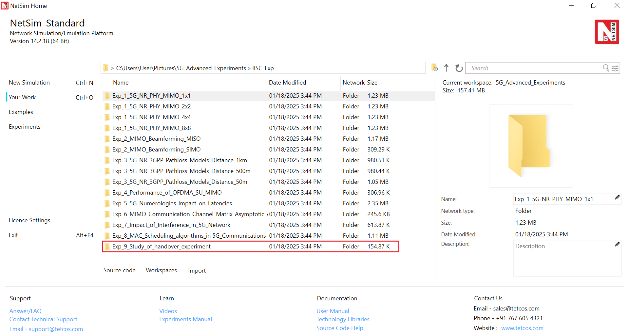

Fig 3: NetSim Your Work Window with the experiment folders inside the workspace

## PART I: HANDOVER ALGORITHM

The Netsim UI displays the network configuration for this experiment as shown below.

Fig : Network set up for studying the 5G handover

### Procedure for 5G Handover

The following set of procedures were done to generate this sample:

**Step 1:** A network scenario is designed in NetSim GUI comprising of 5G-Core, 2 gNBs, and 1 UE in the **“5G NR”** Network Library.

**Step 2:** The device positions are set as per the table given below.

|  |  |  |  |
| --- | --- | --- | --- |
|  | gNB 7 | gNB 8 | UE 9 |
| X Co-ordinate | 500 | 4500 | 500 |
| Y Co-ordinate | 1500 | 1500 | 3000 |

Table : Device positions

**Step 3:** In the Position layer Properties of UE 9, set Mobility Model as File Based Mobility.

**Step 4:** Right click on the gNB_7 and select Properties, the following is set as per the below table.

|  |  |
| --- | --- |
| Interface_4(5G_RAN) Properties | |
| CA_Type | Single Band |
| CA_Configuration | n78 |
| CA_Count | 1 |
| Numerology | 0 |
| Channel Bandwidth (MHz) | 10 |
| PRB Count | 52 |
| MCS Table | QAM64LOWSE |
| CQI Table | Table 3 |
| X_Overhead | XOH0 |
| DL UL Ratio | 4:1 |
| Pathloss Model | 3GPPTR38.901-7.4.1 |
| Outdoor Scenario | Urban Macro |
| LOS_NLOS_Selection | User_Defined |
| LOS Probability | 1 |
| Shadow Fading Model | None |
| Fading _and_Beamforming | NO_FADING_MIMO_UNIT_GAIN |
| Additional Loss Model | None |

Table : gNB_7 > 5G_RAN Interface Properties Window

Similarly, it is set for gNB 8.

**Step 5:** The Tx Antenna Count was set to 2 and Rx Antenna Count was set to 1 in gNB > Interface (5G_RAN) > Physical Layer.

**Step 6:** The Tx Antenna Count was set to 1 and Rx Antenna Count was set to 2 in UE > Interface (5G_RAN) > Physical Layer.

**Step 7:** Configure CBR application from Server 12 to UE 9 by clicking on the set traffic tab in ribbon on the top. Then, click on the created application and expand the application property on the right and set the start time to 40 seconds, and QOS to UGS.

**File Based Mobility:**

In File Based Mobility, users can write their own custom mobility models and define the movement of the mobile users. Create a mobility.txt file for UE’s involved in mobility with each step equal to 0.5 sec with distance 50 m.

The NetSim Mobility File (mobility.txt) format appears on a excel sheet which looks like the following figures:

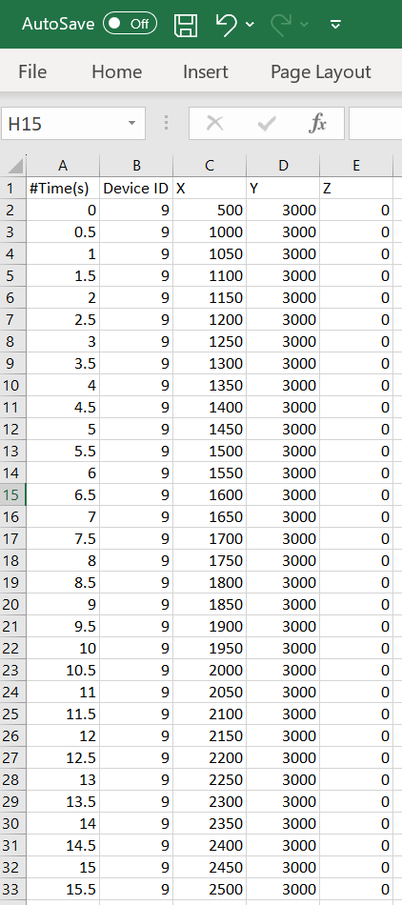 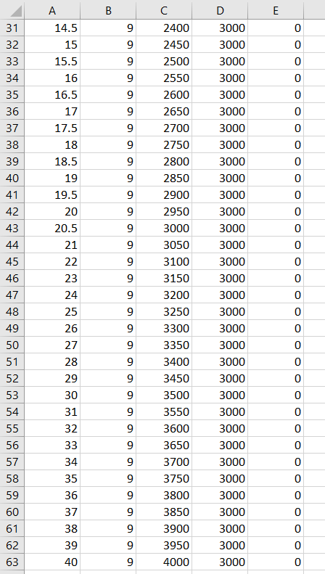

Fig : Mobility file sample

**Step 8:** Packet Trace is enabled in NetSim GUI. At the end of the simulation, a very large .csv file containing all the packet information is available for the users to perform packet level analysis. Plot is enabled in NetSim GUI.

**Step 9:** LTENR Radio measurement, Handover log and SNR vs Time plot under LTENR Radio Measurements plots are enabled for detailed analysis.

**Step 10:** Run the simulation for 50 seconds.

### Results and Discussion

#### Handover Signaling



Fig : Control packet flow in the 5G handover process

The packet flow depicted above can be observed from the packet trace.

1. UE will send the UE MEASUREMENT REPORT every 5 ms to the connected gNB
2. The initial UE-gNB connection and UE association with the core takes place by transferring the RRC and Registration, session request response packets.
3. As Per the configured file-based mobility, UE 9 moves towards gNB 8.
4. After 18.5 s gNB 7sends the HANDOVER REQUEST to gNB 8.
5. gNB 8 sends back HANDOVER REQUEST ACK to gNB 7.
6. After receiving HANDOVER REQUEST ACK from gNB 8, gNB 7 sends the HANDOVER COMMAND to UE 9
7. After the HANDOVER COMMAND packet is transferred to the UE, the target gNB will send the PATH SWITCH packet to the AMF via Switch 4.
8. When the AMF receives the PATH SWITCH packet, it sends MODIFY BEARER REQUEST to the SMF
9. The SMF on receiving the MODIFY BEARER REQUEST provides an acknowledgement to the AMF.
10. On receiving the MODIFY BEARER RESPONSE from the SMF, AMF acknowledges the Path switch request sent by the target gNB by sending the PATH SWITCH ACK packet back to the target gNB via Switch 4.
11. The target gNB sends CONTEXT RELEASE to source gNB, and the source gNB sends back CONTEXT RELEASE ACK to target gNB. The context release request and ack packets are sent between the source and target gNB via Switch 6.
12. RRC Reconfiguration will take place between target gNB and UE 9.
13. The UE 9 will start sending the UE (SS/PBCH) MEASUREMENT REPORT to gNB 8.

Fig : Screenshot of NetSim packet trace file showing the control packets involved in handover. Some columns have been hidden before the last column.

#### Plot of SNR vs. Time

Fig : Plot of the DL SNR over time seen by the UE from the serving cell (gNB 7) and the target cell (gNB 8). The handover process does not commence with Adj. cell SNR is greater than Serving cell SNR but only commences with Adj. cell SNR is greater than Serving cell SNR by the Handover margin (3 dB in this case).

This chart can be obtained in NetSim by enabling the option to plot SNR vs. time prior to the simulation. First, plot the SNR curve for gNB7 and UE9 keeping the channel as SSB. Then select "Add as new series" and select the gNB/eNB as gNB8 and UE name as UE9. Click on plot, and you would then obtain the above "stacked" plot

* At 15.6 seconds, the signal-to-noise ratio (SNR) from both gNB7 and gNB8 is 16.84 dB. This is the point where the SNR curves for both gNBs intersect.
* At 18.6 seconds, the SNR from gNB7 is 15.21 dB and the SNR from gNB8 is 18.54 dB. This is the point where Adj cell RSRP from gNB8 exceeds the serving cell RSRP by the handover margin (HOM) of 3 dB.

## PART II: THROUGHPUT AND DELAY VARIATION DURING HANDOVER

NetSim UI displays the configuration file corresponding to this experiment as shown below

Fig : Network set up for studying the throughput and delay variation during handover

### Procedure for Effect of Handover on Delay and Throughput

The following set of procedures were done to generate this sample:

**Step 1:** A network scenario is designed in NetSim GUI comprising of 2 gNBs, 5G Core, 1 Router, 1 Wired Node and 2 UEs in the **“5G NR”** Network Library.

**Step 2:** The device positions are set as per the table given in

|  |  |  |  |
| --- | --- | --- | --- |
|  | gNB 7 | gNB 8 | UE 9 |
| X Co-ordinate | 500 | 4500 | 500 |
| Y Co-ordinate | 500 | 500 | 1000 |

Table : Device positions.

**Step 3:** Right click on the gNB 7 and select Properties and set the following.

|  |  |
| --- | --- |
| Interface(5G_RAN) Properties |  |
| CA_Type | Single Band |
| CA_Configuration | n78 |
| CA_Count | 1 |
| Numerology | 0 |
| Channel Bandwidth (MHz) | 10 |
| PRB Count | 52 |
| MCS Table | QAM64 |
| CQI Table | Table 1 |
| X_Overhead | XOH0 |
| DL UL Ratio | 4:1 |
| Pathloss Model | 3GPPTR38.901-7.4.1 |
| Outdoor Scenario | Urban Macro |
| LOS_NLOS Selection | User Defined |
| LOS Probability | 1 |
| Shadow Fading Model | None |
| Fading and Beamforming | No Fading MIMO Unit Gain |
| Additional Loss Model | None |

Table : gNB _7> Interface(5G_RAN) Properties Setting.

Similarly, it is set for gNB 8.

**Step 4:** The Tx Antenna Count was set to 2 and Rx Antenna Count was set to 1 in gNB > Interface (5G_RAN) > Physical Layer.

**Step 5:** The Tx Antenna Count was set to 1 and Rx Antenna Count was set to 2 in UE > Interface (5G_RAN) > Physical Layer.

**Step 6:** In the General Properties of UE 9 and UE 10, set Mobility Model as File Based Mobility.

**Step 7:** The BER and propagation delay was set to zero in all the wired links.

**Step 8:** Right click on the Application Flow **App1 CBR** and select Properties or click on the Application icon present in the top ribbon/toolbar.

A CBR Application is generated from Wired Node 12 i.e., Source to UE 9 i.e., Destination, with Packet Size 1460 Bytes and Inter Arrival Time 233.6µs. QOS is set to UGS.

Additionally, the **“Start Time(s)”** parameter is set to 1, while configuring the application.

**File Based Mobility:**

In File Based Mobility, users can write their own custom mobility models and define the movement of the mobile users. Create a mobility.txt file for UE’s involved in mobility with each step equal to 0.5 sec with distance 50 m.

The NetSim Mobility File (mobility.csv) looks like the following figure:

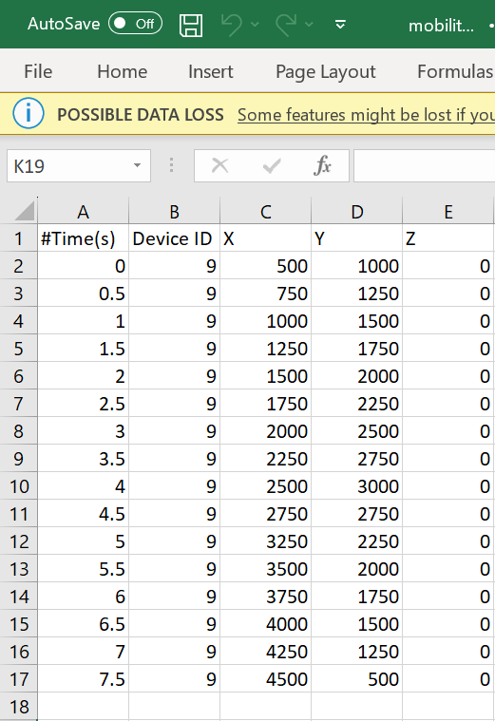

Fig :Mobility file sample

**Step 9:** The LTENR Radio measurement log file can be enabled per the information provided in **Section 3.20 of 5G technology** library document and enable the Latency vs. Time and Throughput vs. Time under application performance plots

**Step 10:** Run the simulation for 20 seconds.

### Results and Discussion

**UDP Throughput Plot**

Fig : We see how throughput varies with time, and the reasons for this variation, as the UE moves from the source gNB to the target gNB. Note that there is a slight typo in the legend. The peak capacity is 62.83 Mbps, not 6383 Mbps.

The application starts at 1s. The generation rate is 50 Mbps and we see the network is able to handle this load, and the throughput is equal to the generation rate. We then observe that the throughput starts dropping from 2.5s onwards because the UE is moving away from the gNB. As it moves as the SNR falls, and therefore a lower MCS is chosen leading to reduced throughput. At 3s there is a further drop in throughput and then a final dip at 3.9s. The time the handover occurs is 5.04 sec. At this point we see the throughput starts increasing once UE attaches to gNB8. The throughput for a short period of time is greater than 50 Mbps because of the transmission of queued packets in the s-gNB buffer which get transferred to the t-gNB buffer over the Xn interface.

**UDP Delay Plot**

Fig : Plot of Delay vs. Time

Since the application starts at 1 s, the UDP plot begins at 1000 ms. The initial UDP delay is , and hence the curve is seen as close to 0 on the Y axis. We then see that the packet delay starts increasing as the UE moves away from the gNB. This is because the link capacity drops as the CQI falls. The peak delay experienced shoots up to 1.1 s at 5.5 s when the handover occurs. Once the handover is complete the delay starts reducing and returns to . The reason is that as the UE moves closer to the gNB its CQI increases and hence the 5G link can transmit at a higher rate (see Fig 12).

Please see the next page for your exercises.

**YOUR EXERCISES:**

**Let the last digit of your trainee ID be x. Then set the transmit power at the BS to (30 + 2*x) dBm at both the gNBs.**

1. **Repeat the above experiment for your value of transmit power by replicating Fig 8, 11 and 12. Infer and justify all your results.**
2. **In this exercise, we will understand the effect of handover margin on the process of handover. To change the handover margin, do the following steps.**

**gNB Properties > Interface_4 (5G_RAN) > DATALINK_LAYER > HANDOVER > Handover Margin (dB)**

**If x is odd, replicate Fig 8, 11 and 12 for two handover margins: 1 dB and 9 dB, with your customized gNB transmit powers.**

**If x is even, replicate Fig 8, 11 and 12 for two handover margins: 2 dB and 10 dB, with your customized gNB transmit powers.**

**Infer and justify your observations on how the handover margin affects the process of handover in terms of points of handover, delay and throughput of the application.**