5G Channel Modeling in NetSim using MATLAB

**Software Recommended:** NetSim Professional v12.2 (64 bit), Visual Studio 2019, MATLAB 2020b

Follow the instructions specified in the following link to clone/download the project folder from GitHub using Visual Studio:

[https://tetcos.freshdesk.com/support/solutions/articles/14000099351-how-to-clone-netsim-file-](https://tetcos.freshdesk.com/support/solutions/articles/14000099351-how-to-clone-netsim-file-exchange-project-repositories-from-github-) [exchange-project-repositories-from-github-](https://tetcos.freshdesk.com/support/solutions/articles/14000099351-how-to-clone-netsim-file-exchange-project-repositories-from-github-)

Other tools such as GitHub Desktop, SVN Client, Sourcetree, Git from the command line, or any client you like to clone the Git repository.

**Note**: It is recommended not to download the project as an archive (compressed zip) to avoid incompatibility while importing workspaces into NetSim.

# Secure URL for the GitHub repository:

**https://github.com/NetSim-TETCOS/ _v12.2.git**

# 5G Channel Models in NetSim:

# As part of 5G module in NetSim channel models are implemented as per 3GPP specifications which includes, Outdoor propagation, Indoor Propagation, and Outdoor to Indoor Penetration loss. Along with this the modes of operation such as Line of Sight (LoS) and Non-Line of Sight (NLoS) will also have an impact on RSSI.

# Path loss and shadow fading models described in 3GPP TR 38.901 includes multiple scenarios on modeling different propagation environments, i.e., indoor, outdoor urban and rural, for frequencies between 0.5 and 100 GHz

# Channel Modelling in MATLAB:

# MATLAB allows creating transmitter and receiver sites with various antenna properties and to define the propagation model for the channel based on which parameters such as pathloss can be computed. Propagation models supported include freespace, gas, fog, rain, close-in, longley-rice, etc.

**Modelling channels for 5G network in NetSim using MATLAB:**

NetSim can be interfaced with MATLAB to exchange information during runtime. In this case, NetSim passes the details of the 5G network model created in NetSim, such as the grid length, gNB properties, output file path etc to MATLAB during simulation start.

Based on the input received from NetSim, pathloss across the simulation grid is calculated for each gNB in MATLAB. A separate log file is written by MATLAB for each gNB in the 5G network in NetSim.

NetSim reads the pathloss log written by MATLAB and uses it to identify best server and for signal strength calculations.

The codes required for the mathematical calculations done in MATLAB are written to a **MATLAB_5G_Channel_Model.m**

file as shown below:

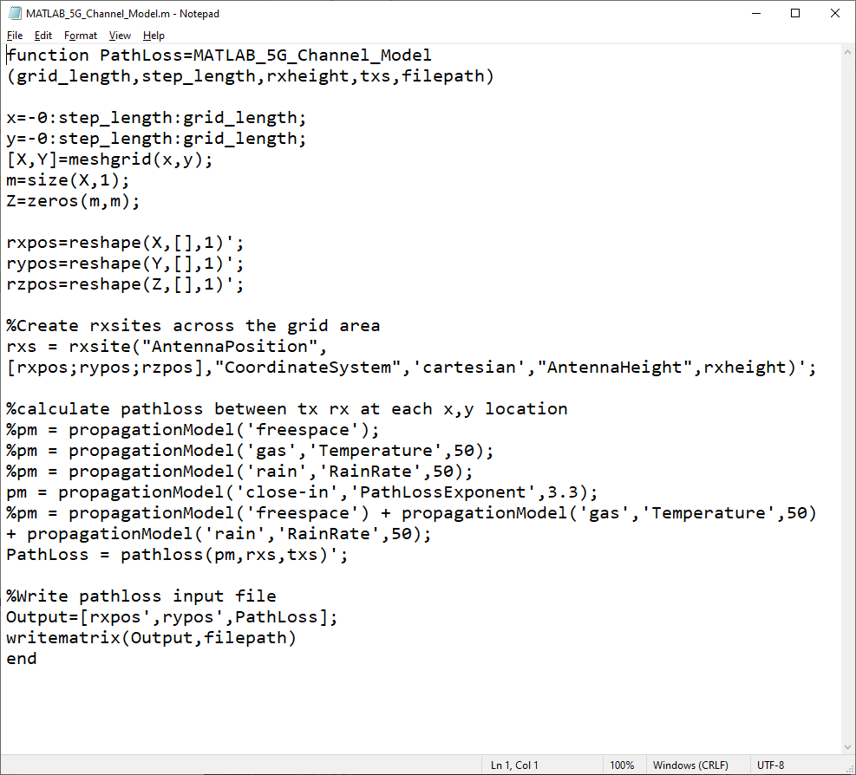

The MATLAB file can be modified to use different pathloss models supported such as freespace, gas, rain, etc. or a combination of the models as required. By default close-in model with pathloss exponent set to 3.3 is used.

A **MATLAB_Interfacing.c** file is added to the LTE_NR project which contains the following functions:

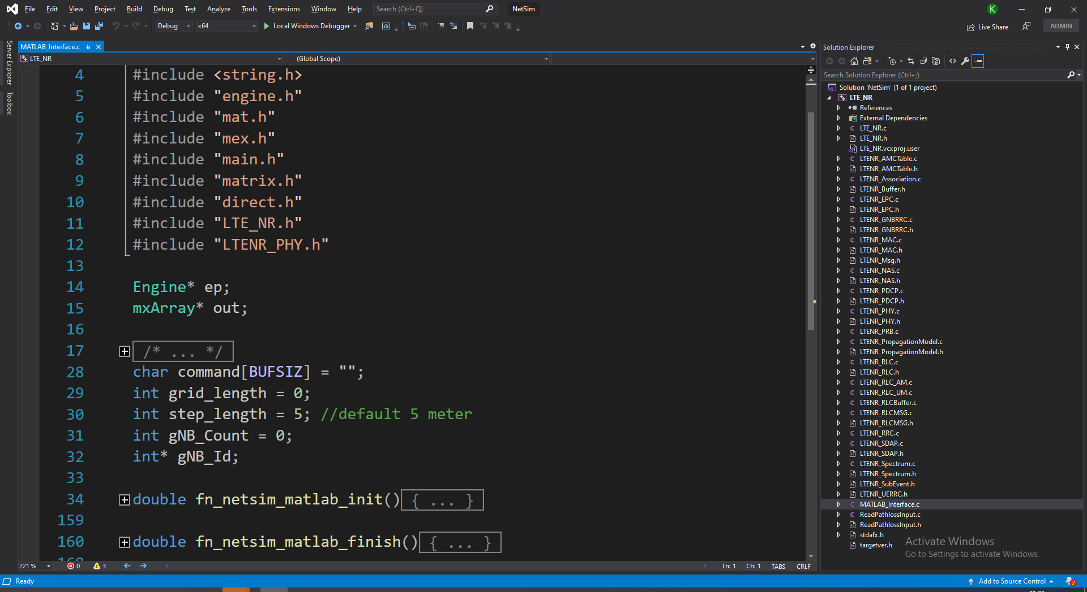

# fn_netsim_matlab_init()

This function initializes MATLAB process as simulation in NetSim starts and takes care of creating txsites in MATLAB as per the gNB configuration in NetSim. This function further generates a pathloss text file for each gNB in NetSim by passing necessary arguments to the function in MATLAB M-Script file MATLAB_5G_Channel_Model.m.

# fn_netsim_matlab_finish()

This function terminates the MATLAB process when simulation ends in NetSim. Further ReadPathlossInput.c and ReadPathlossInput.h files are also added to the LTE_NR source code project.

The ReadPathlossInput.c file contains the following functions:

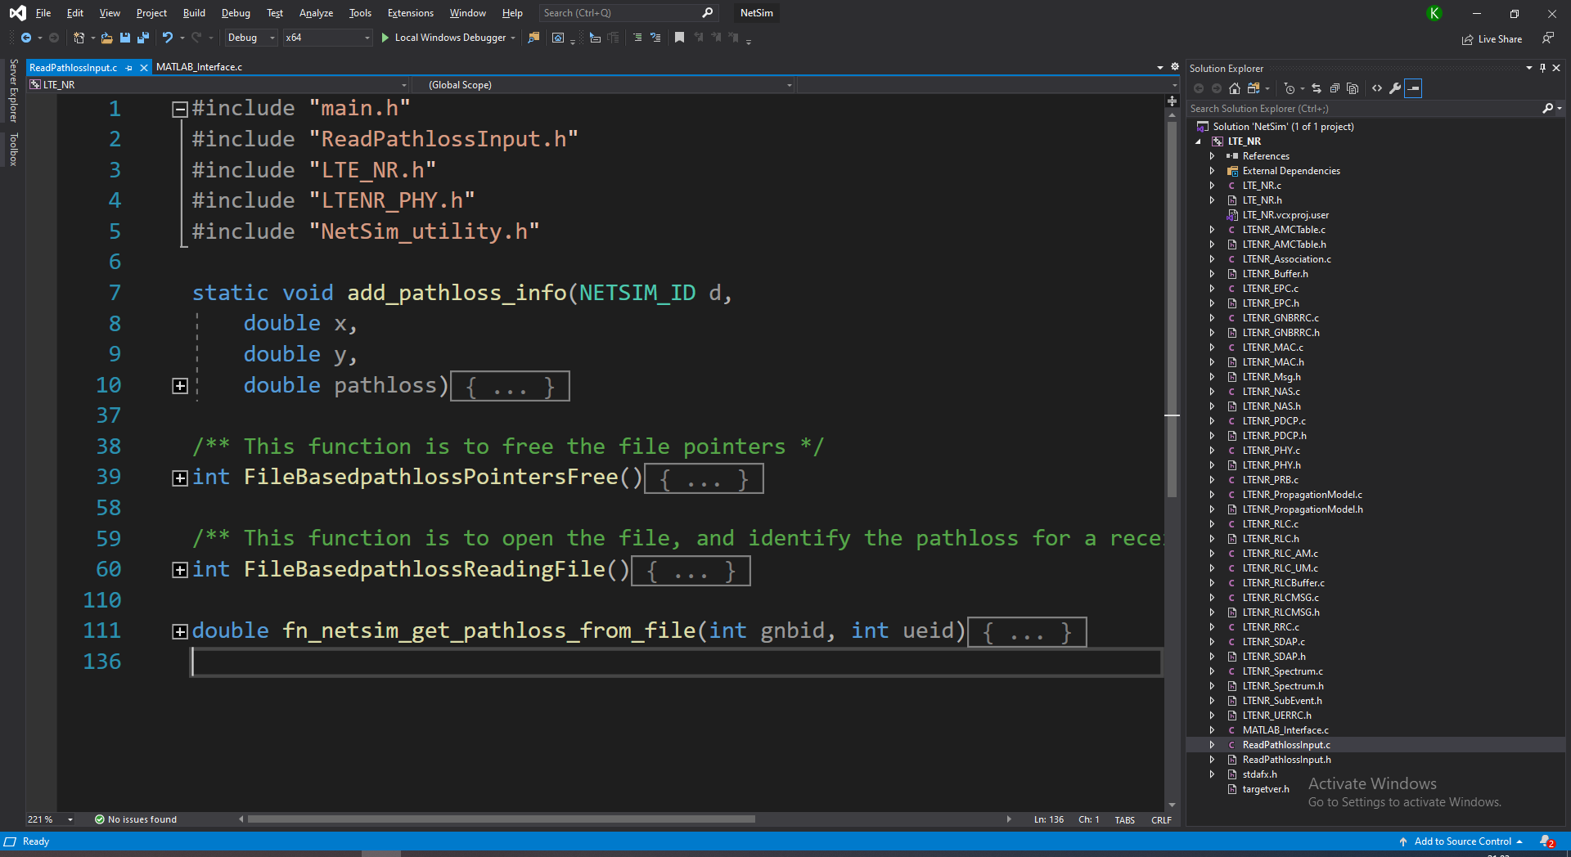

**FileBasedpathlossReadingFile()**

Reads from the pathloss file generated by MATLAB and stores the coordinates and pathloss values for each gNB in a separate list.

**fn_netsim_get_pathloss_from_file()**

Returns the pathloss at a requested receiver coordinate with respect to the transmitter gNB.

**Steps:**

1. The downloaded project folder contains the folders Documentation, MATLAB_Code and 5G_Channel_Model_Workspace directory as shown below:

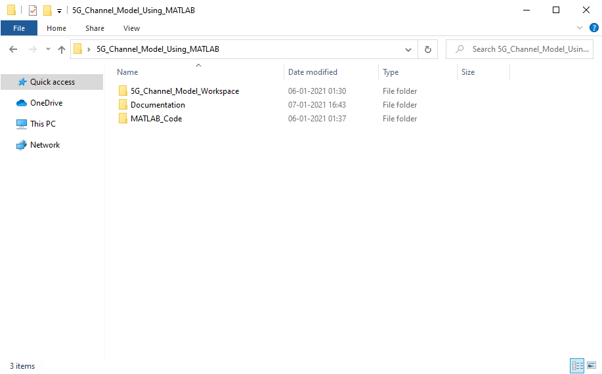

1. Import 5G_Channel_Model_Workspace by going to Open Simulation->Workspace Options-

>More Options in NetSim Home window. Then select Import as shown below:

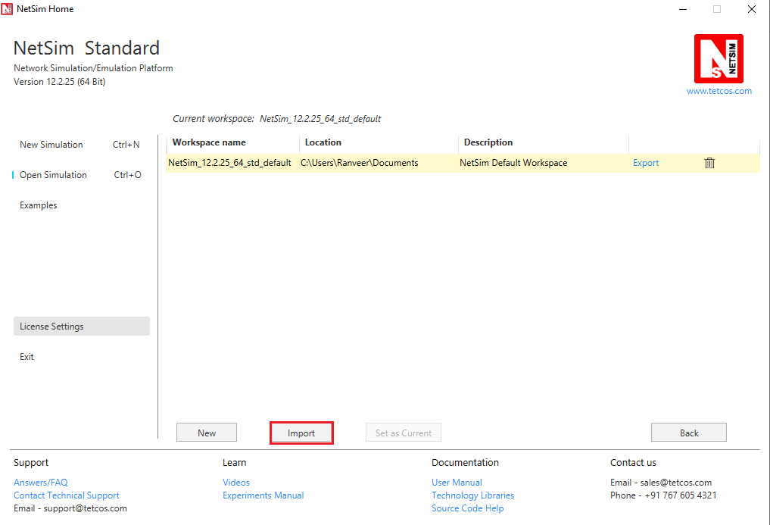

1. It displays a window where users need to give the path of the workspace folder and click on OK as shown below:

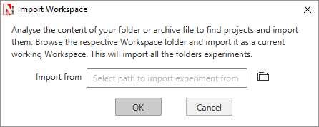

1. Browse to the Dynamic_Clustering_Workspace folder and click on select folder as shown below:

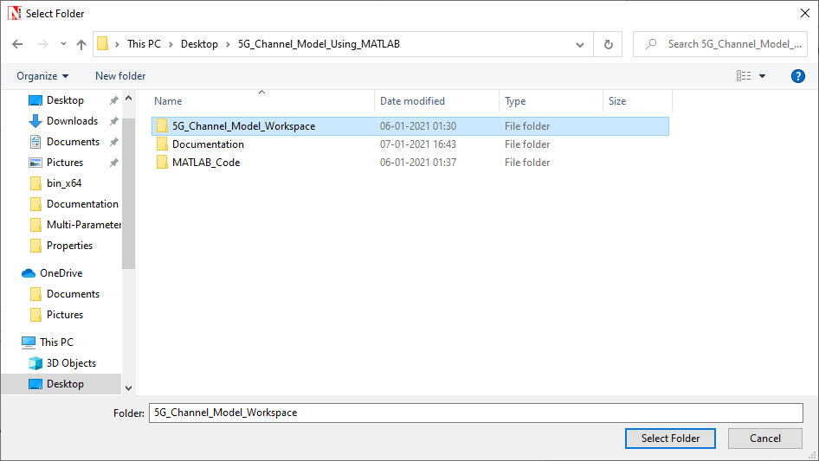

1. After this click on OK button in the Import Workspace window.
2. While importing the workspace, if the following warning message indicating Software Version Mismatch is displayed, you can ignore it and proceed.

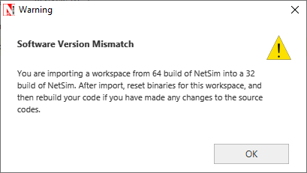

1. The Imported workspace will be set as the current workspace automatically. To see the imported workspace, click on Open Simulation->Workspace Options->More Options as shown below:

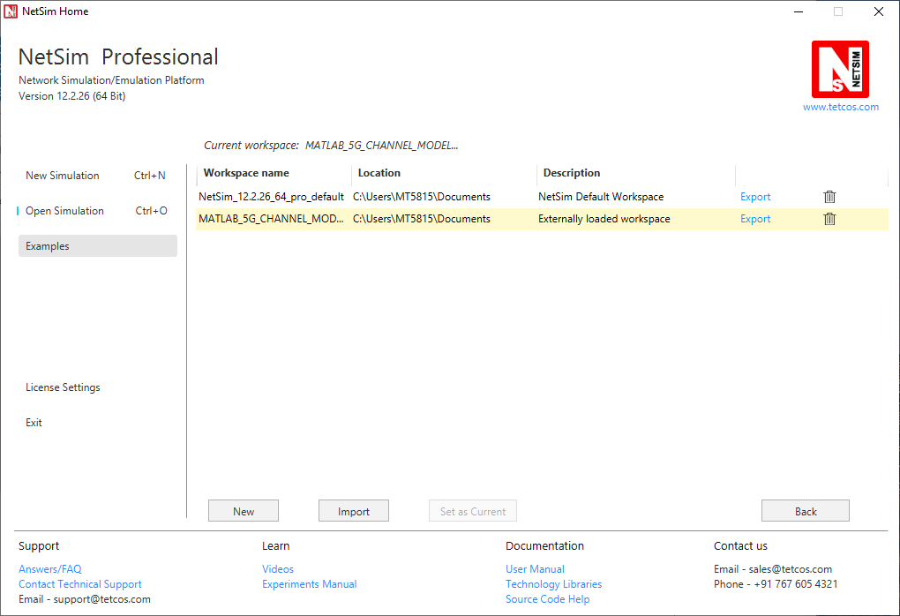

1. Create a user variable with the name of MATLAB_PATH and provide the path of the installation directory of user’s respective MATLAB version.

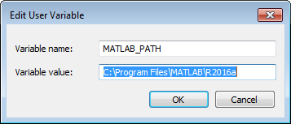

1. Make sure that the following directory is in the PATH(Environment variable)

# <Path where MATLAB is installed>\bin\win64

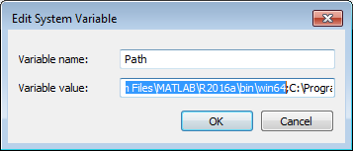

**Note:** If the machine has more than one MATLAB installed, the directory for the target platform must be ahead of any other MATLAB directory (for instance, when compiling a 64-bit application, the directory in the MATLAB 64-bit installation must be the first one on the PATH).

1. Open Command prompt as admin and execute the command “matlab -regserver”. This will register MATLAB as a COM automation server and is required for NetSim to start MATLAB automation server during runtime.

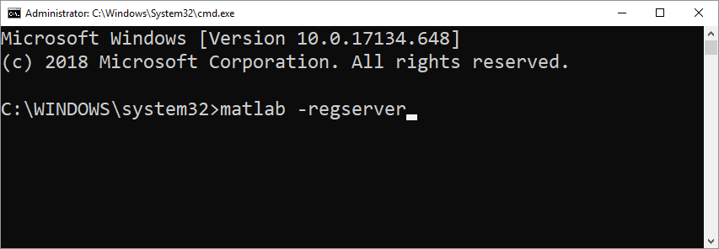

1. Place the **MATLAB_5G_Channel_Model.m file** present in the MATLAB_Code folder of the downloaded project, inside the win64 directory of MATLAB installation directory For Example: **“C:\Program Files\MATLAB\R2020b\bin\win64”**.

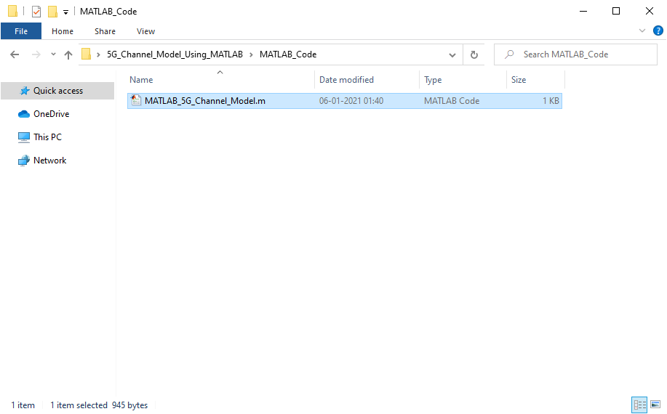

1. Open the Source codes in Visual Studio by going to Open Simulation-> Workspace Options and Clicking on Open code button as shown below:

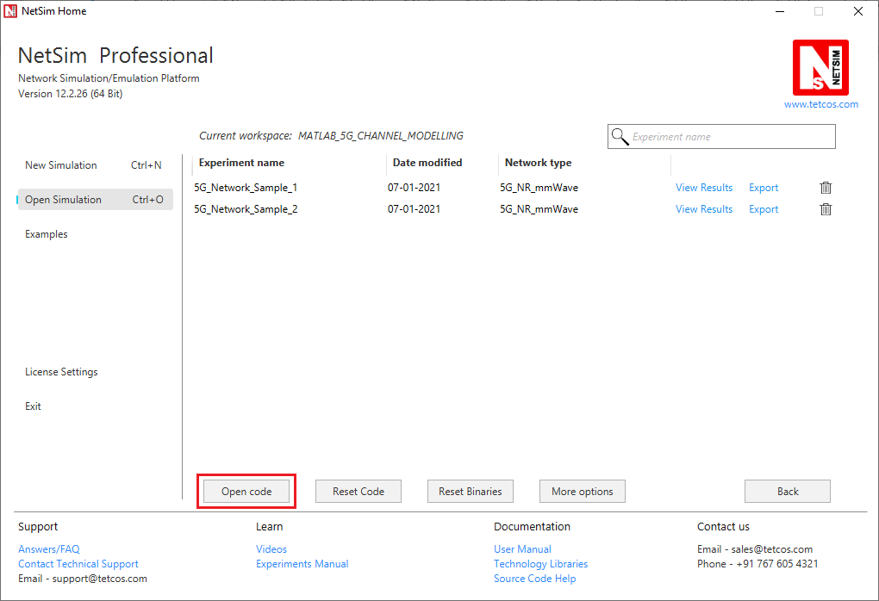

1. Under the LTE_NR project in the solution explorer you will be able to see that **MATLAB_Interface.c, ReadPathlossInput.c** and **ReadPathlossInput.h** files which contain source codes related to interactions with MATLAB and reding from the generated pathloss file respectively.
2. Right click on the solution explorer and select Rebuild.

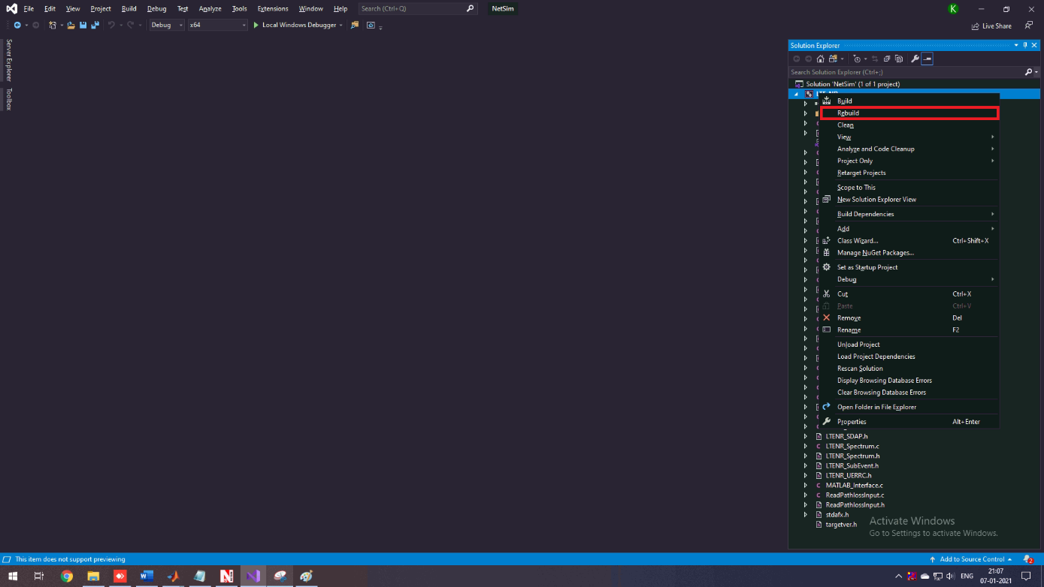

1. Upon successful build modified LTE_NR binaries gets will be updated in the current workspace’s directory containing NetSim binaries.
2. Run NetSim as Administrative mode.
3. The 5G_Channel_Model_Workspace comes with a sample 5G network configurations that are already saved. To open the examples, go to Open Simulation and click on the Example that is present under the list of experiments as shown below:

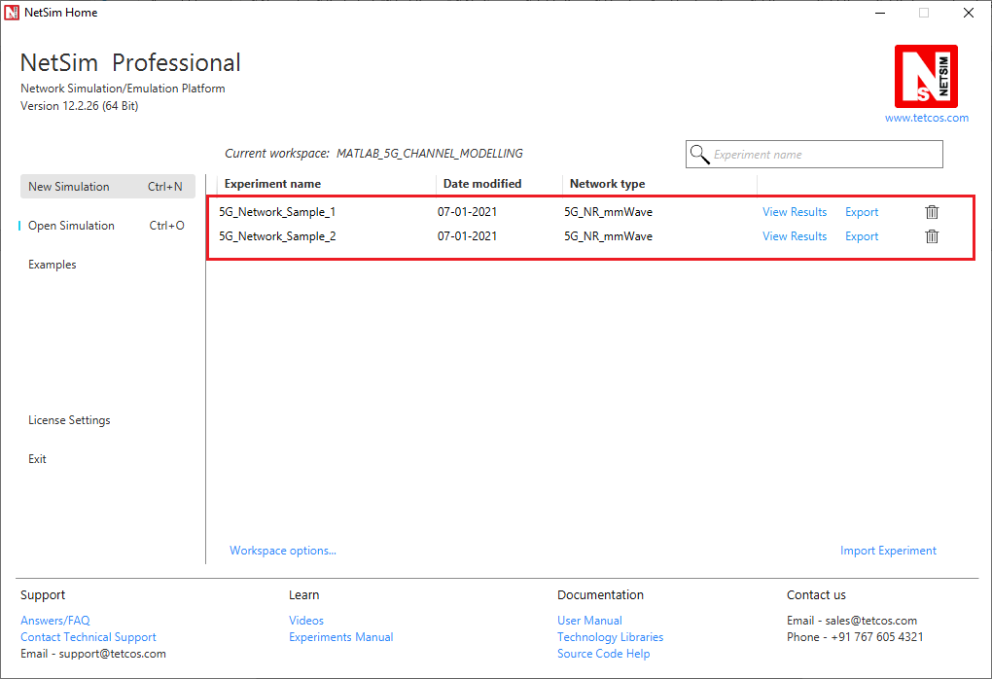

1. The first Sample consists of a single gNB, which has 1 UE performing download as shown below:

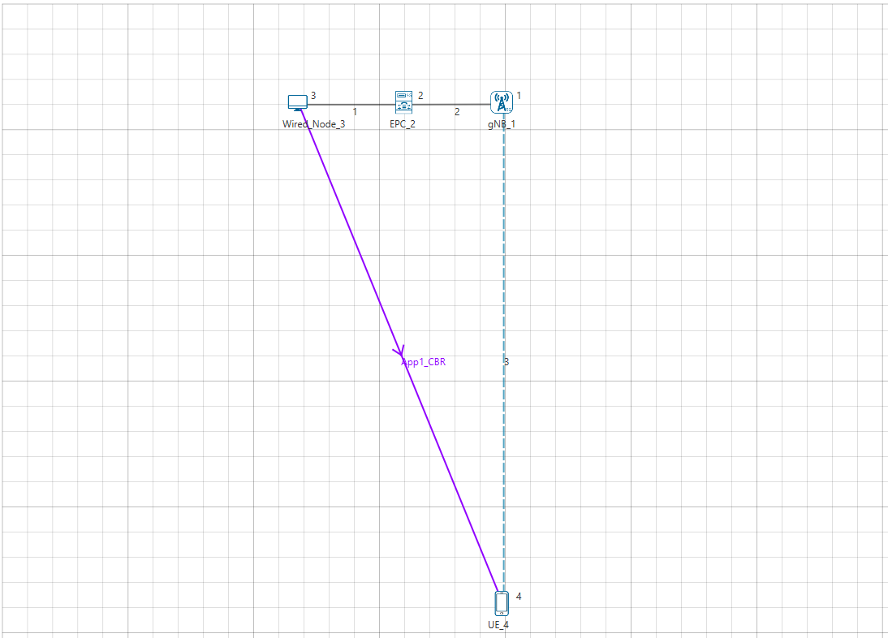

1. Run the Scenario. You will observe that as the simulation starts in NetSim, MATLAB gets initialized. NetSim passes the information related to the gNodeB’s in the 5G Network to MATLAB based on which MATLAB generates individual pathloss files for each gNB. NetSim uses this information during the simulation.

**Analysis:**

The pathloss text file generated by MATLAB is written to NetSim’s IOPATH which is located in the system ‘s temp directory. (For E.g. C:\Users\Admin\AppData\Local\Temp\netsim\pro12.2.26_x64)

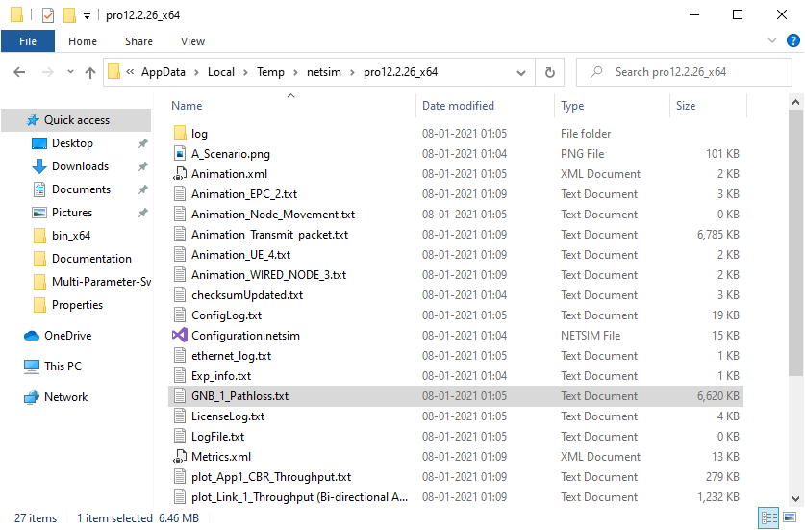

The file consists of position coordinates across the grid area and the pathloss at those locations with respect to the gNB (in the format X,Y,Pathloss) as shown below:

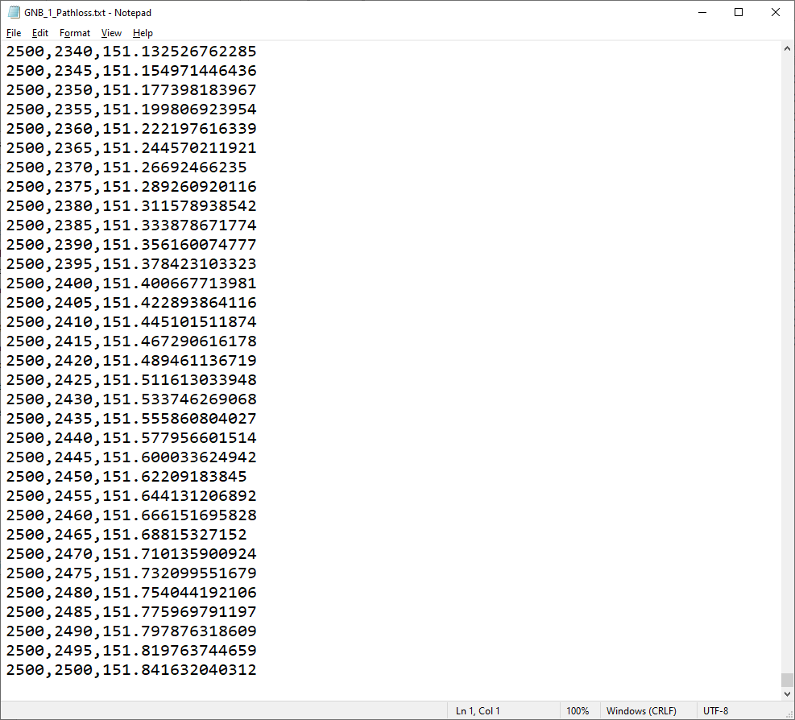

NetSim reads this file to determine the pathloss at any location in the grid instead of using the inbuilt pathloss models.

In case of a network with multiple gNB’s, multiple pathloss files will be created as per the number of gNB’s in the network as shown below:

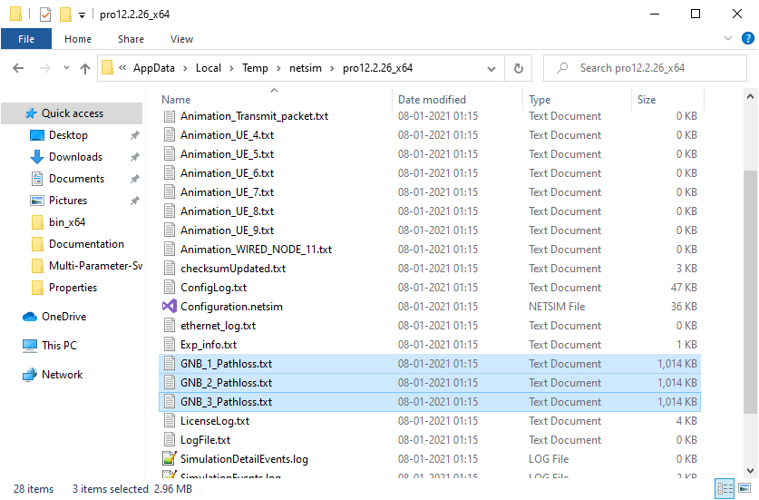

When the network is saved after the simulation, the pathloss files also get saved along with the other data files generated by NetSim.