# MIMO Beamforming in 5G: A start with MISO and SIMO

Objective:Consider 5G communication between a gNB and single UE, over a fading channel. Setup the simplest MIMO cases, namely MISO and SIMO, and investigate the questions:

* How does beamforming gain vary with antenna count?
* How does throughput vary with antenna count?

Theory:Multiple input multiple output (MIMO) is a method for increasing the capacity of the wireless channel using multiple transmitting and receiving antennas. Multiple antennas exploit the spatial dimension, i.e., multiple paths from transmitter to receiver, under suitable spacing within the antenna array, on each side, and channel scattering conditions.

Consider a MIMO system where is the number of transmit antennas and is the number of receive antennas. The simplest MIMO instantiations are when:

* , a special case where the MIMO system reduces to a Multiple Input Single Output (MISO) channel, and
* Reciprocally when, , a special case where the MIMO system simplifies into a Single Input Multiple Output (SIMO) channel.

In both SIMO and MISO, the number of layers (i.e., spatial streams with independent data) is which equals 1.

Fig 1: Top) Single transmit antenna and multiple receive antennas. Bottom) Multiple Transmit and single receive antenna. In both, represents the channel between the receive antenna and the transmit antenna.

**SIMO:** SIMO occurs where the transmitter has a single antenna, and the receiver has multiple antennas. The signal received on multiple antennas is combined in order to maximize an appropriate metric. For example, when the goal is to maximize the received SNR, under additive white Gaussian noise, the optimal receiver is called maximal ratio combining. In the case of fading channels (e.g., with Rayleigh fading, explained in the next section), the channels between the transmitter and the different receive antennas is modelled as independent and identically distributed with unit variance entries; this is shown in Fig *1* above. In this case, maximal ratio combining uses the channel coefficients as the weights to combine the signals, and in turn, this provides *receive diversity* gain. The *average* SNR at the receiver improves by . However, the improvement in SNR is not exactly the same for every channel instantiation, since the channel is random. In this experiment, we will quantify the improvement in the data rate as we vary .

**MISO:** The phase of the signal from each of the transmit antennas is adjusted so that they add constructively at the receiver, yielding an fold power gain on average. As with SIMO, the instantaneous SNR gain, however, will differ from since the channel is random. So, the question is, given a choice between having multiple antennas at either the transmitter or the receiver, which option yields better improvement in the throughput? Or will they be the same? Note that, with a single-antenna receiver, only one data stream is transmitted, and therefore multiple antennas offer only a diversity gain, but not a multiplexing gain. Now, practically speaking, is it better to have multiple antennas at the base station or at the user? In terms of antenna placement, there is more space to install antennas at the base station. In addition, the signal processing capability of the base station is much higher than that of a mobile phone. Thus, multiple antennas at the base station are easier to implement than multiple antennas at the mobile phone.

**The Rayleigh Fading Channel:** For a transmitter (gNB) with antennas and a receiver with antennas, the baseband channel gain matrix (to model fading between every transmit-receive antenna pair) has complex Gaussian distributed elements. The standard model (under the assumption of Rayleigh fading) is that the complex elements are statistically independent across antennas, and each element is a circularly symmetric complex Gaussian distributed with zero mean and unit variance. We denote this matrix by

For the channel matrix defined as above, consider the complex Wishart Matrix defined as follows:

,

Therefore, letting is an nonnegative definite matrix, with eigenvalues It is these eigenvalues that determine the gains in the parallel SISO models that arise from eigen-beamforming at the transmitter and receiver[1].

NetSim permits the user to enable or disable a stochastic fading model. Fading is modelled by the elements of being time varying, with some coherence time. Such time variation results in the eigenvalues of also to vary over time. NetSim models such time variation by letting the user define a *coherence time* during which the eigenvalues are kept fixed. For each value, NetSim maintains a list of samples of eigenvalues for the corresponding Wishart matrix.

## Procedure:

1. Use the following download Link to download a compressed zip folder which contains workspace [GitHub link](https://github.com/NetSim-TETCOS/5G_Experiments_v13_2_20/archive/refs/heads/main.zip%20)
2. Extract the zip folder.
3. The extracted project folder consists of a NetSim workspace file (5G_Advanced_IISC_experiment_v13.2.20.netsimexp).
4. Go to NetSim Home window, go to Your Work and click on Import.

Fig 2: NetSim Home page

1. In the Import Workspace Window, browse and select downloaded .netsimexp file from the extracted directory. Click on create a new workspace option and browse to select a path in your system where you want to set up the workspace folder.
2. Choose a suitable name for the workspace of your choice. Click Import.

Fig 3: NetSim Import workspace window

1. The Imported Project workspace will automatically be set as the current workspace.
2. The list of experiments is now loaded onto the selected workspace.

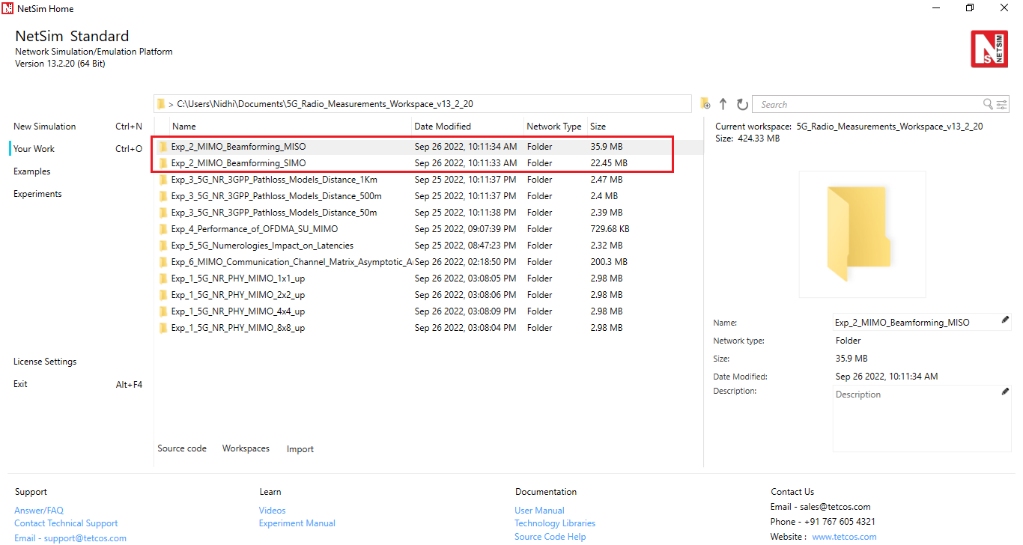

Fig 4: NetSim Your Work Window with the experiment folders inside the workspace

## Network Scenario:

NetSim UI would display the network topology shown in the screenshot below when you open the example configuration file.

Fig 5**:** Network topology in this experiment

## Part 1- MISO. Network Configuration:

The following parameters were configured in the network setup:

1. The gNB- Interface 5G_RAN were set with the following properties:

|  |  |  |
| --- | --- | --- |
| gNB- Interface 5G_RAN Parameters | | |
| gNB Height | 10m |
| Tx Power | 40 dBm |
| Duplex Mode | TDD |
| CA Type | SINGLE BAND |
| CA Configuration | n78 |
| DL: UL Ratio | 4:1 |
| Numerology | 0 |
| Channel Bandwidth (MHz) | 10 |
| Tx Antenna Count | Varied from 1 to 128 |
| Rx Antenna Count | 1 |
| MCS Table | QAM64 |
| CQI Table | TABLE1 |
| Pathloss Model | 3GPPTR38.901-7.4.1 |
| Outdoor Scenario | Urban Macro |
| LOS NLOS Selection | User Defined |
| LOS Probability | 0 (NLOS) |
| Shadow Fading Model | None |
| Fading and Beam Forming | RAYLEIGH with EIGEN Beamforming |
| Coherence Time (ms) | 10 |
| O2I Penetration Model | None |
| Additional Loss Model | None |

Table 1: gNB properties

1. The UE properties were configured with the following parameters:

|  |  |  |
| --- | --- | --- |
| UE Interface 5G RAN | | |
| Tx Power | 23 dBm |
| UE Height | 1.5m |
| Tx Antenna Count | 1 |
| Rx Antenna Count | 1 |

Table 2: UE properties

1. The wired link speed was set to 10 Gbps and the Uplink and Downlink BER were set to 0 in the wired links.
2. A downlink CBR application was configured from wired node to UE with Transport protocol as UDP and Packet Size of 1460 Bytes and Inter Arrival time of 179.69 µs and the Start Time was set to 1s[2].
3. Run simulation for 10s.

After the simulation, note down the Application Throughput obtained from the Application Metrics table in the NetSim Results dashboard. Similarly, note down the average Beamforming Gain in dB obtained for the DL application from the log file generated.

## Part 2- SIMO. Network Configuration:

1. Set all the properties same as part 1- MISO.
2. Set the Tx Antenna count in 5G RAN interface of gNB to 1.
3. Vary the Rx Antenna count in 5G RAN interface of UE from 1 to 16.
4. Run simulation for 10s.

After the simulation, note down the Application Throughput obtained from the Application Metrics table in the NetSim Results dashboard. Similarly, note down the average Beamforming Gain in dB obtained for the DL application from the log file generated.

**Simulation Output:**

Steps to calculate the Throughput, Beamforming Gain, SNR, Pathloss and CQI Index:

1. After the simulation, open NetSim Result dashboard and note down the throughput from the Application Metrics Table as shown below:

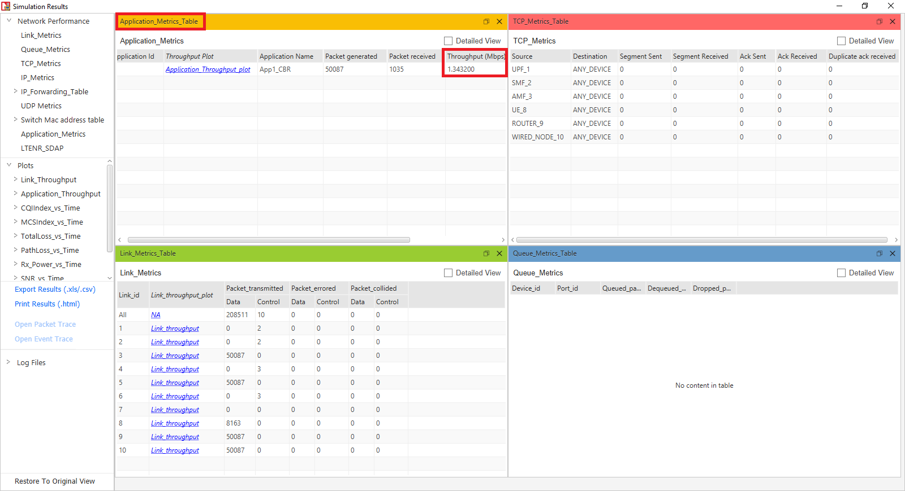

Fig 6: NetSim Results window showing Application Throughput obtained after the simulation.

1. In the results window, expand the Log Files option in the left panel and select 5G_LTE_Parameter_Log.csv file.

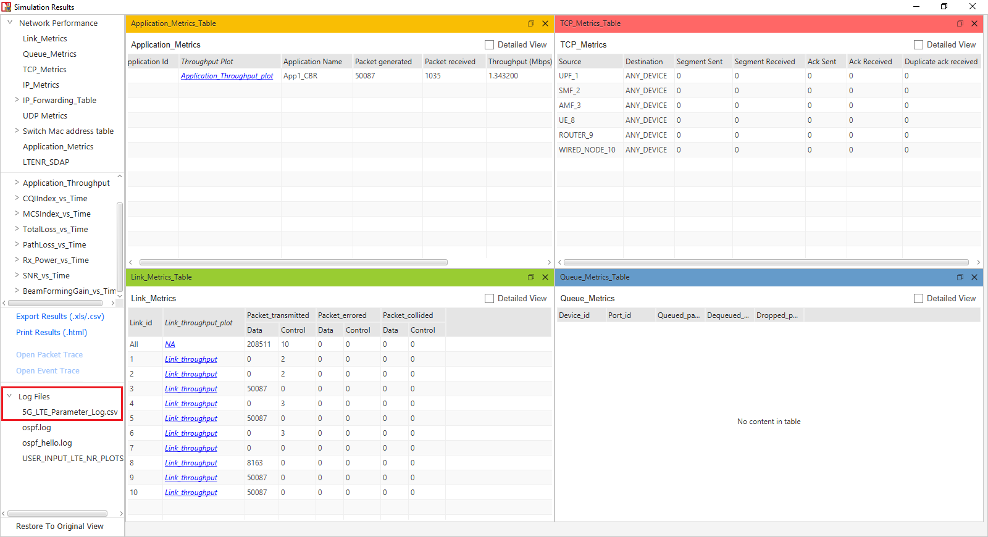

Fig 7: NetSim Results window showing access to log file generated.

1. This will open the csv file which logs the parameters beamforming gain, CQI and MCS Indices, Pathloss etc. over time as shown below.

Fig 8: 5G Parameter log file created after simulation.

1. Filter the Channel to only PUSCH and click on ok since we have considered a DL application from server to UE.

Fig 9: 5G Parameter log file showing the filtering process of DL/UL column.

1. Now select the Beamforming Gain column and note down the average Beamforming Gain in dB per layer.

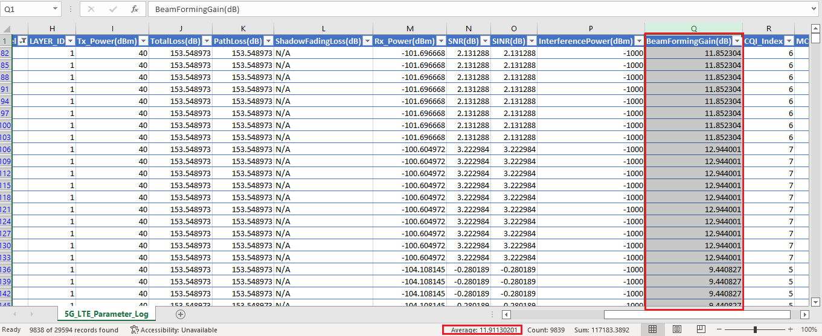

Fig 10: 5G Parameter log file showing average Beamforming Gain obtained.

1. Select the Pathloss column and note down the average pathloss value obtained.

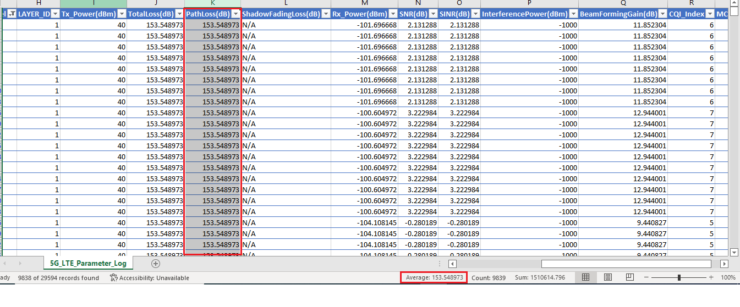

Fig 11: 5G Parameter log file showing average Pathloss obtained.

1. In the same way, select the SNR column and note down the average SNR obtained.

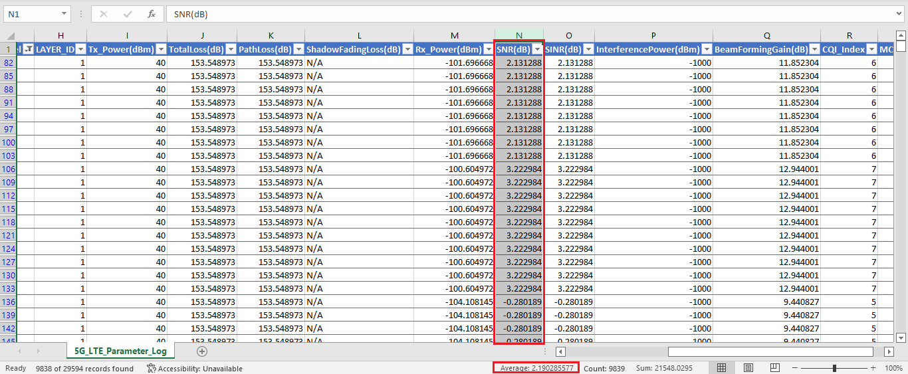

Fig 12: 5G Parameter log file showing average SNR obtained.

1. Similarly, calculate the average CQI Index.

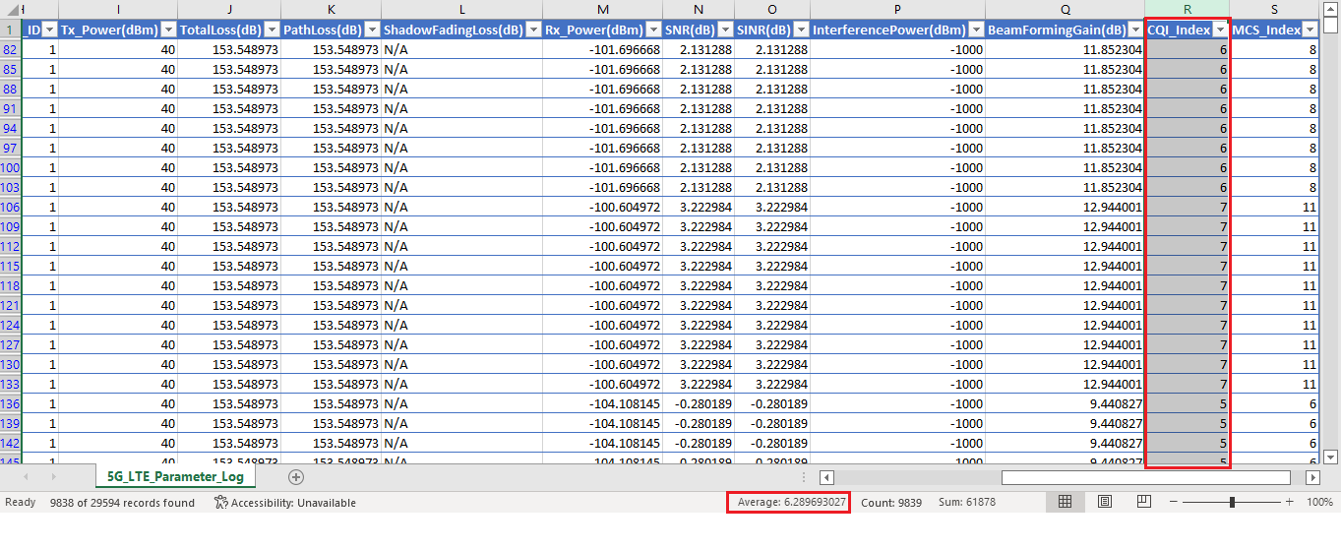

Fig 13: 5G Parameter log file showing average CQI Index obtained.

**Results**

**MISO: Varying Tx Antenna count in the gNB and 1 Rx Antenna in the UE**

|  |  |  |  |  |  |  |  |  |
| --- | --- | --- | --- | --- | --- | --- | --- | --- |
| gNB_Tx Antenna Count | UE_Rx Antenna Count | Throughput (Mbps) | Average Beam Forming Gain (dB). Number of layers = 1 | Upper bound for beam forming gain (dB) | Pathloss (dB) | Average SNR (dB) | Average  CQI  Index | Average MCS  Index |
| 1 | 1 | 0.18 | -2.27 | 0 | 153.54 | -11.99 | 0.63 | 0.35 |
| 2 | 1 | 0.77 | 1.70 | 3.01 | 153.54 | -8.01 | 1.49 | 0.85 |
| 4 | 1 | 1.98 | 5.41 | 6.02 | 153.54 | -4.30 | 2.89 | 2.08 |
| 8 | 1 | 3.78 | 8.66 | 9.03 | 153.54 | -1.06 | 4.40 | 4.83 |
| 16 | 1 | 6.64 | 11.91 | 12.04 | 153.54 | 2.19 | 6.28 | 9.00 |
| 32 | 1 | 10.28 | 14.98 | 15.05 | 153.54 | 5.26 | 7.94 | 12.89 |
| 64 | 1 | 14.83 | 18.04 | 18.06 | 153.54 | 8.32 | 9.95 | 17.84 |
| 128 | 1 | 19.32 | 21.05 | 21.07 | 153.54 | 11.33 | 11.39 | 20.78 |

Table 3: NetSim simulation output showing Throughput, Average beamforming gain and the upper bound (from Jensen’s inequality) on the beamforming gain for a channel.

**SIMO: Varying Rx Antenna count in the UE and 1 Tx Antenna in the gNB**

|  |  |  |  |  |  |  |  |  |
| --- | --- | --- | --- | --- | --- | --- | --- | --- |
| gNB_Tx Antenna Count | UE_Rx Antenna Count | Throughput (Mbps) | Average Beam Forming Gain (dB). | Upper bound for beam forming gain (dB) | Pathloss (dB) | Average SNR (dB) | Average  CQI Index | Average MCS Index |
| 1 | 1 | 0.18 | -2.27 | 0 | 153.54 | -11.99 | 0.63 | 0.35 |
| 1 | 2 | 0.77 | 1.70 | 3.01 | 153.54 | -8.01 | 1.49 | 0.85 |
| 1 | 4 | 1.98 | 5.41 | 6.02 | 153.54 | -4.30 | 2.89 | 2.08 |
| 1 | 8 | 3.78 | 8.66 | 9.03 | 153.54 | -1.06 | 4.40 | 4.83 |
| 1 | 16 | 6.64 | 11.91 | 12.04 | 153.54 | 2.19 | 6.28 | 9.00 |

Table 4: NetSim simulation output showing Throughput, Average beamforming gain and the upper bound (from Jensen’s inequality) on the beamforming gain for a MIMO channel. is limited to 16 since this is the maximum antenna count supported in UEs in NetSim.

Fig 14: NetSim simulation output showing variation in beamforming gain (dB) over the course of simulation. The beamforming gain changes every “coherence time”.

**Discussion**

From the tabulated results, we observe:

* An increase in beamforming gains as
  + increases in the MISO case, and as
  + increases in the SIMO case.
* The beamforming gain when varies (with fixed) is precisely the same as when varies (with fixed).

Next, we turn to the question a network engineer would be interested in: how does beamforming impact throughput? While link level simulators may perform the beamforming computations and provide the SNR at a link level, the power of a “system” level simulator like NetSim lies in its ability to compute the impact of link level factors (such as beamforming) on the system (or network). These computations are explained in an earlier experiment.

Since the distance between the gNB and UE is fixed, the common pathloss for all Tx-Rx antenna pairs is the same. This common pathloss value is factored (or “pulled out”) from the individual - path loss calculations. With this factorization done, the only parameter affecting SNR is the *channel fading*, the effect of which shows up in the output as *beamforming gain*. Quite simply as the (average) beamforming gain increases, the (average) SNR proportionally increases. Notice that every time the *antenna count is doubled* the *SNR increases by 3 dB* (which matches intuition). An increase in SNR improves the channel quality (the CQI), and thereby a higher modulation and coding scheme (MCS) is chosen for data transmission.

*Remark*. Note that these are “average” arguments: in practice, since the fading coefficients are random, one does not obtain a 3 dB improvement by doubling the number of antennas for every channel instantiation. Consequently, the improvement in the spectral efficiency (the reader should study and understand this terminology) is not exactly 1 bit/s/Hz on average. In other words, there is a difference between using the average SNR for computing the data rate versus computing the average data rate by averaging the rate obtained across different channel instantiations. The reader should carry out experiments with different values of and observe the variation in the rate obtained and understand this phenomenon.

Continuing from before the remark, from the MCS the PHY rate is calculated via the procedure for TBS determination per the 3GPP standard. Without getting into the details of these computations, the simplistic inference is that higher MCS leads to higher throughputs.

And finally, the underlying mathematics. The beamforming gains (in linear scale) are the Eigen values of the Wishart) matrix. In the MISO and SIMO cases the Wishart matrix has just one element, which itself is the eigenvalue, i.e., the beamforming gain is

Where are the elements of the Wishart matrix, and or as the case may be. Since

Since the standard deviation of an exponentially distributed random variable is the square of its mean, and since the are independent,

However, the beamforming gains output by NetSim are in dB (log) scale. How does one analytically verify its correctness? The answer lies in Jensen’s inequality. Since the log function is concave, Jensen’s inequality leads to

Here is the eigen value of the Wishart matrix, and is the beamforming gain in dB scale. Therefore, the beamforming gains (in the dB domain) are bounded as

In this experiment (and in NetSim), the number of antennas, N, is of the form ,where and therefore the upper bound on the beam forming gain is

**Exercises**:

1. Quantify the improvement in data rate as a function of (MISO) and (SIMO) in
   1. Low SNR case (SNR << 1), and
   2. High SNR case (SNR >> 1).
2. (For the Instructor or TA) Assign a set of *personalized* questions that will require each student to run the simulator and generate the results needed to write their reports. For example, different distances between the gNB and UE (which will vary the path loss), different Tx powers, different ranges for and , etc.

1. Users can refer to NetSim 5G NR user manual, section PHY implementation, for further details on the MIMO and Beamforming implementation in NetSim.
2. The application end time value of 10,000s is not changed. In NetSim the application runs for . Since the simulation is run for 10s, the application runs for only 10s.