# **Understanding 5G NR (3GPP) pathloss models**

## **Objective:**

In the elementary case of 1gNB communicating with 1UE over a 5G NR network, in a rural setting, we study the question: How does the UE-gNB pathloss vary with the distance between the UE and the gNB and the gNB height? What is the optimal height of a gNB?

## **Motivation:**

We start with a non-technical explanation of the objective. A mobile phone (in the hands of an individual) is the UE; the cell tower is the gNB. Assume the person is in a rural area and is outdoors. Pathloss would determine the signal strength displayed on the phone; a higher loss means a lower signal strength. Mobile network operators (think of the top service providers in our country) invest large sums in setting-up the towers. They wish to know the tower height[1] that gives users the highest signal strength. The answer is not obvious: the more the height of the gNB, the more likely it is that there exists a line-of-sight path to a given UE, but the signal has to traverse a longer distance, incurring a higher path loss. The cell radius might also play a role here: perhaps a lower height is better for smaller sized cells, and a greater height is better for large cells. In this experiment, we will understand these trade-offs.

## **The 5G pathloss equations:**

To answer these questions, we look at the 5G pathloss equations for a rural scenario as defined in the 3GPP 38.901 standards:

|  |  |  |  |  |  |
| --- | --- | --- | --- | --- | --- |
| Scenario | | LOS/ NLOS State | Pathloss (dB) $(f_{c}$ in GHz and d in meters) | Shadow Fading ( $σ)$ | Parameter values and ranges |
| Rural Macro | LOS | | $$P{L_{RMA}}_{LOS}=\left\{\begin{aligned}PL_{1}, 10m≤d_{2D}≤d_{BP} \\ PL_{2}, d_{BP}≤d_{2D}≤10Km\end{aligned}\right.$$ $PL_{1}=20\log_{10}\left(40πd_{3D}f_{c}/3\right)+\min\left(0.03h^{1.72},10\right)\log_{10}\left(d_{3D}\right)-\min\left(0.044h^{1.72}, 14.77\right)+ 0.002\log_{10}\left(h\right)d_{3D}$ $$PL_{2}=PL_{1}\left(d_{BP}\right)+40\log_{10}{(\frac{d_{3D}}{d_{BP}})}$$ | $$σ_{SF}=4$$ $$σ_{SF}=6$$ | $$h_{BS}=35m$$ $$h_{UT}=1.5m$$ $$W=20m$$ $$h=5m$$ $$5m≤h≤50m$$ $$5m≤W≤50m$$ $${10m≤h}_{BS}≤150m$$ $$1m≤h_{UT}≤10m$$ |
| NLOS | | $$P{L_{RMa}}_{NLOS}=max⁡(P{L_{RMa}}_{LOS} , P{L_{RMa}}_{NLOS}^{'})$$ For |  |
| NOTE:   1. Break point distance[2] , where fc is the centre frequency in Hz, $c=3.0*10^{8} m/s$  is the propagation velocity in free space, and hBS and hUT are the antenna heights at the BS and the UT, respectively.   1. fc denotes the centre frequency normalized by 1 GHz, all distance related values are normalized by 1 m, unless stated otherwise. | | | | | |

Table 1**:** Pathloss equations for Rural Macro environment for LOS and NLOS states

|  |  |
| --- | --- |
|  |  |
| Fig 1: Definition of d2D and d3D  for outdoor UEs | Fig 2: Definition of d2D-out, d2D-in  and d3D-out, d3D-in for indoor UEs |

Note that,

$${d_{3D}}_{out}+{d_{3D}}_{in}= \sqrt{{\left(d_{2D_{out}}+{d_{2D}}_{in}\right)}^{2}+{\left(h_{BS}-h_{UT}\right)}^{2} }$$

Observing the above equations, we see that the pathloss is not a simple expression in terms of gNB height. The other parameters affecting the pathloss are a) the UE-gNB 2D distance and b) the UE state[3].

Consequently, we investigate the revised question: how does the UE-gNB pathloss vary for *combinations* of gNB height, UE-gNB 2D distance, and UE states (LOS/NLOS)?

## **Procedure:**

1. Use the following download Link to download a compressed zip folder which contains the workspace [GitHub link](https://github.com/NetSim-TETCOS/5G_Experiments_v13_2_20/archive/refs/heads/main.zip%20)
2. Extract the zip folder.
3. The extracted project folder consists of a NetSim workspace file 5G_advanced_experiments_with_NetSim.netsimexp.
4. Go to NetSim Home window, go to Your Work and click on Import.

Fig 3: NetSim Home Window

1. In the Import Workspace Window, browse and select the 5G_advanced_experiments_with_NetSim.netsimexp file from the extracted directory. Click on create a new workspace option and browse to select a path in your system where you want to set up the workspace folder.
2. Choose a suitable name for the workspace of your choice. Click Import.

Fig 4: NetSim Import workspace window

1. The Imported Project workspace will automatically be set as the current workspace.
2. The list of experiments is now loaded onto the selected workspace.

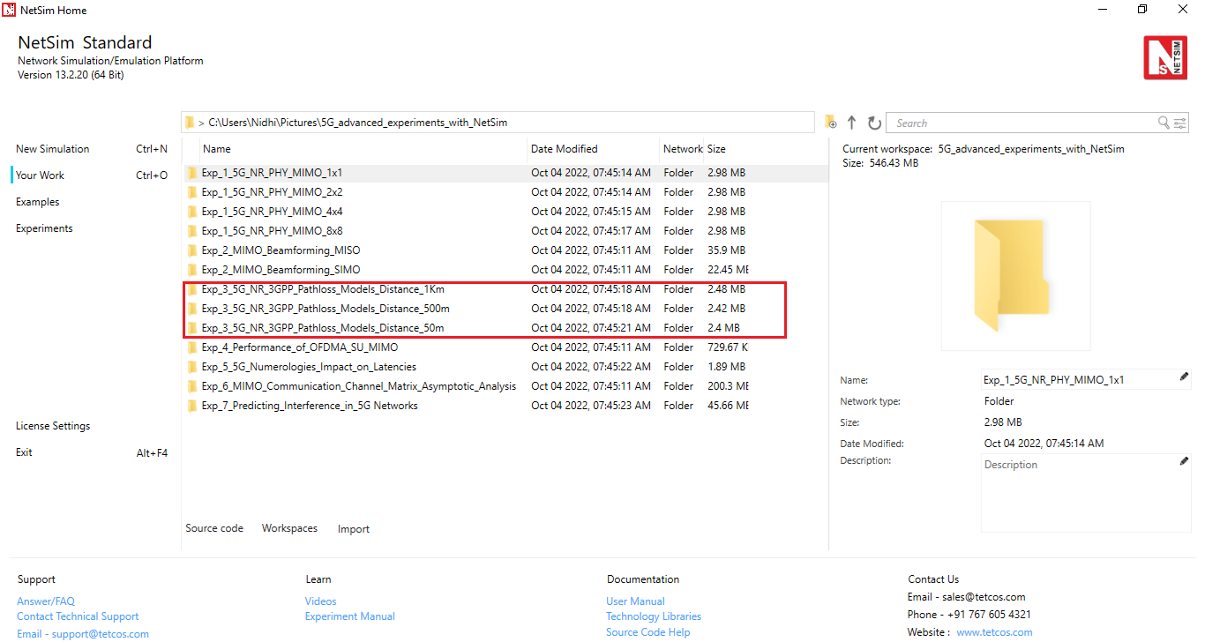

Fig 5: NetSim Your Work Window with the experiment folders inside the workspace

## **Network scenario:**

NetSim UI would display the following network topology when you open the example configuration file as shown below screenshot.

Fig 6**:** Network topology in this experiment

## **Settings:**

The following settings were configured in the network setup.

1. The UE was placed 50m away from the gNB.
2. The following properties were set in Interface 5G RAN, Physical Layer of gNB.

|  |  |
| --- | --- |
| gNB Interface 5G RAN | |
| gNB Height (m) | Varied from 10 to 150 |
| Tx Power (dBm) | 40 |
| Tx Antenna Count | 2 |
| Rx Antenna Count | 2 |
| CA Type | Single Band |
| CA Configuration | n78 |
| DL: UL Ratio | 4:1 |
| F_Low (MHz) | 3300 |
| F_High (MHz) | 3800 |
| Central Frequency (MHz) | 3550 |
| Numerology | 0 |
| Channel Bandwidth (MHz) | 10 |
| MCS Table | QAM64 |
| CQI Table | TABLE1 |
| Outdoor Scenario | Rural Macro |
| Indoor Office Type | Mixed Office |
| Pathloss Model | 3GPPTR38.901-7.4.1 |
| LOS Mode | User Defined |
| LOS Probability | 0 or 1 |
| Shadow Fading Model | None |
| Fading and Beamforming | No Fading |
| O2I Building Penetration Model | LOW LOSS MODEL |

Table 2**:** gNB properties

1. Tx Antenna Count = Rx Antenna Count = 2 in UE > Interface 5G RAN > Physical Layer
2. A downlink CBR application was configured from Wired Node to UE with Packet Size 1460B and IAT 1168µs and the start time was set to 1s.
3. Run simulation for 2s.
4. In Case 2, set the LOS probability to 0 and run simulation for various gNB heights.
5. In case 3, place the UE 1000m away from the gNB and repeat the above procedure.
6. In case 4, set the LOS probability to 0 and run simulation for 2s.
7. After the simulation, note down the Pathloss from the log file generated for various gNB heights.

## **Results:**

1. After simulation, open 5G Parameter Log file from NetSim Result dashboard.Graphical user interface, table

   Description automatically generated

Fig 7**:** NetSim Results window

1. Note down the Pathloss value for each gNB height setting

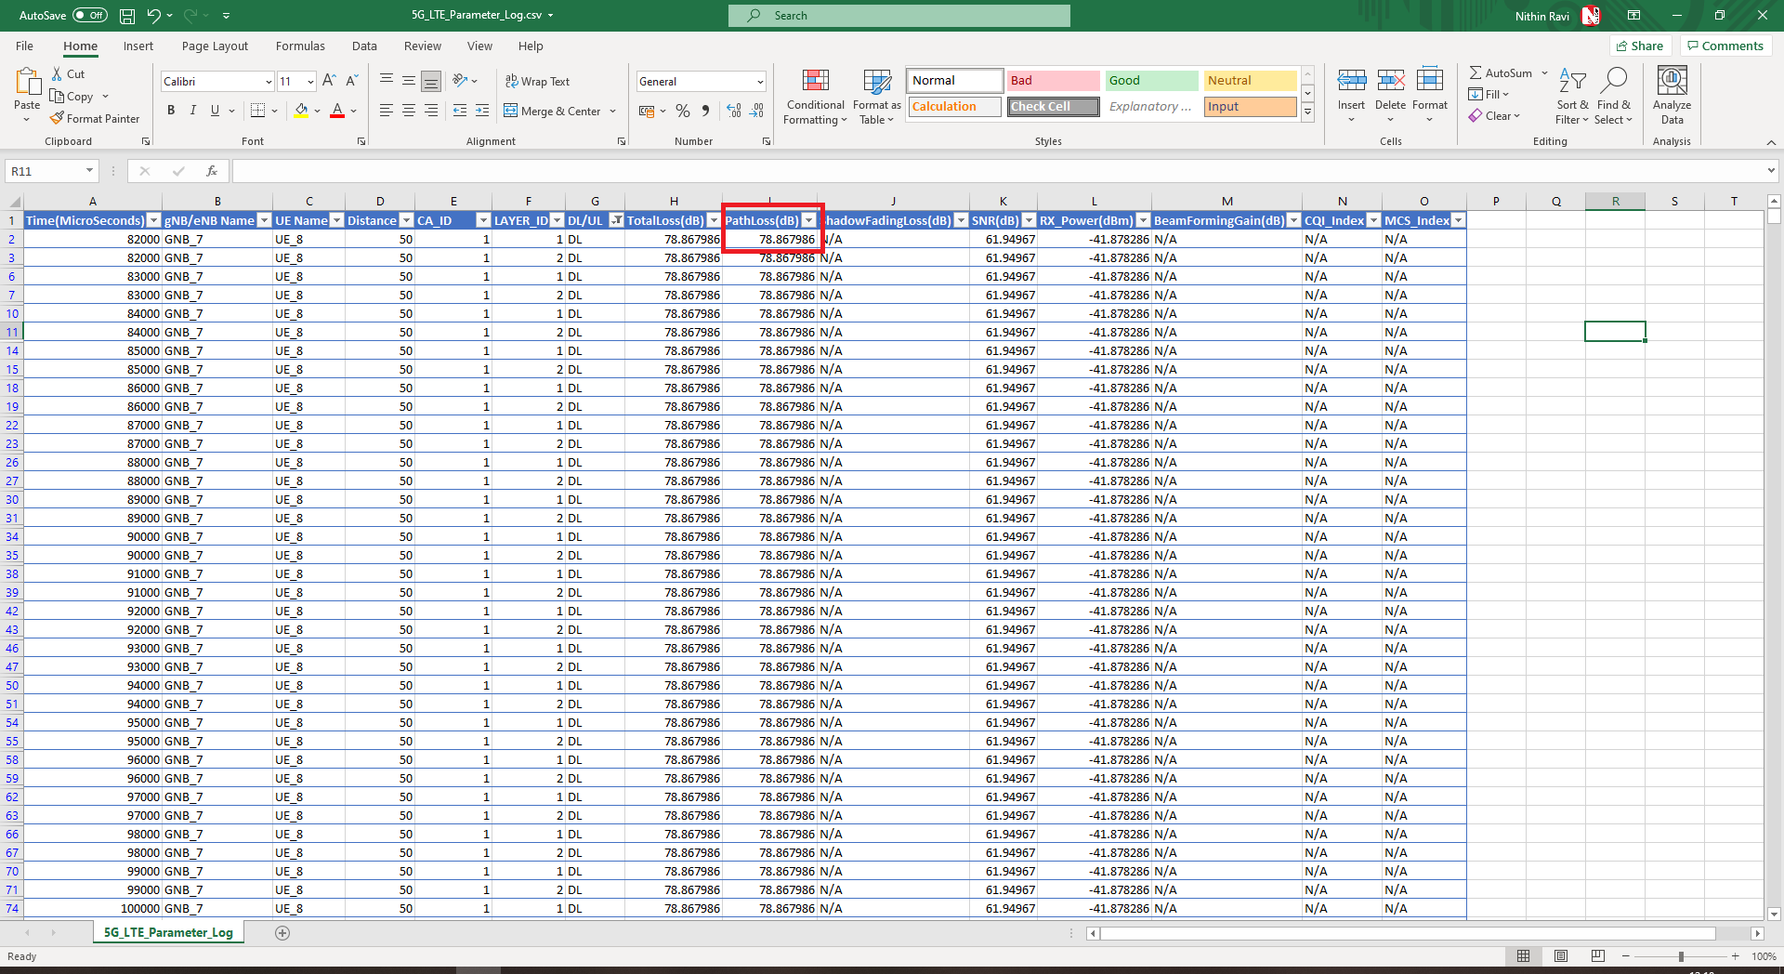

Fig 8**:** NetSim 5G Log file

Upon running simulations, we can obtain the following table below which contains pathloss values for:

* gNB height varying from 10m to 150m in steps of 20m.
* UE placed at 50m, 500m and 1000m away from gNB, and
* UE states: LOS, NLOS

|  |  |  |  |  |  |  |  |
| --- | --- | --- | --- | --- | --- | --- | --- |
| gNB Height(m) | | Pathloss (dB) | | | | | |
|  | UE 50m, LOS | | UE 50m, NLOS | UE 500m, LOS | UE 500m, NLOS | UE 1 km, LOS | UE 1km, NLOS |
| 10 | 77.73 | | 92.39 | 98.71 | 132.47 | 105.57 | 144.60 |
| 30 | 78.86 | | 84.04 | 98.72 | 120.53 | 105.58 | 132.21 |
| 50 | 80.58 | | 82.56 | 98.75 | 115.30 | 105.58 | 126.72 |
| 70 | 82.35 | | 82.72 | 98.80 | 111.92 | 105.60 | 123.15 |
| 90 | 83.98 | | 83.98 | 98.86 | 109.45 | 105.61 | 120.51 |
| 110 | 85.44 | | 85.44 | 98.93 | 107.52 | 105.63 | 118.41 |
| 130 | 86.75 | | 86.75 | 99.02 | 105.95 | 105.66 | 116.67 |
| 150 | 87.91 | | 87.91 | 99.11 | 104.66 | 105.68 | 115.20 |

Table 3**:** Pathloss values for various combinations. The gNB heights are shown in Column 1. Other columns shows the gNB-UE 2D distance (50m, 500m and 1Km) and the UE state (LOS/NLOS)

## **Numerical verification of two cases:**

In this section we numerically calculate the pathloss per the 5G pathloss formula for two cases to verify NetSim’s output.

|  |  |  |  |
| --- | --- | --- | --- |
| Symbol | Description | | Value |
| $$d_{BP}$$ | | $$Breakpoint distance$$ |  |
| $$h_{BS}$$ | | $$Height of Base Station$$ | $$10m$$ |
| $$h_{UT}$$ | | $$Height of UE$$ | $$1.5m$$ |
| $$f_{c}$$ | | $$Central Frequency in Hz$$ | $$3550*{10}^{6}Hz=3.55GHz$$ |
| $$c$$ | | $$Speed of light$$ | $$3*{10}^{8}m/s$$ |
| $$W$$ | | $$Street width$$ | $$20m$$ |
| $$h$$ | | $$Building Height$$ | $$5m$$ |

Table 4: Various parameters used in the pathloss calculations and their values

**Case 1: gNB height = 10m, UE State is LOS and UE-gNB 2D Distance = 50m**

Breakpoint Distance:

$f_{c}=\frac{F_{Low}+F_{High}}{2}$ $=\frac{3300+3800}{2}=3550 MHz=3550*{10}^{6}Hz$

$$d_{Bp}=2* π*h_{BS}*h_{UT}*(f_{c}* 1000000000) / c)$$

$$d_{BP}=2*3.14*10*1.5*\left(\frac{3.55*1000000000}{3*{10}^{8}}\right)=1114.7m$$

Pathloss Calculation

$d_{2D}=50m$, $d_{3D}=\sqrt{{\left(d_{2D}\right)}^{2}+{\left(H_{BS}-H_{UT}\right)}^{2}}$ $= \sqrt{{\left(50\right)}^{2}+{\left(10-1.5\right)}^{2}}=50.71m$

If $(10≤d_{2D}≤d_{BP})$

$PL1 = (20 * log10(40 * PI * distance3D * fc_{(GHz)} / 3)) + fmin((0.03 * pow(h, 1.72)), 10) * log10(distance3D) - fmin((0.044 * pow(h, 1.72)), 14.77) + (0.002 * log10(h) * distance3D)$

$=\left(20*log_{10}\left(40*3.14*50.71*\frac{3.55}{3}\right)\right)+f_{min}\left(\left(0.03*pow\left(5,1.72\right)\right),10\right)*log_{10}\left(50.71\right)-f_{min}\left(\left(0.044*pow\left(5,1.72\right)\right),14.77\right)+\left(0.002*log_{10}\left(5\right)*50.71\right)=77.73 dB$

Pathloss = 77.73 dB (matches NetSim result)

**Case 2: gNB height = 10m, UE State is NLOS and UE-gNB 2D Distance = 50m**

Breakpoint Distance:

$f_{c}=\frac{F_{Low}+F_{High}}{2}$ $=\frac{3300+3800}{2}=3550 MHz=3550*{10}^{6}Hz$

$$d_{Bp}=2* π*h_{BS}*h_{UT}*(f_{c}* 1000000000) / c)$$

$$d_{BP}=2*3.14*10*1.5*\left(\frac{3.55*1000000000}{3*{10}^{8}}\right)=1114.7m$$

Pathloss Calculation

$$d_{2D}=50m$$

$d_{3D}=\sqrt{{\left(d_{2D}\right)}^{2}+{\left(H_{BS}-H_{UT}\right)}^{2}}$ $= \sqrt{{\left(50\right)}^{2}+{\left(10-1.5\right)}^{2}}=50.71m$

If $(10≤d_{2D}≤5Km)$

$$PL_{NLOS} = max⁡(PL_{LOS}, PL_{NLOS}^{'})$$

Where,

$PL_{NLOS}^{'}=161.04-7.1{* log}_{10}\left(W\right)+7.5*\log_{10}\left(h\right)-\left(24.37-3.7*{\left(\frac{h}{h_{BS}}\right)}^{2}\right)*\log_{10}\left(h_{BS}\right)+(43.42-(3.1*\log_{10}{(h_{BS}))*(\log_{10}\left(d_{3D}\right)-3)+20*(\log_{10}{(f_{c}))-(3.2*(\log_{10}{{\left(11.75*h_{UT})\right)}^{2}}} -4.97)}$

$=161.04-(7.1*\log_{10}{(20))+7.5*(\log_{10}\left(5\right))-(24.37-3.7*{\left(\frac{5}{10}\right)}^{2})*(\log_{10}{(10))}+(43.42-(3.1*\log_{10}{(10))*(\log_{10}\left(50.71\right)-3)+20*(\log_{10}{(3.55))-(3.2*(\log_{10}{{\left(11.75*1.5)\right)}^{2}-4.97)=92.39 dB }}}}$

$PL_{LOS} = (20 * log10(40 * PI * distance3D * fc_{(GHz)} / 3)) + fmin((0.03 * pow(h, 1.72)), 10) * log10(distance3D) - fmin((0.044 * pow(h, 1.72)), 14.77) + (0.002 * log10(h) * distance3D)$

$=\left(20*log_{10}\left(40*3.14*50.71*\frac{3.55}{3}\right)\right)+f_{min}\left(\left(0.03*pow\left(5,1.72\right)\right),10\right)*log_{10}\left(50.71\right)-f_{min}\left(\left(0.044*pow\left(5,1.72\right)\right),14.77\right)+\left(0.002*log_{10}\left(5\right)*50.71\right)=77.73 dB$ $$PL_{NLOS} = max⁡(PL_{LOS}, PL_{NLOS}^{'}) =max⁡(77.73,92.39)$$

Pathloss = 92.39 dB (matches NetSim result)

Fig 9: Plots of Pathloss vs. gNB height for different UE-gNB 2D Distances and UE States (LOS, NLOS)

## **Discussion:**

We explain the results in the plots above from the specifics of the pathloss formulas.

* In the LOS plots, the pathloss is flat for different gNB heights when the gNB-UE distance is high, i.e 500m and 1 km. When the gNB-UE distance is low i.e 50m, the pathloss increases with gNB height.
* Observe from the LOS pathloss formula that pathloss is proportional to $\log{(D_{3d})}$. $D_{3d}$ of the 3D distance between the UE and the gNB and is defined as $d_{3D}=\sqrt{{\left(d_{2D}\right)}^{2}+{\left(h_{BS}-h_{UT}\right)}^{2}}$. It is the hypotenuse of the right triangle with the base being the gNB-UE 2D distance.
  + Since the length of the hypotenuse is sensitive to the height of the triangle, when the base is small, we see the pathloss increasing with gNB height when the UE is 50m away.
  + Inversely, the length of the hypotenuse is almost insensitive to the triangle height when the base is much larger than the height. Therefore, when the UE is far, the gNB’s height does not have a noticeable impact. Pathloss is flat when the UE is 500m and 1 km away.
* Let us turn to the NLOS results.
  + The NLOS pathloss decreases with gNB height when the gNB-UE distance is high i.e 500m and 1000m.
  + When the UE is near, i.e 50m, the NLOS pathloss first decreases and then increases with gNB height.
  + The reason for this kind of variation is the NLOS pathloss formulas in which that pathloss has terms proportional to:
    - $\log\left(h_{BS}\right)$, ${\log{(\left(h_{BS}\right)}}^{2})$
 $\log{(d_{3d})}$

   - The reciprocal of ${\left(h_{BS}\right)}^{2}$
* We see that at larger distances LOS pathloss is almost flat and NLOS pathloss decreases, as gNB height increases. From the plots one sees that the optimal gNB height would be between 125m to 150m in the example discussed above.

## **Exercises:**

1. Make a separate plot with the UE distance on the X-axis and show the behavior for three different values of the gNB height. Recommend the gNB height for different cell radii. Does your recommendation make practical sense?
2. Use MATLAB or Python to plot similar curves from the standard pathloss formulas. Compare your results against the NetSim results.
3. (For the Instructor or TA) Generate *personalized* exercises where the student can be asked to
   1. Recommend the gNB height given the cell radius
   2. Recommend gNB height given the transmit power.
   3. Find the cell radius given the gNB height, transmit power and noise figure.

1. The antenna can be placed at different heights on the cell tower. Hence the term “Antenna height” would be technically precise.
2. A question for the reader: Why is it called break point?
3. Can the UE directly see the gNB? If yes, it is in a Line-of-sight (LOS) state and if not, it is in the NLOS state.