# **Performance of OFDMA SU-MIMO in 5G**

The 5G cellular system utilizes OFDMA MIMO technology at the physical layer. This technology permits degrees of freedom in frequency, time, and “space” for multiplexing the data of multiple users. Let us consider the down-link direction, i.e., from the base-station (gNB) to the users (UE). The system bandwidth (e.g., 100 MHz), has several OFDM carriers, separated by a carrier spacing (e.g., 60 KHz, yielding 132 physical resource blocks (PRBs) or carriers). Each PRB has 12 consecutive sub carriers. These carriers (set of usable PRBs) have time-division framing (e.g., 0.25 ms), each frame carrying 14 symbols of which 18% on average is modeled as overheads in NetSim. When the above system is used to carry data to multiple users, it is called OFDMA. In addition, MIMO technology exploits spatial multiplexing, thereby effectively carrying multiple (spatially multiplexed) symbols for each time-symbol in the OFDM carrier. In MIMO all the spatially multiplexed symbols for an OFDM symbol can be destined to one user, in which case it is called Single User MIMO, or SU-MIMO.

In this experiment we study the performance of OFDMA along with SU-MIMO to carry downlink data to multiple UEs. Since we have SU-MIMO, multiple users are multiplexed by OFDMA, and SU-MIMO is used to obtain spatial multiplexing gain, depending on the number of antennas available at the UE. In Multi User MIMO (MU-MIMO) different spatial layers within the same resource block, can be allotted to different UEs.

## **Objective:**

Simulate a maximum data transmission rate[1], using OFDMA and SU-MIMO, for the following 4 cases

* 1 gNB with 8 Tx antennas transmitting to 1 UE with 8 Rx antennas using all the 132 resource blocks
* 1 gNB with 8 Tx antennas transmitting to 2 UEs each with 4 Rx antennas, each using $\frac{132}{2}$ resource blocks on average
* 1 gNB with 8 Tx antennas transmitting to 4 UEs each with 2 Rx antennas, each using $\frac{132}{4}$ resource blocks on average,
* 1 gNB with 8 Tx antennas transmitting to 8 UEs each with 1 Rx antennas, each using $\frac{132}{8}$ resource blocks on average

Repeat the above cases with the number of UEs now set to 1 for each case, while the antenna counts remain the same. Show that there is no difference in maximum capacity between a single user and a multi-user transmission, when using SU-MIMO. And finally, explain the results obtained for different number of receive antennas by using matrix theory to compute the eigen values of the associated Gram matrices.

## **Introduction:**

We begin with a description of the channel model. Consider a transmitter with $N_{t}$ transmit antennas, and a receiver with $N_{r}$ receive antennas. The channel can be represented by the $N_{r}×N_{t}$ matrix $H$ of channel gains $h_{ij}$ representing the gain from transmit antenna $j$ to receive antenna $i.$ The $N_{r} × 1$ received signal $y$ is equal to

$$y = Hx + n$$

The channel state information is the channel matrix $H$ and/or its distribution.

Under rich scattering conditions the MIMO channel can be decomposed into parallel non-interfering channels. The number of such parallel streams is known as the layer count and is equal to $Min(N_{t}, N_{r})$. These parallel channels are commonly referred to as the *eigenmodes* of the channel because the singular values of $H$ are equal to the square root of the eigenvalues of the Wishart matrix $W=H H^{†}$ (for $N_{t}≥N_{r}$).

Since each layer is reduced to a flat fading SISO channel, i.e., for layer $j, 1≤j≤LayerCount$,

$$y_{j}=\sqrt{λ_{j}} x_{j}+w_{j}$$

where, $x_{j}$ is the symbol transmitted, $λ_{j}$ is the corresponding eigenvalue of the Wishart matrix obtained as in the previous section, $w_{j}$ is circular symmetric complex Gaussian noise, and $y_{j}$ is the complex valued baseband received symbol.

If fast fading with eigen-beamforming is enabled in NetSim’s GUI, then the MIMO link is modelled by parallel SISO channels with the symbol level beamforming gain derived from the eigenvalues[2] of the Wishart matrix.

$$BeamFormingGain (dB)=10\log_{10}{(λ)}$$

Three assumptions made in NetSim are:

1. Perfect CSIT and CSIR: The channel matrix $H$ is assumed to be known perfectly, at the start of each frame, at the transmitter and receiver, respectively. With perfect CSIT the transmitter can adapt its transmission rate (MCS) relative to the instantaneous channel state (SNR).
2. No channel errors.
3. The transmit power is equally split between all layers transmitted. The justification lies in the fact that at a high SNR, (iterative) water-filling will lead to nearly equal power allocation across all subcarriers and all layers.

Note that the *LOS probability* parameter in NetSim is solely used to compute the large scale pathloss per the 3GPP 38.901 standard. This parameter is not used in the channel rank (MIMO layers) computations. The *Fading and Beam Forming* parameter is used to determine (i) the number of MIMO layers and (ii) the gains in each layer, as shown in the table below.

|  |  |  |
| --- | --- | --- |
| **Parameter drop down option** | **No. of MIMO layers** | **Beamforming Gain** |
| No fading MIMO unit gain | Min ${(N}_{t}, N_{r})$ | Unity (0 dB) |
| No fading MIMO array gain | Min ${(N}_{t}, N_{r})$ | Max ${(N}_{t}, N_{r})$ |
| Rayleigh with Eigen Beamforming | Min ${(N}_{t}, N_{r})$ | Eigen values of the Wishart Matrix |

## **Procedure:**

1. Use the following download Link to download a compressed zip folder which contains the workspace: [GitHub link](https://github.com/NetSim-TETCOS/5G_Experiments_v13_2_20/archive/refs/heads/main.zip%20)
2. Extract the zip folder.
3. The extracted project folder consists of a NetSim workspace file 5G_advanced_experiments_with_NetSim.netsimexp
4. Go to NetSim Home window, go to Your Work and click on Import.

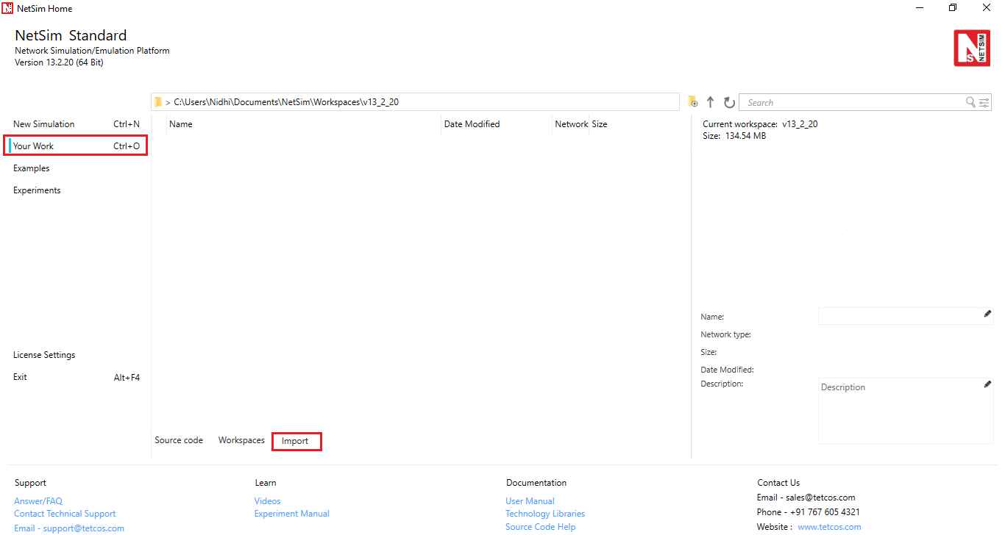

Fig 1: NetSim Home Window

1. In the Import Workspace Window, browse and select 5G_advanced_experiments_with_NetSim.netsimexp file from the extracted directory. Click on create a new workspace option and browse to select a path in your system where you want to set up the workspace folder
2. Choose a suitable name for the workspace of your choice. Click Import.

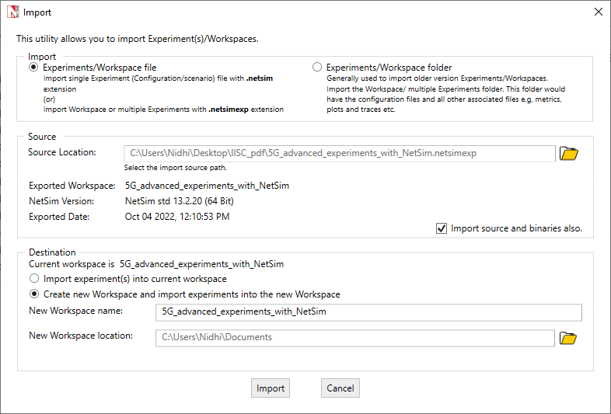

Fig 2: NetSim Import workspace window

1. The Imported Project workspace will automatically be set as the current workspace.
2. The list of experiments is now loaded onto the selected workspace.

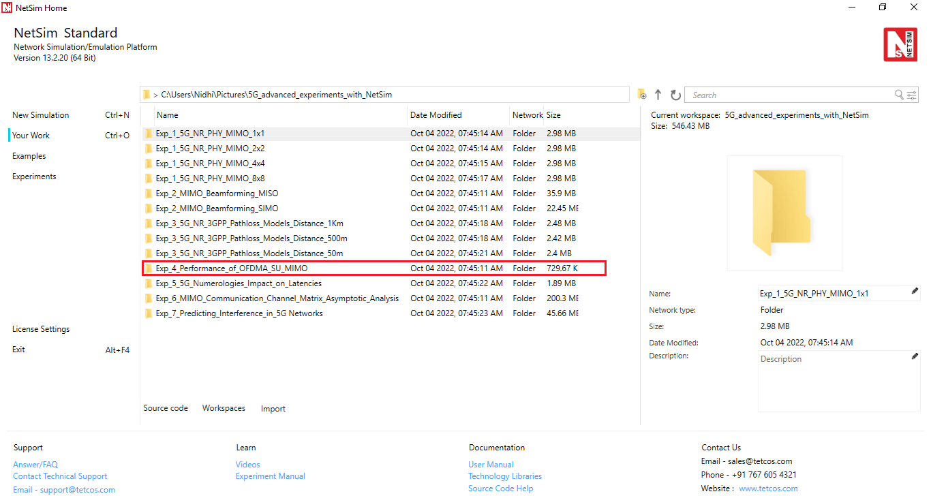

Fig 3: NetSim Your Work Window with the experiment folders inside the workspace

## **NetSim Settings:**

1. The following parameters were configured in Interface 5G RAN- Physical Layer of gNB and UE:

|  |  |
| --- | --- |
| gNB- Interface 5G_RAN Parameters | |
| gNB Height | 10m |
| Tx Power | 40 dBm |
| Duplex Mode | TDD |
| CA Type | SINGLE BAND |
| CA Configuration | n78 |
| DL: UL Ratio | 4:1 |
| Numerology | 2 |
| Channel Bandwidth (MHz) | 100 |
| Tx Antenna Count | 8 |
| Rx Antenna Count | 1 |
| MCS Table | QAM256 |
| CQI Table | TABLE2 |
| Pathloss Model | 3GPPTR38.901-7.4.1 |
| Outdoor Scenario | Urban Macro |
| LOS NLOS Selection | User Defined |
| LOS Probability | 1 |
| Shadow Fading Model | None |
| Fading and Beam Forming | RAYLEIGH with EIGEN Beamforming |
| Coherence Time (ms) | 10 |
| O2I Penetration Model | None |
| Additional Loss Model | None |
| UE Interface 5G RAN | |
| Tx Power | 23 dBm |
| UE Height | 1.5m |
| Tx Antenna Count | 1 |
| Rx Antenna Count | <varied> |

Table 1: gNB and UE properties

1. The following parameters were configured in the wired link properties:

|  |  |
| --- | --- |
| Wired Link Parameters | |
| Wired Link Speed | 10 Gbps |
| Wired Link BER | 0 |
| Wired Link Propagation Delay | 5 µs |

Table 2: Wired link properties

1. Run simulation for 1.1s.

**Case 1: 1 gNB - 8 Tx antennas, 1 UE - 8 Rx antennas**

**Network Scenario:**

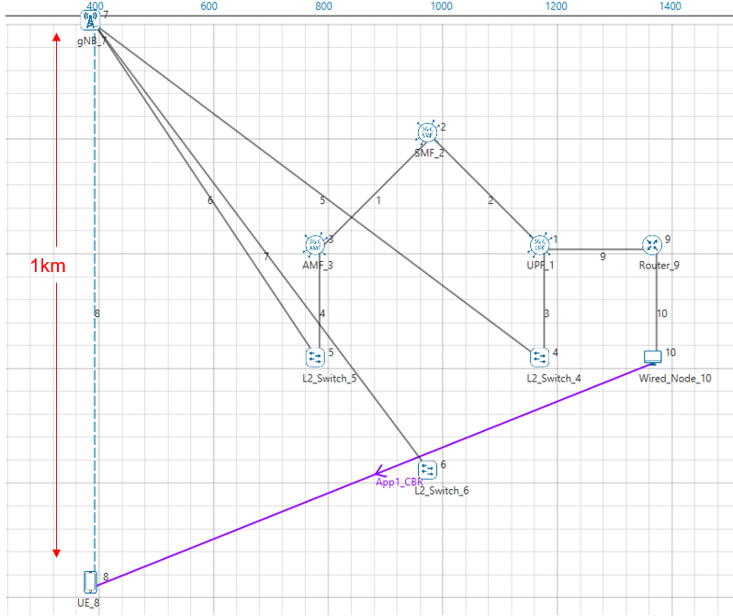

Fig 4: Network topology in this experiment

**Additional Settings:**

1. The Tx Antenna Count was set to 1 and Rx Antenna Count was set to 8 in Interface 5G RAN- Physical Layer in the UE
2. The following parameters were set in Application Properties:

|  |  |
| --- | --- |
| Application Parameters | |
| Application | CBR |
| Packet Size | 1460 |
| Inter Packet Arrival Time (µs) | 3.33 |
| Start Time | 1 |
| Transport Protocol | UDP |

Table 3: Application properties

**Result:**

|  |  |
| --- | --- |
| Application | Throughput (Mbps) |
| App_1_CBR | 1909.09 |

Table 4: Throughput obtained per UE

**Case 2: 1 gNB- 8 Tx antennas, 2 UEs with 4 Rx antennas each**

**Network Scenario:**

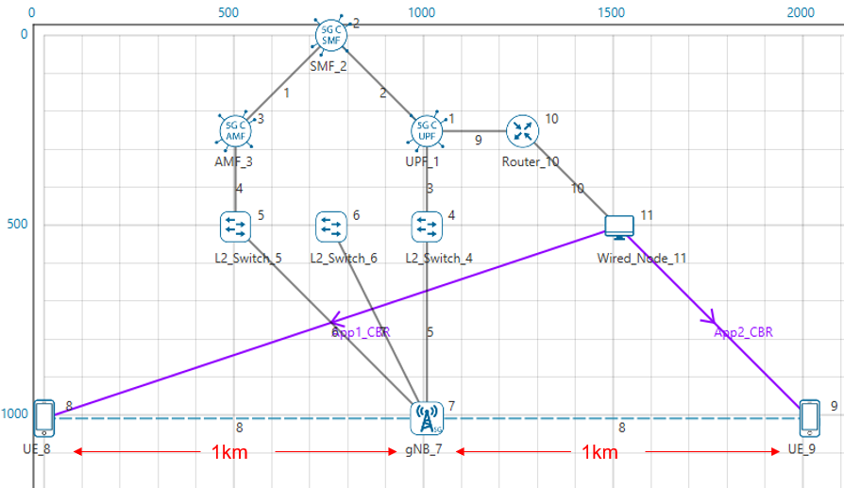

Fig 5: Network topology in this experiment

**Additional Settings:**

1. The Tx Antenna Count was set to 1 and Rx Antenna Count was set to 4 in Interface 5G RAN- Physical Layer in both the UEs.
2. The following parameters were set in Application Properties:

|  |  |  |
| --- | --- | --- |
| Application Parameters | | |
|  | Wired Node- UE_8 | Wired Node- UE_9 |
| Application | CBR | CBR |
| Packet Size | 1460 | 1460 |
| Inter Packet Arrival Time (µs) | 12.97 | 12.97 |
| Start Time | 1 | 1 |
| Transport Protocol | UDP | UDP |

Table 5: Application properties

**Result:**

|  |  |  |
| --- | --- | --- |
| Throughput Obtained (Mbps) | |  |
| UE_8 | UE_9 | Aggregate Throughput (Mbps) |
| 666.92 | 673.35 | 1340.28 |

Table 6: Throughput obtained per uE

**Case 3: 1 gNB 8- Tx antennas, 4 UEs with 2 Rx antennas each**

**Network scenario:**

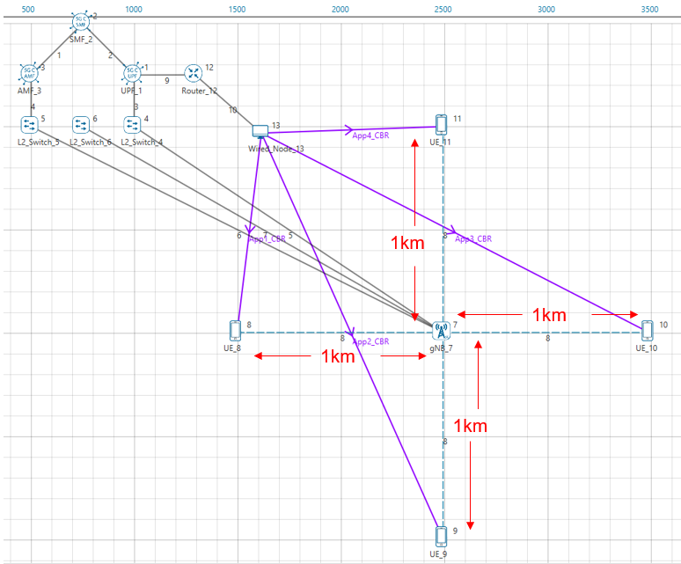

Fig 6: Network topology in this experiment

**Additional Settings:**

1. The Tx Antenna Count was set to 1 and Rx Antenna Count was set to 2 in Interface 5G RAN- Physical Layer in all the UEs.
2. The following parameters were set in Application Properties:

|  |  |  |  |  |
| --- | --- | --- | --- | --- |
| Application Parameters | | | | |
|  | Wired Node- UE_8 | Wired Node- UE_9 | Wired Node- UE_10 | Wired Node- UE_11 |
| Application | CBR | CBR | CBR | CBR |
| Packet Size | 1460 | 1460 | 1460 | 1460 |
| Inter Packet Arrival Time (µs) | 53.09 | 53.09 | 53.09 | 53.09 |
| Start Time | 1 | 1 | 1 | 1 |
| Transport Protocol | UDP | UDP | UDP | UDP |

Table 7: Application properties

**Result:**

|  |  |  |  |  |
| --- | --- | --- | --- | --- |
| Throughput (Mbps) | | | |  |
| UE_8 | UE_9 | UE_10 | UE_11 | Aggregate  Throughput (Mbps) |
| 187.81 | 196.10 | 190.26 | 197.27 | 771.464 |

Table 8: Throughputs obtained per UE

**Case 4: 1 gNB 8 tx antennas, 8 UEs with 1 Rx antennas each**

**Network Scenario:**

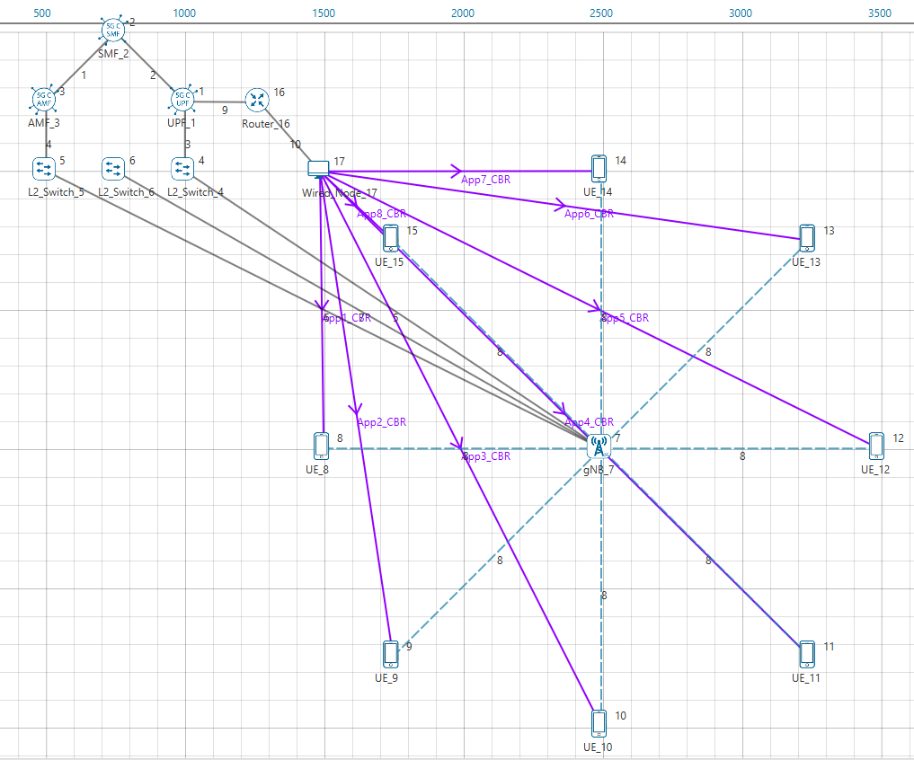

Fig 7: Network topology in this experiment

**Additional Settings:**

1. The Tx Antenna Count was set to 1 and Rx Antenna Count was set to 1 in Interface 5G RAN- Physical Layer in all the UEs.
2. The following parameters were set in Application Properties:

|  |  |  |  |  |  |  |  |  |
| --- | --- | --- | --- | --- | --- | --- | --- | --- |
| Application Parameters | | | | | | | | |
|  | Wired Node- UE_8 | Wired Node- UE_9 | Wired Node- UE_10 | Wired Node- UE_11 | Wired Node- UE_12 | Wired Node- UE_13 | Wired Node- UE_14 | Wired Node- UE_15 |
| Application | CBR | CBR | CBR | CBR | CBR | CBR | CBR | CBR |
| Packet Size | 1460 | 1460 | 1460 | 1460 | 1460 | 1460 | 1460 | 1460 |
| Inter Arrival Time (µs) | 212.36 | 212.36 | 212.36 | 212.36 | 212.36 | 212.36 | 212.36 | 212.36 |
| Start Time | 1 | 1 | 1 | 1 | 1 | 1 | 1 | 1 |
| Transport Protocol | UDP | UDP | UDP | UDP | UDP | UDP | UDP | UDP |

Table 9: Application properties

**Results:**

|  |  |  |  |  |  |  |  |  |
| --- | --- | --- | --- | --- | --- | --- | --- | --- |
| Throughput Obtained (Mbps) | | | | | | | |  |
| UE_8 | UE_9 | UE_10 | UE_11 | UE_12 | UE_13 | UE_14 | UE_15 | Aggregate Throughput (Mbps) |
| 52.20 | 50.69 | 52.20 | 52.09 | 51.50 | 50.92 | 51.39 | 50.69 | 411.72 |

Table 10: Throughputs obtained per UE

## **Discussion**:

We combine the results of the four cases and present it in the table below.

|  |  |  |  |  |  |  |  |  |  |
| --- | --- | --- | --- | --- | --- | --- | --- | --- | --- |
| **Rx Antenna Count per UE** | **Throughput (Mbps)** | | | | | | | | **Aggregate Throughput (Mbps)** |
| **UE_1** | **UE_2** | **UE_3** | **UE_4** | **UE_5** | **UE_6** | **UE_7** | **UE_8** |
| 8 | 1909.09 | - | - | - | - | - | - | - | 1909.09 |
| 4 | 666.92 | 673.35 | - | - | - | - | - | - | 1340.28 |
| 2 | 187.81 | 196.10 | 190.26 | 197.27 | - | - | - | - | 771.464 |
| 1 | 52.20 | 50.69 | 52.20 | 52.09 | 51.50 | 50.92 | 51.39 | 50.69 | 411.72 |

Table 11: Throughput comparison table for different Rx Antenna Counts

We compare the aggregate throughputs (from Table *11*) with single UE peak throughputs.

|  |  |  |
| --- | --- | --- |
| **UE Rx Antenna Count per UE** | **Aggregate Throughput (Mbps)** | **Single UE Peak Throughput (Mbps)** |
| 8 | 1909.09 (1 UE 8 Rx Antennas) | 1909.09 (1 UE 8 Rx Antennas) |
| 4 | 1340.28 (2 UEs with 4 Rx Antennas) | 1330.46 (1 UE 4 Rx Antennas) |
| 2 | 771.464 (4 UEs with 2 Rx Antennas) | 754.52 (1 UE 2 Rx Antennas) |
| 1 | 411.72 (8 UEs with 1 Rx Antennas) | 414.75 (1 UE 1 Rx Antennas) |

Table 12: Throughputs obtained for different Rx Antenna counts in multi and single UE cases.

From Table *12* it becomes clear that the bandwidth is shared across the UEs by OFDMA. It is just like having one UE use the entire bandwidth.

**Theoretical analysis:**

**8*8 SU-MIMO**

* $2^{k}$ carriers in the OFDMA system
* $S:$ symbol rate per carrier (assuming the same numerology for all carriers)
* $L:$ is the large-scale pathloss, including shadowing (not including the fading). Note that, $L$ is modelled as $c{\left(\frac{d}{d_{0}}\right)}^{-η}$ where $η$ is the pathloss coefficient.

Then the expected rate to the single SU-MIMO user is given by

$$E\left(R_{1}\right)=2^{k}×S×E\left(\sum_{j=1}^{8}{log}\left(1+\frac{P_{j}×L×λ_{j}}{ σ^{2}}\right)\right)$$

where $P_{j}$ is the power allotted to the $j^{th}$ equivalent channel, with $\sum_{j=1}^{8}{P_{j}=P, }$ the total transmit power. We assume equal power allocation, so that $P_{j}=\frac{P}{8},$ so that

$$E\left(R_{1}\right)=2^{k}×S×E\left(\sum_{j=1}^{8}{log}\left(1+\frac{P×L×λ_{j}}{ {8σ}^{2}}\right)\right)$$

**8*1 SU-MIMO, with 8 such UEs**

* $2^{k-3}$ OFDMA carriers per UE

Then, for the same OFDMA symbol rate, $S,$ and large-scale pathloss, $L,$ the total expected rate for the 8 UEs is given by $:$

$$E\left(R_{2}\right)=2^{k-3}×S×\left(\sum_{j=1}^{8}{E log}\left(1+\frac{P×L×‖h_{j}^{2}‖}{ σ^{2}}\right)\right)=2^{k}×S×E\log\left(1+\frac{P×L}{σ^{2}}×\left\|h_{1}^{2}\right\|\right)$$

From matrix theory we know that the sum of the eigenvalues of a matrix is equal to its trace. Therefore

$$\sum_{i=1}^{8}{λ_{i}=\left\|h_{1}^{2}\right\|+ \left\|h_{2}^{2}\right\|…+ \left\|h_{8}^{2}\right\|}$$

We know that when $a, λ_{1}, λ_{2}>0$

$$1+a\left(λ_{1}+λ_{2}\right)≤\left(1+aλ_{1}\right)\left(1+aλ_{2}\right)$$

and by monotonicity of log function, it follows that

$$\log\left(1+a\left(λ_{1}+λ_{2}\right)\right)≤\log\left(1+aλ_{1}\right)+\log\left(1+aλ_{2}\right)$$

Extending this inequality recursively, we get

$$\log\left(1+a\left(λ_{1}+λ_{2}…λ_{8}\right)\right)≤\log\left(1+aλ_{1}\right)+\log\left(1+aλ_{2}\right)…+log⁡(1+aλ_{8})$$

Using the above expressions, we can compare the expected total downlink throughputs for one 8x8 SU-MIMO UE, with eight 8x1 SU-MIMO UEs, as follows:

$${ER_{1}= 2}^{k}×S×E\left(\sum_{j=1}^{8}{log}\left(1+\frac{P×L×λ_{j}}{ {8σ}^{2}}\right)\right)≥ 2^{k}×S×E{log\left(1+\frac{P×L}{8σ^{2}}×\sum_{j=1}^{8}{λ_{j} }\right)}$$

$$=2^{k}×S×E log⁡( 1+ \frac{P×L}{{8σ}^{2}}× \sum_{j=1}^{8}{‖h_{j}^{2}‖) }$$

$$≥2^{k}×S×\sum_{j=1}^{8}{\frac{1}{8}}E\log\left(1+\frac{P×L}{σ^{2}}×\left\|h_{j}^{2}\right\|\right)$$

$$=2^{k}×S×E\log\left(1+\frac{P×L}{σ^{2}}×\left\|h_{1}^{2}\right\|\right)=E R_{2}$$

where the first inequality arises from the argument given earlier, and the second equality follows from the equality between the trace of a matrix and the sum of its eigenvalues. Physically, the first inequality captures the performance gain obtained by splitting the power over the different spatial degrees of freedom. The second inequality follows from the fact the fact that the logarithm function is concave and by an application of Jensen’s inequality. We see from Table *11* that $ER_{1}=1942.26 Mbps,$ whereas $ER_{2}=418.46 Mbps$, showing the large effect of the two inequalities in the above argument.

## **Exercises:**

1. Carefully explain your observations. Also, place the UEs at different distances from the gNB and see how the throughput changes. Again, explain your observations.
2. Vary the height of UEs (as this also effects pathloss) and see how the throughput changes. Again, explain your observations.

1. We mean the saturation or full buffer case. There is always a packet in the gNB queue to transmit; the queue is never empty.
2. Note that the eigenvectors are not required as they are only a part of the receive and transmit signal processing; NetSim only needs to work with the equivalent symbol-by-symbol flat fading SISO channels.