# MIMO Communication: Channel Matrix Asymptotic Analysis

## Objective

In this experiment, properties of MIMO channel matrices in 5G wireless communications are studied in the asymptotic number of antennas. In particular, the condition number of a large MIMO matrix, which dictates the performance of spatial multiplexing and subsequently the behaviour of the eigen spectrum of large MIMO matrices, are investigated through simulations setup in NetSim v13.2.

## Introduction

A MIMO channel matrix in wireless communications is, in general, a random matrix. Hence, all the parameters obtained out of matrix entries are essentially random variables. For e.g., the eigen values, the condition number are all random variables. In particular, the condition number of a MIMO channel matrix is of significant importance in characterizing the capacity of a MIMO channel. For example, by virtue of Jensen’s inequality we have,

,

with equality holding true iff condition number of the MIMO matrix is 1 and other parameters have usual meanings, and with being the rank of the MIMO channel matrix. Thus, for a given rank and SNR of the channel, condition number of the matrix determines how close to the upper bound the achievable rate is. In this view, the eigen spectrum and condition number distribution of large MIMO matrices are investigated. By means of theory, it will be shown that the condition number of a large MIMO matrix stabilizes near unity, indicating superior spatial multiplexing capability in the asymptotic number of antennas.

## Procedure:

1. Use the following download Link to download a compressed zip folder which contains the workspace: [GitHub link](https://github.com/NetSim-TETCOS/5G_Experiments_v13_2_20/archive/refs/heads/main.zip%20)
2. Extract the zip folder.
3. The extracted project folder consists of a NetSim workspace file 5G_Advanced_IISC_experiment_v13.2.20.netsimexp.
4. Go to NetSim Home window, go to Your Work and click on Import.

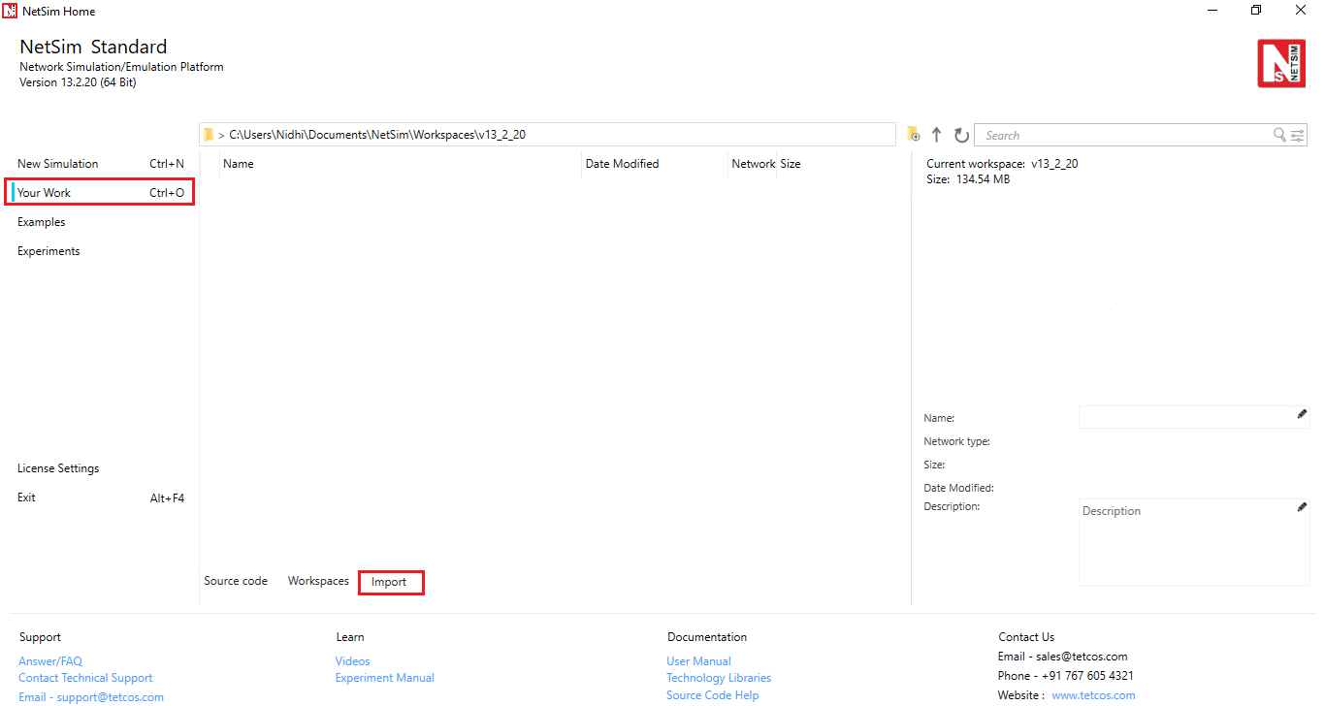

Fig 1: NetSim Home Window

1. In the Import Workspace Window, browse and select the 5G_Advanced_IISC_experiment_v13.2.20.netsimexp file from the extracted directory. Click on create a new workspace option and browse to select a path in your system where you want to set up the workspace folder.
2. Choose a suitable name for the workspace of your choice. Click Import.

Fig 2: NetSim Import workspace window

1. The Imported Project workspace will automatically be set as the current workspace.
2. The list of experiments is now loaded onto the selected workspace.

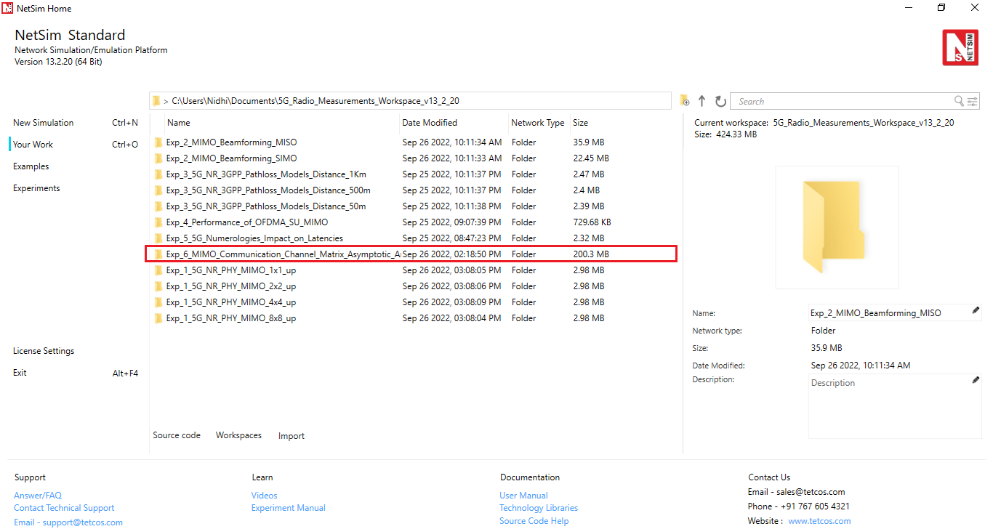

Fig 3: NetSim Your Work Window with the experiment folders inside the workspace

## Network Scenario

NetSim UI would display the network topology shown in the screenshot below when you open the example configuration file.

Fig 4: Network topology in this experiment

## Settings:

The following parameters were configured in the network setup:

1. The gNB- Interface 5G_RAN were set with the following properties:

|  |  |  |
| --- | --- | --- |
| gNB- Interface 5G_RAN Parameters | | |
| gNB Height | 10m |
| Tx Power | 40 dBm |
| Duplex Mode | TDD |
| CA Type | SINGLE BAND |
| CA Configuration | n78 |
| DL: UL Ratio | 4:1 |
| Numerology | 0 |
| Channel Bandwidth (MHz) | 10 |
| Tx Antenna Count | Varied from 16 to 128 |
| Rx Antenna Count | 16 |
| MCS Table | QAM64LOWES |
| CQI Table | TABLE1 |
| Pathloss Model | 3GPPTR38.901-7.4.1 |
| Outdoor Scenario | Rural Macro |
| LOS NLOS Selection | User Defined |
| LOS Probability | 1 (LOS) |
| Shadow Fading Model | LOG_NORMAL |
| Fading and Beam Forming | RAYLEIGH with EIGEN Beamforming |
| Coherence Time (ms) | 10 |
| O2I Penetration Model | LOW_LOSS_MODEL |
| Additional Loss Model | None |

Table 1: gNB properties

1. The UE properties were configured with the following parameters:

|  |  |  |
| --- | --- | --- |
| UE Interface 5G RAN | | |
| Tx Power | 23 dBm |
| UE Height | 1.5m |
| Tx Antenna Count | 16 |
| Rx Antenna Count | 16 |

Table 2: UE properties

1. A downlink CBR application was configured from wired node to UE with Transport protocol as UDP and Packet Size of 1460 Bytes and Inter Arrival time of 2000 µs and the Start Time was set to 1s[1].
2. Run simulation for 10s.

After the simulation, note down the average linear Beamforming Gain (eigen value) obtained for the DL application from the log file generated and then condition number can be obtained.

# Part 1: Asymptotic Condition Number Mean

Steps to calculate the condition number through Eigen value (BeamForming Gain Linear):

1. In the results window, expand the Log Files option in the left panel and select 5G_LTE_Parameter_Log.csv file.

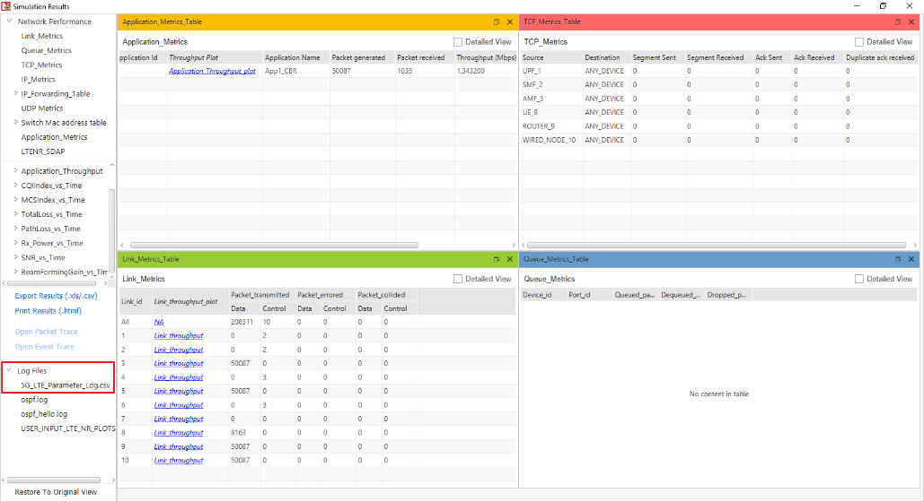

Fig 5: NetSim Results window showing access to log file generated

1. This will open a csv file which logs the parameters beamforming gain, over time as shown below.

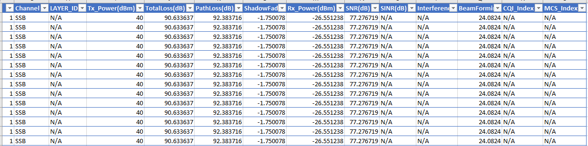

Fig 6: 5G Parameter log file created after simulation.

1. To change the beamforming gain from dB scale to linear, the following method is used:

In a new column, enter the following function to calculate the linear Beamforming gain:

1. Now goto Insert, select Pivot table option, and then select new sheet option and click ok.

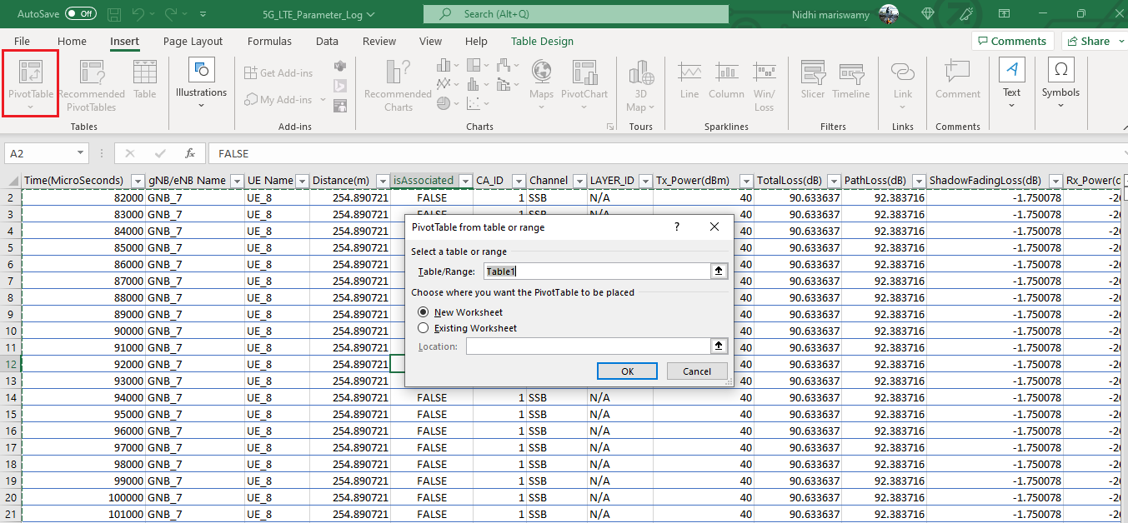

Fig 7: Create pivot tale

1. Drag and drop the Channel and LAYER_ID field to filter block. Filter the Channel to only PDSCH since we have considered a DL application from server to UE. Similarly, drag and drop the linear beamforming gain to values field and Time to Rows field.

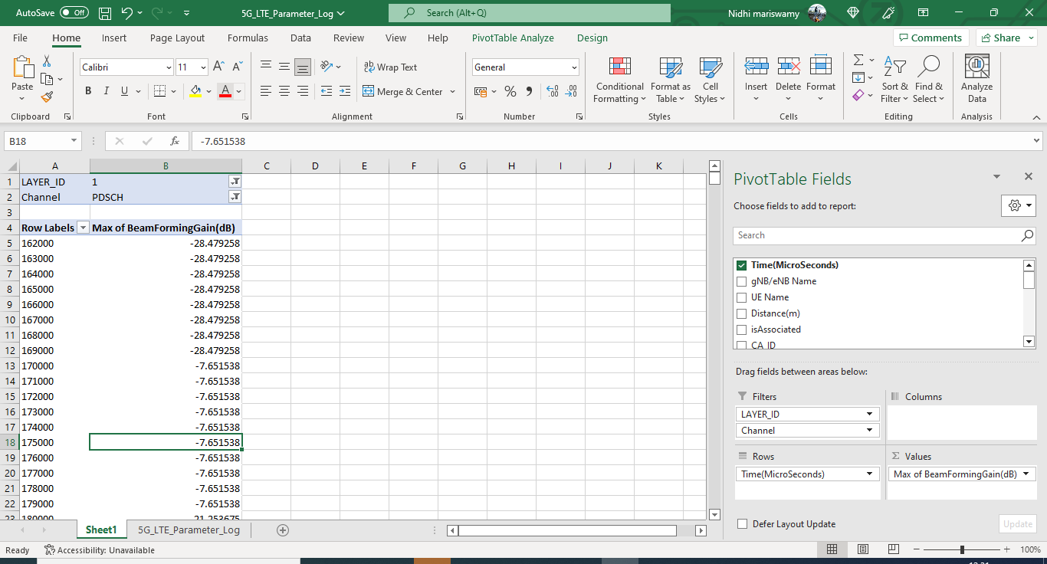

Fig 8: 5G Parameter log file pivot table showing the filtering process of DL/UL column

1. Now, filter the Layer_Id to layer 1. Now, copy the beamforming values and paste the values in new sheet with column name as Layer1.

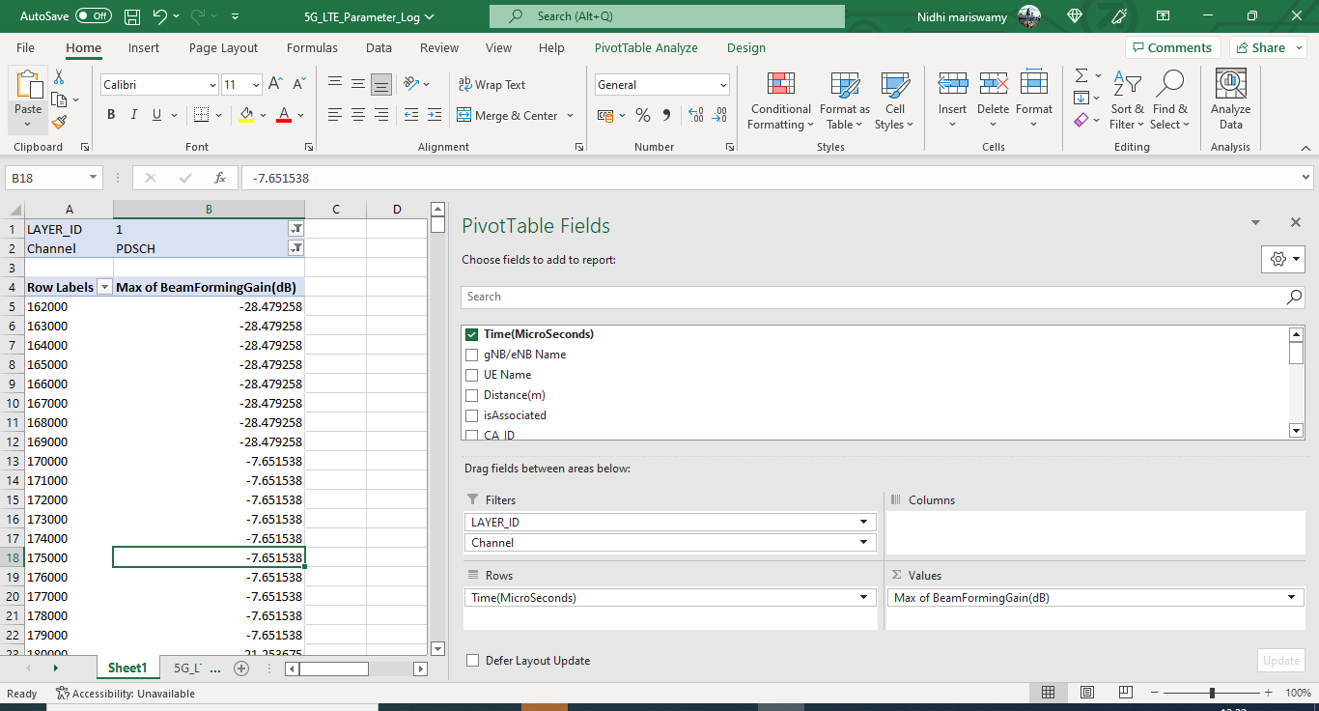

Fig 9: 5G Parameter log file showing eigen value obtained for layer1.

1. Similarly, filter the LAYER_ID as 16 and copy all the eigen values and paste in new sheet with column name Layer16 as below.

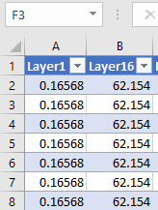

Fig 10: Layer 1 and layer 16 eigen value in new table

1. Now in the next column, enter the formula, to calculate . Note that the eigenvalues of Layer 16 are while the eigenvalue of Layer1 is Rename the column suitably.

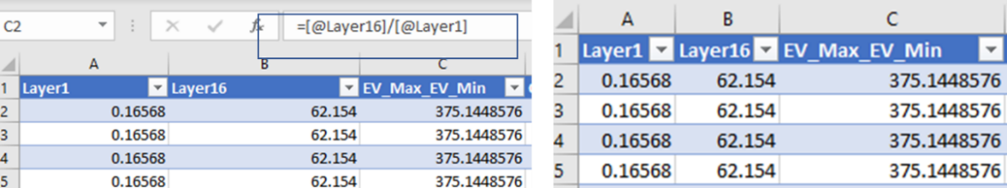

Figure 11: Showing obtained

1. Now in the next column, enter the formula, . This will calculate square root of the ratio which is known as the condition number.

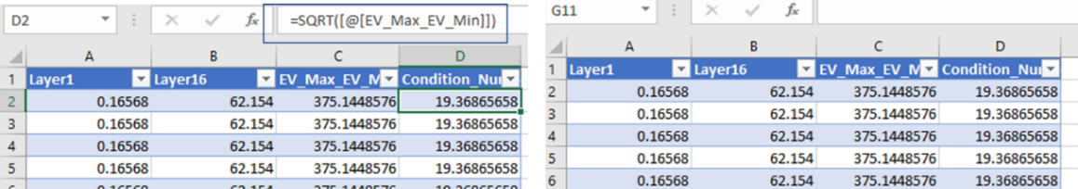

Figure 12: Condition Number obtained

1. In a new cell, enter the formula to calculate the average of condition number.

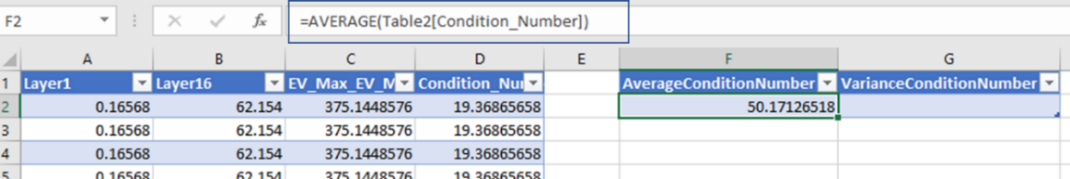

Figure 13: Average eigen value obtained

1. Similarly, enter the formula, in a new cell, to calculate the variance of condition number.

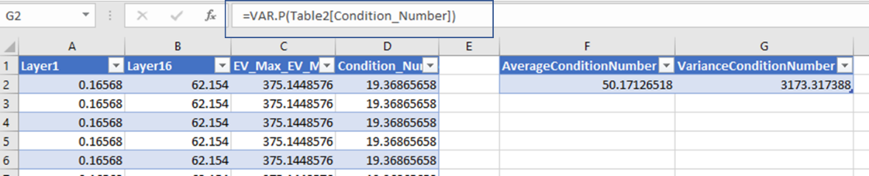

Figure 14: Variance of eigen value obtained

1. Repeat the steps 1 to 10 with varying Tx antenna count in gNB as 32, 64, and 128. Note down the mean and variance of condition number.

## Results

|  |  |  |
| --- | --- | --- |
| Tx, Rx | Condition Number Mean | Condition Number Variance |
| 16, 16 | 50.118 | 3168.400 |
| 32, 16 | 4.423 | 0.259669 |
| 64, 16 | 2.561 | 0.026435 |
| 128,16 | 1.878 | 0.005593 |

Table 3: Showing Mean and Variance of Condition Number with varying Tx

1. **Case1: gNB Tx = 32, UE Rx = 16**

From theory . NetSim result = 4.423.

1. **Case2: gNB Tx = 64, UE Rx = 16**

From theory . NetSim result = 2.561.

1. **Case3: gNB Tx = 128, UE Rx = 16**

From theory . NetSim result = 1.879.

Since theory is for the asymptotic mean, we will not get an exact match. The results show the trend that as N increases simulation outputs approach theoretical predictions.

# Part 2: Asymptotic Condition Number Distribution

## Theory

Consider a i.i.d complex Gaussian random matrix . Define the Wishart matrix with parameters and , and eigenvalues as .

The condition number of is defined as

From [1], if , and then converges in distribution to a random variable whose PDF is given by

We simulate the case , since the antenna count is limited to 16, in the UEs in NetSim. Fig 15 is a comparison of the normalized histogram of from NetSim vs. the asymptotic pdf equation. At itself, there seems to be a reasonable fit.

## Comparison of NetSim Results with asymptotic function

**Steps to plot histogram of condition number:**

1. Calculate the Condition Number using the 5G_Parameter_Log file.
2. In a new column, divide the Condition_Number by 16 using the following excel function:
3. Click on Insert-> Pivot Table, drag and drop Column1 to Rows field.
4. Copy the values in Row Labels column.
5. In MATLAB create a new file, create an array **Condition_Number_array**, paste the values to it as

**Condition_Number_array** = [c1

c2

c3

….

cn];

1. Now use below MATLB code to plot the normalized histogram plot with the function

hold on;

c = histogram(Condition_Number_array,'Normalization','probability');

x = 0:0.1:50; %x varies from 0 to 50 in steps of 0.2.

y = (8./x.^3).*(exp(-4./x.^2));

plot(x,y,'r');

hold off;

% For CDF plot use below MATLB code

cdfplot(Condition_Number_array);

Program 1: MATLAB code for plotting condition number from NetSim and comparing against the asymptotic PDF from analysis.

**Histogram Plot for 16 Tx Layer Count (gNB) and 16 Rx Layer Count (UE)**

Normalized histogram of from NetSim

Fig 15: The normalized histogram for itself fits well with the asymptotic distribution of

# Part 3: Marchenko-Pasteur Distribution

## Theory

The Marchenko Pasteur distribution for with is

where and .

Let us consider the case where, the number of transmit antennas and the number of receive antennas , are related as Substituting for we get the MP distribution as

## Comparison of NetSim Results with Marchenko- Pasteur function

**Steps to plot the histogram:**

* 1. Create a scenario with Tx antenna count as 128 and Rx antenna count as 16.
  2. Now open the file 5G_LTE_Parameter_Log.csv file.
  3. Filter the DL/UL to DL.
  4. Now, in the 5G parameter log file we have Eigen values from Layer Id 1 to Layer Id 16.
  5. Select the eigen values in Beamforming Gain column and copy all the values.
  6. Create a new file in MATLAB. Create an array Eigen_value_array and paste the copied values from the 5G parameter log csv file as shown.

Eigen_value_array = [ev1

ev2

…

evN];

* 1. Use below MATLAB code to plot the MP distribution function along with the normalized histogram.

For the MP distribution function, the x varies from 0.418 to 1.832 in steps of 0.001.

x = 0.418:0.001:1.832;

y = (1.27324./x).*sqrt(0.5 - (x-9/8).^2);

hold on;

plot(x,y);

histogram(Eigen_value_array /128,'Normalization','pdf');

hold off;

Program 2: MATLAB code for plotting the MP distribution for and pooled eigenvalues histogram, from NetSim simulation results

Result:

Fig 16: NetSim Results vs. Marchenko-Pasteur distribution for and

# References

* 1. Edelman, A. (1988). Eigenvalues and Condition Numbers of Random Matrices. *SIAM Journal on Matrix Analysis and Applications*, 543-560.

1. The application end time value of 10,000s is not changed. In NetSim the application runs for . Since the simulation is run for 10s, the application runs for only 10s.