5G Channel Model – Pathloss File Input

Table of Contents

1 Download and project setup 2

2 Features 4

3 Code Modifications 5

4 Example 7

# Download and project setup

**Software Recommended**: NetSim Standard v13.0 (32-bit/ 64-bit), Visual Studio 2017/2019

**Project Download Link**:

<https://github.com/NetSim-TETCOS/NetSim_5G_LTE_Plots_v13_0/archive/refs/heads/main.zip>

Procedure:

1. After you unzip the downloaded project folder, Open NetSim Home Page click on Your work option,

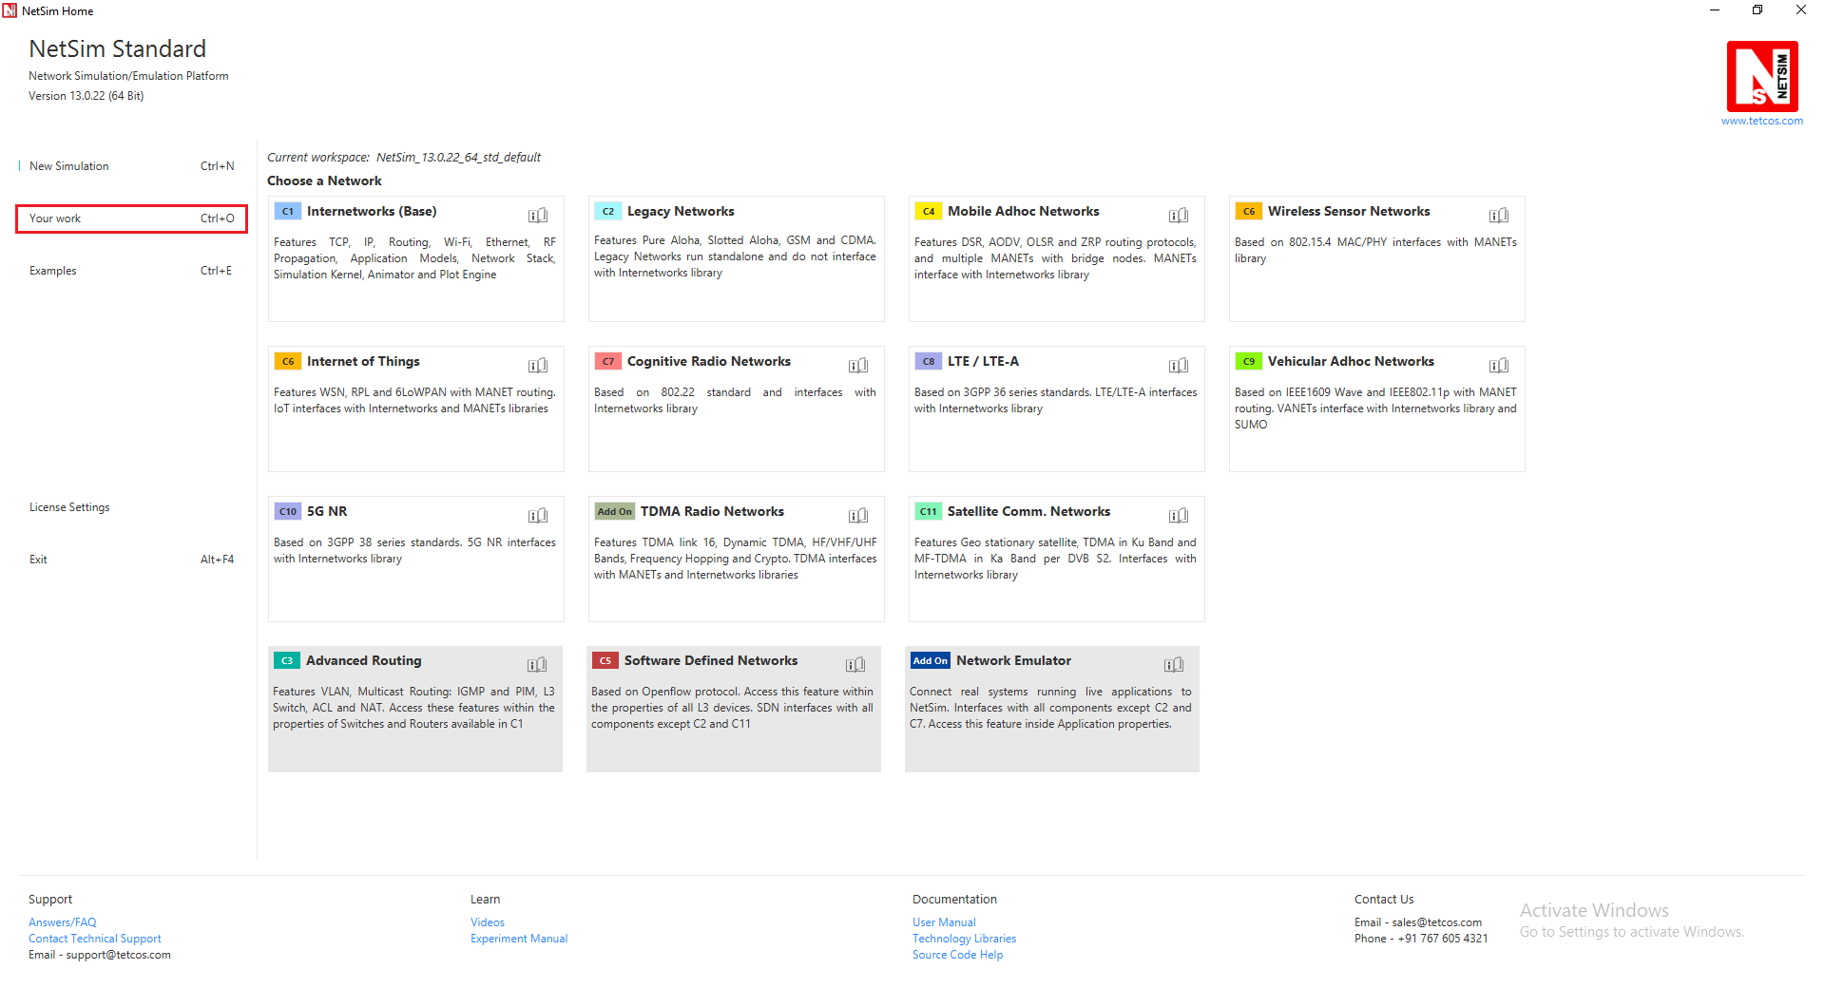

1. Click on Workspace options

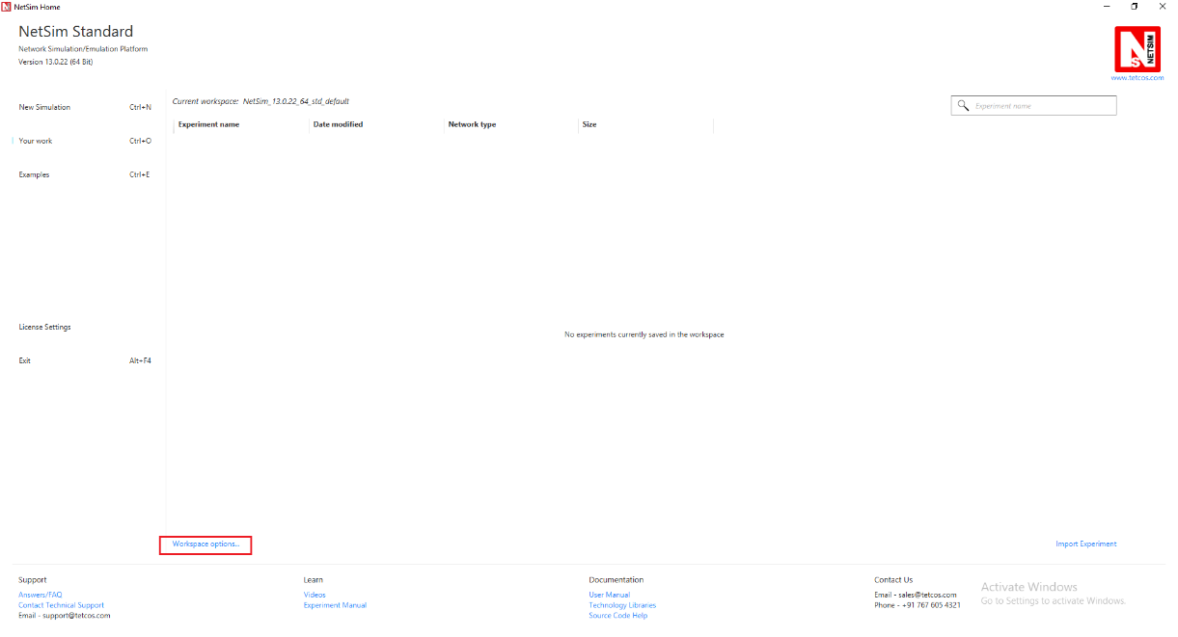

1. Click on More Options,

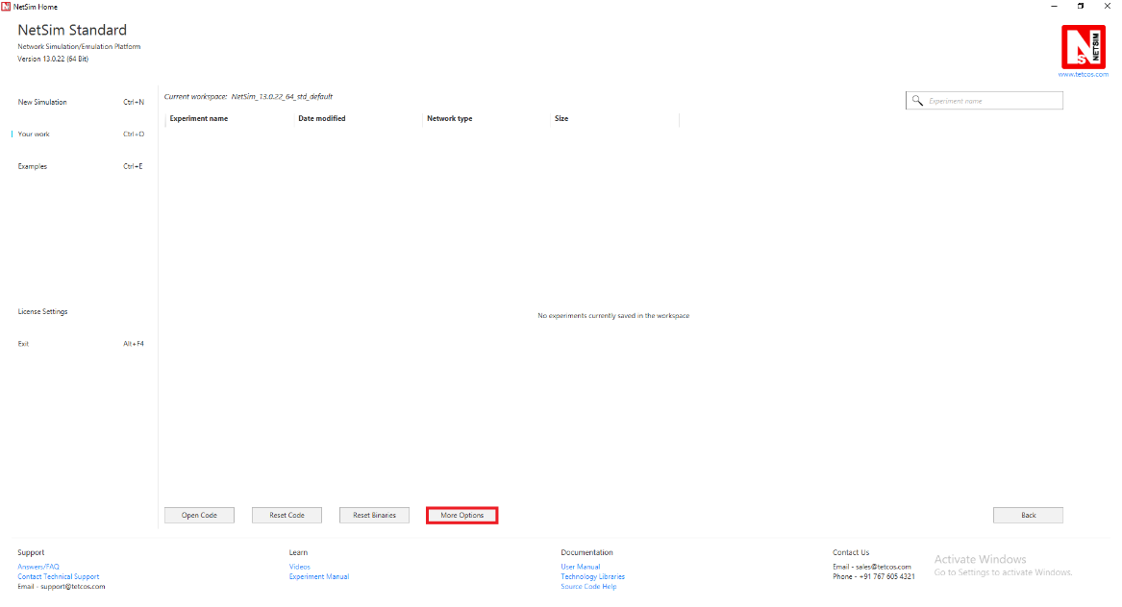

1. This will display a window were users need to give the source file (exported workspace file) and the Destination, the path where the workspace is to be imported to and then click on ok.

Note: Only exported workspaces with “.netsim_wsp” extension can be imported

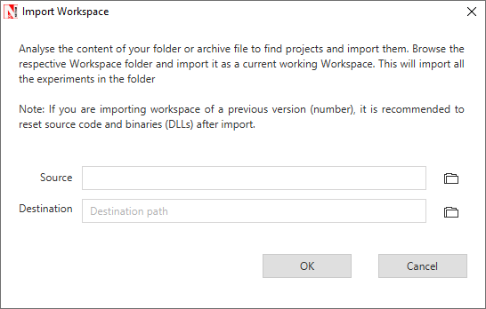

1. Browse and select the downloaded 5G_Pathloss_File_Input_13_0.netsim_wsp file for the source option and click on Open. Browse and select a location to import for the destination option.
2. After this click on OK button in the Import Workspace window.
3. While importing the workspace, if the following warning message indicating Software Version Mismatch is displayed, you can ignore it and proceed.

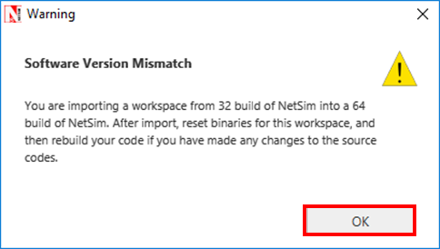

1. The Imported workspace will be set as the current workspace automatically.
2. Open the Source codes in Visual Studio by going to Your work-> Workspace Options and Clicking on Open code button as shown below:

# Features

Using this workspace users can

* vary the 5G channel model in NetSim
* input a pathloss file for each gNB in the network. NetSim would read the pathloss text file for the gNB in the network and use it to identify best server and for signal strength calculations.

# Code Modifications

In LTE_NR.c file function for reading and opening the input pathloss file has been called

static bool isLTENRTraceConfigured = false;

static bool isCalledOnce = false;

//Function prototype

int fn_NetSim_LTE_NR_Init_F();

int fn_NetSim_LTE_NR_Configure_F(void** var);

int fn_NetSim_LTE_NR_Finish_F();

#pragma endregion

#pragma region LTENR_INIT

_declspec(dllexport) int fn_NetSim_LTE_NR_Init()

{

if (!isCalledOnce)

{

FileBasedPathlossWritingFile();

FileBasedpathlossReadingFile();

isCalledOnce = true;

}

return fn_NetSim_LTE_NR_Init_F();

}

In LTENR_Propagation_Model.c the below highlighted edits

static double calculate_pathloss_only(ptrLTENR_PROPAGATIONINFO info)

{

if (pathlossInfo[info->gnbId - 1])

{

return fn_netsim_get_pathloss_from_file(info->gnbId, info->ueId);

}

double fc = info->frequency_gHz;

double PL1, PL2, PL3, distance2D, distance3D, distanceBP;

double pathloss_RMa_LOS = 0, pathloss_RMa_NLOS = 0;

double pathloss_UMa_LOS = 0, pathloss_UMa_NLOS = 0;

double pathloss_UMi_LOS = 0, pathloss_UMi_NLOS = 0;

double pathloss_InH_LOS = 0, pathloss_InH_NLOS = 0;

double hBS, hUT, W, h;

double h_effectiveEnv, hBS_effective, hUT_effective;

distance2D = info->dist2D;

distance3D = info->dist3D;

LTENR_LOS_NLOS_STATE state = info->propagationConfig->state;

The ReadPathlossInput.c file contains the following functions:

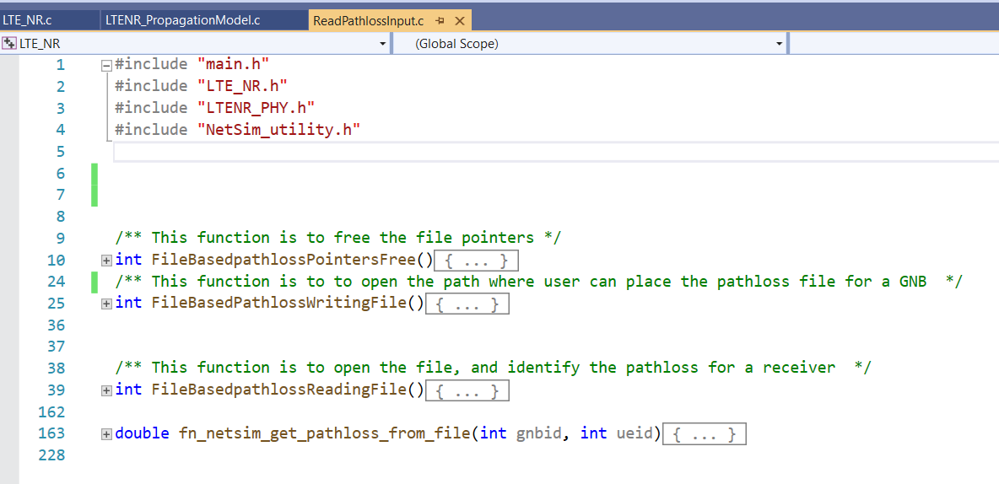

**FileBasedpathlossReadingFile()**

Reads the pathloss file given by user and stores the coordinates and pathloss values for each gNB in a separate list.

**fn_netsim_get_pathloss_from_file()**

Returns the pathloss at a requested receiver coordinate with respect to the transmitter gNB.

**FileBasedPathlossWritingFile()**

This function is to open the path where user can place the pathloss file for a GNB.

# Example

The below scenario

* Consists of 1 gNB and 1 UE. An external pathloss file is given as input to the gNB. This will override whatever channel model is set via the GUI.
* Users should pay attention to the gNB’s co-ordinates. It is *not* part of the pathloss file, and is set via the GUI (X, Y co-ordinates). Take care that the gNB co-ordinates match (or is suitably transformed) the co-ordinates used for generating the pathloss file
* The network is simulated for 60 s with application generation rate as 23 Mbps.

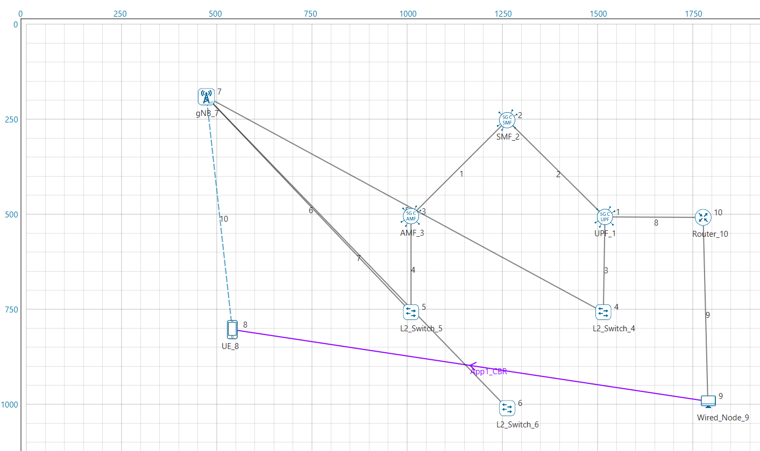

Upon clicking the RUN button, the log folder path is automatically opened. User should place the files containing the pathloss for eNB/Gnb’s in the network here:

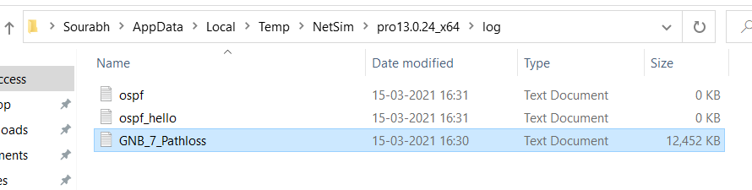

The pathloss file should start with the device name followed by “_Pathloss” and be saved as a text file (*.txt).

The pathloss file should be per the given format:

The first two lines must have the below parameters

xmax=1000,ymax=1000,zmax=100

xstep=5,ystep=5,zstep=10

Subsequently, x, y, z coordinates with pathloss value must be given.

x_cordinate (m),y_cordinate (m),z_cordinate (m),pathloss (dB)

An example screen shot is provided below

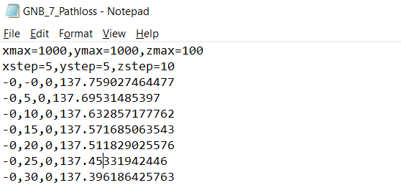

Note that if UE is placed at or moves to a location beyond xmax, ymax then the pathloss will be taken as 500 dB.

If input file is provided for a eNB/gNB then pathloss calculations will happen as per that, else NetSim will use the standard pathloss models to calculate the pathloss.

Once the simulation starts, the cmd window would look as shown below

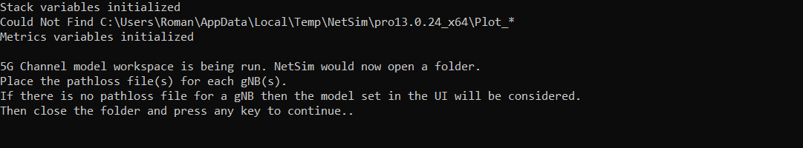

Next, close the folder and press any key.

Simulation starts running.

Upon completion of simulation the impact of the pathloss input provided can be understood from the performance metrics parameters such as the application throughput, that are part of the results dashboard

