5G LTE Radio Measurements Logging and Plotting

Software: NetSim Pro v13.2.20 (64-bit), Visual Studio 2022.

Project Download Link:
https://github.com/NetSim-TETCOS/5G_Radio_Measurements_Pro_v13.1/archive/refs/heads/main.zip

Follow the instructions specified in the following link to download and setup the Project in NetSim:

https://support.tetcos.com/en/support/solutions/articles/14000128666-downloading-and-setting-up-netsim-file-exchange-projects

Introduction
There are several radio measurement parameters associated with a 5G network, such as pathloss, received power, SINR, MCS, CQI, Beamforming gain, etc which can be very useful in understanding the network performance metrics obtained upon simulation. Though these parameters can be found in the LTE NR log file of NetSim, for quick analysis and plotting capabilities CSV log and time series plots can be obtained using the radio measurements instrumented workspace.

Features
Using this workspace:
- Users can plot Pathloss, Shadow Fading Loss, Total Loss, Rx_Power, SNR, Beam Forming Gain, MCS Index, and CQI Index vs. time using NetSim Plot.

- Users can log Pathloss, Shadow Fading Loss, Total Loss, Rx_Power, SNR, Beam Forming Gain, MCS Index, and CQI Index with time stamps, to a CSV log file.

- Users need to provide a file-based input (per a certain format) at the start of simulation for the parameters to be plotted or logged.

- The plots are unique to
- Each gNB-UE pair
- Carrier ID
- DL or UL

- The log entries are unique to
- Each gNB-UE pair
- Carrier ID
- DL or UL
- Each layer
- The output parameters for different MIMO layers ($Min \left(N_{t}, N_{r}\right))$ are stacked in a single plot
- Parameters are logged every slot time (1ms) and plotted.

- There is no restriction in NetSim on the number of gNBs / UE in the network.

Example
Network Scenario:

Figure 1: Network Topology in this experiment

Simulation parameters

Parameter | Value
gNB transmit power | 40 dBm
gNB bandwidth | 10 MHz
gNB Tx/Rx | 2 x 1
DL:UL Ratio | 4:1
UE Transmit power | 23 dBm
UE Tx/Rx | 1 x 2
UE Mobility | File Based Mobility
Beamforming | Enabled
Channel model | 3G PP UMa
LOS probability | 0
Traffic | DL CBR 10 Mbps
Simulation Time | 50 seconds

- Upon running the simulation, a text file will open for the user to provide input for logging and plotting radio measurement parameters.
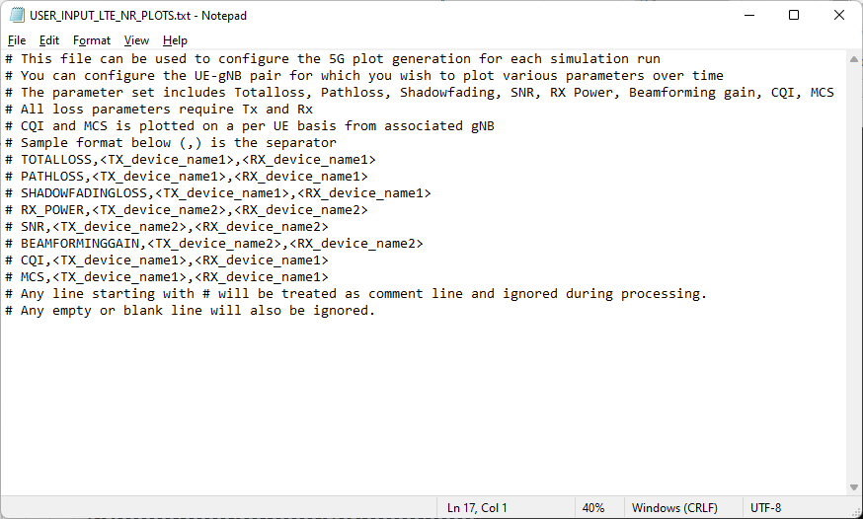
- For plotting, the input is per the format $<parameter>,<device1>,<device2>$ in the text file. To log gNB – UE (DL) data flow the gNB would be the 1st device while the UE would be the 2nd device. In the reverse direction (UL, UE to gNB) the UE would be the 1st device and the gNB the 2nd devices. In case of multiple gNBs, this input can be given for various gNB-UE pairs.
- For logging, the input is per the format $LOG<space><parameter>$. This will log the specified parameter for all the gNB-UE pairs in the network.
- Inputs are not case sensitive.
- For the above example, the input in the text file for logging and plotting all the parameters will be:

TOTALLOSS,gNB_7,UE_8
PATHLOSS,gNB_7,UE_8
SHADOWFADINGLOSS,gnb_7,ue_8
RX_POWER,gNB_7,UE_8
SNR,gNB_7,UE_8
BEAMFORMINGGAIN,gNB_7,UE_8
CQI,gNB_7,UE_8
MCS,gNB_7,UE_8
LOG TOTALLOSS
LOG PATHLOSS
LOG SHADOWFADINGLOSS
LOG RX_POWER
LOG SNR
LOG BEAMFORMINGGAIN
LOG CQI
LOG MCS
- Once the simulation starts, In the command prompt window it will show a message as “Please update, Save and close the file and press any key to continue”.
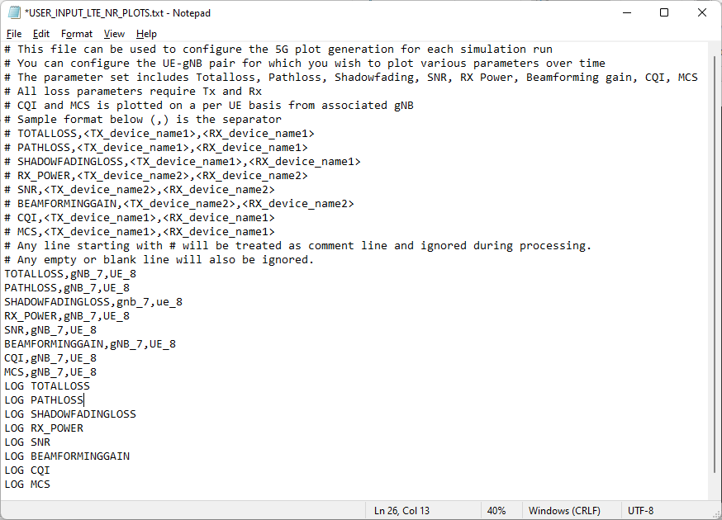
- Add the parameters to be logged, close the input text file and press any key.
- Simulation starts running.

Results and discussion

Upon completion of simulation in the result window users can view the various plots.

Figure 2: NetSim results dashboard with throughput highlighted
For each carrier, a separate plot is plotted with all the MIMO layers stacked in a single plot.
The pathloss, shadow fading loss, and total loss remains same across the layers. Hence, for these parameters there is a single plot for all layers.

Result Plots

- Pathloss Plot
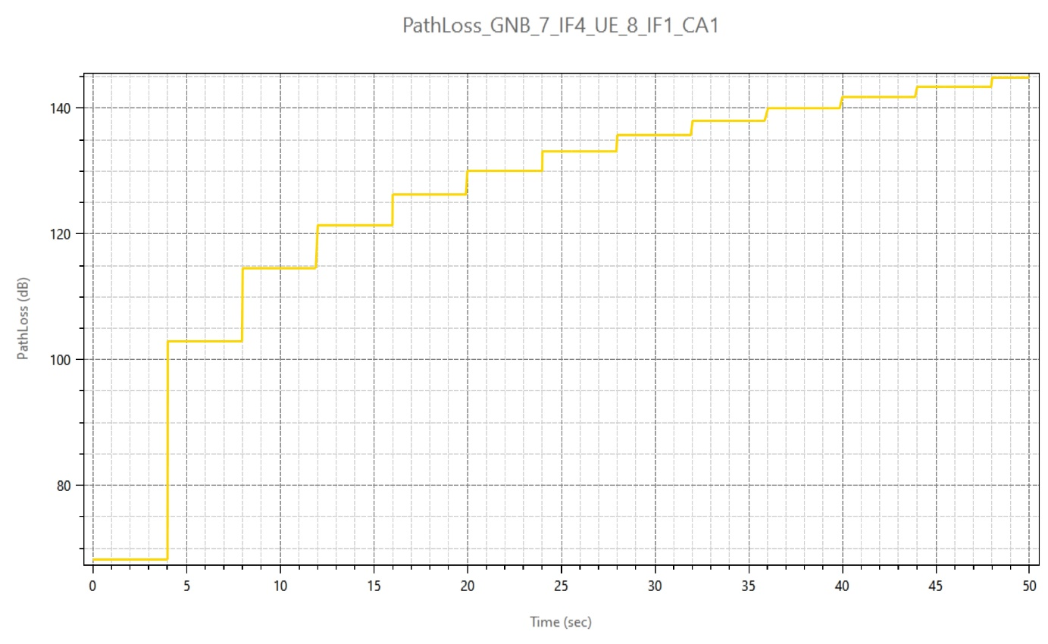

Figure 3: Pathloss Plot in NetSim

- Total Loss (Shadow Fading loss plus Path loss)
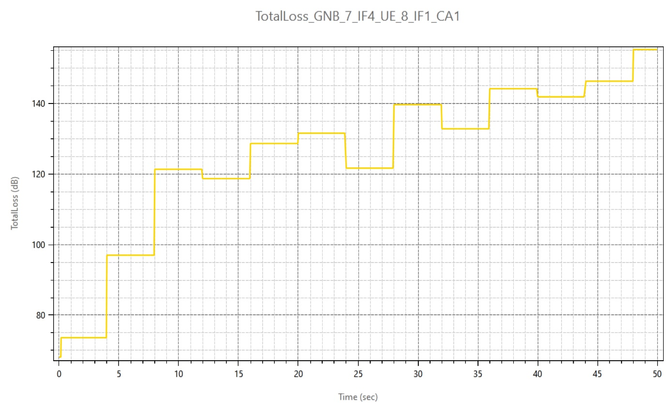
Figure 4: Total Loss (Shadow Fading loss plus Path loss) in NetSim
- Shadow Fading Loss
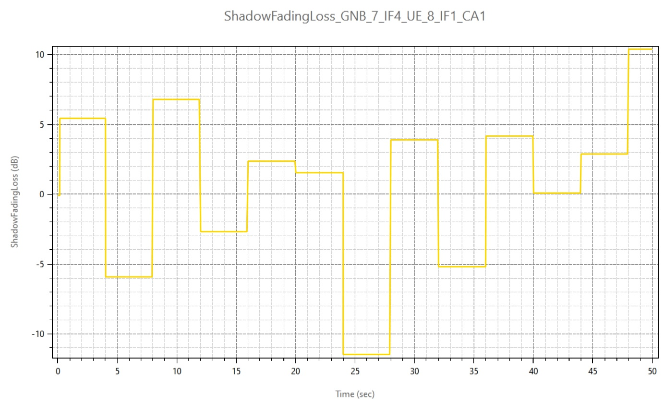
Figure 5: Shadow Fading Loss in NetSim
The plot title is ShadowFadingLoss_GNB_7_IF4_UE_10_IF1_CA1. And the naming convention is <ParameterType>_GNB_<ID>_IF<InterfaceID>_UE_<ID>_IF<InterfaceID>_CA<Carrier_ID>

- Rx_Power Plot
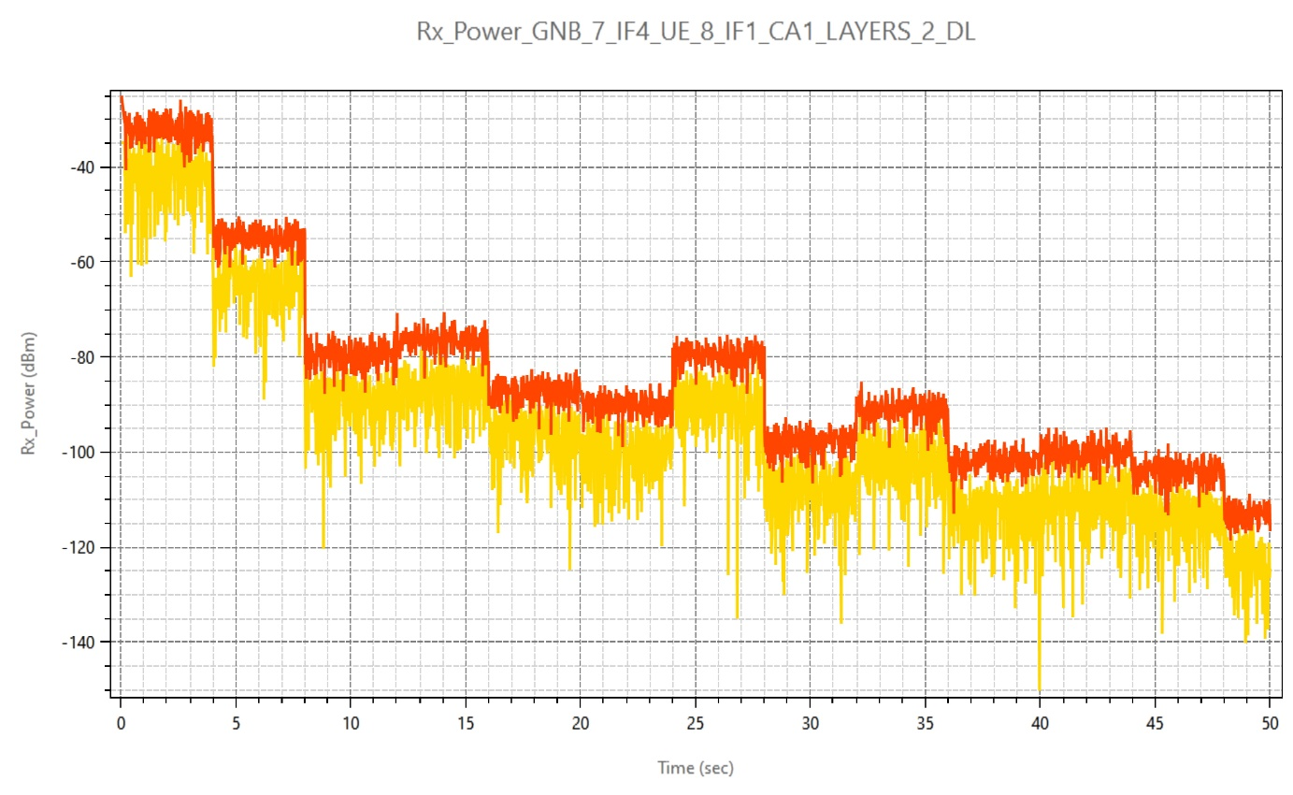
Layer_2
Layer_1
Figure 6: Rx_Power Plot in NetSim
- SNR Plot

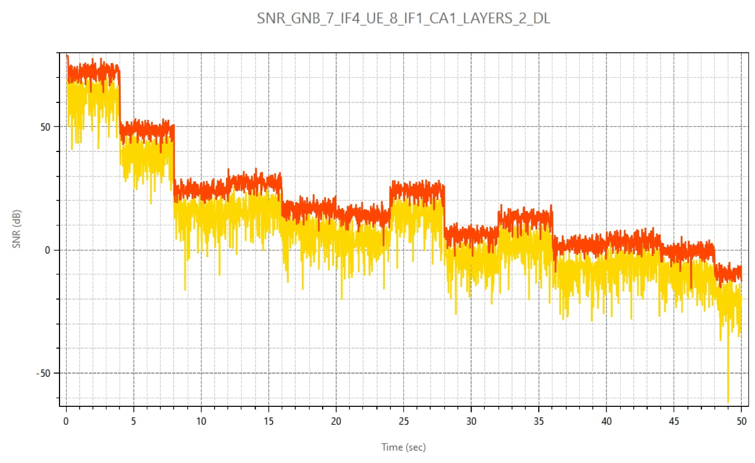
Layer_1
Layer_2

Figure 7: SNR Plot in NetSim

- Beam Forming Gain (if, the Fast-Fading Model is set to Rayleigh with Eigen Beamforming)
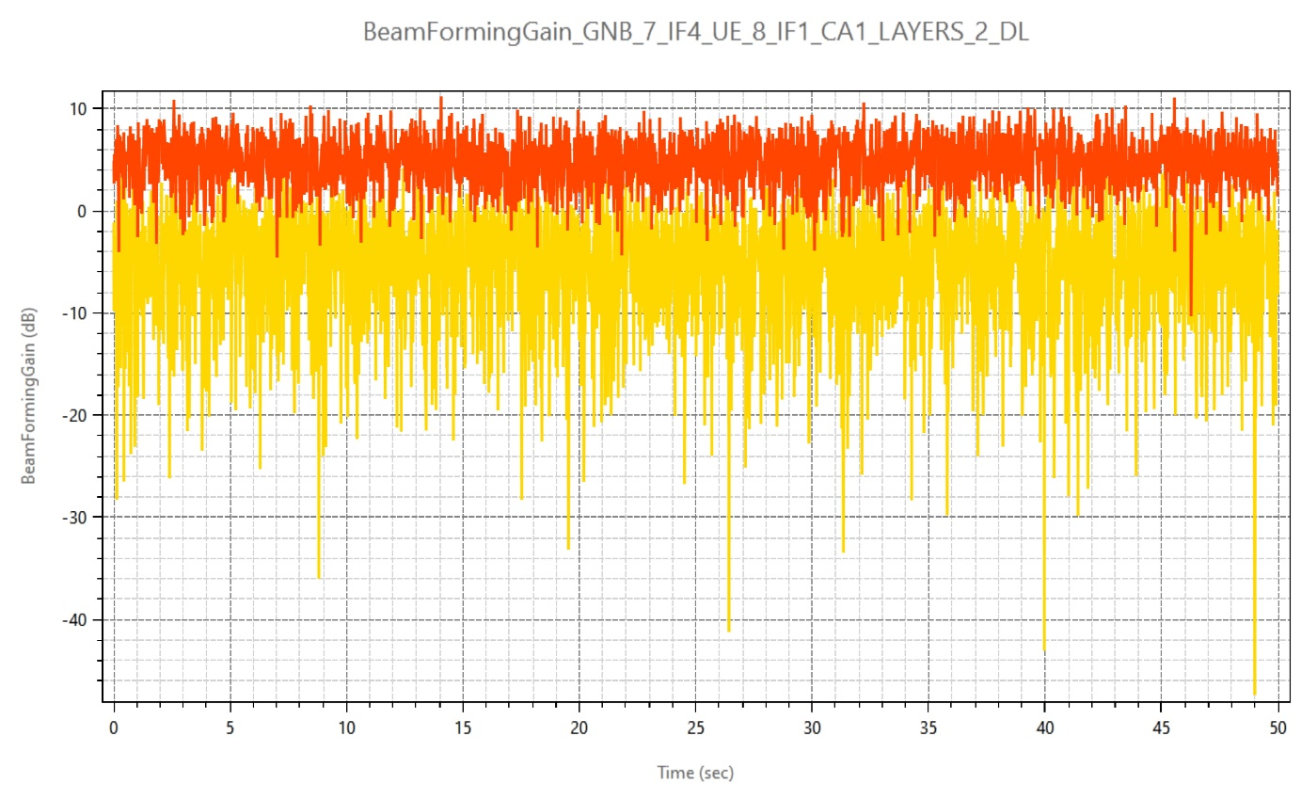
Layer_1
Layer_2
Figure 8: Beam Forming Gain in NetSim
- CQI Index Plot
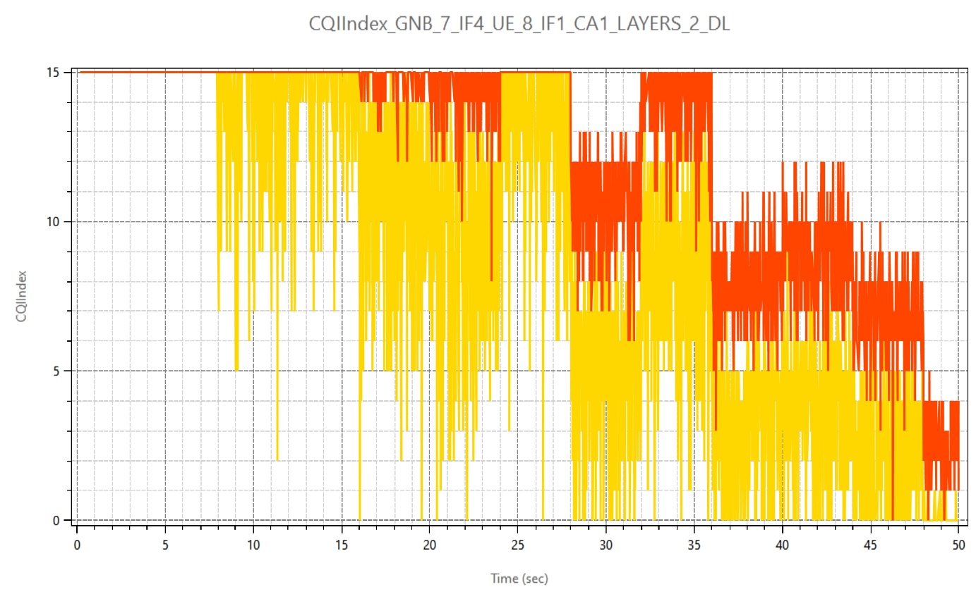

Layer_2
Layer_1

Figure 9: CQI Index Plot in NetSim

- MCS Index Plot
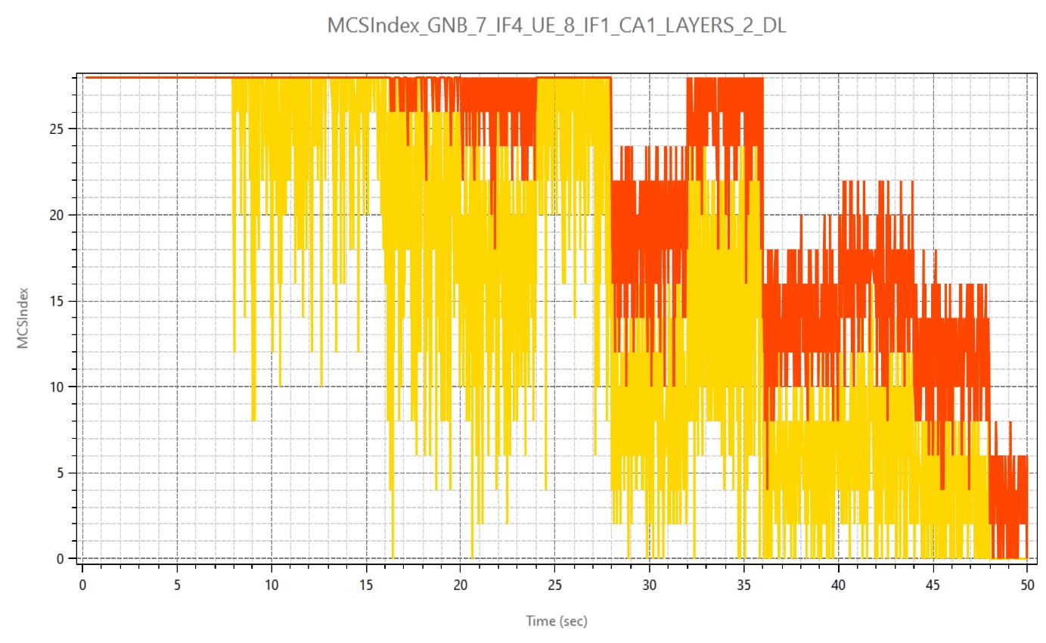

Layer_2
Layer_1
Figure 10: MCS Index Plot in NetSim
The parameters such as the SNR, Rx_Power, Beam Forming Gain, CQI Index, MCS Index are plotted for all MIMO layers. In case of multiple carriers, plot files are generated per carrier. The file name and the chart title consists of information such as
- Parameter
- gNB ID
- gNB Interface
- UE ID
- UE Interface
- Carrier ID
- Layer Count
- Channel information (DL/UL)

Parameter log file
Figure 11: 5G Log file parameter
The 5G_LTE_Parameter_Log.csv file logs the details of parameters specified in the input file with respect to time.

Appendix: NetSim source code modifications

Open the Source codes in Visual Studio by going to Your work-> Workspace Options and Clicking on Open code button.

To the in LTE_NR project, files LTE_NR_Plot.c and LTE_NR_Parameter_Log.c has been added. These files contain the definitions of the functions that responsible for plotting and logging parameters associated with 5G/LTE networks in NetSim.

The function fn_NetSim_LTE_NR_Init_Plots and fn_NetSim_LTE_NR_init_Parameter_Log has been called in LTENR.c file for initializing the plot.

static bool isplotinit= false;
//Function prototype
int fn_NetSim_LTE_NR_Init_F();
int fn_NetSim_LTE_NR_Configure_F(void** var);
int fn_NetSim_LTE_NR_Finish_F();
#pragma endregion

#pragma region LTENR_INIT
_declspec(dllexport) int fn_NetSim_LTE_NR_Init()
{
if(!isplotinit)
{
fn_NetSim_LTE_NR_Init_Plots();
fn_NetSim_LTE_NR_init_Parameter_Log();
isplotinit= true;
}
return fn_NetSim_LTE_NR_Init_F();
}

The initialization of functions and functions to add values to the plot and CSV logs are called from the LTENR_handleStartSlotEvent() function which is part of the LTENR_PHY.c file as highlighted below:

void LTENR_handleStartSlotEvent()
{
NETSIM_ID gnbId = pstruEventDetails->nDeviceId;
NETSIM_ID gnbIf = pstruEventDetails->nInterfaceId;
ptrLTENR_GNBPHY phy = LTENR_GNBPHY_GET(gnbId, gnbIf);

#pragma warning (disable : 4047)
int CA_ID = pstruEventDetails->szOtherDetails;
#pragma warning (default : 4047)

ptrLTENR_CA ca = phy->spectrumConfig->CA[CA_ID];

LTENR_resetSlot(phy, CA_ID);
print_ltenr_log("Starting new slot for gNB %d:%d\n", gnbId, gnbIf);
print_ltenr_log("CA_ID for Slot = %d\n", CA_ID);
print_ltenr_log("\tFrame Id = %d\n", phy->frameInfo[CA_ID]->frameId);
print_ltenr_log("\tSubFrame Id = %d\n", phy->frameInfo[CA_ID]->subFrameId);
print_ltenr_log("\tSlot Id = %d\n", phy->frameInfo[CA_ID]->slotId);
print_ltenr_log("\tSlot start time (us) = %lf\n", phy->frameInfo[CA_ID]->slotStartTime);
print_ltenr_log("\tslot end time (us) = %lf\n", phy->frameInfo[CA_ID]->slotEndTime);
print_ltenr_log("\tSlot type = %s\n", strLTENR_SLOTTYPE[phy->frameInfo[CA_ID]->slotType]);

phy->currentFrameInfo = phy->frameInfo[CA_ID];
phy->currentFrameInfo->Current_CA_ID = CA_ID;
if (phy->frameInfo[CA_ID]->slotId != ca->slotPerSubframe)
LTENR_addStartSlotEvent(gnbId, gnbIf,
phy->frameInfo[CA_ID]->slotEndTime, CA_ID);

ptrLTENR_ASSOCIATEDUEPHYINFO info = phy->associatedUEPhyInfo;
//
if (pstruEventDetails->dEventTime ==0 || pstruEventDetails->dEventTime==200000)
{
for (NETSIM_ID d = 1; d <= NETWORK->nDeviceCount; d++)
{
for (NETSIM_ID in = 1; in <= DEVICE(d)->nNumOfInterface; in++)
{
if (!isLTE_NRInterface(d, in))
continue;
if (!isGNB(d, in))
continue;

ptrLTENR_GNBPHY phy_ = LTENR_GNBPHY_GET(d, in);
ptrLTENR_ASSOCIATEDUEPHYINFO info_ = phy_->associatedUEPhyInfo;

while (info_)
{
fn_NetSim_LTE_NR_init_PropagationInfo_Plots(phy_, info_);
fn_NetSim_LTE_NR_init_Power_Plots(phy_, info_);
LTENR_ASSOCIATEDUEPHYINFO_NEXT(info_);
}

}
}
}
while (info)
{
if (info->isAssociated)
{
for (NETSIM_ID i = 0; i < phy->ca_count; i++)
LTENR_PHY_setAMCInfo(phy, info, i);
}

fn_NetSim_LTE_NR_add_PropagationInfo_Plot_data(info, CA_ID);
fn_NetSim_LTE_NR_add_Power_Plot_data(info, CA_ID);
ptrINFO param_info = parameter_log_info;
if (param_info->isParameterlog)
fn_NetSim_LTE_NR_Log_Parameters(phy, CA_ID, info);
info = LTENR_ASSOCIATEDUEPHYINFO_NEXT(info);
}

LTENR_NotifyMACForStartingSlot();

phy->frameInfo[CA_ID]->prevSlotType = phy->frameInfo[CA_ID]->slotType;
}

For adding plot data at every slot time (1 ms) the below highlighted function has been used in LTENR_phy.c file.
static void LTENR_PHY_setAMCInfo(ptrLTENR_GNBPHY phy, ptrLTENR_ASSOCIATEDUEPHYINFO info, int CA_ID)
{
UINT layerCount;
ptrLTENR_UEPHY uePhy = LTENR_UEPHY_GET(info->ueId, info->ueIf);

//Downlink
layerCount = LTENR_PHY_GET_DLLAYER_COUNT(uePhy);
for (UINT i = 0; i < layerCount; i++)
{
print_ltenr_log("\tAMC info between gNB %d:%d and UE %d:%d, Carrier Id = %d, Layer Id = %d for downlink-\n",
phy->gnbId, phy->gnbIf,
info->ueId, info->ueIf,
CA_ID, i);
info->downlinkAMCInfo[CA_ID][i]->SpectralEfficiency = LTENR_PHY_GetDownlinkSpectralEfficiency(info->propagationInfo[CA_ID], i);
setAMCInfo(phy, info->downlinkAMCInfo[CA_ID][i]);
}

//Uplink
layerCount = LTENR_PHY_GET_ULLAYER_COUNT(uePhy);
for (UINT i = 0; i < layerCount; i++)
{
print_ltenr_log("\tAMC info between gNB %d:%d and UE %d:%d, Carrier Id = %d, Layer Id = %d for uplink-\n",
phy->gnbId, phy->gnbIf,
info->ueId, info->ueIf,
CA_ID, i);
info->uplinkAMCInfo[CA_ID][i]->SpectralEfficiency = LTENR_PHY_GetUplinkSpectralEfficiency(info->propagationInfo[CA_ID], i);
setAMCInfo(phy, info->uplinkAMCInfo[CA_ID][i]);
}
fn_NetSim_LTE_NR_add_AMCInfo_Plot_data(info, CA_ID);
}

Disabling Plotting/Logging

Generation of plots or the parameter log can be disabled by commenting the function calls in the fn_NetSim_LTE_NR_Init() function. The function call fn_NetSim_LTE_NR_Init_Plots can be commented to disable plots and the function call fn_NetSim_LTE_NR_init_Parameter_Log can be commented to disable generation of a parameter log CSV file.
_declspec(dllexport) int fn_NetSim_LTE_NR_Init()
{
if(!isplotinit)
{
fn_NetSim_LTE_NR_Init_Plots(); //comment line to disable plots
fn_NetSim_LTE_NR_init_Parameter_Log(); //comment line to disable parameter log
isplotinit = true;
}
return fn_NetSim_LTE_NR_Init_F();
}

