Channel notching in Cognitive Radio Networks

**Software:** NetSim Standard v14.0, Visual Studio 2022

**Project Download Link:**

Follow the instructions specified in the following link to download and setup the Project in NetSim:

<https://support.tetcos.com/support/solutions/articles/14000128666-downloading-and-setting-up-netsim-file-exchange-projects>

**Introduction:**

In Cognitive Radio networks, the secondary user (CR CPE) actively senses for the presence of the primary user (Incumbent). If the CR_CPE detects the primary user, then UCS(Urgent Co-existence Situation)Notifications will be sent by the secondary user to the base station. UCS notifications are generated at the end of the quiet period. Upon receiving the UCS notification BS(Base-Station) checks for possible interference between Primary and secondary users. If interference is detected, secondary users vacate the channel and will be moved to a different vacant channel if available.

Channel Notching basically allows the primary and secondary users to co-exist in the same channel. This is achieved by allowing the secondary users to use the free sub channels which are not occupied by the primary users, as compared to the standard case (without channel notching), where the entire channel is blocked even if some of the sub channels of that channel are being used by the Incumbent.

Hence, in cases where there are limited available channels, using Channel Notching will help in achieving higher throughput and channel utilization.

**Note:** Channel notching code will work only for a single Channel, single CR-CPE and for at-most one Incumbent.

**Real-World Context:**

Here we are considering a office network scenario where employees use fixed desktop computers (wired nodes) and mobile laptops (CR-CPE devices) to collaborate. The office has a central collaboration hub (base station) that manages communication, and a router ensures efficient data flow between devices.

Figure 1: Channel notching in Cognitive Radio Networks

**Overview of Channel Notching in CR:**

**With channel Notching:**

In the Cognitive Radio (CR) network, channel notching is like implementing a dynamic workspace allocation system. If a particular frequency (channel) is occupied or has priority users (primary users), channel notching dynamically allocates nearby available frequencies (free subchannels) for other users (CR-CPE devices) to operate without disruption.

**With-out channel Notching:**

Without channel notching, workspaces (frequency channels) are fixed. If a frequency (workspace) is occupied by primary users, CR-CPE devices might face challenges in finding alternative frequencies, potentially causing delays in communication.

**The Role of NetSim Simulator:**

NetSim plays a vital role in understanding channel notching dynamics and its impact on CR network performance. It's a flexible simulation platform to recreate real-world scenarios and test channel notching. NetSim's simple metrics offer insights into channel notching effectiveness, making it essential for understanding channel notching dynamics in CR networks also it enables a straightforward comparison of network performance with and without channel notching.

This document will provide a comprehensive overview of our project's objectives for studying the sinkhole attacks.

**Example:**

1. The **Channel-Notching-Workspace** comes with a sample configuration that is already saved. To open this example, Go to Your work in the Home screen of NetSim and click on the **Channel-Notching-Example** from the list of experiments.
2. The saved network scenario consisting of 1 Wired Node,1 router, 1 Base-Station and 1 CR_CPE in the grid environment. Application Traffic is configured from CR_CPE to the Wired node.

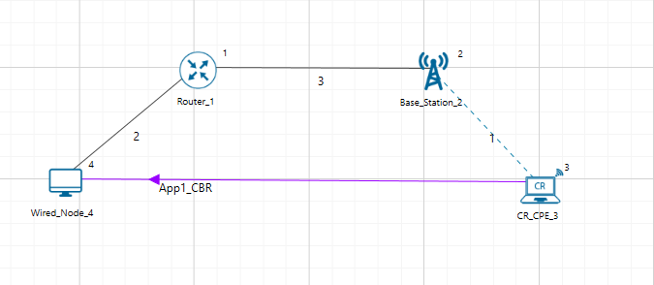

Figure 2: Network Topology in this Project

1. Go to Base-stations Properties > Interface_1(Cognitive-Radio) > Datalink-Layer

|  |  |
| --- | --- |
| **Base-Station Properties** | |
| Operating_Frequency_Start(MHz) | 55 |
| Operating_Frequency _End(MHz) | 56 |
| ON Duration(s) | 10 |
| OFF Duration(s) | 0 |
| Keepout_Distance(m) | 500 |

Table 1: Base station properties in Data-Link layer

1. Run the Simulation for 100 seconds and check the results (by Enabling and Disabling CHANNEL_NOTCHING in Source Code as mentioned in Appendix below).

**Note:** If the NetSim Simulation Console window halts after completing the simulation, manually terminate it by pressing Ctrl+C until it closes.

**Results and discussion:** The throughputs obtained from result dashboard.

|  |  |
| --- | --- |
| Samples | Throughputs (Mbps) |
| With channel notching | 0.002949 |
| Without channel notching | 0.000000 |

Table 2: Different cases with throughputs

**Appendix: NetSim source code modifications and steps.**

1. Open the Source codes in Visual Studio by going to Your work-> Source Code and Clicking on Open code button.

1. In the Solution Explorer, Go to **Cognitive Radio > 802_22.h** and open it.
2. If you want to enable Channel Notching,Uncomment (if commented)**#define _CHANNEL_NOTCHING_**

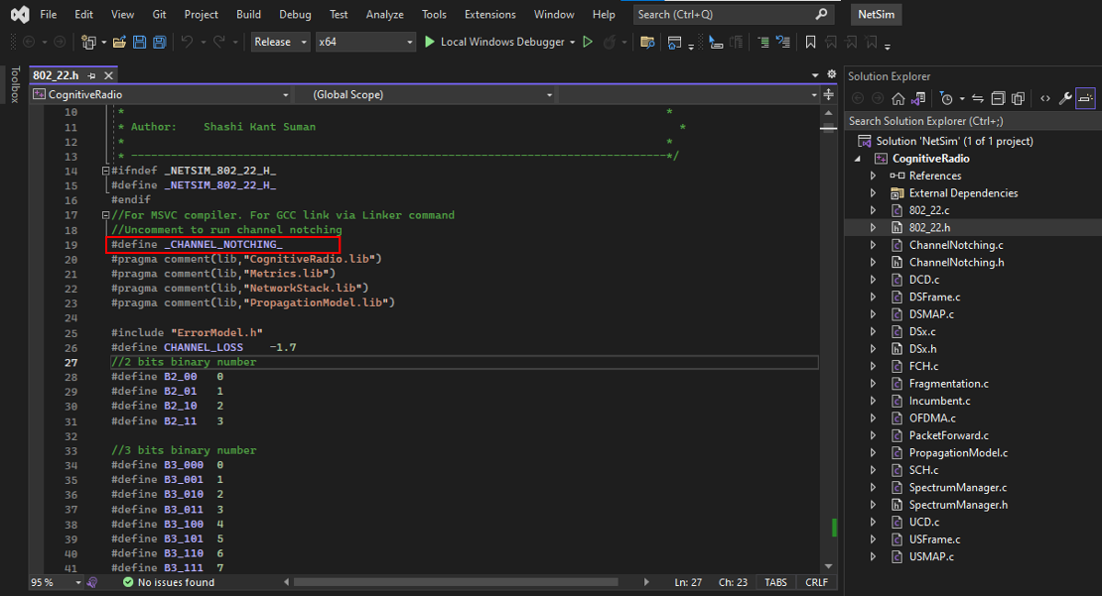

Figure *3*: Comment/Uncomment Channel Notching code

1. If you want do disable Channel Notching, comment **#define_CHANNEL_NOTCHING_**
2. Right click on Solution Explorer-> Rebuild project.