Channel notching in Cognitive Radio Networks

**Software:** NetSim Standard v13.1 (64 bit), Visual Studio 2019

**Project Download Link:**

<https://github.com/NetSim-TETCOS/Channel_Notching_in_CR_Network_v13.1/archive/refs/heads/main.zip>

Follow the instructions specified in the following link to download and setup the Project in NetSim:

https://support.tetcos.com/en/support/solutions/articles/14000128666-downloading-and-setting-up-netsim-file-exchange-projects

**Introduction**

In Cognitive Radio networks, the secondary user (CR CPE) actively senses for the presence of the primary user (Incumbent). If the CR_CPE detects the primary user, then UCS Notifications will be sent by the secondary user to the base station. UCS notifications are generated at the end of the quiet period. Upon receiving the UCS notification BS checks for possible interference between Primary and secondary users. If interference is detected, secondary users vacate the channel and will be moved to a different vacant channel if available.

Channel Notching basically allows the primary and secondary users to co-exist in the same channel. This is achieved by allowing the secondary users to use the free sub channels which are not occupied by the primary users, as compared to the standard case (without channel notching), where the entire channel is blocked even if some of the sub channels of that channel are being used by the Incumbent.

Hence, in cases where there are limited available channels, using Channel Notching will help in achieving higher throughput and channel utilization.

**Note:** Channel notching code will work only for a single Channel, single CR-CPE and for at-most one Incumbent.

**Example**

1. Then Channel_Notching_Workspace comes with a sample configuration that is already saved. To open this example, go to Your work and click on the that is present under the list of experiments as shown below:
2. The saved network scenario consisting of 1 Wired Nodes, 1 router, 1 Base Station and 1 CR_CPE in the grid environment. Traffic is configured from CR_CPE to the Wired node.

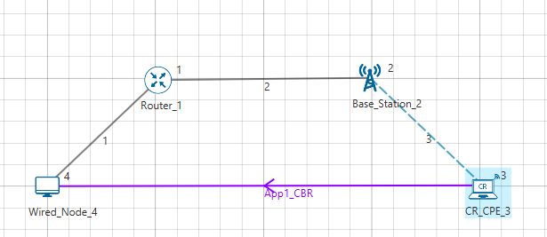

**Figure 1:** Network Topology in this Project

1. Set Base Station properties as

* Oper_Freq_Start(MHz) - 55
* Oper_Freq_End(MHz) - 56
* ON Duration(s) - 10
* OFF Duration(s) - 0
* Keepout_Distance(m) – 500

1. Run the Simulation for both the Samples and check the results.

Note: If the NetSim Simulation Console window haults at Packet Trace completed, terminate the simulation manually by pressing ctrl+c.

**Results and discussion:** The throughputs obtained from result dashboard.

|  |  |
| --- | --- |
| Samples | Throughputs (Mbps) |
| With channel notching | **0.002949** |
| Without channel notching | **0.000000** |

Table 1: Different cases with throughputs

**Appendix: NetSim source code modifications and steps.**

1. Open the Source codes in Visual Studio by going to Your work-> Source Code and Clicking on Open code button.

1. In the Solution Explorer, go to **Cognitive Radio > 802_22.h** and open it.
2. If you want to enable Channel Notching, uncomment (if commented)

**#define _CHANNEL_NOTCHING_**

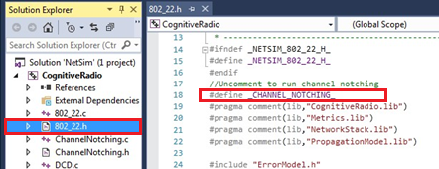

**Figure 2**: Comment/Uncomment Channel Notching code

1. Right click on Solution Explorer-> Rebuild project.