# Study and simulate the LTE handover procedure

## Introduction

The handover logic in NetSim LTE is based on the Strongest Adjacent Cell Handover Algorithm [1]. The algorithm enables each UE to connect to that eNB which provides the highest Reference Signal Received Power (RSRP). Therefore, a handover occurs the moment a better eNB (adjacent cell has offset stronger RSRP, measured as SNR in NetSim) is detected.

This algorithm is similar to Event A3 wherein Neighbor cell’s RSRP becomes Offset better than serving cell’s RSRP. Note that in NetSim report-type is periodical and not eventTrigerred since NetSim is a discrete event simulator and not a continuous time simulator.

# Use of SNR instead of RSRP

NetSim is a packet-level simulator for simulating the performance of end-to-end applications over various packet transport technologies. NetSim can scale to simulating networks with 100s of UEs, eNBs, routers, switches, etc. In order to achieve a scalable simulation, that can execute in reasonable time on desktop-level computers, many details of the physical layer techniques have been abstracted.

In NetSim LTE, there are no pilots/reference/synchronization signals. The channel matrix H is assumed to be known perfectly and instantaneously at the transmitter and receiver, respectively. Hence there is no RSRP, and all signal power related calculations are done using the data channel itself. Therefore, the hand-over is based on the SNR measured at the s-eNB and the t-eNB. Since the noise power would be the same at s-eNB and t-eNB, in effect the handover is based on received signal level on the PDSCH.

## Handover Signalling

1. A data call is established between the UE, S-eNB (Source-eNB) and the network elements. Data packets are transferred to/from the UE to/from the network in both directions (Downlink as well as Uplink).
2. The network sends the MEASUREMENT CONTROL REQ message to the UE to set the parameters to measure and set thresholds for those parameters. Its purpose is to instruct the UE to send a measurement report to the network as soon as it detects the thresholds.
3. The UE sends the UE MEASUREMENT REPORT to the Serving eNB, which contains the RQRS from all the nearby eNBs. The Serving eNB makes the decision to hand off the UE to a T-eNB (Target-eNB) using the handover algorithm mentioned in the Introduction.
4. The S-eNB issues a HANDOVER REQUEST message to the T-eNB passing necessary information to prepare the handover at the target side.
5. The T-eNB sends back the HANDOVER REQUEST ACKNOWLEDGE message including a transparent container to be sent to the UE as an RRC message to perform the handover.
6. The S-eNB generates the RRC (Radio resource control used for signaling transfer) message to perform the handover, i.e., RRC CONNECTION RECONFIGURATION message including the mobility Control Information.
7. The S-eNB starts forwarding the downlink data packets to the T-eNB for all the data bearers which are being established in the T-eNB during the HANDOVER REQ message processing.
8. The T-eNB now requests the S-eNB to release the resources. With this, the handover procedure is complete.

## Procedure

1. Use the following download Link to download a compressed zip folder which contains workspace
2. Extract the zip folder.
3. The extracted project folder consists of a NetSim workspace file (4G_advanced_experiments_with_NetSim.netsimexp).
4. Go to NetSim Home window, go to Your Work and click on Import.

Fig 1: NetSim Home page

1. In the Import Workspace Window, browse and select downloaded. netsimexp file from the extracted directory. Click on create a new workspace option and browse to select a path in your system where you want to set up the workspace folder.
2. Choose a suitable name for the workspace of your choice. Click Import.

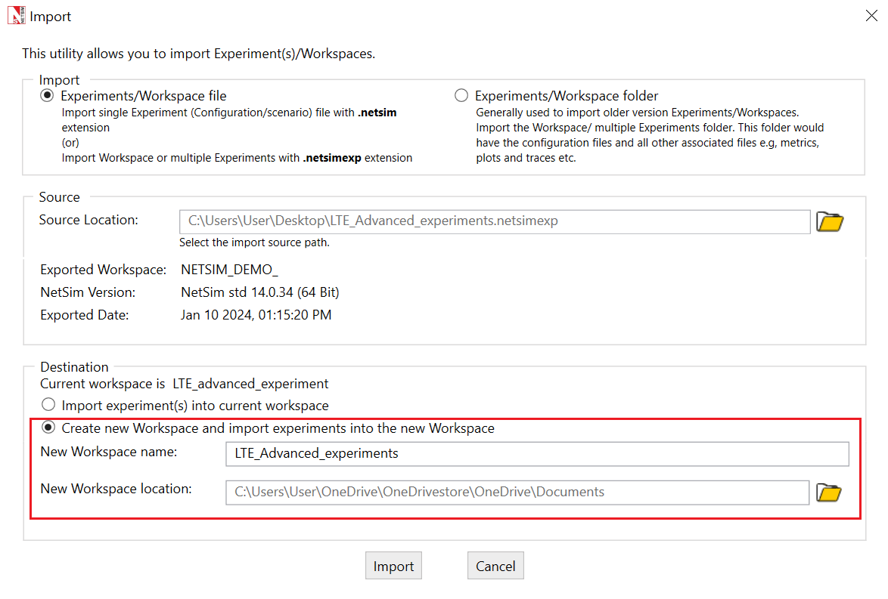

Fig 2: NetSim Import workspace window.

1. The Imported Project workspace will automatically be set as the current workspace.
2. The list of experiments is now loaded onto the selected workspace.

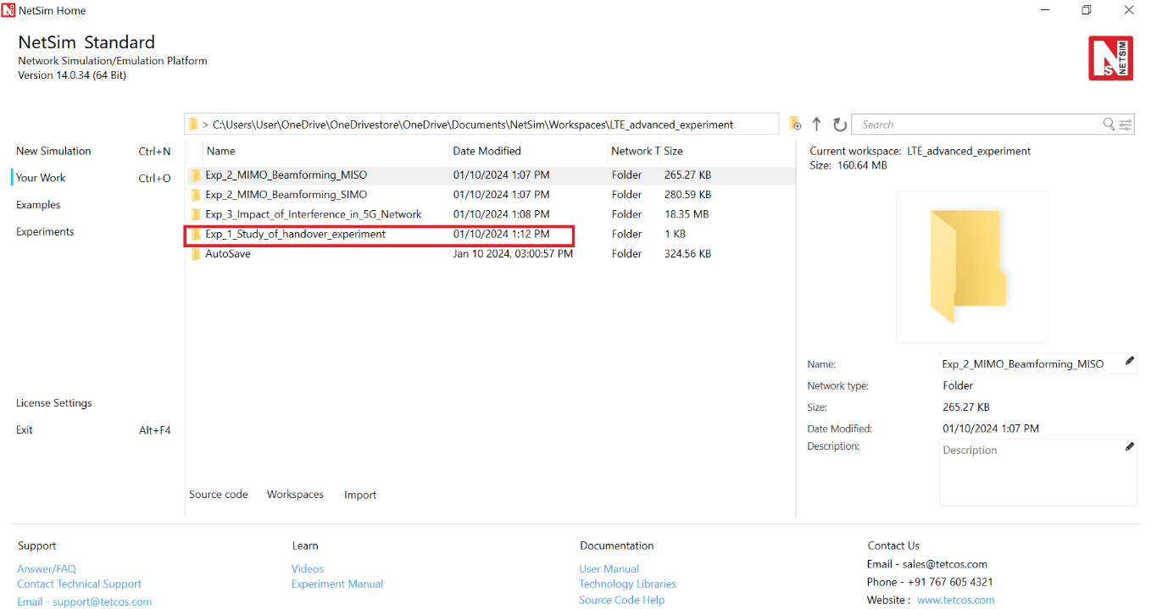

Fig 3: NetSim Your Work Window with the experiment folders inside the workspace

Fig : Network set up for studying the LTE-Handover

## Network Settings

The following set of procedures were done to generate this sample:

**Step 1:** Environment Grid length: 5000m x 5000m.

**Step 2:** A network scenario is designed in NetSim GUI comprising of 2 ENBs, 1 EPC, and 2UEs in the “LTE/LTE-A” Network Library.

**Step 3:** The device positions are set as per the table given below.

|  |  |  |  |  |
| --- | --- | --- | --- | --- |
|  | ENB 4 | ENB 6 | UE 5 | UE 7 |
| X Co-ordinate | 500 | 4500 | 500 | 4500 |
| Y Co-ordinate | 2000 | 2000 | 3500 | 3500 |

Table : Device Position

**Step 4:** In the General Properties of UE 5, set Mobility Model as File Based Mobility.

**Step 5:** Right click on eNB 4 and select open properties as new window, the following properties are set.

|  |  |
| --- | --- |
| Interface (LTE) Properties | |
| CA TYPE | SINGLE BAND |
| CA Configuration | BAND42 |
| CA Count | 1 |
| Numerology | 0 |
| Channel Bandwidth (MHz) | 10 |
| PRB Count | 50 |
| MCS Table | QAM64 |
| CQI Table | TABLE1 |
| X Overhead | XOHO |
| DL UL Ratio | 4:1 |
| Outdoor Scenario | URBAN_MACRO |
| LOS NLOS Selection | USER_DEFINED |
| LOS Probability | 1 |
| Shadow Fading Model | None |
| Fading and Beamforming | NO_FADING_MIMO_UNIT_GAIN |

Table : Interface (LTE) Properties Setting

Similarly, it is set for eNB 6.

**Step 6:** Configure an application between two nodes by selecting a CBR application from the Set Traffic tab. Right click and select properties.

A CBR Application is generated from Server i.e., Node 3 to UE 5 i.e., Destination with Packet Size remaining 1460Bytes and Inter Arrival Time remaining 20000µs. QOS is set to UGS.

**File Based Mobility**

In File Based Mobility, users can write their own custom mobility models and define the movement of the mobile users. Create a mobility.csv file for UE’s involved in mobility with each step equal to 0.5 sec with distance 150 m.

The NetSim Mobility File (mobility.csv) format is as follows:

|  |  |  |  |  |
| --- | --- | --- | --- | --- |
| #Time(s) | Device ID | X | Y | Z |
| 0 | 5 | 1000 | 3500 | 0 |
| 0.5 | 5 | 1250 | 3500 | 0 |
| 1 | 5 | 1500 | 3500 | 0 |
| 1.5 | 5 | 1750 | 3500 | 0 |
| 2 | 5 | 2000 | 3500 | 0 |
| 2.5 | 5 | 2250 | 3500 | 0 |
| . | . | . | . | . |
| . | . | . | . | . |
| . | . | . | . | . |
| 5.5 | 5 | 3750 | 3500 | 0 |
| 6 | 5 | 4000 | 3500 | 0 |
| 6.5 | 5 | 4250 | 3500 | 0 |
| 7 | 5 | 4500 | 3500 | 0 |

Table : Mobility.csv file

**Step 7:** Enable Packet Trace, Plots and Logs in NetSim GUI as shown in below figure. At the end of the simulation, a large .csv file contains all the packet information and is available for the users to perform packet level analysis.

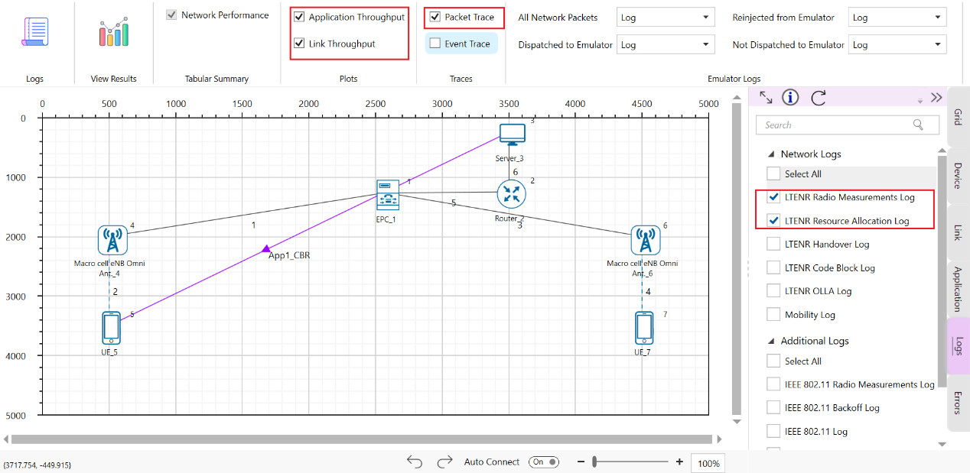

Fig : Enabling plots, packet trace and log file.

**Step 9**: Run the Simulation for 10 Seconds.

### Results and Discussion

### Handover Signalling

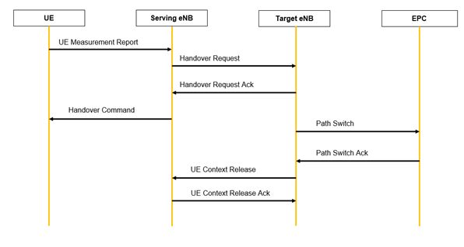

Fig : Control packet flow in the LTE handover process

Note:

* The Handover Request and Handover Request Ack will be sent from the serving eNB to Target eNB through EPC.
* Context Release and Context Release Ack will be sent from the serving eNB and to Target eNB through EPC.

The packet flow depicted above can be observed from the packet trace.

1. UE will send the UE_MEASUREMENT_REPORT every 120ms to the connected eNB
2. The initial UE- eNB connection, eNB will send the RRC_MIB packets to the UE every 40 ms and RRC_SIB1 every 80 ms.
3. After the transmission of the RRC_MIB and RRC_SIB1 packets, the eNB will send RRC_SI packet to the UE.
4. After reception of RRC_SI packet, UE will send RRC_Setup_Request to the eNB.
5. On receiving the RRC_Setup_Request packet, the eNB will acknowledge the request by transmitting RRC_Setup packet to the UE.
6. The UE will send back the RRC_Setup_Complete packet on the receipt of RRC_Setup message.
7. As Per the configured file-based mobility, UE 5 moves towards eNB 6.
8. After 6s eNB 4 sends the HANDOVER REQUEST to eNB 6.
9. eNB 6 sends back HANDOVER REQUEST ACK to eNB 4.
10. After receiving HANDOVER REQUEST ACK from eNB 6, eNB 4 sends the HANDOVER COMMAND to UE 5
11. After the HANDOVER COMMAND packet is transferred to the UE, the target eNB will send the PATH SWITCH packet to the EPC_1.
12. When the EPC_1 receives the PATH SWITCH packet, it sends PATH_SWICTH_ACK packet to the eNB 6.
13. The target eNB sends CONTEXT RELEASE to source eNB, and the source eNB sends back CONTEXT RELEASE ACK to target eNB. The context release request and ack packets are sent between the source and target eNB via EPC 1.
14. RRC Reconfiguration will take place between target eNB and UE 5.

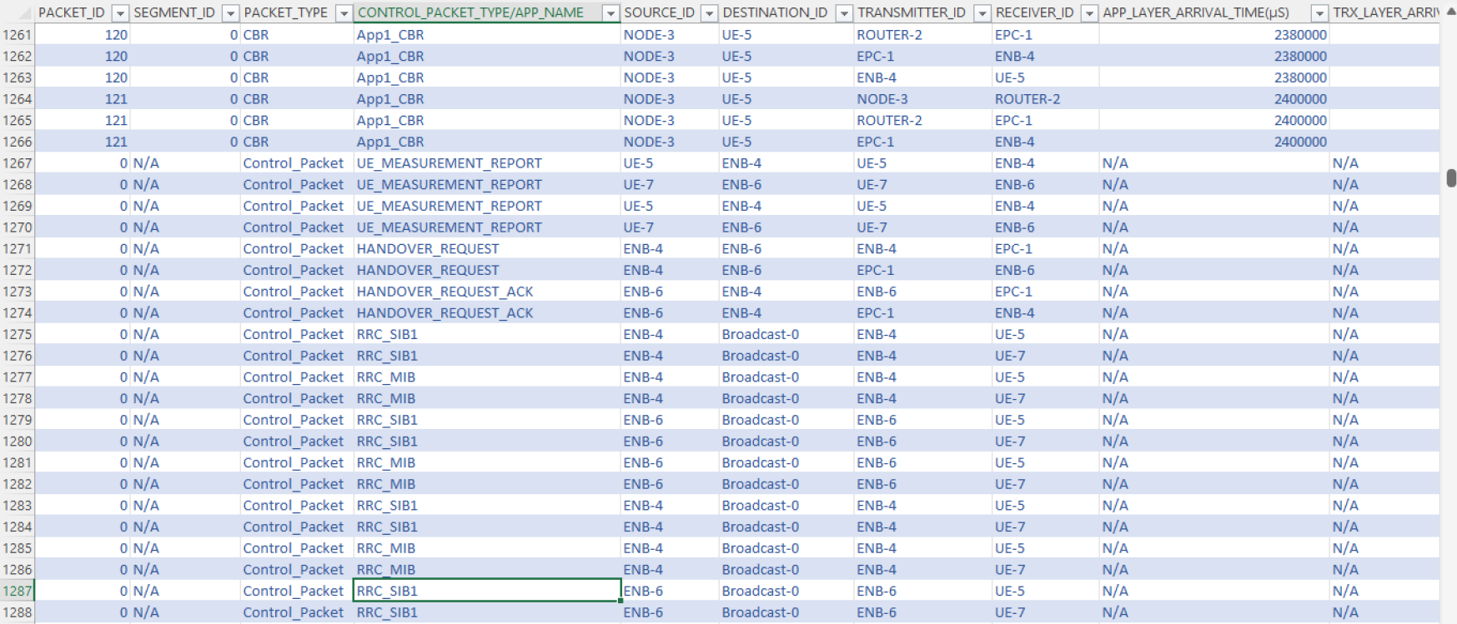

Fig : NetSim packet trace file showing the control packets involved in handover.

1. The UE 5 will start sending the UE MEASUREMENT REPORT to eNB 6

**Plot of SNR vs. Time**

Fig : Plot of DL SNR (at UE_5 from eNB4 and eNB6) vs time

* Time 4s when the SNR from eNB 4 is 5.15dB and the SNR from eNB 6 is 10.67dB. This represents the point where Adj cell RSRP is greater than serving cell RSRP by Hand-over margin (HOM) of 3dB.

The above plot can be obtained from LTE Radio Measurement log. Follow the below steps to generate the above plot.

1. After simulation, open LTENR Radio measurement log present under the Log files section in the Results Dashboard

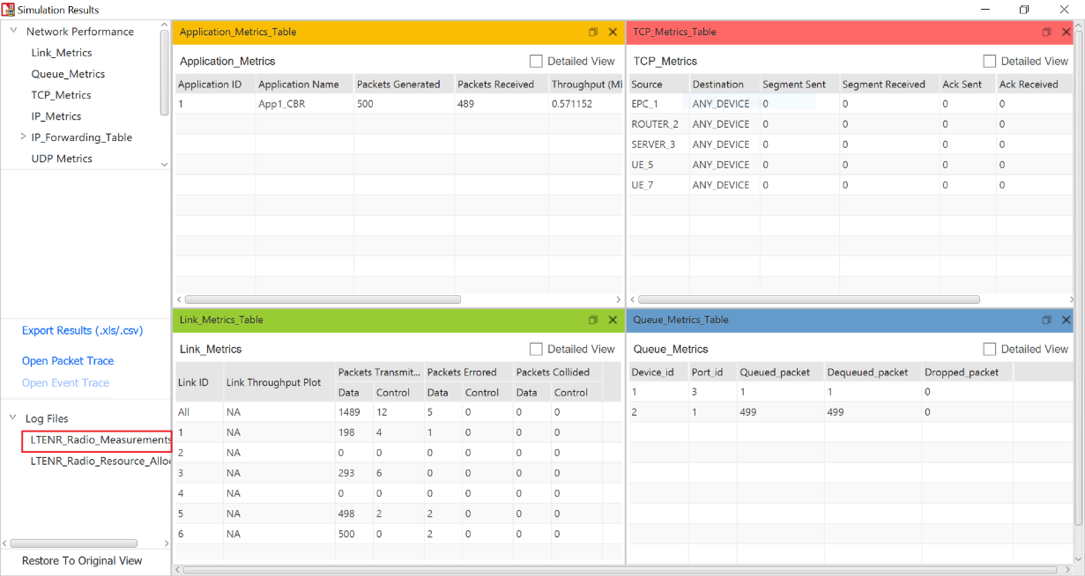

Fig : Opening the LTENR Radio Measurement logs from simulation result window.

1. Create a pivot table for this log file by clicking the pivot option present at the top of the ribbon under insert section as shown below.
2. In the pivot table drop ‘eNB/eNB Name’, ‘UE Name’, ‘Channel’ fields under filters area, drop ‘Time (ms)’ in Row area and drop ‘SINR’ in Value area. Set the SINR values to max by clicking on the arrow icon present at the end of the field ->value field setting->max as shown below as shown in below figure.

|  |  |
| --- | --- |
| Fig : Inserting pivot table | Fig : Creating pivot table. |

1. Now filter eNB as eNB4, UE name as UE_5, Channel as PDSCH
2. Copy the values of Row Labels and Max_SINR_dB header and paste it into another sheet. These are the downlink SNR value of UE5 from eNB4.

|  |  |
| --- | --- |
| Fig : Time and SINR values for eNB4 | Fig : Pasting the Time and SINR values into new sheet. |

1. Similarly filter gNB/eNB name to eNB_6 and copy only the row label value and paste it at the end of previously pasted values sheet.

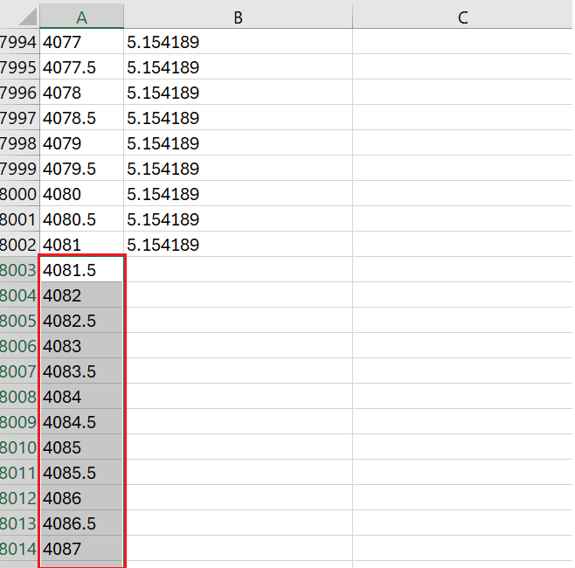

Fig : Pasting the Time values for eNB6 to new sheet.

1. Copy the SNR values from eNB6, create a new header labelled 'DL SNR at UE5 from eNB6,' and paste them starting from the exact 'Time(ms)' when the SNR values for eNB6 are logged.

|  |  |
| --- | --- |
| Fig : Creating the heading for SNR values obtained for eNB6. | Fig : Pasting the SINR values of eNB6 to new sheet. |

1. Then select all the values and insert the scatter chart in the excel sheet.

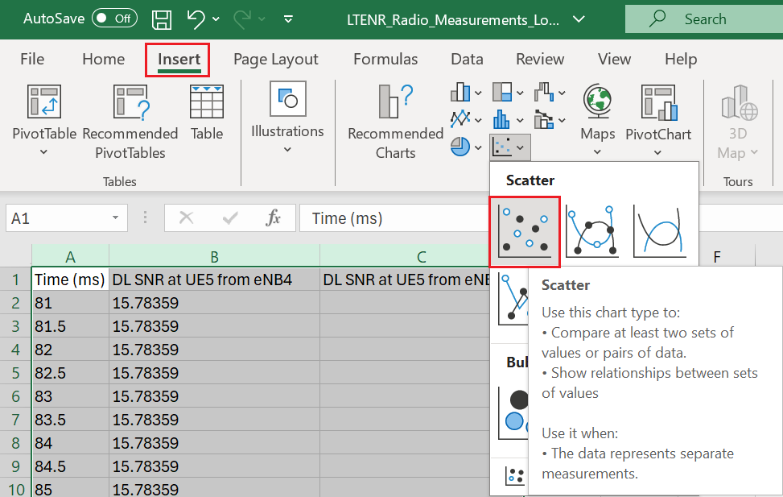

Fig : Creating the plot from the excel sheet.

# Reference

|  |  |
| --- | --- |
| [1] | K. Dimou, "Handover within 3GPP LTE: Design Principles and Performance," Ericsson Research. |