# Pathloss, Shadowing and Fading

Part 1: Pathloss and Shadowing

**Log-distance pathloss**

Path loss is the reduction in power density of an electromagnetic wave as it propagates through space. Path loss is a positive quantity measured in dB and is defined as the difference (in dB) between the transmitted power and the received power and may or may not include the effect of antenna gains.

Both theoretical and measurement-based propagation models indicate that average received signal power decreases logarithmically with distance whether in outdoor or in indoor ratio channels. The average large-scale pathloss for an arbitrary transmitter-receiver separation is expressed as a function of distance by using the pathloss exponent , which indicates the rate at which the pathloss increases with distance [1]. Therefore pathloss .

The general formula (when written in dB scale) by which received power is calculated when using the log-distance model and including the effect of antenna gains is

Where,

is the received power,

is the transmit power,

is the transmitter antenna gain, and is the receiver antenna again.

𝑑 is the distance between the transmitter and receiver.

𝑑0 is the reference distance, and the model is applicable only for

𝜆 is the wavelength and is equal to where 𝑐 is the speed of light and 𝑓 is the frequency in

is the path loss exponent, whose value is normally in the range of 2 to 5,

Define the path loss at reference distance as Now, when the antenna gains at the transmitter and receiver is unity, i.e., when , the general pathloss formula can be re-written as

which shows us that (in the dB scale) the received power is the transmitted power minus the pathloss.

**Log Normal Shadowing**

With pathloss models the predicted path loss between a transmitter and a receiver is constant for a given distance. However, different types of terrain and clutter may exist in the transmitter-receiver path. Therefore, the path losses may be vastly different than the *average* value predicted in (1), for two different locations having the same transmitter-receiver separation distance. Some paths undergo more loss while others are less obstructed and may have higher received signal strength. The variation of path loss with respect to the mean path loss values predicted by the propagation models, depending on the type of environment is called *shadowing*. Shadowing is also termed *shadow-fading* or *slow fading*.

Models for path loss and shadowing can be superimposed to capture power falloff versus distance along with the random attenuation about this average path loss from shadowing. Empirical studies have shown that this randomness is captured well by a second factor, , of the form with being a Gaussian random variable with mean and variance . This is called the shadowing component of the attenuation, and, since has a Gaussian (or normal) distribution, it is called log-normal shadowing [2]. In the combined model the total loss in dB scale is given by

Where is a zero-mean Gaussian distributed random variable (in dB) with standard deviation (in dB). In NetSim, the default value for 𝑖𝑠 , and the range of (in dB) is .

### Procedure

1. Use the following download Link to download a compressed zip folder which contains workspace [GitHub link](https://codeload.github.com/NetSim-TETCOS/Communication-Lab_BITS-Goa/zip/refs/heads/main)
2. Extract the zip folder.
3. The extracted project folder consists of a NetSim workspace file (4G_advanced_experiments_with_NetSim.netsimexp).
4. Go to NetSim Home window, go to Your Work and click on Import.

Figure 1‑1: Your Work Page of Netsim.

1. In the Import Workspace Window, browse and select downloaded. netsimexp file from the extracted directory. Click on create a new workspace option and browse to select a path in your system where you want to set up the workspace folder.
2. Choose a suitable name for the workspace of your choice. Click Import

Figure 1‑2: Creating a new Workspace.

1. The Imported Project workspace will automatically be set as the current workspace.
2. The list of experiments is now loaded onto the selected workspace.

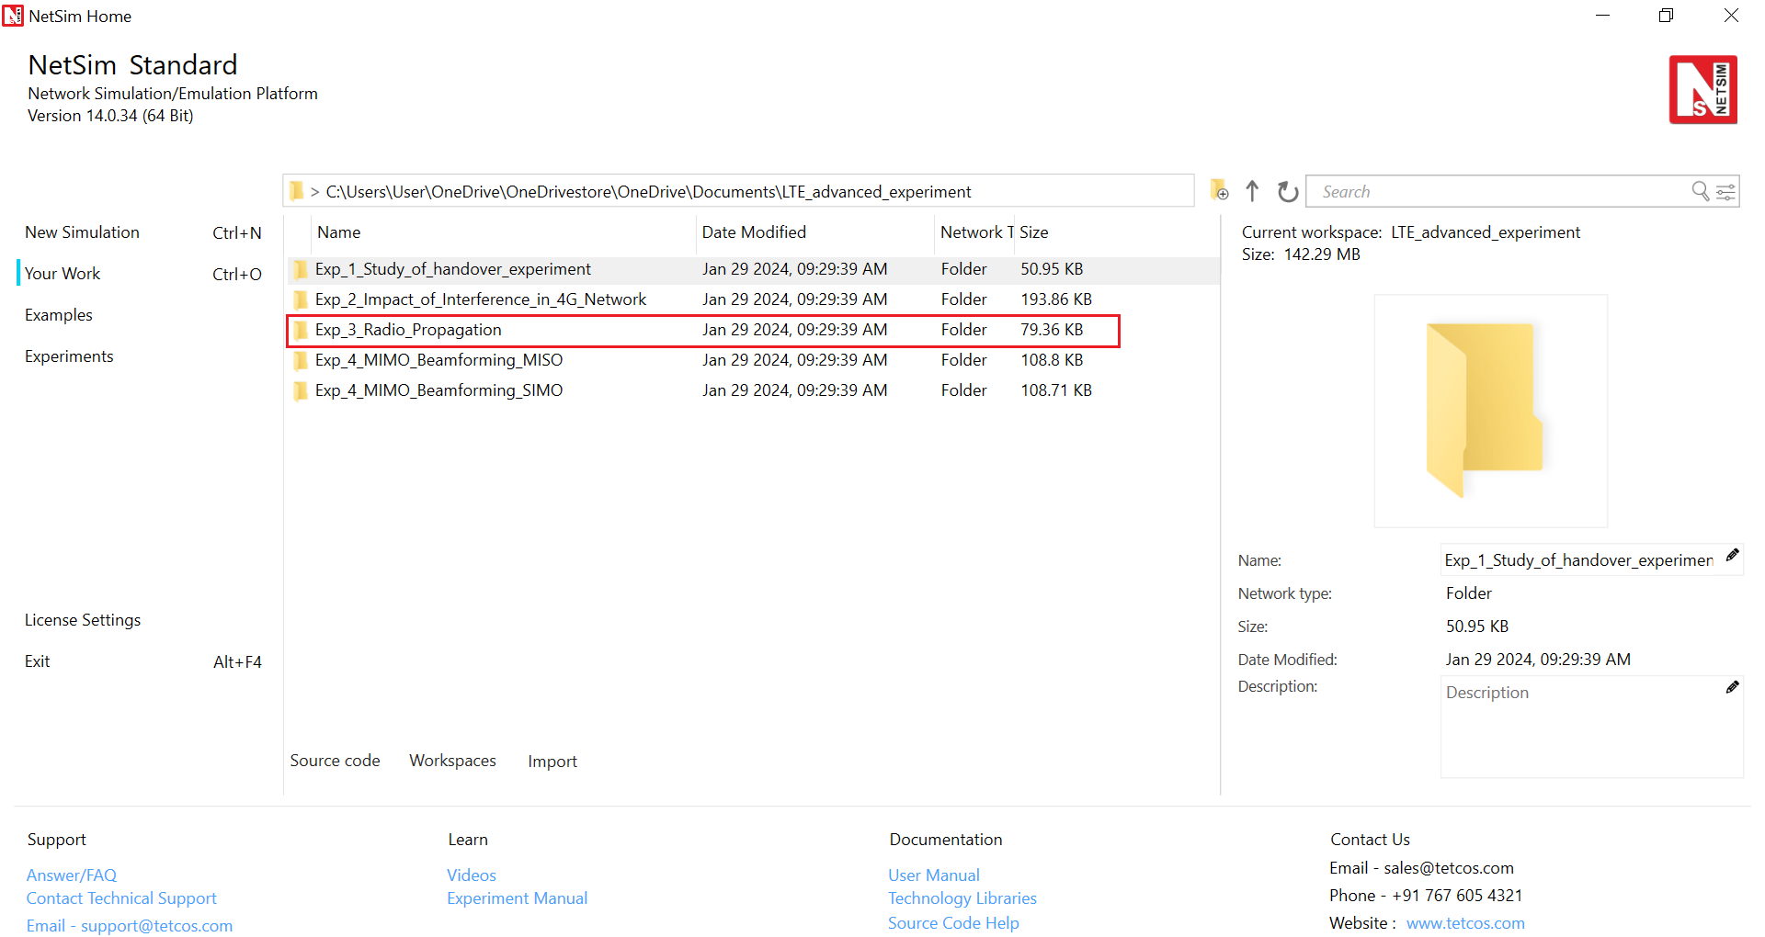

Figure 1‑3: NetSim Your Work Window with the experiment folders inside the workspace

### Network Setup

**Pathloss Only**

**Step 1:** Open NetSim and click on Mobile Ad hoc Network.

**Step 2:** Create a scenario with 2 wireless nodes.

Figure 1‑4: A Network consists of 2 Wireless Nodes. Wireless Node 1 and Wireless Node 2 separated by distance in meters. The values of are provided in **Table 1‑4**.

**Step 3:** Go to the Properties of Wireless Node 1 🡪 Position Layer 🡪 Mobility Layer 🡪 Mobility Model set to No Mobility.

**Step 4:** Go to the Properties of Wireless Node 1 🡪 Network Layer 🡪 Enable the static route.

**Step 5:** Configure static routing in Wireless Node 1 as shown in below below

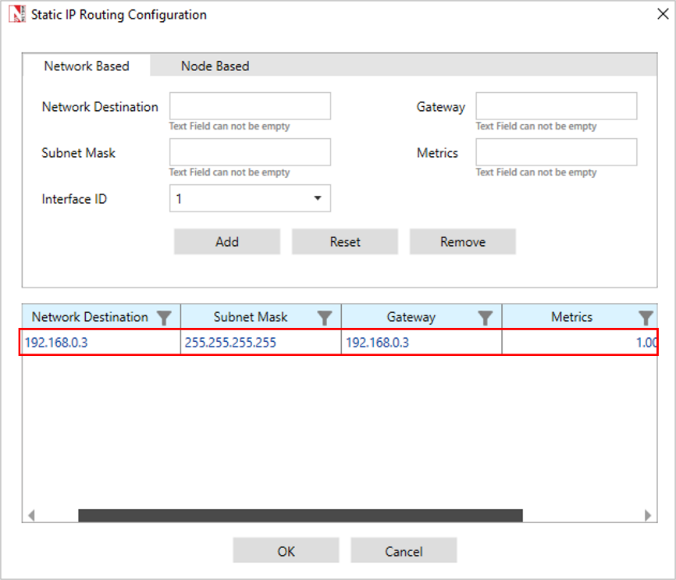

Figure 1‑5: Configure Static Routing in Wireless Node 1 via GUI

**Step 6:** Configure the Wireless link properties as per Table 1‑1.

|  |  |
| --- | --- |
| Link_1 Properties | |
| Channel Characteristics | PATHLOSS_ONLY |
| Pathloss Model | LOG_DISTANCE |
| Pathloss Exponent () | 3 |

Table 1‑1: Wireless Link Properties.

**Step 7:** To configure the Application Traffic, Go to Set Traffic Tab and set the properties as below in Table 1‑2.

|  |  |
| --- | --- |
| Application Properties | |
| Application Method | UNICAST |
| Application Type | CBR |
| Source ID | 1 |
| Destination ID | 2 |
| Start Time (s) | 5 |
| Packet Size (Bytes) | 500 |
| Inter Arrival Time | 20 |

Table 1‑2: Application Properties

**Step 8:** Enable the IEEE 802.11 Radio Measurements Log in NetSim GUI from Configure Reports Tab 🡪 Logs Section as shown below.

Figure 1‑6: Enabling Radio Measurement Log from GUI

**Step 9:** Run the simulation for 10 seconds and for each simulation use different seed values.

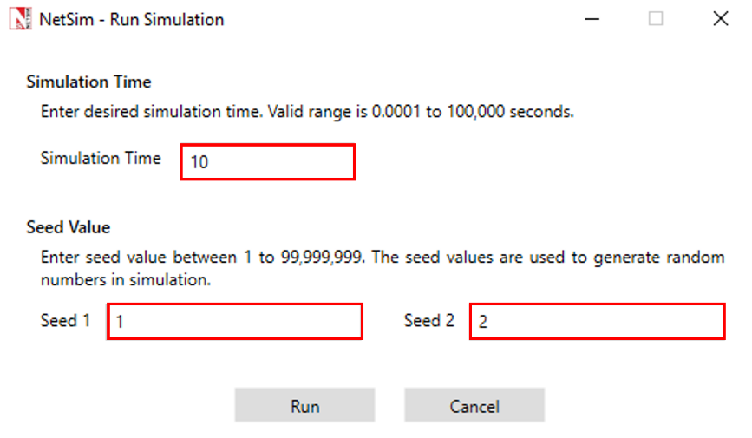

Figure 1‑7: Run simulation window shown with the seed values.

**Step** **10**: For each simulation vary the distance between the Transmitter that is Wireless Node 1 and Receiver that is Wireless Node 2 as 1, 2, 5, 10, 20, 50, 100, 200 (in meters).

**Step 11:** Note Down the Pathloss (dB), Receiver Power (dBm) from Radio Measurement log file present under log section in result dashboard.

Figure 1‑8: Radio Measurement Log under Logs section in Result Dashboard.

**Pathloss and Shadowing**

Consider Previous Scenario,

**Step 1:** Configure the Wireless link properties as per Table 1‑3.

|  |  |
| --- | --- |
| Link_1 Properties | |
| Channel Characteristics | PATHLOSS_AND_SHADOWING |
| Pathloss Model | LOG_DISTANCE |
| Pathloss Exponent | 3 |
| Shadowing Model | LOGNORMAL |
| Standard Deviation (dB) | 5 |

Table 1‑3: Wireless Link Properties

**Step** **2:** Run the simulation for 10 seconds and for each simulation use different seed values.

**Step 3:** For each simulation vary the distance between the Transmitter that is Wireless Node 1 and Receiver that is Wireless Node 2 as 1, 2, 5, 10, 20, 50, 100, 200 (in meters).

**Step 4:** Note Down the Pathloss (dB), Receiver Power (dBm), Shadowing Loss (dB) and Total Loss (dB) from Radio Measurement log file present under log section in result dashboard.

### Results and Discussion

**Pathloss Only**

|  |  |  |  |  |  |
| --- | --- | --- | --- | --- | --- |
| Distance (m) | RNG Seed 1 | RNG  Seed 2 | TX Power (dBm) | Path Loss (dB) | RX Power (dBm) |
| 1 | 1 | 2 | 20 | 40.09 | -20.09 |
| 2 | 2 | 3 | 20 | 49.12 | -29.12 |
| 5 | 3 | 4 | 20 | 61.06 | -41.06 |
| 10 | 4 | 5 | 20 | 70.09 | -50.09 |
| 20 | 5 | 6 | 20 | 79.12 | -59.12 |
| 50 | 6 | 7 | 20 | 91.06 | -71.06 |
| 100 | 7 | 8 | 20 | 100.09 | -80.09 |
| 200 | 8 | 9 | 20 | 109.12 | -89.12 |

Table 1‑4: Results of NetSim simulations showing Pathloss and Received power vs. Distance with different seed values. Note that NetSim uses two input seeds for its random number generator.

**Pathloss and Shadowing**

|  |  |  |  |  |  |  |  |
| --- | --- | --- | --- | --- | --- | --- | --- |
| Distance, (m) | RNG  Seed 1 | RNG  Seed 2 | TX Power (dBm) | Path Loss (dB) | Shadowing Loss (dB) | Total Loss (dB) | RX Power (dBm) |
| 1 | 1 | 2 | 20 | 40.09 | -2.14 | 37.95 | -17.95 |
| 2 | 2 | 3 | 20 | 49.12 | 6.86 | 55.99 | -35.99 |
| 5 | 3 | 4 | 20 | 61.06 | 4.84 | 65.9 | -45.9 |
| 10 | 4 | 5 | 20 | 70.09 | 4.31 | 74.4 | -54.4 |
| 20 | 5 | 6 | 20 | 79.12 | -1.23 | 77.89 | -57.89 |
| 50 | 6 | 7 | 20 | 91.06 | -4.76 | 86.3 | -66.3 |
| 100 | 7 | 8 | 20 | 100.09 | -4.57 | 95.52 | -75.52 |
| 200 | 8 | 9 | 20 | 109.12 | 3.44 | 112.56 | -92.56 |

Table 1‑5: Results of NetSim simulations showing Pathloss, Shadowing loss and Received Power vs Distance with different seed values.

Figure 1‑9: Simulation results of Loss (dB) vs. Distance (m) for Pathloss only and for Pathloss with shadowing. The X-axis is a log scale. We can also easily calculate that the slope of the pathloss (green) line is 30 which is the value of .

On comparing Table 1‑4 and Table 1‑5, we can observe identical pathloss values at equal distances. This shows that the pathloss is deterministic, showing no dependency on the seed used in the random number generator. Recall that implying that pathloss plots as a linear line against the logarithm of distance. This is exactly what we observe in the above figure. Furthermore, the slope of this pathloss line turns out to be 3 which is the value of configured in the simulation. Both of the above observations are consistent with the log-distance pathloss model. On the other hand, the shadowing loss behaves as a random variable.

Let us theoretically calculate the value of pathloss at a distance of 100m. We know that , where the speed of light is taken as and the frequency, is GHz.

This agrees with the result shown in Table 1‑5.

Part 2: Rayleigh Fading

**Introduction**

Small-scale fading or simply *fading,* is used to describe the rapid fluctuation of the amplitude of a radio signal over a short period of time. Fading is caused by interference between two or more versions of the transmitted signal which arrive at the receiver at slightly different times. These waves called *multipath waves,* combine at the receiver antenna to give a resultant signal which can vary widely in amplitude and phase depending on the distribution of the intensity and relative propagation time of the waves. [1]

Rayleigh fading is widely used in to model rapid fluctuations in signal strength due to multipath propagation in wireless networks. In part 1, we saw the impact of two terms pathloss (PL) and shadowing (S) in signal attenuation. The third factor, Rayleigh fading, denoted as has a probability density function (pdf) given by

The distribution of the amplitude attenuation is Rayleigh; hence this is also called Rayleigh fading.

### Procedure

### Network Setup

**Pathloss** **Only**

**Step 1:** Open NetSim and click on Mobile ad hoc Network.

**Step 2:** Create a scenario with 2 wireless nodes 100m from each other.

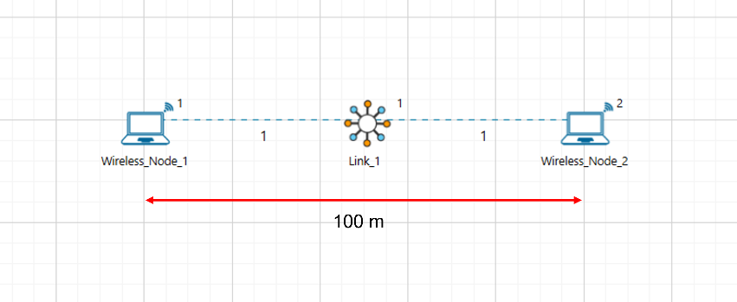

Figure 1‑10: A Network consists of 2 Wireless Nodes. Wireless Node 1 and Wireless Node 2 separated by distance .

**Step 3:** Go to the Properties of Wireless Node 1 🡪 Position Layer 🡪 Mobility Layer 🡪 Mobility Model set to No Mobility.

**Step 4:** Go to the Properties of Wireless Node 1 🡪 Network Layer 🡪 Enable the static route.

**Step 5:** Configure static routing in Wireless Node 1 as shown in below figure.

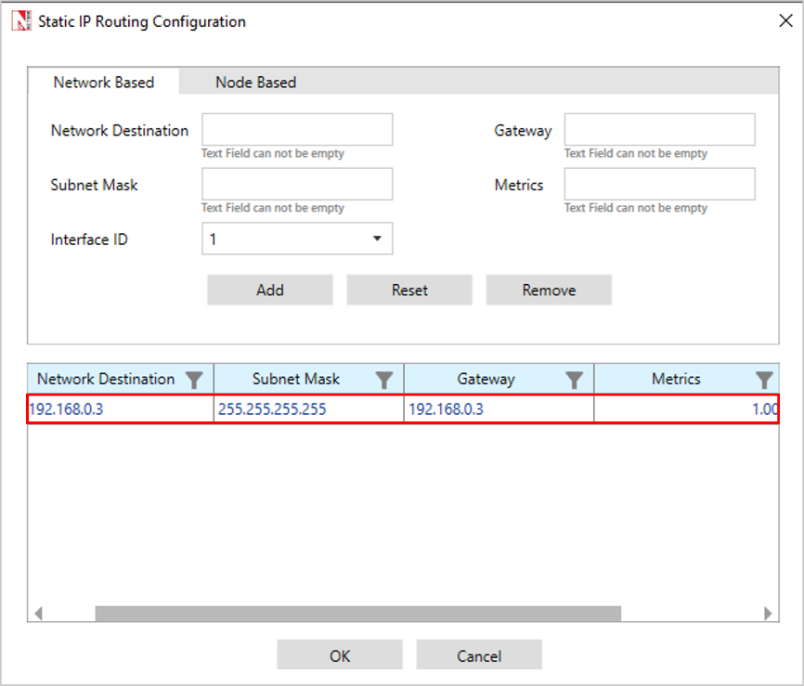

Figure 1‑11: Configure Static Routing in GUI

**Step 6:** Configure the Wireless link properties as per Table 1‑6.

|  |  |
| --- | --- |
| Link_1 Properties | |
| Channel Characteristics | PATHLOSS_ONLY |
| Pathloss Model | LOG_DISTANCE |
| Pathloss Exponent () | 3 |

Table 1‑6: Wireless Link Properties

**Step 7:** To configure the Application Traffic, Go to Set Traffic Tab and set the properties as below Table 1‑7.

|  |  |
| --- | --- |
| Application Properties | |
| Application Method | UNICAST |
| Application Type | CBR |
| Source ID | 1 |
| Destination ID | 2 |
| Start Time (s) | 0 |
| Packet Size (Bytes) | 1460 |
| Inter Arrival Time | 100000 |

Table 1‑7: Application Properties

**Step 8:** Enable the IEEE 802.11 Radio Measurements Log in NetSim GUI from Configure Reports Tab 🡪 Logs Section.

**Step 9:** Run the simulation for 5 seconds.

**Step 10:** In the Radio Measurement log file present under log section of the result dashboard, filter packet type to CBR and then note down the Time (, Pathloss (dB) and Total Loss(dB).

**Pathloss and Fading**

Consider the previous scenario.

**Step 1:** Configure the Wireless link properties as per Table 1‑8.

|  |  |
| --- | --- |
| Link_1 Properties | |
| Channel Characteristics | PATHLOSS_AND_SHADOWING_AND_FADING |
| Pathloss Model | LOG_DISTANCE |
| Pathloss Exponent () | 3 |
| Shadowing Model | NONE |
| Fading Model | RAYLEIGH |
| Scale Parameter (w) | 1 |

Table 1‑8: Wireless Link Properties

**Step 2:** Run the simulation for 5 seconds.

**Step 3:** In the Radio Measurement log file present under log section of the result dashboard, filter packet type to CBR and then note down the Time (, Pathloss (dB) and Total Loss(dB).

### Results and Discussion

|  |  |  |  |  |  |
| --- | --- | --- | --- | --- | --- |
| Time (s) | Pathloss Only | | Pathloss and fading | | |
| **Path Loss (dB)** | **Total Loss (dB)** | **Path Loss (dB)** | **Fading Loss (dB)** | **Total Loss (dB)** |
| 0.012806 | 100.09 | 100.09 | 100.09 | 0 | 100.09 |
| 0.112826 | 100.09 | 100.09 | 100.09 | -5.08 | 95.01 |
| 0.212546 | 100.09 | 100.09 | 100.09 | -2.99 | 97.1 |
| 0.312686 | 100.09 | 100.09 | 100.09 | -4.26 | 95.83 |
| 0.412526 | 100.09 | 100.09 | 100.09 | -3.49 | 96.6 |
| 0.512506 | 100.09 | 100.09 | 100.09 | 1 | 101.09 |
| 0.612506 | 100.09 | 100.09 | 100.09 | -7.87 | 92.22 |
| 0.712866 | 100.09 | 100.09 | 100.09 | 0.13 | 100.22 |
| 0.812486 | 100.09 | 100.09 | 100.09 | 2.36 | 102.45 |
| 0.912506 | 100.09 | 100.09 | 100.09 | -11.82 | 88.27 |
| 1.013006 | 100.09 | 100.09 | 100.09 | -2.62 | 97.47 |
| 1.112666 | 100.09 | 100.09 | 100.09 | -5.57 | 94.52 |
| 1.213006 | 100.09 | 100.09 | 100.09 | -7.88 | 92.21 |
| 1.312726 | 100.09 | 100.09 | 100.09 | -12.64 | 87.45 |
| 1.412706 | 100.09 | 100.09 | 100.09 | -4.49 | 95.6 |
| 1.512686 | 100.09 | 100.09 | 100.09 | 0.29 | 100.38 |
| 1.612586 | 100.09 | 100.09 | 100.09 | 5.61 | 105.7 |
| 1.712566 | 100.09 | 100.09 | 100.09 | 1.17 | 101.26 |
| 1.812866 | 100.09 | 100.09 | 100.09 | -8.49 | 91.6 |
| 1.912486 | 100.09 | 100.09 | 100.09 | 1.84 | 101.93 |
| 2.012766 | 100.09 | 100.09 | 100.09 | -9.02 | 91.07 |
| 2.112726 | 100.09 | 100.09 | 100.09 | 5.53 | 105.62 |
| 2.212766 | 100.09 | 100.09 | 100.09 | -3.39 | 96.7 |
| 2.312486 | 100.09 | 100.09 | 100.09 | -1.94 | 98.15 |
| 2.412706 | 100.09 | 100.09 | 100.09 | 1.23 | 101.32 |
| 2.513066 | 100.09 | 100.09 | 100.09 | 2.95 | 103.04 |
| 2.612886 | 100.09 | 100.09 | 100.09 | -15.58 | 84.51 |
| 2.713066 | 100.09 | 100.09 | 100.09 | -6.99 | 93.1 |
| 2.812766 | 100.09 | 100.09 | 100.09 | 5.44 | 105.53 |
| 2.912846 | 100.09 | 100.09 | 100.09 | 2.55 | 102.64 |
| 3.012486 | 100.09 | 100.09 | 100.09 | 1.48 | 101.57 |
| 3.112646 | 100.09 | 100.09 | 100.09 | -3.41 | 96.68 |
| 3.213046 | 100.09 | 100.09 | 100.09 | 0.03 | 100.12 |
| 3.312686 | 100.09 | 100.09 | 100.09 | -3.26 | 96.83 |
| 3.412486 | 100.09 | 100.09 | 100.09 | -0.3 | 99.79 |
| 3.512926 | 100.09 | 100.09 | 100.09 | 1.4 | 101.49 |
| 3.612566 | 100.09 | 100.09 | 100.09 | -5.85 | 94.24 |
| 3.712646 | 100.09 | 100.09 | 100.09 | -2.73 | 97.36 |
| 3.813066 | 100.09 | 100.09 | 100.09 | -3.53 | 96.56 |
| 3.912986 | 100.09 | 100.09 | 100.09 | -14.11 | 85.98 |
| 4.012886 | 100.09 | 100.09 | 100.09 | -3.29 | 96.8 |
| 4.112846 | 100.09 | 100.09 | 100.09 | -7.14 | 92.95 |
| 4.212506 | 100.09 | 100.09 | 100.09 | -2.67 | 97.42 |
| 4.312686 | 100.09 | 100.09 | 100.09 | -5.31 | 94.78 |
| 4.412586 | 100.09 | 100.09 | 100.09 | 6.92 | 107.01 |
| 4.512926 | 100.09 | 100.09 | 100.09 | 0.45 | 100.54 |
| 4.612686 | 100.09 | 100.09 | 100.09 | -8.77 | 91.32 |
| 4.712486 | 100.09 | 100.09 | 100.09 | -6.04 | 94.05 |
| 4.812926 | 100.09 | 100.09 | 100.09 | -8.63 | 91.46 |
| 4.912686 | 100.09 | 100.09 | 100.09 | -0.15 | 99.94 |

Table 1‑9: Results Table for Wireless Node 1 and Wireless Node 2 100m from each other with pathloss only and pathloss and fading.

Figure 1‑12: Loss in dB vs. Time when running Pathloss and Pathloss with Fading cases.

From the above figure, it is evident that pathloss (green line) remains constant over time. However, when fading is factored in, the total loss (yellow line) exhibits temporal variability. This total loss is composed of two elements: pathloss and fading loss. Among these, pathloss is time-invariant, whereas fading loss fluctuates over time as can be seen from Table 1‑9.

|  |  |
| --- | --- |
| [1] | T. Rappaport, "Wireless Communications," 2002. |
| [2] | D. M. J. K. Anurag Kumar, "Wireless Networking," Morgan Kaufmann, 2008. |

## References