# **MATLAB INTERFACE FOR RPL DODAG VISUALIZATION**

**Software Recommended:** NetSim Standard v10.2 (64bit), Visual Studio 2015, MATLAB 2016a (64bit)

**Note:** This project works only MATLAB v2015b and onwards.

**Steps to run MATLAB interface**

1. Open Nesim.sln from Code folder, present in the DODAG Virtualization project folder.

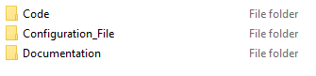

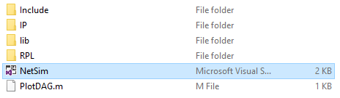

1. Place **PlotDAG.m** file inside the installation folder of MATLAB i.e. **“C:\Program Files\MATLAB\R2016a”, (Note: PlotDAG.m** is provided in the folder)

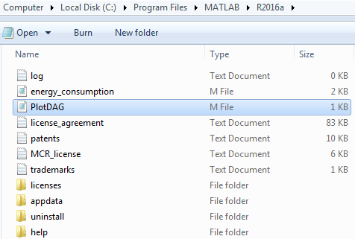

1. Open RPL.c file and add **fn_netsim_matlab_init()**, **fn_netsim_matlab_DODDAG_run()** and **fn_netsim_matlab_DODDAG_Init()** inside **fn_NetSim_RPL_Init()** and **fn_netsim_matlab_Finish()** inside **fn_NetSim_WLAN_Finish ()**.

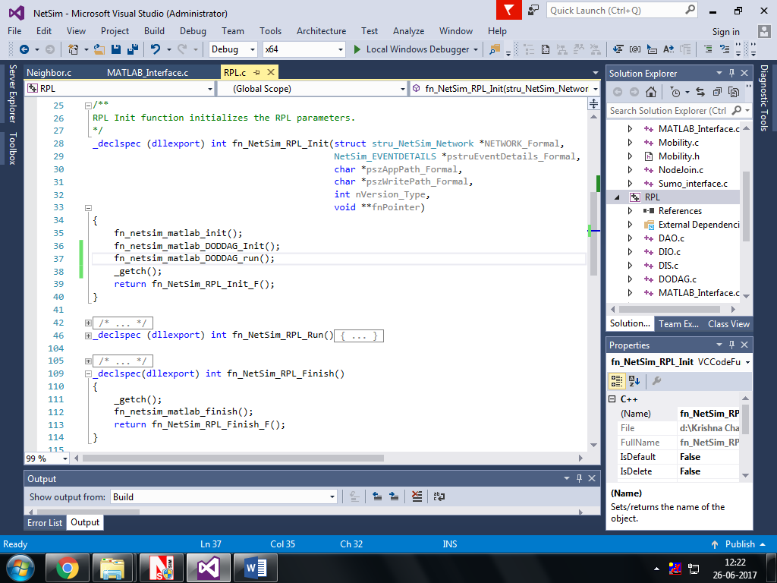

1. Add definitions of the following functions inside **RPL.h** file

**double fn_netsim_matlab_init();**

**double fn_netsim_matlab_DODDAG_Init();**

**double fn_netsim_matlab_DODDAG_run();**

**double fn_netsim_matlab_finish();**

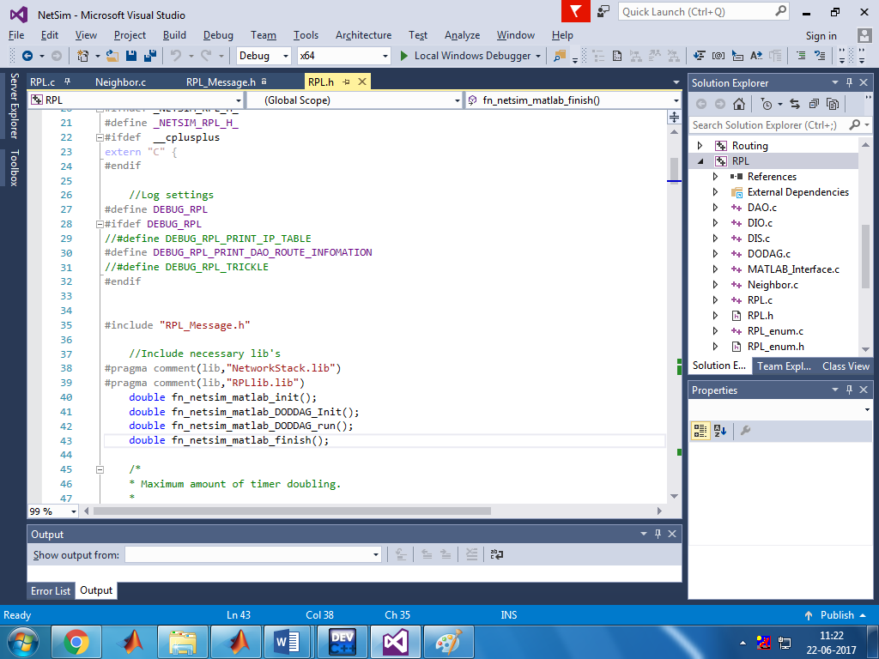

1. Go to the **Neighbor.c** file. Inside Function **void choose_parents_and_siblings(NETSIM_ID d)** add **fn_netsim_matlab_DODDAG_run()** below **rpl_add_route_to_parent()**

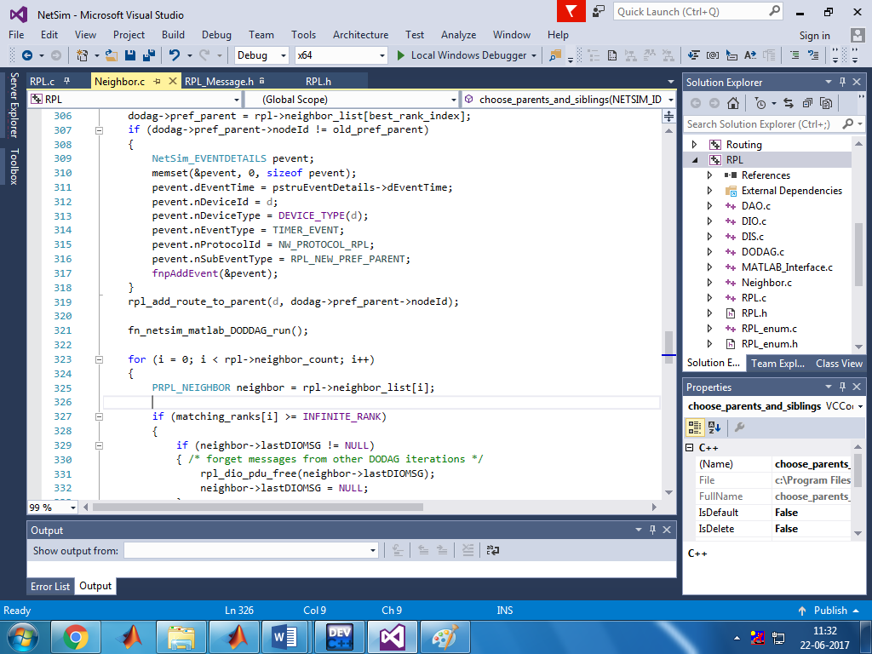

1. Create a user variable with the name of MATLAB_PATH and provide the path of the installation directory of user’s respective MATLAB version.

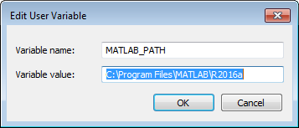

1. Make sure that the following directory is in the PATH(Environment variable)

<Path where MATLAB is installed>\bin\win64

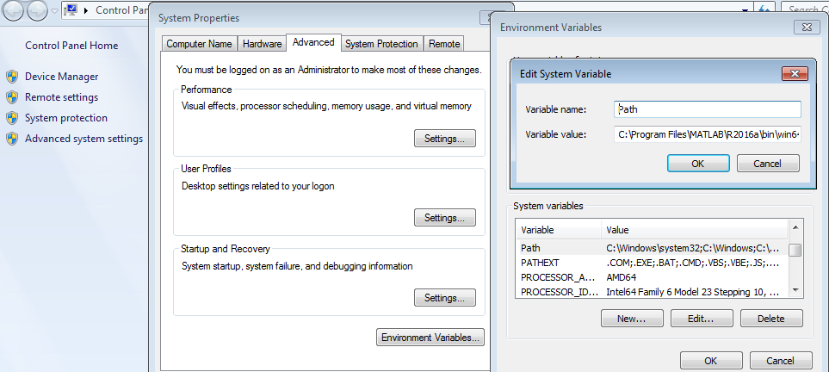

(**Note:** To run this code 64- bit version of MATLAB must be installed in your system. If you are interfacing for the first time then open command window and go to the **<NetSim installed directory>\bin** and type **matlab -regserver**)

1. Now Right Click on RPL project and select Rebuild.
2. Now replace the newly built libRPL.dll from the DLL folder, into the NetSim bin folder. Please ensure you rename the original libRPL.dll file to retain a copy of the original file.
3. Run NetSim in Administrative mode. Create a Network scenario IoT.

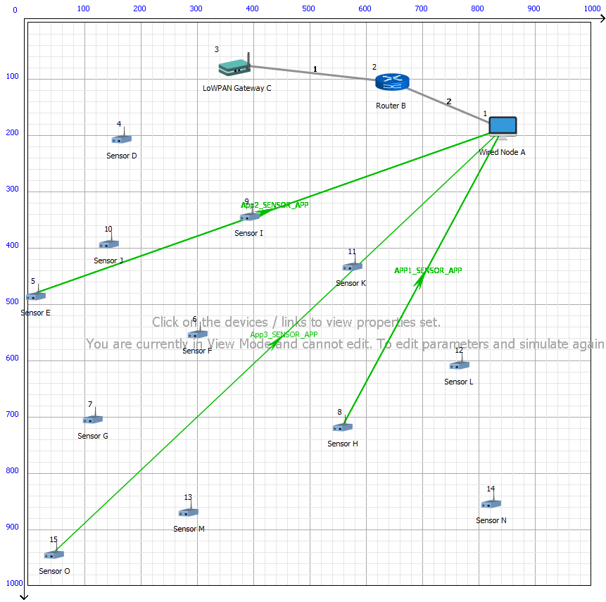

Set Velocity to the sensors

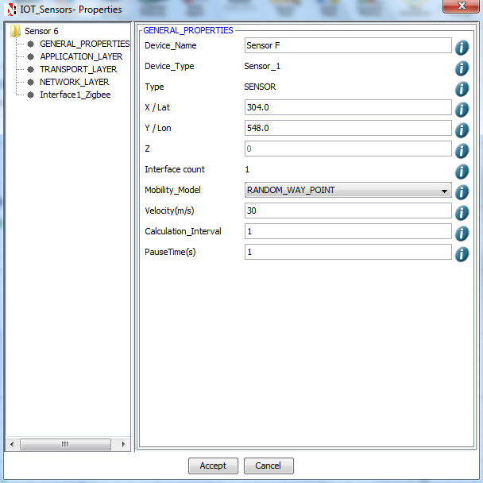

**Output:**

A plot will open, showing the DODAG when the simulation is started and the first route is formed between sink node and the sensor. And the DODAG will be dynamically updated.

**Initially formed DODAG**

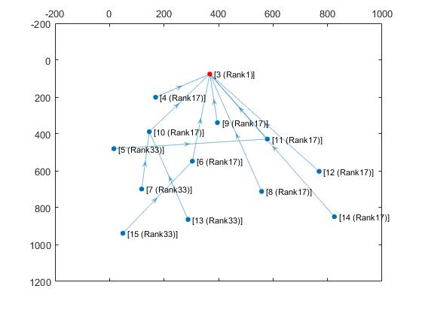

**DODAG formed after some time due to movement in sensors**

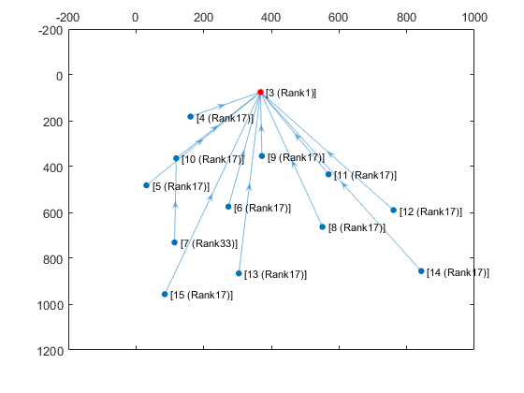

After simulation press any key in the NetSim command window to close the MATLAB.