**Network Scenario:**

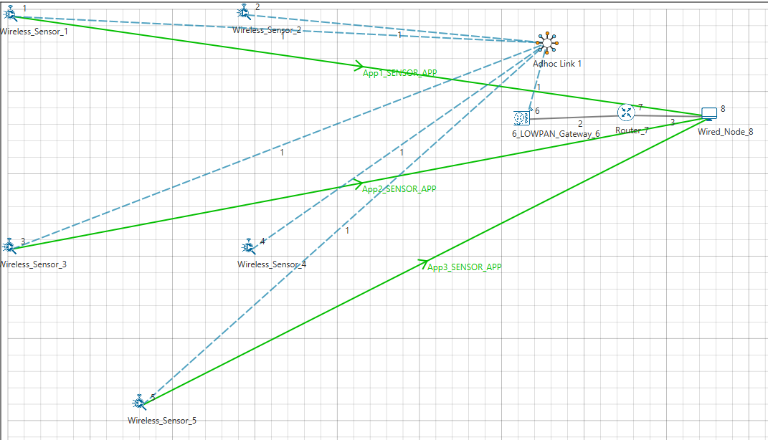

**Settings done in example config file:**

|  |  |
| --- | --- |
| Properties |  |
| Network Layer Properties (Sensor and 6_LOWPAN_Gateway) | |
| Routing Protocol | RPL |
| Wireless Link Properties | |
| Channel Characteristic | PATHLOSS_ONLY |
| Pathloss Model | LOG_DISTANCE |
| Pathloss Exponent (η) | 3.5 |
| Application Properties | |
| Application Type | SENSOR_APP |
| Source Id | 1,3,5 |
| Destination Id | 8,8,8 |

Run simulation for 100 sec.

**Result:**

**Explanation of the log file:**

Node 2 and Node 4 receives a DIO message from Node 6. Node 2 and Node 4 found the DODAG id. Based on the DIO message received from Node 6, Node 2 and Node 4 choses its “Parent as Node 6” and establishes its “New Rank = 15”. It doesn’t have any siblings.

Node 1 receives a DIO message from Node 4. Node 1 found the DODAG id. Based on the DIO message received from Node 4, Node 1 choses its “Parent as Node 4” and establishes its “New Rank = 30”. It doesn’t have any siblings.

Node 2 receives a DIO message from Node 4. Node 1 found the DODAG id. Based on the DIO message received from Node 4, Node 2 choses its “siblings as Node 4 and Parent as Node 6” and establishes its “New Rank = 15”.

Node 3 receives a DIO message from Node 4. Node 3 found the DODAG id. Based on the DIO message received from Node 4, Node 3 choses its “Parent as Node 4” and establishes its “New Rank = 28”. It doesn’t have any siblings.

Node 5 receives a DIO message from Node 4. Node 5 found the DODAG id. Based on the DIO message received from Node 4, Node 5 choses its “Parent as Node 4” and establishes its “New Rank = 27”. It doesn’t have any siblings.

Node 1 again receives a DIO message from Node 2. Node 1 found the DODAG id. Based on the DIO message received from Node 2, Node 1 changes its “Parent from Node 4 to Node 2” and establishes its “New Rank = 28”. It doesn’t have any siblings.

Node 3 receives a DIO message from Node 2. Node 3 found the DODAG id. Based on the DIO message received from Node 2, Node 3 still choses its “Parent as Node 4” and establishes its “New Rank = 28”. It doesn’t have any siblings.

Node 4 receives a DIO message from Node 2. Node 4 found the DODAG id. Based on the DIO message received from Node 2, Node 4 choses its “siblings as Node 2 and Parent as Node 6” and establishes its “New Rank = 15”.

Node 1 receives a DIO message from Node 3. Node 1 found the DODAG id. Based on the DIO message received from Node 3, Node 1 choses its “siblings as Node 3 and Parent as Node 2” and establishes its “New Rank = 28”.

Node 3 receives a DIO message from Node 5. Node 3 found the DODAG id. Based on the DIO message received from Node 5, Node 3 still choses its “Parent as Node 4” and establishes its “New Rank = 28”. It doesn’t have any siblings.

Node 3 receives a DIO message from Node 1. Node 3 found the DODAG id. Based on the DIO message received from Node 1, Node 3 choses its “siblings as Node 1 and Parent as Node 4” and establishes its “New Rank = 28”.

According to the distance, dodag formed 3 groups. Node 2 and Node 4 are siblings and chooses their parents as Node 6 (Root Node) and establishes rank as 15. Node 1 and Node 3 are siblings. Node 1 chooses its parents as Node 2 and Node 3 establishes its parents as Node 4 and establishes rank as 28. Node 5 doesn’t have any siblings. it has established rank as 27. Since there is no mobility the dodag formation will be according to the above given description.

|  |  |  |  |  |  |  |
| --- | --- | --- | --- | --- | --- | --- |
| **Node** | **Rank** | **Updated Rank** | **Parent list** | **Updated Parent Node ID** | **Sibling Node ID** | **Received DIO From Node ID** |
| **Node 1** | 30 | 28 | Node 2,  Node 4 | Node 2 | Node 3 | Node 2,  Node 3,  Node 4 |
| **Node 2** | 15 | 15 | Node 6 | Node 6 | Node 4 | Node 4,  Node 6 |
| **Node 3** | 28 | 28 | Node 2, Node 4, Node 5 | Node 4 | Node 1 | Node 1, Node 2, Node 4, Node 5 |
| **Node 4** | 15 | 15 | Node 6 | Node 6 | Node 2 | Node 2,  Node 6 |
| **Node 5** | 27 | 27 | Node 4 | Node 4 | - | Node 4 |

