# Introduction to NetSim

## Introduction to network simulation with NetSim, NetSim feature list and NetSim Simulation environment

**NetSim** is a network simulation tool that allows you to create network scenarios, model traffic, design protocols and analyze network performance. Users can study the behavior of a network by test combinations of network parameters. The various network technologies covered in NetSim include:

* Internetworks - Ethernet, WLAN, IP, TCP
* Legacy Networks - Aloha, Slotted Aloha
* Cellular Networks - GSM, CDMA
* Mobile Adhoc Networks - DSR, AODV, OLSR, ZRP
* Wireless Sensor Networks - 802.15.4
* Internet of Things - 6LoWPAN gateway, 802.15.4 MAC / PHY, RPL
* Cognitive Radio Networks - 802.22
* Long-Term Evolution Networks – LTE/LTE-A/LTE Femto Cell/LTE D2D/LTE Vanet
* Software Defined Networking
* Advanced Routing and Switching - VLAN, IGMP, PIM, L3 Switch, ACL and NAT
* 5G NR mmWave – LTE NR

NetSim home screen will appear as shown below:

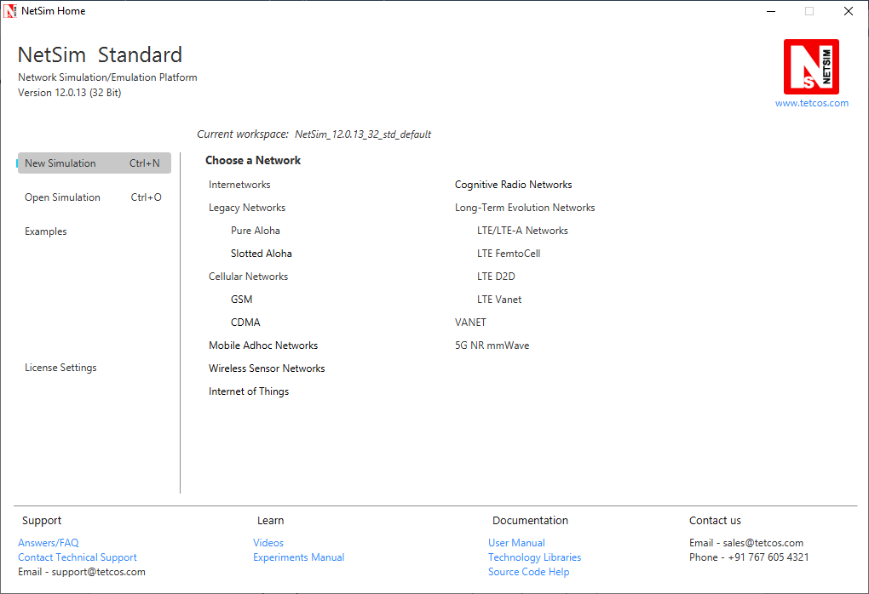

* **Network Design Window:** NetSim design window or the GUI, enables users to model a network comprising of network devices like switches, routers, nodes, etc., connect them through links, and model application traffic to flow through the network. The network devices shown are specific to the network technologies chosen by the user.

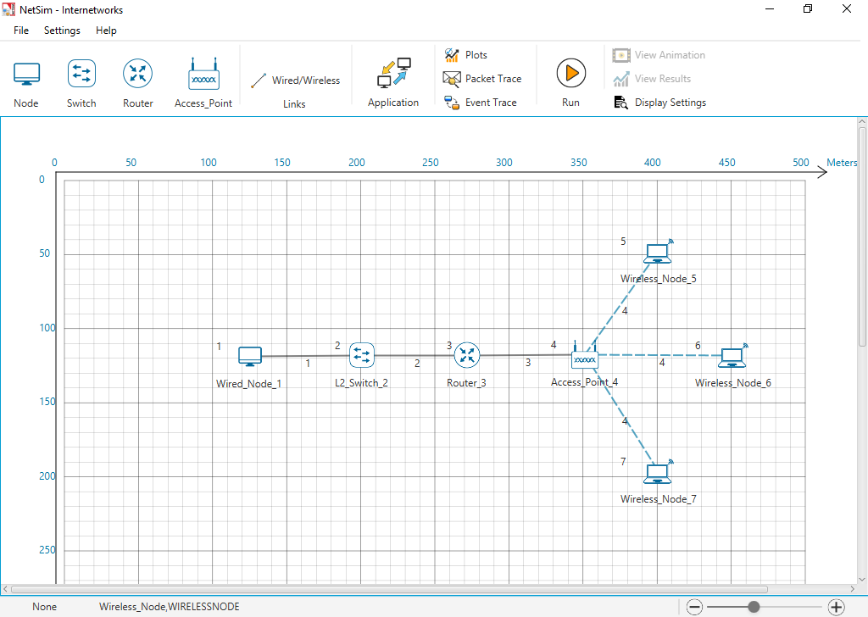

**Description:**

1. **File** - In order to save the network scenario before or after running the simulation into the current workspace,

* Click on File 🡪 Save to save the simulation inside the current workspace. Users can specify their own Experiment Name and Description (Optional).
* Click on File 🡪 Save As to save an already saved simulation in a different name after performing required modifications to it.
* Click on Close, to close the design window or GUI. It will take you to the home screen of NetSim.

1. **Settings** - Go to Settings 🡪 Environmental Settings and choose the type of environment. Here we have chosen the Environment in the form of a Grid. Map option can be used for specific cases like while designing VANET scenarios.
2. **Help** - Help option allows the users to access all the help features.

* **About NetSim** – Assists the users with basic information like,

Which version of NetSim is used and whether it is a 32-bit build or 64-bit build?

What kind of License is being used? Whether Floating or Node Locked?

* **Video Tutorials** – Assists the users by directing them to our dedicated YouTube Channel **“TETCOS”**, where we have lots of video presentations ranging from short to long, covering different versions of NetSim up to the latest release.
* **Answers/FAQ** – Assists the user by directing them to our **“NetSim Support Portal”**, where one can find a well-structured **“Knowledge Base”**, consisting of answers or solutions to all the commonest queries which a new user can go through.
* **Raise a Support Ticket** – Assists the user by directing them to our **“NetSim Support Portal”**, where one can **“Submit a ticket”** or in other words raise his/her query, which reaches our dedicated Helpdesk and due support will be provided to the user.
* **User Manual** – Assists the user with the usability of the entire tool and its features. It highly facilitates a new user with lots of key information about NetSim.
* **Source Code Help** – Assists the user with a structured documentation for **“NetSim Source Code Help”**, which helps the users who are doing their R&D using NetSim with a structured code documentation consisting of more than 5000 pages with very much ease of navigation from one part of the document to another.
* **Open Source Code** – Assists the user to open the entire source codes of NetSim protocol libraries in Visual Studio, where one can start initiating the debugging process or performing modifications to existing code or adding new lines of code. Visual Studio Community Edition is a highly recommended IDE to our users who are using the R&D Version of NetSim.
* **Experiments** – Assists the user with separate links provided for 30+ different experiments covering almost all the network technologies present in NetSim.
* **Technology Libraries** – Assists the user by directing them to a folder comprising of individual technology library files comprising all the components present in NetSim.

Below the menu options, the entire region constitutes the Ribbon/Toolbar using which the following actions can be performed:

1. Click and drop network devices and right click to edit properties
2. Click on Wired/Wireless links to connect the devices to one another. It automatically detects whether to use a Wired/Wireless link based on the devices we are trying to connect
3. Click on Application to configure different types of applications and generate traffic
4. Click on Plots, Packet Trace, and Event Trace and click on the enable check box option which appears in their respective windows to generate additional metrics to further analyze the network performance.
5. Click on Run to perform the simulation and specify the simulation time in seconds.
6. Next to Run, we have View Animation and View Results options. Both the options remain hidden before we run the simulation or if the respective windows are already open.
7. Display Settings option is mainly used to display various parameters like Device Name, IP, etc., to provide a better understanding especially during the design and animation.

* **Results Window:** Upon completion of simulation, Network statistics or network performance metrics reported in the form of graphs and tables. The report includes metrics like throughput, simulation time, packets generated, packets dropped, collision counts etc.

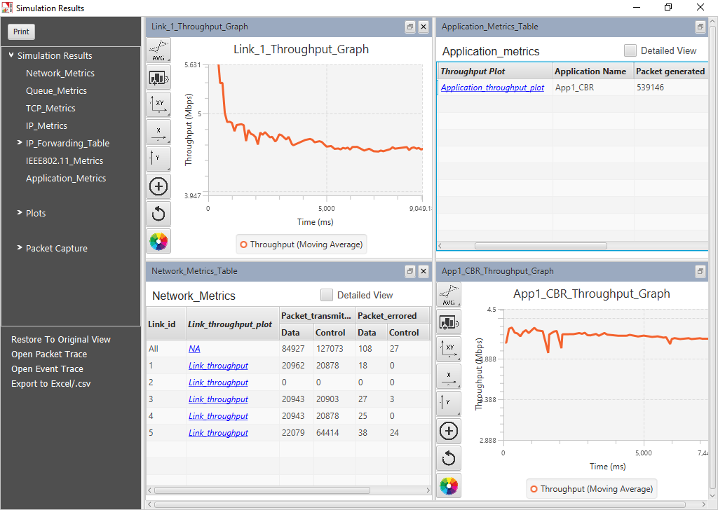

**Description:**

1. Below Simulation Results, Clicking on a particular metrics will display the respective metrics window.
2. Clicking on links in a particular metrics will display the plot in a separate window
3. Enabling Detailed View by clicking on it will display the remaining properties
4. Clicking on Restore to Original View will get back to the original view
5. Click on Open Packet Trace / Open Event Trace to open the additional metrics which provide in depth analysis on each Packets / Events.

* **Packet Animation Window:** When we click on run simulation, we have the option to record / play & record animation. If this is enabled, users can view the animation during the run time or upon completion of the simulation users can see the flow of packets through the network. Along with this, more than 25+ fields of packet information is available as a table at the bottom. This table contains all the fields recorded in the packet trace. In addition, animation options are available for viewing different graphs, IP Addresses, Node movement etc.

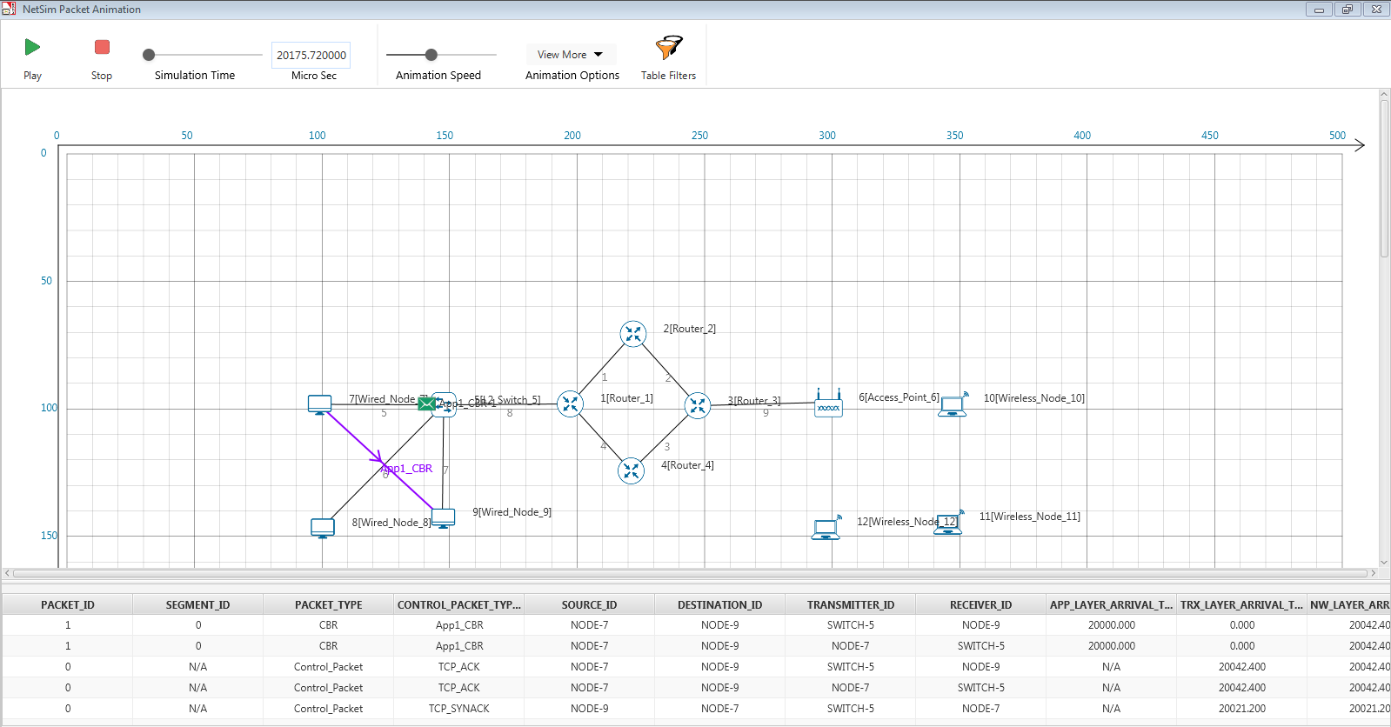

**Description:**

1. Click on Play to view the animation. You can Pause the animation at any interval and Play again.
2. Click on Stop to stop the animation. Now click on Play to start the animation from the beginning.
3. Next to that we also have speed controllers to increase/decrease Simulation Time and Animation Speed
4. View More option enables the user to view Plots, Throughputs, and IP Tables during the animation
5. Table Filters are used to filter the packet information’s shown in the below table during simulation as per user requirement
6. While setting more than one application, it is differentiated using different color indications
7. Packets are indicated using different color combinations say, blue color indicates control packets, green color indicates data packets and red color indicates error packets.

## How does a user create and save an experiment in workspace?

To create an experiment, select New Simulation-> <Any Network> in the NetSim Home Screen.

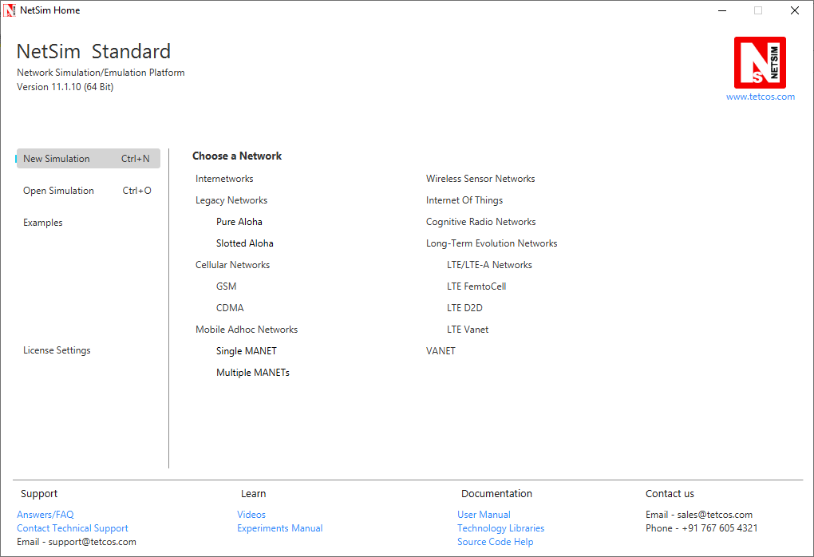

Create a network and save the experiment by clicking on File->Save button on the top left.

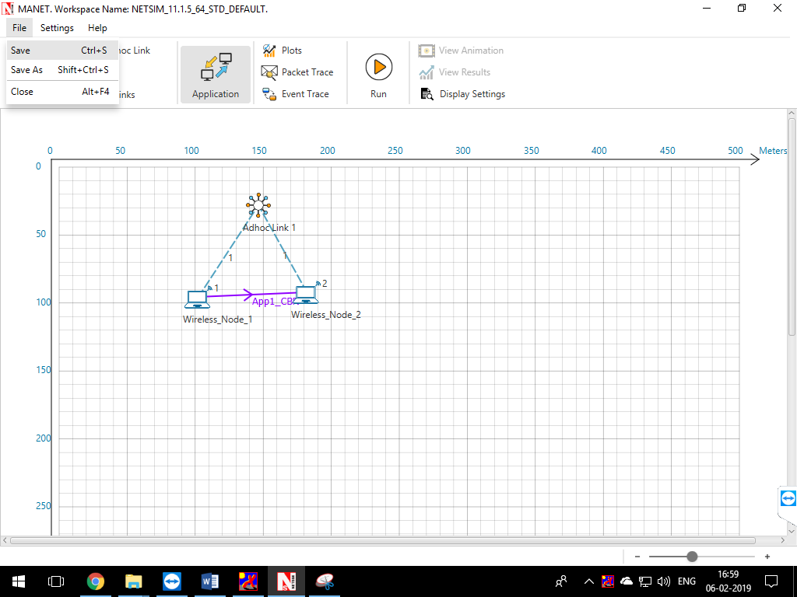

A save popup window appears which contains Experiment Name, Folder Name, Workspace path and Description.

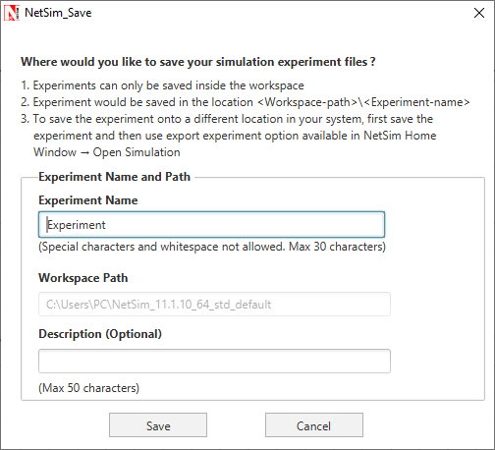

Specify the Experiment Name and Description (Optional) and then click on Save. The workspace path is non-editable. Hence all the experiments will be saved in the default workspace path. After specifying the Experiment Name click on Save.

In our example we saved with the name MANET and this experiment can be found in the default workspace path as shown below:

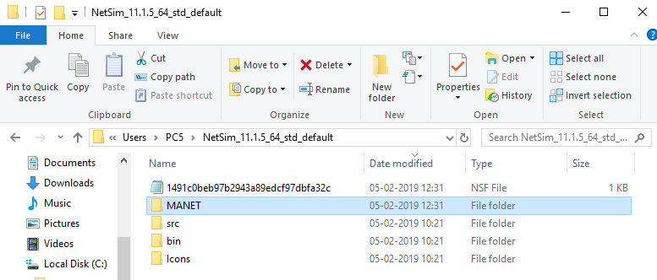

Users can also see the saved experiments in Open Simulation menu shown below:

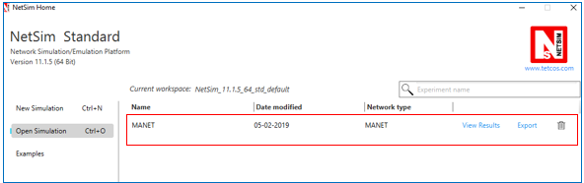

**“Save As”** option is also available to save the current experiment with a different name.

## Typical sequence of steps to do experiments in this manual

The typical steps involved in doing experiments in NetSim are,

* **Network Set up:** Drag and drop devices, and connect them using wired or wireless links
* **Configure Properties:** Configure device, protocol or link properties by right clicking on the device or link and modifying parameters in the properties window.
* **Model Traffic:** Click on the Application icon present on the ribbon and set traffic flows.
* **Enable Trace/Plots (optional):** Click on packet trace, event trace and Plots to enable. Packet trace logs packet flow, event trace logs each event (NetSim is a discrete event simulator) and the Plots button enables charting of various throughputs over time.
* **Save/Save As/Open/Edit:** Click on File 🡪 Save / File 🡪 Save As to save the experiments in the current workspace. Saved experiments can then opened from NetSim home screen to run the simulation or to modify the parameters and again run the simulation.
* **View Animation/View Results:** Visualize through the animator to understand working and to analyze results and draw inferences.

***NOTE: Example Configuration files for all experiments would available where NetSim has been installed. This directory is (<NetSim_Install_Directory>\Docs\Sample_Configuration\NetSim_Experiment_Manual)***