

Experiments Manual



The information contained in this document represents the current view of TETCOS on the issues discussed as of the date of publication. Because TETCOS must respond to changing market conditions, it should not be interpreted to be a commitment on the part of TETCOS, and TETCOS cannot guarantee the accuracy of any information presented after the date of publication.

This manual is for informational purposes only. TETCOS MAKES NO WARRANTIES, EXPRESS, IMPLIED OR STATUTORY, AS TO THE INFORMATION IN THIS DOCUMENT.

**Warning! DO NOT COPY**

Copyright in the whole and every part of this manual belongs to **TETCOS**and may not be used, sold, transferred, copied or reproduced in whole or in part in any manner or in any media to any person, without the prior written consent of **TETCOS**. If you use this manual you do so at your own risk and on the understanding that **TETCOS**shall not be liable for any loss or damage of any kind.

TETCOS may have patents, patent applications, trademarks, copyrights, or other intellectual property rights covering subject matter in this document. Except as expressly provided in any written license agreement from TETCOS, the furnishing of this document does not give you any license to these patents, trademarks, copyrights, or other intellectual property. Unless otherwise noted, the example companies, organizations, products, domain names, e-mail addresses, logos, people, places, and events depicted herein are fictitious, and no association with any real company, organization, product, domain name, email address, logo, person, place, or event is intended or should be inferred.

Rev 12.0 (V), Aug 2019, TETCOS. All rights reserved.

**All trademarks are property of their respective owner.**

**Contact us at**

TETCOS

# 214, 39th A Cross, 7th Main, 5th Block Jayanagar,

Bangalore - 560 041, Karnataka, INDIA. Phone: +91 80 26630624

E-Mail: [sales@tetcos.com](mailto:sales@tetcos.com)

Visit: [www.tetcos.com](http://www.tetcos.com)

**LIST OF EXPERIMENTS**

1. Study how call blocking probability varies as the load on a GSM network is continuously increased 4

# Study how call blocking probability varies as the load on a GSM network is continuously increased

## Network Setup:

Open NetSim and click **Examples > Experiments > Call-blocking-probability** as shown below:

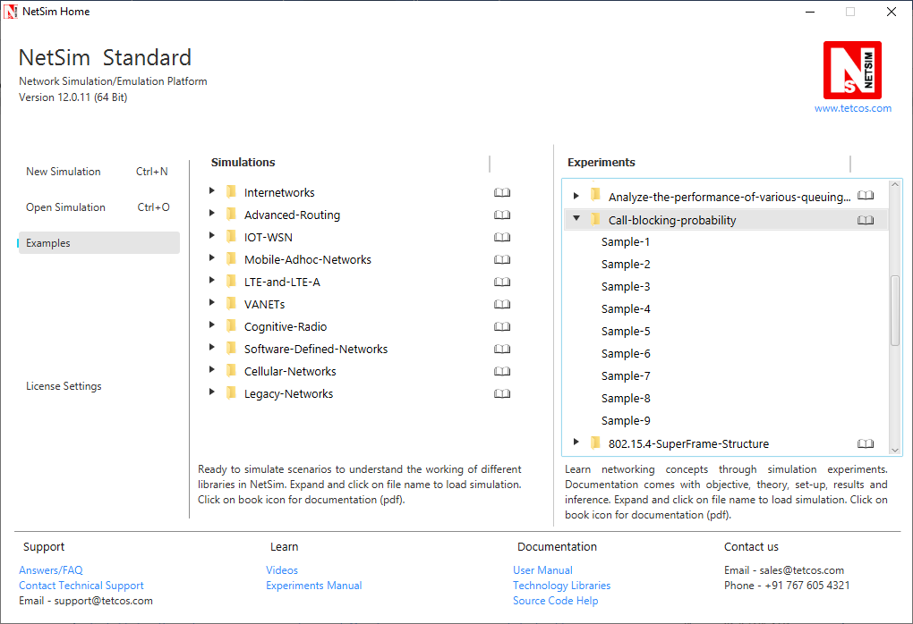

NetSim UI displays the configuration file corresponding to this experiment as shown below:

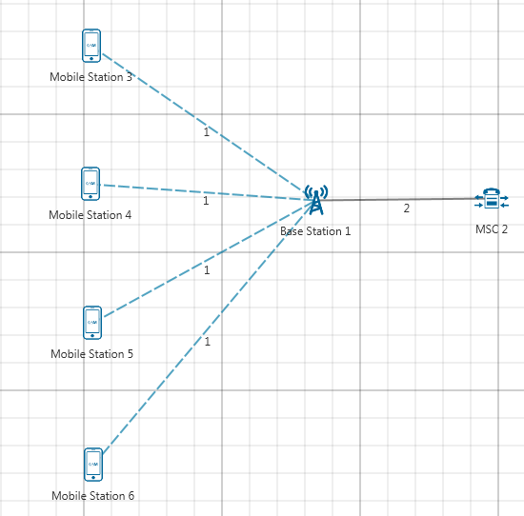

## Procedure:

The following set of procedures were done to generate this sample:

**Step 1:** A network scenario is designed in NetSim GUI comprising of 4 Mobile Stations, 1 MSC, and 1 Base Station in the **“Cellular Networks”** Network Library.

**Step 2:** Ensure all the Mobile Stations are placed within the range of Base Station.

**Step 3:** In the Interface GSM > Data Link Layer Properties of MSC 2, Uplink BW Min and Uplink BW Max are set to 890 MHz and 890.2 MHz respectively.

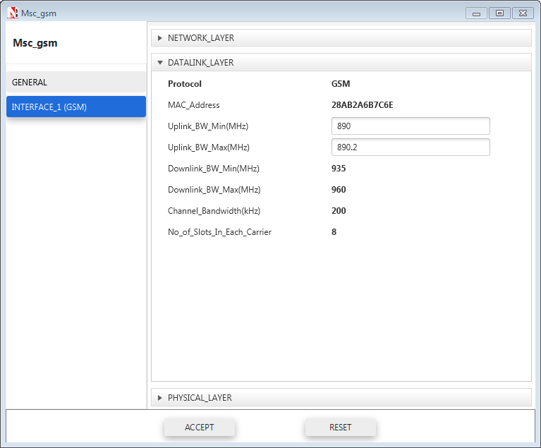

**Step 4:** Right click on the Application Flow **App1 ERLANG CALL** and select Properties or click on the Application icon present in the top ribbon/toolbar.

The applications are set as per the below table:

|  |  |  |
| --- | --- | --- |
| Application Properties | Application 1 | Application2 |
| Application type | Erlang_call | Erlang_call |
| Source_Id | 3 | 5 |
| Destination_Id | 4 | 6 |
| Call | | |
| Duration_ Distribution | Exponential | Exponential |
| Duration(s) | 60 | 60 |
| Inter Arrival Time (sec) | 10 | 10 |
| IAT_ Distribution | Exponential | Exponential |
| Codec | Custom | Custom |
| Inter Arrival Time distribution | Constant | Constant |
| Packet Distribution | Constant | Constant |
| Service Type | CBR | CBR |
| Packet Size | 33 | 33 |
| Inter Arrival Time (µs) | 20000 | 20000 |

**Step 5:** Run the Simulation for 100 Seconds.

The following changes in settings are done from the previous sample:

**Step 1:** In the next sample, increase the number of Mobile Stations by 2 and add one more application between them.

**Step 2:** Run the Simulation for 100 Seconds.

The following changes in settings are done from the previous sample:

**Step 1:** Similarly, increase the number of Mobile Stations by 2 up to 20 and set properties for different Samples by adding an application every time and changing Source ID and Destination ID.

**Step 2:** Run the Simulation for 100 Seconds.

## Output

To view the output, go to the Cellular Metrics. In MS metrics, take sum of call blocking probability (It is the as ratio of Total call blocked to Total call generated).

**Comparison Charts:**

*** All the above plots highly depend upon the placement of Mobile station in the simulation environment. So, note that even if the placement is slightly different the same set of values will not be got but one would notice a similar trend.

## Inference:

When the number of MS is increased from 4 to 20 the call blocking probability increases from 0 to 3.46. As we increase the number of mobile stations more calls are generated. This increases the traffic load on the system & more calls generated implies more channel requests arrive at the base station but the number of channels is fixed. So when the base station does not find any free channel the call is blocked. An additional observation is that the call blocking is zero until 8 MS. This is because the number of channels is sufficient to handle all call that 6 MS may generate. Only after this the base station does not find free channels and blocks calls.