**Working of RPL protocol in IOT**

**Network Scenario:**

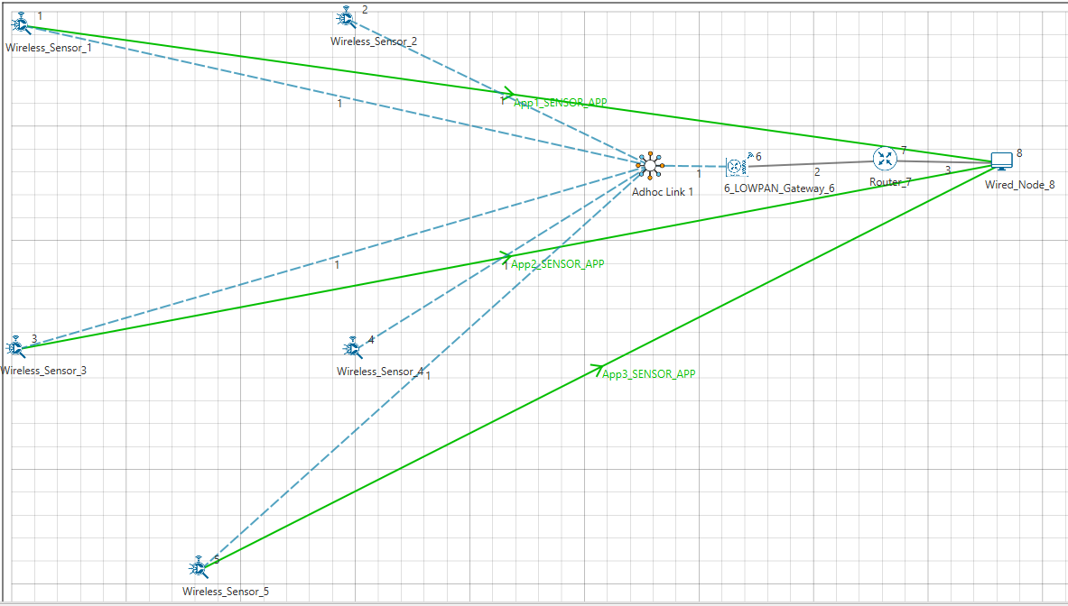

**Settings done in example config file:**

|  |  |
| --- | --- |
| Properties |  |
| Network Layer Properties (Sensor and 6_LOWPAN_Gateway) | |
| Routing Protocol | RPL |
| Wireless Link Properties | |
| Channel Characteristic | PATHLOSS_ONLY |
| Pathloss Model | LOG_DISTANCE |
| Pathloss Exponent (η) | 3.5 |
| Application Properties | |
| Application Type | SENSOR_APP |
| Source Id | 1,3,5 |
| Destination Id | 8,8,8 |

**Procedure to get detailed RPL log file:**

* Go to NetSim Home page and click on **Open Simulation**.
* Click on Workspace Options and then click on **Open Code** and open the codes in Visual Studio. Set **Win32** or **x64** according to the NetSim build which you are using.
* Go to the RPL Project in the Solution Explorer. Open RPL.h file and change //**#define DEBUG_RPL** to **#define DEBUG_RPL** as shown below:

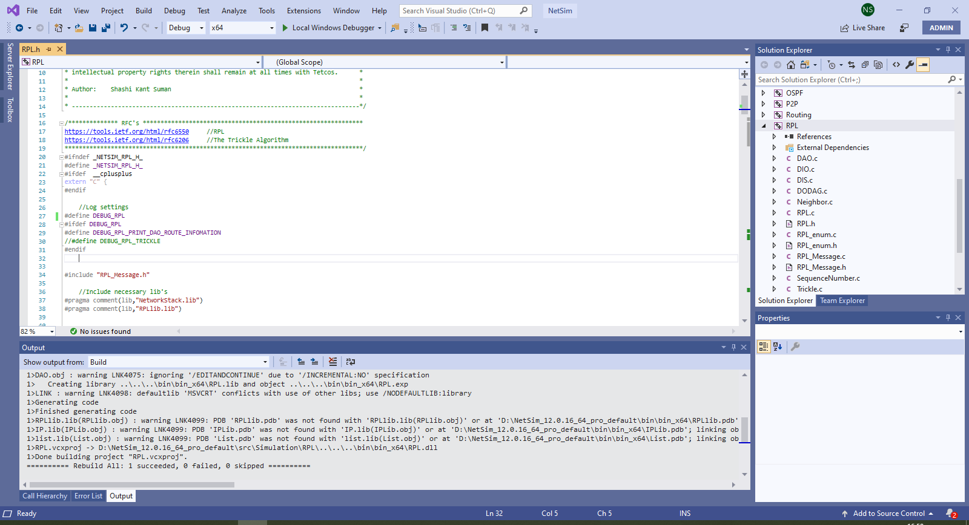

* Right click on the **RPL** project in the solution explorer and click on rebuild.
* After the RPL project is rebuild successful, go back to the network scenario.

Run simulation for 100 sec.

**Result:**

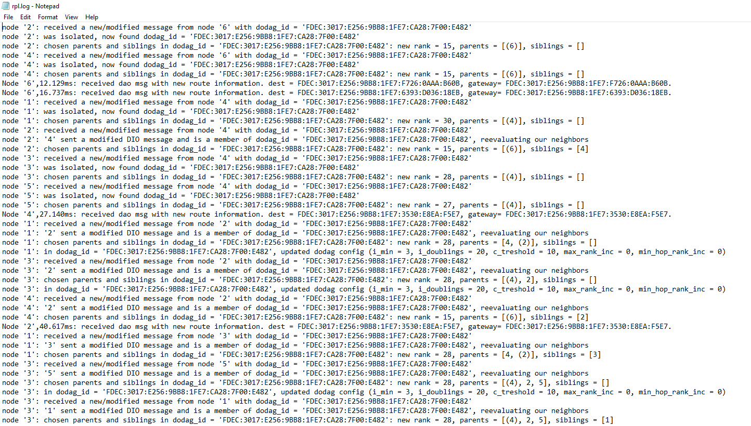

|  |  |  |  |  |  |  |
| --- | --- | --- | --- | --- | --- | --- |
| **Node** | **Rank** | **Updated Rank** | **Parent list** | **Updated Parent Node ID** | **Sibling Node ID** | **Received DIO From Node ID** |
| **Node 1** | 30 | 28 | Node 2,  Node 4 | Node 2 | Node 3 | Node 2,  Node 3,  Node 4 |
| **Node 2** | 15 | 15 | Node 6 | Node 6 | Node 4 | Node 4,  Node 6 |
| **Node 3** | 28 | 28 | Node 2, Node 4, Node 5 | Node 4 | Node 1 | Node 1, Node 2, Node 4, Node 5 |
| **Node 4** | 15 | 15 | Node 6 | Node 6 | Node 2 | Node 2,  Node 6 |
| **Node 5** | 27 | 27 | Node 4 | Node 4 | - | Node 4 |

According to the distance, DODAG is formed.

* Node 2 and Node 4 are siblings and their parent is Node 6 (Root Node). Rank is 15.
* Node 1 and Node 3 are siblings.
  + Node 1 established its parent as Node 2. Rank is 28.
  + Node 3 establishes its parent as Node 4. Rank is 28
* Node 5 doesn’t have any siblings. Its rank is 27.

The parent IDs and ranks are as shown below

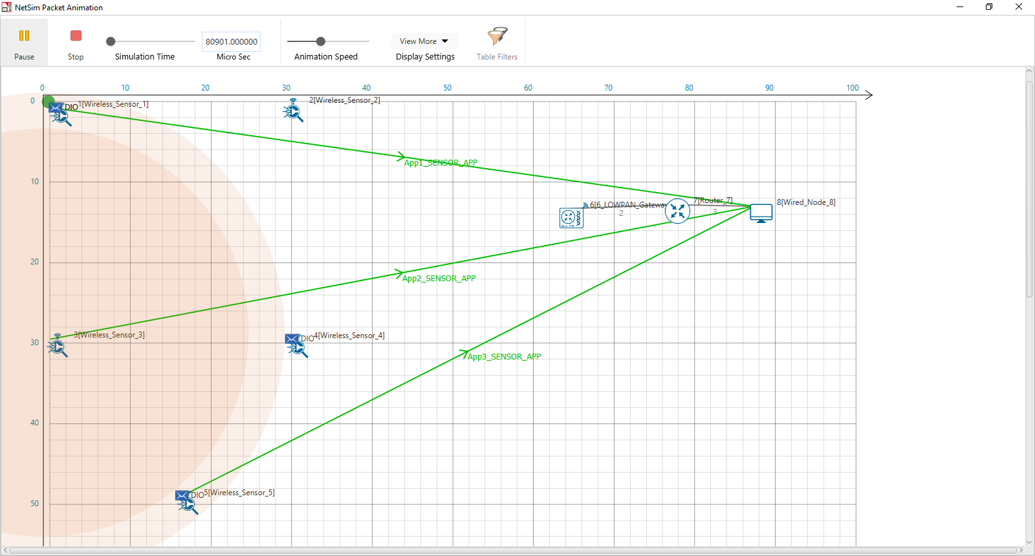

**Rank= 28 Parent Id = 2, 4**

**Rank= 27 Parent Id = 4**

**Rank= 15 Parent Id = 6**