**DTDMA Data Rate Analysis**

Applicable Release: NetSim v13.3.17 or higher

Applicable Version(s): Pro

Project download link: See Appssendix-1. The URL has the configuration files (scenario, settings, and other related files) of the examples discussed in this analysis for users to import and run in NetSim.

# Effect of Modulation and Coding Rate

# NetSim Scenario:

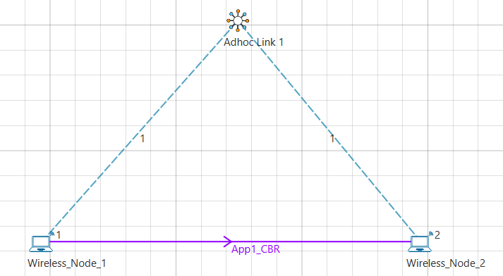

Fig 1: NetSim Scenario with 2 Wireless Nodes and Application Traffic is from N1 to N2

**PHY Rate Calculation**

Calculation for PHY Rate in the wireless links used for all 6 cases.

$$SymbolsPerSlot=SlotDuration(ms)×DataSymbolRate(kBd)$$

$$BitsPerSlot=SymbolsPerSlot×ModulationOrder×CodingRate$$

$$Phy Rate\left(kbps\right)=\frac{BitsPerSlot}{SlotDuration\left(ms\right)}=1.024 kbps$$

The Slot Duration, Data Symbol rate, Modulation Technique, Bandwidth and Coding rate can be configured in the Wireless Nodes.

**Network Settings to be done:**

|  |  |
| --- | --- |
| Physical Layer DTDMA | |
| Bandwidth (KHz) | 10000 |
| Data symbol rate(kBd) | 10000 |
| Modulation Technique | BPSK, QPSK, GMSK, 16QAM,64QAM |
| Coding Rate | 1/2, 2/3,3/4,5/6 |
| MAC Layer |  |
| Slot Duration(ms) | 2 |
| Application properties | |
| Packet Size | 1460 |
| IAT (micro sec) | 116 |
| Simulation Parameters | |
| Simulation Time (s) | 100 |

# Phy Rate Calculation for various Modulation and Coding rates

|  |  |  |  |  |
| --- | --- | --- | --- | --- |
| Modulation Technique | Modulation Bits | Coding rate | Phy Rate (Mbps) | Application Throughput (Mbps) |
| BPSK | 1 | 1/2 | 5 | 3.89 |
| 2/3 | 6.67 | 5.19 |
| 3/4 | 7.50 | 5.84 |
| 5/6 | 8.33 | 6.49 |
| GMSK | 1 | 1/2 | 5 | 3.89 |
| 2/3 | 6.67 | 5.19 |
| 3/4 | 7.50 | 5.84 |
| 5/6 | 8.33 | 6.49 |
| QPSK | 2 | 1/2 | 10 | 7.78 |
| 2/3 | 13.33 | 10.38 |
| 3/4 | 15 | 11.68 |
| 5/6 | 16.67 | 12.97 |
| 16QAM | 4 | 1/2 | 20 | 15.56 |
| 2/3 | 26.67 | 20.75 |
| 3/4 | 30 | 23.34 |
| 5/6 | 33.33 | 25.93 |
| 64QAM | 6 | 1/2 | 30 | 23.34 |
| 2/3 | 40 | 31.12 |
| 3/4 | 45 | 34.99 |
| 5/6 | 50 | 38.87 |

**Printing Phy rate values to console:**

Modify the source code of DTDMA.c and use the following command to print Data rate value on to the console.

fprintf (stderr, "\n phy->dDataRate =%lf(Mbps) \n", phy->dDataRate);

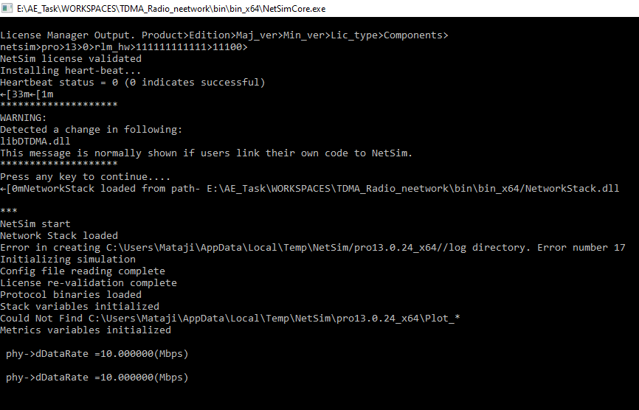

# Appendix 1: Download Link

The configuration files (scenario, settings, and other related files) of the examples discussed in this analysis are available for users to import and run in NetSim.

Users can download the files from NetSim’s git-repository.

Link: <Not Yer Uploaded>

1. Click on the link given and download the folder.
2. Extract the zip folder. The extracted project folder consists of one NetSim Experiments file, namely *DTDMA-Datarate-Analysis_v13.3.17.netsimexp*
3. Import per steps given in section 4.9.2 in NetSim User Manual

All the experiments can now be seen folder wise within NetSim > Your Work.