Dynamic Clustering in WSN

**Software:** NetSim Standard v13.1 (64 bit), Visual Studio 2019, MATLAB R2016 or higher

**Project Download Link:**

Follow the instructions specified in the following link to download and setup the Project in NetSim:

<https://support.tetcos.com/en/support/solutions/articles/14000128666-downloading-and-setting-up-netsim-file-exchange-projects>

**Clustering in WSN**

Clustering is the process partitioning a group of sensors into small numbers of clusters. In environments where the sensors are mobile clusters cannot be static. Like cluster heads in each cluster are elected dynamically, the members in each cluster also need to be dynamically identified. Therefore, the size of each cluster is not fixed and can vary depending on the position of the sensors.

Dynamic Clustering helps in efficiently grouping sensors into clusters dynamically. There is no fixed cluster size, and the sensors are divided into the required number of clusters with members of each cluster calculated dynamically.

**Clustering using k-means algorithm**

kmeans(X,k) partitions the points in the n-by-p data matrix X into k clusters. This iterative partitioning minimizes the sum, over all clusters, of the within-cluster sums of point-to-cluster-centroid distances. Rows of X correspond to points, columns correspond to variables. kmeans returns an n-by-1 vector IDX containing the cluster indices of each point. By default, kmeans uses squared Euclidean distances. When X is a vector, kmeans treats it as an n-by-1 data matrix, regardless of its orientation.

The sensor positions and number of clusters,

X - a matrix containing the x, y coordinates of the sensors in the scenario.

k- the number of clusters. are passed to k-means algorithm. [IDX,C] = kmeans(X,k).

IDX – Contains the cluster id’s of each sensor (i.e) the cluster to which the sensor belongs.

C – Centroids of each cluster.

**Clustering using Fuzzy C-Means Algorithm**

Fuzzy c-means (FCM) is a data clustering technique in which a dataset is grouped into n clusters with every data point in the dataset belonging to every cluster to a certain degree. For example, a certain data point that lies close to the center of a cluster will have a high degree of belonging or membership to that cluster and another data point that lies far away from the center of a cluster will have a low degree of belonging or membership to that cluster.

**Cluster head election based on distance from Centroid**

After grouping the sensors into different clusters, the cluster heads are determined based on the distance between the sensor and the centroid of the cluster to which it belongs.

The sensor which is closer to the centroid will be elected as the cluster head. Here the position values (i.e., value of x-coordinate and y-coordinate) of each sensor are passing from NetSim to MATLAB as a sole parameter.

**Cluster head election based on distance and power**

After grouping the sensors into different clusters, the cluster heads are determined based on the distance between the sensor and the remaining power of each sensor. After that the sensors are assigned in respective cluster.

The sensor which is closer to the centroid and has the more power than other sensor will be elected as the cluster head. Here the position values (i.e., value of x-coordinate and y-coordinate) of each sensor and power are passing from NetSim to MATLAB as a sole parameter.

**Dynamic Clustering in NetSim with MATLAB Interfacing**

Dynamic Clustering is implemented in NetSim by Interfacing with MATLAB for the purpose of mathematical calculation. The sensor coordinates are fed as input to MATLAB and k-means algorithm that is implemented in MATLAB is used to dynamically perform clustering of the sensors into n number of clusters.

In addition to clustering, we also determine the cluster head of each cluster mathematically in MATLAB. The distance of each sensor from the centroid of the cluster to which it belongs is calculated. Then the sensor which has the least distance is elected as the cluster head.

From MATLAB we get the cluster id of each sensor, cluster heads of each cluster and the size of each cluster.

All the above steps are performed periodically which can be defined as per the implementation. Each time the cluster members and the cluster heads are determined based on the current position and they are not fixed.

The codes required for the mathematical calculations done in MATLAB are written to a clustering.m file and this file available in MATLAB folder under bin_x64 of Dynamic_Clustering_Workspace_v13_1

The **clustering.m** file can be run in four different modes cluster head election.

A **Dynamic_Clustering.c** file is added to the DSR project which contains the following functions:

* fn_NetSim_dynamic_clustering_CheckDestination()//This function is used to determine whether the current device is the destination.
* fn_NetSim_dynamic_clustering_GetNextHop()//This function statically defines the routes within the cluster and from cluster to sinknode. It returns the next hop based on the static routing that is defined.
* fn_NetSim_dynamic_clustering_IdentifyCluster()//This function returns the cluster id of the cluster to which a sensor belongs.
* fn_NetSim_dynamic_clustering_run()//This function makes a call to MATLAB interfacing function and passes the inputs from NetSim (i.e) the sensor coordinates, number of clusters and the sensor count.
* fn_netsim_dynamic_form_clusters()//This function assigns each sensor to its respective clusters based on the cluster id’s obtained from MATLAB.
* fn_netsim_assign_cluster_heads()//This function assigns the cluster heads for each cluster based on the cluster head id’s obtained from MATLAB.
* fn_NetSim_Dynamic_Clustering_Init()//This function initializes all parameter values.

**Static Routing**

Static Routing is defined in such a way that the sensors in the cluster send the packets to the cluster head. The cluster head then directly sends the packets to the destination (sinknode).

If the current sensor is the source device and if it is not a cluster head, then its next hop is its cluster head.

If the current sensor is the source device and if it is a cluster head, then its next hop is the destination (i.e.) the sinknode.

If the current sensor is not the source, then the packet is sent to the destination (i.e.) the sinknode.

**NOTE:** To run this code 64- bit version of MATLAB must be installed in your system.

**Steps to simulate**

1. Add the following MATLAB install directory path in the Environment PATH variable

<MATLAB_INSTALL_DIRECTORY>\bin\win64

For eg: C:\Program Files\MATLAB\R2020a\bin\win64

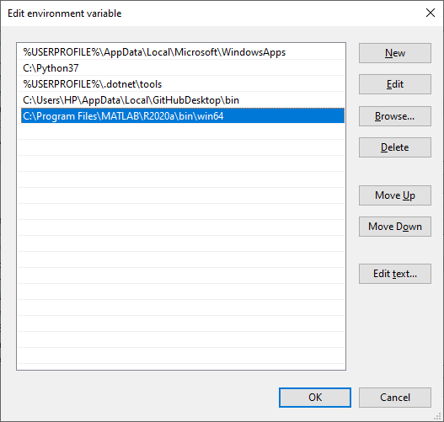

**Figure 1:** Environment variable PATH

**Note**: If the machine has more than one MATLAB installed, the directory for the target platform must be ahead of any other MATLAB directory (for instance, when compiling a 64-bit application, the directory in the MATLAB 64-bit installation must be the first one on the PATH).

1. Open Command prompt as admin and execute the command “matlab -regserver”. This will register MATLAB as a COM automation server and is required for NetSim to start MATLAB automation server during runtime.
2. Open the Source codes in Visual Studio by going to Your work-> Source code and Clicking on Open code button in NetSim Home Screen window.
3. Under the DSR project in the solution explorer you will be able to see that and **Dynamic_Clustering.c** files which contain source codes related to interactions with MATLAB and handling clustering in NetSim respectively.
4. Right click on the solution in the solution explorer and select Rebuild.

**Example**

1. Run NetSim as administrative mode.
2. The Dynamic_Clustering_Workspace_v13_1 comes with a sample network configuration that are already saved. To open this example, go to Your work in the Home screen of NetSim and click on the Dynamic_Clustering_Example from the list of experiments.
3. The saved network scenario consisting of 64 sensors uniformly distributed in the grid environment along with a sink node forming a Wireless Sensor Network. Traffic is configured from each sensor node to the Sink Node.

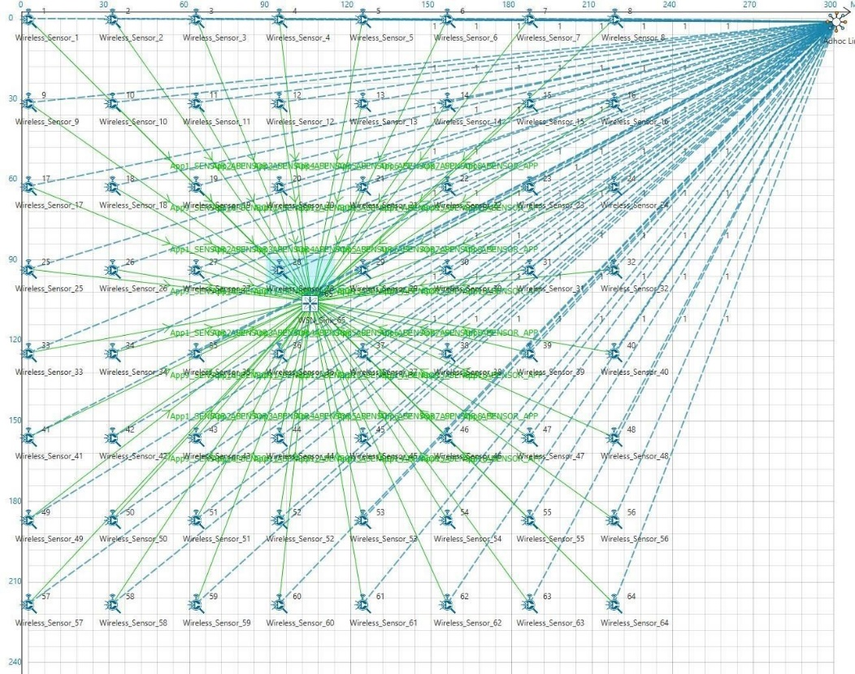

**Figure 2**: Network Scenario in this project

1. Run simulation and press any key to continue. NetSim simulation console will show the following message in the console “Waiting for NetSim MATLAB Interface to connect...”
2. Click on **Options** from NetSim design window and click on **Open MATLAB Interface** as shown in below given screenshot.

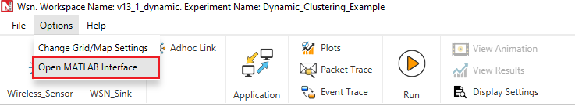

**Figure 3:** Open MATLAB Interface using NetSim design window

1. It will open the popup related MATLAB Interfacing, Click on **OK.**
2. It will open MatlabInterface.exe console window. You will observe that as the simulation starts in NetSim, MATLAB gets initialized and graph associated with energy consumption in the sensor network is plotted during runtime.

**Results and discussion**

A total of 64 sensors are placed evenly on the grid environment and each sensor is set to have equal initial energy.

At the end of the simulation, NetSim provides Battery Model Metrics which provides detailed information related to energy consumption in each sensor node with respect to transmission, reception, idle mode, sleep mode etc. as shown below:

**Figure 4:** NetSim provides Battery Model Metrics

This information can also be obtained at different points of simulation time either to log or to send to other external tools. The battery information and the position coordinates are passed to MATLAB periodically for clustering (number of clusters is set to 4), cluster head election and to obtain energy consumption plots.

**Cluster head election using distance alone as a parameter**

Running simulations with Clustering Method set to 1 and 2 in the clustering.m file will provide energy consumption plots for k means and fuzzy c-means algorithms respectively as shown below:

|  |  |  |
| --- | --- | --- |
| C:\Users\TETCOS-PC\Desktop\Capture.PNG |  | C:\Users\TETCOS-PC\Desktop\Capture.PNG |

**Figure 5:** Energy consumption plots for kmeans and fuzzy c-means algorithms using method 1 and 2

As it is seen from the plot, there are 4 peaks in the plot corresponding to higher energy consumption in the nodes in the center of the cluster, as they always become the cluster heads. This is because distance is used as a parameter for electing the cluster heads.

**Cluster head election using distance and remaining energy as parameters**

Running simulations with Clustering Method set to 3 and 4 in the **clustering.m** file will provide energy consumption plots for k means and fuzzy c-means algorithms respectively as shown below:

|  |  |  |
| --- | --- | --- |
|  |  |  |

**Figure 6**: Energy consumption plots for kmeans and fuzzy c-means algorithms using method 3 and 4

In the initial phase the plot resembles the previous one. However, as the time passes, it can be observed that the power is consumed by all the sensors at approximately the same rate.

There are no sharp peaks in this plot unlike the previous one because modified K-means considers the power level of each sensor and thus sensors other than those in the center of the cluster will also get a chance to be elected as the cluster head in its respective cluster.