**Heterogeneous LEACH for WSN**

**Software:** NetSim Standard v13.1, Visual Studio 2022, MATLAB 64-bit

**Project Download Link:**

Follow the instructions specified in the following link to download and setup the Project in NetSim:

[https://support.tetcos.com/en/support/solutions/articles/14000128666-downloading-and-setting-upnetsim-file-exchange-projects](https://support.tetcos.com/support/solutions/articles/14000128666-downloading-and-setting-up-netsim-file-exchange-projects)

**Introduction**

In Wireless Sensor Networks energy efficiency plays a crucial role as the sensors are generally battery powered. Hierarchical routing protocols can be used to overcome this constraint.

LEACH is a hierarchical protocol in which most nodes transmit to cluster heads, and the cluster heads aggregate and compress the data and forward it to the base station (sink). Each node uses a stochastic algorithm at each round to determine whether it will become a cluster head in this round. LEACH assumes that each node has a radio powerful enough to directly reach the base station or the nearest cluster head, but that using this radio at full power all the time would waste energy.

Heterogeneous LEACH involves a network with sensor nodes of different energy levels. Clusters are formed periodically, and cluster heads are elected. Nodes send packets either to the cluster head or to the sink node based on whichever is located near.

**Heterogeneous LEACH in NetSim with MATLAB Interfacing**

Heterogeneous LEACH is implemented in NetSim by Interfacing with MATLAB for the purpose of mathematical calculation. The sensor coordinates and remaining energy are fed as input to MATLAB. Heterogeneous LEACH algorithm that is implemented in MATLAB is used to dynamically form clusters and elect cluster heads.

From MATLAB the number of clusters, cluster head id’s and cluster membership is retrieved to perform routing in NetSim.

All the above steps are performed periodically and can be defined as per the implementation. Each time a node dies, the algorithm is invoked to perform clustering excluding the dead nodes.

**LEACH_HETERO.m** file contains the code for mathematical calculations done in MATLAB

function [num_cls,cl_head,cl_mem,prob_s]=LEACH_HETERO(NDid,Xc,Yc,Pwr,n,sinkx,sinky,grid_size,sinkid)

xm=grid_size;

ym=grid_size;

p=0.1;

%Values for Hetereogeneity

%Percentage of nodes than are advanced

m=0.1;

%%%%%%%%%%%%%%%%%%%%%%%%%%%%%%%%%%%%%%%%%%%%%%%%%%%%%%%%%%%%%%%%%%%%%%%%%%%

%%%% LEACH %%%%%%%%

%%%%%%%%%%%%%%%%%%%%%%%%%%%%%%%%%%%%%%%%%%%%%%%%%%%%%%%%%%%%%%%%%%%%%%%%%%%

for h=1:1

Et=0;

for i=1:1:n

S(i).xd=Xc(i);

XR(i)=S(i).xd;

S(i).yd=Yc(i);

YR(i)=S(i).yd;

distance=sqrt( (S(i).xd-(sinkx) )^2 + (S(i).yd-(sinky) )^2 );

S(i).distance=distance;

S(i).G=0;

%initially there are no cluster heads only nodes

S(i).type='N';

S(i).E=Pwr(i);

Et=Et+S(i).E;

%initially there are no cluster heads only nodes

temp_rnd0=i;

%Random Election of Normal Nodes

if (temp_rnd0>=m*n+1)

S(i).type='N';

end

%Random Election of Advanced Nodes

if (temp_rnd0<m*n+1)

S(i).type='A';

end

end

A **LEACH_HETEROGENEOUS.c** file contains the following functions is added to the DSR project

* **fn_NetSim_LEACH_HETERO_CheckDestination();** //This function is used to determine whether the current device is the destination of a packet or an intermediate node.
* **fn_NetSim_LEACH_HETERO_GetNextHop();** //This function handles routing in the sensor network by determining the next hop device based on the clusters and cluster heads elected using LEACH protocol.
* **fn_NetSim_LEACH_HETERO_run();** //This function makes a call to MATLAB interfacing function and passes the inputs from NetSim to MATLAB and also retrieves the computed parameters from MATLAB workspace for further calculations in NetSim.
* **fn_NetSim_LEACH_HETERO_form_cluster();** //This function updates the information obtained from MATLAB to identify clusters and cluster heads formed using LEACH protocol.
* **fn_NetSim_LEACH_HETERO_Init();** //This function initializes the parameters specific to LEACH protocol and identifies the number of sensors that are alive at any instance of simulation.
* **fn_NetSim_LEACH_HETERO_CheckIfCH();** //This function is used to check whether a node is a cluster head or a normal sensor node.

**Static Routing**

Static Routing is defined in such a way that the sensors send packets to its cluster head. Once packet arrives at the cluster head it is forwarded to the destination or the sinknode.

**Steps to simulate**

* Add the following MATLAB install directory path in the Environment PATH variable

<MATLAB_INSTALL_DIRECTORY>\bin\win64

For eg: C:\Program Files\MATLAB\R2020b\bin\win64

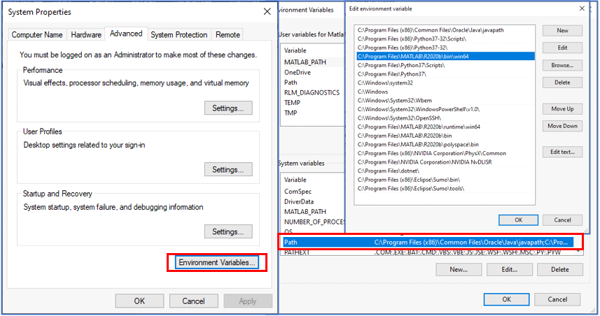

*Figure : Environment variable PATH*

**Note**:

* To run this code 64- bit version of MATLAB must be installed in your system.
* If the machine has more than one MATLAB installed, the directory for the target platform must be ahead of any other MATLAB directory (for instance, when compiling a 64-bit application, the directory in the MATLAB 64-bit installation must be the first one on the PATH).
* Open Command prompt as admin and execute the command “matlab -regserver”. This will register MATLAB as a COM automation server and is required for NetSim to start MATLAB automation server during runtime.
* Place the **LEACH_HETERO.m** present in the MATLAB Code folder inside the bin x64 folder of the current workspace. for example: **“C:\Users\Hi\Documents\NetSim\Workspaces\v13.1_std_FE_Hetero_Leach\bin_x64\MATLAB”**.
* Open the Source codes in Visual Studio by going to Your work-> Workspace Options and Clicking on Open code button in NetSim Home Screen window.
* Under the DSR project in the solution explorer you will be able to see that **MATLAB_Interface.c** and **LEACH_HETEROGENEOUS.c** files which contain source codes related to interactions with MATLAB and handling clustering in NetSim, respectively.
* Run the simulation of the NetSim scenario.

**Example**

* Run NetSim as administrative mode.
* The **Workspace_Heterogeneous_Leach_in_WSN** comes with a sample network configuration that is already saved. To open this example, go to Your Work in the Home screen of NetSim and click on the LEACH_HETEROGENEOUS example from the list of experiments
* The network scenario consists of 100 sensors deployed randomly in a 50x50m grid environment with a sink node placed in the center.

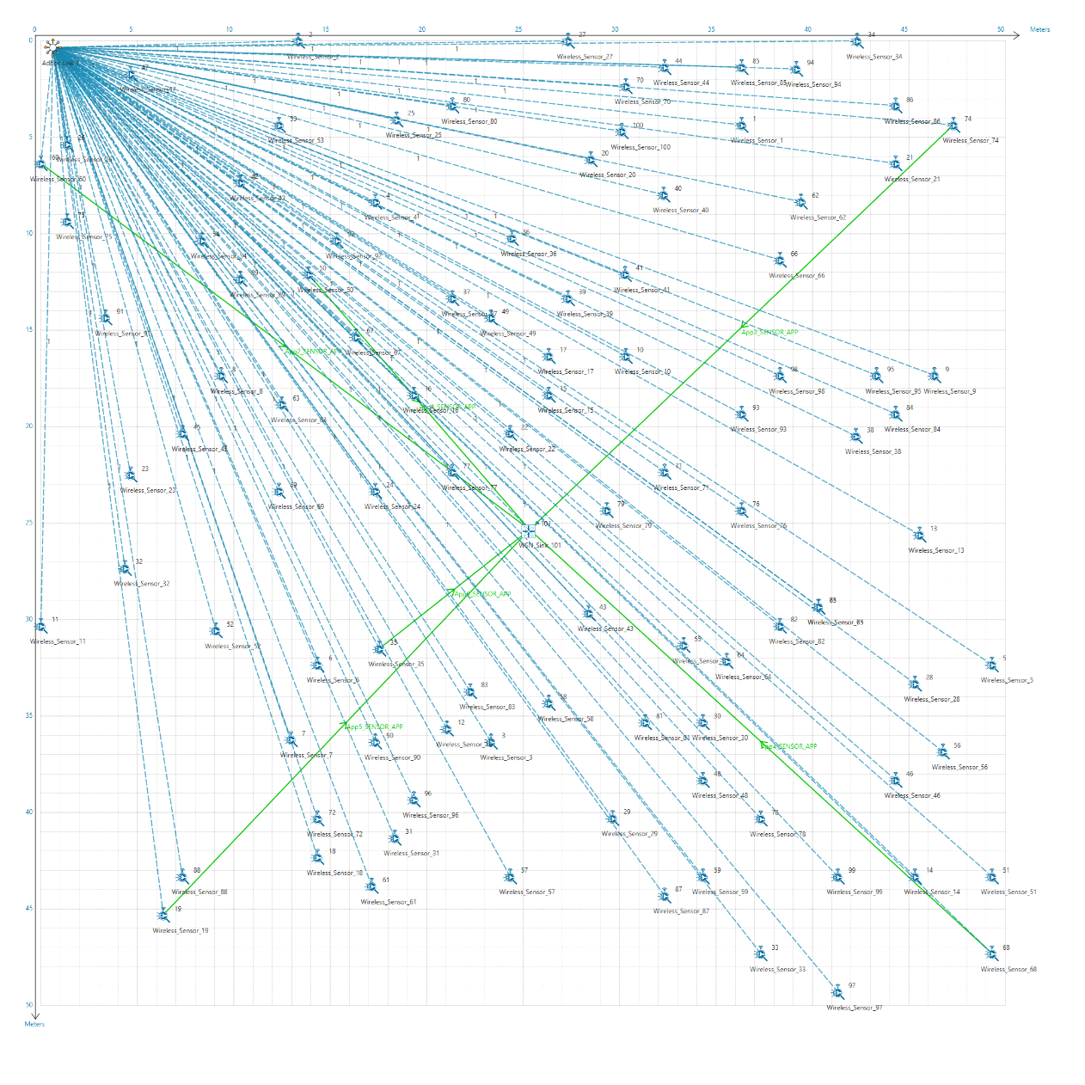

*Figure : Network Scenario of 100 sensors deployed randomly*

* Run simulation and press any key to continue. It will start MATLAB process automatically

**Results and discussion:** You will observe that as the simulation starts, and the plots will be displayed in MATLAB shown below:

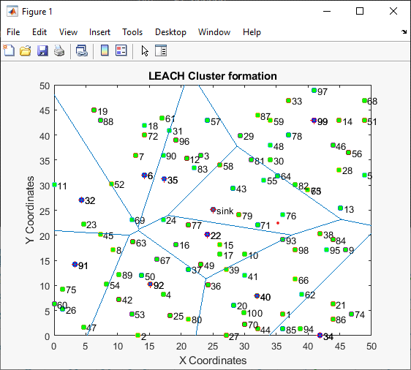

*Figure : LEACH Cluster formation in MATLAB*

The above plot contains the nodes that are part of the network in NetSim. All sensor nodes are initially alive. Sink node that is highlighted in the center and the nodes marked in blue act as cluster heads.

The plot is further divided into different regions based on the location of the cluster heads using a Voronoi diagram.

The clusters and cluster heads are calculated periodically and whenever one or more nodes run out of energy and dies.