**Heterogeneous LEACH for WSN**

**Software Recommended:** NetSim Standard v11.1 (32/64 bit), Visual Studio 2017/2019, MATLAB (32/64 bit)

In Wireless Sensor Networks energy efficiency plays a crucial role as the sensors are generally battery powered. Hierarchical routing protocols can be used to overcome this constraint.

LEACH is a hierarchical protocol in which most nodes transmit to cluster heads, and the cluster heads aggregate and compress the data and forward it to the base station (sink). Each node uses a stochastic algorithm at each round to determine whether it will become a cluster head in this round. LEACH assumes that each node has a radio powerful enough to directly reach the base station or the nearest cluster head, but that using this radio at full power all the time would waste energy.

Heterogeneous LEACH involves a network with sensor nodes of different energy levels. Clusters are formed periodically and cluster heads are elected. Nodes send packets either to the cluster head or to the sinknode based on whichever is located near.

**Heterogeneous LEACH in NetSim with MATLAB Interfacing:**

Heterogeneous LEACH is implemented in NetSim by Interfacing with MATLAB for the purpose of mathematical calculation. The sensor coordinates and remaining energy are fed as input to MATLAB. Heterogeneous LEACH algorithm that is implemented in MATLAB is used to dynamically form clusters and elect cluster heads.

From MATLAB the number of clusters, cluster head id’s and cluster memebership is retrieved to perform routing in NetSim.

All the above steps are performed periodically and can be defined as per the implementation. Each time a node dies, the algorithm is invoked to perform clustering excluding the dead nodes.

The codes required for the mathematical calculations done in MATLAB are written to a **LEACH_HETERO.m** file as shown below:

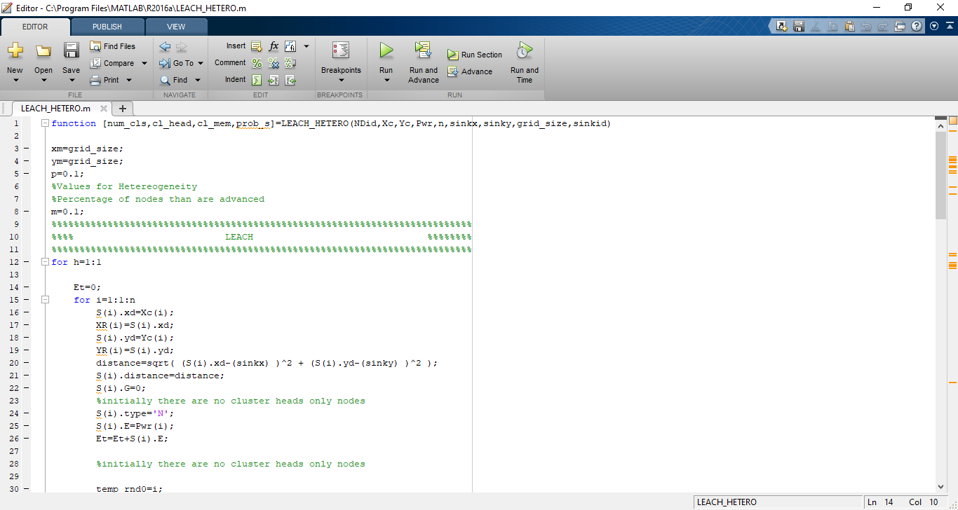

A **LEACH_HETEROGENEOUS.c** file is added to the DSR project which contains the following functions:

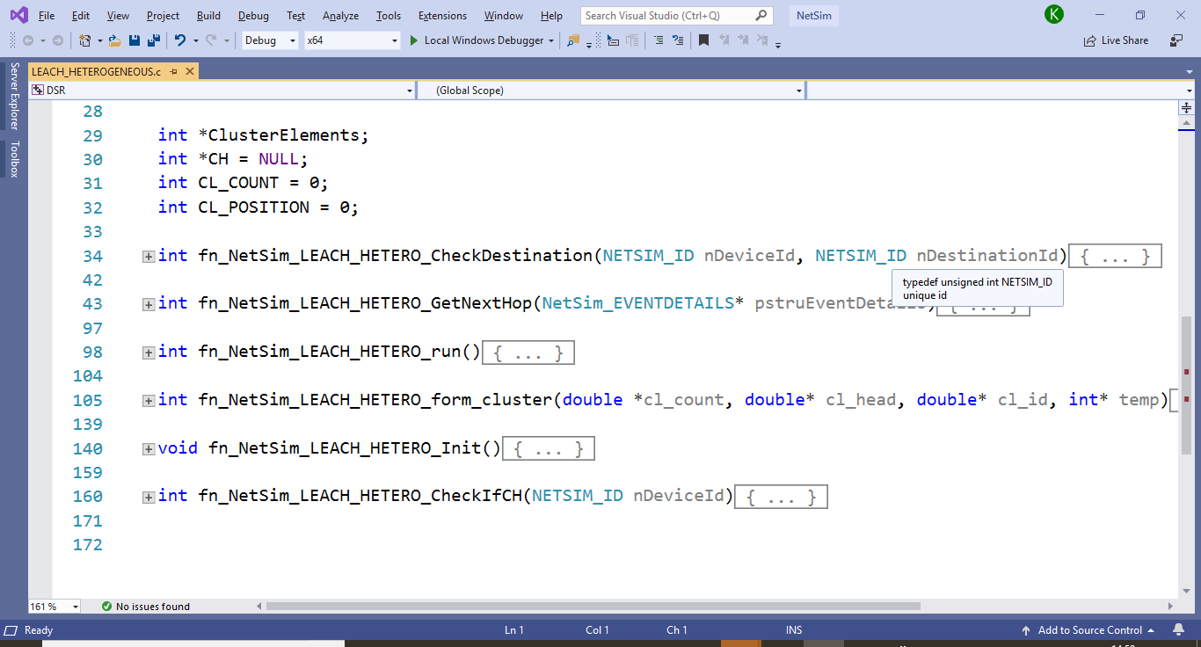

**fn_NetSim_LEACH_HETERO_CheckDestination()**

This function is used to determine whether the current device is the destination of a packet or an intermediate node.

**fn_NetSim_LEACH_HETERO_GetNextHop()**

This function handles routing in the sensor network by determining the next hop device based on the clusters and cluster heads elected using LEACH protocol.

**fn_NetSim_LEACH_HETERO_run()**

This function makes a call to MATLAB interfacing function and passes the inputs from NetSim to MATLAB and also retrieves the computed parameters from MATLAB workspace for further calculations in NetSim.

**fn_NetSim_LEACH_HETERO_form_cluster()**

This function updates the information obtained from MATLAB to identify clusters and cluster heads formed using LEACH protocol.

**fn_NetSim_LEACH_HETERO_Init()**

This function initializes the parameters specific to LEACH protocol and identifies the number of sensors that are alive at any instance of simulation.

**fn_NetSim_LEACH_HETERO_CheckIfCH()**

This function is used to check whether a node is a cluster head or a normal sensor node.

**Static Routing:**

Static Routing is defined in such a way that the sensors send packets to its cluster head. Once packet arrives at the cluster head it is forwarded to the destination or the sinknode.

**NOTE:**

To run this code 64- bit version of MATLAB must be installed in your system.

# Steps:

1. The downloaded project folder contains the folders Documentation, MATLAB_Code and LEACH_HETERO_WORKSPACE directory as shown below:

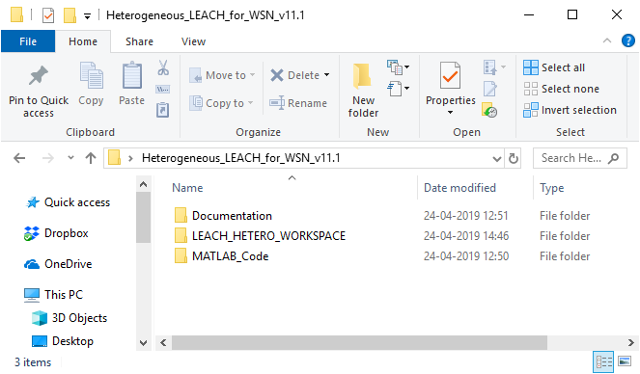

1. Import LEACH_HETERO_WORKSPACE by going to Open Simulation->Workspace Options->More Options in NetSim Home window. Then select Import as shown below:

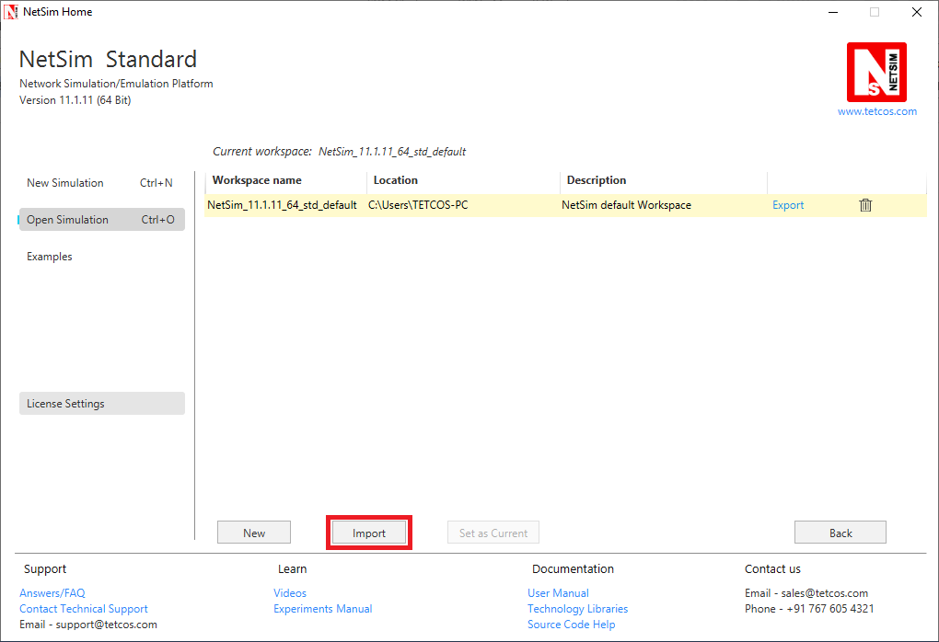

1. It displays a window where users need to give the path of the workspace folder and click on OK as shown below:

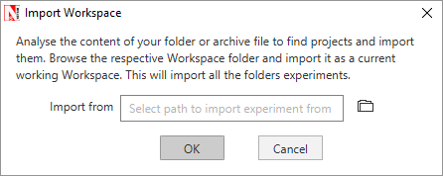

1. Browse to the LEACH_HETERO_WORKSPACE folder and click on select folder as shown below:

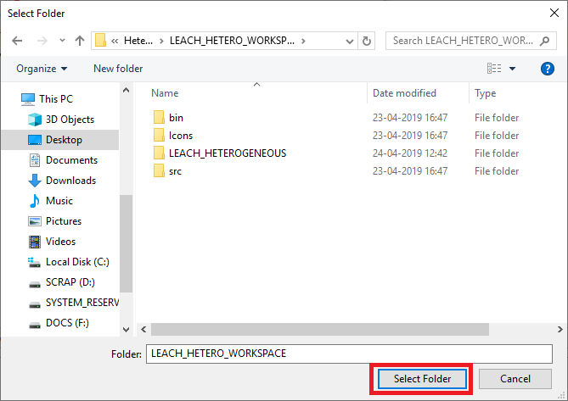

1. After this click on OK button in the Import Workspace window.
2. While importing the workspace, if the following warning message indicating Software Version Mismatch is displayed, you can ignore it and proceed.

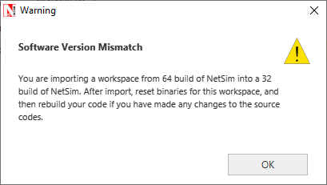

1. The Imported workspace will be set as the current workspace automatically. To see the imported workspace, click on Open Simulation->Workspace Options->More Options as shown below:

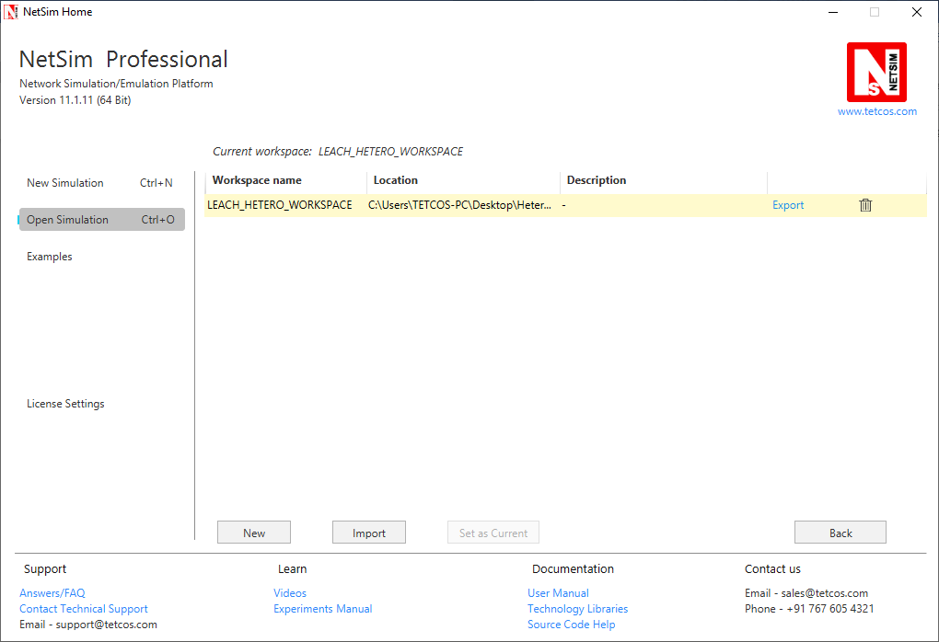

1. Create a user variable with the name of MATLAB_PATH and provide the path of the installation directory of user’s respective MATLAB version.

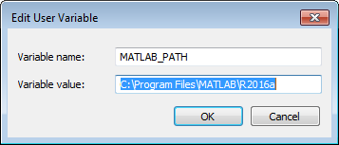

1. Make sure that the following directory is in the PATH(Environment variable)

**<Path where MATLAB is installed>\bin\win64**

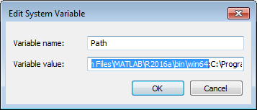

**Note:** If the machine has more than one MATLAB installed, the directory for the target platform must be ahead of any other MATLAB directory (for instance, when compiling a 64-bit application, the directory in the MATLAB 64-bit installation must be the first one on the PATH).

1. Open Command prompt as admin and execute the command “matlab -regserver”. This will register MATLAB as a COM automation server and is required for NetSim to start MATLAB automation server during runtime.

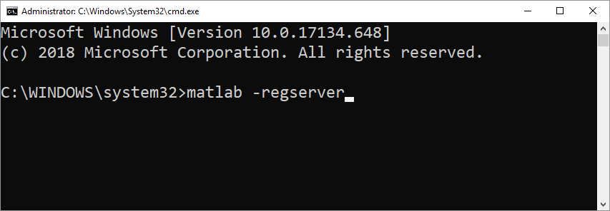

1. Place **LEACH_HETERO.m** present in the MATLAB_Code folder inside the root directory of MATLAB. For Example: **“C:\Program Files\MATLAB\R2016a”**.

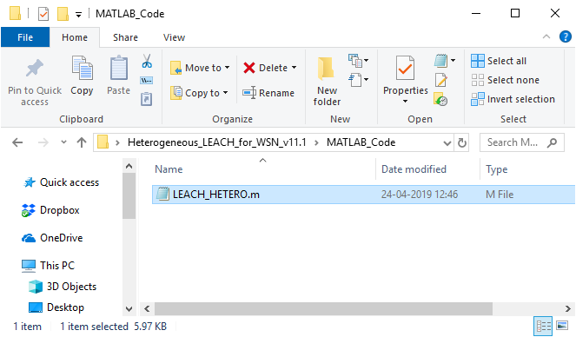

1. Open the Source codes in Visual Studio by going to Open Simulation-> Workspace Options and Clicking on Open code button as shown below:

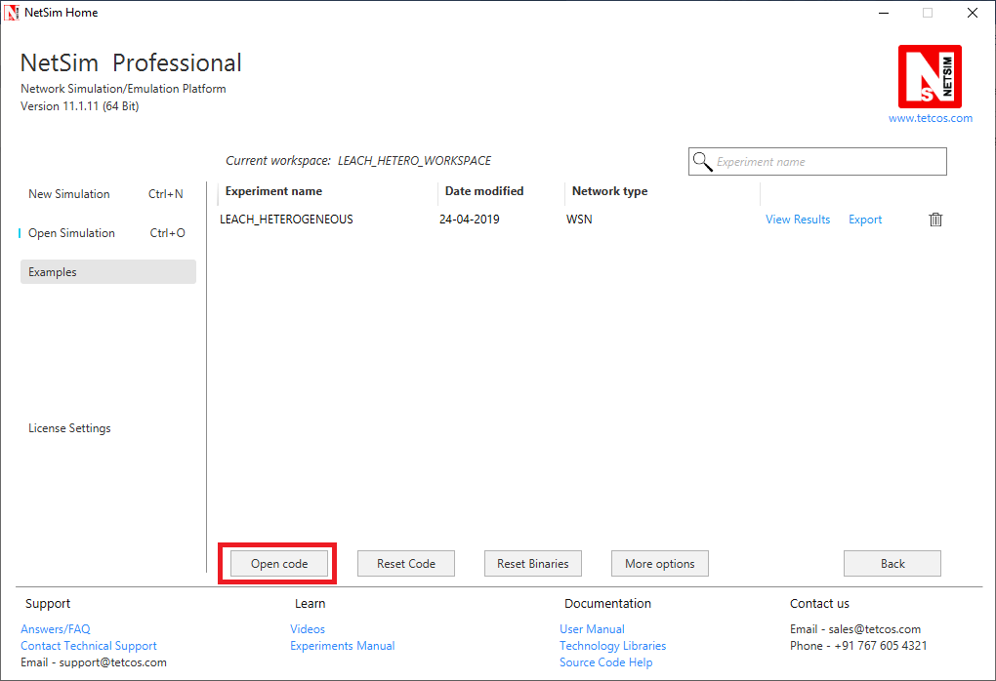

1. Under the DSR project in the solution explorer you will be able to see that **MATLAB_Interface.c** and **LEACH_HETEROGENEOUS.c** files which contain source codes related to interactions with MATLAB and handling clustering in NetSim respectively.
2. Based on whether you are using NetSim 32 bit or 64 bit setup you can configure Visual studio to build 32 bit or 64 bit Dll files respectively as shown below:

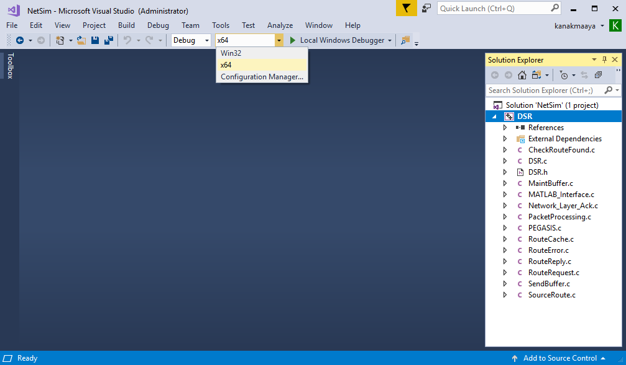

1. Right click on the DSR project in the solution explorer and select Rebuild.

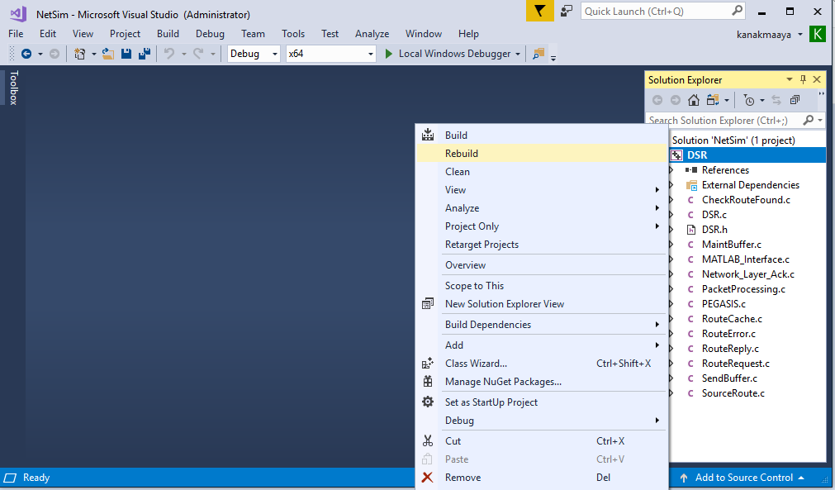

1. Upon successful build modified libDSR.dll file gets automatically updated in the directory containing NetSim binaries.
2. Run NetSim as Administrative mode.
3. Then LEACH_HETERO_WORKSPACE comes with a sample configuration that is already saved. To open this example, go to Open Simulation and click on the LEACH_HETEROGENEOUS that is present under the list of experiments as shown below:

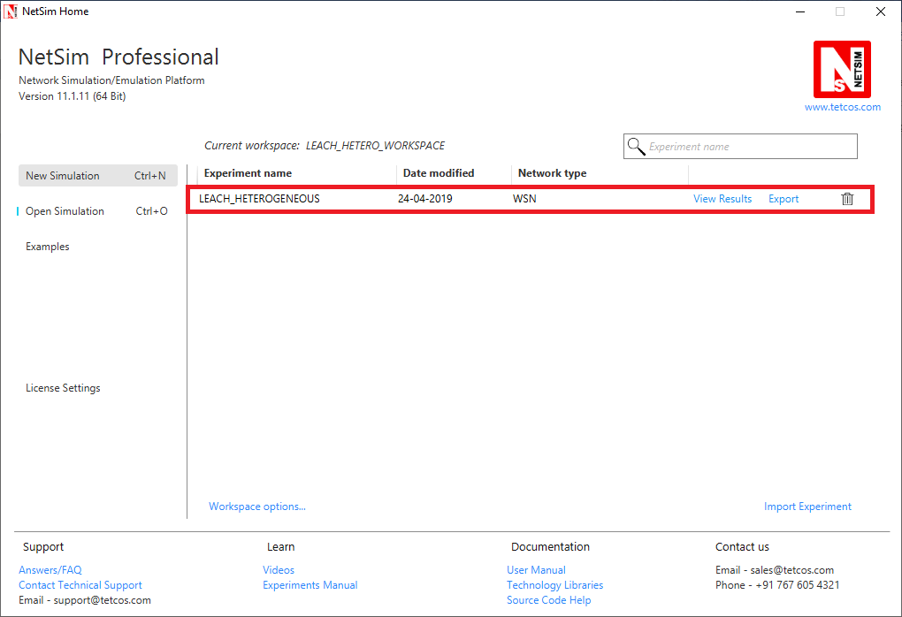

1. The network scenario consists of 100 sensors deployed randomly in a 50x50m grid environment with a sink node placed in the centre.

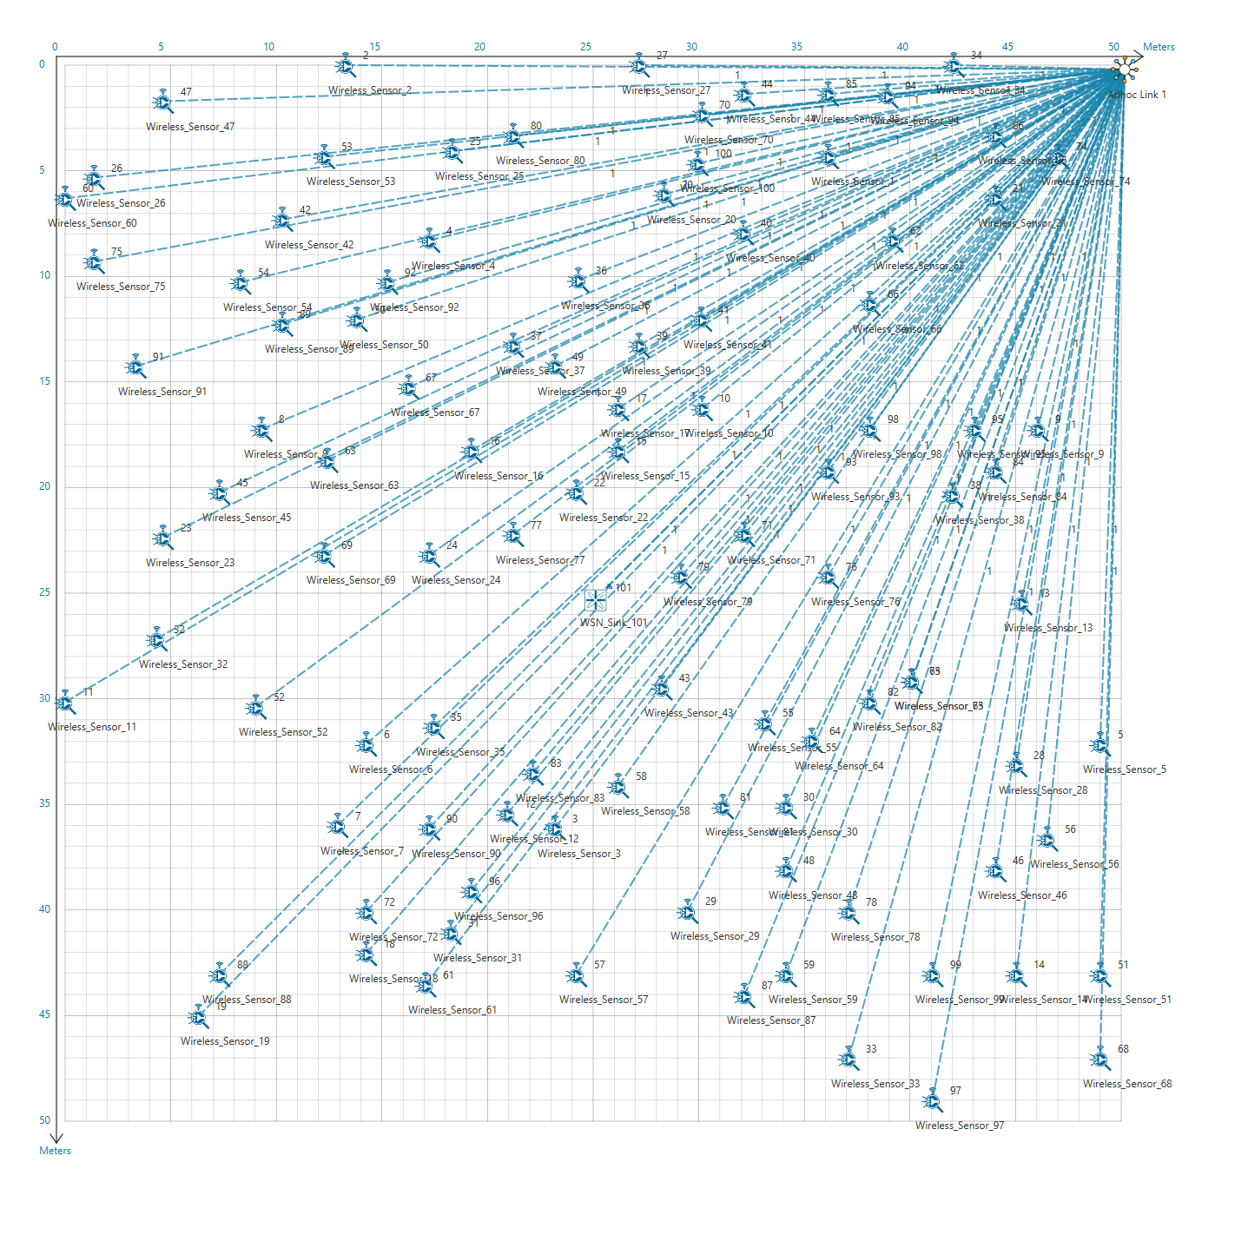

1. Run the Scenario. You will observe that as the simulation starts, NetSim automatically initializes MATLAB and the plots will be displayed as shown below:

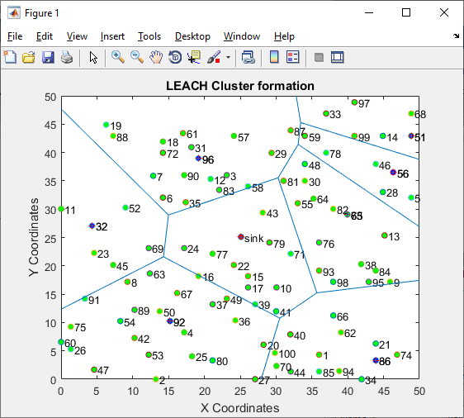

# Explanation:

The above plot contains the nodes that are part of the network in NetSim. All sensor nodes are initially alive. Sink node that is highlighted in the centre and the nodes marked in blue act as cluster heads.

The plot is further divided into different regions based on the location of the cluster heads using a Voronoi diagram.

The clusters and cluster heads are calculated periodically and also whenever one or more node runs out of energy and dies.