Intrusion detection system for LEACH

Software: NetSim Standard v14.4, Visual Studio 2022
Project Download Link:
https://github.com/NetSim-TETCOS/IDS_in_Leach_v14.2/archive/refs/heads/main.zip

Follow the instructions specified in the following link to download and setup the Project in NetSim:

https://support.tetcos.com/en/support/solutions/articles/14000128666-downloading-and-setting-up-netsim-file-exchange-projects

Introduction

An Intrusion Detection System (IDS) is a security mechanism designed to monitor network traffic and detect unauthorized access or malicious activities. The Low-Energy Adaptive Clustering Hierarchy (LEACH) is a clustering-based protocol that divides the sensor nodes into clusters, with one node acting as the cluster head, responsible for collecting data from the cluster members this protocol is used in wireless sensor networks to reduce energy consumption and prolong network lifetime.
In the context of LEACH, an IDS can help to detect and prevent attacks that target the network's nodes, such as denial-of-service (DoS) attacks, sinkhole attacks, and compromised node attacks. IDS for the
LEACH is a security solution designed specifically for WSNs that use the LEACH protocol. It works by monitoring the network traffic, analyzing it for anomalies or malicious activities, and taking appropriate actions to prevent them.
The goal of an IDS for LEACH in Netsim is to provide an additional layer of security to protect the network and the data transmitted through it. By detecting and responding to potential threats in a timely manner, the system can help prevent attacks and ensure the integrity and availability of the network.

Example
- The IDS_in_LEACH workspace comes with a sample network configuration that are already saved. To open this example, go to Your work in the Home screen of NetSim and click on the IDS-Leach-Example from the list of experiments.
- This Network is created in WSN Network as per the Number of clusters and size of clusters that are set in the LEACH code. By default, the code runs for a scenario with 64 sensors uniformly placed, with the SINKNODE placed as per the screenshot shown below.
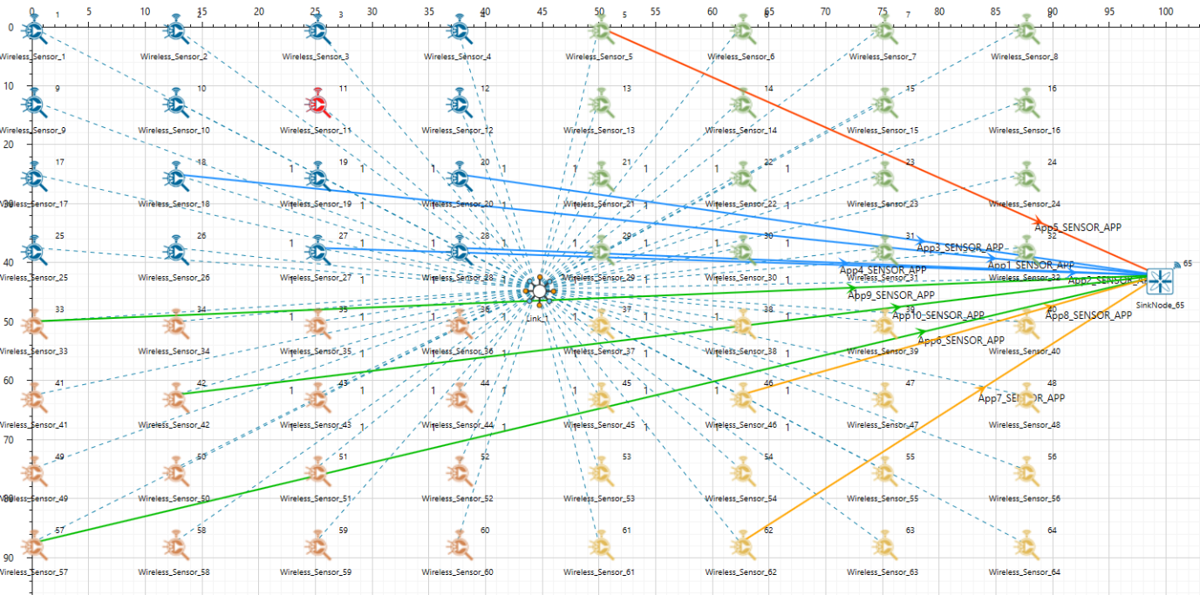
Figure 1: 64 sensors uniformly placed, with the SINKNODE
- Wireless Link Properties
- Channel Characteristics - Pathloss only
- Path loss model - LOG_DISTANCE
- Path loss exponent – 2.5
- Run the simulation for 100 seconds.

Results and discussion
- You will note that the sensors directly start transmitting packets without route establishment since the routes are statically defined in LEACH.
- In LEACH.csv file in the result dashboard, you will also note that the cluster heads keep changing dynamically in Clusters 2, 3 and 4.
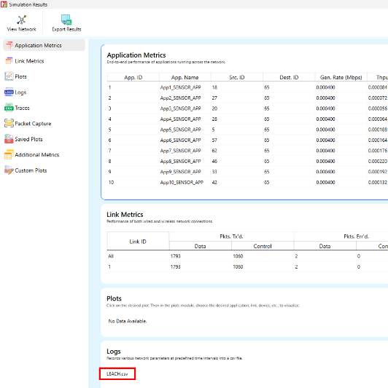
Figure 2: LEACH log file in result dashboard.
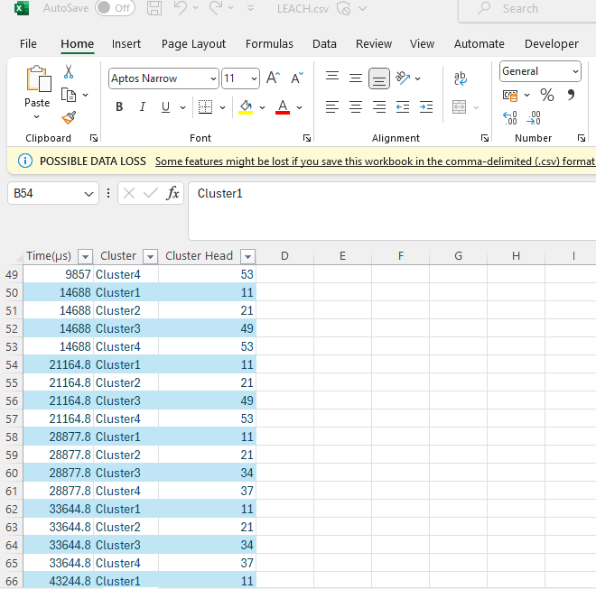
Figure 3: LEACH log file screenshot showing the cluster heads at different time
- In cluster1, initially the cluster members transmit packets to malicious node (device id 11) since it advertises false battery information to become a cluster head. Per the original code setting the Watchdog timer is set to 2 seconds and the failure threshold is set to 20 packets. You would notice that around 59 seconds, the malicious node is detected and then cluster head is elected dynamically based on the remaining energy of the sensor.
- This can be observed in Packet trace by applying filters to Source_ID column by selecting only Sensor-18, 20, 27 and 28 as we are checking on cluster 1 where malicious node is present and application is only configured from this particular node. You will be able to see that the receiver id is sensor-11 from 1s till 59s of simulation time and then it is changed when it gets blacklisted.

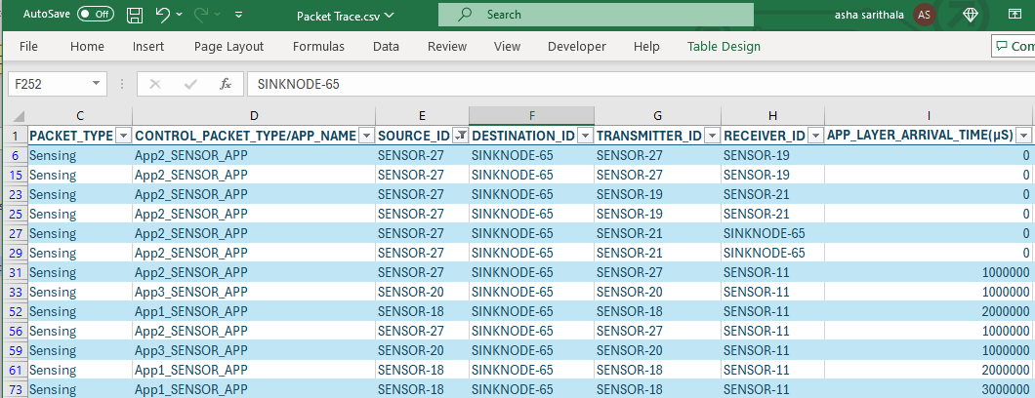
Figure 4: NetSim Packet trace after filtering Sensor 18, 20, 27 and 28 as source ID
- Now undo filter in Source_Id column and apply filter to transmitter_Id column by selecting only Sensor-11. You will be able to see that no data packets are forwarded by the malicious node.
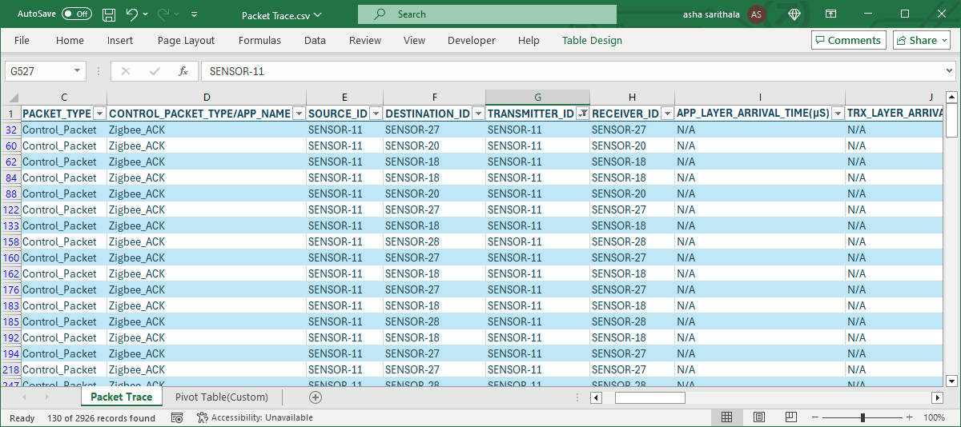
Figure 5: Undo filter in Source_Id column and transmitter_Id column by selecting only Sensor-11
- This will have a direct impact on the Application Throughput which can be observed in the Application Metrics table present in NetSim Simulation Results window. The throughput for applications 1, 2, 3 and 4 are less since the source ids belongs to cluster1 having malicious node (device id 11).

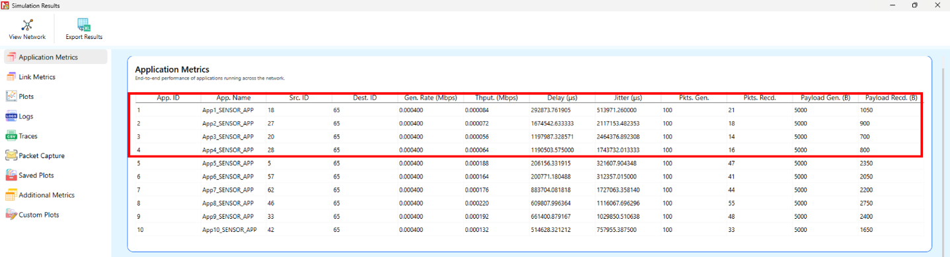
Figure 6: Application Metrics Window
- The time at which a malicious node is detected can be obtained from the CUSTOM METRICS (IDS METRICS). These metrics can be accessed by navigating to the additional metrics section, where you can find the start time (the time from which a node becomes malicious) and the detection time (the time at which the node was added to the blacklist).
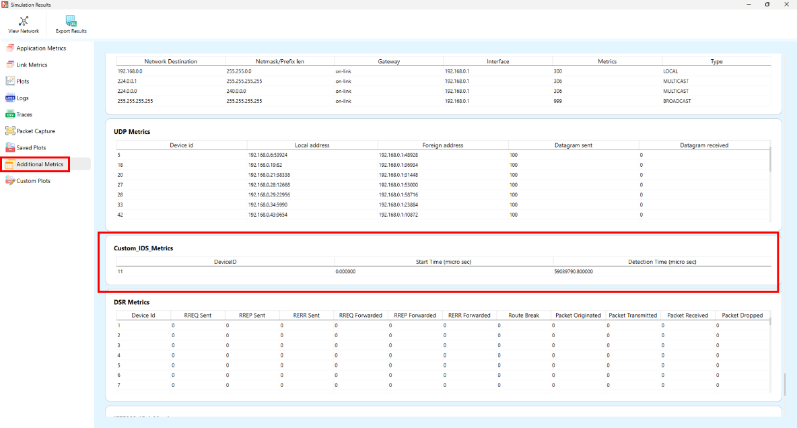
Figure 7: Dedicated Metrics for IDS

Files Used in this project
The following steps show how a user can run the IDS in NetSim to detect a malicious node, and then setup a new route to the destination avoiding the malicious node.
- Creating Malicious nodes for a particular network scenario is explained in Malicious.c file which is present in DSR Project.
- Clustering and cluster head election is explained in LEACH.c file which is present in DSR Project.

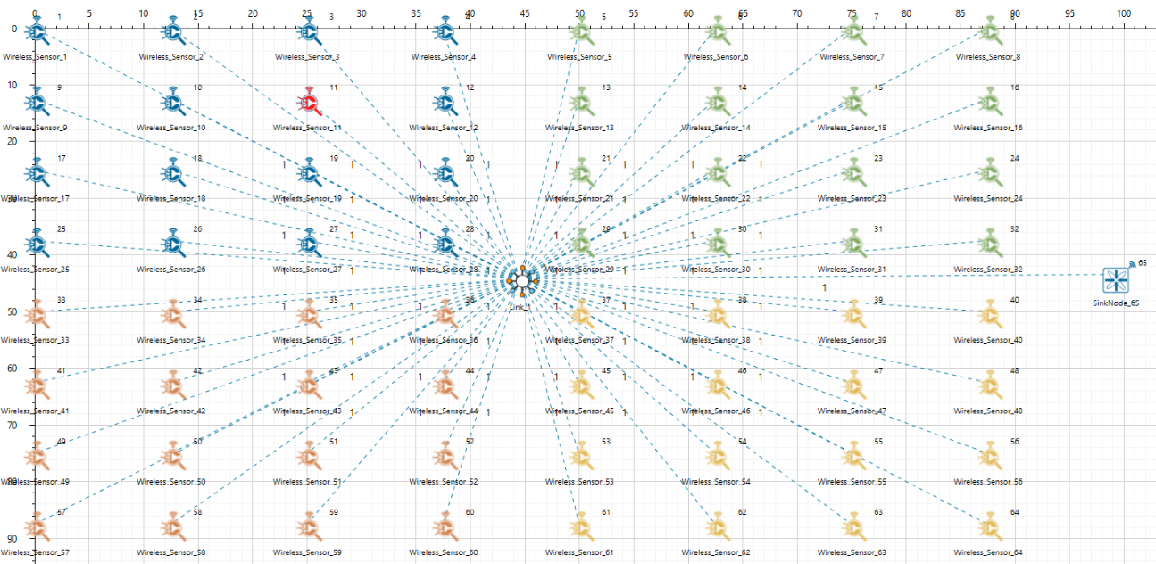
- For this implementation of LEACH, the number of Clusters is fixed as 4 and all the 4 clusters are equal. If the user wants to change it, then he/she must also change the static routing for the Cluster Heads and the ClusterElement array accordingly in leach.c
Cluster 1
Cluster 2
Cluster 3
Cluster 4

Figure 8: Sensor nodes present in each Clusters
To make 4 equal clusters the number of sensors must be 4,16,36,64,100. Depending on the number of sensors, the ClusterElements array must be defined. Here, it has been defined and commented for 4,16,36,64,100 sensors. Uncomment the one you want to use.

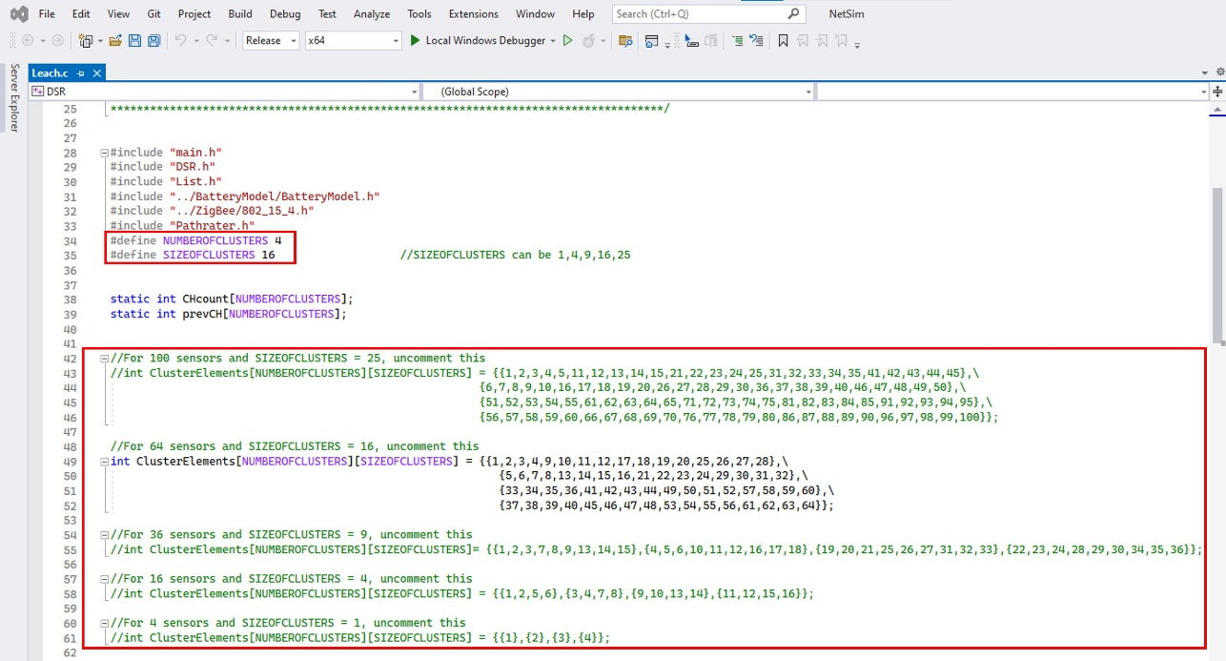
Figure 9: Leach.c file present in DSR project
- To detect the intruder and to send data via a new route, the following files are added in DSR(Pathrater.c) and Zigbee(Watchdog.c)

Pathrater.c:
This file contains code for avoiding the malicious node and finding a new route (once the IDS detects the malicious node) in networks running DSR in Layer 3. Note that this system would work only for UDP and not for TCP, since TCP involves receiving ack’s from the destination.
If _NETSIM_PATHRATER_ is defined, the code is used to validate routes. When the Node is a Malicious Node and a Route Reply is processed, the Function verifies the route reply in the route cache and checks for the blacklisted node.
i.e., malicious node. When a malicious node is found that route entry is deleted from the cache.
Watchdog.c:
This file contains code for the IDS and is added in Zigbee operating in Layer 3.
If _NETSIM_WATCHDOG_ is defined, a watchdog timer starts the moment a packet is sent. Once a packet is forwarded to next hop node, the current node checks for watchdog timer duration if the packet is getting forwarded further on to destination node or not.
The malicious node does not forward packets that it receives. The watchdog timer in the node (which forwarded the packet to the malicious node) expires. A counter is present which measures the number of times the watchdog timer expires (in other words the number of packets sent out but not forwarded by the next hop node). Once this counter’s value reaches the failure threshold the next hope is marked by the current node as a malicious node.

