**LTE X2 Handover**

**Software Recommended:** NetSim Standard v10.2 (32-bit), Microsoft Visual Studio 2015

**Handover**

Handover is an important function that maintains seamless connectivity when transitioning  
from one base station to another.

* Due to mobility UEs can move from one place to another.
* Then UE sends the MEASUREMENT REPORT to the S-eNB.
* The S-eNB issues a HANDOVER REQUEST message to the T-eNB.
* The T-eNB checks for resource availability and, if available, reserves the resources  
  and sends back the HANDOVER REQUEST ACKNOWLEDGE message.

**LTE X2 Handover**

In event-triggered handover procedures, each UE evaluates the Event condition every time a new averaged measurement sample is available .The evaluated condition is the entering condition of Event whether the RSRP/SNR measured from a neighbouring cell becomes an offset better than the RSRP/SNR measured from the serving cell . The offset is represented as hysteresis.

The UE generates a measurement report and transmit it as an RRC message to the serving cell. This report typically contains measurement results of at least the serving cell, but is extendable with measurement results of neighboring cells. Series of steps occurs to carry out handover process which can be seen in the diagram below and also in our table in Result Section.

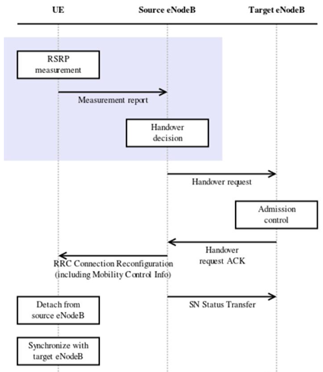

Simulation that runs with small hysteresis produced large number of handovers, especially of Ping-Pong type. The number of handovers can be substantially reduced with proper parameterization. This proves that the simulated behavior demonstrated by our model is sensitive to these parameters and in accord with results from several other published research works in the field.

**Steps to run LTE X2 Handover in NetSim**

1. Select File Based Mobility as Mobility Model in both UEs. User will get this option under General Properties of UE properties.
2. Check the tutorial on <https://tetcos.freshdesk.com/support/solutions/articles/14000072645-how-can-i-plot-snr-measured-by-ue-> to get basic knowledge of SNR measured by each UE for each ENB in range.
3. In file LTE Phy.c do the following changes

**#include "main.h"**

**#include "LTE.h"**

**#define devid(id) fn_NetSim_GetDeviceIdByConfigId(id)**

**NETSIM_ID fn_NetSim_LTE_FindNearesteNB(NETSIM_ID nDeviceId);**

**FILE* fp;**

**char snrlog[100];**

**int fn_NetSim_LTE_CalculateReceivedPower()**

**{**

**NETSIM_ID i;**

**//fp = fopen("LTE_UE_SNR.txt", "w+");**

**for(i=0;i<NETWORK->nDeviceCount;i++)**

**{**

**…………………………………………………………**

**if(ber<TARGET_BER)**

**break;**

**else**

**{**

**info->DLInfo[j].nCQIIndex--;**

**info->ULInfo[j].nCQIIndex--;**

**}**

**}**

**sprintf(snrlog, "LTE_UE_SNR_%d.csv", devid(info->nUEId));**

**fp = fopen(snrlog, "w+");**

**int arr[512],k=0,c;**

**if (fp)**

**{**

**for (c = 0; c < NETWORK->nDeviceCount; c++)**

**{**

**if (NETWORK->ppstruDeviceList[c]->nDeviceType == eNB)**

**{**

**arr[k] = NETWORK->ppstruDeviceList[c]->nDeviceId;**

**k++;**

**}**

**}**

**fprintf(fp, "UE_ID,Time");**

**for (c = 0; c < k; c++)**

**{**

**fprintf(fp, ",SNR_ENB_ID_%d",arr[c]);**

**}**

**fclose(fp);**

**}**

}

**info=(LTE_ASSOCIATEUE_INFO*)LIST_NEXT(info);**

**}**

**}**

**}**

**return 1;**

**}**

Now in NAS.c change the initial function as following

**#define MEASUREMENT_REPORT_SIZE 184/8.0**

**#define HO_REQUEST_SIZE 288/8.0**

**#define HO_CONFIRM_SIZE 112/8.0**

**#define HANDOVER_DIFF      3 //db**

**#define devid(id) fn_NetSim_GetDeviceIdByConfigId(id)**

**int fn_NetSim_LTE_InitHandover(NETSIM_ID ueId,NETSIM_ID nENBId)**

**{**

**//Prepare the measurement report**

**NetSim_PACKET* packet;**

**LTE_MAC_PACKET* macPacket;**

**LTE_PHY_PACKET* phyPacket;**

**LTE_MEASUREMENT_REPORT* report=NULL;**

**NETSIM_ID i;**

**FILE* fp = NULL;**

**char snrlog[100];**

**sprintf(snrlog, "LTE_UE_SNR_%d.csv", fn_NetSim_GetDeviceIdByConfigId(ueId));**

**fp = fopen(snrlog, "a+");**

**fprintf(fp, "\n%d,%lf", fn_NetSim_GetDeviceIdByConfigId(ueId), pstruEventDetails->dEventTime);**

**for(i=0;i<NETWORK->nDeviceCount;i++)**

**{**

**//fprintf(fp, "\n%d,%lf", devid(info->nUEId), pstruEventDetails->dEventTime);**

**if(DEVICE_TYPE(i+1) == eNB)**

**{**

**unsigned int j;**

**LTE_MEASUREMENT_REPORT* temp=MEASUREMENT_REPORT_ALLOC();**

**LTE_ASSOCIATEUE_INFO* info = UEINFO_ALLOC();**

**LTE_ENB_PHY* enbPhy=(LTE_ENB_PHY*)DEVICE_PHYVAR(i+1,1);**

**info->nUEId=ueId;**

**info->nUEInterface=1;**

**temp->nENBId=i+1;**

**temp->nUEId=ueId;**

**temp->carrier_count = enbPhy->ca_count;**

**for(j=0;j<enbPhy->ca_count;j++)**

**{**

**fn_NetSim_LTE_CalculateRxPower(i+1,1,info,j);**

**fn_NetSim_LTE_CalculateSNR(i+1,1,info,j);**

**fn_NetSim_LTE_GetCQIIndex(i+1,1,info,j);**

**fn_NetSim_LTE_GetMCS_TBS_Index(info,j);**

**while(info->DLInfo[j].nCQIIndex>1 && info->ULInfo[j].nCQIIndex>1)**

**{**

**double ber;**

**fn_NetSim_LTE_GetMCS_TBS_Index(info,j);**

**ber = fn_NetSim_LTE_CalculateBER(0,info->DLInfo[j].MCSIndex,info->DLInfo[j].dSNR);**

**if(ber<TARGET_BER)**

**break;**

**else**

**{**

**info->DLInfo[j].nCQIIndex--;**

**info->ULInfo[j].nCQIIndex--;**

**}**

**}**

**temp->nCQIIndex_DL[j]=info->DLInfo[j].nCQIIndex;**

**temp->dSNR_DL[j]=info->DLInfo[j].dSNR;**

**//dETime = pstruEventDetails->dEventTime;**

**if (fp)**

**{**

**if (j == 0)**

**{**

**fprintf(fp, ",%lf", info->DLInfo[j].dSNR);**

**}**

**}**

**}**

**LIST_FREE((void**)&info,info);**

**LIST_ADD_LAST((void**)&report,temp);**

**}**

**}**

**fclose(fp);**

**if(report)**

**{**

**packet=fn_NetSim_LTE_CreateCtrlPacket(pstruEventDetails->dEventTime,**

**LTEPacket_MeasurementReport,**

**nENBId,**

**ueId,**

**nENBId,**

**MEASUREMENT_REPORT_SIZE);**

**macPacket=calloc(1,sizeof* macPacket);**

**macPacket->logicalChannel=LogicalChannel_CCCH;**

**macPacket->MessageType=LTEPacket_MeasurementReport;**

**macPacket->MessageVar=report;**

**macPacket->transportChannel=TransportChannel_RACH;**

**phyPacket=PACKET_PHYPROTOCOLDATA(packet);**

**phyPacket->physicalChannel=PhysicalChannel_PRACH;**

**packet->pstruMacData->Packet_MACProtocol=macPacket;**

**packet->pstruPhyData->Packet_PhyData=phyPacket;**

**//Add physical out event**

**pstruEventDetails->nDeviceId=ueId;**

**pstruEventDetails->nDeviceType=UE;**

**pstruEventDetails->nInterfaceId=1;**

**pstruEventDetails->nProtocolId=MAC_PROTOCOL_LTE;**

**pstruEventDetails->dPacketSize=MEASUREMENT_REPORT_SIZE;**

**pstruEventDetails->nApplicationId=0;**

**pstruEventDetails->nEventType=PHYSICAL_OUT_EVENT;**

**pstruEventDetails->nPacketId=0;**

**pstruEventDetails->nSegmentId=0;**

**pstruEventDetails->nSubEventType=0;**

**pstruEventDetails->pPacket=packet;**

**pstruEventDetails->szOtherDetails=NULL;**

**fnpAddEvent(pstruEventDetails);**

**}**

**return 0;**

**}**

**Steps to be done in NetSim scenario to Create LTE X2 Handover**

**Configuration**

Grid Length: 5000m

Distance between ENB: 5Km

Distance between UE: 5Km

Properties UE-ENB Link: Default

Simulation Time = 50 Sec

Velocity UE 6 =100m/s Velocity UE 7 = 0 m/s

Mobility model = File based mobility (for UE6)

Time of observation for each step = 0.5 sec

**Network Scenario:**

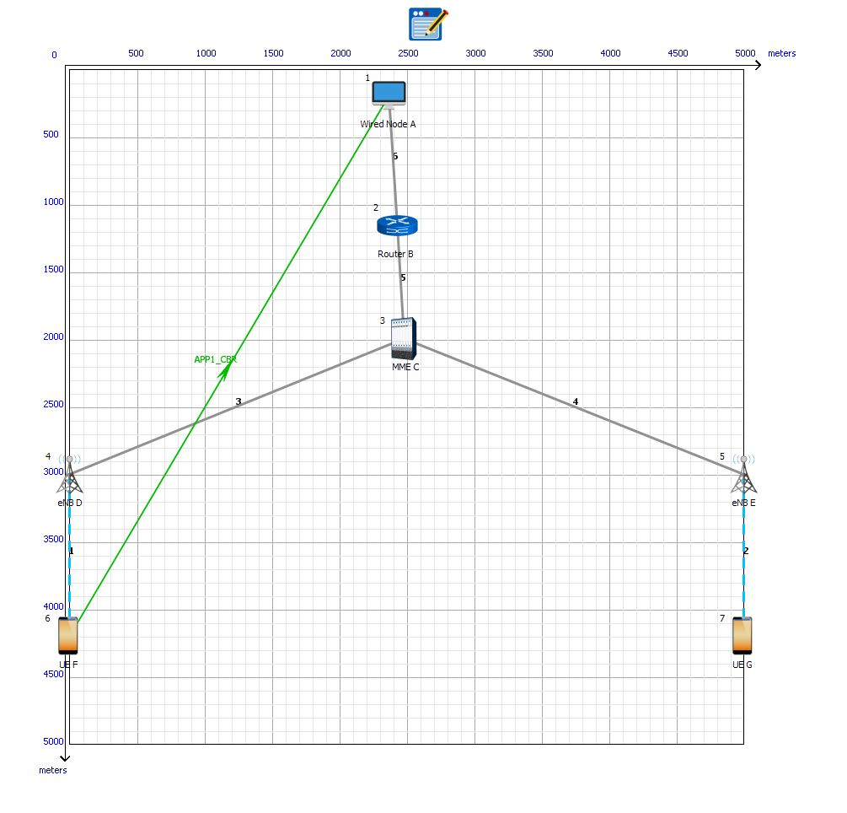

1. Create a scenario as shown above and define UE-ENB link properties as defined in Configuration above and also choose Mobility Model as FILE_BASED_MOBILITY for UE 6. Also define velocity for each UE similar to values shown above.
2. Create a mobility.txt file for UE’s involved in FILE_BASED_MOBILITY with each step equal to 0.5 sec with velocity 100 m/s and place it inside the bin folder of Netsim.Take help of mobility_generator.py but modify steps according to scenario and Netsim address.
3. Simulate the scenario in Netsim and you will get two .csv files in bin folder of Netsim corresponding to each UE’s involved in FILE_BASED_MOBILITY. Open any .csv file and you will observe the columns containing SNR measured by each ENB with respect to that particular UE.

C:\Users\GUI\Desktop\csv.PNG

1. With the help of Excel tools create a graph between SNR measured by each ENB with respect to time period. Properly set the gaps on x-axis and y-axis so you will get a clear graph.
2. Handover occurs when SNR difference between two ENBs is equal to 3 db. So for this scenario find in the graph the time value when SNR_ENB_5-SNR_ENB_4 measured is equal to 3 db.
3. This is the time value at which handover occurs.

**Result**

Handover occurs when difference between SNR measured by two ENB is equal to 3 db. In below chart Handover occurs when Difference value is equal to 3 on y axis which is between 30.5 sec and 31 sec.

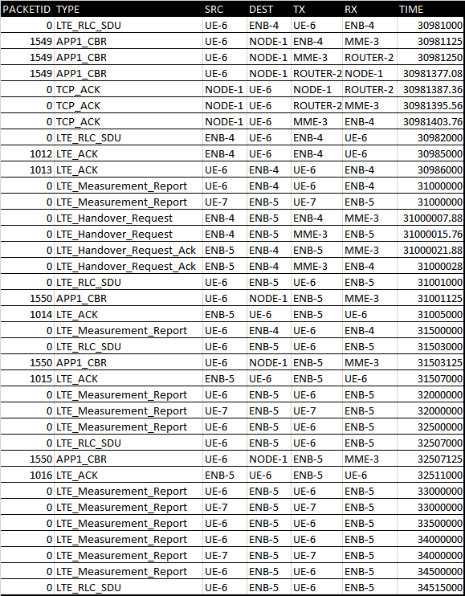

As UE moves from one position to another it sends measurement report to each ENB in range. As it moves SNR received by each ENB keeps on changing based on distance between ENB and UE. If the difference between SNR received by new ENB to that of old ENB to which it is connected gets greater than 3 decibel than at that point handover occurs.