**Localization in WSN**

**Software Recommended:** NetSim Standard v12.0 (32 bit/ 64 bit), Microsoft Visual Studio 2019

Localization is the process of finding the physical or relative location of a sensor node as data and information are useless if the nodes have no idea of their geographical positions. GPS (global positioning system) is the simplest method for localization of nodes, but it becomes very expensive if large number of nodes exists in a given network.

**Anchor Nodes:**

Sensor nodes with known location information are called “Anchor nodes‟. Typically, anchor nodes obtain their location information by using a global positioning system (GPS), or by manually being placed at defined coordinates.

**Unknown Nodes:**

Sensor nodes with unknown location information are called “Non-Anchor nodes‟ or “Unknown nodes”. Localization is estimated through communication between localized node and unknown node for determining their geometrical placement or position. Location is determined by means of distance and angle between nodes.

**Trilateration:**

Location of node is estimated through distance measurement from three nodes. In this concept, intersection of three circles is calculated, which gives a single point which is a position of unknown node.

Use the distance equation. If your unknown point is (x, y) and known points are (xi, yi) which are at distances ri from unknown point, then you get three equations:

$${(x – x1)}^{2}+ {(y – y1)}^{2} = {r1}^{2}$$

$${(x – x2)}^{2}+ {(y – y2)}^{2} = {r2}^{2}$$

$${(x – x3)}^{2}+ {(y – y3)}^{2} = {r3}^{2}$$

To calculate the distance between to sensors we have used NetSim API

DEVICE_DISTANCE(d1,d2)

Expand out the squares and subtract the second equation from the first and third equation from second, we get

$$2(x2 – x1)x + 2(y2 – y1)y = {r1}^{2} – {r2}^{2} + {x2}^{2 }– {x1}^{2} + {y2}^{2} – {y1}^{2}$$

$$2(x3 – x2)x + 2(y3 – y2)y = {r2}^{2} – {r3}^{2} + {x3}^{2 }– {x2}^{2} + {y3}^{2} – {y2}^{2}$$

This is a system of two equations with two unknowns:

$$Ax + By = C$$

$$Dx + Ey = F$$

The values of x and y is obtained from the below equations:

$$x = (CE – FB) / (EA – BD)$$

$$y = (CD – AF) / (BD – AE)$$

**Localisation in NetSim:**

1. To implement Localisation, we have added **Localisation.c** file in Zigbee project. The file contains the following functions:

* int fn_NetSim_localisation()

This function is used to find the anchor nodes based on the highest received powers received at unknown sensors from anchor nodes.

* int fn_NetSim_trilateration_method()

This function is used to implement the trilateration method to calculate the position / location of the unknown sensor.

* bool IsUnknownNode()

This function is used to check whether the given node is unknown node or not.

* bool determine_anchor_node()

This function is used to check whether the given node is anchor node or not.

1. Users can give their own unknown node IDs and unknown node count in **Localisation.c** file. NetSim knows all the positions of sensor nodes. Localisation is used to find the position of unknown nodes and then comparing this position with NetSim sensor positions.

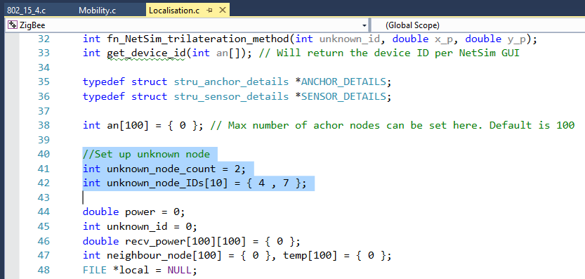

1. Since the unknown nodes are mobile, we have added a call to localisation in **fn_NetSim_Mobility_Run()** function present in **mobility.c** file inside Mobility project to calculate the new positions of the unknown node whenever a node moves.

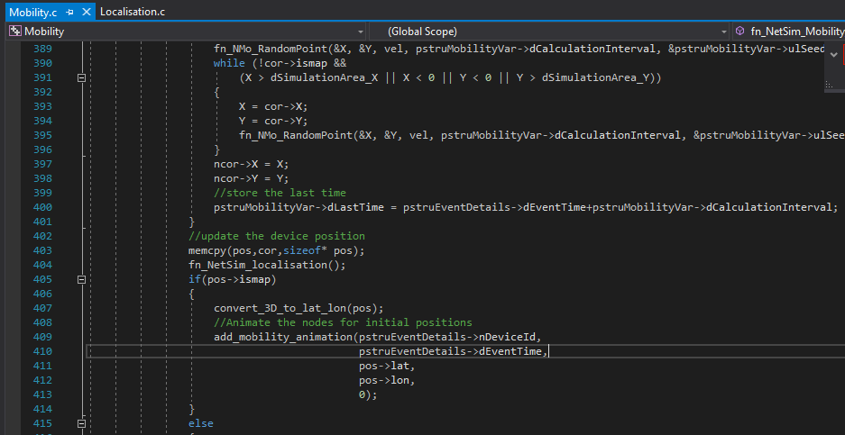

**Steps:**

* After you unzip the downloaded project directory, Open NetSim Home Page click on **Open Simulation** option,

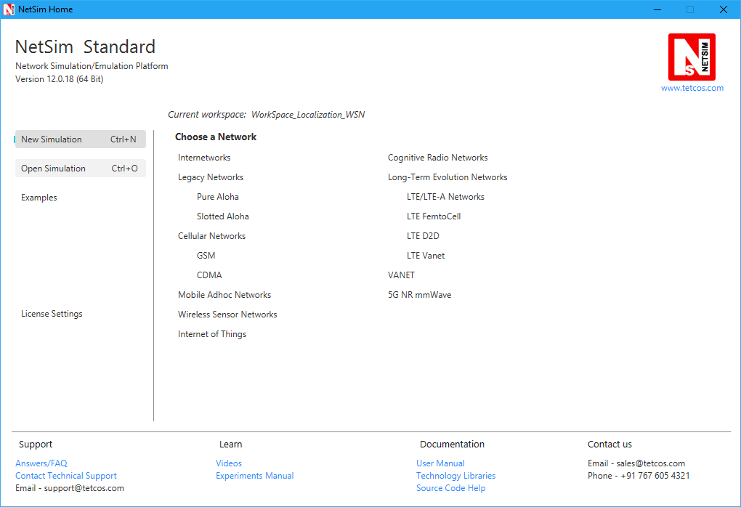

* Click on **Workspace options**

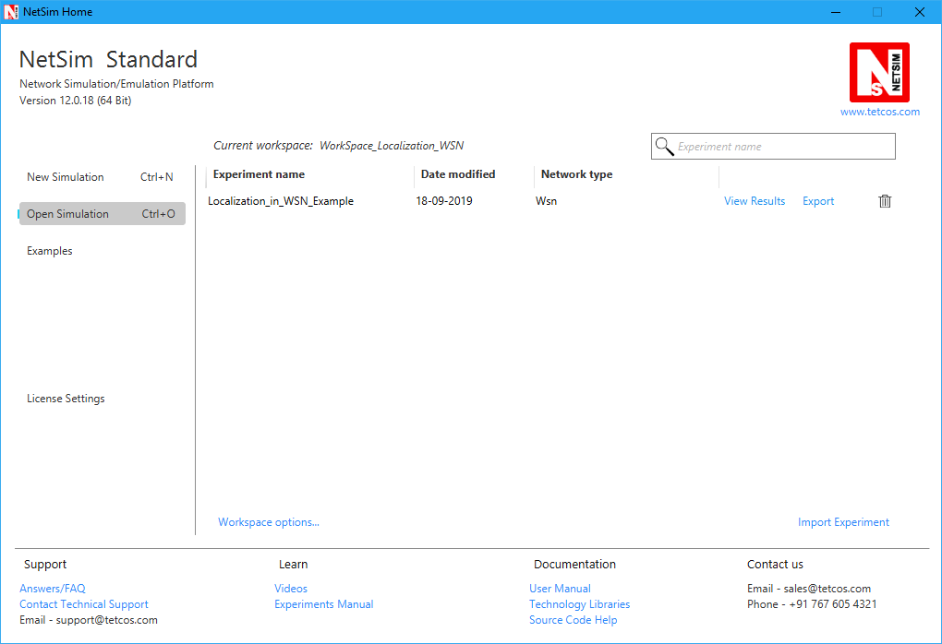

* Click on **More Options,**

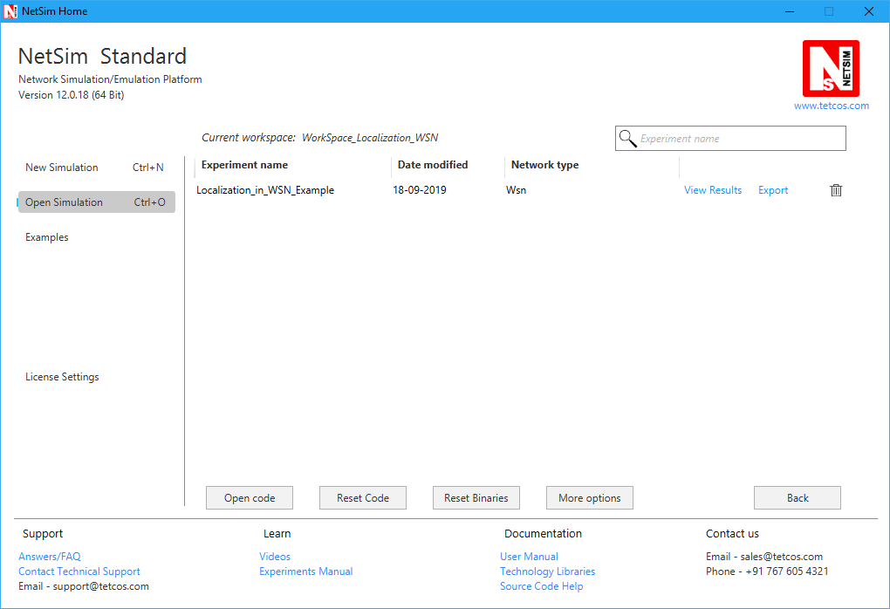

* Click on **Import**, browse the extracted folder path and go into the WorkSpace_Localization_WSN directory. Click on the Select folder button and then on **OK.**

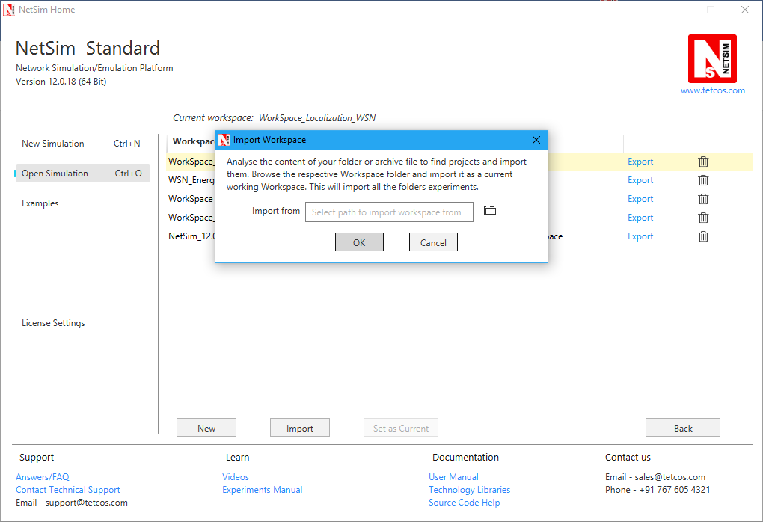

* Go to home page, Click on **Open Simulation** 🡪 **Workspace options** 🡪 **Open code**

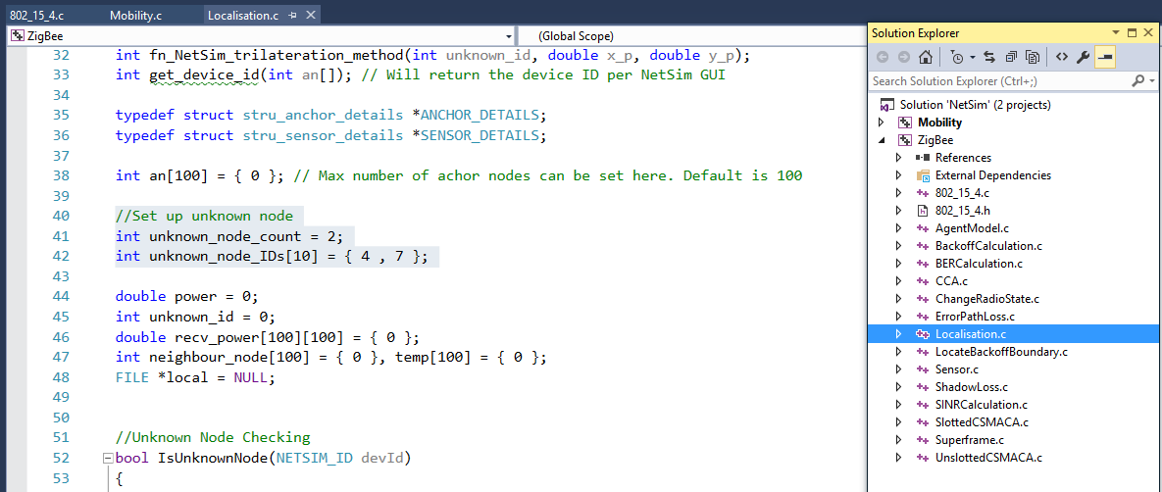

* 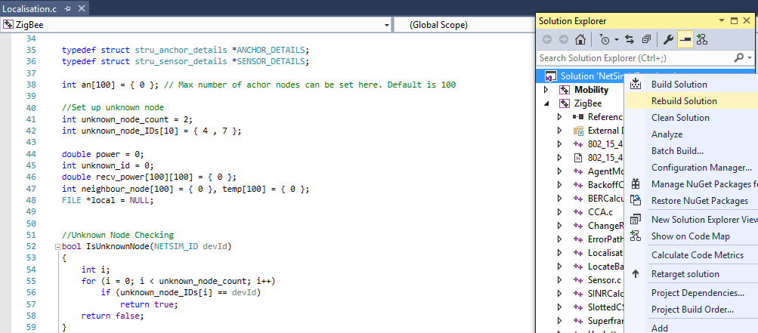Right click on Solution in Solution Explorer and select rebuild solution.
* Upon rebuilding, **libZigbee.dll** and **libMobility.dll** will automatically get updated in NetSim binary folder.

**Note:** Based on whether you are using NetSim 32 bit or 64 bit setup you can configure Visual studio to build 32 bit or 64 bit Dll files respectively as shown below:

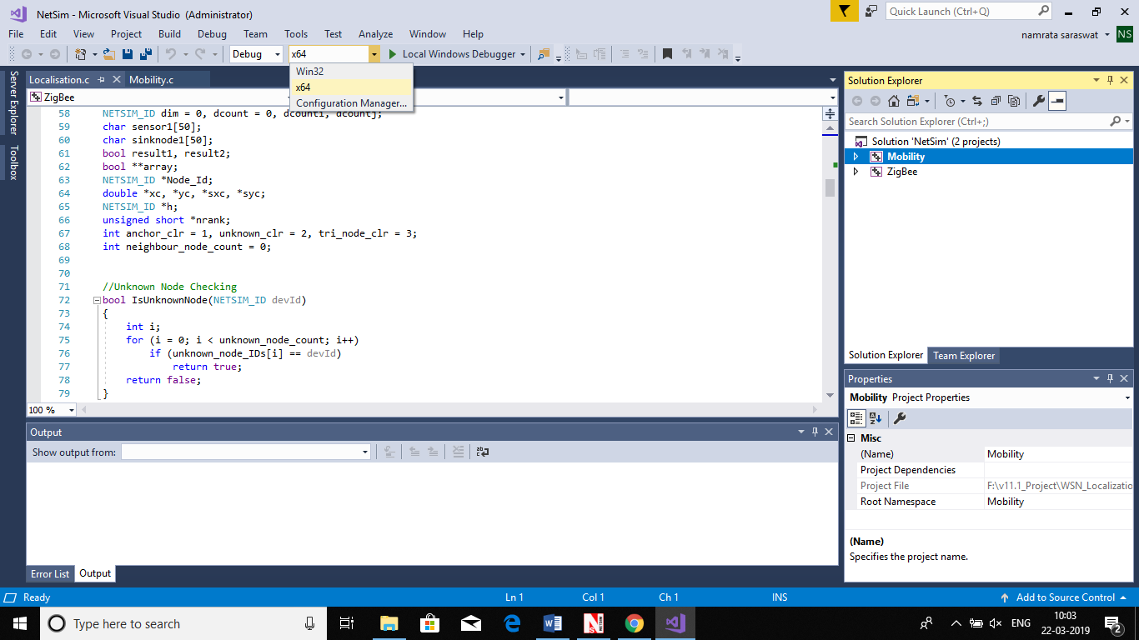

* Go to NetSim home page, click on **Open Simulation**, Click on **Localization_in_WSN_Example**.

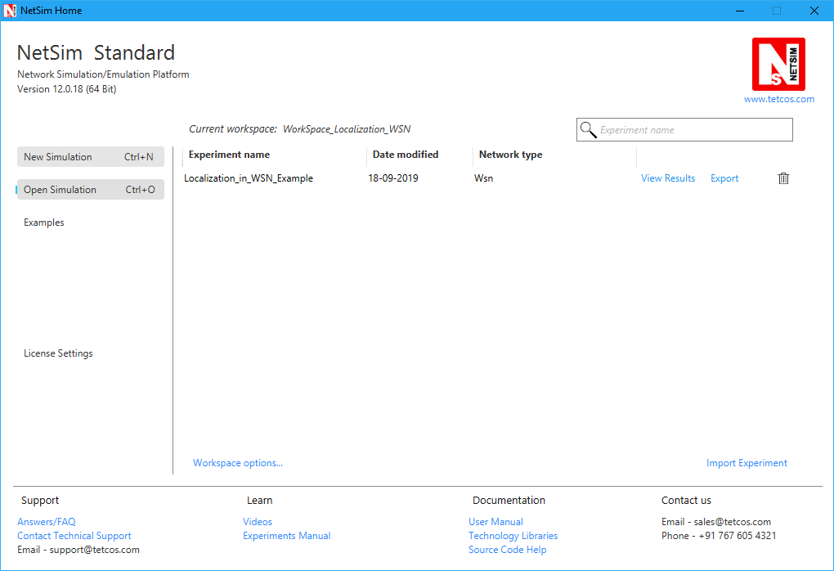

* Run simulation after the network scenario gets loaded.
* After simulation, localisation.txt file will get created in the **bin** folder of NetSim. Right click on the NetSim shortcut icon in your desktop and select Open file location to go to NetSim bin folder. The localisation.txt file logs the unknown node IDs, received powers from all anchor nodes to unknown nodes, anchor node IDs based on highest received powers and the position or coordinates of the unknown nodes with variation in time as shown below.

