Localization in WSN

**Software:** NetSim Standard v13.1 (64 bit), Microsoft Visual Studio 2019

**Project Download Link:**

Follow the instructions specified in the following link to download and setup the Project in NetSim:

<https://support.tetcos.com/en/support/solutions/articles/14000128666-downloading-and-setting-up-netsim-file-exchange-projects>

**Introduction**

Localization is the process of finding the physical or relative location of a sensor node as data and information are useless if the nodes have no idea of their geographical positions. GPS (global positioning system) is the simplest method for localization of nodes, but it becomes expensive if large number of nodes exists in each network.

**Anchor Nodes**

Sensor nodes with known location information are called “Anchor nodes‟. Typically, anchor nodes obtain their location information by using a global positioning system (GPS), or by manually being placed at defined coordinates.

**Unknown Nodes**

Sensor nodes with unknown location information are called “Non-Anchor nodes’” or “Unknown nodes”. Localization is estimated through communication between localized node and unknown node for determining their geometrical placement or position. Location is determined by means of distance and angle between nodes.

**Trilateration**

Location of node is estimated through distance measurement from three nodes. In this concept, intersection of three circles is calculated, which gives a single point which is a position of unknown node.

Use the distance equation. If your unknown point is (x, y) and known points are (xi, yi) which are at distances ri from unknown point, then you get three equations:

# (𝑥 – 𝑥1)2 + (𝑦 – 𝑦1)2 = 𝑟12 (𝑥

– 𝑥2)2 + (𝑦 – 𝑦2)2 = 𝑟22 (𝑥 –

𝑥3)2 + (𝑦 – 𝑦3)2 = 𝑟32

To calculate the distance between to sensors we have used NetSim API.

DEVICE_DISTANCE(d1,d2)

Expand out the squares and subtract the second equation from the first and third equation from second, we get.

2(𝑥2 – 𝑥1) + 2(𝑦2 – 𝑦1) 𝑦 = 𝑟12 – 𝑟22 + 𝑥22 – 𝑥12 + 𝑦22 – 𝑦12

2(𝑥3 – 𝑥2) + 2(𝑦3 – 𝑦2) 𝑦 = 𝑟22 – 𝑟32 + 𝑥32 – 𝑥22 + 𝑦32 – 𝑦22

This is a system of two equations with two unknowns:

𝐴𝑥 + 𝐵𝑦 = 𝐶

𝐷𝑥 + 𝐸𝑦 = 𝐹

The values of x and y is obtained from the below equations:

𝑥 = (𝐶𝐸 – 𝐹𝐵) / (𝐸𝐴 – 𝐵𝐷)

𝑦 = (𝐶𝐷 – 𝐴𝐹) / (𝐵𝐷 – 𝐴𝐸)

**Steps to simulate**

1. Open the Source codes in Visual Studio by going to Your work-> Source code and Clicking on Open code button in NetSim Home Screen window.
2. Right click on Solution in Solution Explorer and select rebuild solution.

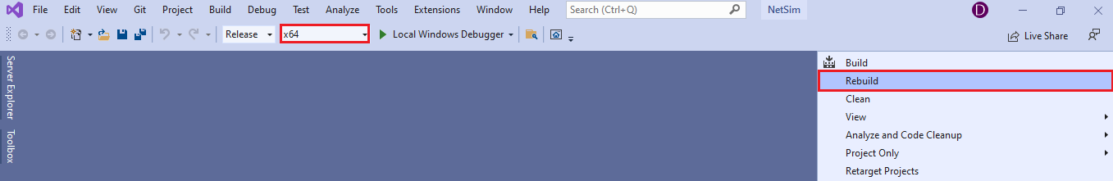

**Figure 1:** Screen shot of NetSim project source code in Visual Studio

1. Rebuild Zigbee project first then Mobility project, upon rebuilding **libZigbee.dll** and **libMobility.dll** will automatically get updated in NetSim binary folder.

**Example**

1. The WorkSpace_Localization_WSN with a sample network configuration that are already saved. To open this example, go to Your work in the Home screen of NetSim and click on the Localization_in_WSN_Example from the list of experiments.
2. Run simulation after the network scenario gets loaded.

**Results and discussion**

After simulation, localisation.txt file will get created in the bin folder of NetSim. Right click on the NetSim shortcut icon in your desktop and select Open file location to go to NetSim bin folder. The localisation.txt file logs the unknown node IDs, received powers from all anchor nodes to unknown nodes, anchor node IDs based on highest received powers and the position or coordinates of the unknown nodes with variation in time as shown below.

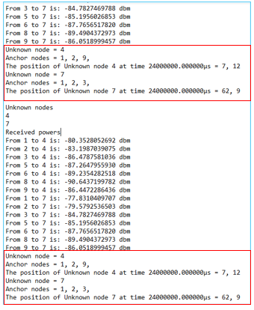

**Figure 2:** localisation.txt file created in bin folder

**Appendix: NetSim source code modifications**

**Localization in NetSim**

1. To implement Localization, we have added **Localisation.c** file in Zigbee project. The file contains the following functions:

* int fn_NetSim_localisation(); //This function is used to find the anchor nodes based on the highest received powers received at unknown sensors from anchor nodes.
* int fn_NetSim_trilateration_method(); //This function is used to implement the trilateration method to calculate the position / location of the unknown sensor.
* bool IsUnknownNode(); //This function is used to check whether the given node is unknown node or not.
* bool determine_anchor_node(); //This function is used to check whether the given node is anchor node or not.

**Set unknown node number in Localisation.c**

/* Users can give their own unknown node IDs and unknown node count in **Localisation.c** file. NetSim knows all the positions of sensor nodes. Localization is used to find the position of unknown nodes and then comparing this position with NetSim sensor positions */

// Set up unknown node

int unknown_node_count =2;

int unknown_node_IDs[10] = {4, 7};

**Added fn_NetSim_Mobility_Run() function in mobility.c file**

/* Since the unknown nodes are mobile, this function is user calculate the new positions of the unknown node whenever a node moves */

fn_NetSim_ Localisation();

memcpy(pos,cor,sizeof* pos);

mobility_pass_position_to_animation(pstruEventDetails->nDeviceId,

pstruEventDetails->dEventTime,pos);

//Add event for next point

pstruEventDetails->dEventTime+=pstruMobilityVar->dCalculationInterval;

fnpAddEvent(pstruEventDetails);

pstruEventDetails->dEventTime-=pstruMobilityVar->dCalculationInterval;

}