Longley Rice in DTDMA

**Software:** NetSim Standard v13.0 (64 bit), Visual Studio 2019, MATLAB R2016 or higher

**Project Download Link:**

<https://github.com/NetSim-TETCOS/Dynamic_Clustering_Project_v13.0/archive/refs/heads/main.zip>

Follow the instructions specified in the following link to download and setup the Project in NetSim:

<https://support.tetcos.com/en/support/solutions/articles/14000128666-downloading-and-setting-up-netsim-file-exchange-projects>

Follow the instructions specified below to place the additional NetSim and MATLAB files in respective folders:

1. Copy the Configuration.xsd file provided in the NetSim_Files folder of the project directory and paste it in <NetSim_install_directory>/bin/bin_x64 path(For eg: C:\Program Files\NetSim\Pro_v13_0\bin\bin_x64), after renaming the already existing file as a backup.
2. Copy the GeneralInterfaceProperties.xml file provided in the NetSim_Files folder of the project directory and paste it in <NetSim_install_directory>/ Docs\xml\Properties path(For eg: C:\Program Files\NetSim\Pro_v13_0\Docs\xml\Properties), after renaming the already existing file as a backup.
3. Copy the Longley_Rice.m file present in the MATLAB_Files folder of the project directory and paste it in <MATLAB_Install_Directory>/bin/win64 path(For eg: C:\Program Files\MATLAB\R2019a\bin\win64).

**Propagation Model:**

Propagation models allow you to predict the propagation and attenuation of radio signals as the signals travel through the environment. You can simulate different models by using the propagation Model function.

**Longley Model:**

The Longley–Rice model (LR) is a radio propagation model: a method for predicting the attenuation of radio signals for a telecommunication link in the frequency range of 20 MHz to 20 GHz.

Longley-Rice is also known as the irregular terrain model (ITM).

**Configuration:**

In NetSim Longley-Rice Loss Model can be configured in the Wireless Nodes INTERFACE(WIRELESS) Physical Layer properties as shown below:

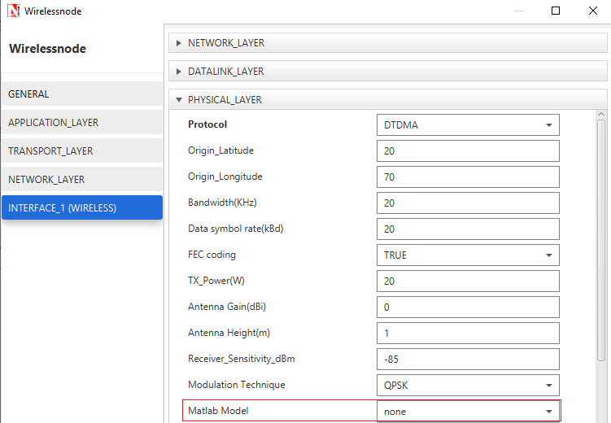

**Figure 1**:Wireless Node>Interafce_1(WIRELESS)>Physical layer properties.

Similarly, this can be configured in Bridge Wired/Wireless Node Wireless Interface_1(WIRELESS) properties section of Physical Layer as shown below:

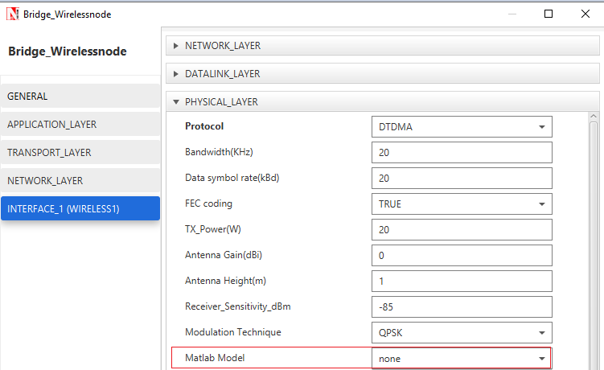

Figure 2: Bridge Wireless Node>Interafce_1(WIRELESS)>Physical layer properties.

Longley_Rice Loss Model is set to NONE by default. When Longley_Rice model is selected, MODEL drop down with options Longley_Rice will appear along with associated parameters as shown below:

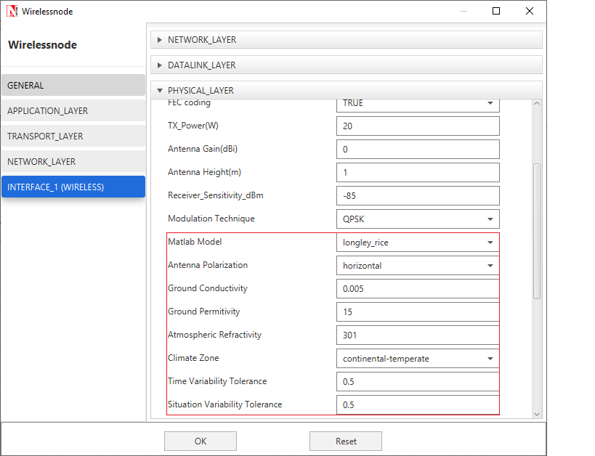

**Figure 3:** MATLAB Model is set to Longley_Rice Loss Model in Wireless Node >Interface_1 (WIRELESS) >Physical layer properties

Longley_Rice model has associated parameters that can be configured, which is listed in the table

below:

|  |  |
| --- | --- |
| Longley Rice Model Parameter’s | Values |
| Antenna Polarization | horizontal (default),vertical |
| Ground Conductivity | 0.005 (default) |
| GroundPermitivity | 15 (default) Range 1 to 100 |
| Atmospheric Refractivity(Depends on Climate Zone) | 301 (default), 360,320,370,280,320,350 |
| Climate Zone | continental-temperate (default), equatorial, continental-subtropicl,maritime-subtropical,desert,maritime-over-land,maritime-over-sea |
| Time Variability Tolerance | 0.5 (default) Range 0.001 to 0.999 |
| Situation Variability Tolerance | 0.5 (default) Range 0.001 to 0.999 |

**Table 1**: Longley Rice Associated Parameters

**Note:** Longley_Rice model support frequencies from 1 to 1000 GHz and Fog model supports

frequencies from of 20 MHz to 20 GHz only.

**Longley Rice in NetSim with MATLAB Interfacing**

Longley Rice is implemented in NetSim by Interfacing with MATLAB for point-to-point path loss. The devices Latitude, Longitude, Antenna Gain, Antenna Height, Antenna Polarization, Ground Conductivity, Ground Permittivity, Atmospheric Refractivity, Climate Zone, Time variability tolerance, Situation variability tolerance are fed as input to MATLAB.

**Additional Loss Models:**

Apart from the channel losses, NetSim allows modelling Additional losses using MATLAB. This includes attenuation due to rain, and fog.

The codes required for the Pathloss calculations done in MATLAB are written to Longley_Rice.m file and this file available in MATLAB folder under bin_x64 of Longley_Workspace_v13

A **matlablossmodel.c** file is added to the DTDMA project which contains the following functions:

* static double netsim_matlab_get_rainLoss()
* static double netsim_matlab_get_fogLoss()
* static double netsim_matlab_get_LongleyRicePathLoss()
* double netsim_matlab_calculate_loss_matlab_model()
* double netsim_matlab_calculate_loss_additional_model()
* double fn_netsim_matlab_run_matlab_model()
* double fn_netsim_matlab_run_additional_model()
* double fn_netsim_matlab_finish()

**NOTE:** To run this code 64- bit version of MATLAB must be installed in your system.

**Steps to simulate**

1. Add the following MATLAB install directory path in the Environment PATH variable

<MATLAB_INSTALL_DIRECTORY>\bin\win64

For eg: C:\Program Files\MATLAB\R2020a\bin\win64

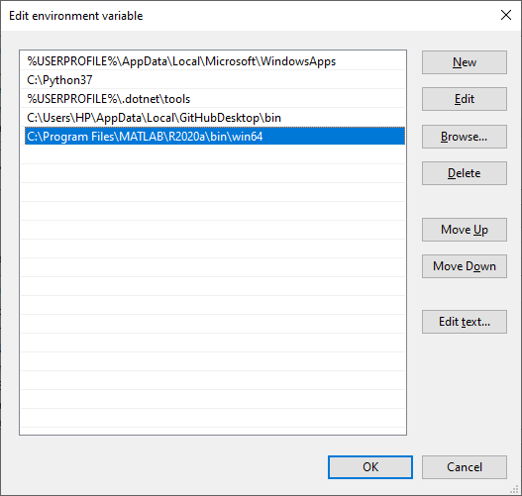

**Figure 4:** Environment variable PATH

**Note**: If the machine has more than one MATLAB installed, the directory for the target platform must be ahead of any other MATLAB directory (for instance, when compiling a 64-bit application, the directory in the MATLAB 64-bit installation must be the first one on the PATH).

1. Open Command prompt as admin and execute the command “matlab -regserver”. This will register MATLAB as a COM automation server and is required for NetSim to start MATLAB automation server during runtime.
2. Open the Source codes in Visual Studio by going to Your work-> Workspace Options and Clicking on Open code button in NetSim Home Screen window.
3. Under the DTDMA project in the solution explorer you will be able to see that and **Matlablossmodel.c** files which contain source codes related to interactions with MATLAB and handling clustering in NetSim respectively.
4. Right click on the solution in the solution explorer and select Rebuild.

**Example**

1. Start NetSim as administrator.
2. The Longley_Rice_Workspace_v13 comes with a sample network configuration that are already saved. To open this example, go to the Your Work menu in the Home screen of NetSim and click on the Longley_Rice_Example from the list of experiments.
3. The saved network scenario consisting of 2 Wireless Nodes uniformly distributed in the grid environment. Traffic is configured from Wireless Node and to Wireless Node.

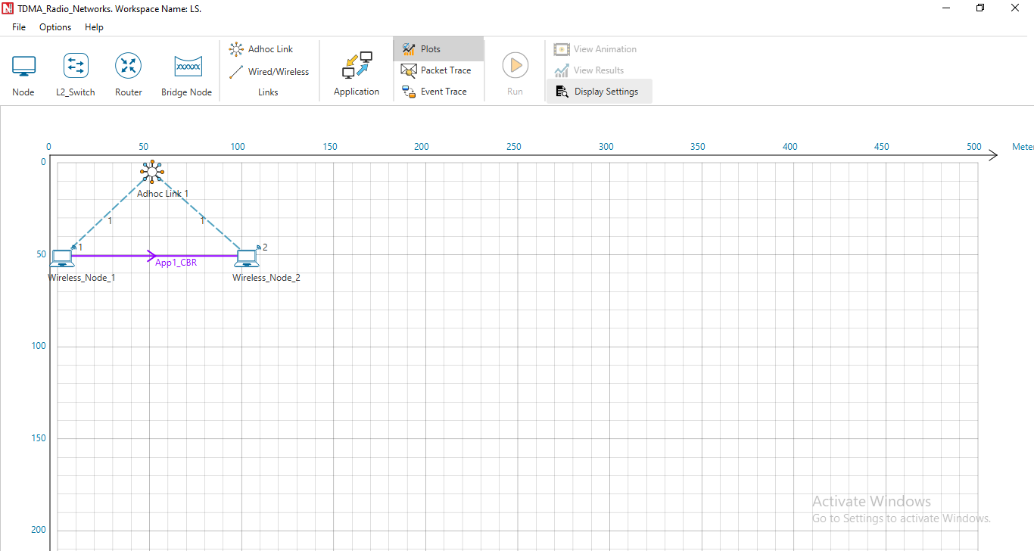

**Figure 5**: Network Scenario in this project

1. Run simulation and press any key to continue. NetSim simulation console will show the following message in the console “Waiting for NetSim MATLAB Interface to connect...”
2. Click on **Options** from NetSim design window and click on **Open MATLAB Interface** as shown in below given screenshot.

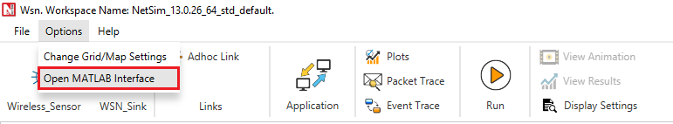

**Figure 6:** Open MATLAB Interface using NetSim design window

1. It will open the popup related MATLAB Interfacing, Click on **OK.**

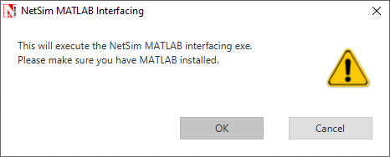

**Figure 7:** NetSim MATLAB Interface warning message.

1. Following Input Parameters are passed to MATLAB via Nestim

function [Pathloss] = Longley_Rice (centralFrequency_MHz, transmitter_lat, transmitter_lon, receiver_lat, receiver_lon, antennaPolarization,groundConductivity,groundPermittivity,atmosphericRefractivity,climateZone, timeVariablityTolerance,situationVariabilityTolerance)

1. It will open MatlabInterface.exe console window. You will observe that as the simulation starts in NetSim, MATLAB gets initialized

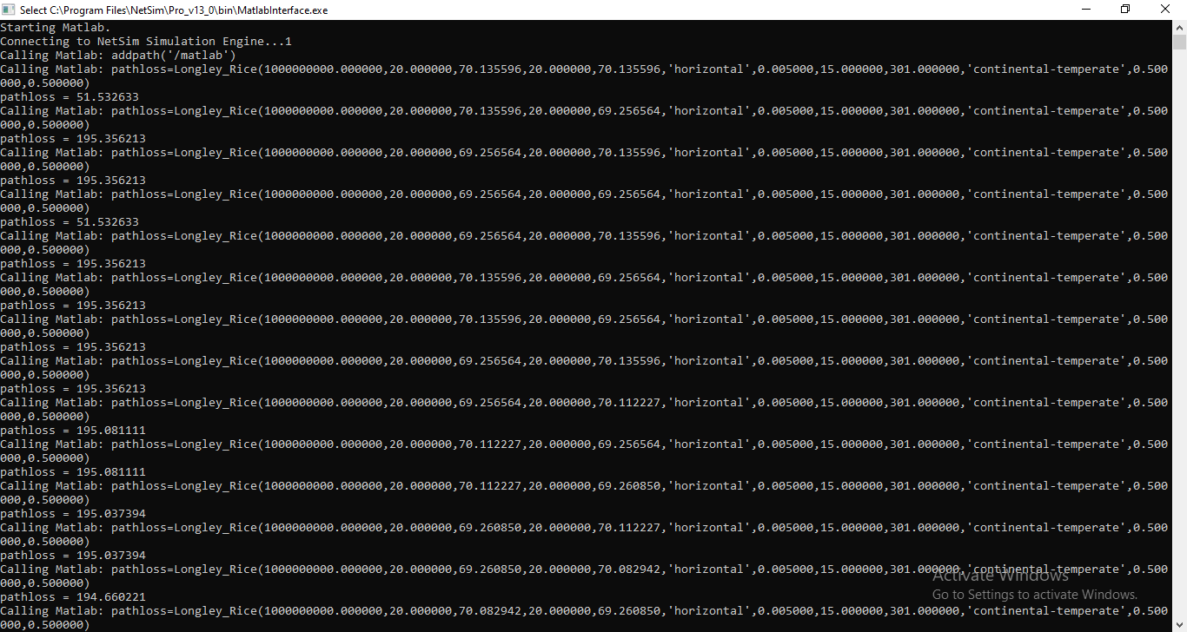

**Figure 8:** Runtime MATLAB interfacing window.

The pathloss value obtained from MATLAB is added to the total loss calculated as per the

Longley_Rice Model specifications. At simulation end the MATLAB Interface process closes the

MATLAB process that it started.