**Implementing a new Crypto Algorithm – Mysty1**

**Software Recommended:** NetSim Standard v12.0 (32/64-bit), Visual Studio 2017/2019, Wireshark

In NetSim the packet payload in the application layer can be encrypted optionally using the inbuilt encryption models such as AES, DES, XOR and TEA algorithms. However, users can also implement their own encryption algorithms. In this project we have attempted to implement Mysty1 encryption algorithm in NetSim encrypt the packet payload.

MISTY1 is one of the selected algorithms in the European NESSIE project, and has been among the cryptographic techniques recommended for Japanese government use by CRYPTREC in 2003. "MISTY" can stand for "Mitsubishi Improved Security Technology"; it is also the initials of the researchers involved in its development: Matsui Mitsuru, Ichikawa Tetsuya, Sorimachi Toru, Tokita Toshio, and Yamagishi Atsuhiro. MISTY1 is covered by patents, although the algorithm is freely available for academic (non-profit) use in RFC 2994.

**Procedure to run the project:**

1. After you unzip the downloaded project folder, Open NetSim Home Page click on **Open Simulation** option,

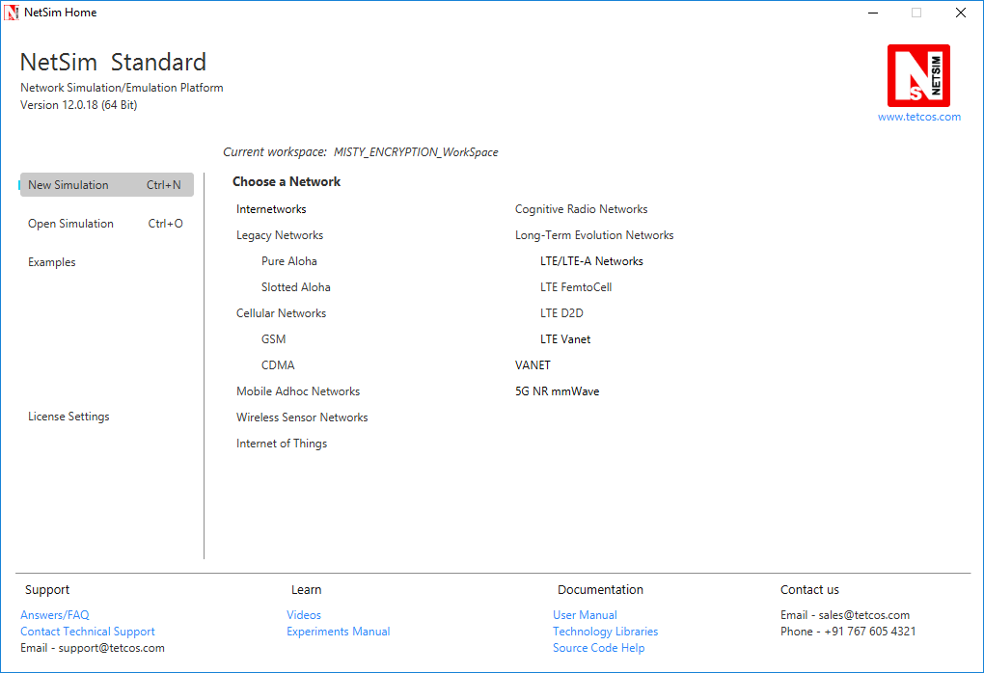

1. Click on Workspace options

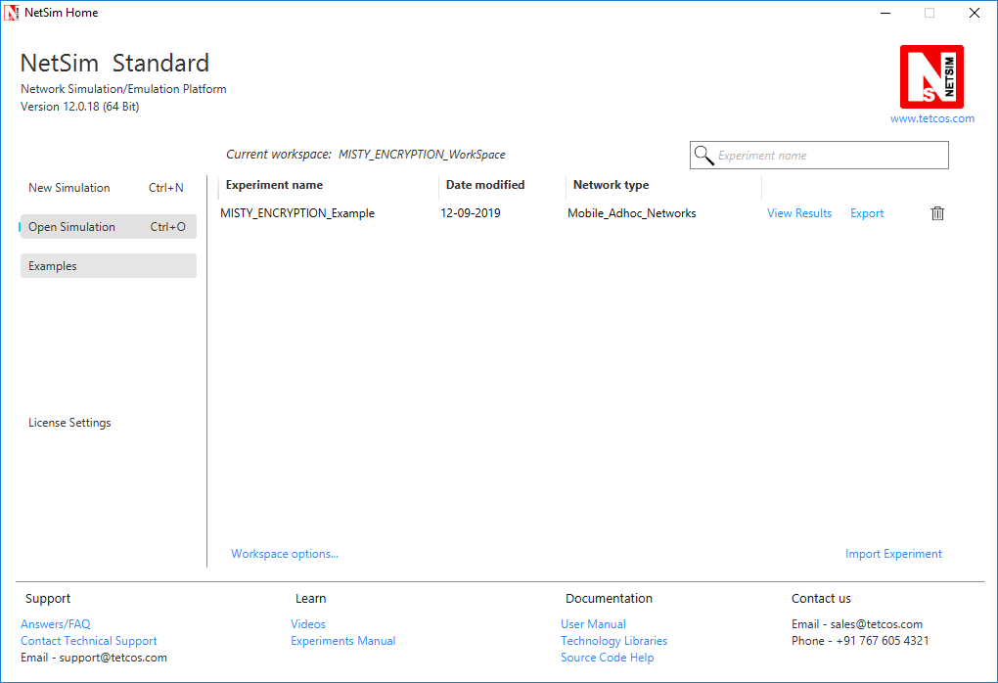

1. Click on More Options,

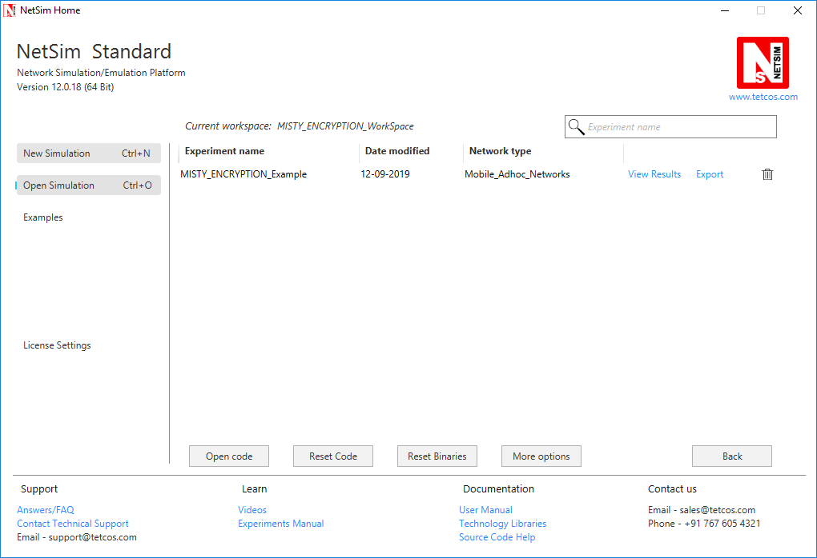

1. Click on Import, browse the extracted folder path and go into MISTY_ENCRYPTION_WorkSpace directory. Click on Select folder button and then on OK.

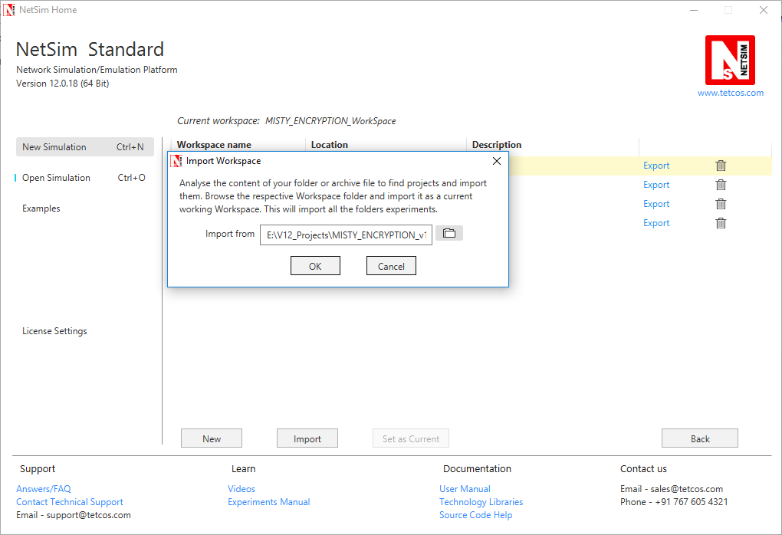

1. While importing the workspace, if the following warning message indicating Software Version Mismatch is displayed, you can ignore it and proceed.

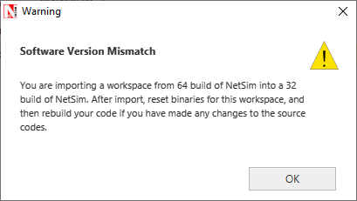

1. Go to home page, Click on Open Simulation 🡪 Workspace options 🡪 Open code
2. Based on whether you are using NetSim 32 bit or 64 bit setup you can configure Visual studio to build 32 bit or 64 bit Dll files respectively as shown below:

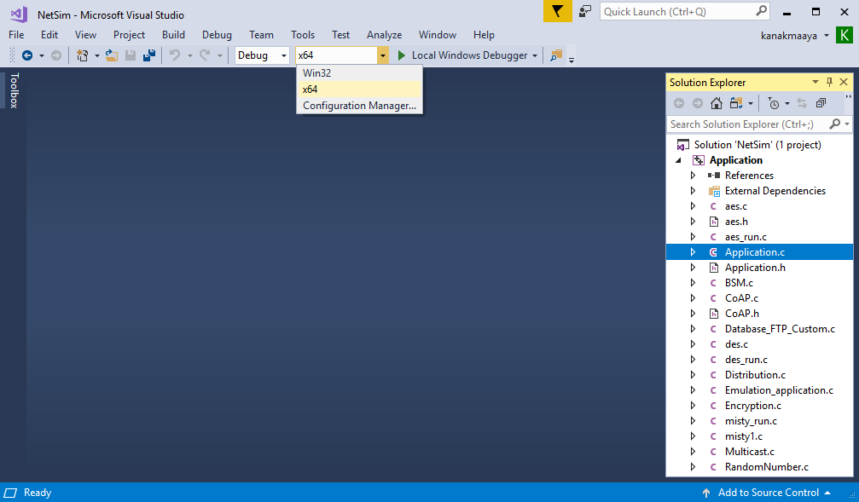

1. Now expand Application Project and click mysty_run.c file. This file contains the following lines of code

#include <string.h>

#include <stdlib.h>

#include <stdio.h>

#include "application.h"

void misty_run(char* str, int* len)

{

int n;

int l = *len;

unsigned char buf[32];

unsigned char key[32];

for (n = 0; n < *len; n += 16, str += 16, l -= 16)

{

/* Set the plain-text */

memcpy(buf, str, min(16, l));

misty1_main(buf);

memcpy(str, buf, 16);

}

}

In the mysty_run() function inside the mysty_run.c file we pass the plain text in parts of 16 bytes each time to get it encrypted. This is done because the crypto algorithm accepts a 16 byte plaintext as input. Here the variable str contains the packet payload and len corresponds to the size of payload in bytes.

1. Modifications that were done to the source codes of the Application project is explained below:
2. Addition of #include<application.h> and #define uint8 unsigned char to the beginning of the file(shown in red).
   * 1. #include <stdlib.h>
     2. #include <string.h>
     3. #include "application.h"
     4. typedef unsigned long u4;
     5. typedef unsigned char byte;
     6. #define MISTY1_KEYSIZE 32
     7. #define uint8 unsigned char
3. Removed inline keyword that is present before the functions fi(), fo(), fl() and flinv().

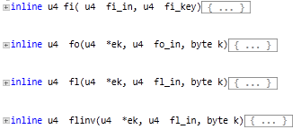

To

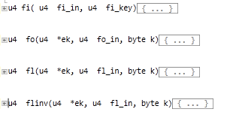

1. Now go to the main() function in the file and check that line #ifdef TESTMAIN was removed or commented before the main() function and also the associated #endif at the end of the main() function.
2. main() function was renamed to unsigned char* misty1_main(uint8* input)

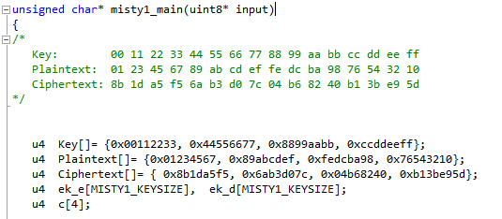

1. Commented the declaration of Cipher text, Modify the declaration of Plaintext variable, as shown below:

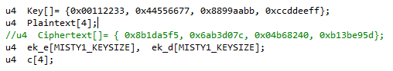

1. Now check the commented lines starting from misty1_keyinit() to misty1_key_destroy() as shown below:

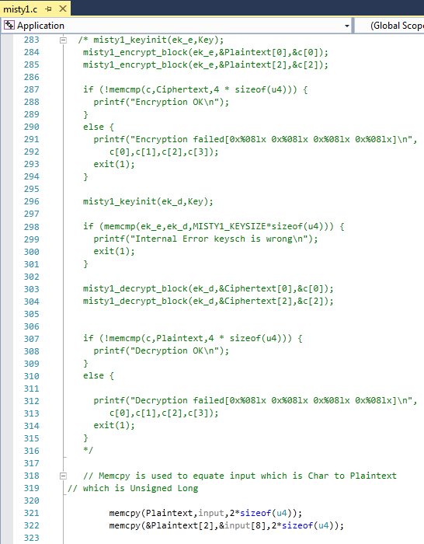

1. Addition of the following lines of code just above the misty1_key_destroy(ek_e); statement as shown below:

// Memcpy is used to equate input which is Char to Plaintext

// which is Unsigned Long

memcpy(Plaintext,input,2*sizeof(u4));

memcpy(&Plaintext[2],&input[8],2*sizeof(u4));

misty1_keyinit(ek_e,Key);

misty1_encrypt_block(ek_e,Plaintext,&c[0]);

misty1_encrypt_block(ek_e,&Plaintext[2],&c[2]);

memcpy(input,c,2*sizeof(u4));

memcpy(&input[8],&c[2],2*sizeof(u4));

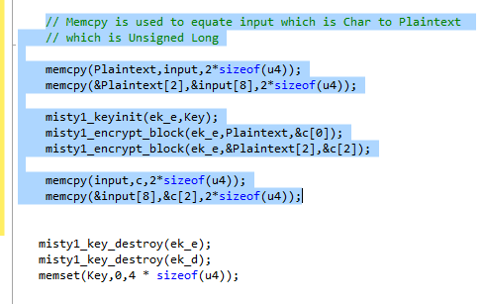

1. Inside the mysty1_main function the above codes were modified to ensure that the plaintext is properly initialized with the 16 bytes of payload received, for the encryption to happen.
2. Here, memcpy() is done initially to equate input received as which is char, to the plain text which is unsigned long.

memcpy(Plaintext,input,2*sizeof(u4));

memcpy(&Plaintext[2],&input[8],2*sizeof(u4));

1. After the calls to misty1_encrypt_block() memcpy() is done to equate the encrypted cipher text back to the input.

memcpy(input,c,2*sizeof(u4));

memcpy(&input[8],&c[2],2*sizeof(u4));

1. Now double click on the application.c file and make a call to mysty_run() function instead of the call to aes256, inside the copy_payload() function as shown below (changes are marked in red):

if(info->encryption==Encryption_TEA)

encryptBlock(real,payload,&key);

else if(info->encryption==Encryption_AES)

{

**misty_run(real,payload);**

//aes256(real,payload);

}

else if(info->encryption==Encryption_DES)

des(real,payload);

1. Right click on Solution in Solution Explorer and select rebuild solution
2. Upon rebuilding, libApplication.dll will get created in the bin_x86/ bin_x64 folder.

**Note:** While using NetSim 64-bit setup, users need to change solution platform as **x64**

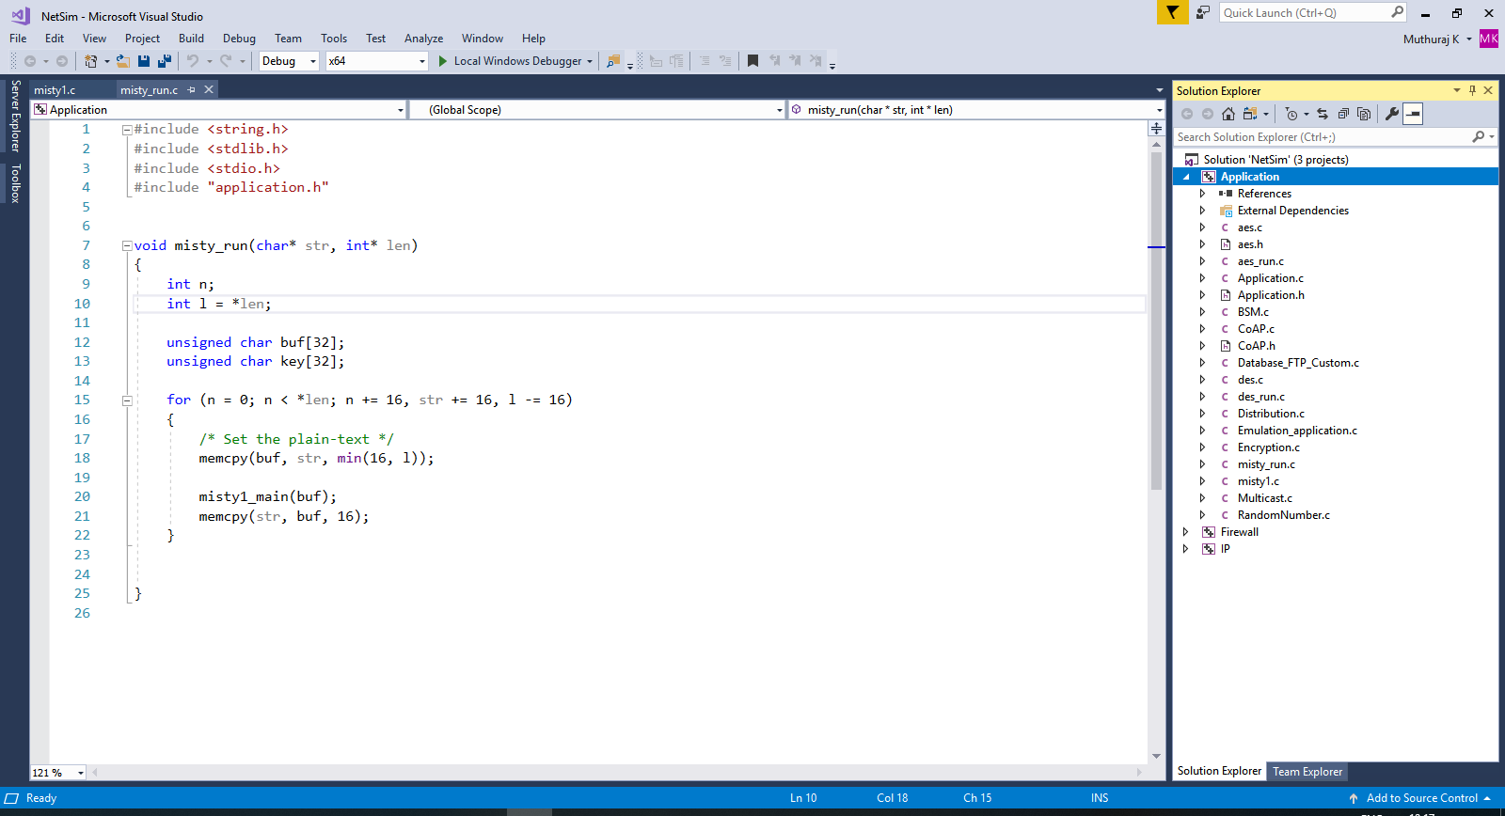

1. Open **Configuration.netsim** file from the zip and make sure that AES encryption is selected in the application properties.

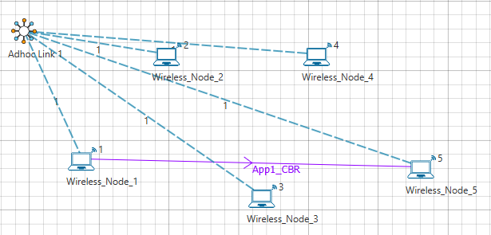

1. Also Wireshark option has to be set to either Online or Offline in any of the nodes where AES256 encryption is enabled.
2. Now mysty1 codes will be running instead of AES256.
3. You can see the encrypted payload in Wireshark either during simulation if online is set or after the simulation if offline is set.
4. Setting Wireshark to either online or offline will give you Packet Capture metrics where links to .pcap files are provided. The number of links available depends on the number of nodes in which Wireshark is enabled.