Modelling Obstacles between UEs and eNB in NetSim LTE

**Software Recommended:** NetSim Standard v12.2 (32-bit/64-bit), Visual Studio 2017/2019

Follow the instructions specified in the following link to clone/download the project folder from GitHub using Visual Studio:

<https://tetcos.freshdesk.com/support/solutions/articles/14000099351-how-to-clone-netsim-file-exchange-project-repositories-from-github->

Other tools such as GitHub Desktop, SVN Client, Sourcetree, Git from the command line, or any client you like to clone the Git repository.

**Note**: It is recommended not to download the project as an archive (compressed zip) to avoid incompatibility while importing workspaces into NetSim.

**Secure URL for the GitHub repository:**

**https://github.com/NetSim-TETCOS/MODELLING_OBSTACLES_IN_LTE_v12.2.git**

Users can model obstacles to vary the channel losses between the eNB and the connected UEs, by modifying the underlying LTE code.

This is required because, as of **NetSim v12.2**, in the GUI, the wireless link (between one eNB and all connected UEs) properties are same i.e. if we change in one of the UE-eNB links, the change will reflect in all the connect UE-eNB links.

Obstacles are modelled by adding an attenuation (dB) value. Other channel conditions can be varying the stochastic pathloss model based on 3GPPTR38.900 standard. These include environment/parameters such Rural/urban, indoor/outdoor, LOS/NLOS, O2I High-lows/Low loss etc.

# Steps:

* After you unzip the downloaded project folder, Open NetSim Home Page click on **Open Simulation** option,

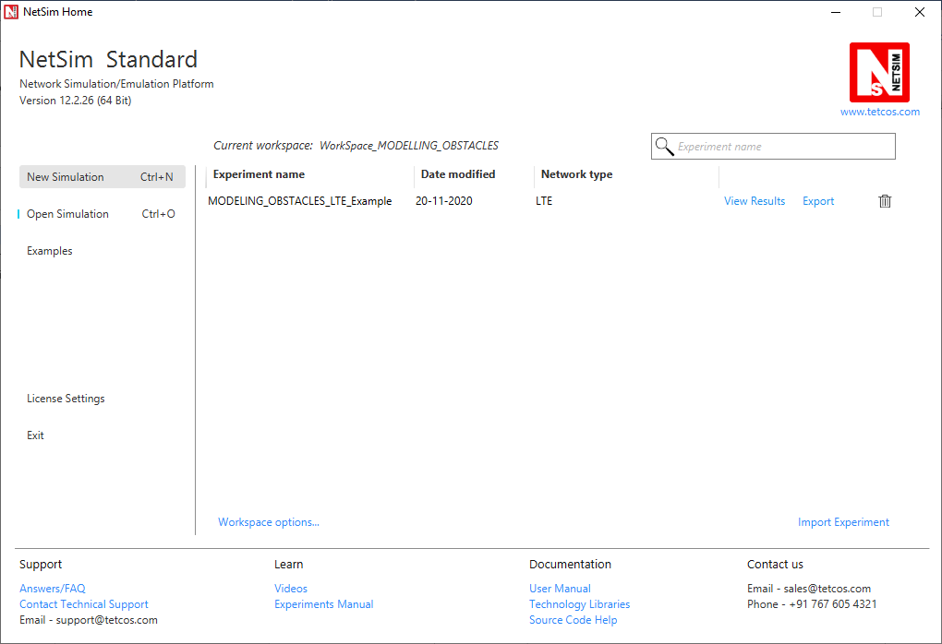

* Click on **Workspace options**



* Click on **More Options,**

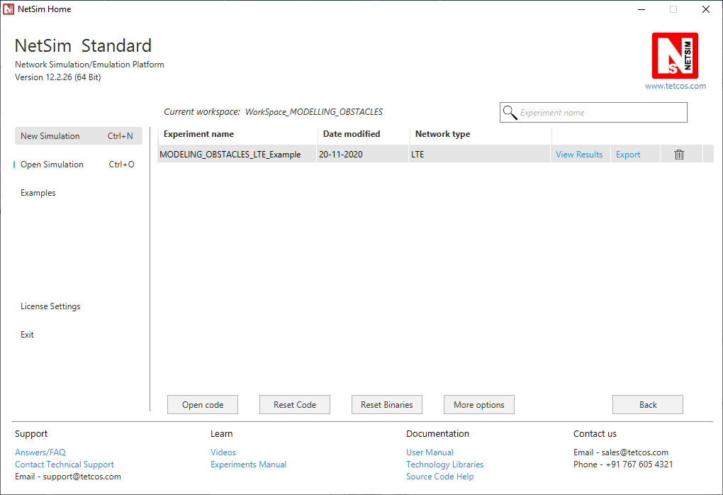

* Click on Import, browse the extracted folder path and go into WorkSpace_MODELING_OBSTACLES directory. Click on Select folder and then on **OK**.

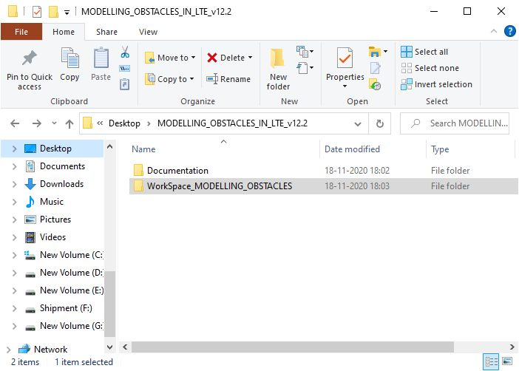

* Go to NetSim Home Page, click on Open Simulation->Workspace Options and click on the Open Code button.

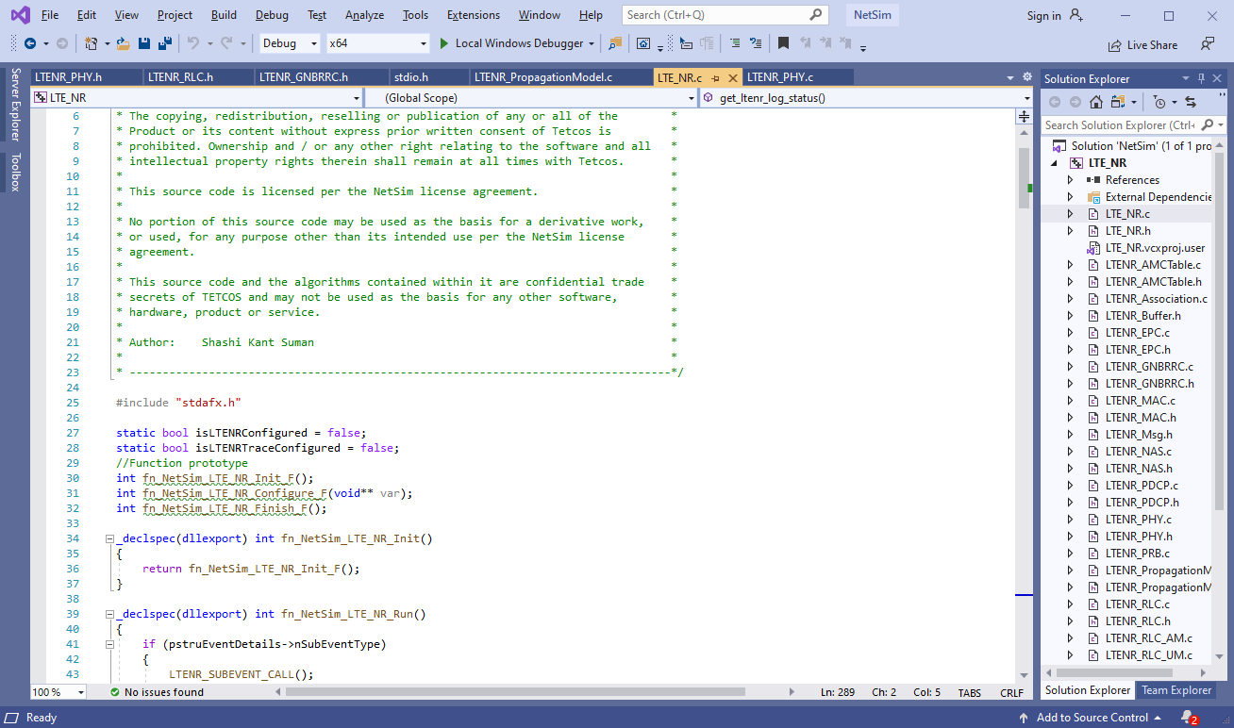

* Based on whether you are using NetSim 32 bit or 64 bit setup you can configure Visual studio to build 32 bit or 64 bit Dll files respectively as shown below:

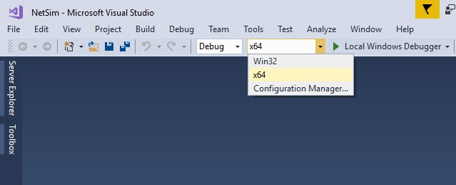

* Right click on Solution in Solution Explorer and select rebuild solution
* Upon rebuilding, libLTE.dll will get created in the bin_x86/ bin_x64 folder.
* Go to NetSim home page, click on Open Simulation, Click on MODELING_OBSTACLES_LTE_Experiment.



* After simulation, note down the throughputs available in the metrics window.

# Steps to be done in NetSim to configure different path loss exponents:

To read the file content, we have added the following lines of code in LTENR_PHY.c file present inside LTE_NR project as shown below:

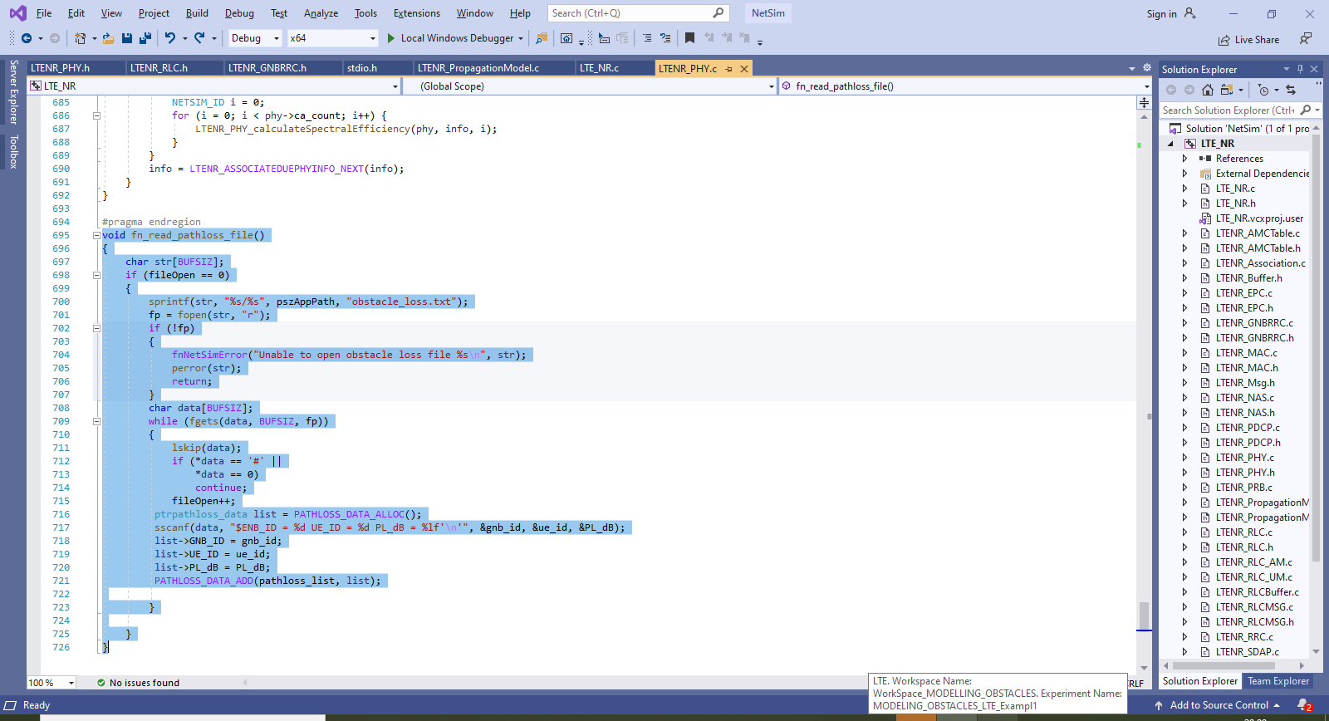

We have added the following lines of code in fn_NetSim_LTENR_PHY_Init () present in LTE_PHY.c file.

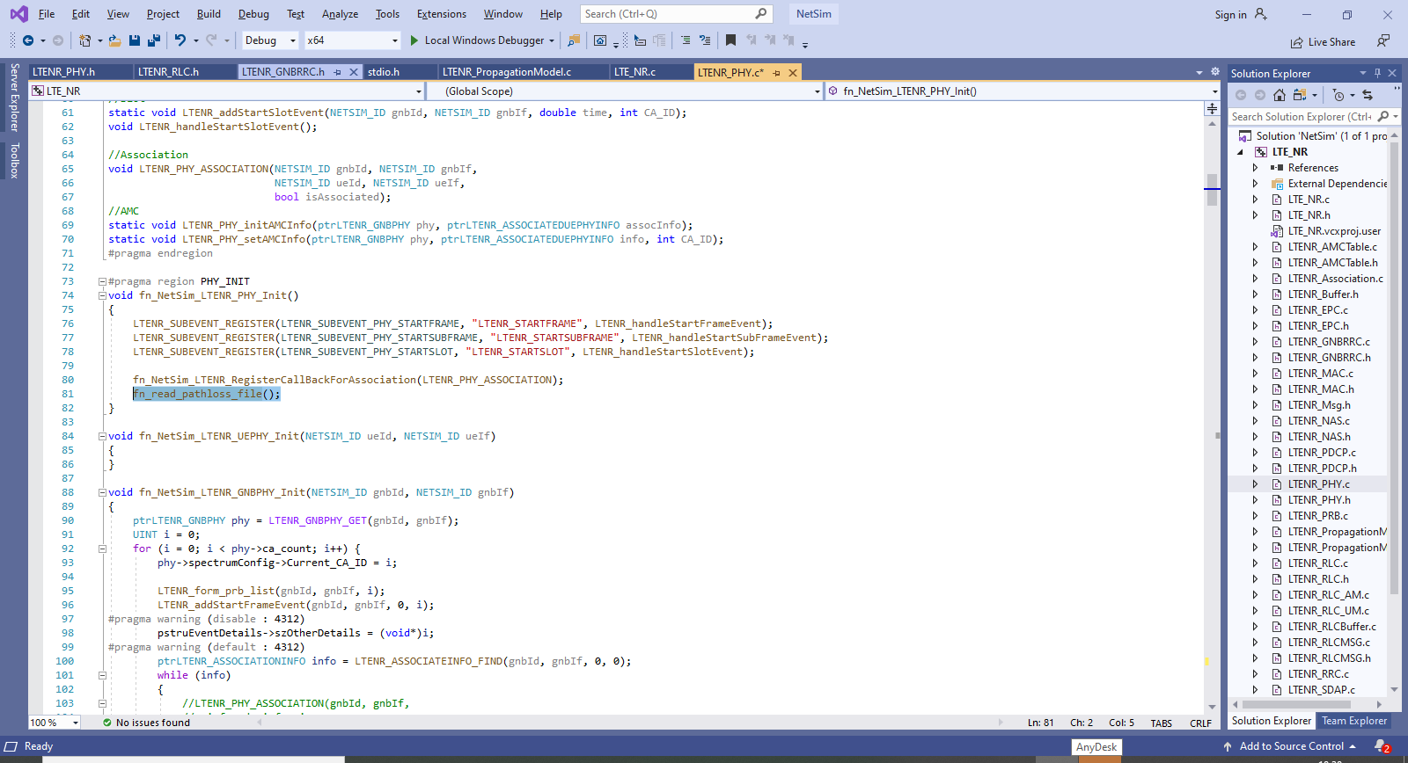

And then the following lines in LTENR_PHY_calculateSpectralEfficiency() present in LTENR_PHY.c file.

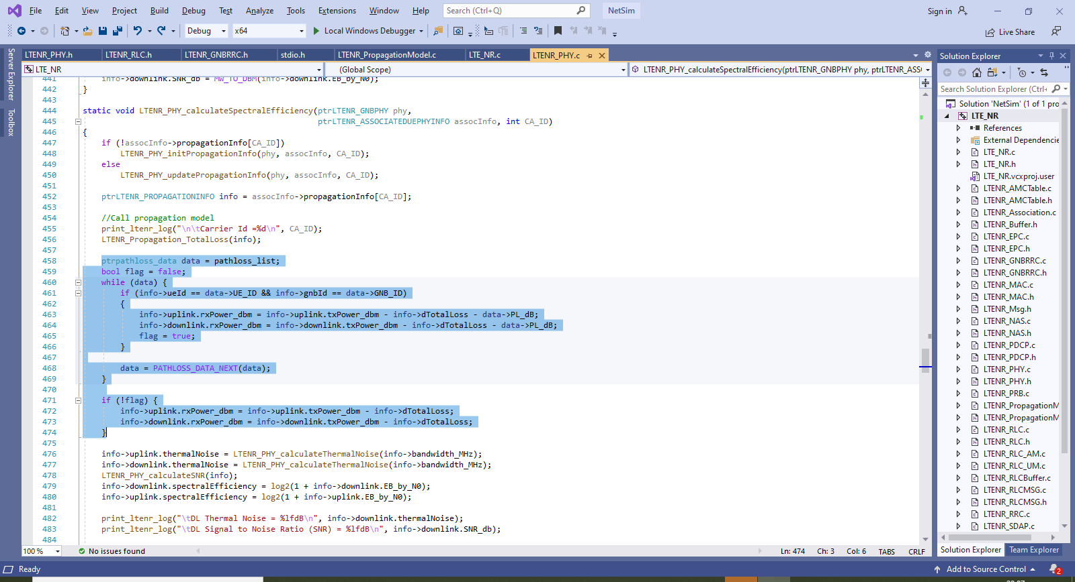

the following lines added starting of LTENR_PHY.c file.

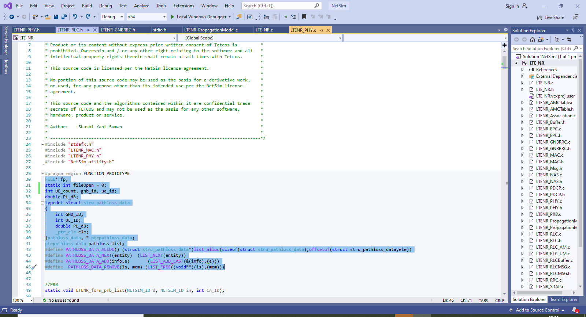

Create a obstacle_loss.txt file and paste it in the install directory of NetSim would look something like **“<MODELLING_OBSTACLES_IN_LTE_v12.2 path>\bin\bin_x64”** and the file format should be

#Obstacle pathloss file. Naming: obstacle_loss.txt

#Place this file in "workspace/bin/bin_x64" folder of NetSim

#The format of this file is

#1st parameter - ENB ID

#2nd parameter - UE ID

#3rd parameter – Obstacle pathloss in dB (A positive loss value which implies a negative gain)

#This obstacle pathloss will get added to the regular pathloss thereby

#reducing the signal power at receiver

#Ex: To set an obstacle pathloss of 5dB between 1 to 2 you have to set it

$ENB_ID = 1 UE_ID = 2 PL_dB = 50

$ENB_ID = 1 UE_ID = 5 PL_dB = 50

First line represents the number of UEs (whose path loss value needs to be changed). In the above sample, the numbers of UEs are 7, while the UEs which will be impacted by obstacle losses are 2. The second line represents UE id and the path loss exponent of the gNB-UE link and so on.

# Settings to be done to create the network scenario:

* Click and drop 1EPC, 1 wired node, 1eNB and 7UEs as per the below screenshot

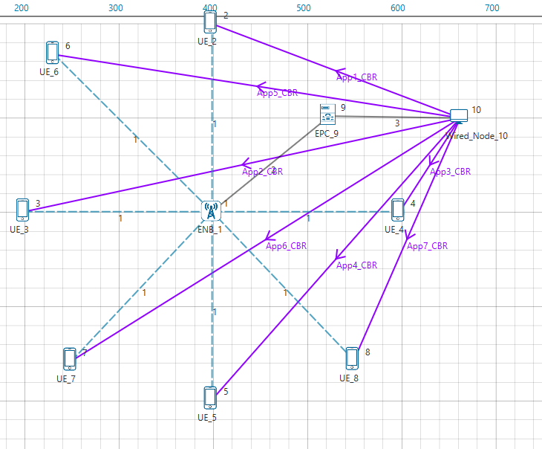

* Create applications from wired node to all UEs with packet size 1460Bytes and Inter arrival Time 584µs.
* Set channel characteristics as Path loss only, LOS_Mode as USER_DEFINED, and LOS_Probability as 1.

# Results:

Without obstacles:

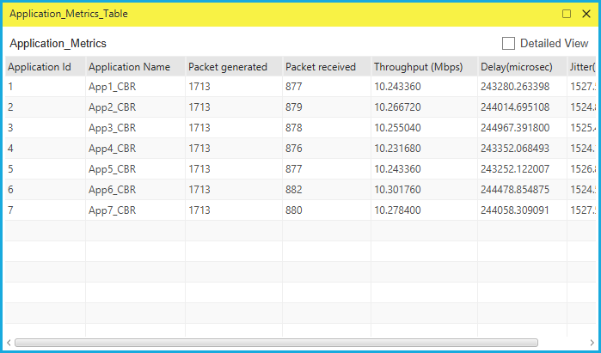

After simulation, note down the throughputs available in the simulation results window and compare with the previous results (Without Obstacles between UEs and eNB). Users can observe the change in throughputs

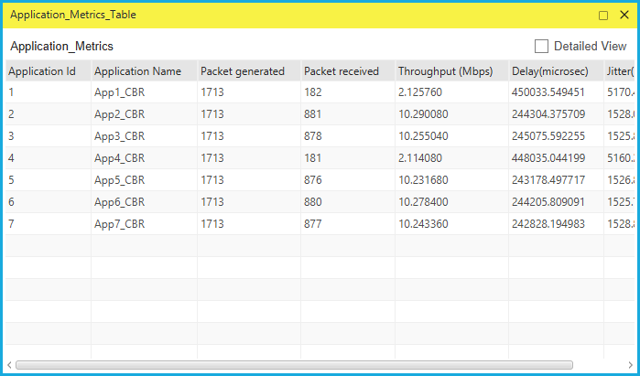

# Comparison Table

|  |  |  |
| --- | --- | --- |
| Application_Id | Throughput (Mbps)  Without_obstacle_loss | Throughput (Mbps)  With_obstacle_loss |
| 1 | 10.24 | 2.13 |
| 2 | 10.27 | 10.29 |
| 3 | 10.26 | 10.26 |
| 4 | 10.23 | 2.11 |
| 5 | 10.24 | 10.23 |
| 6 | 10.30 | 10.28 |
| 7 | 10.28 | 10.24 |

**Table 1:** Shows the variation in throughput with and without obstacle losses for UE2 and UE5, running App1 and App4