**Implementing a new Crypto Algorithm – Mysty1**

**Software Recommended:** NetSim Standard v11.0 (64-bit), Visual Studio 2015, 2017, Wireshark

1. How to add a new crypto algorithm for encryption, unzip “Addition of Mysty Encryption Algorithm” project. It would look like

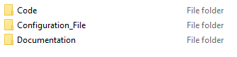

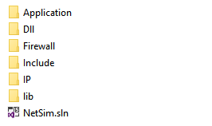

1. Double click on the NetSim.sln file to view the Application codes in Visual Studio 2015.

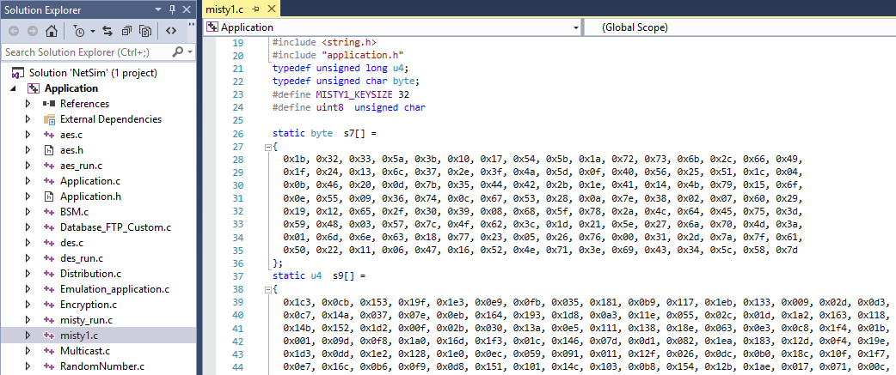

1. Now expand Application Project and click mysty_run.c file. This file contains the following lines of code.

#include <string.h>

#include <stdlib.h>

#include <stdio.h>

#include "application.h"

void misty_run(char* str,int* len)

{

int n;

int l=*len;

unsigned char buf[32];

unsigned char key[32];

for (n = 0; n < *len; n+=16,str+=16,l-=16)

{

/* Set the plain-text */

memcpy( buf, str, min(16,l));

misty1_main(buf);

memcpy(str,buf,16);

}

}

In the mysty_run() function inside the mysty_run.c file we pass the plain text in parts of 16 bytes each time to get it encrypted. This is done because the crypto algorithm expects a 16 byte plaintext as input. Here the variable str contains the packet payload and len corresponds to the size of payload in bytes.

1. Now double click on the mysty1.c file present in Application project inside the solution explorer and check the following changes to it.
2. Addition of #include<application.h> and #define uint8 unsigned char to the beginning of the file(shown in red).

#include <stdlib.h>

#include <string.h>

#include "application.h"

typedef unsigned long u4;

typedef unsigned char byte;

#define MISTY1_KEYSIZE 32

#define uint8 unsigned char

1. Removed **inline** keyword that is present before the functions fi(), fo(), fl() and flinv().

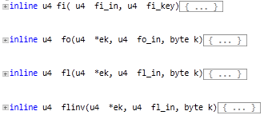

To

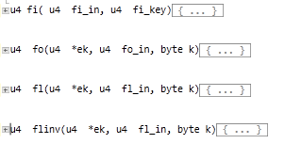

1. Now go to the main() function in the file and check that line **#ifdef TESTMAIN** was removed or commented before the main() function and also the associated **#endif** at the end of the main() function.
2. **main() function** was renamed to **unsigned char* misty1_main(uint8* input)**

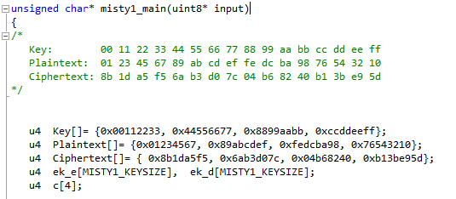

1. Commented the declaration of Ciphertext, Modify the declaration of Plaintext variable, as shown below:

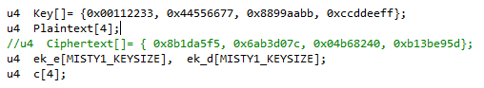

1. Now check the commented lines starting from misty1_keyinit() to misty1_key_destroy() as shown below:

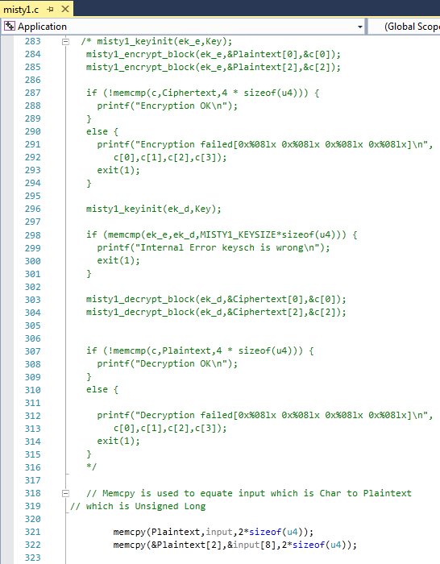

1. Addition of the following lines of code just above the misty1_key_destroy(ek_e); statement as shown below:

// Memcpy is used to equate input which is Char to Plaintext

// which is Unsigned Long

memcpy(Plaintext,input,2*sizeof(u4));

memcpy(&Plaintext[2],&input[8],2*sizeof(u4));

misty1_keyinit(ek_e,Key);

misty1_encrypt_block(ek_e,Plaintext,&c[0]);

misty1_encrypt_block(ek_e,&Plaintext[2],&c[2]);

memcpy(input,c,2*sizeof(u4));

memcpy(&input[8],&c[2],2*sizeof(u4));

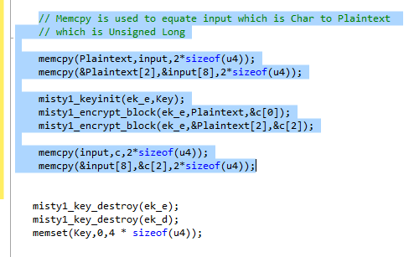

1. Inside the mysty1_main function the above codes were modified to ensure that the plaintext is properly initialized with the 16 bytes of payload received, for the encryption to happen.
2. Here, memcpy() is done initially to equate input received as which is char, to the plain text which is unsigned long.

memcpy(Plaintext,input,2*sizeof(u4));

memcpy(&Plaintext[2],&input[8],2*sizeof(u4));

1. After the calls to misty1_encrypt_block() memcpy() is done to equate the encrypted cipher text back to the input.

memcpy(input,c,2*sizeof(u4));

memcpy(&input[8],&c[2],2*sizeof(u4));

1. Now double click on the application.c file and make a call to mysty_run() function instead of the call to aes256, inside the copy_payload() function as shown below (changes are marked in red):

if(info->encryption==Encryption_TEA)

encryptBlock(real,payload,&key);

else if(info->encryption==Encryption_AES)

{

**misty_run(real,payload);**

**//aes256(real,payload);**

}

else if(info->encryption==Encryption_DES)

des(real,payload);

1. Rebuild Application project and replace the **libApplication.dll** file in NetSim bin folder i.e. **“C:\Program Files\NetSim Standard\bin”**.
2. Open **Configuration.netsim** file from the zip and make sure that AES encryption is selected in the application properties.

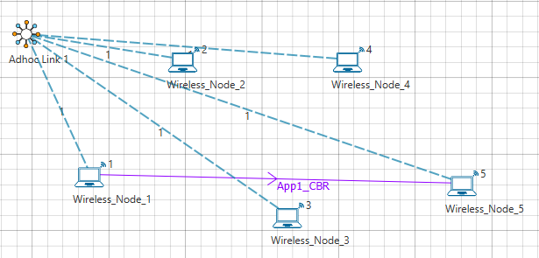

1. Also Wireshark option has to be set to either Online or Offline in any of the nodes where AES256 encryption is enabled.
2. Now mysty1 codes will be running instead of AES256.
3. You can see the encrypted payload in Wireshark either during simulation if online is set or after the simulation if offline is set.
4. Setting Wireshark to either online or offline will give you Packet Capture metrics where links to .pcap files are provided. The number of links available depends on the number of nodes in which Wireshark is enabled.

